SIMATS ENGINEERING
ASSESSMENT TOOL 1

COURSE NAME: Artificial Intelligence COURSE CODE: CSA17

COURSE OUTCOME COVERED

CO1: Apply AI basics such as intelligent agents and uninformed search methods to solve problems effectively. (BL3)

Assessment Tool Weightage: 35%

QUESTIONS: 5 Duration : 1 Hour
Total Marks:50

Annexure A

Analytical Problem Solving

Code of Conduct:

I K.Niharika(192411124) (Name / Reg No) certify that this submission is my original work and that I have adhered to the guidelines specified for this assessment.
I understand that any violation of academic integrity rules will result in disciplinary action.

Signature of the student:

Annexure A

Analytical Problem Solving

- Solve the Water Jug problem: you are given 2 jugs, a 4-gallon one and 3-gallon one. Neither has any measuring maker on it. There is a pump that can be used to fill the jugs with water. How can you get exactly 2 gallons of water into 4-gallon jug? Explicit assumptions: A jug can be filled from the pump, water can be poured out of a jug onto the ground, water can be poured from one jug to another and that there are no other measuring devices available.

- Find out how Mars Rover, analyse and explore the samples on Mars by answering the following questions.
- What are the percept’s for this agent?
- Characterize the operating environment.
- What are the actions the agent can take?
- How can one evaluate the performance of the agent?
- What sort of agent architecture do you think is most suitable for this agent? Why?

- Explore the search space using search strategies and formulate the problem components for the 8-Queens problem using the following information: Place 8 queens on a chessboard such that none of the queen’s attack any of the others. A configuration of 8 queens on the board as shown in the figure below, but this does not represent a solution as the queen in the first column is on the same diagonal as the queen in the last column.

- A customer wants to travel from the one location to another location using OLA Cab booking mobile application. The customer can select the any of the cab type as mini, micro, sedan, shared, prime and so on based on his comfort to reach the destination. Identify what type of problem-solving agent can be used and write the pseudocode for the above problem.

- A logistics company operates a delivery network where packages must be transported between warehouses at minimum cost. Each route between warehouses has an associated travel cost (fuel + time). The company wants to determine the least-cost path from the starting warehouse S to the destination warehouse G using the Uniform Cost Search (UCS) algorithm.

The delivery network is represented as a weighted graph:
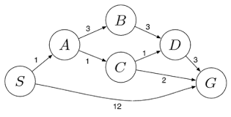

RUBRICS FOR CALCULATION:
Criteria | Weightage | Level 4 (Exemplary) | Level 3 (Proficient) | Level 2 (Developing) | Level 1 (Beginning)
Problem Understanding | 20% | Clearly interprets problem, identifies all parameters and requirements accurately | Understands problem with minor gaps | Partial understanding; misses key elements | Misinterprets or unable to understand problem
Method Selection | 20% | Selects most appropriate method/formula with strong justification | Selects correct method with minor errors | Inappropriate or partially correct method | Unable to select method
Solution Process | 25% | Logical, systematic steps with correct approach throughout | Mostly correct steps with minor mistakes | Disorganized steps; multiple errors | No clear process
Accuracy of Calculation | 20% | All calculations accurate; correct final answer | Minor calculation errors | Frequent errors; incorrect final answer | No valid calculations
Interpretation of Results | 15% | Clearly interprets results with units and engineering relevance | Basic interpretation with minor omissions | Limited or unclear interpretation | No interpretation
Problem Understanding | 20% | Clearly interprets problem, identifies all parameters and requirements accurately | Understands problem with minor gaps | Partial understanding; misses key elements | Misinterprets or unable to understand problem

SOLUTIONS
Question 1 :Water Jug Problem
Problem: We are given a 4-gallon jug and a 3-gallon jug. Neither has a measuring scale. Using a water pump and the allowed operations, obtain exactly 2 gallons in the 4-gallon jug.
1.1 State Representation
Represent a state as (x, y), where x is the amount of water in the 4-gallon jug and y is the amount in the 3-gallon jug.
Initial state: (0, 0)
Goal state: (2, 0)
1.2 Allowed Actions
- Fill the 4-gallon jug.
- Fill the 3-gallon jug.
- Empty the 4-gallon jug.
- Empty the 3-gallon jug.
- Pour water from the 4-gallon jug into the 3-gallon jug.
- Pour water from the 3-gallon jug into the 4-gallon jug.
1.3 Step-by-Step Solution
Step | Action | 4-Gallon Jug | 3-Gallon Jug
1 | Start | 0 | 0
2 | Fill 3-gallon jug | 0 | 3
3 | Pour 3-gallon into 4-gallon | 3 | 0
4 | Fill 3-gallon jug again | 3 | 3
5 | Pour 3-gallon into 4-gallon until full | 4 | 2
6 | Empty the 4-gallon jug | 0 | 2
7 | Pour the remaining 2 gallons into 4-gallon jug | 2 | 0
Final state: (2, 0)
Conclusion: Exactly 2 gallons are obtained in the 4-gallon jug.
Question 2 : Mars Rover as an Intelligent Agent
Problem: Analyze how a Mars Rover explores Mars and collects scientific samples.
2.1 Percepts
Percepts are the information received from the environment through sensors.
- Camera images and visual information.
- Distance and obstacle information.
- Temperature and pressure readings.
- Soil and rock information.
- Rover position and orientation.
- Sample and terrain information.
2.2 Operating Environment
Property | Mars Rover Environment | Reason
Observability | Partially observable | The rover cannot observe the entire Mars surface.
Determinism | Stochastic | Sensor readings and movement can have uncertainty.
Episodes | Sequential | Current actions affect future decisions.
Change | Dynamic | Environmental conditions may change.
State | Continuous | Position, speed, temperature etc. can vary continuously.
Agents | Single-agent | The rover mainly operates independently.
2.3 Actions
- Move forward or backward.
- Turn left or right.
- Stop.
- Avoid obstacles.
- Collect soil or rock samples.
- Analyze samples.
- Take photographs.
- Send scientific data to Earth.
2.4 Performance Measure:
The rover's performance can be evaluated using:
- Amount and quality of useful scientific data collected.
- Number and quality of samples collected.
- Accuracy and safety of navigation.
- Distance explored.
- Energy consumed.
- Time taken.
- Successful communication with Earth.
Overall performance: Maximum useful exploration and scientific information with minimum risk, time and energy.
2.5 Suitable Agent Architecture
Answer: Utility-Based Agent
A utility-based agent is suitable because the rover must balance several factors such as scientific value, safety, energy consumption and time. It can select the action that gives the best overall utility.
Question 3: 8-Queens Problem
Problem: Place 8 queens on an 8 × 8 chessboard so that no two queens attack each other.
3.1 State Representation
Represent each queen by its (row, column) position. The required solution is:
Q1 → (1,4)
Q2 → (2,6)
Q3 → (3,8)
Q4 → (4,2)
Q5 → (5,7)
Q6 → (6,1)
Q7 → (7,3)
Q8 → (8,5)
State representation: [4, 6, 8, 2, 7, 1, 3, 5]
3.2 Initial State
Initially, the 8 × 8 board is empty. Queens are placed row by row and every new position is checked for conflicts.
3.3 Goal Test
The goal is reached when all 8 queens are placed and no two queens attack each other.
No two queens are in the same row.
No two queens are in the same column.
No two queens are on the same diagonal.
Diagonal condition: For queens (r1,c1) and (r2,c2), a diagonal conflict occurs when |r1 − r2| = |c1 − c2|.
3.4 Step-by-Step Placement
Step | Queen | Position | Check
1 | Q1 | (1,4) | No conflict
2 | Q2 | (2,6) | No conflict with Q1
3 | Q3 | (3,8) | No conflict with Q1, Q2
4 | Q4 | (4,2) | No conflict with Q1–Q3
5 | Q5 | (5,7) | No conflict with Q1–Q4
6 | Q6 | (6,1) | No conflict with Q1–Q5
7 | Q7 | (7,3) | No conflict with Q1–Q6
8 | Q8 | (8,5) | No conflict with Q1–Q7
3.5 Final Board
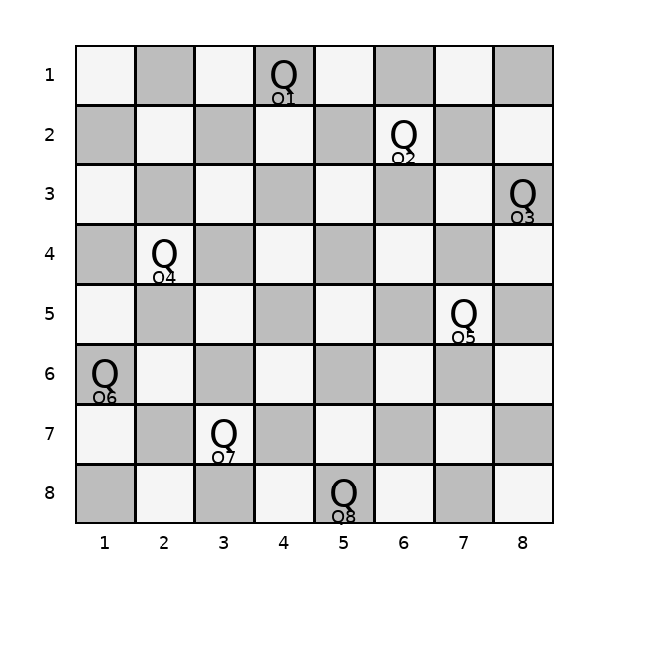
Figure: Final valid 8-Queens configuration
Final state: [4, 6, 8, 2, 7, 1, 3, 5]
Conclusion: All 8 queens are placed successfully with no row, column or diagonal conflicts.
Question 4 :OLA Cab Booking – Problem-Solving Agent
Problem: A customer wants to travel from one location to another using an OLA Cab booking application. The customer can choose Mini, Micro, Sedan, Shared or Prime.
4.1 Suitable Agent
Answer: Goal-Based Agent
A goal-based agent is suitable because the main goal is to take the customer from the source location to the destination. The agent selects actions that help achieve this goal.
4.2 Problem Formulation
Component | Description
Initial State | Customer is at the source location.
Goal State | Customer reaches the destination.
Actions | Select cab, search availability, book cab, assign driver and navigate.
Constraints | Cab must be available and the selected cab type must be available.
4.3 Pseudocode
START
Input source
Input destination
Input cab_type
IF source == destination
Display "Already at destination"
STOP
END IF
Search for available cab of cab_type
IF cab is available
Show fare and estimated time
Ask customer for confirmation
IF customer confirms
Book cab
Assign driver
Navigate to destination
Display "Reached destination"
ELSE
Display "Booking cancelled"
END IF
ELSE
Display "Cab not available"
END IF
STOP
Question 5:Uniform Cost Search (UCS) – Logistics Delivery Network
Problem: Find the least-cost path from starting warehouse S to destination warehouse G using Uniform Cost Search.
5.1 Given Weighted Graph
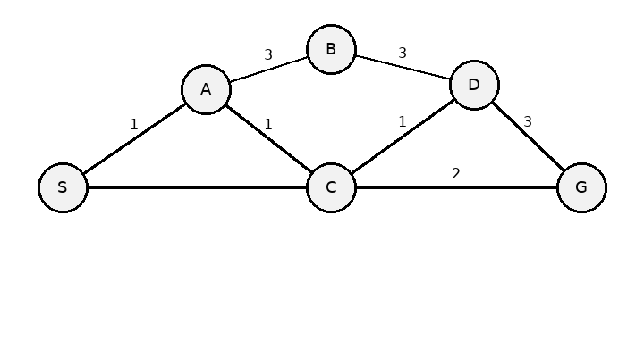
5.2 UCS Principle
Uniform Cost Search always expands the node with the lowest total path cost g(n) from the start node S.
Rule: Choose the lowest cumulative cost first.
5.3 Step-by-Step Search
Step | Expanded Node | Path | Cost
1 | S | S | 0
2 | A | S → A | 1
3 | C | S → A → C | 2
4 | D | S → A → C → D | 3
5 | B | S → A → B | 4
6 | G | S → A → C → G | 4

5.4 Cost Calculation
S → A → C → G = 1 + 1 + 2 = 4
S → A → C → D → G = 1 + 1 + 1 + 3 = 6
S → A → B → D → G = 1 + 3 + 3 + 3 = 10
S → G = 12
Optimal path: S → A → C → G
Minimum cost: 4
Conclusion:
UCS finds S → A → C → G because it has the lowest total path cost of 4.

