SIMATS ENGINEERING (SAVEETHA SCHOOL OF ENGINEERING)
Department of Computer Science and Engineering
ASSESSMENT TOOL 2 – SCENARIO BASED ASSESSMENT
Course Code: | CSA06 | Course Title: | Design and Analysis of Algorithms
CO Assessed: | CO2 – Manipulation (BL1, BL2, BL3) | Assessment: | Assessment Tool 2 – Scenario Based Assessment
Weightage: | 20% of CIA | Total Marks: | 100
CO2 Statement: | Apply Brute Force technique to solve sorting, searching, Closest-Pair and Convex-Hull problems (BL1, BL2, BL3)
Student Name: | M . Niharika | Reg. No.: | 192472392
Section / Batch: | CSE-AI | Date: | 21-07-26

Instructions to Students
• Answer BOTH scenario-based questions. Each question carries 50 Marks. Total: 100 Marks.
• Carefully analyze the given scenario and identify the computational problem involved.
• Apply appropriate Brute Force techniques for sorting, searching, Closest-Pair, and Convex-Hull problems wherever applicable.
• Clearly justify the chosen solution approach with proper reasoning and analytical interpretation.
• Demonstrate decision-making skills by comparing possible solutions and selecting the most suitable approach.
• Use diagrams, stepwise illustrations, or algorithmic representations wherever necessary.
• Maintain clarity, logical organization, and proper technical presentation throughout the answers.

Question Type | Focus Area | Questions | Marks
Scenario Based Assessment | Analyze real-world scenarios and apply Brute Force techniques for sorting, searching, Closest-Pair, and Convex-Hull problems | Q1 - Q2 | 100 (2 × 50)
GRAND TOTAL: |  | 100 Marks

SECTION A – SCENARIO BASED ASSESSMENT

Code of Conduct
I __________________________ (Name / Reg No) certify that this submission is my original work and that I have adhered to the guidelines specified for this assessment. I understand that any violation of academic integrity rules will result in disciplinary action.
Signature of the Student: _________________________
RUBRICS FOR CALCULATION
Criteria | Wt. | Level 4 – Exemplary | Level 3 – Proficient | Level 2 – Developing | Level 1 – Beginning
Problem Understanding & Context Analysis | 25 | Thoroughly understands the scenario with accurate interpretation of all requirements | Clearly understands the scenario with minor gaps | Basic understanding; some aspects of the scenario unclear | Poor understanding or misinterpretation of the scenario
Application of Concepts | 30 | Applies appropriate concepts effectively to solve complex real-world problems | Applies relevant concepts correctly with minor errors | Applies basic concepts but with limited accuracy | Fails to apply appropriate concepts
Analytical & Decision-Making Skills | 20 | Demonstrates strong analysis and selects optimal solutions with justification | Good analysis with reasonable solutions | Limited analysis; solutions lack justification | Poor or no analysis; incorrect decisions
Solution Design & Approach | 15 | Well-structured, innovative, and feasible solution approach | Logical and structured solution with minor gaps | Basic solution with limited structure or feasibility | Unclear or incorrect solution approach
Clarity, Justification & Presentation | 10 | Clear, well-justified explanation with strong reasoning | Clear explanation with some justification | Limited clarity and weak justification | Poorly explained with no justification

Marks Evaluation:
Question No. | Problem Understanding & Context Analysis (25%) | Application of Concepts (30%) | Analytical & Decision-Making Skills (20%) | Solution Design & Approach (15%) | Clarity, Justification & Presentation (10%) | Total Marks (Each – 50)
Q1
Q2
Overall Total (100)

Faculty In-charge | Course Coordinator | Head of Department
Signature: _______________ | Signature: _______________ | Signature: _______________
Date: ___________________ | Date: ___________________ | Date: ___________________

CO2 AT-2 : SCENARIO BASED ASSESSMENT

Q141. A financial analytics system collects fluctuating stock prices in random order and
needs sorting before analysis.
a) Compare Selection Sort and Bubble Sort for this dataset.
b) Analyze their computational cost.
c) Recommend the better algorithm with justification.
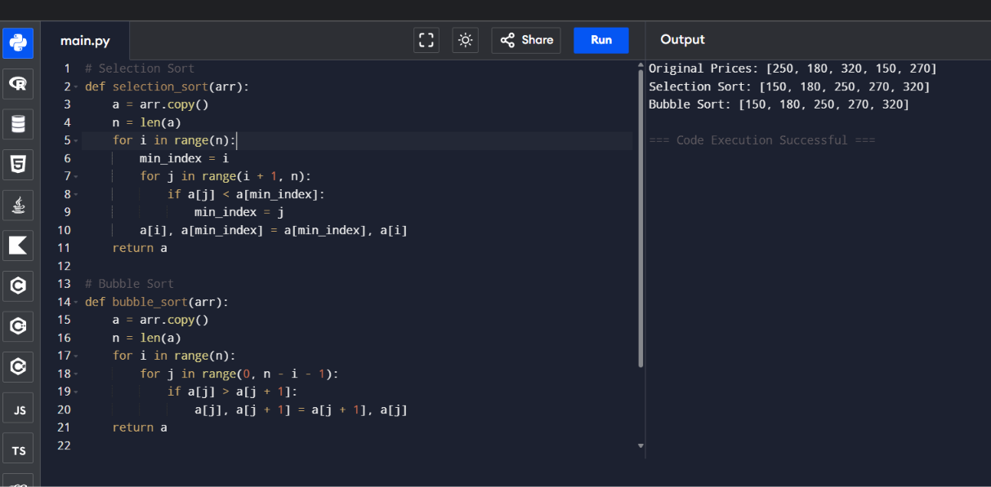
Q142. A telecom infrastructure system evaluates distances between communication
towers to optimize connectivity using brute-force closest pair computation.
a) Explain how the brute-force method works.
b) Derive the time complexity.
c) Discuss performance limitations.
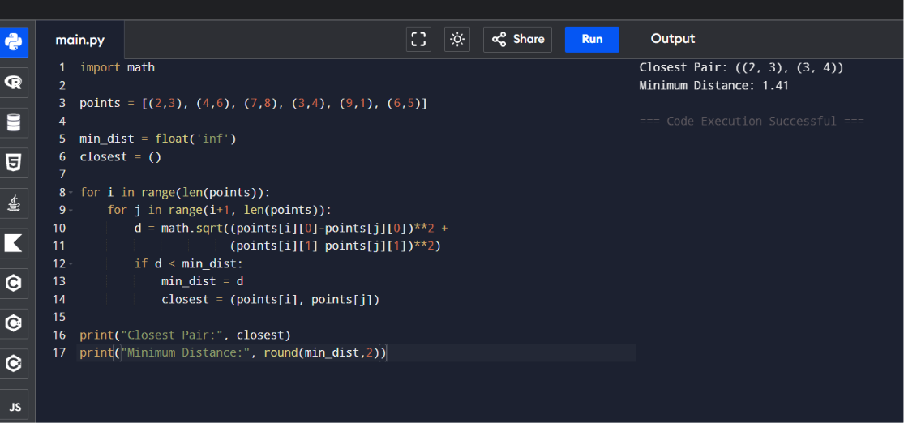
Q143. A hospital database stores patient records unsorted and retrieves them using
Linear Search during emergencies.
a) Explain how Linear Search operates.
b) Analyze its efficiency.
c) Justify whether sorting is beneficial.
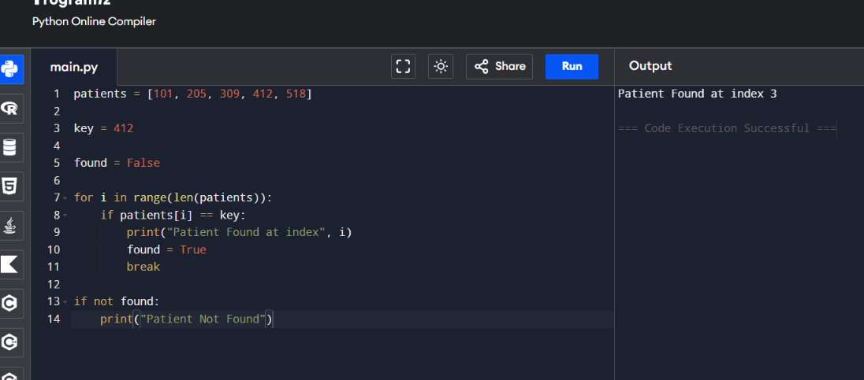
Q144. A geographic mapping system determines terrain boundaries using convex hull
algorithms on large datasets.
a) Explain how brute-force convex hull identifies boundary points.
b) Analyze the time complexity.
c) Discuss inefficiency for large datasets.
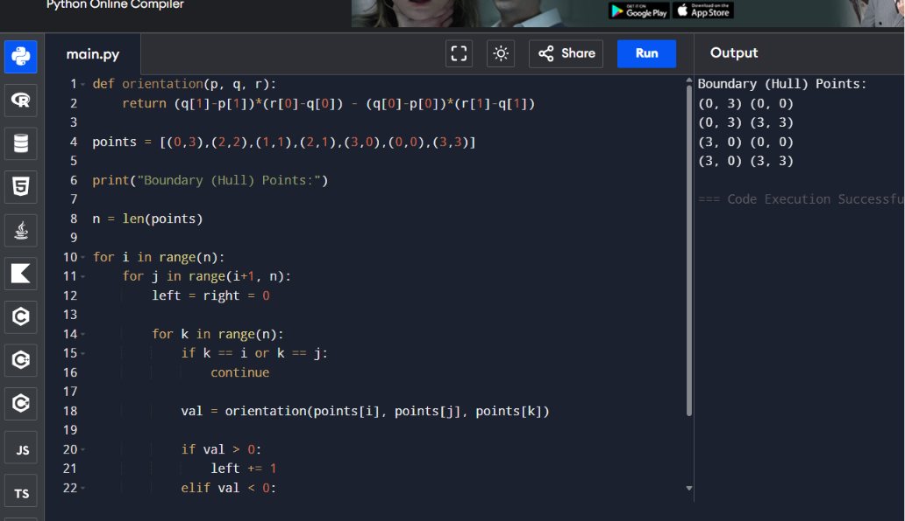
Q145. A document analysis system scans large files using brute-force string matching to
detect keywords.
a) Explain how the algorithm works.
b) Analyze the time complexity.
c) Discuss inefficiency for large inputs.
