SCHOOL OF COMPUTER SCIENCE AND ARTIFICIAL INTELLIGENCE |  |  |  |  | DEPARTMENT OF COMPUTER SCIENCE ENGINEERING
ProgramName:B. Tech |  |  |  | Assignment Type: Lab |  |  | AcademicYear:2025-2026
CourseCoordinatorName |  |  |  | Venkataramana Veeramsetty
Instructor(s)Name |  |  |  | 1. Dr. Mohammed Ali Shaik  2. Dr. T Sampath Kumar  3. Mr. S Naresh Kumar  4. Dr. V. Rajesh  5. Dr. Brij Kishore  6. Dr Pramoda Patro  7. Dr. Venkataramana  8. Dr. Ravi Chander  9. Dr. Jagjeeth Singh
CourseCode |  |  | 24CS002PC215 | CourseTitle |  | AI Assisted Coding
Year/Sem |  |  | II/I | Regulation |  | R24
Date and Day  of Assignment |  |  |  | Time(s)
Duration |  |  | 2 Hours | Applicableto  Batches
AssignmentNumber:3.3(Present assignment number)/24(Total number of assignments)
 | Q.No. | Question |  |  |  |  |  | ExpectedTime  to complete
 | 1 | Lab 3: Prompt Engineering – Improving Prompts and Context Management  Lab Objectives:  - To understand how prompt structure and wording influence AI-generated code.  - To explore how context (like comments and function names) helps AI generate relevant output.  - To evaluate the quality and accuracy of code based on prompt clarity.  - To develop effective prompting strategies for AI-assisted programming.  Lab Outcomes (LOs):  After completing this lab, students will be able to:  - Generate Python code using Google Gemini in Google Colab.  - Analyze the effectiveness of code explanations and suggestions by Gemini.  - Set up and use Cursor AI for AI-powered coding assistance.  - Evaluate and refactor code using Cursor AI features.  - Compare AI tool behavior and code quality across different platforms.  Task Description#1  - Try 3 different prompts to generate a factorial function.  Expected Output#1  - Comparison of AI-generated code styles  Prompt 1:Write a python code that take input from the console and a print stmt for calculating the factorial of a number  Code:  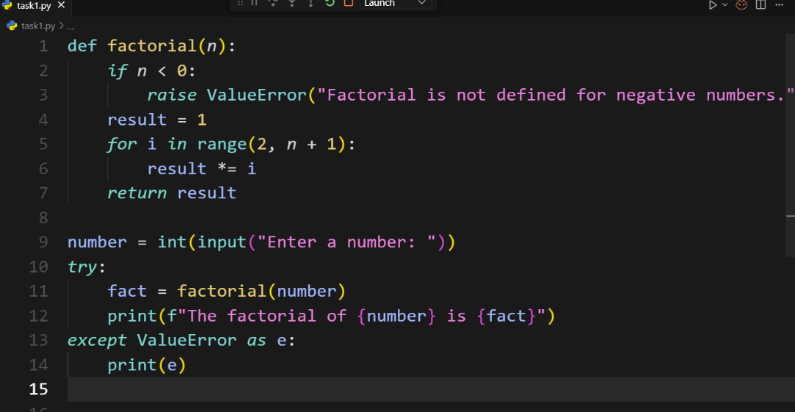  Output:  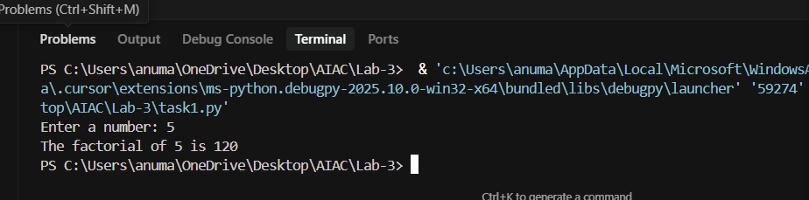  Prompt 2: Write a python code that do not take input from the console to calculate factorial of a number  Code:  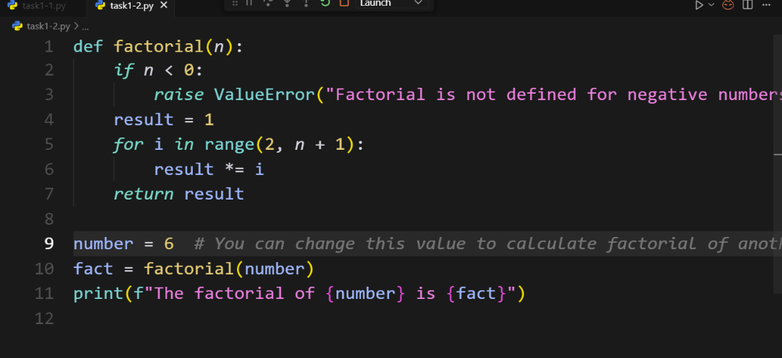  Output:  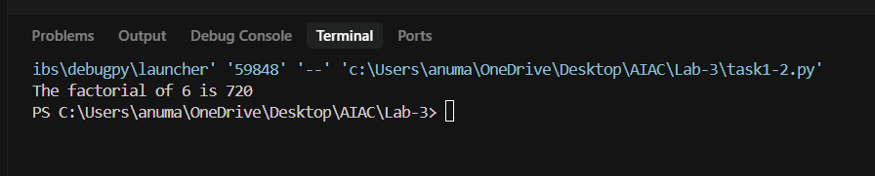  Prompt 3: Write a python function that calculate factorial of a number 8  Code:  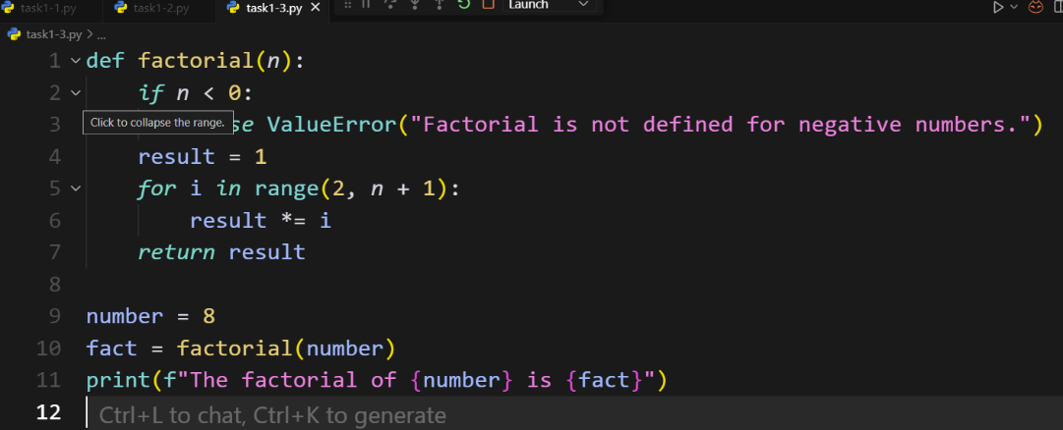  Output:  Comparision: All three codes calculate factorial using the same logic, but they differ in how the input is given. task1.py takes input from the user at runtime, making it interactive. task1_2.py uses a hardcoded value 10, so it always calculates factorial of 10. task1_3.py also uses a hardcoded value 5, but adds a helpful comment suggesting the value can be changed. In short, the difference lies only in input method—user input vs fixed value.  Task Description#2  - Provide a clear example input-output prompt to generate a sorting function.  Expected Output#2  - Functional sorting code from AI  Prompt 1: write a python code that Provide a clear example input-output prompt to generate a sorting function.  Code: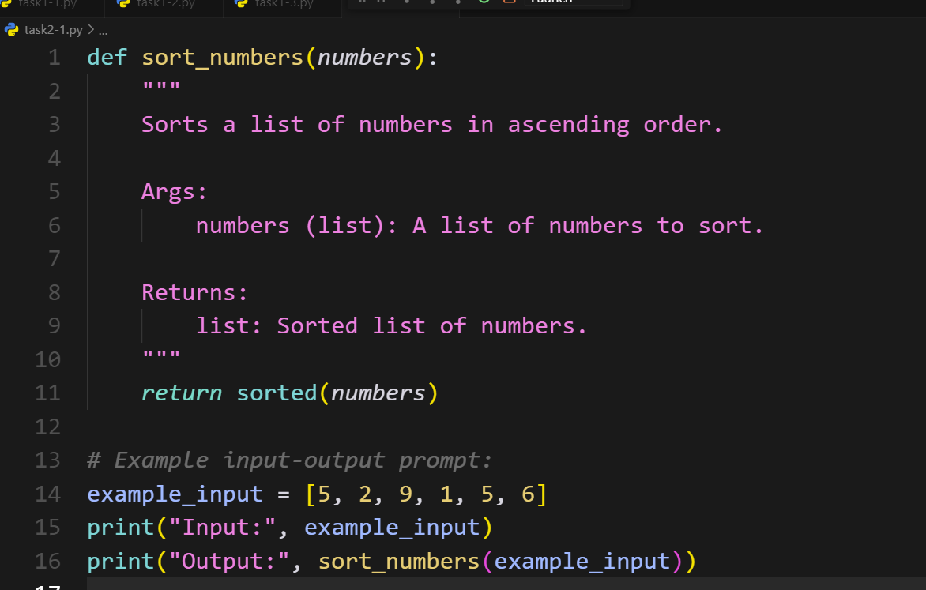  Output:  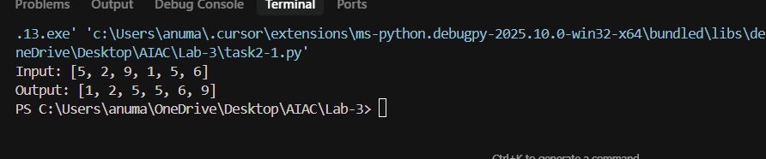  Prompt 2: write a python code without the function that generate a sorting function  Code:  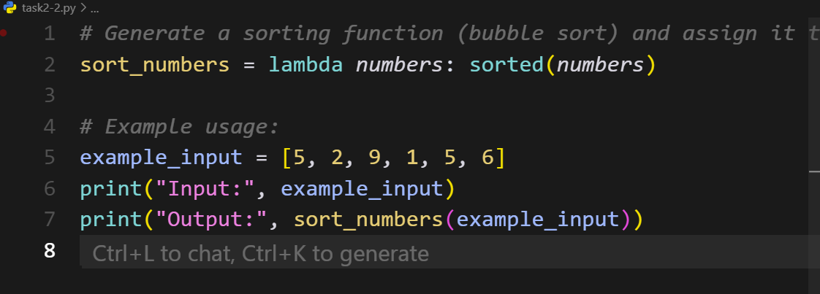  Output:  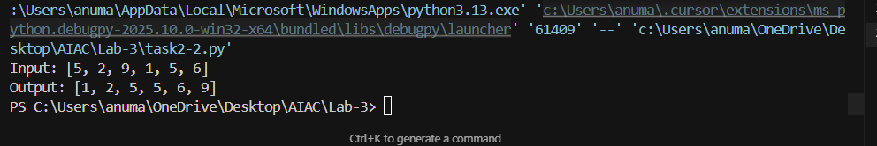  Prompt 3: write a python code that generate the sorting numbers without using function and lambda  Code:  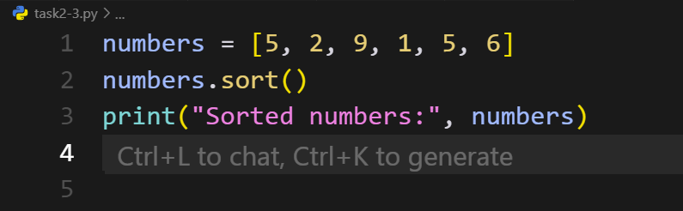  Output:  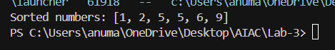  Comparision: All three codes sort a list but differ in approach. task2_1.py and task2_2.py use Python’s inbuilt sorted() function, making them short, efficient, and practical for real-world use. task2_3.py implements sorting manually using the Bubble Sort algorithm, which is longer and slower.  Task Description#3  - Start with the vague prompt “Generate python code to calculate power bill” and improve it step-by-step  Expected Output#3  - Enhanced AI output with clearer prompts  Prompt 1: write a python code to calculate power bill  Code:  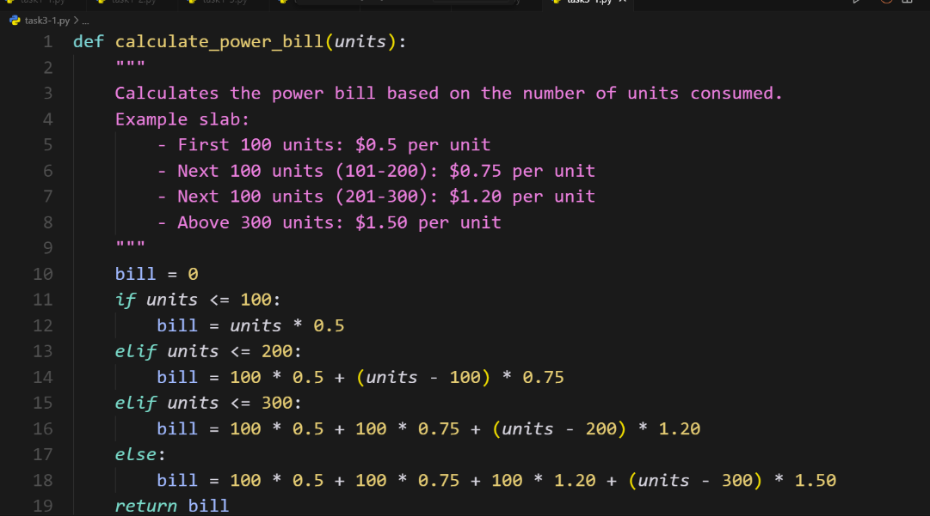  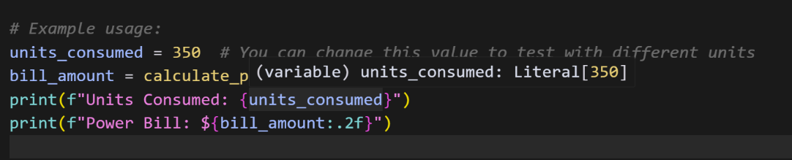  Output:  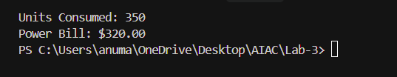  Prompt 2:Write a python code that take units from the console to calculate power bill  Code: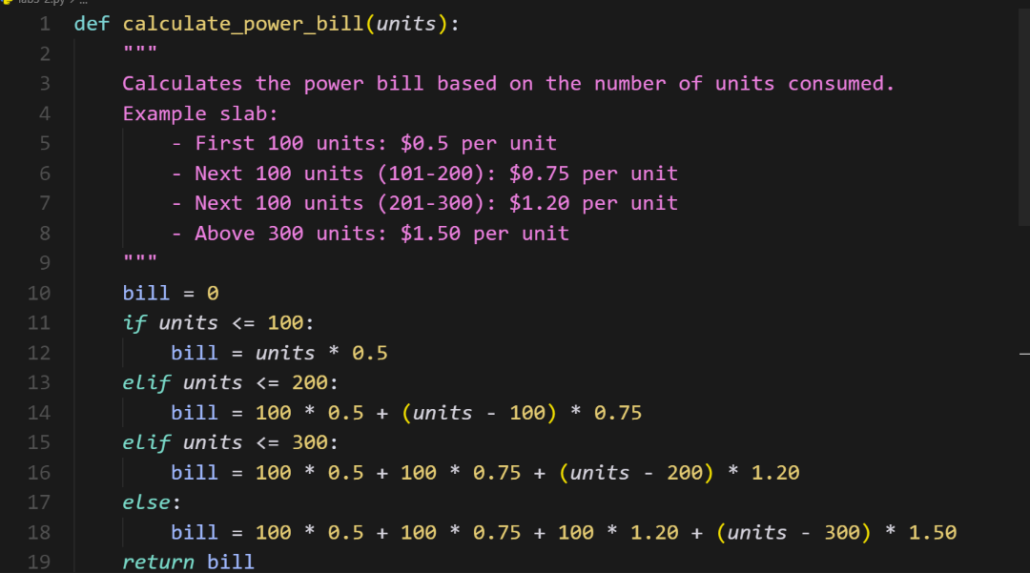  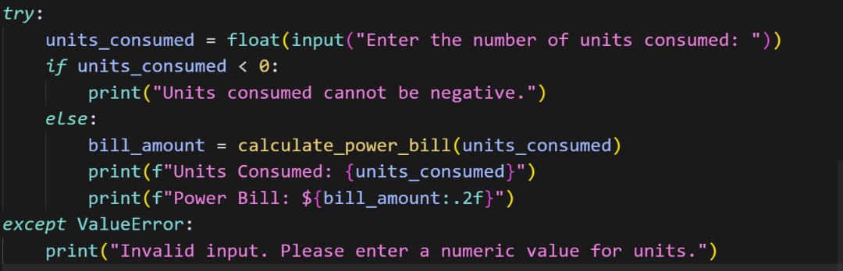  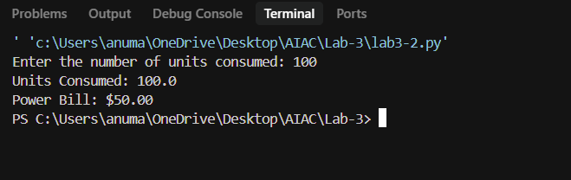  Prompt 3: Write a python code that calculate power bill from the different types of customers  Code:  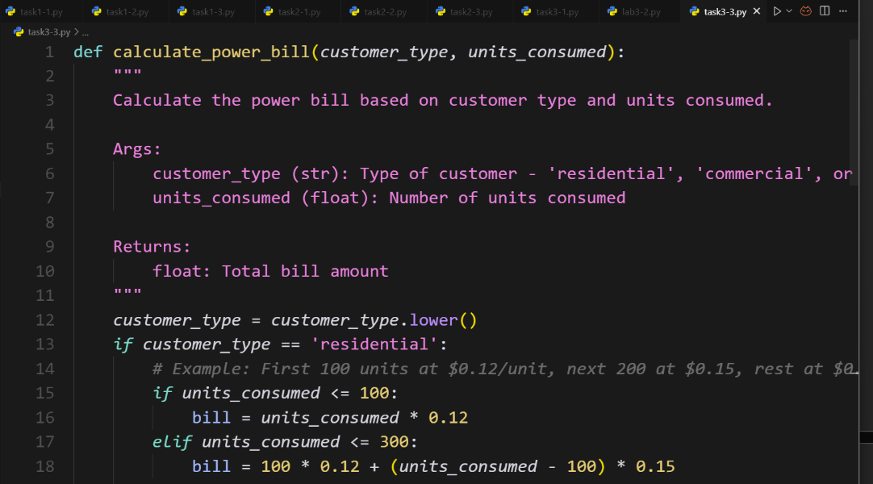  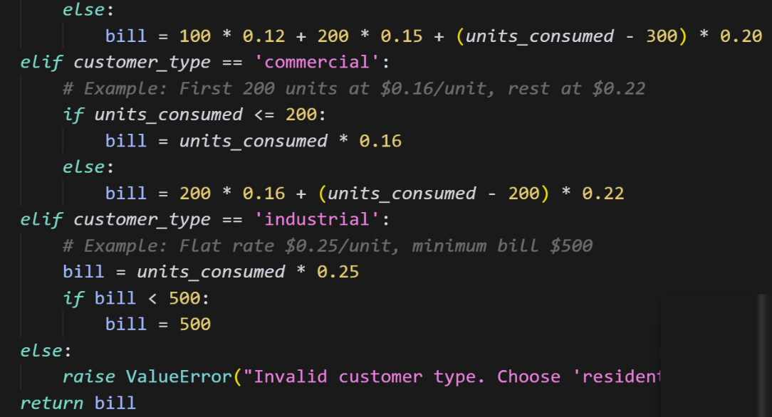  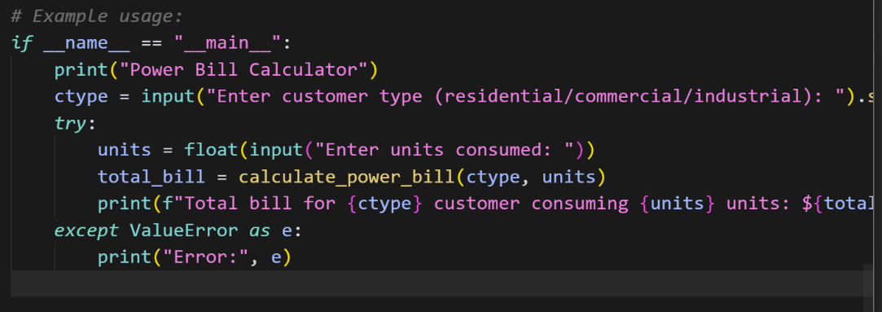  Output:  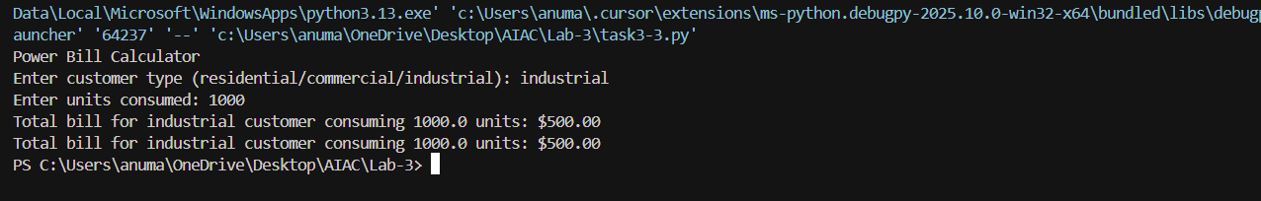  Comparision: These three codes all calculate electricity bills but differ in flexibility. task3_1.py uses fixed rates (Residential = 5, Commercial = 8, Industrial = 10) for billing, making it the simplest. task3_2.py improves flexibility by letting the user enter custom per-unit rates for each type before billing. task3_3.py is the most advanced, as it allows defining multiple slabs (consumption ranges with different rates) for each customer type, making it closer to real-world billing systems. In short, the difference is in rate handling—fixed, user-defined, and slab-based.  Task Description#4  - Write structured comments to help AI generate two linked functions (e.g., login_user() and register_user())..  Expected Output#4  - Consistent functions with shared logic  Prompt1: write a python code that generates to help AI generate two linked functions (e.g e.g., login_user() and register_user()).that take input from the console.  Code: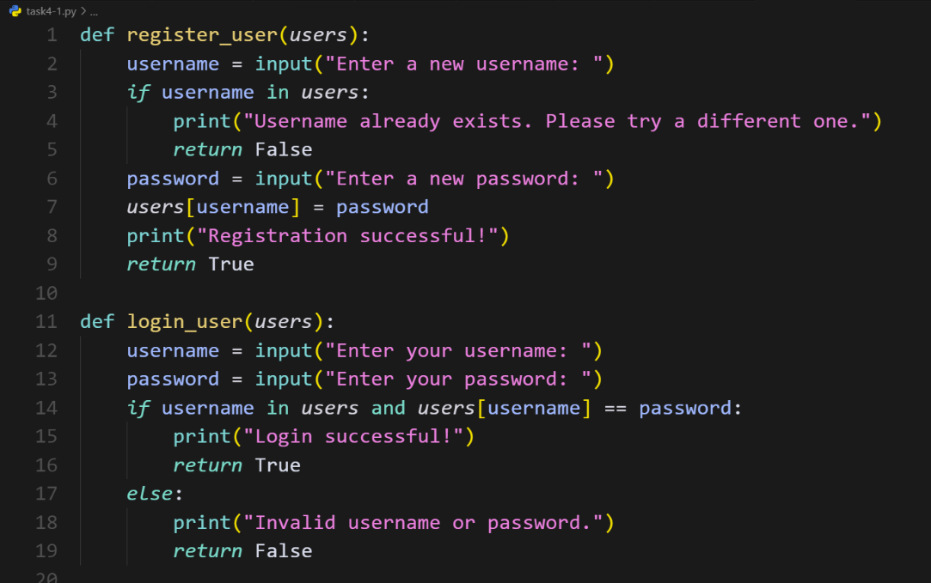  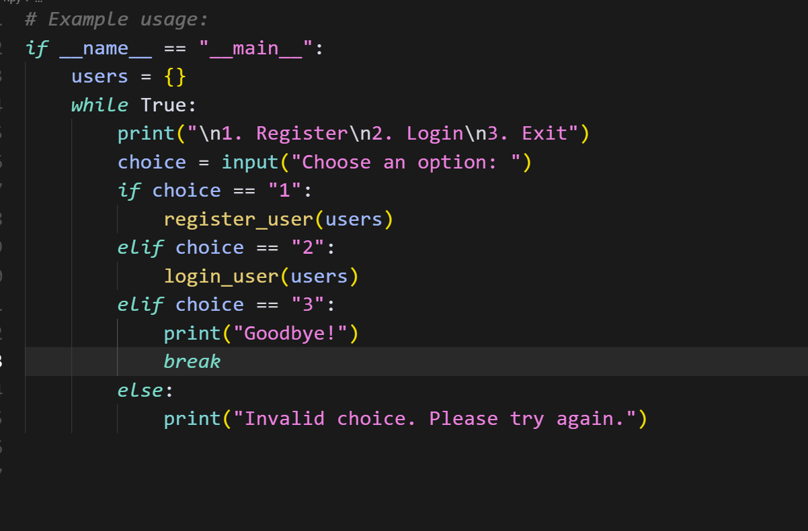  Output:  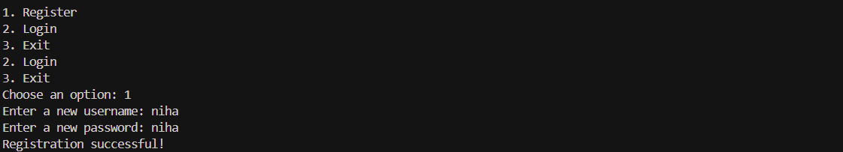  Promt2: write a python code that generates to help AI generate two linked functions (e.g e.g., login_user() and register_user()).that do not take input from the console.  Code:  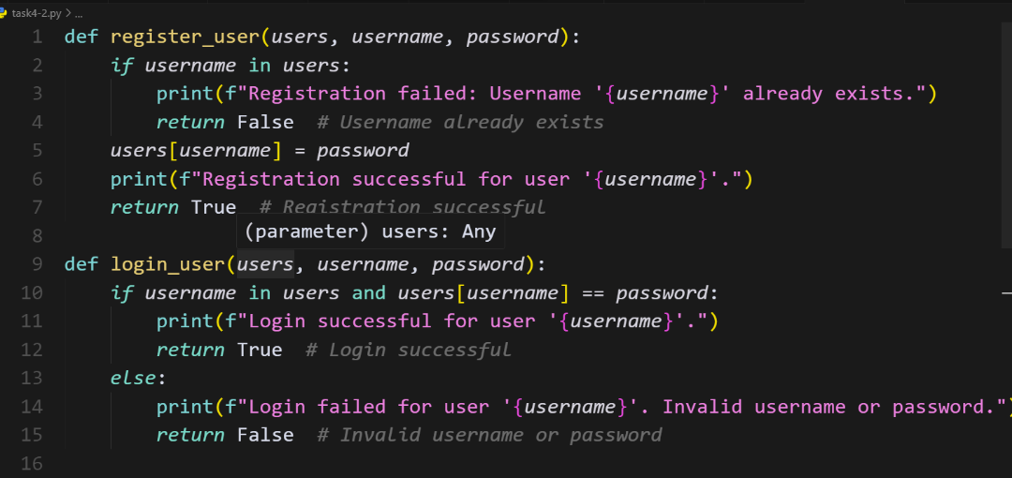  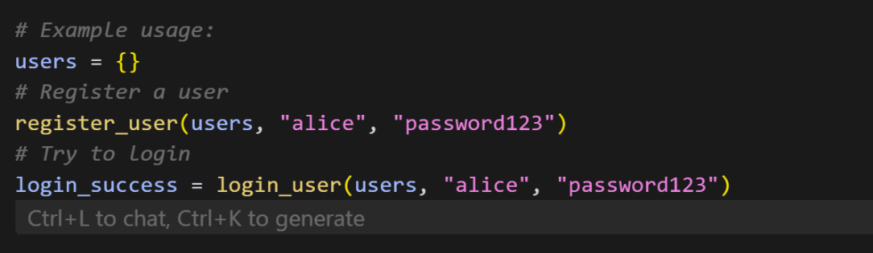  Output:  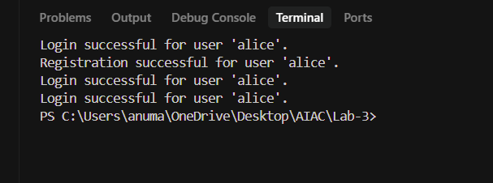  Conclusion: The codes show two different implementations of a user registration and login system in Python. The key difference lies in their main logic loop and the user's ability to exit.  The first version is designed to force the user to register and log in before they can proceed. The while loop continues as long as logged_in is False. There is no option to exit the program without successfully logging in. The loop terminates only after a successful login, at which point it prints "You are now logged in. Proceed with your tasks."  The second version gives the user more control by providing an exit option. The while True loop runs indefinitely until the user explicitly chooses to exit by selecting option "3". The break statement then terminates the loop and the program. This version doesn't force a login; it allows the user to register, log in, or exit at their discretion.  Task Description#5  - Analyzing Prompt Specificity: Improving Temperature Conversion Function with Clear Instructions  Expected Output#5  - Code quality difference analysis for various prompts  Prompt1:write a python code for temperature conversion from Fahrenheit to Celsius  Code:  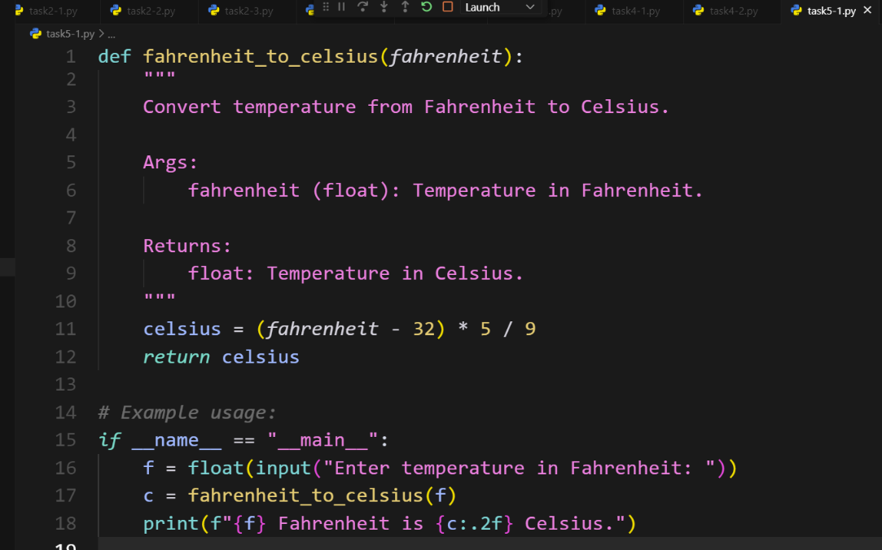  Output:  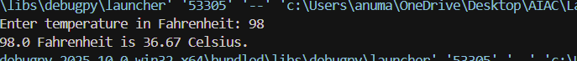  Prompt2: write a python code for temperature conversion from Fahrenheit to Celsius that do not take input from the console  Code: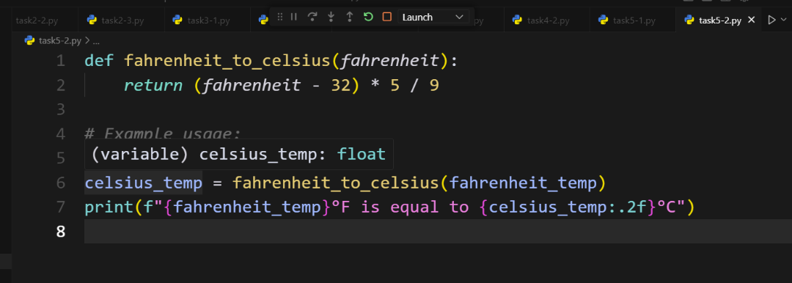  Output:  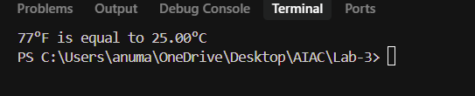  Conclusion:  The two Python code snippets both deal with temperature conversion, but they differ in their structure and modularity.  The first code uses a single function, temperature_conversion(), to handle both Celsius to Fahrenheit and Fahrenheit to Celsius conversions. It prompts the user for their choice of conversion type within this function and then performs the calculation and prints the result directly.  In contrast, the second code demonstrates a more modular approach. It defines a dedicated function, fahrenheit_to_celcius(), specifically for converting Fahrenheit to Celsius. This function takes a Fahrenheit temperature as input and returns the calculated Celsius value, separating the conversion logic from the user interaction and output. If a Celsius to Fahrenheit conversion was also needed, a separate function for that would likely be created, promoting code reusability and better organization.  Evaluation Criteria:  Criteria Max Marks  Factorial Function (Task#1) 0.5  Sorting Function (Task#2) 0.5  Vogue Vs. Specific Prompting (Task #3) 0.5  Linked Functions (Task #4) 0.5  Temperature Conversion Function (Task #5) 0.5  Total 2.5 Marks |  |  |  |  |  | 03.08.2025 EOD

