PROJECT REPORT
Echo-Audit: Voice-Based Task Detection and Deadline Management System

Title:
Echo-Audit: Voice-Based Task Detection and Deadline Management System
Team Details:
Pulyala Ashritha
Roll No: 2403A52229
Department: Computer Science and Engineering
Anumala Niharika
Roll No: 2403A52234
Department: Computer Science and Engineering
Abstract:
Voice recording has emerged as an easy and effective method of helping individuals to store ideas, reminders and day-to-day activities. Rather than typing, people tend to talk as this saves time and effort. Most voice recording programs do not, however, intelligently process the files, merely providing storage of the audio files. This causes users to have to listen to the recordings repeatedly to extract important information, something that cannot be done frequently.

The Echo-Audit system is created to address this weakness by enabling users to upload audio files that are recorded and automatically transform them into meaningful tasks. After uploading, the system runs the audio on a speech recognition model to create text. This transcription is then processed by applying the techniques of natural language processing to determine the task related sentences and detecting deadlines.
The resulting tasks are saved in a database and listed on the user interface where the users can monitor and control the tasks. The system also sends alerts on the impending deadlines and enables the user to download the transcription.
Using a voice-recording, transcription, and intelligent analysis, Echo-Audit converts unstructured audio into structured and actionable data. This saves time, is less manual and has enhanced productivity among users in their day-to-day operations.
Introduction and Discussion on Existing Methods:
Voice-based interaction has become very popular in recent years as it is convenient and fast. Individuals are becoming more dependent on voice recordings to record ideas, reminders, and day-to-day activities without necessarily typing. This can be very helpful where the user is multitasking or even where he or she cannot use a keyboard. Nevertheless, conventional voice recording systems are not very useful as they do not offer any meaningful analysis but store audio files. To obtain meaningful information, users have to listen to recordings manually once again, which can be time-consuming and inefficient. In case of transcription facilities, they merely translate speech to text without knowing what the content is all about. This will create a disconnect on the information capture and its application. The Echo-Audit system attempts to overcome this shortcoming with a workflow that allows users to record audio and upload the recording file to be processed. When uploaded, the system translates the audio into a text and analyses it to find out significant tasks and deadlines. In this fashion, there is no repetitive listening and handwriting. The system enhances productivity by converting the unstructured voice input into structured and actionable data to enable users manage their tasks more effectively.
Conventional task management programs like to-do list programs have the disadvantage that users have the task of manually entering tasks and setting deadlines. Although these systems are common, they require a lot of user work, and uniformity. Users can easily forget to add tasks or postpone the updating of their lists that diminish the effectiveness of such tools. In some contemporary applications, voice input functions have been implemented, however, they usually do not understand natural language well. To illustrate, when a user enters a sentence such as I need to finish my assignment tomorrow, most systems merely store the text without a system recognizing the text as an assignment with a deadline. Such a weakness shows the necessity of more intelligent systems, which can comprehend and interpret natural language. Echo-Audit is better than the current procedures as it enables users to post the audio files recorded which are automatically processed. The system incorporates the detection of keywords to locate task relevant sentences and the use of date recognition methods to obtain deadlines. This minimizes the use of
manual input and makes sure that crucial tasks are not missed. The system offers an improved and easy to use way of managing tasks as compared to the traditional ways of doing so since it combines the voice recording and intelligent analysis.
Speech recognition technology is very important in the transformation of audio recordings into text. Recent developments in machine learning have led to much higher accuracy and reliability of speech-to-text systems that can be used in the real world. Under Echo-Audit system, after a user uploads an audio file that has been recorded, the file is sent to a speech recognition model that produces a textual transcription. This is a crucial step since the quality of the text generated determines all the subsequent analysis. Most of the currently available systems only go up to the transcription stage, leaving users with raw text, which still needs to be interpreted manually. But Echo-Audit goes a step further and evaluates the transcription and finds the meaningful tasks. It employs segmentation of sentences to divide the text into smaller components and detection of key words to sieve out irrelevant information. This will make sure that only actionable content will be extracted and offered to the user. The system offers a better solution to voice-based information management by incorporating the effective text processing and accurate transcription. This combination of technologies enables the users to instantly transform their thoughts aloud into ordered tasks without further efforts.
Natural Language Processing is a crucial part of the Echo-Audit system, as it allows extracting meaningful information out of the transcribed text. Once the audio is transformed into the text, NLP methods are used to recognize such things as dates and times. Indicators such as by tomorrow, before Monday, due next week, etc., are identified and translated into standard date formats. This enables the system to automatically give deadlines to tasks. Most of the current systems find it hard to analyze such natural language expressions resulting in partial or misleading results. Echo-Audit is a solution to this problem; it incorporates both keyword-based detection and entity recognition. This will make sure that explicit and implicit time references are both properly represented. The system also verifies the existence of duplicate tasks and only then stores the data in the database, and this is to ensure that there is consistency in the data and to prevent any redundancy. NLP helps the system to manage tasks efficiently by converting unstructured text to structured data. This renders the system more dependable and user friendly since users do not have to take it upon themselves to organize and interpret the information they record manually.
One of the useful characteristics of a task management system is the possibility of timely reminders about the deadlines. Most of the available applications have a notification capability, although in most cases they need users to create reminders manually, which may be forgotten or skipped. To ease this process, Echo-Audit automatically creates alerts on the basis of identified deadlines. Once tasks are extracted and stored, the system keeps on monitoring them and it identifies tasks that are near due dates. Once a deadline is close, the user will be alerted by a notification and alert sound, so that no important tasks are missed. This active method enhances productivity of the user and can aid in time management. Besides notifications, the system enables one to indicate that the work has been done, and one is able to have a clear view of what has to be done and what has been done. The user interface is intuitive and easy to use so that the user can easily record audio, upload files, read transcriptions and manage tasks. Echo-Audit provides an all-in-one solution of voice-based task management by combining recording, uploading, transcription, task extraction, and notification capabilities into one platform. It minimizes manual work and increases efficiency compared to the current methods.
Methodology:
1. User records audio
2. User uploads the recorded file
3. File is sent to Node.js server
4. Node.js routes file to FastAPI backend.
5. Audio is converted into text using Whisper
6. NLP is applied to process text.
7. Deadlines and tasks are de-extracted.
8. Data in MongoDB.
9. Results to user.
Results and Discussion:
The system is able to convert audio recordings uploaded in the system into text, and extract tasks with reasonable accuracy. The transcription algorithm works well with clear audio sources and the key word based method is effective in identifying task relevant sentences. Common expressions can also be extracted with deadline. The interface is not complicated and can be easily interacted with. Notifications will keep users in touch. Nevertheless, more complicated sentences can decrease accuracy, and in the future, it is possible to work on the enhancement of language comprehension.
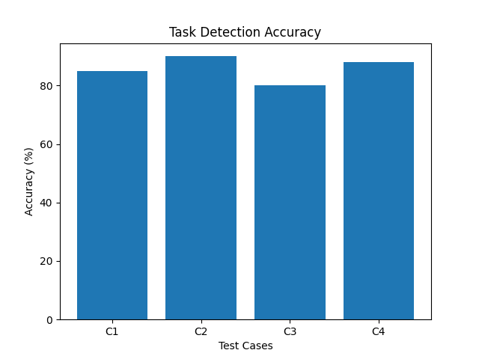
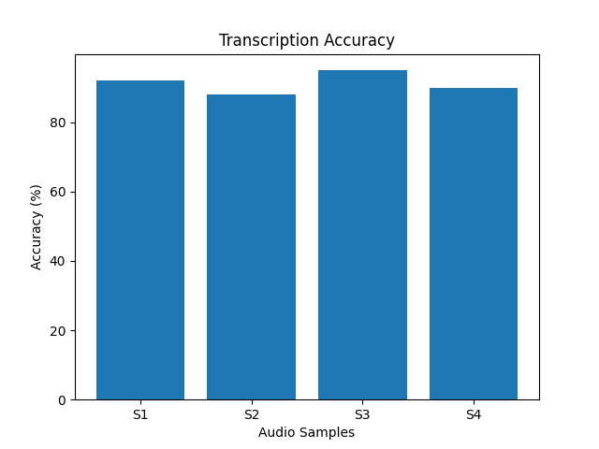
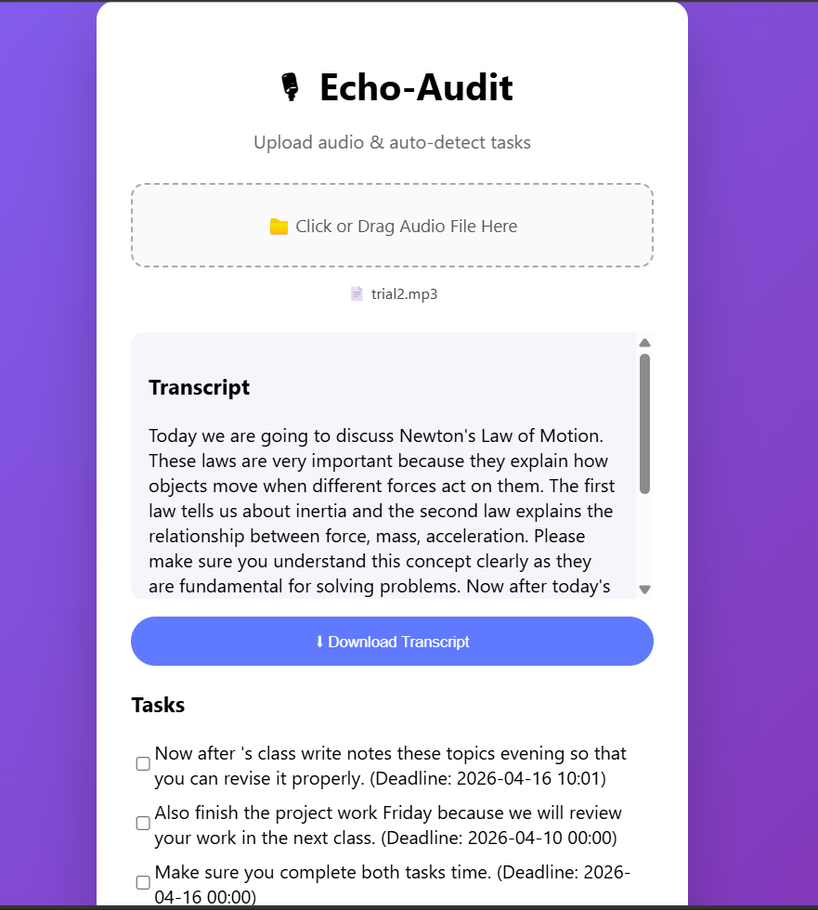
Conclusion:
Echo-Audit is a practical system that transforms voice recordings into structured tasks. It reduces manual effort and improves productivity by combining speech recognition and NLP. The system is easy to use and provides useful features like alerts and task tracking. With further enhancements, it can become a powerful tool for everyday use.
References:
1. Radford, A., et al. “Robust Speech Recognition via Large-Scale Weak Supervision.” OpenAI Whisper Research.
2. Explosion AI. spaCy: Industrial-Strength Natural Language Processing in Python.
3. FastAPI Documentation.
4. MongoDB Inc.
5. Python dateparser Library.
6. React.js Documentation.
7. Node.js Documentation.

