* Graph
* LargeTraces
* Multitraces
* Github

# Graph

Trial and error, tried to get other libraries like graphviz/tried multiple things. Will adjust/fix later.

## Check causal relationship



## See any node’s relations/children.

EXAMPLE: Initial Node 0 (0 : cpu0:cache0:wt:req) ✅

EXAMPLE: Middle Node 7 : cache1:cache0:wt:req✅

EXAMPLE: Terminating Node 25 : cache0:cpu0:wt:resp✅

## Graph

No incoming messages to initial nodes, no outgoing arrows from terminating nodes. ✅

Tried using graphviz: (too messy, but when zoomed in the image is clearer)

Or

Groups from message file:

# Reading in Large Traces

**Trace-large-5 example**

**Audio-membus Example: should have these numbers ('audio', 'membus', (5, 36, 39, 41, 48, 49, 58, 59))**

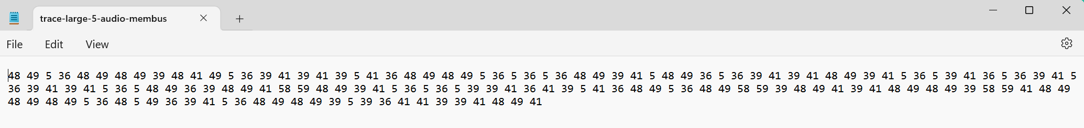

**Verification (ran a python function to check all unique numbers)** **✅**

36, 5, 39, 41, 48, 49, 58, 59

# Reading in Multiple Traces

## multipleTraces-synthetic (has 6 traces)

And each trace has

## multipleTraces-syntheticSmall (has 3)

## multipleTraces-syntheticLarge (has 3)

## multipleTraces-RubelMultiTrace (has 100)

**Example for trace 63**

