**ASSIGNMENT : LOADING DATABASE**

**1.Command used to create table :: NJ_CONSUMER_COMPLAINTS**

CREATE or replace table NJ_CONSUMER_COMPLAINTS

( DATE_RECEIVED STRING,

PRODUCT_NAME VARCHAR2(50),

SUB_PRODUCT VARCHAR2(100),

ISSUE VARCHAR2(100),

SUB_ISSUE VARCHAR2(100),

CONSUMER_COMPLAINT_NARRATIVE string,

Company_Public_Response STRING,

Company VARCHAR(100),

State_Name CHAR(4),

Zip_Code string,

Tags VARCHAR(40),

Consumer_Consent_Provided CHAR(25),

Submitted_via STRING,

Date_Sent_to_Company STRING,

Company_Response_to_Consumer VARCHAR(40),

Timely_Response CHAR(4),

CONSUMER_DISPUTED CHAR(4),

COMPLAINT_ID NUMBER(12,0) NOT NULL PRIMARY KEY

);

**2. Once created view the table using below command.**

select * from New_CONSUMER_COMPLAINTS;

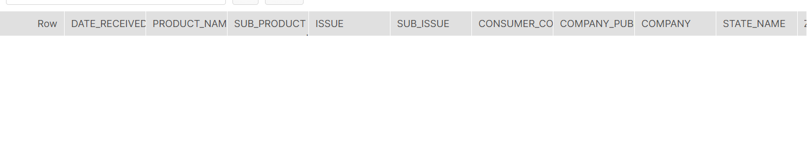

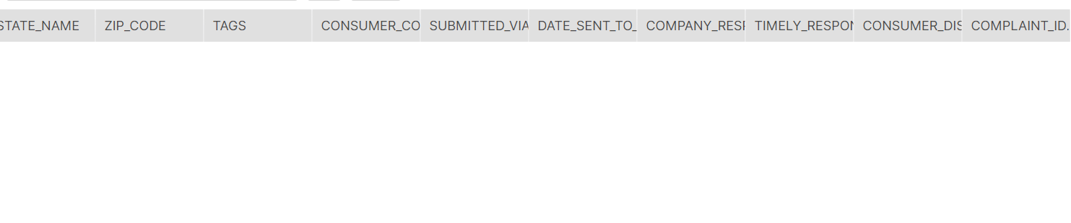

**3. Once table is created next step is to load the data .For that will follow the below steps :**

* **Click on Database**







* **Select the Table Name**

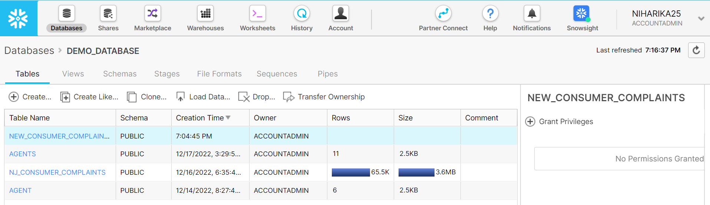



Will select New_CONSUMER_COMPLAINTS table.

* **Click on LOAD TABLE**

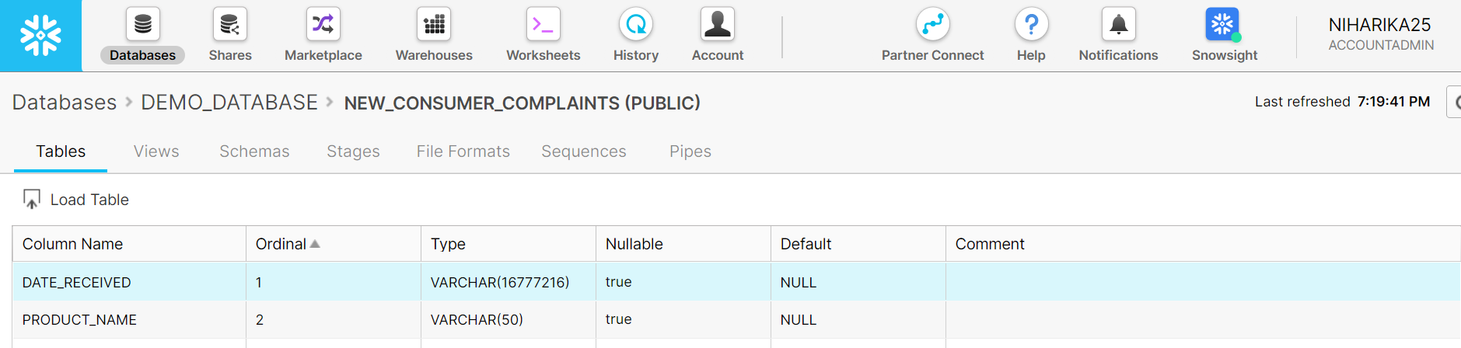



* **Select the Datawarehouse. And then click Next Button.**

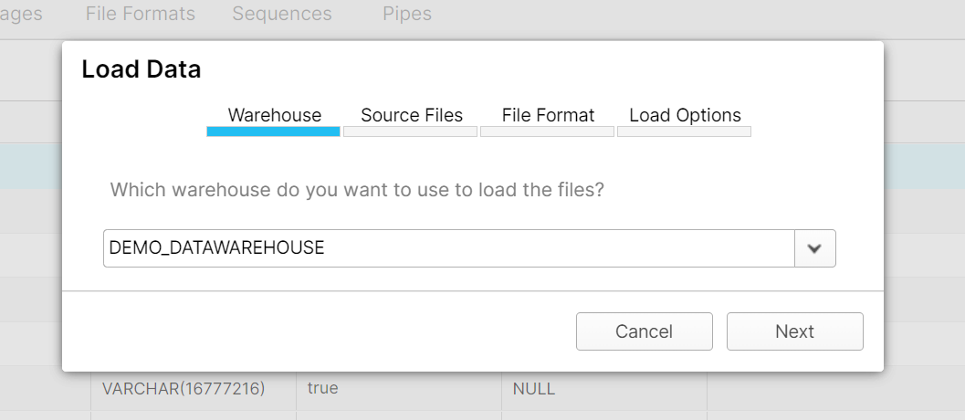



* **Click on select files.**

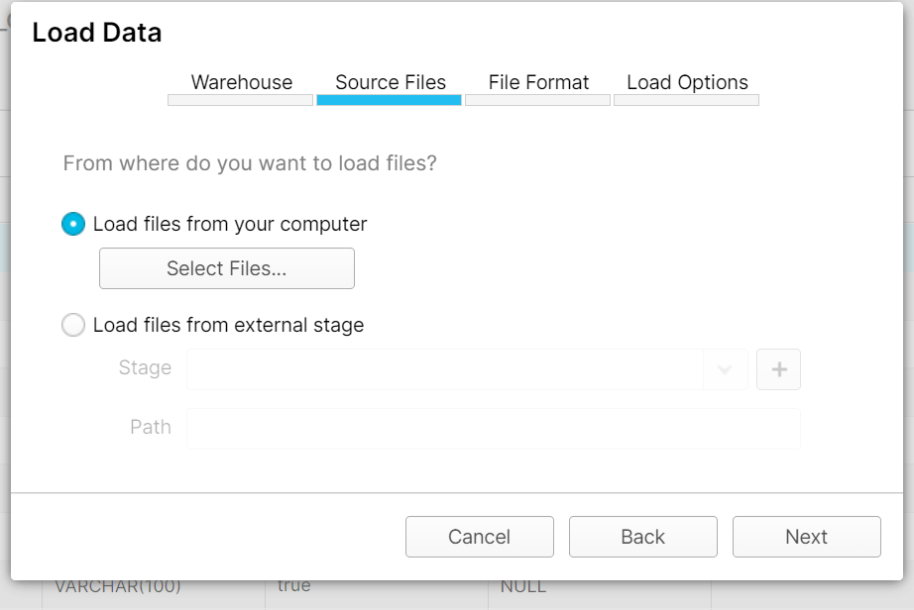



* **Select the dataset which you want to import. Here will import ConsumerComplaints_new.csv file**

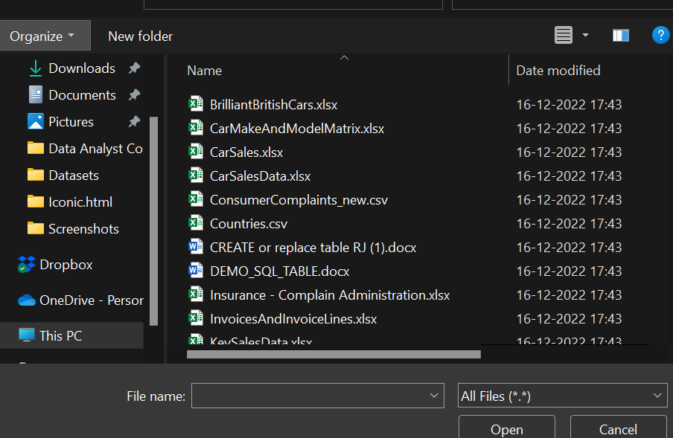



* **File selected click on next.**

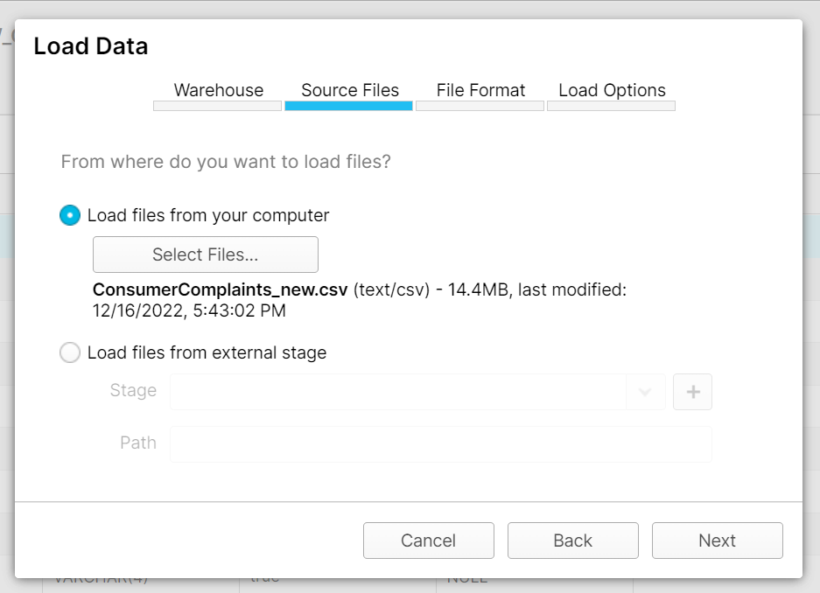



* **Create the File Format by click + button.**

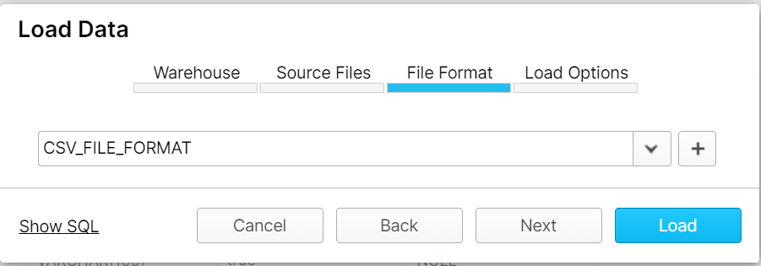



* **Enter the Name and change Header Line to skip to 1.**

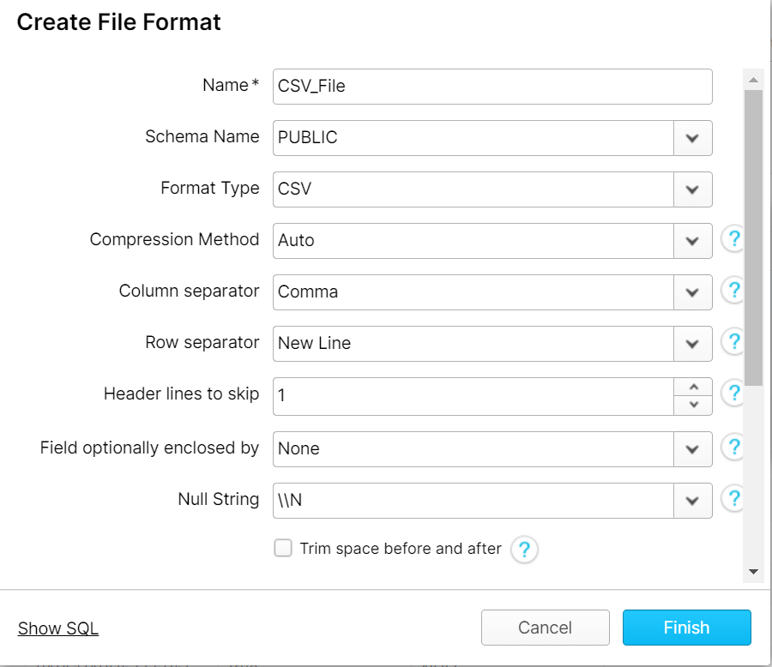



* **Once done click on Next button**

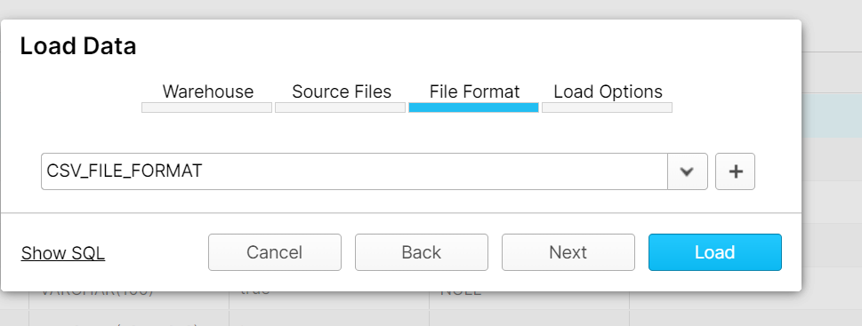



* **Always select stop loading, rollback and return the error option and then Load**

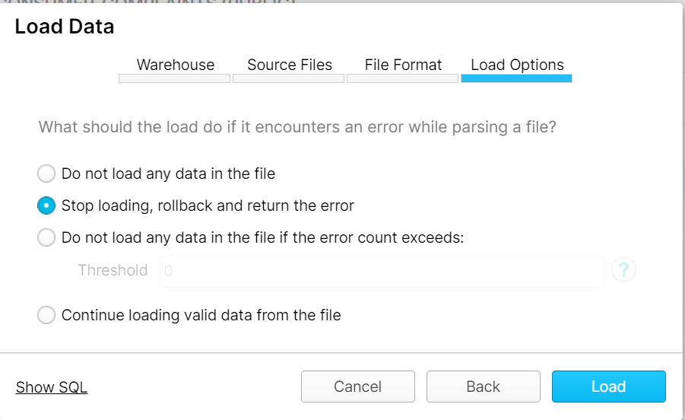



* **Importing Started.**

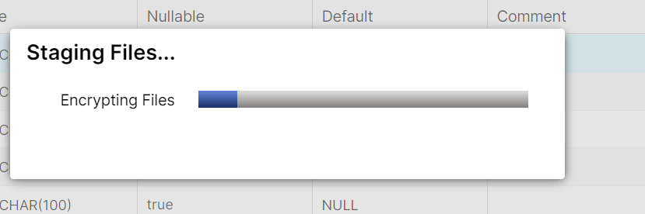

* **Importing Completed.**

**File Successfully got Loaded.**

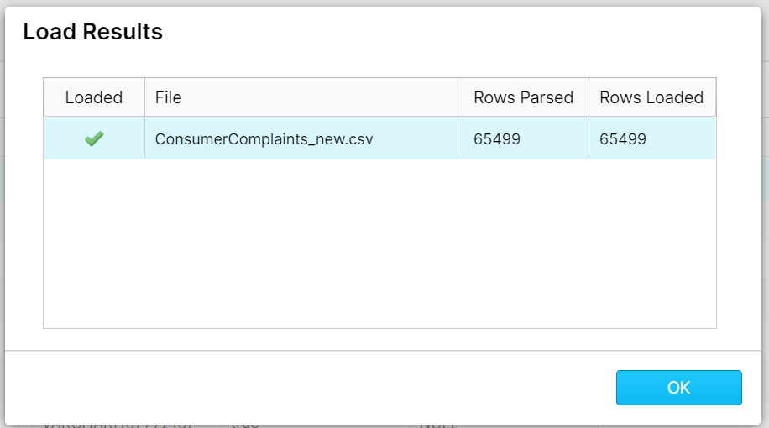

1. **To cross verify that the data is loaded check the table content using cmd.**

**select * from New_CONSUMER_COMPLAINTS;**

