SaleSpotter

Group Members

1. Niharika Balaga
2. Porkodi Rajan
3. Juan Jacobo Florez Monroy

PROG8750-24W-Sec9-Capstone (Web Development)

Fourth Semester

Submitted to

Pankaj Bains

# **SaleSpotter**

## **Introduction**

* **Define/Describe your project.**
  + The project we want to develop consists of a mobile application that will allow people to find the products on sale available in different places in their area.
  + Users will have the option to post a product with the following product information:
    - Location
    - Photo
    - Description,
    - Current and old price
    - Current and old quantity
    - Current Discount.
  + Users who create a post will be rewarded if others click on their post and visit it to examine product details.
  + Rewards consist of stars representing a specific amount of money, so users can use those stars to acquire products.
  + Users will be able to enter the app and see a list of the different posts that have been made; they will then be able to click on a product, view its details, post a comment, like, dislike or report it if they believe the post is wrong.
* **Why do you like to do this project/the benefits of doing this project?**
  + We discovered that here in Canada, there are a lot of Facebook groups where people post and share products that are on sale; the problem is that generally, the Facebook group scope is only for a specific store; there is no group that covers all the stores in Canada or a particular city. Seeing this, we came up with the idea of creating a mobile application, which we believe will be easier to use and follow than a Facebook group, where people can go and search for products on sale near their location. This will help people find such products much more effortlessly than now.

## **Design and Data Flow**

**Wireframes – Page Flow**

1. **App Launch Screen –** This is the application launch screen. It contains the app's logo and will appear when the user launches the application. After 2-3 seconds, the user is automatically sent the login screen.

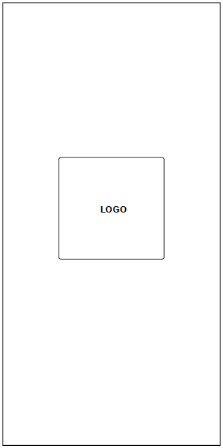

1. **Login Screen –** This is the application login screen, where the user enters his or her phone number for authentication using OTP verification. New users can register their information from this screen using the signup option.

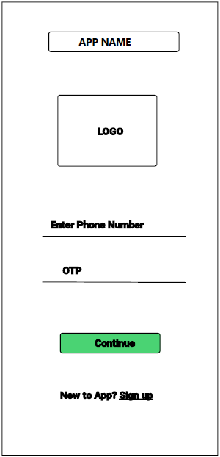

1. **Sign Up Screen:** In this page, New users will register their information, such as their name, phone number, and email address, and for validation, they will enter an OTP. Clicking the sign up button will create their record in the database.

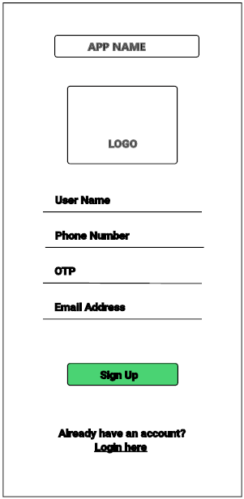

1. **Home Page:** From the Home Page, the user can access the following features.
   1. **View Products:** The product list will be shown based on the user's current location.
   2. **Search Product:** The user can search for a product by its name, location, category, etc.
   3. **Filter the Product:** The user will have the ability to filter the product by shop name, category, etc.
   4. **Sort the Product Results:** The Sort capability allows the user to sort the products by offer price (low to high, high to low), latest, and oldest posts.

The Home Page allows users to easily navigate to the home page, the user profile, the post page, and rewards page.

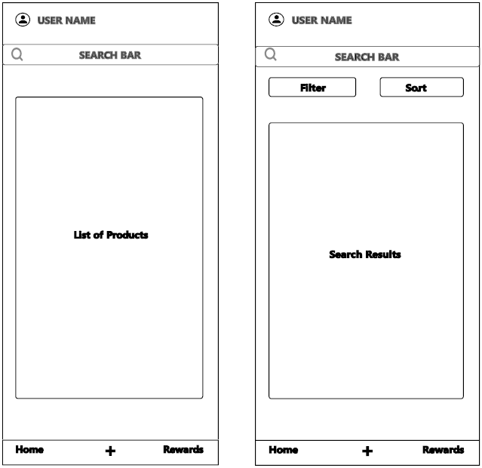

1. **The Post Page:** This page contains the application's main functionality; from this page, users can upload photographs to the application. The following features provide a clear view of this page.
   1. **Enter Post Details:** The user must fill out all of the information to submit the product details. In the first field, the user can enter store details or choose from the options when typing the location details.
   2. **Product Image and Price Tag Image:** Users are allowed to snap images from their cameras but are not permitted to upload images from their phones. This will help to avoid any incorrect product image uploads and is also one way of presenting authentic data about the deals.

After adding more details such as the product name, description, offer price, and quantity, the user is permitted to post the product; these details will be entered into the post table in the database. The Post Page allows users to easily navigate to the home page, the post page, and rewards page. The cancel button will navigate to the Home Page.

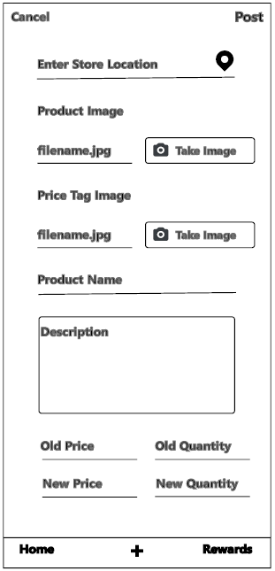

1. **The Post Details Page:** This page allows users to view detailed product posts, including product images, price tag images, and product details (product name, price, and quantity). If someone opens the product page, the user who posted this product will receive reward points. This page allows the user to perform the following two activities.
   1. **Report -** Users can report any posts that are misleading, out of stock, or not found at the actual location/store. When a user clicks on the Report button, the user is redirected to the reason page, where they must select one choice and either confirm their selection or cancel, after which the app redirects them to the Post details page.
   2. **Upvote –** If a user enjoys the product offers, they can click the Upvote button, which will award the user who posted the product offer reward point.

The Post Details Page allows users to easily navigate to the home page, post page, and rewards page.

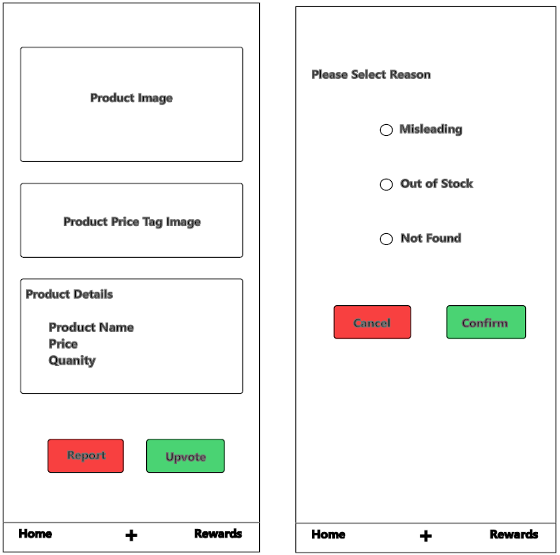

1. **User Profile Screen –** In this screen, the user has access to his/her details, including his/her first name, last name, email address, and phone number, which can be edited. My Posts: Users can view their post data by clicking on this information. This will send them to my posts page, where they can view both active and inactive posts.
   1. **Active Post:** Contains the post details that are currently active and Users can modify and delete active posts.
   2. **Inactive Post:** Posts that have been inactive for longer than three days will be displayed.

The user Profile Page and My Posts page allow users to easily navigate to the home page, the user profile, the post page, and the rewards page.

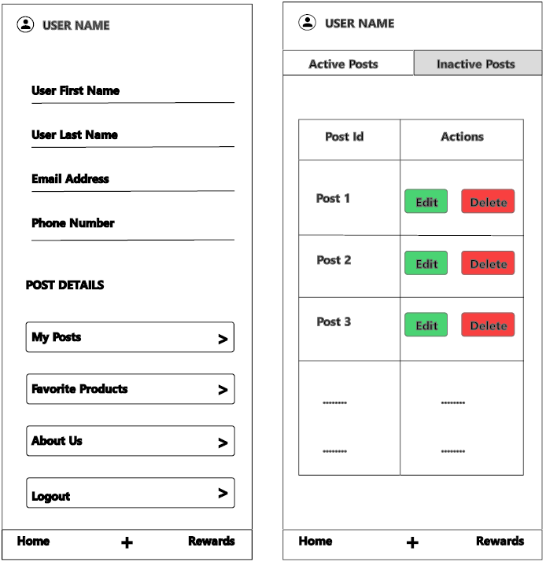

1. **The Rewards Page** **-** allows users to explore reward details, including My Rewards and Earning Stars sections.
   1. **My rewards:** Total number of stars gained, the progress bar for reward points, and details about the rewards based on the stars obtained.
   2. **Earning Stars:** This part displays the number of stars earned for a specific post.

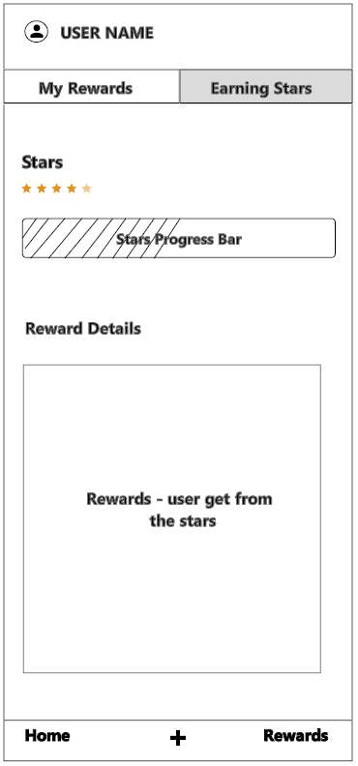

**App Flow**

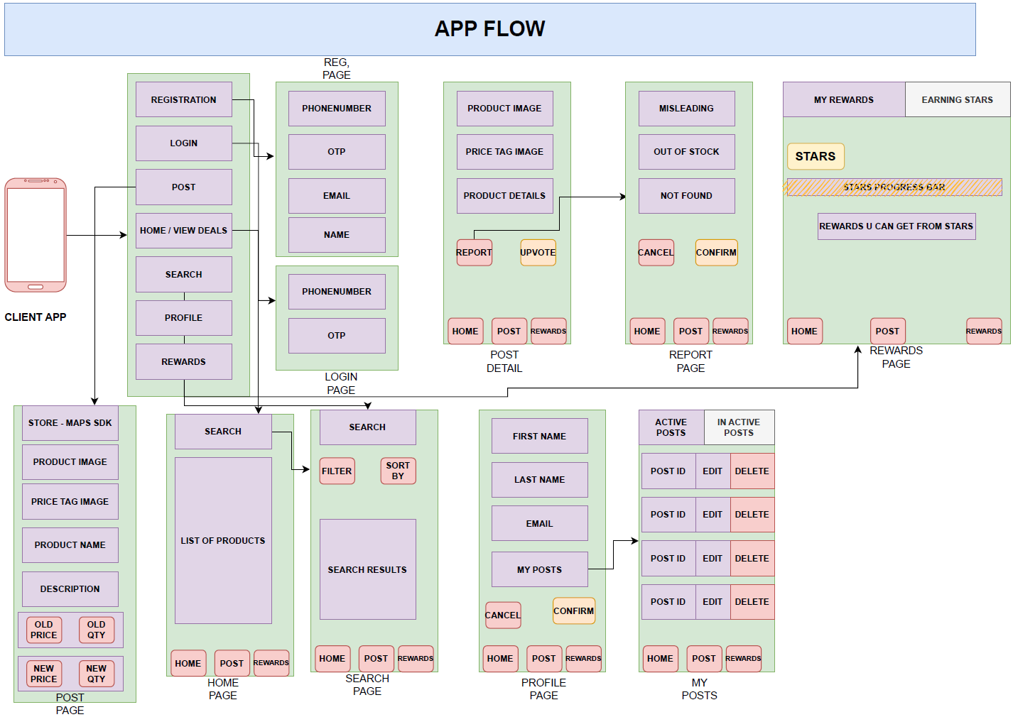

**High-Level Design Backend**

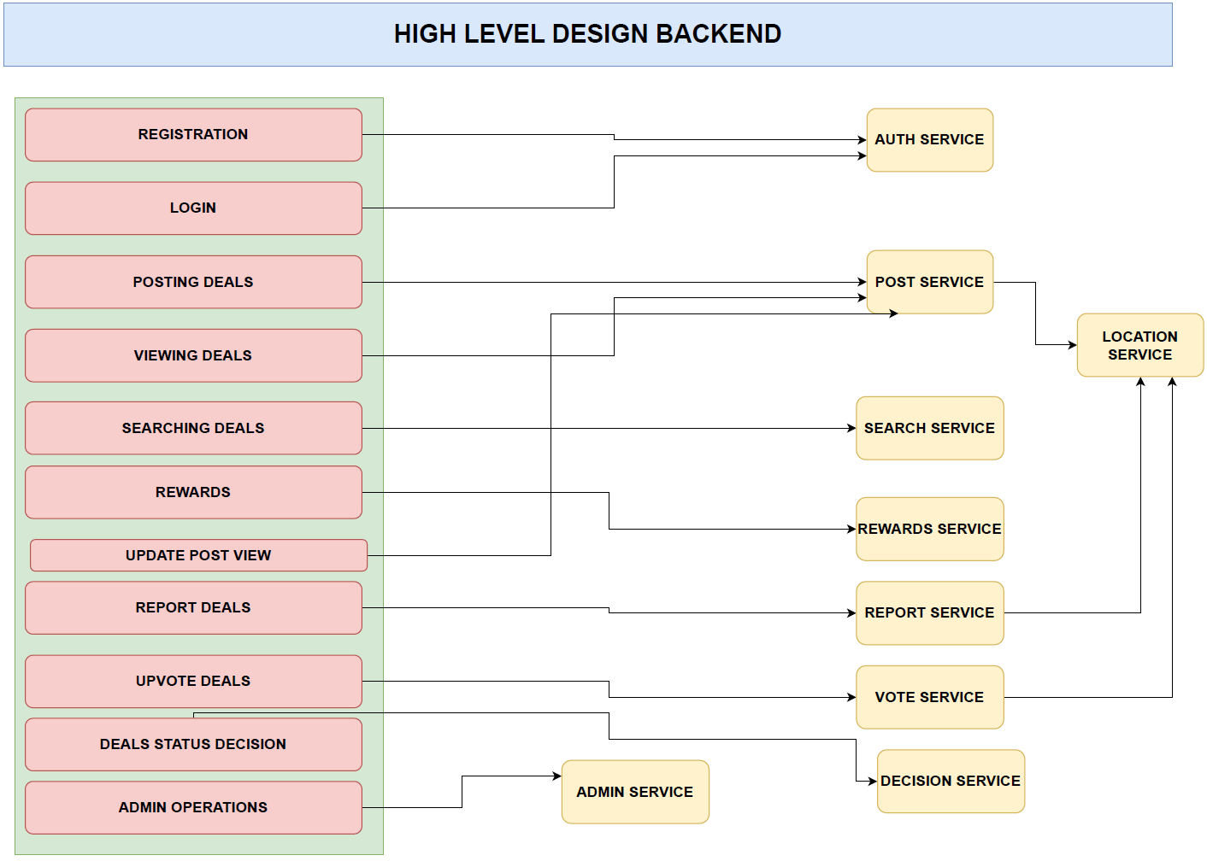

**Database High-Level Design**

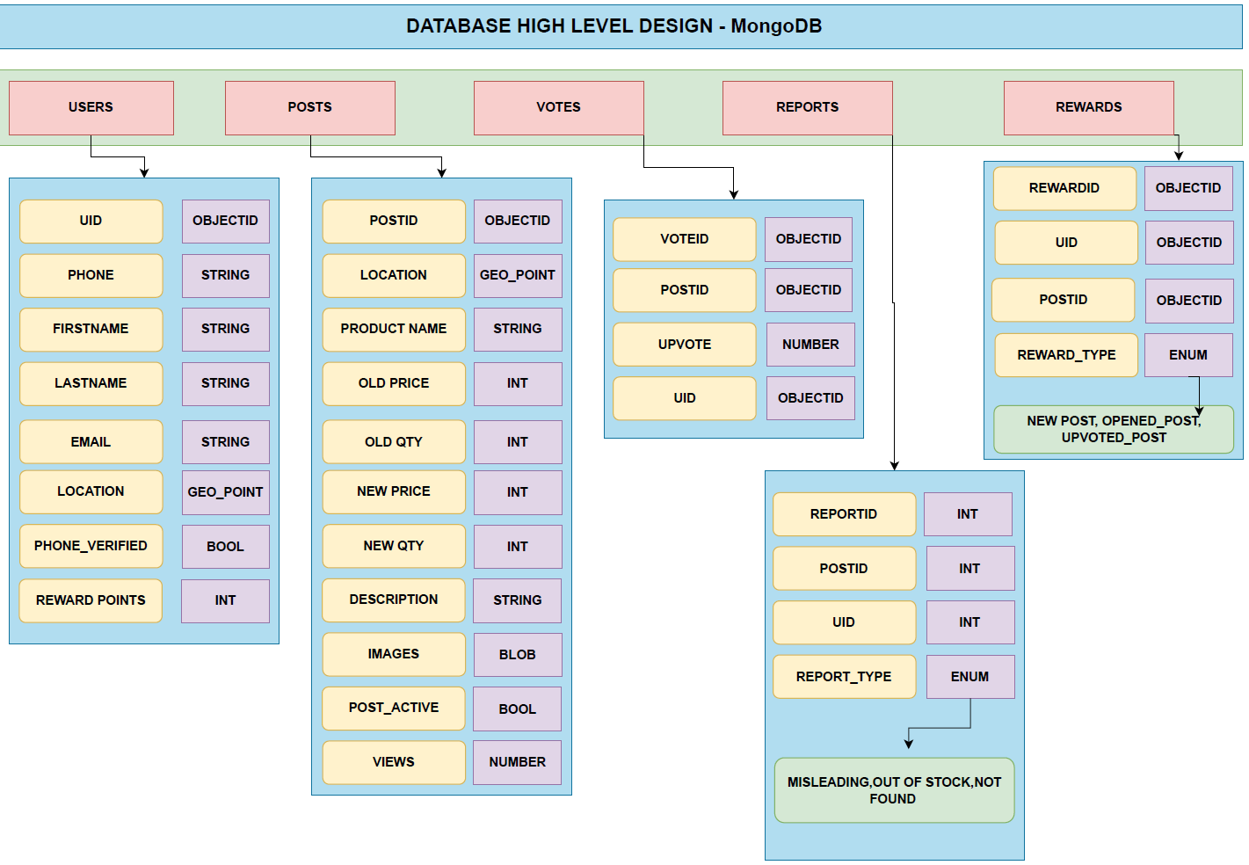

**Backend Design**

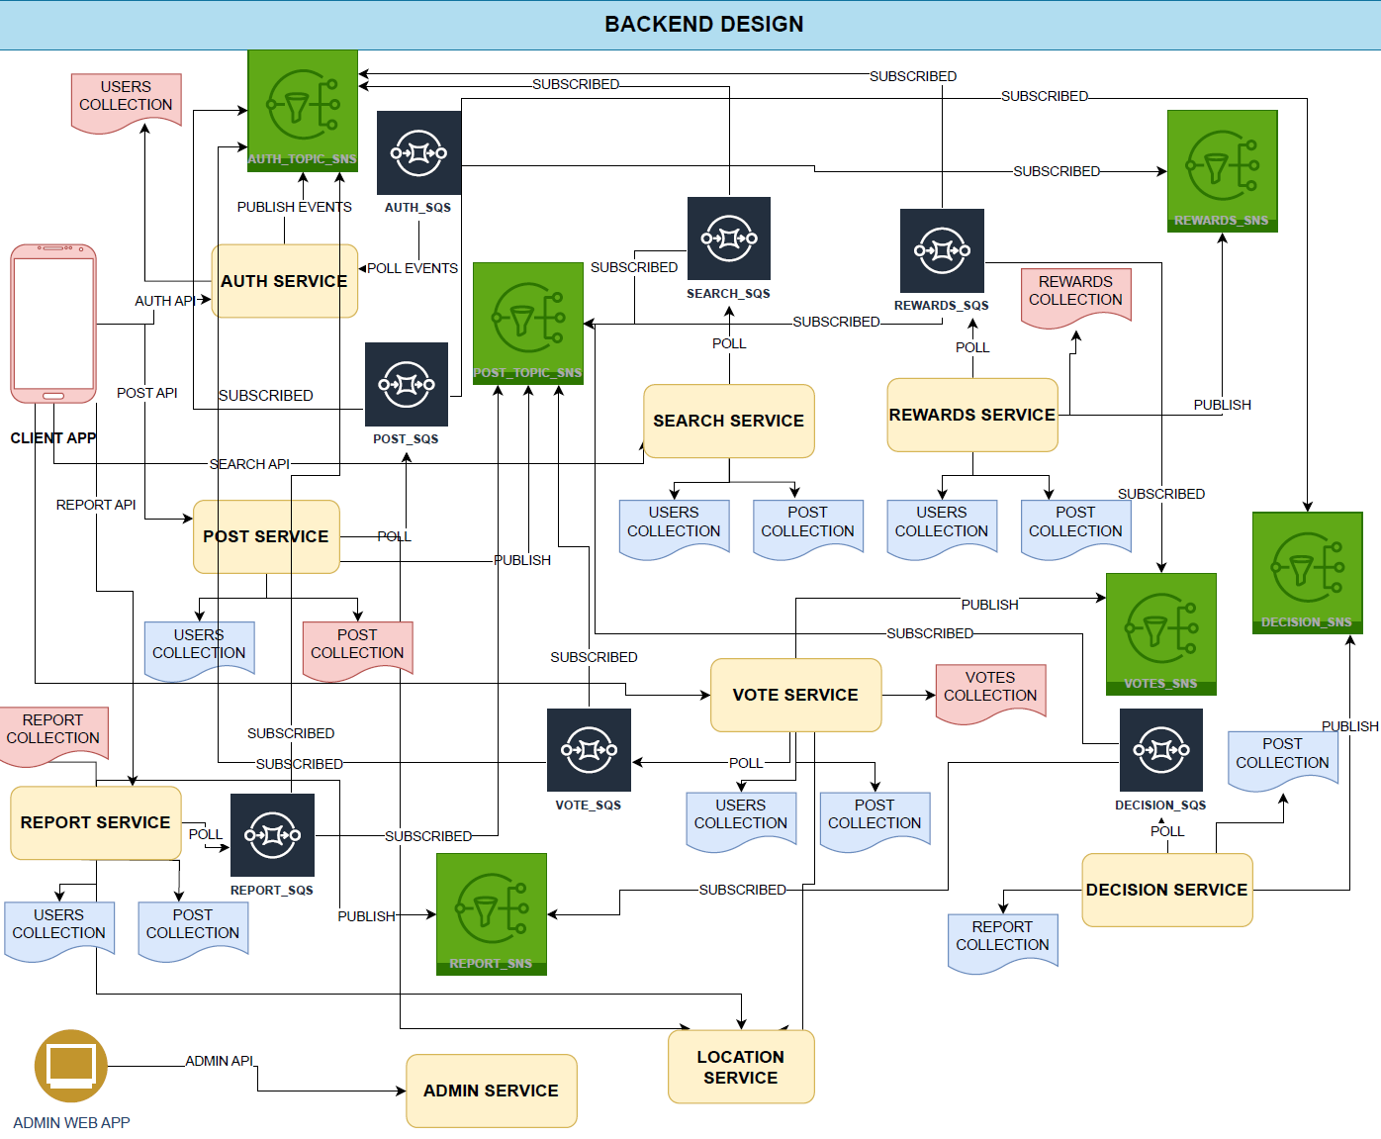

## **Technology Description**

* The technologies that we are planning to use to develop our project are:
  + **Flutter:** We decided to use Flutter because we have in mind to develop a mobile application. During our web development program, we learned two different technologies in that field, Android Studio + Java/Kotlin and Android Studio + Dart with Flutter. We believe Flutter can be easier to learn and offers more features and freedom to develop the application’s UI. Flutter also provides another great advantage, which is the fact that it is cross-platform, meaning that the app will be able to run automatically on a PC, a tablet and a mobile device and still look good and attractive.
  + **Node.js:** Node.js allows developers to code on the server side, allowing us to create the backend for our mobile application. It is a server-side runtime environment that uses JavaScript, a language we learned during the program; therefore, we feel confident working with it. Another advantage is that we can work along with Express to develop our backend side.
  + **Express:** Express is a node.js framework that provides many features for developing mobile and web applications. In our app, we will use Express to develop the backend side. Express will allow us to connect to a database and code APIs that will contain all the procedures of our application. Those APIs will be consumed from the front-end side, allowing us communication between the backend and the front-end. Express also offers different tools to facilitate the work of the backend, such as the management of the routes, controllers, and middleware.
  + **MongoDB**: Thanks to the flexible schema that MongoDB offers, we will be able to store and manipulate data in our application easily; also, MongoDB offers high performance with the queries, which will allow us to execute queries in a reduced response time, which is outstanding nowadays when the user expects the application to respond in just a few seconds. Thanks to the document-oriented model, it will be easier to represent real-world entities, in this case, all entities for users, rewards, posts and more.
  + **React:** We chose react because we are aware that react is in high demand nowadays by many companies in Canada, so we want to gain more experience with this framework and have it in our resume. We learned about it during our program, so we feel we can deal with and work with such a framework. We plan to use React to develop the admin section of our application, which will be more intended for use in a web application.

## **Market Survey**

**Please list the top-ten technologies asked in the most recent job postings. We do not need the definition or description of the technology in this document. The goal of a market survey is to encourage you to choose a project and work on project that will help you find a job after graduation.**

We researched through the LinkedIn and Indeed websites using the word “Web Developer,” which showed us many jobs for different roles, such as “Front-end Developer,” “Back-end Developer,” “Full-Stack Developer,” and “Software developer.” On both websites, we reviewed 25 job applications from different companies and started writing down all the technologies that the companies were asking for in the job postings. If a technology appeared more than once, we assigned it a point so we could keep track of the number of times it was requested. In the end, we were able to identify the ten most in-demand technologies for those jobs at this moment, which are:

|  |  |  |  |
| --- | --- | --- | --- |
| **Name** | **LinkedIn Count** | **Indeed Count** | **Total Count** |
| JavaScript | 14 | 16 | 30 |
| React | 9 | 14 | 23 |
| SQL (SQL Server, PostgreSQL, …) | 5 | 16 | 21 |
| Python | 5 | 10 | 15 |
| Typescript | 8 | 6 | 14 |
| Angular | 3 | 11 | 14 |
| RESTful APIs | 3 | 10 | 13 |
| Git | 6 | 7 | 13 |
| Node.js | 5 | 7 | 12 |
| Java | 4 | 8 | 12 |

## **Conclusion**

**The conclusion of your proposal includes a rough idea of the project completion timeline and related comments.**

We expect to complete this project during the current term. To monitor the process and ensure there are no delays, the group will use Scrum to have meetings during four sprints, where we will check the current progress of the project and resolve any issues each member may have. Those meetings will create an opportunity to identify and solve problems to meet the project deadline.

With this project, we expect to solve a need that we found here in Canada while learning and gaining more experience with different technologies that we learned during our Web Development program, which will help us in the future to get a job and perform well there.

This mobile application will create a place to make people’s lives easier, where they can find all the available sale products close to their area, instead of visiting different groups on Facebook in search of a specific product, which is very time-consuming.

We have high expectations for this mobile application; since we do not want to create just any app, our goal is to create something that was missing, something that solves a real need; because of that, we believe that this app will generate the possibility of thinking beyond the college, it might help us create a product for the real world, which would be a perfect option for anyone.

## **GitHub Link**

The GitHub repository link that we created can be found below:

* <https://github.com/NiharikaBalaga/rewarding-sale-app>

## **Contributions**

The contribution for each member can be found below:

* **Niharika Balaga:** App Flow, High-Level Design Backend, Database High-Level Design, Backend Design, GitHub Repository.
* **Porkodi Rajan:** All the mobile wireframes showing the page flow.
* **Juan Jacobo Florez Monroy:** Introduction, Technology Description, Market Survey, Conclusion, GitHub Link, Contributions.