# CONTACT

 [niharikabayyarapu@gmail.com](mailto:lokeshyarramsetti319@gmail.com)  8374997919

 Tiruvuru, India.

# SKILLS

* Programming Languages- Java,Python.
* Web Techonologies:HTML,CSS,Java script
* SoftwareDevelopmentcourses:Data structures,Algorithms,OOPS,SDLC
* Database Management:MYSQL
* Tools : Github,Vscode
* Operating Systems: Windows

EDUCATION

 B.Tech ECE(2021-2025)

Malla Reddy Engineering College For Women-CGPA: 9.04

 Inter(2019- 2021)

1. VLSI Digital Circuit Design- Gaining hands on experience in designing and testing integrated circuits.
2. Innovated Web application development at Unified Mentor.

# PROJECTS

1. Smart Utility Fan

Smart Utility Fan is designed automated speed adjustments based on temperature and humidity,Energy saving residential,Solar powered operation with integrated LED.

1. Multiple Disease Prediction System Using Machine Learning

Developed an advanced machine learning system for

predicting multiple diseases based on patient data,aimed at early detection and improved healthcare outcomes.It improves patient care through effective web-based tools.

1. Earthquake and Tsunami simulation through GSM Network

This project focuses on the development of simulation system to model and predict the impact of earthquakes and tsunamis using GSM network Technology.

## ADD-ONS

Sri Chaitanya Mahila Junior

Kalasala- CGPA:9.5

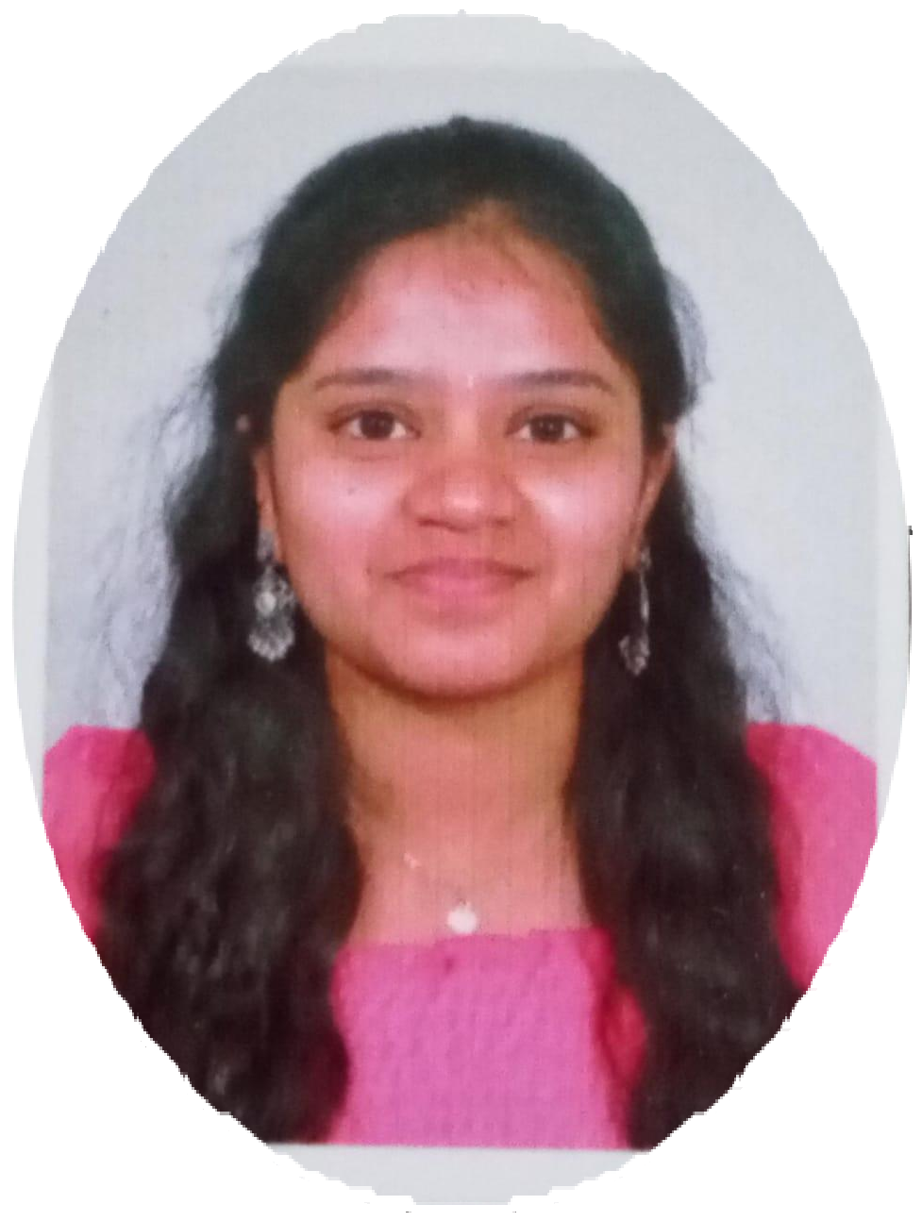

B.NIHARIKA

INTERSHIPS

* + 10th Z.P.G.High School(2019) CGPA-8.8

## LANGUAGES

 English  Telugu  Hindi

Networking Basics(Cisco Networking Academy):Enhanced router reliability by 30% and reduced downtime by 20%.

AWS Fundamentals: Addressing Security Risk(coursera):Implemented security best pratices,decreasing system vulnerabilities by 25% Oracle: Demonstrated ability to deploy and manage generative AI solutions on Oracle cloud Infrastructure with 100% completion certification.