Pizza Sales Queries
KPI’S
- Total Revenue
Select sum(total_price) as Total_Revenue from pizza_sales
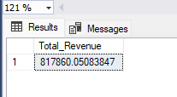

- Average Order Value
Select sum(total_price)/count(distinct order_id) as Average_Order_Value from pizza_sales
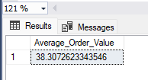

- Total Pizzas Sold
Select sum(quantity) as Total_Pizza_Sold from pizza_sales
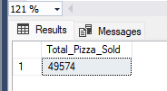

- Total Orders
Select count(distinct order_id) as Total_Orders from pizza_sales
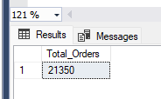

- Average Quantity(Pizza) Per Order
Select cast(cast(sum(quantity) as decimal(10,2))/
cast(count(distinct order_id)as decimal(10,2)) as decimal(10,2))
as Average_Quantity_Per_Order from pizza_sales
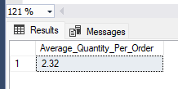

Charts and Visualizations
- Daily Trends for Total Orders
SELECT DATENAME(DW, order_date) AS Order_Day, COUNT(DISTINCT order_id) AS Total_Orders
FROM pizza_sales
GROUP BY DATENAME(DW, order_date)
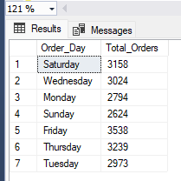

- Monthly Trends for Total Orders
SELECT DATENAME(month, order_date) AS Order_Day, COUNT(DISTINCT order_id) AS Total_Orders
FROM pizza_sales
GROUP BY DATENAME(month, order_date)
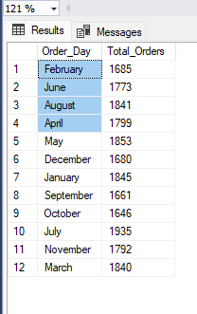

- Percentage of Sales by Pizza Category
Select pizza_category, cast(sum(total_price) as decimal(10,0)) as Total_Revenue, cast(sum(total_price)*100/(Select sum(total_price) from pizza_sales) as decimal(10,2)) as Percentage_By_category
from pizza_sales
group by pizza_category
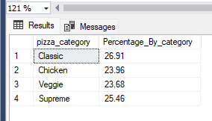

- Percentage of Sales by Pizza Size
Select pizza_size, cast(sum(total_price) as decimal(10,0)) as Total_Revenue, cast(sum(total_price)*100/(Select sum(total_price) from pizza_sales) as decimal(10,2)) as Percentage_By_size
from pizza_sales
group by pizza_size
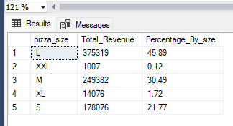

- Total Pizza Sold by Pizza Category
Select pizza_category, sum(quantity) as Quantity_Sold
from pizza_sales Group By pizza_category
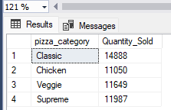

- Top 5 Best Seller Pizza By Revenue
Select Top 5 pizza_name, sum(total_price) as Total_Revenue
from pizza_sales
group by pizza_name
order by Total_Revenue Desc
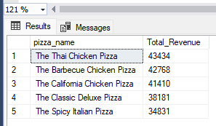

- Top 5 Best Seller Pizza By Quantity
Select Top 5 pizza_name, sum(quantity) as Total_Quantity
from pizza_sales
group by pizza_name
order by Total_Quantity Desc
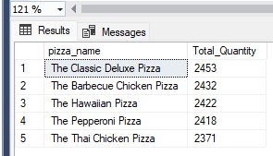

- Top 5 Best Seller Pizza By Orders
SELECT Top 5 pizza_name, COUNT(DISTINCT order_id) AS Total_Orders
FROM pizza_sales
GROUP BY pizza_name
ORDER BY Total_Orders DESC
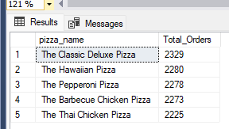

- Bottom 5 Worst Seller Pizza By Revenue
Select Top 5 pizza_name, cast(sum(total_price) as decimal(10,2)) as Total_Revenue
from pizza_sales
group by pizza_name
order by Total_Revenue
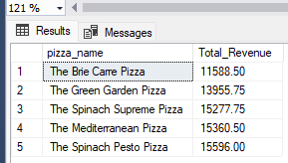

- Bottom 5 Worst Seller Pizza By Quantity
Select Top 5 pizza_name, sum(quantity) as Total_Quantity
from pizza_sales
group by pizza_name
order by Total_Quantity Desc
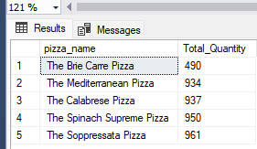

- Bottom 5 Worst Seller Pizza By Orders
SELECT Top 5 pizza_name, COUNT(DISTINCT order_id) AS Total_Orders
FROM pizza_sales
GROUP BY pizza_name
ORDER BY Total_Orders
