1.
The problem in using visualization stems from the fact that models have many dimensions or
variables, but we are restricted to showing these dimensions on a two-dimensional computer screen or
paper. For example, we may wish to view the relationship between credit risk and age, sex, marital
status, own-or-rent, years in job, etc. Consequently, visualization tools must use clever representations
to collapse
n
dimensions into two. Increasingly powerful and sophisticated data visualization tools are
being developed, but they often require people to train their eyes through practice in order to
understand the information being conveyed. Users who are color-blind or who are not spatially
oriented may also have problems with visualization tools

1.[b]
After training a ridge regression model, you find that the training and test set accuracies are 0.98 and 0.54 respectively. Which of the following would be the best choice for the next ridge regression model you train?
You are overfitting, the next model trained should have a lower value for alpha
You are overfitting, the next model trained should have a higher value for alpha
You are underfitting, the next model trained should have a lower value for alpha
You are underfitting, the next model trained should have a higher value for alpha

2.
After training a Radial Basis Function (RBF) kernel SVM, you decide to increase the influence of each training point and to simplify the decision surface. Which of the following would be the best choice for the next RBF SVM you train?
Decrease C and gamma
Increase C and gamma
Increase C, decrease gamma
Decrease C, increase gamma

3. [a,b]
Which of the following is an example of multiclass classification? (Select all that apply)
Classify a set of fruits as apples, oranges, bananas, or lemons
Predict whether an article is relevant to one or more topics (e.g. sports, politics, finance, science)
Predicting both the rating and profit of soon to be released movie
Classify a voice recording as an authorized user or not an authorized user.

4.[10]
lambda is a parameter designed to prevent overfitting. Good for generalization instead.
Looking at the plot below which shows accuracy scores for different values of a regularization parameter lambda, what value of lambda is the best choice for generalization?
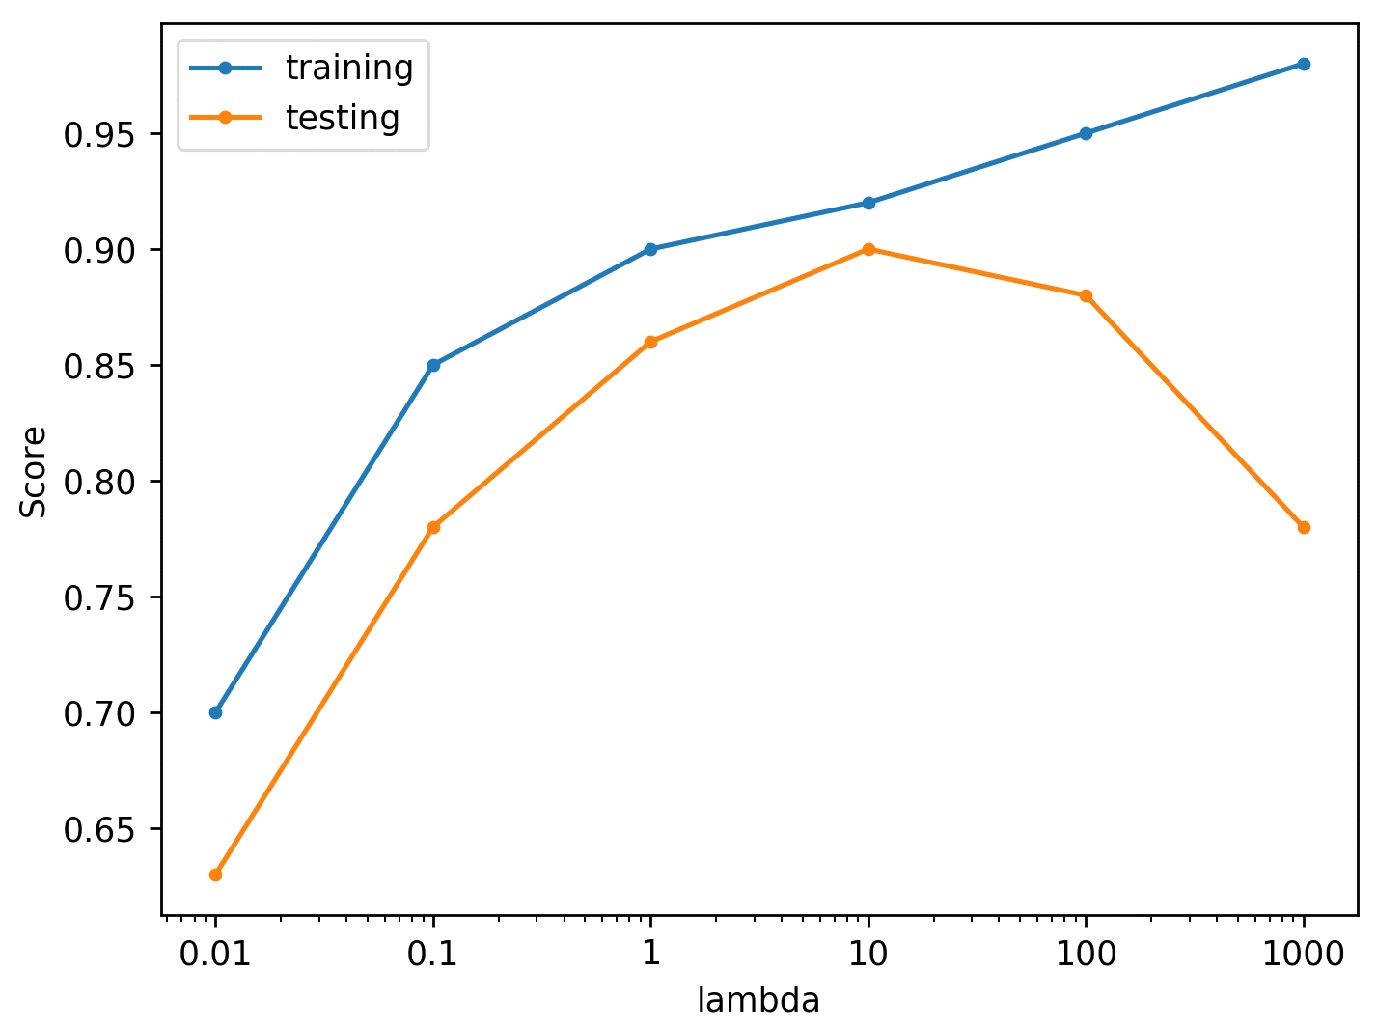
5. [d]
Suppose you are interested in finding a parsimonious model (the model that accomplishes the desired level of prediction with as few predictor variables as possible) to predict housing prices. Which of the following would be the best choice?
Ridge Regression
Logistic Regression
Ordinary Least Squares Regression
Lasso Regression

6. [b]
Match the plots of SVM margins below to the values of the C parameter that correspond to them.
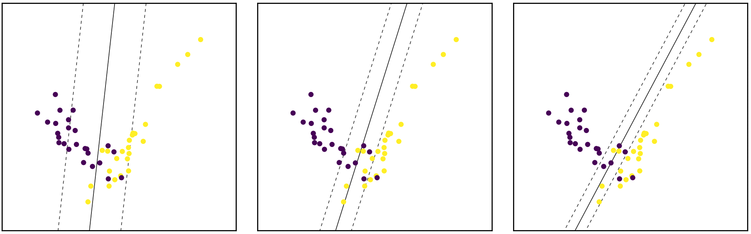
1, 0.1, 10
0.1, 1, 10
10, 1, 0.1
10, 0.1, 1

7.
Use Figures A and B below to answer questions 7, 8, 9, and 10.
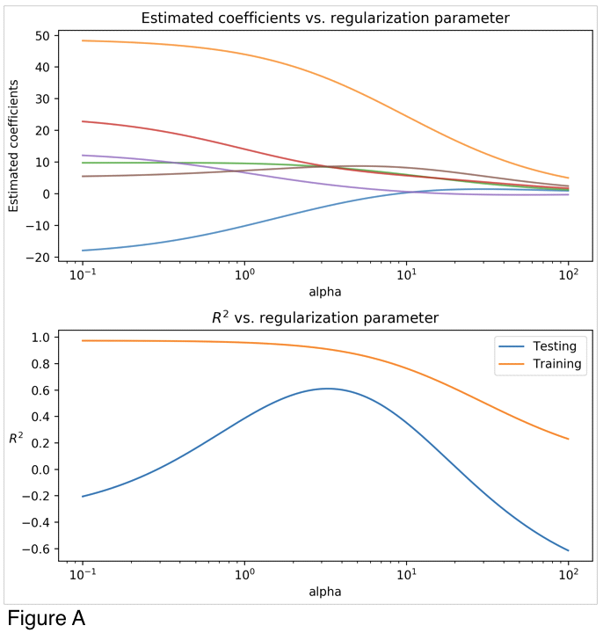

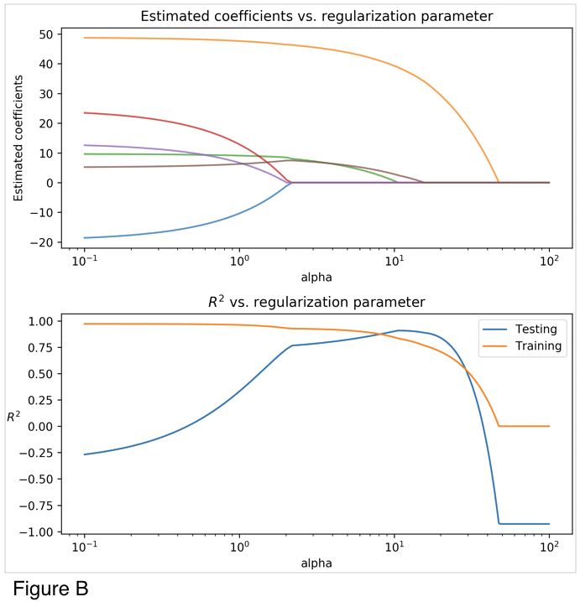
Looking at the two figures (Figure A, Figure B), determine which linear model each figure corresponds to:[c]
Figure A: Ridge Regression, Figure B: Lasso Regression
Figure A: Lasso Regression, Figure B: Ridge Regression
Figure A: Ordinary Least Squares Regression, Figure B: Ridge Regression
Figure A: Ridge Regression, Figure B: Ordinary Least Squares Regression
Figure A: Ordinary Least Squares Regression, Figure B: Lasso Regression
Figure A: Lasso Regression, Figure B: Ordinary Least Squares Regression

8. [1]
Looking at Figure A and B, what is a value of alpha that optimizes the R2 score for the Ridge Model?

9. [1]
Looking at Figure A and B, what is a value of alpha that optimizes the R2 score for the Lasso Model?

10. [16.2]
When running a LinearRegression() model with default parameters on the same data that generated Figures A and B the output coefficients are:
Coef 0 | -19.5
Coef 1 | 48.8
Coef 2 | 9.7
Coef 3 | 24.6
Coef 4 | 13.2
Coef 5 | 5.1
For what value of Coef 3 is R2 score maximized for the Lasso Model?

11. [b,e,c]
Which of the following is true of cross-validation? (Select all that apply)
Increases generalization ability and reduces computational complexity
Fits multiple models on different splits of the data
Increases generalization ability and computational complexity
Removes need for training and test sets
Helps prevent knowledge about the test set from leaking into the model

