TicketGuard: Fraud Detection via
Graph and Column-Store Databases
Review 2: Database Implementation & Prototype
BCSE406L - NoSQL Databases
Fall Semester 2026-2027
Faculty: Lydia Jane G
Team Members
Niharika Lathish (23BCE2162)
Sivaraj Swetha Srri (23BCE2180)
Source code: https://github.com/NiharikaLathish/TicketGuard

Contents
Table of contents: choose Yes when Word asks to update fields, or right-click here and choose Update Field.
If the list above is empty, click inside it and press F9 (or right-click, Update Field, Update entire table).

1. Introduction and Scope of Review 2

1.1 Project recap
TicketGuard is a prototype that detects fraud on ticket resale platforms: circular resale between a few accounts, coordinated bot groups that grab tickets for an event, accounts that trade with an unusually large number of others, and resale at abnormal prices. Fraud of this kind involves several accounts and many transactions, so it is hard to see by looking at one transaction at a time. It is easy to see when the accounts and tickets are drawn as a network.
The design uses two NoSQL databases, each for what it does best. Apache Cassandra (wide-column) stores the high-volume transaction events. Neo4j (graph) stores the relationships between accounts, tickets and transactions, and the fraud detection runs on that graph. The detection is rule and graph based, with no machine-learning model to train.

1.2 What Review 1 delivered
Review 1 covered the problem statement, literature survey, research gaps, requirements, the justification for using Cassandra and Neo4j, the system architecture, the initial database schema and the project plan.

1.3 What this report covers
Review 2 is the implementation review. This report documents the working prototype and maps it to the Review 2 deliverables and marking criteria.
Review 2 criterion | Where it is covered in this report
Database implementation: collections, nodes and tables created correctly | Section 4 (Cassandra tables, Neo4j nodes, constraints and indexes)
CRUD operations: insert, update, delete, retrieve | Section 6, with API screenshots
Data modelling quality: embedding/referencing, indexing, partitioning | Section 4.3 (design decisions and reasons)
Functional prototype: core features working | Sections 7 to 10 (sync, detection, API, web console) and Section 11 (test results)
Progress and documentation: code quality, Git usage, technical documentation | Sections 12 and 13, plus the README and API documentation in the repository

Review 2 deliverable | Status | Location
Working prototype | Done | Sections 7 to 10; run with the steps in Appendix A
Source code | Done | github.com/NiharikaLathish/TicketGuard
Database dump | Done | dumps/ in the repository (Cassandra schema and CSV; Neo4j schema, node and relationship CSVs)
API documentation | Done | docs/API.md, and live Swagger UI at /docs (Section 9)
Progress report | Done | This document
Sample dataset | Done | dumps/sample_dataset.csv (50,000 transactions)
Intermediate demonstration | Ready | Live demo using the web console (Section 10)

2. Progress Against the Project Plan
The plan in Review 1 had twelve phases. The table shows where each stands at Review 2.
Phase (Review 1 plan) | Status | Evidence
1-3. Problem, literature survey, requirements, database design | Done in Review 1 | Review 1 report
4. Architecture design | Done | Section 3
5. Synthetic data generation | Done | Section 5; generator/generate.py
6. Cassandra implementation and CRUD | Done | Sections 4.1 and 6
7. Neo4j implementation and Cypher queries | Done | Sections 4.2 and 8
8. Database synchronisation | Done | Section 7; automatic every 60 seconds
9. Fraud detection implementation | Done | Section 8; all four detectors working
10. Visualisation | Done (prototype) | Section 10
11. Testing and performance evaluation | Started | Section 11; larger-scale performance testing planned for Review 3
12. Final integration and demonstration | Review 3 | Section 14

Milestones M1 to M8 from the plan are complete (problem, requirements, database design, dataset, Cassandra, Neo4j, synchronisation, detection). M9 (visualisation and testing) is partly complete, and M10 (final integrated prototype) is the Review 3 target.

3. System Architecture
The implemented architecture follows the workflow proposed in Review 1, with one addition: a FastAPI backend sits in front of both databases and serves the web console.
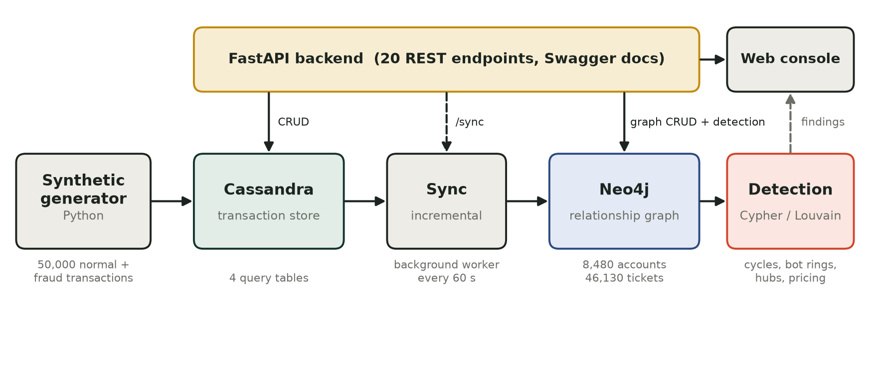
Figure 3.1: Implemented architecture of TicketGuard

3.1 Components
Component | Technology | Role
Data generator | Python | Creates normal and fraudulent transactions with ground-truth labels
Transaction store | Apache Cassandra 4.1 | High-volume writes; reads by buyer, ticket, day or id
Graph store | Neo4j 5.26 Community with Graph Data Science plugin | Accounts, tickets, events and transactions as a connected graph
Synchronisation | Python (app/sync.py, app/sync_worker.py) | Copies new transactions from Cassandra to Neo4j
Detection | Cypher, Louvain (Neo4j GDS), NetworkX for PageRank and degree statistics | Finds loops, bot rings, hubs and price anomalies
Backend API | FastAPI (Python 3.11) | 20 REST endpoints with automatic Swagger documentation
Web console | HTML, JavaScript, vis-network | Shows results, the relationship map and the transaction form
Environment | Docker Compose | Runs both databases with one command

3.2 Running environment
Both databases run as Docker containers defined in docker-compose.yml. The application runs on Python 3.11. (Python 3.12 and newer are not supported by the Cassandra driver's default event loop, which is documented in the README.)
INSERT IMAGE HERE | Figure 3.2
Image of: Both database containers running
What it must show: The terminal output of docker ps showing ticketguard-cassandra with status (healthy) and ticketguard-neo4j with status Up.
How to take it: Open a terminal, run: docker ps then take a screenshot of the terminal window.
Size: Full width (about 16 cm)
(delete this box after pasting the image)
Figure 3.2: Both database containers running

4. Database Implementation

4.1 Cassandra (wide-column store)
The keyspace ticketguard uses SimpleStrategy with replication factor 1, which is appropriate for a single-node prototype. Cassandra can only filter efficiently on the partition key, so the tables are designed around the questions the application asks, not around the entities. Review 1 proposed a single transactions table; the implementation refines it into four tables with identical columns and different keys.
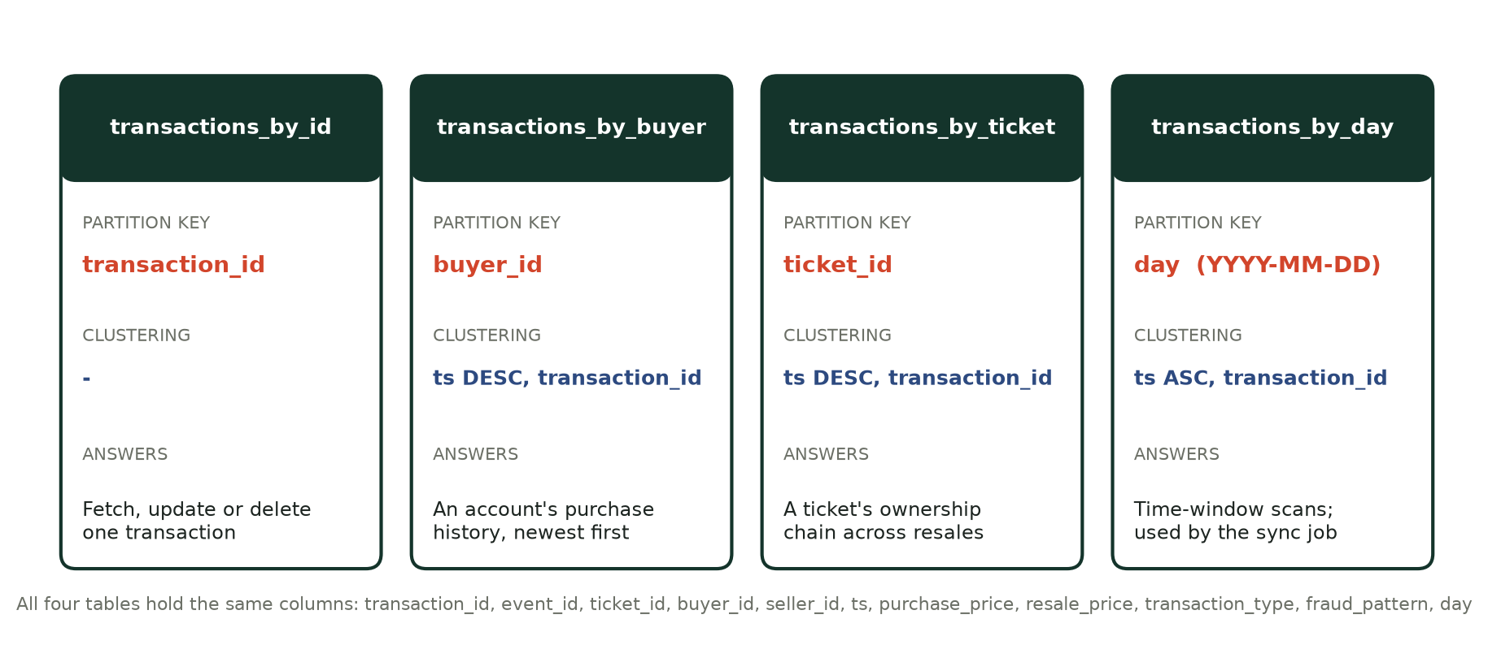
Figure 4.1: The four Cassandra tables, with partition and clustering keys
Example definition (the other three differ only in the key):
CREATE TABLE transactions_by_buyer (
transaction_id uuid, event_id uuid, ticket_id uuid, buyer_id uuid, seller_id uuid,
ts timestamp, purchase_price decimal, resale_price decimal,
transaction_type text, fraud_pattern text, day text,
PRIMARY KEY ((buyer_id), ts, transaction_id)
) WITH CLUSTERING ORDER BY (ts DESC, transaction_id ASC);

Table | Partition key | Clustering | Used for
transactions_by_id | transaction_id | - | Get, update, delete one transaction
transactions_by_buyer | buyer_id | ts DESC, transaction_id | An account's history, newest first
transactions_by_ticket | ticket_id | ts DESC, transaction_id | The ownership chain of a ticket
transactions_by_day | day (text, YYYY-MM-DD) | ts ASC, transaction_id | Time-window scans; the sync job reads this

INSERT IMAGE HERE | Figure 4.2
Image of: The Cassandra keyspace and tables created
What it must show: The output of DESCRIBE TABLES inside the ticketguard keyspace, listing all four transactions_by_* tables.
How to take it: Open a terminal and run: docker exec -it ticketguard-cassandra cqlsh then type: USE ticketguard; then: DESCRIBE TABLES; Screenshot the result.
Size: Full width (about 16 cm)
(delete this box after pasting the image)
Figure 4.2: The Cassandra keyspace and tables created
INSERT IMAGE HERE | Figure 4.3
Image of: Data stored in Cassandra, read through a partition key
What it must show: A CQL query on transactions_by_buyer (or by_ticket) and the rows it returns, newest first.
How to take it: In the same cqlsh window run a query from docs/queries.md, for example: SELECT ts, ticket_id, transaction_type, resale_price FROM transactions_by_buyer WHERE buyer_id = <an id from the CSV> LIMIT 5; Screenshot the query and the result.
Size: Full width (about 16 cm)
(delete this box after pasting the image)
Figure 4.3: Data stored in Cassandra, read through a partition key

4.2 Neo4j (graph store)
The graph has four node labels and six relationship types. A ticket changing hands is stored twice on purpose: as a Transaction node that records the details, and as a TRANSFERRED_TO relationship between the two accounts that carries the ticket id, price and time. The relationship is what makes loop detection cheap, because a traversal can follow one ticket by filtering on that property.
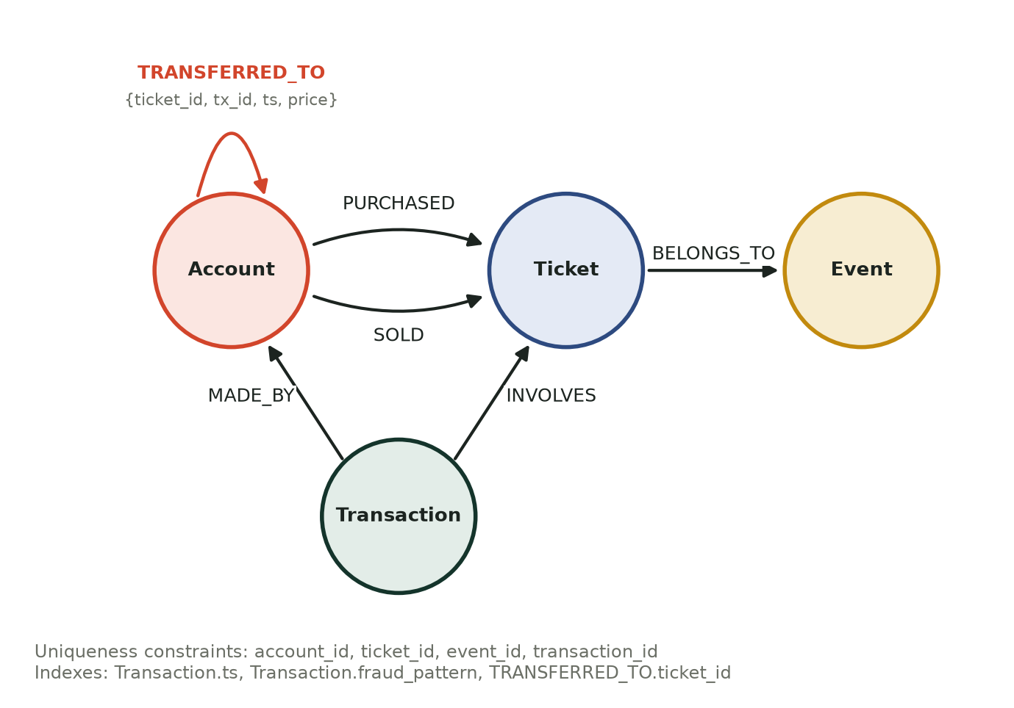
Figure 4.4: Neo4j graph model
Element | Definition
Nodes | Account {account_id, is_platform}, Ticket {ticket_id}, Event {event_id}, Transaction {transaction_id, ts, purchase_price, resale_price, transaction_type, fraud_pattern}
Relationships | PURCHASED and SOLD (Account to Ticket), TRANSFERRED_TO (Account to Account, with ticket_id, tx_id, ts, price), INVOLVES (Transaction to Ticket), MADE_BY (Transaction to Account), BELONGS_TO (Ticket to Event)
Special node | One platform account (id 000...001) is the seller on primary-market purchases

Constraints and indexes created at start-up:
CREATE CONSTRAINT account_id IF NOT EXISTS FOR (a:Account) REQUIRE a.account_id IS UNIQUE
CREATE CONSTRAINT ticket_id IF NOT EXISTS FOR (t:Ticket) REQUIRE t.ticket_id IS UNIQUE
CREATE CONSTRAINT event_id IF NOT EXISTS FOR (e:Event) REQUIRE e.event_id IS UNIQUE
CREATE CONSTRAINT tx_id IF NOT EXISTS FOR (x:Transaction) REQUIRE x.transaction_id IS UNIQUE
CREATE INDEX tx_ts IF NOT EXISTS FOR (x:Transaction) ON (x.ts)
CREATE INDEX tx_fraud IF NOT EXISTS FOR (x:Transaction) ON (x.fraud_pattern)
CREATE INDEX transfer_ticket IF NOT EXISTS FOR ()-[r:TRANSFERRED_TO]-() ON (r.ticket_id)

INSERT IMAGE HERE | Figure 4.5
Image of: Neo4j graph schema as seen in Neo4j Browser
What it must show: The schema diagram Neo4j draws: Account, Ticket, Event and Transaction nodes with the relationship types between them.
How to take it: Open http://localhost:7474, log in (user neo4j, password ticketguard123), run: CALL db.schema.visualization() then screenshot the graph that appears.
Size: Full width (about 16 cm)
(delete this box after pasting the image)
Figure 4.5: Neo4j graph schema as seen in Neo4j Browser
INSERT IMAGE HERE | Figure 4.6
Image of: Data loaded in Neo4j
What it must show: Node counts by label (Transaction 50000, Ticket 46130, Account 8480, Event 60).
How to take it: In Neo4j Browser run: MATCH (n) WHERE n:Account OR n:Ticket OR n:Event OR n:Transaction RETURN labels(n)[0] AS label, count(*) AS nodes ORDER BY nodes DESC then switch to the Table view and screenshot it.
Size: Full width (about 16 cm)
(delete this box after pasting the image)
Figure 4.6: Data loaded in Neo4j

4.3 Data modelling decisions
Decision | Reason
One Cassandra table per query (denormalised, same columns in each) | Cassandra reads are fast only along the partition key. Storing the data four times replaces joins and secondary indexes with single-partition reads. The cost is extra storage and four writes per transaction.
Day bucket as the partition key of transactions_by_day | A single global time-ordered partition would grow without limit and become a hot spot. One partition per day stays bounded (about 2,000 rows per day in the sample data) and still allows time-range reads.
Clustering by ts (newest first for buyer and ticket) | History queries return in the order users want with no sorting at read time.
Referencing, not embedding | Transactions hold the buyer, seller, ticket and event as ids. The details of those entities live in Neo4j as nodes. Nothing is nested inside a transaction row, so a change to an account never requires rewriting transactions.
Neo4j uniqueness constraints on every id | MERGE is safe to repeat and never creates duplicate nodes, which is what makes the sync idempotent. A constraint also creates an index for lookups.
Index on Transaction.ts and fraud_pattern, and on the TRANSFERRED_TO ticket_id property | Speeds up time filtering, ground-truth checks and the per-ticket loop search.
Cassandra keeps the full history, Neo4j keeps only what analysis needs | Cassandra is the system of record; the graph is a derived view that can be rebuilt with a full sync.

5. Sample Dataset
No real customer data is used. The generator (generator/generate.py) creates 50,000 synthetic transactions over a 30-day window using a fixed random seed, so the same data can be reproduced. Every transaction carries a fraud_pattern label for evaluation only; the detectors never read that column.
Part of the dataset | Content | Volume
Normal traffic | Primary purchases from the platform; honest resales at 0.85 to 1.35 times face value; occasional gifts (transfers) | 47,538 transactions
Circular resale | A ticket passed around a ring of 3 to 5 accounts and back to the first one | 25 rings, 98 accounts
Bot rings | 10 bot accounts each buying 6 to 10 tickets for one event within two minutes, forwarding them to a collector account | 6 rings, 66 accounts
Hub accounts | One account trading with 40 to 80 different counterparties | 5 accounts
Price manipulation | Resales at 3 to 8 times the original price | 150 tickets

Loaded into the databases, the dataset gives:
- Cassandra: 50,000 transactions, stored in each of 4 tables (200,000 rows), across 29 daily partitions.
- Neo4j: 8,480 accounts (including one platform account), 46,130 tickets, 60 events, 50,000 transactions and 249,931 relationships (3,870 of them TRANSFERRED_TO).
INSERT IMAGE HERE | Figure 5.1
Image of: Sample dataset file
What it must show: The first 8 to 10 rows of dumps/sample_dataset.csv with the column headers visible (transaction_id, event_id, ticket_id, buyer_id, seller_id, ts, purchase_price, resale_price, transaction_type, fraud_pattern).
How to take it: Open dumps/sample_dataset.csv in Excel (or VS Code) and screenshot the top of the sheet.
Size: Full width (about 16 cm)
(delete this box after pasting the image)
Figure 5.1: Sample dataset file
INSERT IMAGE HERE | Figure 5.2
Image of: Loading the dataset
What it must show: The terminal output of the generator: 'generated 50000 transactions', 'inserted into Cassandra in ...s' and the sync line.
How to take it: In the project folder run: python -m generator.generate --transactions 50000 --load --sync --reset and screenshot the final lines of output.
Size: Full width (about 16 cm)
(delete this box after pasting the image)
Figure 5.2: Loading the dataset

6. CRUD Operations
Transactions are managed in Cassandra; accounts and tickets are managed in Neo4j. All operations are exposed through the API.
Entity (store) | Create | Retrieve | Update | Delete
Transaction (Cassandra) | POST /transactions | GET /transactions/{id}; GET /transactions?buyer_id= or ticket_id= or day= | PUT /transactions/{id} | DELETE /transactions/{id}
Account (Neo4j) | POST /accounts | GET /accounts; GET /accounts/{id} | PUT /accounts/{id} | DELETE /accounts/{id}
Ticket (Neo4j) | created by sync | GET /tickets/{id}/history | changed by sync | removed with its last transaction

6.1 How writes work
- Create: one transaction is written to all four Cassandra tables in a single logged batch, so the tables cannot disagree. Bulk loading uses concurrent asynchronous writes, which are safe to repeat because they are keyed by primary key.
- Update: only price, type and label can change. The key columns (ids and timestamp) are immutable, because changing a partition or clustering key in Cassandra means writing a new row. The update is applied to all four tables and then to the graph.
- Delete: removes the row from all four tables and the transaction from Neo4j. It also removes the ticket, event and accounts that existed only because of that transaction, so no orphan nodes remain.
- Validation: prices must not be negative, the type must be Purchase, Resale or Transfer, and ids must be valid UUIDs. Invalid input returns HTTP 422; unknown ids return 404.

6.2 Evidence
The following screenshots show one full lifecycle of a transaction using the Swagger page at http://localhost:8000/docs (open the endpoint, choose Try it out, paste the body, choose Execute). Use the same transaction for all four so the story is consistent. Example body for the create step:
{
"event_id": "11111111-1111-1111-1111-111111111111",
"ticket_id": "22222222-2222-2222-2222-222222222222",
"buyer_id": "33333333-3333-3333-3333-333333333333",
"seller_id": "44444444-4444-4444-4444-444444444444",
"purchase_price": 100, "resale_price": 140, "transaction_type": "Resale"
}

INSERT IMAGE HERE | Figure 6.1
Image of: CREATE: POST /transactions
What it must show: The request body and the response with HTTP status 201 and the new transaction_id.
How to take it: Swagger page, POST /transactions, Try it out, paste the body above, Execute. Screenshot the request and the response section together. Copy the transaction_id for the next steps.
Size: Full width (about 16 cm)
(delete this box after pasting the image)
Figure 6.1: CREATE: POST /transactions
INSERT IMAGE HERE | Figure 6.2
Image of: RETRIEVE: GET /transactions/{transaction_id}
What it must show: Status 200 and the same transaction returned, with resale_price 140.
How to take it: Swagger page, GET /transactions/{transaction_id}, paste the id, Execute, screenshot.
Size: Full width (about 16 cm)
(delete this box after pasting the image)
Figure 6.2: RETRIEVE: GET /transactions/{transaction_id}
INSERT IMAGE HERE | Figure 6.3
Image of: UPDATE: PUT /transactions/{transaction_id}
What it must show: The request body {"resale_price": 999} and the response showing resale_price 999.
How to take it: Swagger page, PUT /transactions/{transaction_id}, body {"resale_price": 999}, Execute, screenshot.
Size: Full width (about 16 cm)
(delete this box after pasting the image)
Figure 6.3: UPDATE: PUT /transactions/{transaction_id}
INSERT IMAGE HERE | Figure 6.4
Image of: DELETE: DELETE /transactions/{transaction_id}, then GET returns 404
What it must show: Two things in one image: DELETE returning 204, and a following GET of the same id returning 404 Not Found.
How to take it: Run DELETE, then GET the same id again. Combine the two screenshots into one image (paste one above the other in Paint or PowerPoint), or insert them as two images.
Size: Full width (about 16 cm)
(delete this box after pasting the image)
Figure 6.4: DELETE: DELETE /transactions/{transaction_id}, then GET returns 404
INSERT IMAGE HERE | Figure 6.5
Image of: Account CRUD in Neo4j
What it must show: POST /accounts returning 201 with the account, and GET /accounts/{id} returning the same account.
How to take it: Swagger page, POST /accounts with body {"name": "Test User"}, then GET /accounts/{account_id}. Screenshot both responses.
Size: Full width (about 16 cm)
(delete this box after pasting the image)
Figure 6.5: Account CRUD in Neo4j

7. Synchronisation from Cassandra to Neo4j
The sync module (app/sync.py) keeps the graph up to date with the transaction store. It works in four steps:
- Read the watermark (the timestamp of the newest transaction already copied) from a SyncState node in Neo4j.
- Read the Cassandra day partitions from the watermark's day up to the latest day, keeping only rows newer than the watermark.
- Write them to Neo4j in batches of 2,000 with MERGE statements, which create each node and relationship only if it does not already exist.
- Store the new watermark.
Because everything is written with MERGE, running a sync twice changes nothing, which the tests confirm. A background worker (app/sync_worker.py) repeats the sync every 60 seconds; the interval is set with SYNC_INTERVAL_SECONDS and 0 turns it off. POST /sync triggers an immediate sync, and POST /sync?full=true re-copies everything.
Measurement | Result
Initial sync of 50,000 transactions | about 22 seconds
Repeat sync with no new data | 0 records synced
A new transaction added through the API | appears in Neo4j within one sync interval

INSERT IMAGE HERE | Figure 7.1
Image of: Synchronisation working
What it must show: POST /sync returning the number of records synced, and (below it) GET /stats showing the same 50,000 transactions in Cassandra and Neo4j.
How to take it: Swagger page: run POST /sync, screenshot the response; then run GET /stats and screenshot that too (or stack them into one image).
Size: Full width (about 16 cm)
(delete this box after pasting the image)
Figure 7.1: Synchronisation working

8. Fraud Detection
All four detectors read the Neo4j graph, and every finding comes with a plain-language reason (the explainability requirement from Review 1).

8.1 Circular resale
A ticket that leaves an account and returns to it through 2 to 6 transfers is suspicious. The search is restricted to one ticket at a time by matching on the ticket_id property, so it stays fast on the full graph.
MATCH (a:Account)-[f:TRANSFERRED_TO]->()
WITH a, f.ticket_id AS tid
MATCH p = (a)-[rs:TRANSFERRED_TO*2..6 {ticket_id: tid}]->(a)
RETURN tid AS ticket, [n IN nodes(p) | n.account_id] AS accounts

8.2 Coordinated bot rings
Louvain community detection (Neo4j Graph Data Science) groups accounts that trade mostly among themselves. A community is flagged when it has at least 5 members, an average of at least 1.8 internal links per member, and either 3 or more members who bought many tickets for one event within minutes, or a very high link density. The rapid-purchase evidence comes from a Cypher query on transaction timestamps.

8.3 Hub accounts
For each account the number of distinct trading partners is compared with the network average. An account is flagged when it has at least 20 partners and a z-score of at least 4. PageRank is reported alongside as a second measure of importance.

8.4 Price manipulation
A resale is flagged when the resale price is at least twice the original price. The threshold is a parameter of the endpoint.

8.5 Results against ground truth
Pattern | Injected | Found | Precision | Recall | Query time
Circular resale (accounts) | 98 | 98 | 1.0 | 1.0 | 0.1 s
Bot ring (accounts) | 66 | 66 | 1.0 | 1.0 | 1.99 s
Hub account (accounts) | 5 | 5 | 1.0 | 1.0 | 0.28 s
Price manipulation (tickets) | 150 | 150 | 1.0 | 1.0 | 0.03 s

The data is synthetic and the fraud patterns are clearly separated from normal traffic, so perfect scores are expected. They show that each detector finds what was planted and does not flag normal accounts; they do not predict accuracy on real data. Review 3 will test noisier cases (prices near the threshold, overlapping patterns).
INSERT IMAGE HERE | Figure 8.1
Image of: A detected circular-resale ring drawn in Neo4j Browser
What it must show: A small closed loop of 3 to 5 account nodes joined by TRANSFERRED_TO arrows, with the loop clearly visible.
How to take it: In Neo4j Browser run: MATCH p = (a:Account)-[:TRANSFERRED_TO*3..5 {ticket_id: '480a202f-1cde-4b69-b8fb-04f3cbbc04a3'}]->(a) RETURN p LIMIT 1 (if that ticket id does not exist in your data, take any ticket_id from the first row of GET /fraud/cycles). Screenshot the graph view.
Size: Full width (about 16 cm)
(delete this box after pasting the image)
Figure 8.1: A detected circular-resale ring drawn in Neo4j Browser
INSERT IMAGE HERE | Figure 8.2
Image of: A detected bot ring drawn in Neo4j Browser
What it must show: A dense cluster of about 11 accounts with many links between them.
How to take it: Easiest way: use the Bot rings tab of the web console and take the screenshot there (this is the same picture as Figure 10.3, so you may insert that one here instead). In Neo4j Browser you can instead copy the account ids of one item from GET /fraud/communities and run: MATCH (a:Account)-[r:TRANSFERRED_TO]->(b:Account) WHERE a.account_id IN [ ...ids... ] AND b.account_id IN [ ...ids... ] RETURN a, r, b
Size: Full width (about 16 cm)
(delete this box after pasting the image)
Figure 8.2: A detected bot ring drawn in Neo4j Browser
INSERT IMAGE HERE | Figure 8.3
Image of: Detection accuracy against ground truth
What it must show: The terminal table printed by the evaluation script (pattern, expected, found, precision, recall, seconds).
How to take it: In the project folder run: python -m scripts.evaluate and screenshot the output table.
Size: Full width (about 16 cm)
(delete this box after pasting the image)
Figure 8.3: Detection accuracy against ground truth
INSERT IMAGE HERE | Figure 8.4
Image of: Detection results returned by the API
What it must show: The JSON of GET /fraud/summary (counts per pattern) and, below it, one item of GET /fraud/cycles showing the 'reason' text.
How to take it: Swagger page: run GET /fraud/summary and GET /fraud/cycles; screenshot both responses (stack them into one image).
Size: Full width (about 16 cm)
(delete this box after pasting the image)
Figure 8.4: Detection results returned by the API

9. Backend API
The backend is a FastAPI application (app/main.py) with 20 endpoints. Swagger documentation is generated automatically at /docs and the full reference is in docs/API.md.
Group | Endpoints
System | GET /health, GET /stats
Transactions (Cassandra) | POST /transactions, GET /transactions/{id}, GET /transactions (by buyer_id, ticket_id or day), PUT /transactions/{id}, DELETE /transactions/{id}
Accounts and tickets (Neo4j) | POST /accounts, GET /accounts, GET /accounts/{id}, PUT /accounts/{id}, DELETE /accounts/{id}, GET /tickets/{id}/history
Synchronisation | POST /sync
Fraud detection | GET /fraud/summary, /fraud/cycles, /fraud/communities, /fraud/hubs, /fraud/pricing, /fraud/graph
Web console | GET /

INSERT IMAGE HERE | Figure 9.1
Image of: The Swagger documentation page
What it must show: The full list of endpoints grouped under system, transactions (Cassandra), graph (Neo4j), sync and fraud detection.
How to take it: Open http://localhost:8000/docs in a browser, zoom the browser out (Ctrl and minus) until all groups are visible, and screenshot the page.
Size: Full width (about 16 cm)
(delete this box after pasting the image)
Figure 9.1: The Swagger documentation page

10. Web Console
The console at http://localhost:8000/ is the visual part of the prototype. It shows the live state of both databases, the number of findings per fraud type, a relationship map, and a case list where every case has its reason. Selecting a case highlights that ring on the map. The map can be filtered by pattern. A pop-up form lets a user add a transaction, which is saved to Cassandra, synced to Neo4j and analysed immediately; two one-click demos (a price spike and a full circular-resale ring) make the pipeline easy to show.
INSERT IMAGE HERE | Figure 10.1
Image of: The console home page
What it must show: The whole page: header with Cassandra and Neo4j status and counts, the big flagged-accounts number, the four summary cards, the relationship map and the case list.
How to take it: Start the app (uvicorn app.main:app), open http://localhost:8000/ and wait 5 seconds for the map to load. Screenshot the full window. If the page is taller than the screen, take it in two parts or zoom the browser out.
Size: Full width (about 16 cm)
(delete this box after pasting the image)
Figure 10.1: The console home page
INSERT IMAGE HERE | Figure 10.2
Image of: Adding a transaction from the console
What it must show: The Log transaction pop-up after a successful save, with the confirmation line ('Saved ... to Cassandra and synced ... to Neo4j').
How to take it: Click Log transaction, choose 'Example: 5x price spike', then Save and analyse. Screenshot the pop-up including the confirmation message. To keep the dataset clean afterwards, press 'Undo added' in the same pop-up.
Size: Full width (about 16 cm)
(delete this box after pasting the image)
Figure 10.2: Adding a transaction from the console
INSERT IMAGE HERE | Figure 10.3
Image of: Filtering and highlighting a bot ring
What it must show: The map filtered to Bot rings, with one ring zoomed in and highlighted, and the matching case selected in the list.
How to take it: Click the Bot rings tab above the map, then click any case in the list on the right. Screenshot the map and the list together.
Size: Full width (about 16 cm)
(delete this box after pasting the image)
Figure 10.3: Filtering and highlighting a bot ring

11. Testing and Results

11.1 Automated tests
Nineteen automated integration tests (pytest) run against the live databases and all pass. They cover:
- The health check of both databases.
- Full create, retrieve, update and delete lifecycles for transactions (checking every Cassandra table) and accounts.
- Input validation and error codes (422, 400, 404), including malformed ids and negative prices.
- Result ordering (a buyer's history is newest first).
- Sync behaviour: a new transaction reaches the graph, a repeat sync does nothing, and deleting a transaction leaves no orphan nodes.
- The background sync: a transaction added through the API reaches Neo4j without anyone calling /sync.
- Detection recall and precision against the ground truth, and that every finding has a reason.
INSERT IMAGE HERE | Figure 11.1
Image of: Automated test results
What it must show: The pytest summary line showing 19 passed.
How to take it: In the project folder run: pytest -q and screenshot the terminal when it finishes (about 20 seconds). The 19 count includes Swetha's extra tests (tests/test_extra.py). If only 10 tests exist so far, take this screenshot after her files are merged.
Size: Full width (about 16 cm)
(delete this box after pasting the image)
Figure 11.1: Automated test results

11.2 Manual test cases
A further 17 manual cases (insert, retrieve through each table, update, sync, delete, validation, account CRUD and each detector) were executed against the running system, with the expected and observed results recorded in docs/test_plan.md. All 17 passed.

11.3 Performance on the prototype dataset
Operation | Result
Bulk load into Cassandra (4 tables) | 50,000 transactions in about 97 seconds (about 200,000 row writes)
Cassandra to Neo4j sync | 50,000 transactions in about 22 seconds
Circular-resale detection | 0.1 seconds
Bot-ring detection (Louvain plus rapid-purchase query) | about 2 seconds
Hub detection | 0.3 seconds
Price-anomaly query | 0.03 seconds

These figures were measured on a single laptop with one Cassandra node. They show the prototype works at 50,000 transactions; they say little about cluster-scale throughput, which is outside the scope of the prototype.

12. Version Control and Code Quality
The source is in a Git repository at https://github.com/NiharikaLathish/TicketGuard. Work was committed in small steps with descriptive messages, one component at a time.
Commit | Date | Message
9f6e27a | 2026-09-25 | Add project setup: Docker Compose for Cassandra and Neo4j, config, dependencies
db9502b | 2026-09-25 | Add Cassandra layer: query-driven tables (by id/buyer/ticket/day) and CRUD
22f8700 | 2026-09-25 | Add Neo4j layer: constraints, indexes, graph upsert and account/ticket CRUD
cd7ecce | 2026-09-25 | Add incremental Cassandra-to-Neo4j sync with watermark
50e6d1c | 2026-09-25 | Add synthetic data generator with labelled fraud patterns and sample dataset
d41a401 | 2026-09-25 | Add graph fraud detection: cycles, communities, hubs, pricing anomalies
4b4eaea | 2026-09-25 | Add FastAPI backend and fraud visualisation page
04554fe | 2026-09-25 | Add integration tests and database dump script
f775b3d | 2026-09-25 | Add README and API documentation
a6e5a8b | 2026-09-25 | Fix generator future-dated timestamps, silence Neo4j notifications, add evaluation script and database dumps
ae72657 | 2026-09-25 | Add Review 2 progress report (Word) and report generator
b6fc50b | 2026-09-25 | Add transaction form to console; clean up orphan graph nodes on delete; refresh dumps and report
4ec03db | 2026-09-25 | Redesign console: case-file layout, live data-flow strip, clickable cases, transaction dialog with demo scenarios
6441f3d | 2026-09-25 | Restyle console as a clean dashboard: Inter typeface, KPI cards, segmented tabs, badge case list, compact graph layout
9900a60 | 2026-09-25 | Change console palette and typeface: evergreen header, warm sand surface, IBM Plex
f6c0867 | 2026-09-25 | Restore previous console styling (Inter, blue accent)
e70dbac | 2026-09-25 | Redesign console from landing-page reference: dark window on pastel gradient, gradient headline, outlined controls, orbit focal graphic
3e6808d | 2026-09-25 | Add automatic background Cassandra-to-Neo4j sync; update docs and report

Path | Contents
app/db/cassandra_db.py, app/db/neo4j_db.py | Database layers: schema and CRUD for each store
app/sync.py, app/sync_worker.py | Incremental sync and the background worker
app/detection.py | The four fraud detectors
app/main.py | FastAPI endpoints
generator/generate.py | Synthetic data with labelled fraud
static/index.html | Web console
scripts/ | Database dump, evaluation and report scripts
tests/ | Automated tests
docs/ | API reference, query showcase, test plan, this report
dumps/ | Sample dataset, ground truth, database exports

Code-quality practices: configuration and credentials are kept in a git-ignored .env file (an example file is committed); database access is separated from the API and detection logic; every detector returns a reason; and inputs are validated.

12.1 Team contribution
[Fill in before submitting: who worked on what. The rows below are suggestions; replace them with the real split.]
Team member | Contribution
Niharika Lathish (23BCE2162) | [e.g. Cassandra and Neo4j schemas, generator, sync, detection, API, web console, Git repository]
Sivaraj Swetha Srri (23BCE2180) | [e.g. query showcase (docs/queries.md), test plan (docs/test_plan.md), extra automated tests]

INSERT IMAGE HERE | Figure 12.1
Image of: Commit history on GitHub
What it must show: The list of commits on the main branch of the repository, showing the commit messages and dates.
How to take it: Open https://github.com/NiharikaLathish/TicketGuard, click 'Commits' (next to the branch name) and screenshot the first page.
Size: Full width (about 16 cm)
(delete this box after pasting the image)
Figure 12.1: Commit history on GitHub
INSERT IMAGE HERE | Figure 12.2
Image of: Both team members as contributors
What it must show: The repository Contributors view (or the commit list) showing commits from Swetha as well as Niharika.
How to take it: On GitHub open Insights, then Contributors, and screenshot it. Do this only after Swetha has pushed her commits.
Size: Full width (about 16 cm)
(delete this box after pasting the image)
Figure 12.2: Both team members as contributors

13. Problems Found and How They Were Resolved
Problem | Resolution
The single transactions table proposed in Review 1 does not suit Cassandra's query-first modelling. | Replaced by four query-specific tables (Section 4.1).
The generator created timestamps up to three days in the future (resale delays added to recent purchases). This broke the sync watermark and the day queries. The automated tests caught it. | Purchases are now generated at least four days before the end of the window.
Deleting a transaction left the ticket, event and account nodes it had created in Neo4j. | Delete now removes nodes and relationships that only that transaction justified. A test checks it.
The Cassandra driver has no usable event loop on Python 3.12 and newer. | The project runs on Python 3.11 (documented in the README).
Review 1 described the sync as periodic, but the first version only ran when called. | Added a background worker that syncs every 60 seconds, with a test.

14. Limitations and Plan for Review 3

14.1 Known limitations
- The incremental sync uses an event-time watermark, so a transaction back-dated to before the newest synced one is not picked up until a full sync (POST /sync?full=true). A marker based on ingestion time would remove this.
- The detection thresholds (price ratio 2, hub z-score 4, community density 1.8) are tuned on synthetic data only.
- Both databases run as single nodes, so replication and multi-node behaviour are not demonstrated.
- Results are perfect on clean synthetic data and should not be read as accuracy on real platforms.

14.2 Review 3 plan
- Performance evaluation at larger volumes (200,000 or more transactions), with insert and query timings.
- Noisier fraud scenarios: prices close to the threshold, overlapping patterns, and legitimate high-volume resellers.
- Improved visualisation and any changes from Review 2 feedback.
- Final documentation, presentation and demonstration.

15. Conclusion
The prototype now does what the Review 1 design set out to do. Cassandra stores 50,000 transactions in tables designed around the way they are read; Neo4j holds the same activity as a graph; a synchronisation job keeps the two consistent; and four graph-based detectors find every planted fraud pattern and explain each finding. The API supports full create, read, update and delete on both databases, and a web console shows the results. The remaining work for Review 3 is evaluation at larger scale and with harder data, not new core features.

References
[1] L. Akoglu, H. Tong, D. Koutra, "Graph based anomaly detection and description: a survey", Data Mining and Knowledge Discovery, 2015 (as cited in Review 1).
[2] Apache Cassandra documentation, Data Modeling. https://cassandra.apache.org/doc/latest/
[3] Neo4j Cypher Manual and Graph Data Science Library (Louvain). https://neo4j.com/docs/
[4] FastAPI documentation. https://fastapi.tiangolo.com/
[5] Review 1 report: TicketGuard, BCSE406L, Fall 2026-2027.

Appendix A: How to run the prototype
docker compose up -d # starts Cassandra and Neo4j (first run downloads about 1 GB)
py -3.11 -m venv .venv
.venv\Scripts\activate
pip install -r requirements.txt
copy .env.example .env

python -m generator.generate --transactions 50000 --load --sync --reset
uvicorn app.main:app # console: http://localhost:8000/ API docs: http://localhost:8000/docs

pytest -q # 19 tests
python -m scripts.evaluate # precision / recall against ground truth
python -m scripts.dump # exports both databases to dumps/

Appendix B: Image checklist (delete this page before submitting)
There are 24 screenshots to paste. Each yellow box in the report describes its image in detail; this is the summary. The architecture diagram, the Cassandra table diagram and the Neo4j model diagram are already drawn and inserted.
Figure | Screenshot of | Take it from
3.2 | Both database containers running | Open a terminal, run: docker ps then take a screenshot of the terminal window.
4.2 | The Cassandra keyspace and tables created | Open a terminal and run: docker exec -it ticketguard-cassandra cqlsh then type: USE ticketguard; then: DESCRIBE TABLES; Screenshot the resu...
4.3 | Data stored in Cassandra, read through a partition key | In the same cqlsh window run a query from docs/queries.md, for example: SELECT ts, ticket_id, transaction_type, resale_price FROM transactions_by_...
4.5 | Neo4j graph schema as seen in Neo4j Browser | Open http://localhost:7474, log in (user neo4j, password ticketguard123), run: CALL db.schema.visualization() then screenshot the graph that app...
4.6 | Data loaded in Neo4j | In Neo4j Browser run: MATCH (n) WHERE n:Account OR n:Ticket OR n:Event OR n:Transaction RETURN labels(n)[0] AS label, count(*) AS nodes ORDER BY n...
5.1 | Sample dataset file | Open dumps/sample_dataset.csv in Excel (or VS Code) and screenshot the top of the sheet.
5.2 | Loading the dataset | In the project folder run: python -m generator.generate --transactions 50000 --load --sync --reset and screenshot the final lines of output.
6.1 | CREATE: POST /transactions | Swagger page, POST /transactions, Try it out, paste the body above, Execute. Screenshot the request and the response section together. Copy the tra...
6.2 | RETRIEVE: GET /transactions/{transaction_id} | Swagger page, GET /transactions/{transaction_id}, paste the id, Execute, screenshot.
6.3 | UPDATE: PUT /transactions/{transaction_id} | Swagger page, PUT /transactions/{transaction_id}, body {"resale_price": 999}, Execute, screenshot.
6.4 | DELETE: DELETE /transactions/{transaction_id}, then GET returns 404 | Run DELETE, then GET the same id again. Combine the two screenshots into one image (paste one above the other in Paint or PowerPoint), or insert th...
6.5 | Account CRUD in Neo4j | Swagger page, POST /accounts with body {"name": "Test User"}, then GET /accounts/{account_id}. Screenshot both responses.
7.1 | Synchronisation working | Swagger page: run POST /sync, screenshot the response; then run GET /stats and screenshot that too (or stack them into one image).
8.1 | A detected circular-resale ring drawn in Neo4j Browser | In Neo4j Browser run: MATCH p = (a:Account)-[:TRANSFERRED_TO*3..5 {ticket_id: '480a202f-1cde-4b69-b8fb-04f3cbbc04a3'}]->(a) RETURN p LIMIT 1 (if...
8.2 | A detected bot ring drawn in Neo4j Browser | Easiest way: use the Bot rings tab of the web console and take the screenshot there (this is the same picture as Figure 10.3, so you may insert tha...
8.3 | Detection accuracy against ground truth | In the project folder run: python -m scripts.evaluate and screenshot the output table.
8.4 | Detection results returned by the API | Swagger page: run GET /fraud/summary and GET /fraud/cycles; screenshot both responses (stack them into one image).
9.1 | The Swagger documentation page | Open http://localhost:8000/docs in a browser, zoom the browser out (Ctrl and minus) until all groups are visible, and screenshot the page.
10.1 | The console home page | Start the app (uvicorn app.main:app), open http://localhost:8000/ and wait 5 seconds for the map to load. Screenshot the full window. If the page i...
10.2 | Adding a transaction from the console | Click Log transaction, choose 'Example: 5x price spike', then Save and analyse. Screenshot the pop-up including the confirmation message. To keep t...
10.3 | Filtering and highlighting a bot ring | Click the Bot rings tab above the map, then click any case in the list on the right. Screenshot the map and the list together.
11.1 | Automated test results | In the project folder run: pytest -q and screenshot the terminal when it finishes (about 20 seconds). The 19 count includes Swetha's extra tests...
12.1 | Commit history on GitHub | Open https://github.com/NiharikaLathish/TicketGuard, click 'Commits' (next to the branch name) and screenshot the first page.
12.2 | Both team members as contributors | On GitHub open Insights, then Contributors, and screenshot it. Do this only after Swetha has pushed her commits.

