VendorShield
Part 2 — Data Cleaning, Validation & Exploratory Analysis
Prepared for handoff to Person 3 (Machine Learning & Explainable AI)

1. Overview
This report covers Part 2 of the VendorShield project: validating, cleaning, and exploring the synthetic procurement dataset generated by Person 1, and engineering baseline features for the modeling stage. The source data spans five relational tables — vendors, products, purchases, invoices, and payments — totalling 300,000 purchase transactions with an overall fraud rate of 6.92%.
Table | Rows | Grain
vendors.csv | 3,200 | one row per vendor
products.csv | 220 | one row per product/SKU
purchases.csv | 300,000 | one row per purchase order (fraud-labeled)
invoices.csv | 300,000 | one row per invoice (1:1 with purchases)
payments.csv | 300,000 | one row per payment (1:1 with invoices)

2. Data Validation & Quality Findings
A full validation pass was run across all five tables, checking referential integrity, duplicates, missing values, label consistency, value sanity, and date logic. Summary of what was checked and found:
Check | Result | Detail
Referential integrity (purchases→vendors/products, invoices→purchases, payments→invoices) | PASS | 0 orphaned foreign keys in any table
1:1 cardinality (purchase↔invoice↔payment) | PASS | Every purchase has exactly one invoice and one payment
Duplicate rows / duplicate IDs | PASS | 0 duplicate rows or IDs in any table
Missing values | PASS (expected nulls only) | shell_cluster_id null for ~95% of vendors (by design); fraud_reason empty for clean rows (by design)
Label consistency (fraud_label ↔ fraud_reason) | PASS | Every fraud_label=1 row has a non-empty reason and vice versa, 0 exceptions
Value sanity (negative qty/price, purchase_amount = qty×price, negative invoice/payment) | PASS | 0 violations found
Date logic (invoice before purchase, payment before invoice) | PASS | 0 violations found
Purchase date before vendor registration date | ISSUE FOUND | 16,197 rows (5.4%) — see below

2.1 Issue found: purchases dated before vendor registration
16,197 purchase rows (5.4% of all purchases) have a purchase_date earlier than the vendor's registration_date in vendors.csv — i.e. the company appears to have bought from a vendor before that vendor was onboarded. This is not documented as an intentional fraud pattern in the data dictionary, so it was treated as a data-generation artifact (registration_date and purchase_date appear to have been drawn independently rather than constrained relative to each other).
How it was handled: the fraud rate among these rows (7.11%) is close to the overall base rate (6.92%), confirming the anomaly carries no fraud signal — it was not injected fraud, just an inconsistency in the synthetic timeline. Rather than dropping ~5.4% of otherwise valid transactions, the rows were kept and flagged with a new boolean column, purchase_before_vendor_registration, so any downstream user (auditor or model builder) can filter or inspect them if needed.

2.2 Shell-vendor validation
The data dictionary provides shell_cluster_id as ground truth: 160 vendors (in 57 clusters) intentionally share a bank_account_number and/or tax_id with a different vendor_id/vendor_name, simulating shell-vendor rings. As a validation exercise, shell vendors were independently re-detected by grouping on bank_account_number and tax_id and flagging any vendor whose bank account or tax ID is shared by more than one vendor_id.
Independent detection found 159 of the 160 ground-truth shell vendors (99.4% recall) with zero false positives, confirming the injected pattern is realistically detectable from the raw fields. This detection logic was kept as an engineered feature (is_suspected_shell_vendor) — see Section 4 — while shell_cluster_id itself is retained in the cleaned data for reference/validation only, as instructed, not as a direct model feature.

2.3 Duplicates & missing values — cleaning actions taken
- No exact duplicate rows and no duplicate primary keys were found in any of the five tables — no de-duplication was necessary.
- shell_cluster_id nulls (3,040 of 3,200 vendors) are meaningful — they indicate the vendor is not part of a shell cluster — so they were left as null rather than imputed.
- fraud_reason nulls/blank (279,241 of 300,000 purchases) are meaningful — they indicate a clean transaction — the column was left as an empty string rather than imputed.
- No other missing values were present anywhere in the five source tables.

2.4 No data leakage confirmed
Purchase-level correlations between fraud_label and the raw numeric fields (quantity, unit_price, purchase_amount) were all weak (|r| < 0.04), confirming no single raw column trivially reveals the label. The engineered features introduced in Section 4 do carry real signal (as intended — that is their purpose for modeling) but none reaches near-perfect correlation with the label, so there is no leakage beyond the fraud_label/fraud_reason columns themselves, which are excluded from the feature set handed to Person 3 as directed.

3. Exploratory Data Analysis

3.1 Fraud distribution by vendor & product category
Fraud rate is close to uniform across vendor categories (6.6%–7.2%) and product categories (6.8%–7.2%) — there is no single category that concentrates fraud. Electrical Components (vendor side) and Industrial Machinery (product side) sit slightly above the rest, but the spread is narrow enough that category alone is a weak predictor.
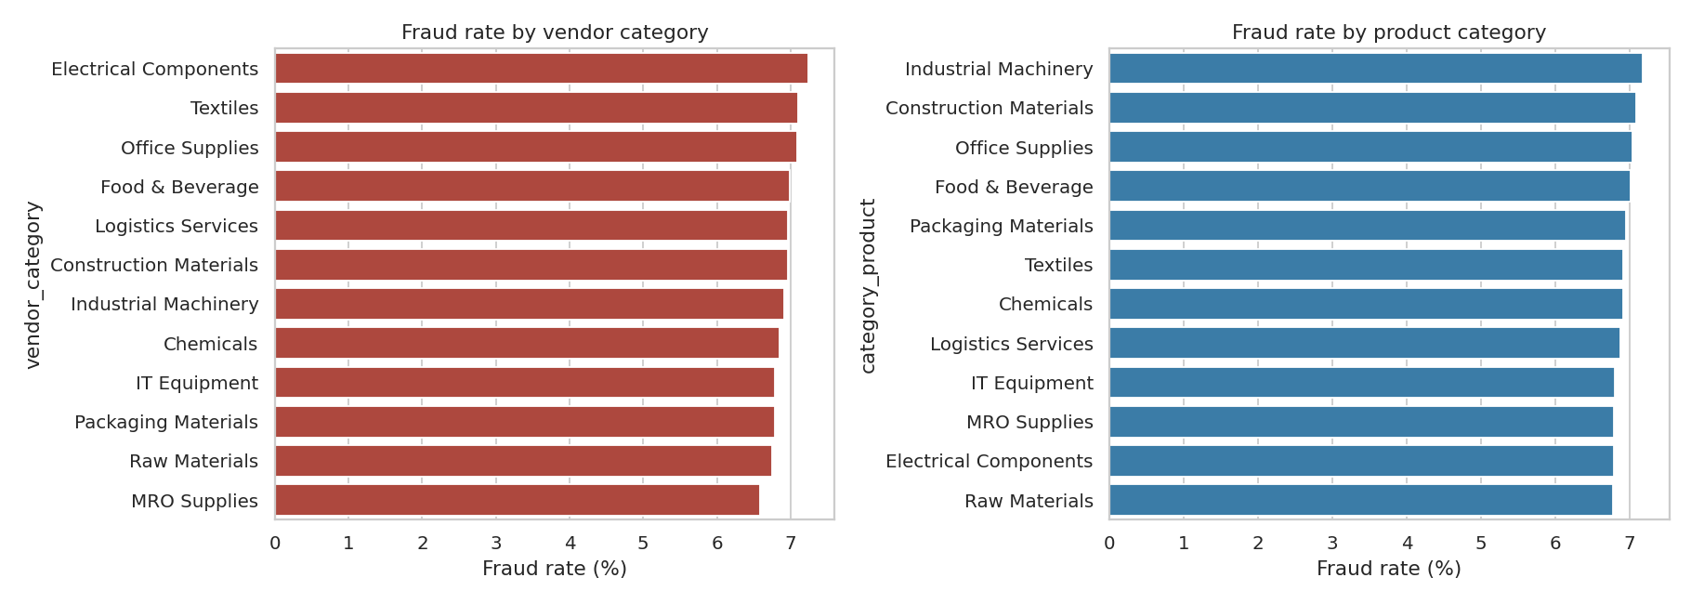
Figure 1. Fraud rate by vendor category (left) and product category (right).
Fraud rate over time (by purchase month) fluctuates in a narrow band of roughly 6.0%–7.8% with no strong upward or downward trend across the dataset's date range — consistent with fraud being injected at a fairly constant rate rather than concentrated in specific periods.
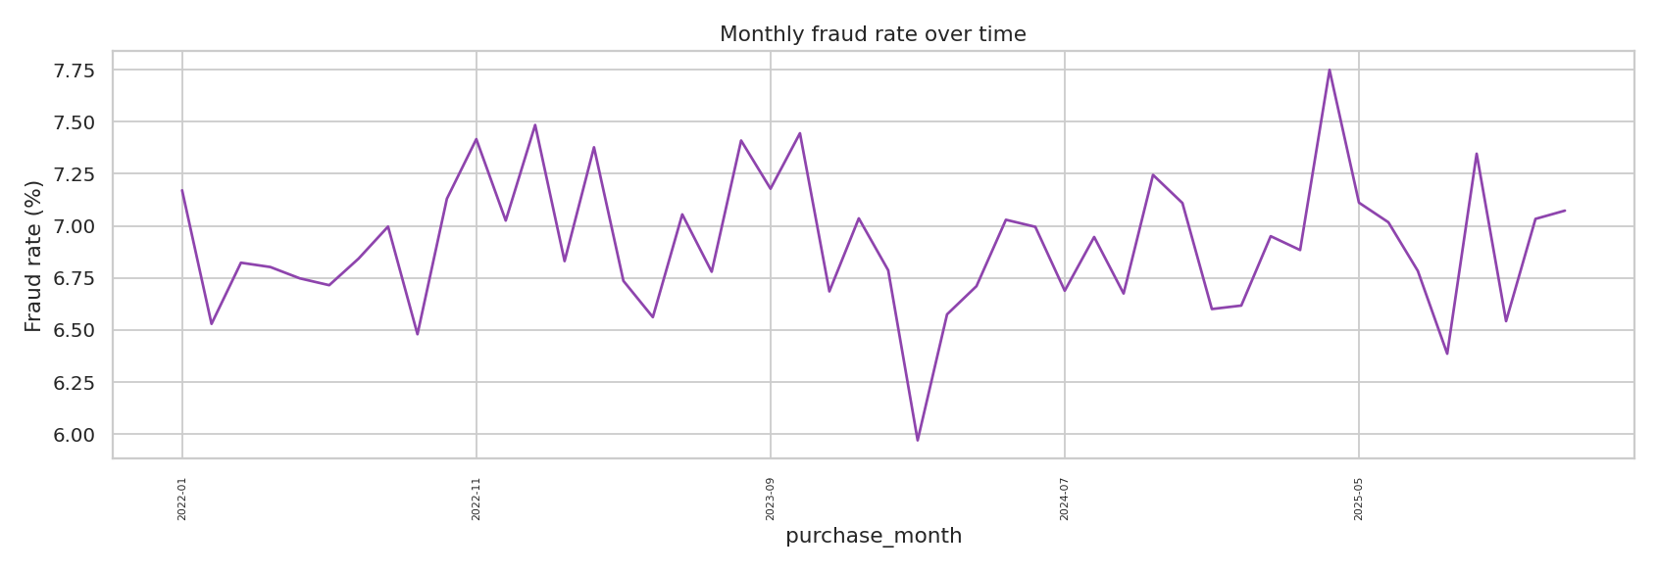
Figure 2. Monthly fraud rate over the full date range.

3.2 Price distribution: fraud vs. clean
Fraudulent transactions skew toward higher unit prices — mean unit price is ₹3,340.59 for fraud rows vs ₹2,542.28 for clean rows, consistent with the price_inflation fraud pattern (1.4×–2.8× the vendor's historical average).
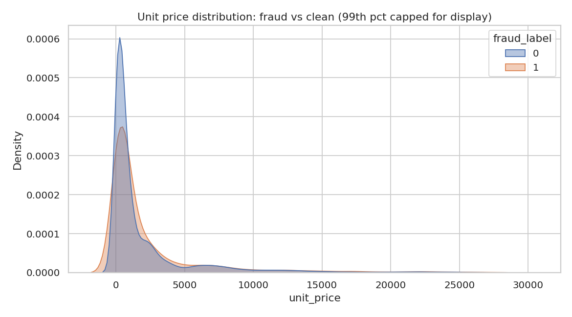
Figure 3. Unit-price distribution, fraud vs. clean (99th-percentile capped for display).
The engineered price-deviation ratio (transaction price ÷ vendor's own historical average price, see Section 4) shows the same separation more directly: mean ratio 2.657 for fraud vs 1.986 for clean, with fraud rows visibly right-shifted.
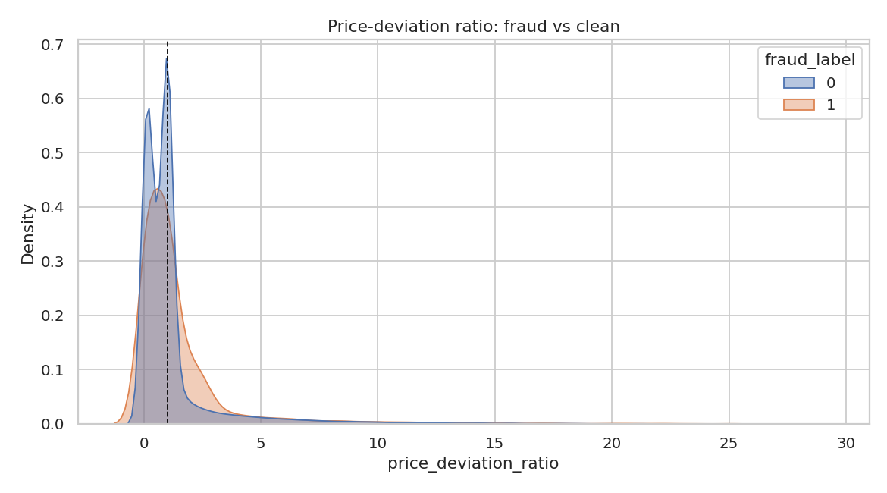
Figure 4. Price-deviation ratio distribution, fraud vs. clean.

3.3 Payment-timing distribution
Days between invoice and payment differs sharply by label: fraud rows average 11.91 days vs 17.34 for clean rows, and 32.7% of fraud rows are paid same-day/next-day (the injected rushed_payment pattern) vs only 0.67% of clean rows.
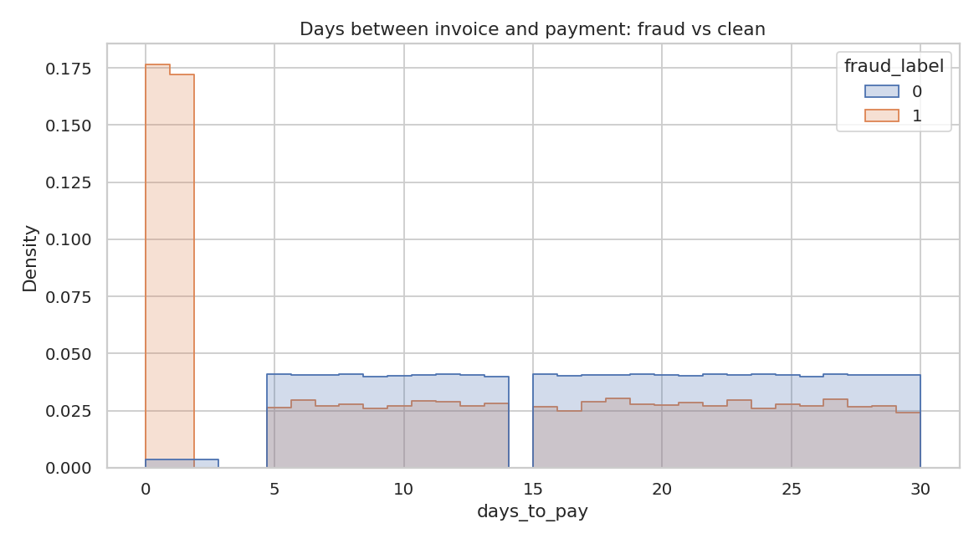
Figure 5. Days-to-pay distribution, fraud vs. clean — note the spike near 0-1 days for fraud.

3.4 Invoice amount patterns
Round-number invoices (amounts that land exactly on a ₹1,000 or ₹5,000 boundary) are essentially exclusive to fraud: 32.91% of fraud rows are round-numbered vs 0.01% of clean rows — this single engineered flag is the strongest individual signal found (correlation 0.559 with fraud_label). Similarly, the invoice amount deviates by more than 5% from the true purchase amount in 35.23% of fraud rows vs 0.0% of clean rows.
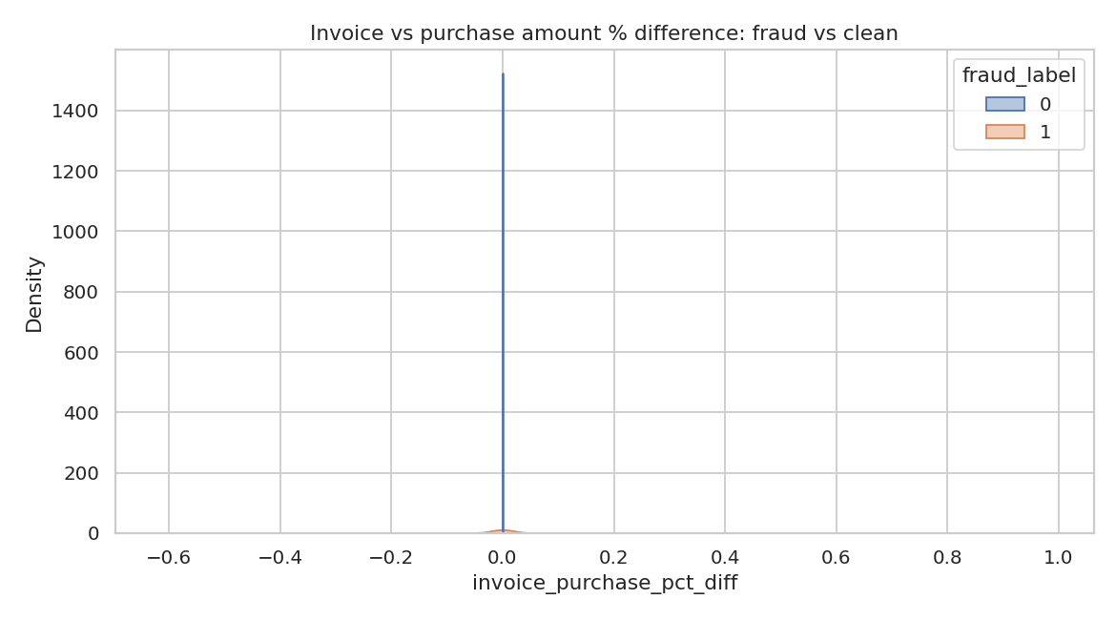
Figure 6. Invoice-vs-purchase amount percentage difference, fraud vs. clean.

3.5 Correlation check
A correlation matrix across the engineered numeric/boolean features and fraud_label confirms the strongest linear signals are is_round_invoice (r = 0.559) and is_rushed_payment (r = 0.486), with days_invoice_to_payment moderately negative (r = -0.173, i.e. faster payment associates with fraud). unit_price, purchase_amount, invoice_purchase_pct_diff and price_deviation_ratio show weaker but real positive correlation (r ≈ 0.02–0.03) — this is a modeling note, not a data-quality problem: their relationship with fraud is non-linear/vendor-relative, so tree-based or interaction-aware models should capture more signal from them than a linear correlation coefficient suggests.
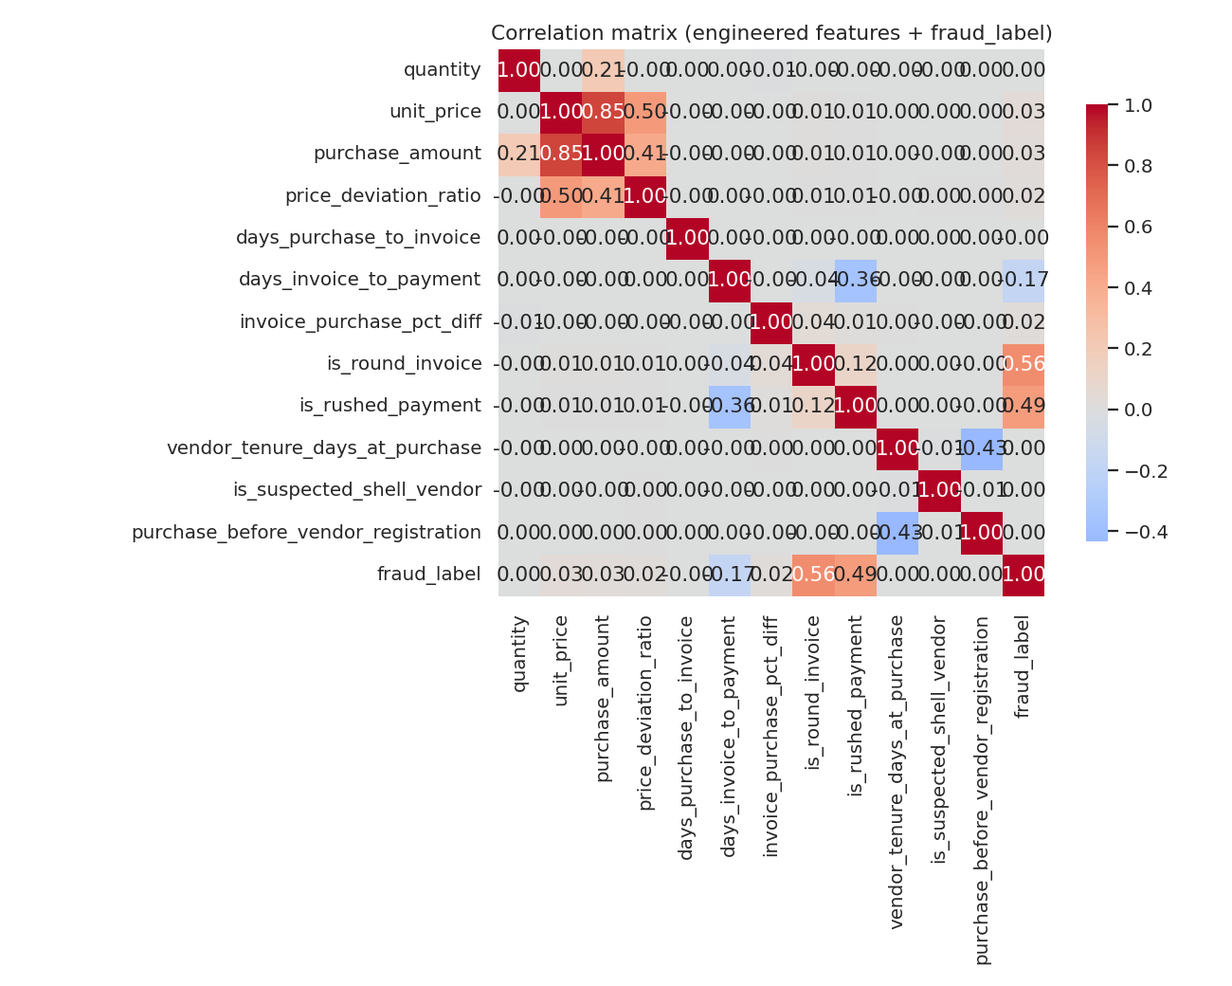
Figure 7. Correlation matrix, engineered features vs. fraud_label.

3.6 Shell-vendor rings
Transactions with vendors independently flagged as suspected shell vendors (Section 2.2) show a fraud rate of 7.05% vs 6.91% for other vendors — essentially no difference. This confirms shell-vendor membership, on its own, is not predictive of individual transaction fraud in this dataset; it is a separate risk signal (vendor-identity risk) rather than a transaction-fraud signal, and should be surfaced to auditors alongside — not merged into — the transaction-level fraud model.
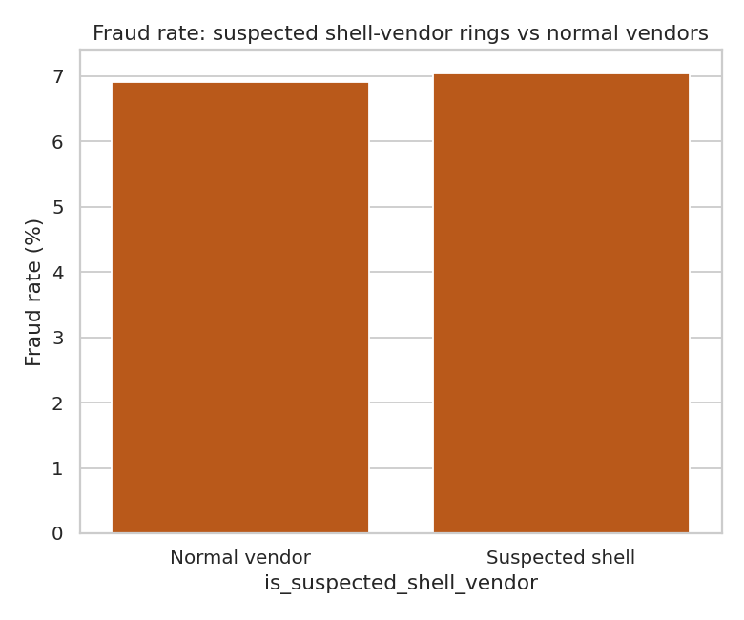
Figure 8. Fraud rate: suspected shell-vendor rings vs. normal vendors.

3.7 Fraud pattern breakdown
Among the 20,760 fraud-labeled rows, the four injected patterns are almost evenly represented (consistent with the generator's 70% single-pattern / 30% combined-pattern design): round_number_invoice (6,831), rushed_payment (6,789), invoice_mismatch (6,730), and price_inflation (6,721).
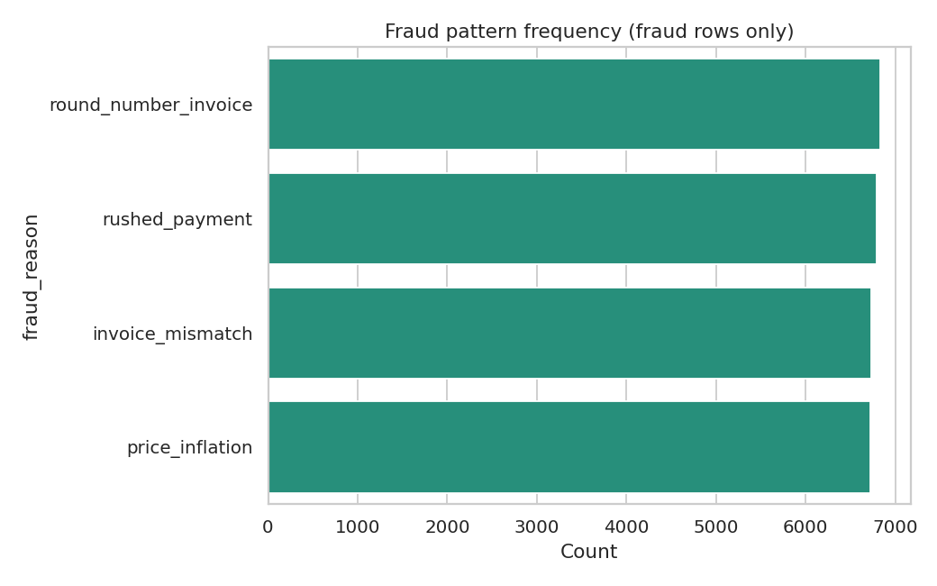
Figure 9. Frequency of each fraud pattern among fraud-labeled rows (rows with two patterns are counted once per pattern).

4. Engineered Features
The following baseline features were added on top of the cleaned data, for use in Part 3 modeling. All are computed without referencing fraud_label or fraud_reason, so they are safe to use as model inputs.
Feature | Definition
vendor_historical_avg_price | Vendor's average unit price for this product, excluding the current transaction (leave-one-out); falls back to the vendor's category average, then the product's catalog standard price, when history is too thin.
price_deviation_ratio | unit_price ÷ vendor_historical_avg_price — how far this transaction's price sits from the vendor's own norm.
days_purchase_to_invoice | Days between purchase_date and invoice_date.
days_invoice_to_payment | Days between invoice_date and payment_date (equivalent to days_to_pay).
days_purchase_to_payment | Total days from purchase to payment (full cycle time).
is_round_invoice / invoice_amount_round_1000 / _5000 | Flags whether invoice_amount lands exactly on a ₹1,000 or ₹5,000 boundary.
invoice_purchase_pct_diff | (invoice_amount − purchase_amount) ÷ purchase_amount — signed percentage mismatch.
is_rushed_payment | True when days_to_pay ≤ 1.
vendor_tenure_days_at_purchase | Vendor's age (days since registration_date) at the time of the purchase.
is_suspected_shell_vendor | True if the vendor shares a bank_account_number or tax_id with another vendor_id (independent re-detection of shell rings, see Section 2.2).
purchase_before_vendor_registration | True if purchase_date predates the vendor's registration_date (data-quality flag, see Section 2.1).
Note on vendor_historical_avg_price / price_deviation_ratio: because many vendor–product pairs have few purchases, the leave-one-out average can be noisy for low-volume pairs. Person 3 may want to winsorize price_deviation_ratio or weight it by the underlying transaction count when building models.

5. Deliverables
- vendorshield_data_cleaned_v1.csv — validated, merged, cleaned dataset at purchase grain (no engineered features).
- vendorshield_data_features_v1.csv — the above plus all engineered columns from Section 4, ready for Part 3 modeling.
- This report — data quality findings (Section 2) and EDA charts + insights (Section 3).
fraud_label and fraud_reason are included in both CSVs for training/evaluation but must be excluded from the model's input feature set, as they are the prediction target and its explanation, not features.

