VendorShield
Part 3 — Machine Learning & Explainable AI: Model Evaluation Report
Prepared for handoff to Person 4 (Backend, Dashboard & Deployment)

1. Overview
This report covers Part 3 of the VendorShield project: building and evaluating a fraud-detection classifier on the cleaned, feature-engineered dataset delivered by Person 2 (300,000 purchase transactions, 6.92% base fraud rate), and generating per-transaction explanations using SHAP. Three model families were trained and compared; the best performer was selected, its decision threshold was tuned against a precision/recall trade-off appropriate for a fraud-audit workflow, and SHAP was used to translate predictions into plain-language reasons an auditor can act on.

2. Feature Set
24 input features were used, spanning five groups: categorical context (vendor category, region, product category, unit of measure, payment method), pricing signals (unit price, purchase amount, price deviation ratio vs. vendor's own history), timing signals (days from purchase to invoice, invoice to payment, and purchase to payment), invoice-integrity flags (round-number invoice, invoice-vs-purchase amount mismatch), and vendor-risk flags (suspected shell vendor, purchase before vendor registration).
Excluded from the model input: all identifier columns (purchase_id, vendor_id, invoice_id, etc. — high-cardinality with no generalizable signal), raw date fields (superseded by the pre-computed day-count features), shell_cluster_id (ground-truth ring label, not knowable at real scoring time), and fraud_reason / fraud_label (the target and its explanation — including either would leak the answer directly into the features). The full field list is in vendorshield_model_spec.json.
price_deviation_ratio was winsorized at the 99th percentile (cap ≈ 28.19×) per Person 2's note that the leave-one-out vendor average is noisy for low-volume vendor-product pairs.

3. Handling Class Imbalance
The dataset's 6.92% fraud rate is already close to Person 1's stated real-world range (3–5%), so aggressive downsampling was not needed and would have discarded useful minority-class examples. Instead, class imbalance was handled via class weighting: class_weight='balanced' for Logistic Regression and Random Forest, and scale_pos_weight (≈13.45, the train-set class ratio) for XGBoost. All 240,000 training rows were retained. An 80/20 stratified train/test split preserved the original fraud rate in both sets.

4. Model Comparison
Three classifiers were trained on identical preprocessing (one-hot encoding for categoricals, standard scaling for numerics) and compared on the held-out 20% test set (60,000 transactions):
Model | ROC-AUC | PR-AUC | Precision@0.5 | Recall@0.5 | F1@0.5
XGBoost (selected) | 0.998 | 0.980 | 0.876 | 0.978 | 0.924
Random Forest | 0.982 | 0.889 | 0.888 | 0.855 | 0.871
Logistic Regression | 0.892 | 0.743 | 0.759 | 0.667 | 0.710

XGBoost was selected: it dominates on every metric, most notably PR-AUC (0.980 vs. 0.889 for Random Forest and 0.743 for Logistic Regression) — the most informative metric under class imbalance since it doesn't reward the trivial majority-class baseline the way ROC-AUC can.

5. Decision Threshold Tuning
Reasoning: in a fraud-audit workflow, a false negative (missed fraud) lets money walk out the door, while a false positive only costs an auditor a few minutes reviewing a clean transaction. This asymmetry argues for prioritizing recall. However, precision can't be ignored either — if auditors are shown mostly false alarms they stop trusting (and using) the tool, which defeats the purpose.
Policy adopted: maximize recall subject to precision ≥ 0.85 — i.e., at least 85% of every batch of flagged transactions must be genuinely fraudulent, keeping the auditor's queue trustworthy, while still catching the great majority of actual fraud. This model's strong class separability (PR-AUC 0.98) makes both targets achievable simultaneously without a steep trade-off.
Resulting threshold: fraud_probability ≥ 0.310 → flagged as fraud. At this threshold on the test set:
Precision | 0.850
Recall | 0.987
F1-score | 0.913
ROC-AUC | 0.998
PR-AUC (Average Precision) | 0.980
Decision threshold | 0.310

Confusion matrix (test set, n = 60,000):
 | Predicted: Clean | Predicted: Fraud
Actual: Clean | 55,125 (TN) | 723 (FP)
Actual: Fraud | 55 (FN) | 4,097 (TP)

In practice: of 4,152 truly fraudulent transactions in the test set, 4,097 were caught (98.7% recall) and only 55 were missed. Of the 4,820 transactions flagged for audit, 4,097 were genuinely fraudulent (85.0% precision) — an auditor reviewing the flagged queue finds real fraud on roughly 5 out of every 6 transactions checked.
Two additional risk bands were derived for the API output (see Section 8): High risk uses this same 0.310 threshold; Medium risk starts at half that (0.155), giving a middle tier for transactions worth a lighter secondary review even if they don't meet the primary audit-trigger bar; everything below is Low.

6. Evaluation Charts

6.1 ROC Curve
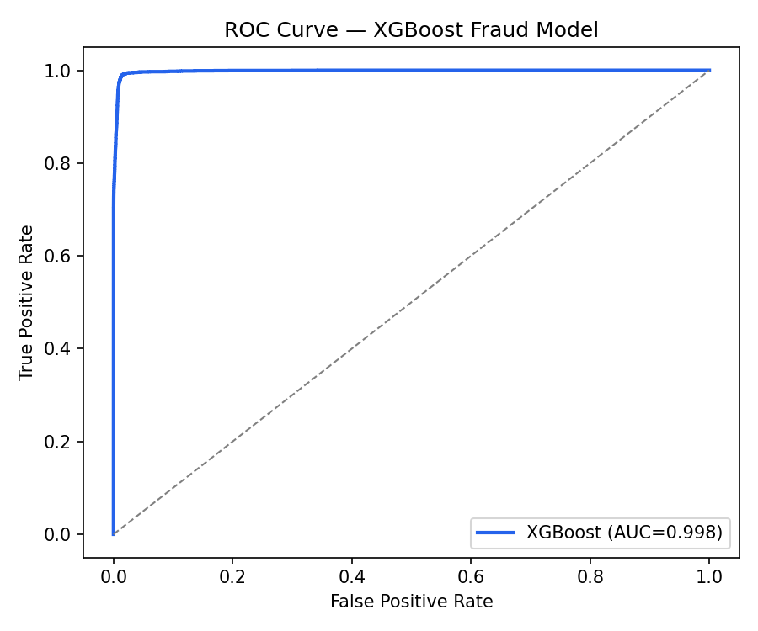

6.2 Precision-Recall Curve
The marked point shows the chosen operating threshold (0.310).
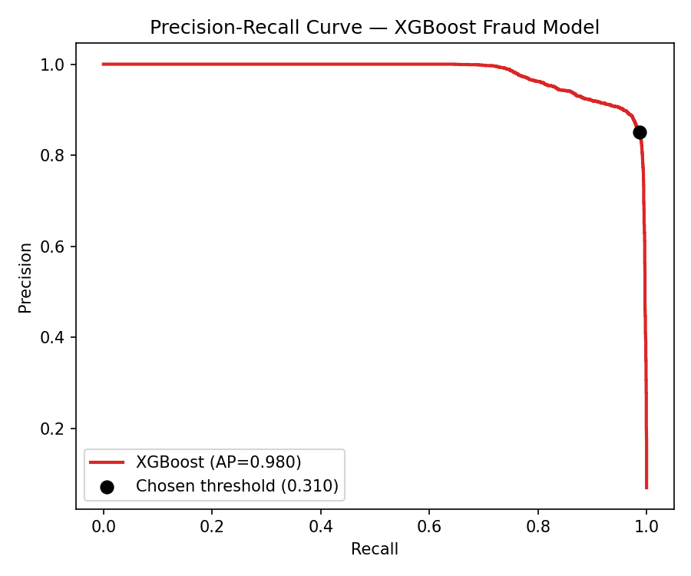

6.3 Global Feature Importance (mean |SHAP value|)
Computed on a 5,000-row sample of the test set. Pricing signals (standard/unit price relative to catalog and vendor history) and payment-timing signals dominate, consistent with Person 2's EDA findings on price inflation and rushed payments.
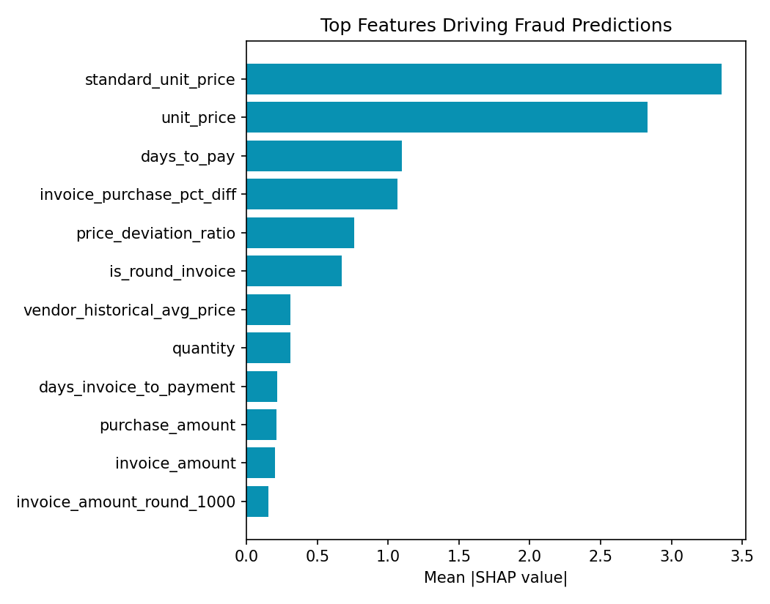

7. SHAP Explainability — Worked Examples
For each transaction, SHAP (TreeExplainer on the trained XGBoost model) attributes the predicted fraud probability to individual input features. Features pushing the prediction toward 'fraud' are translated into plain-language reasons via a lookup table, ranked by contribution size, and the top 3 are returned as top_reasons in the API output. Below are four real examples from correctly-identified fraud cases in the test set:
Example 1 — fraud_probability: 0.9999 risk_level: High
- invoice amount is a suspiciously round number
- invoice amount lands exactly on a ₹1,000 boundary
- invoice amount lands exactly on a ₹5,000 boundary
Example 2 — fraud_probability: 1 risk_level: High
- invoice amount differs from purchase amount by -0.2%
- payment settled within 0 days of invoicing (unusually fast)
- unit price of ₹3,450.35 is unusually high
Example 3 — fraud_probability: 0.969 risk_level: High
- payment settled within 1 days of invoicing (unusually fast)
- standard catalog price is ₹71.61
- only 1 days between invoice and payment
Example 4 — fraud_probability: 0.976 risk_level: High
- standard catalog price is ₹149.72
- unit price of ₹354.27 is unusually high
- quantity of 18 units

Note the reasons map naturally onto the four fraud patterns Person 2 identified in EDA: round-number invoicing, rushed payment approval, invoice/purchase amount mismatch, and price inflation vs. vendor history — confirming the model has learned the intended signal rather than spurious correlations.

8. Deliverables & Handoff to Person 4
- vendorshield_model_v1.joblib — trained scikit-learn Pipeline (preprocessing + XGBoost classifier), loadable directly with joblib.load().
- vendorshield_model_spec.json — machine-readable input/output field-by-field contract (names, types, examples, exclusions).
- vendorshield_predict.py — reusable inference module exposing predict_fraud(transaction_dict) -> {fraud_probability, risk_level, top_reasons}, ready to import into an API layer.
- This report — model comparison, threshold reasoning, evaluation metrics, and SHAP examples.

Person 4: the exact input field names, types, and the excluded-field list are authoritative in vendorshield_model_spec.json — please build the API request/response schema directly from that file rather than this report's prose, to avoid transcription drift.

