To connect EC2 instance with jenkins install some plugins:

1. SSH
2. AWS EC2

Once installed open credentials page and enter AWS access key id and secret access key.

Include .pem file in SSH credentials to establish connection with instance and use ssh.

Below screen is for AWS access key and secret key:

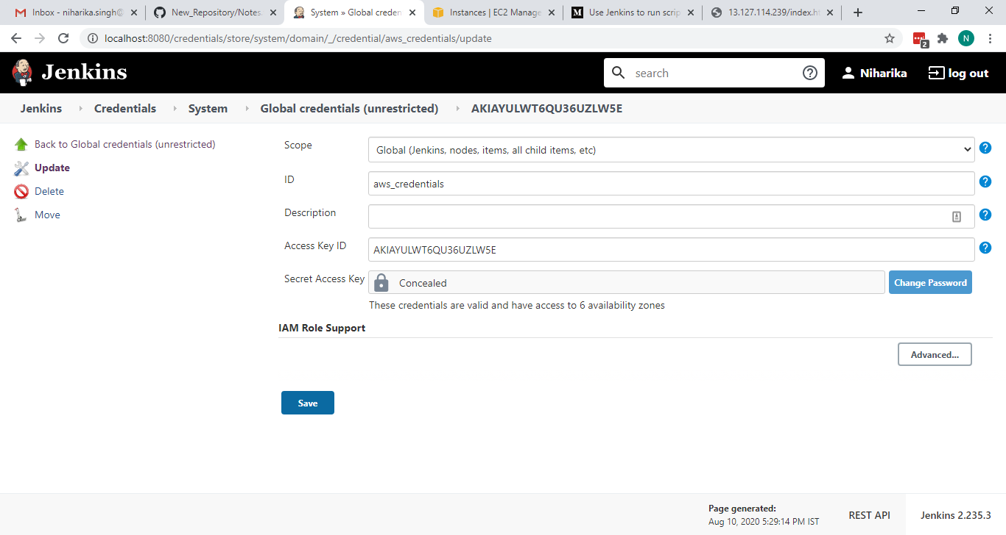

Manage ssh connection:

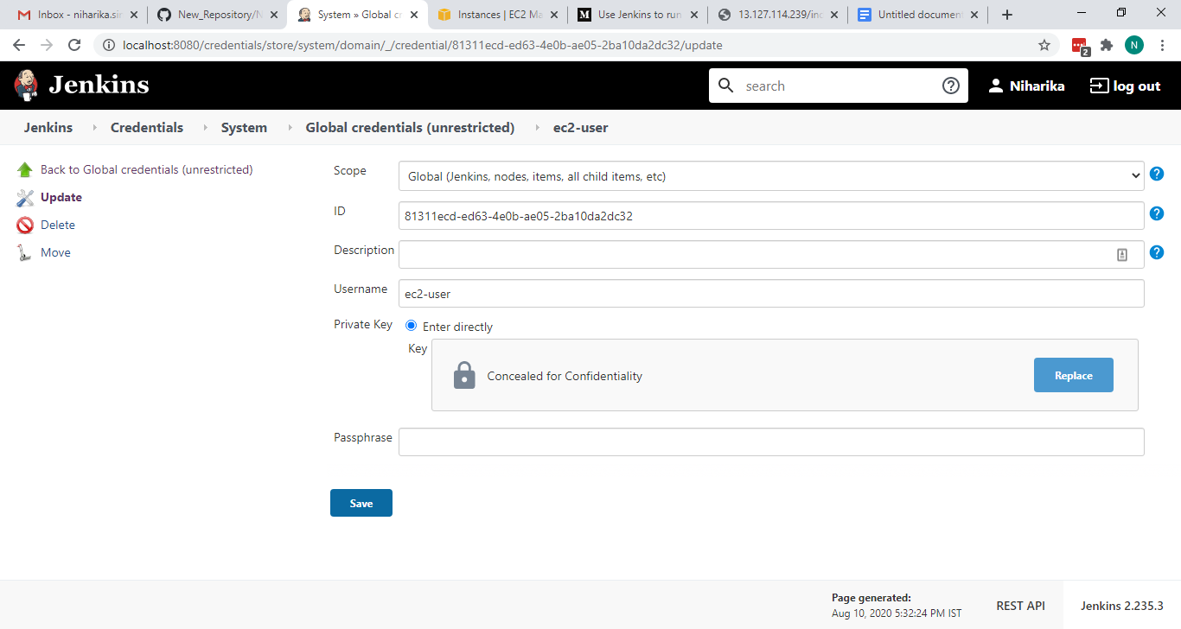

If you have launched an ec2 instance then make a username: ec2-user and if ubuntu then include username:ubuntu.

Copy .pem file and paste in private key section

After that go to Manage Connection:

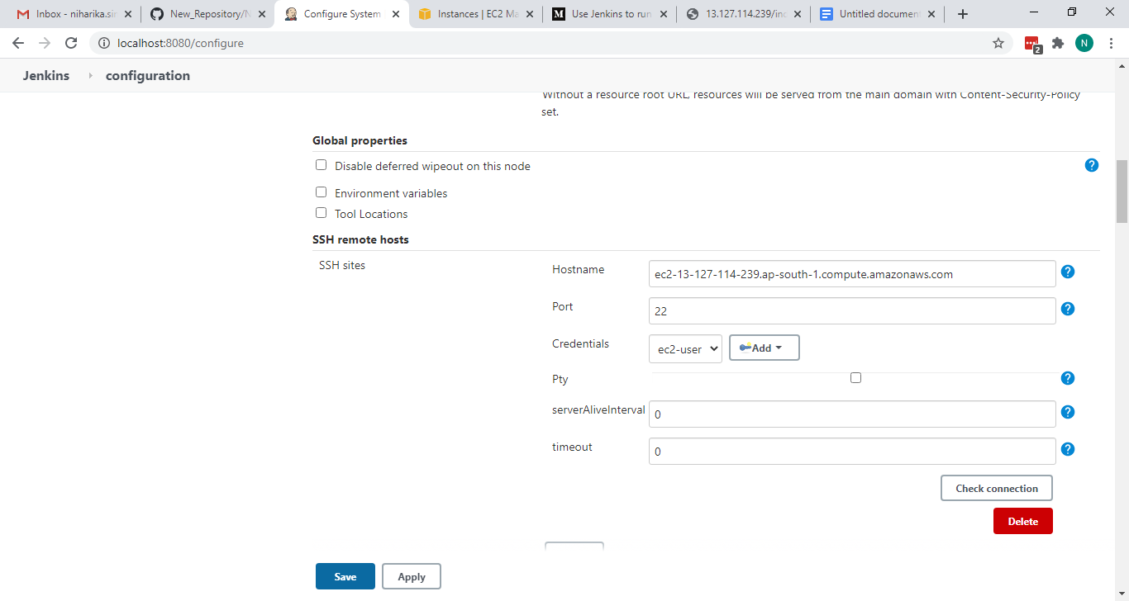

Now create a freestyle project and include build project.

