23CSE202 DATABASE MANAGEMENT SYSTEMS
S3 B.Tech CSE
Department of Computer Science and Engineering
Amrita School of Computing, Amritapuri Campus

3. Database Design Document

Group No :
Team Members :
Roll No | Student Name
AM.SC.U4CSE25338 | NIHARIKA S H
AM.SC.U4CSE25330 | MADHAV S THAMPY
AM.SC.U4CSE25323 | ISHAAN S VANNERI

Project Title :
3.1. Detailed description of the project
Helios is an online watch store that allows customers to browse, favourite, and purchase watches from different brands and categories. The system manages customers, sellers, products, shopping carts, addresses, orders, and payments. It maintains product details, stock, order information, and payment records while ensuring that the relationships between these entities are properly maintained.
USERS
 | Description
  User Type
Customer
  Browses watches, manages cart and favourites, places orders, and makes payments.
Seller | Adds and manages watches available for sale.
Admin | Manages the overall system and its data.
• Seller → Products: "A seller can list multiple products, but each product is associated with one seller."
• Brand → Products: "Each product belongs to one brand, while a brand can have multiple products."
• Products ↔ Categories: "A product can belong to multiple categories..."
• Customer → Cart: "Each customer has one shopping cart..."
• Customer → Addresses: "A customer can save multiple delivery addresses..."
• Customer → Orders: "A customer can place multiple orders."
• Order → Products: "Each order can contain multiple products..."
• Order → Payment: "Each order is associated with one payment record."

Entity | Important Attributes
Users | User ID, Name, Email, Password, Phone, Role
Brands | Brand ID, Brand Name
Categories | Category ID, Category Name
Products | Product ID, Name, Price, Description, Stock, Image, Strap Material, Dial Colour, Case Material, Movement Type, Water Resistance, Warranty, Gender, Display Type
Carts | Cart ID, User ID
Cart Items
  Cart ID, Product ID, Quantity
Favourites
  User ID, Product ID
Addresses
  Address ID, User ID, Address, City, State, Pincode
Orders | Order ID, User ID, Address ID, Order Date, Total Amount, Order Status
Order Items | Order ID, Product ID, Quantity, Unit Price
Payments
  Payment ID, Order ID, Payment Method, Payment Status, Payment Date, Amount
Business Rules
· Each user must have a unique user ID and email address, and can be assigned the role of customer, seller, or admin.
· A seller can list multiple products, but each product is associated with one seller.
· Each product belongs to one brand, while a brand can have multiple products.
· A product can belong to multiple categories, and each category can contain multiple products.
· Each customer has one shopping cart, and a cart can contain multiple products with their respective quantities.
· A customer can add multiple products to their favourites, and a product can be favourited by multiple customers.
· A customer can save multiple delivery addresses and place multiple orders.
· Each order can contain multiple products, with the quantity and unit price recorded for each product.
· Each order is associated with one payment record.
· Product stock must be sufficient before an order can be placed, and the stock is reduced after a successful purchase.
· An order can have one of five statuses: Pending, Confirmed, Shipped, Delivered, or Cancelled
3.2. ER Diagram
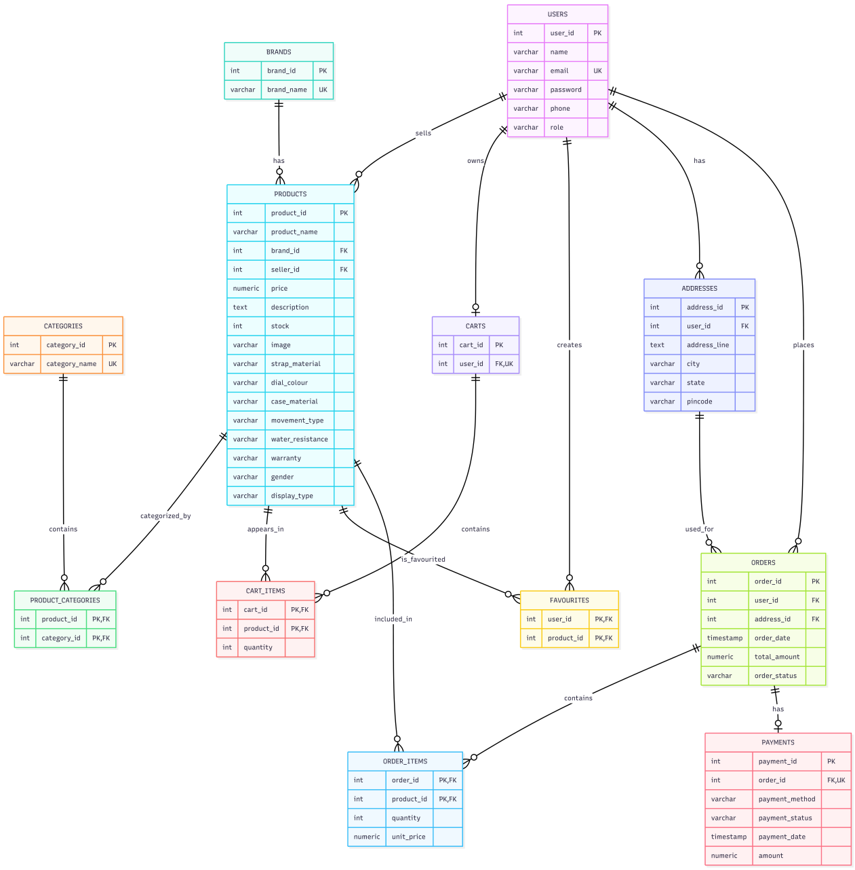

3.3 Relational Schema
The ER model is converted into a relational schema by representing each entity as a relation (table). Primary keys uniquely identify records, while foreign keys establish relationships between related tables. Composite primary keys are used in associative relations such as PRODUCT_CATEGORIES, CART_ITEMS, FAVOURITES, and ORDER_ITEMS.
USERS
Attribute Name | Data Type | Key / Constraint
user_id | SERIAL | PK
name | VARCHAR(100) | NOT NULL
email | VARCHAR(150) | UNIQUE, NOT NULL
password | VARCHAR(255) | NOT NULL
phone | VARCHAR(20) | —
role | VARCHAR(20) | NOT NULL

BRANDS
Attribute Name | Data Type | Key / Constraint
brand_id | SERIAL | PK
brand_name | VARCHAR(100) | UNIQUE, NOT NULL
CATEGORIES
Attribute Name | Data Type | Key / Constraint
category_id | SERIAL | PK
category_name | VARCHAR(50) | UNIQUE, NOT NULL
PRODUCTS
Attribute Name | Data Type | Key / Constraint
product_id | SERIAL | PK
product_name | VARCHAR(150) | NOT NULL
brand_id | INT | FK, NOT NULL
seller_id | INT | FK, NOT NULL
  price
  DECIMAL(10,2)
  NOT NULL
  description
  TEXT
  —
stock | INT | NOT NULL
image | VARCHAR(255) | —
strap_material | VARCHAR(80) | —
dial_colour | VARCHAR(50) | —
case_material | VARCHAR(80) | —
movement_type | VARCHAR(80) | —
water_resistance | VARCHAR(50) | —
warranty | VARCHAR(80) | —
gender | VARCHAR(20) | —
display_type | VARCHAR(50) | —
FK: brand_id → brands(brand_id)
FK: seller_id → users(user_id)
PRODUCT_CATEGORIES
Attribute Name | Data Type | Key / Constraint
product_id | INT | PK, FK
category_id | INT | PK, FK
Composite Primary Key: (product_id, category_id)
FK: product_id → products(product_id)
FK: category_id → categories(category_id)
CARTS
Attribute Name | Data Type | Key / Constraint
cart_id | SERIAL | PK
user_id | INT | FK, UNIQUE, NOT NULL
FK: user_id → users(user_id)
CART_ITEMS
Attribute Name | Data Type | Key / Constraint
cart_id | INT | PK, FK
product_id | INT | PK, FK
quantity | INT | NOT NULL, CHECK
Composite Primary Key: (cart_id, product_id)
FAVOURITES
Attribute Name | Data Type | Key / Constraint
user_id | INT | PK, FK
product_id | INT | PK, FK
Composite Primary Key: (user_id, product_id)
ADDRESSES
Attribute Name | Data Type | Key / Constraint
address_id | SERIAL | PK
user_id | INT | FK, NOT NULL
Address_line | TEXT | NOT NULL
city | VARCHAR(80) | NOT NULL
state | VARCHAR(80) | NOT NULL
pincode | VARCHAR(10) | NOT NULL

ORDERS
Attribute Name | Data Type | Key / Constraint
order_id | SERIAL | PK
user_id | INT | FK, NOT NULL
address_id | INT | FK, NOT NULL
order_date | TIMESTAMP | NOT NULL, DEFAULT
total_amount | NUMERIC(10,2) | NOT NULL, CHECK
order_status | VARCHAR(20) | NOT NULL, CHECK, DEFAULT
ORDER_ITEMS
Attribute Name | Data Type | Key / Constraint
order_id | INT | PK,FK
product_id | INT | PK,FK
quantity | INT | NOT NULL, CHECK
unit_price | NUMERIC(10,2) | NOT NULL, CHECK
Composite Primary Key: (order_id, product_id)
PAYMENTS
Attribute Name | Data Type | Key / Constraint
payment_id | SERIAL | PK
order_id | INT | FK, UNIQUE, NOT NULL
payment_method | VARCHAR(30) | NOT NULL, CHECK
payment_status | VARCHAR(20) | NOT NULL, DEFAULT, CHECK
payment_date | TIMESTAMP | DEFAULT
amount | NUMERIC(10,2) | NOT NULL

Relationship Conversion
Relationship | Cardinality | Relational Schema Representation
USERS sells PRODUCTS | 1 : M | PRODUCTS.seller_id → USERS.user_id
BRANDS has PRODUCTS | 1 : M | PRODUCTS.brand_id → BRANDS.brand_id
PRODUCTS belongs to CATEGORIES | M : N | PRODUCT_CATEGORIES(product_id, category_id)
USERS owns CARTS | 1 : 0..1 | CARTS.user_id → USERS.user_id (UNIQUE)
CARTS contains PRODUCTS | M : N | CART_ITEMS(cart_id, product_id)
USERS favourites PRODUCTS | M : N | FAVOURITES(user_id, product_id)
USERS has ADDRESSES | 1 : M | ADDRESSES.user_id → USERS.user_id
USERS places ORDERS | 1 : M | ORDERS.user_id → USERS.user_id
ADDRESSES used for ORDERS | 1 : M | ORDERS.address_id → ADDRESSES.address_id
ORDERS contains PRODUCTS | M : N | ORDER_ITEMS(order_id, product_id)
ORDERS has PAYMENTS | 1 : 0..1 | PAYMENTS.order_id → ORDERS.order_id (UNIQUE)

3.4 Normalization and Functional dependency analysis
Functional Dependency
A functional dependency (FD) describes a relationship where one attribute or set of attributes uniquely determines another attribute or set of attributes.
Relation | Functional Dependency
USERS | user_id → name, email, password, phone, role
BRANDS | brand_id → brand_name
CATEGORIES | category_id → category_name
  PRODUCTS
  product_id → product_name, brand_id, seller_id, price, description, stock, image, strap_material, dial_colour, case_material, movement_type, water_resistance, warranty, gender, display_type
  PRODUCT_CATEGORIES
  (product_id, category_id) → no non-key attributes
  CARTS
  cart_id → user_id
  CART_ITEMS
  (cart_id, product_id) → quantity
  FAVOURITES
  (user_id, product_id) → no non-key attributes
  ADDRESSES
  address_id → user_id, address_line, city, state, pincode
  ORDERS
  order_id → user_id, address_id, order_date, total_amount, order_status
  ORDER_ITEMS
  (order_id, product_id) → quantity, unit_price
  PAYMENTS
  payment_id → order_id, payment_method, payment_status, payment_date, amount

These dependencies show that the primary key of each relation uniquely determines the remaining attributes of that relation.
For relations with composite primary keys, such as CART_ITEMS and ORDER_ITEMS, the combination of the key attributes determines the non-key attributes. These dependencies help identify redundancy and verify whether the relations satisfy the required normal forms

Candidate Keys and Attribute Closure
A candidate key is a minimal set of attributes that uniquely identifies every tuple in a relation. Attribute closure is used to determine whether a set of attributes can determine all attributes of a relation.
Relation | Candidate Key | Attribute Closure
  USERS
  user_id
  {user_id, name, email, password, phone, role}
  BRANDS
  brand_id
  {brand_id, brand_name}
  CATEGORIES
  category_id
  {category_id, category_name}
  PRODUCTS
  product_id
  {product_id, product_name, brand_id, seller_id, price, description, stock, image, strap_material, dial_colour, case_material, movement_type, water_resistance, warranty, gender, display_type}
  CARTS
  cart_id
  {cart_id, user_id}
  CART_ITEMS
  {cart_id, product_id}
  {cart_id, product_id, quantity}
  FAVOURITES
  {user_id, product_id}
  {user_id, product_id}
  ADDRESSES
  address_id
  {address_id, user_id, address_line, city, state, pincode}
  ORDERS
  order_id
  {order_id, user_id, address_id, order_date, total_amount, order_status}
  ORDER_ITEMS
  {order_id, product_id}
  {order_id, product_id, quantity, unit_price}
  PAYMENTS
  payment_id
  {payment_id, order_id, payment_method, payment_status, payment_date, amount}

The selected candidate keys uniquely identify each tuple in their respective relations. Single-attribute keys such as user_id, brand_id, and product_id determine all other attributes in their relations. Composite keys such as (cart_id, product_id) and (order_id, product_id) are required because both attributes together uniquely identify each record. Removing any attribute from a composite key would result in loss of uniqueness.
Normalization Process
The HELIOS database is normalized from 1NF to BCNF to reduce redundancy and maintain data consistency.

1NF
- All attributes contain atomic values.
- There are no repeating groups or multi-valued attributes.
- Each relation has a primary key.

2NF
- The relations are already in 1NF.
- There are no partial dependencies.
- In composite-key relations, non-key attributes depend on the complete key.
Example: (order_id, product_id) → quantity, unit_price.

3NF
- The relations are already in 2NF.
- There are no transitive dependencies.
- Related information such as brands and categories is stored in separate relations to avoid redundancy.

BCNF
- Every non-trivial functional dependency has a candidate key as its determinant.
- For example, user_id → name, email, password, phone, role, where user_id is a candidate key.
NORMAL FORM JUSTIFICATION
1NF | All attributes contain atomic values and there are no repeating groups or multi-valued attributes
2NF | No partial dependencies exist; in composite-key relations, non-key attributes depend on the complete key.
3NF | No transitive dependencies exist; brands and categories are maintained in separate relations.
BCNF | Every determinant in the identified functional dependencies is a candidate key.
Therefore, the HELIOS database satisfies BCNF.

