1. **Adding a new brand**

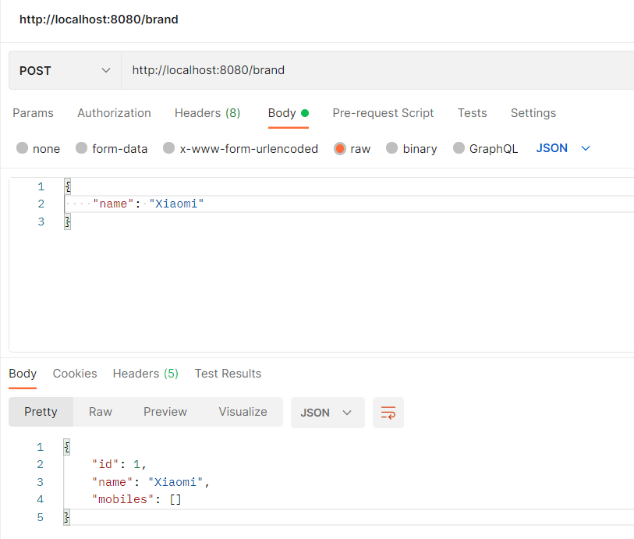

1. **Fetching the brands**

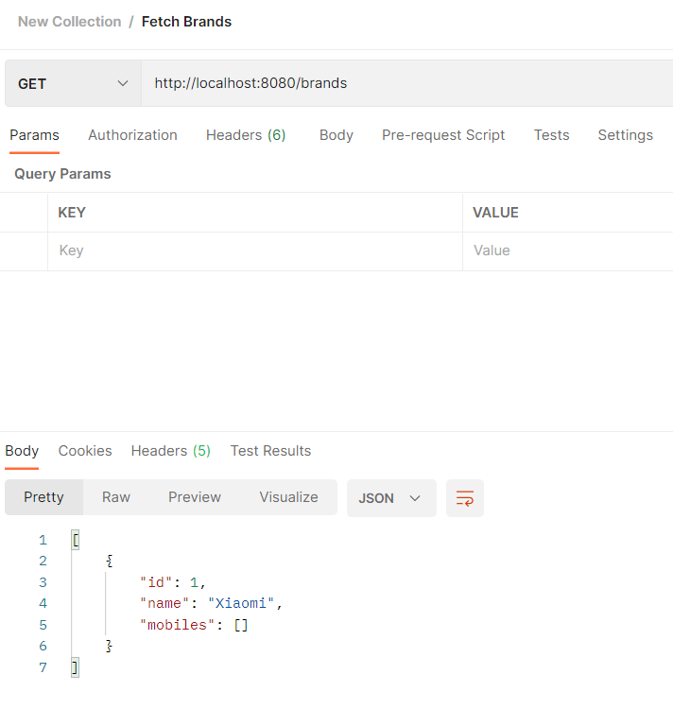

1. **Updating the mobile price of mobile where the brand not exists (Exception)**

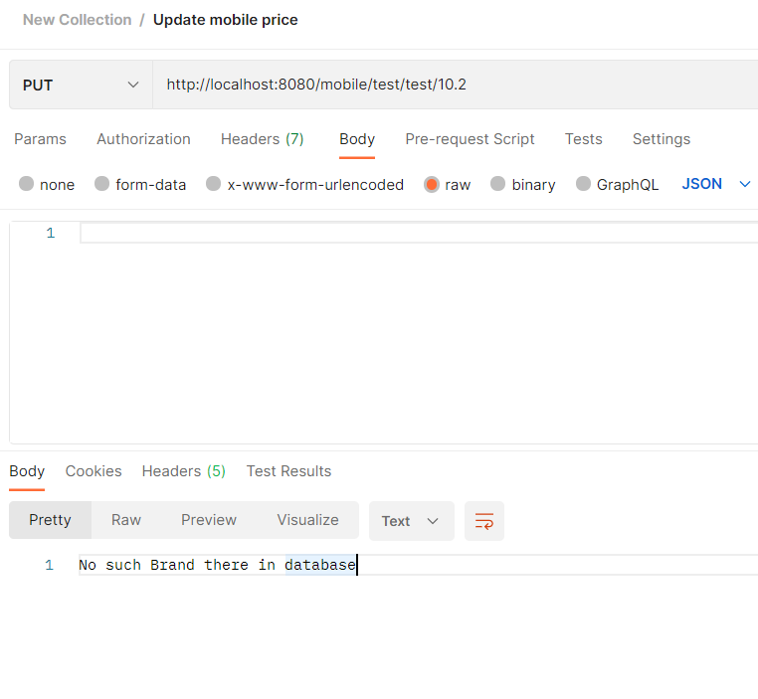

1. **Adding a mobile for a particular brand**

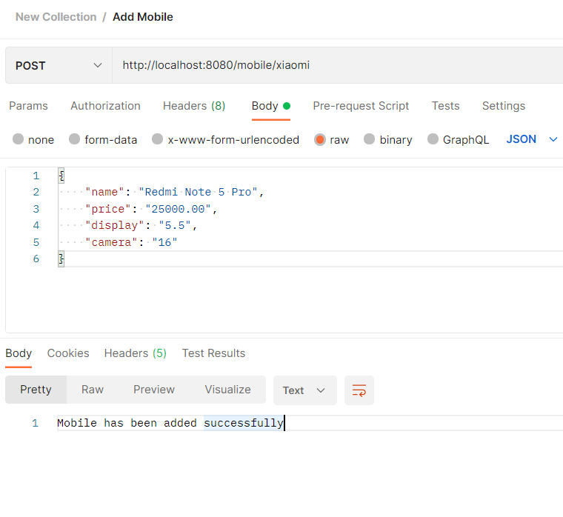

1. **Fetching brand and mobile details**

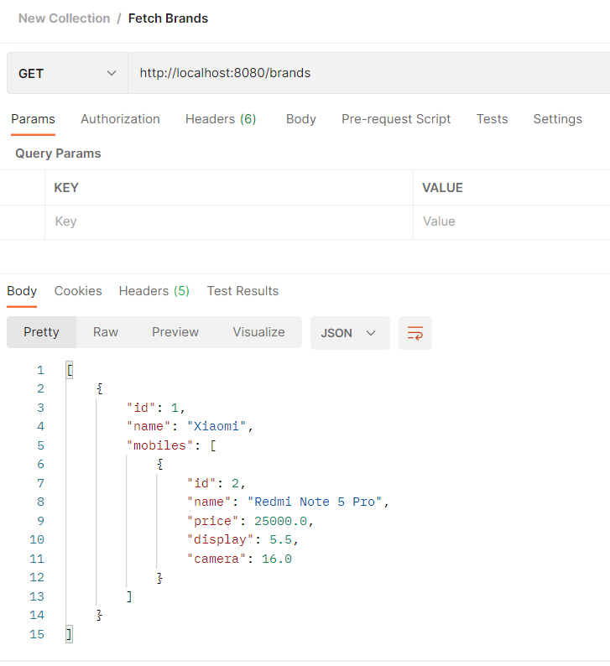

1. **Adding multiple brands to check the sorted order of brands**

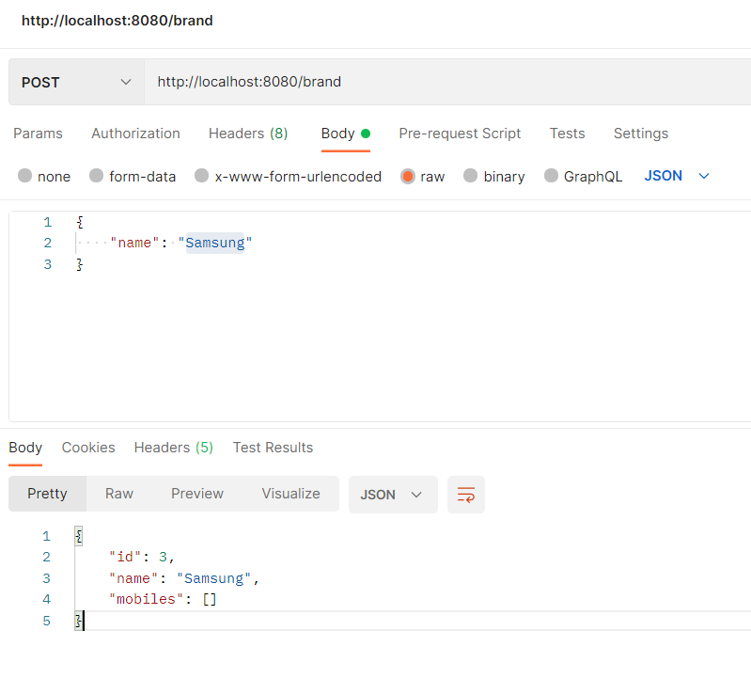

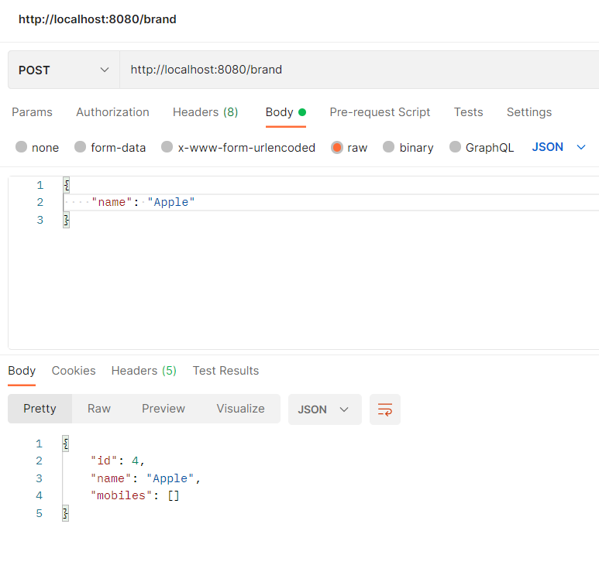

1. **Fetched brands in ascending order of brand name**

