Retail Data Platform – Requirements Document
Platform: Databricks (Delta Lake, Unity Catalog, PySpark)
Industry: Retail (Omnichannel)
Architecture: Medallion (Bronze → Silver → Gold)

1. Purpose of the Document
This document defines the business, functional, technical, data, and non-functional requirements for building a scalable, governed, and real-time retail analytics platform using Databricks and Delta Lake, enabling:
- Historical and real-time retail analytics
- Customer, product, and inventory insights
- Regulatory compliance and data governance
- Support for BI, ML, and advanced analytics
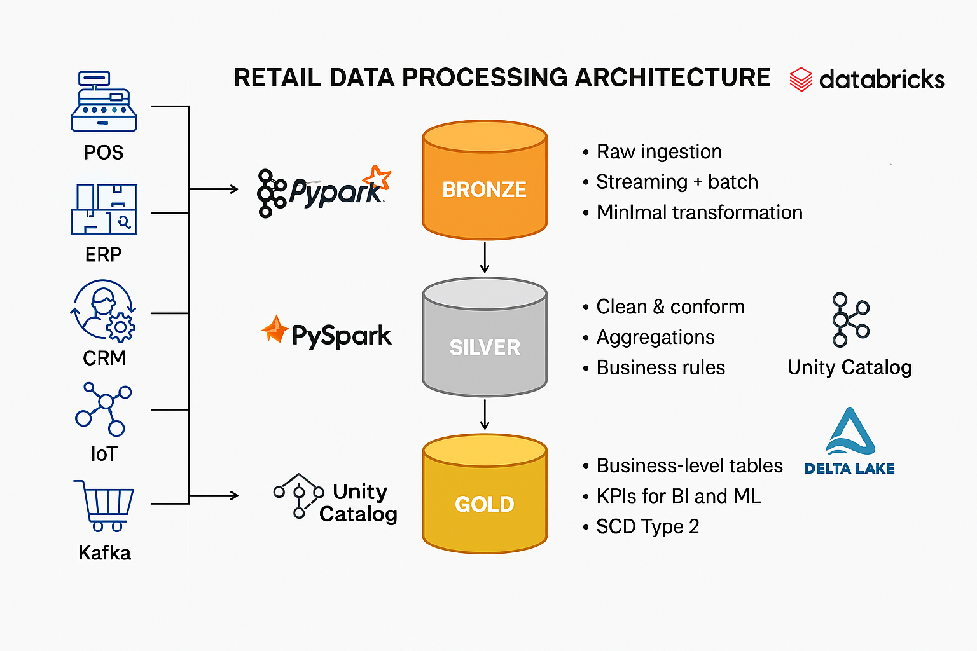

2. Business Objectives
Primary Objectives
- Provide single source of truth for retail data
- Enable real-time and batch analytics
- Track historical dimension changes (SCD Type-2)
- Reduce data latency (< 5 minutes for streaming use cases)
- Support self-service BI and ML
Success Metrics
Metric | Target
Data availability SLA | ≥ 99.9%
Streaming latency (Not Applicable for Offline data process) | < 2 minutes
Query performance | < 5 sec (Gold layer)
Data quality errors | < 0.5%

3. In-Scope Use Cases
Business Use Cases
- Omnichannel Sales Analytics
- Customer 360 View
- Inventory Monitoring & Alerts
- Product & Promotion Performance
- Demand Forecasting (future phase)
- Audit & Historical Reporting
Out of Scope (Phase-1)
- Third-party data monetization
- Unstructured social media data

4. Source Systems & Data Ingestion Requirements
Source Systems
Source | Type | Ingestion Mode
POS Systems | CSV / Kafka | Streaming
E-Commerce | API / CSV | Batch
CRM | CSV | Batch
ERP (Products) | CSV | Batch
IoT Inventory Sensors | Kafka | Streaming

5. Architecture Requirements
Medallion Architecture
BRONZE – Raw, Immutable
SILVER – Cleansed, Conformed
GOLD – Business Aggregates & Dimensions
Platform Constraints
- Databricks Runtime with Photon enabled
- Delta Lake as the only storage format
- Unity Catalog mandatory for governance

6. Data Layer Requirements

6.1 Bronze Layer Requirements
Purpose
Store raw source data with full fidelity.
Functional Requirements
- Append-only storage
- Support schema evolution
- Capture ingestion metadata
Mandatory Columns
Column | Description
ingestion_ts | Load timestamp
source_system | Origin
source_file | File name / topic
Sample Bronze Dataset – sales_raw.csv
CSV
order_id,order_date,store_id,product_id,customer_id,quantity,price
ORD1001,2026-04-20,STR01,PRD101,CUST01,2,500
ORD1002,2026-04-20,STR02,PRD102,CUST02,1,1200
Show more lines

6.2 Silver Layer Requirements
Purpose
Provide clean, standardized, and conformed data.
Functional Requirements
- Deduplication
- Data quality validation
- Business rule validation
- Reference data enrichment
Data Quality Rules
- quantity > 0
- price > 0
- customer_id NOT NULL
Silver Tables
- sales
- customers
- products
- inventory_events

Sample Silver Dataset – customers.csv
CSV
customer_id,name,email,city,loyalty_tier
CUST01,Rahul,rahul@gmail.com,Chennai,GOLD
CUST02,Anita,anita@gmail.com,Bangalore,SILVER
Show more lines

6.3 SCD Type-2 Dimension Requirements
Dimension: Customer
Business Need
Track historical changes for:
- City
- Loyalty Tier
- Contact details
Rules
- One active record per business key
- Changes create a new row
- History must never be lost
Required Columns
Column | Description
customer_sk | Surrogate key
customer_id | Business key
effective_start_date | Start
effective_end_date | End
is_current | Current flag

6.4 Gold Layer Requirements
Purpose
Support business reporting, dashboards, ML, and KPIs.
Gold Tables
Table | Description
fact_sales | Transaction facts
dim_customer | SCD-2
dim_product | SCD-2
daily_store_sales | Aggregates
Sample Gold Dataset – fact_sales.csv
CSV
order_id,customer_id,store_id,product_id,sale_date,net_amount
ORD1001,CUST01,STR01,PRD101,2026-04-20,1000
ORD1002,CUST02,STR02,PRD102,2026-04-20,1200
Show more lines

7. Real-Time Processing Requirements
Streaming Scenarios
- Real-time sales tracking
- Inventory threshold alerts
SLA
- End-to-end latency < 2 minutes
- Exactly-once processing
Sample Streaming Dataset – inventory_events.csv
CSV
product_id,store_id,event_time,stock_level
PRD101,STR01,2026-04-20T10:30:00,5
PRD102,STR02,2026-04-20T10:32:00,45
Show more lines

8. Unity Catalog & Governance Requirements
Mandatory Controls
- Centralized metadata
- Column-level PII masking
- Role-based access
- Lineage tracking
Catalog Structure
retail_prod
├── bronze
├── silver
└── gold
PII Fields
- email
- phone
- address

9. Performance & Optimization Requirements
Spark
- Enable Adaptive Query Execution
- Broadcast joins for small dimensions
Delta
- Partition by date
- Z-Order: customer_id, product_id
- OPTIMIZE weekly

10. Security & Compliance Requirements
- Encryption at rest (Delta)
- Encryption in transit
- GDPR/PII compliance
- Audit access logs

11. Non-Functional Requirements
Category | Requirement
Scalability | Handle 10x data growth
Availability | 99.9%
Recovery | Time travel & rollback
Maintainability | Modular pipelines

12. Assumptions & Dependencies
Assumptions
- Source data adheres to agreed schema
- Business keys uniquely identify records
Dependencies
- CRM and POS data availability
- Network connectivity to Databricks

13. Acceptance Criteria
✅ Data loads successfully to Bronze
✅ Clean data available in Silver
✅ SCD Type-2 history maintained
✅ Gold tables BI-ready
✅ Unity Catalog enforcement

14. Deliverables
- Databricks notebooks (PySpark & SQL)
- Delta tables (Bronze/Silver/Gold)
- Sample datasets (CSV / Excel)
- Data model & ER diagram
- Power BI dashboards (optional)

