AI Assistant Coding
Assignment 1.2
Name : NIHARSHITH
Roll No : 2303A52044
Batch – 31

Task 1:
AI-Generated Logic Without Modularization (Factorial without Functions)
Scenario: You are building a small command-line utility for a startup intern onboarding task. The program is simple and must be written quickly without modular design.
Task Description: Use GitHub Copilot to generate a java program that computes a mathematical product-based value (factorial-like logic) directly in the main execution flow, without using any user-defined functions.
Constraint:
- Do not define any custom function
- Logic must be implemented using loops and variables only Prompt :
Code:
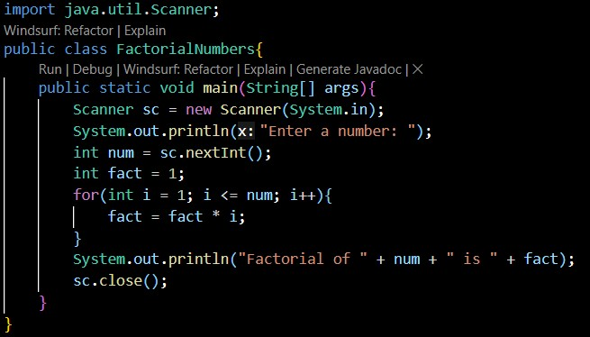
Output:

Explanation :
The code above is a Java program that calculates the factorial of a given number using loops and variables. It prompts the user to enter a number, then uses a for loop to multiply all integers from 1 to that number to compute the factorial, and finally prints the result.
Task 2:
AI Code Optimization & Cleanup (Improving Efficiency)
Scenario: Your team lead asks you to review AI-generated code before committing it to a shared repository.
Task Description : Analyze the code generated in Task 1 and use Copilot again to:
- Reduce unnecessary variables
- Improve loop clarity
- Enhance readability and efficiency
Hint: Prompt Copilot with phrases like
“optimize this code”, “simplify logic”, or “make it more readable

Prompt:
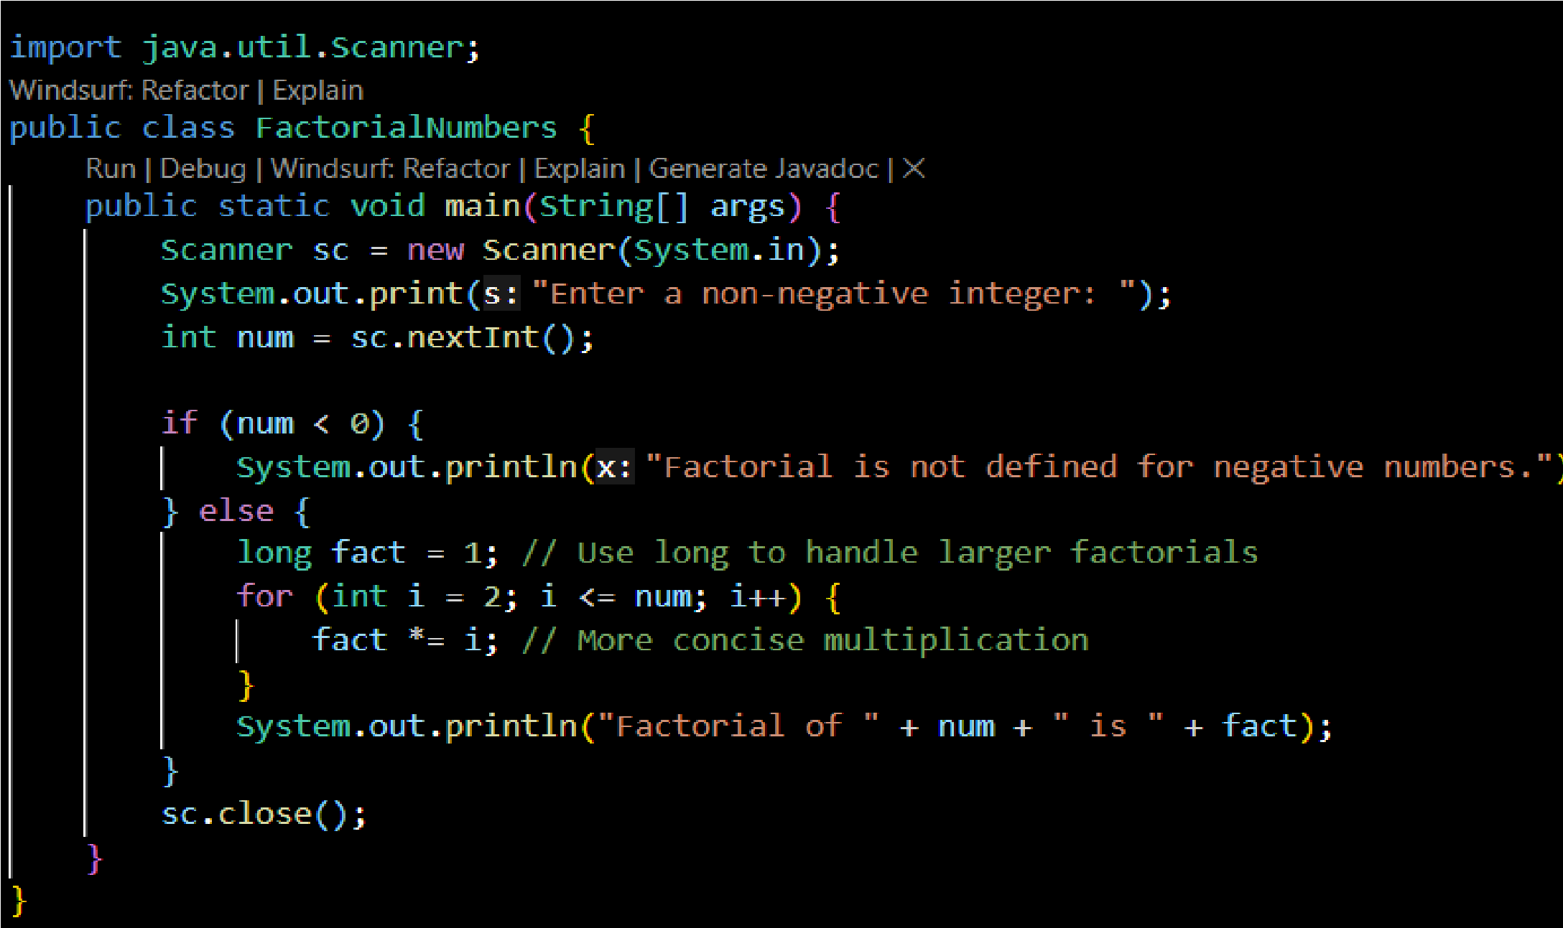
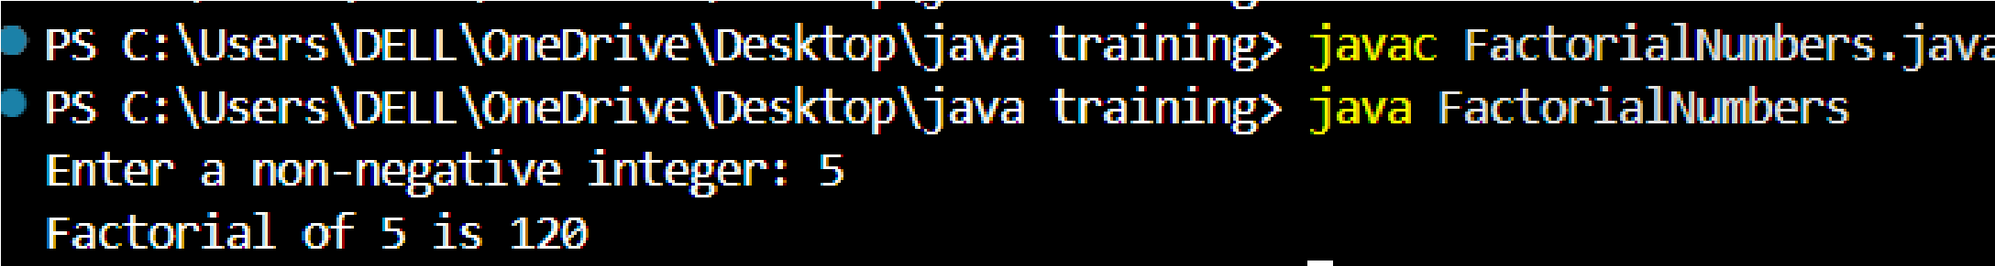
Code :

Output:
Explanation:
Compared to previous code this code was most efficient as it handles the edge case for negative and zero input and more readable code

Task 3:
Modular Design Using AI Assistance (Factorial with Functions)
Scenario: The same logic now needs to be reused in multiple scripts.
Task Description: Use GitHub Copilot to generate a modular version of the program by:
- Creating a user-defined function
- Calling the function from the main block

Constraints
- Use meaningful function and variable names
- Include inline comments (preferably suggested by Copilot) Prompt :
Code :

Output :
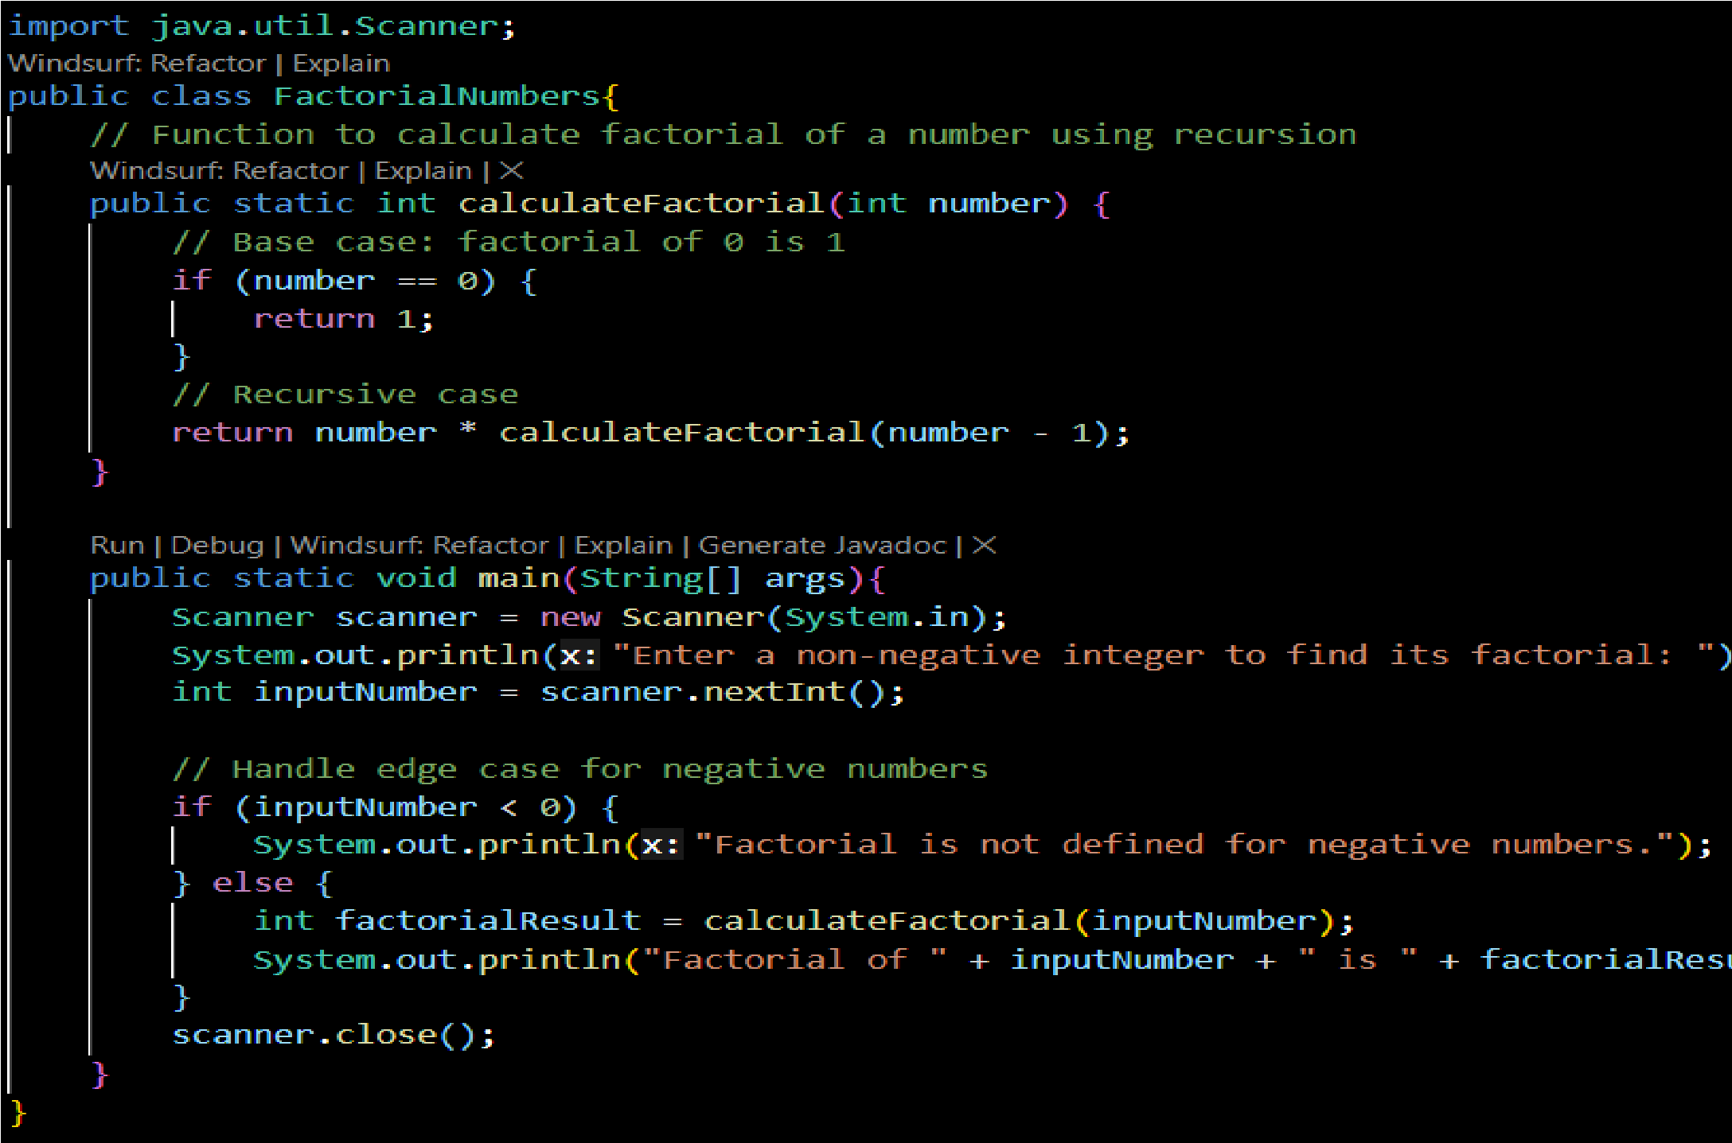
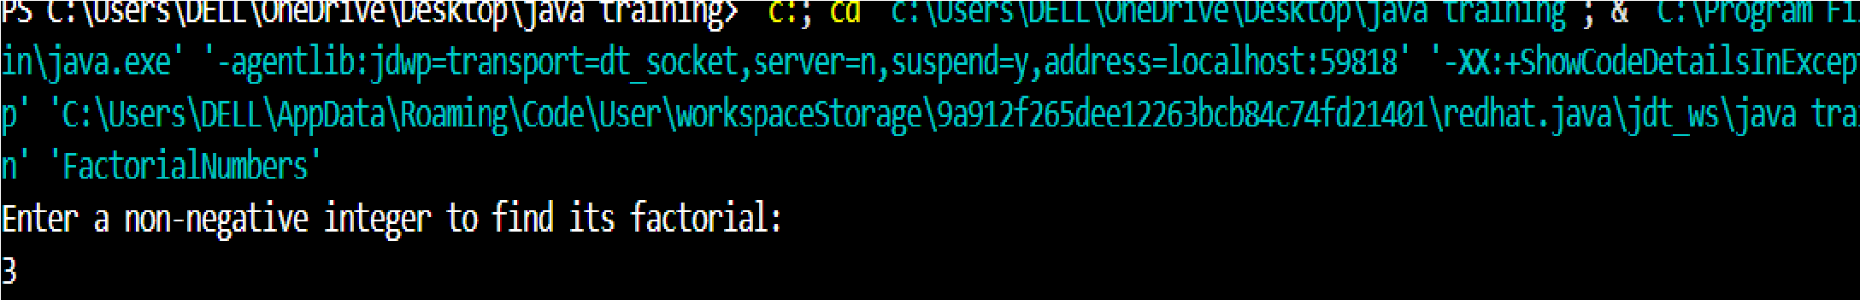
Explanation :
- Meaningful Function Name: The function to calculate the factorial is named `calculateFactorial`, which clearly indicates its purpose.
- Recursion: The factorial calculation is implemented using recursion, which is a more elegant approach for this problem.
- Edge Case Handling: The program checks for negative input and provides a relevant message, ensuring robustness.
- Clear Variable Names: Variables like `inputNumber` and `factorialResult` are used to enhance code readability.
- Commented Code: The code is commented to explain its purpose and flow, making it easier to understand.

Task 4:
Comparative Analysis – Procedural vs Modular AI Code (With vs Without Functions)

Scenario
As part of a code review meeting, you are asked to justify design choices.

Task Description
Compare the non-function and function-based Copilot-generated programs on the following criteria:
- Logic clarity
- Reusability
- Debugging ease
- Suitability for large projects
- AI dependency risk

Criteria | Non-  Functio  Function  nal Style  al Style  (Recursi  (Iterative  ve)  )
Logic Clarity | ^{Less} Very clear for clear and
^{beginne} intuitive
rs

ve)
)
(recursiv e thinking needed)
Readability | Short  and Slightly  mathem longer atically but  expressi straightfo  ve rward
Reusability | High Moderat (pure e  function (depends , no side on effects) impleme ntation)
Debugging Ease | Harder  Easy (deep  (loop,  call step-by-  stack) step)
Performance | Slower  (functio  n call  Faster  overhea  d)
ve)
)

Scalability (large n) | Stack  Safe for  overflo large  w risk inputs
AI Dependency Risk | Higher  (AI often Lower
AI Dependency Risk | generat es recursio n blindly) | (explicit logic,  human- m readable)
Task 5:
AI-Generated Iterative vs Recursive Thinking

Scenario: Your mentor wants to test how well AI understands different computational paradigms.
Task Description: Prompt Copilot to generate:
An iterative version of the logic
A recursive version of the same logic

Constraints :Both implementations must produce identical outputs
Students must not manually write the code first

❖ Expected Deliverables
ve)
)
Two AI-generated implementations
Execution flow explanation (in your own words) Comparison covering:
- Readability
- Stack usage
- Performance implications
When recursion is not recommended

Iterative Approach :
Prompt :
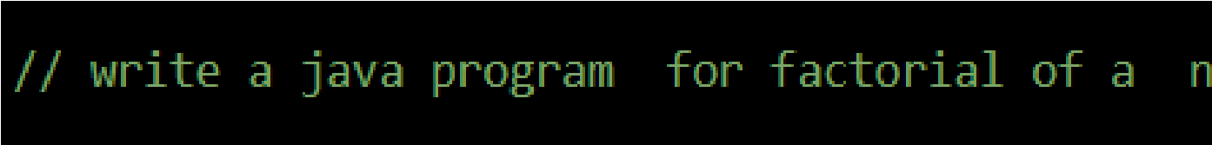
Code :

ve)
)
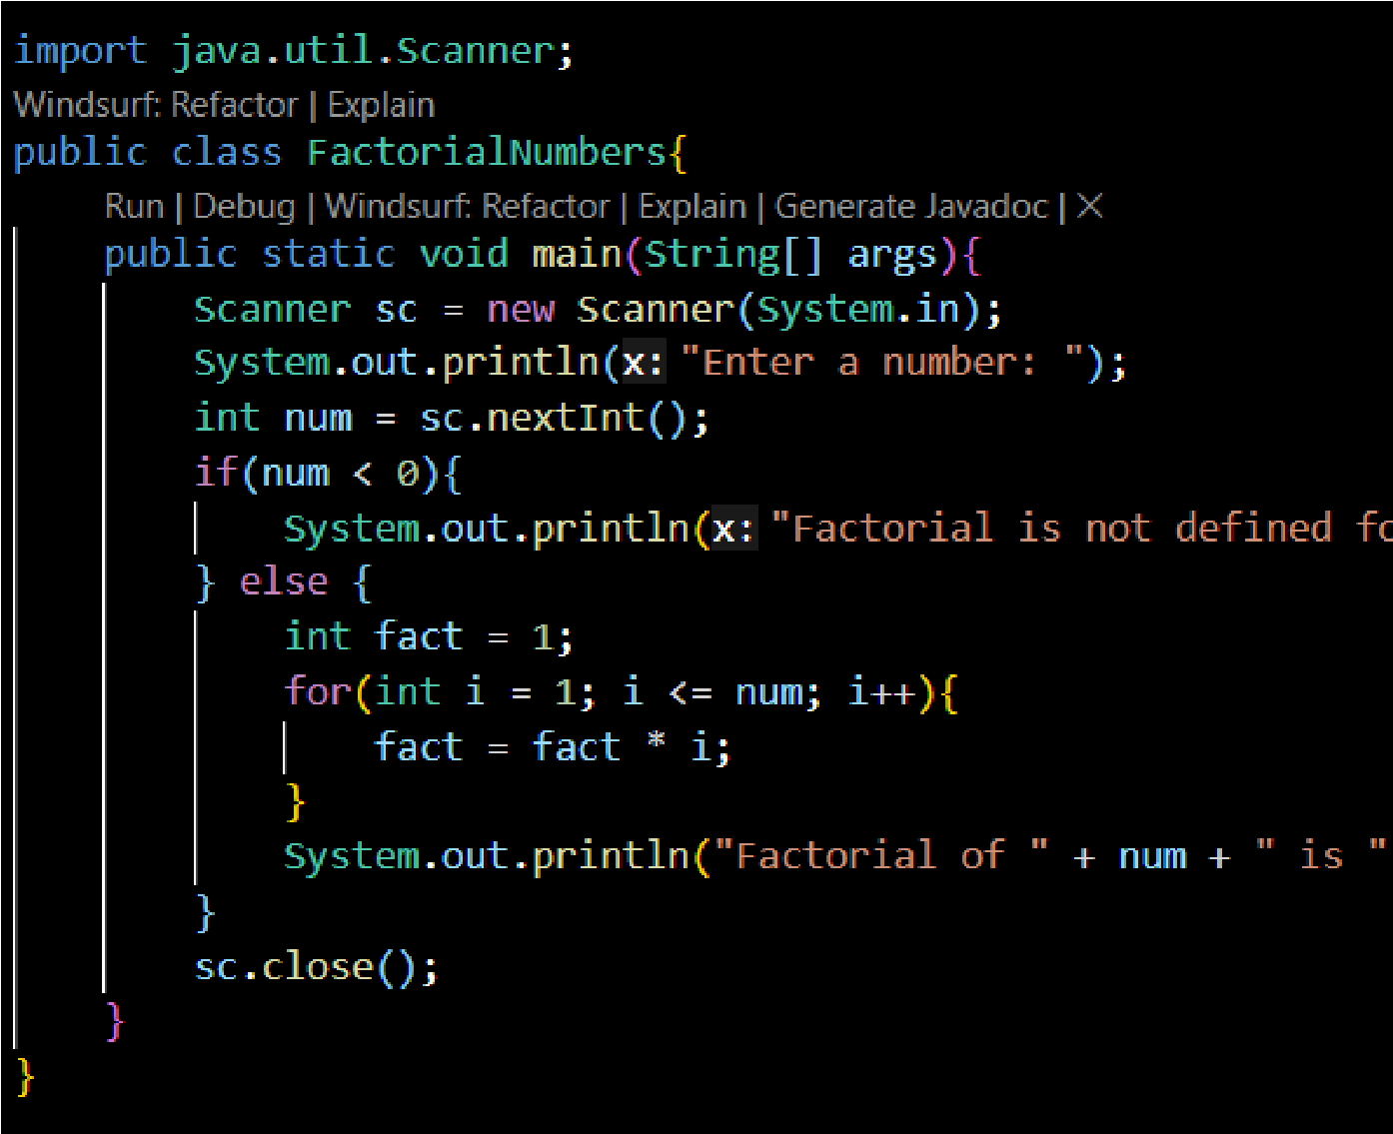
Output :
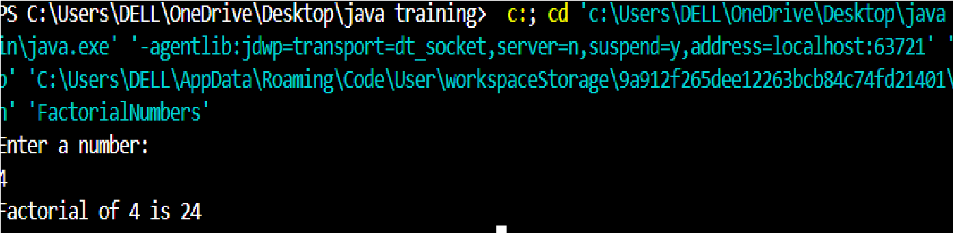

Recursive Approach:
Prompt :
Code :

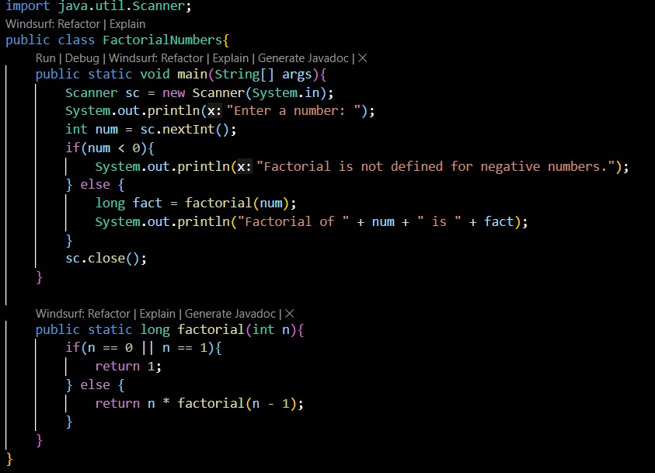
Output :
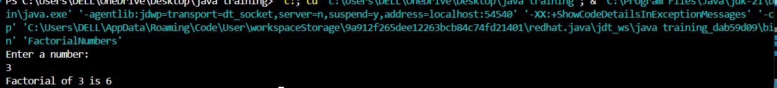

Iterative Approach vs Recursive Approach

Aspect Iterative Approach Recursive Approach
Readability Easy to understand Less intuitive
Stack Usage No extra stack used Uses call stack
Performance Faster Slower

