SIMATS ENGINEERING
Saveetha Institute of Medical and Technical Sciences
ASSESSMENT TOOL 1: CONCEPT MAPPING
Cloud Foundations, Service Models and Architecture Design
Item | Details
Course name | Cloud Computing and Big Data Analytics
Course code | CSA15
Course outcome | CO1: Apply cloud computing technologies including hardware-software evolution, virtualization, web services and service models to develop cloud-based solutions (BL2)
Project used | CampusIQ: an AI-powered student performance analytics portal [REPLACE WITH YOUR OWN PROJECT]
Student name | L Nihas Goud
Register number | 192472346
Tools used | Python/matplotlib (diagrams), draw.io (editable source), GitHub, Microsoft Word
Repository | CSA15_CO1_AT1_<192472346>

Code of Conduct
I, L Nihas Goud (Name / Reg No), certify that this submission is my original work and that I have adhered to the guidelines specified for this assessment. I understand that any violation of academic integrity rules will result in disciplinary action.
Signature of the student: NIHASGOUD

1. Project Overview and Design Assumptions
This report demonstrates Course Outcome 1 (CO1) through a single worked project, CampusIQ. Every diagram and matrix in the report refers to the same system, so the concept map, the service matrices and the architecture diagram can be checked against one another.

1.1 The project in brief
CampusIQ is a web and mobile portal where students and faculty view attendance, marks and engagement, and where an AI module predicts students at risk of falling behind. Traffic is highly uneven: it is quiet most of the day and spikes sharply when results are published or attendance is submitted. That unpredictable demand is the reason cloud services (elasticity, managed scaling and pay-per-use billing) are a better fit than fixed servers.

1.2 Cloud actors and functional modules
Element | Description
Cloud consumer | The CampusIQ development team, who build, deploy and operate the application on rented cloud resources.
Cloud provider | Amazon Web Services (used here as the reference provider; every service has an equivalent on Azure or Google Cloud).
End users | Students, faculty and administrators using web or mobile clients over HTTPS.
Modules | Authentication, frontend hosting, backend API, database, object storage, analytics and logging, notification, AI/Python risk-prediction, security, CI/CD, backup, monitoring.

1.3 Design principles applied throughout
- Managed over self-managed. Choose the highest abstraction level that still meets the requirement, so the provider carries operational burden.
- Right-sized, not maximal. Only services with a clear job in CampusIQ are included. Section 4 lists services deliberately left out and why.
- Elastic by default. Each tier scales independently, so a spike on one tier does not require over-provisioning all of them.
- Defence in depth. Public, edge, private and managed zones each have their own controls (Section 5).

1.4 How this report maps to the assessment
Brief task | Where it is answered | Evidence
Task 1 | Section 2 | Concept map (exported PNG and .drawio), relationship table
Task 2A | Section 3 | Service model responsibility matrix (8 categories)
Task 2B | Section 4 | Cloud service decision matrix (12 modules)
Task 3 | Section 5 | Architecture and API flow diagram with scaling points
Task 4 | Section 6 | Five-question technical justification
Evidence pack | Appendices A and B | README content, repository layout, rubric self-check

2. Task 1: Concept Map
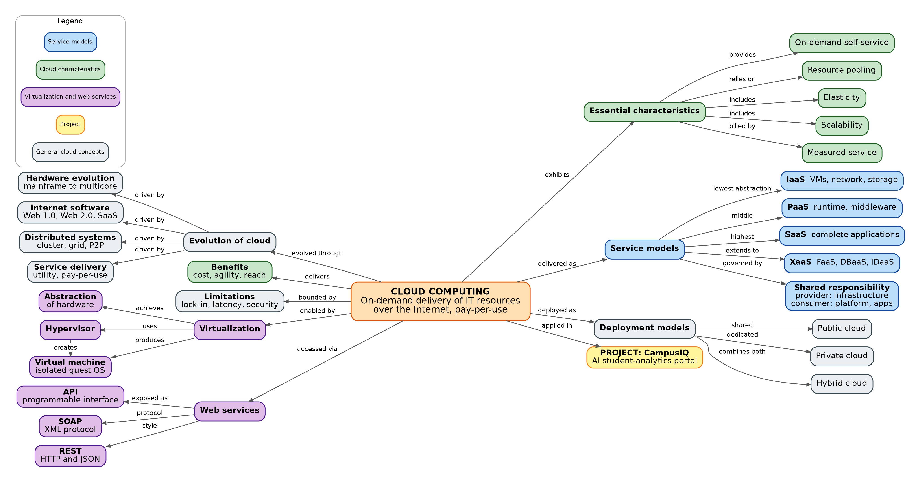
Figure 1: Concept map of the cloud ecosystem for CampusIQ. Arrows read outwards from the central concept, so every link forms a sentence (for example, Cloud Computing exhibits Essential characteristics). Colours are explained in the legend.

2.1 Coverage of the four required maps
The brief lists four maps and the task section asks for one integrated map. Figure 1 is a single hierarchy in which each required map is a labelled cluster hanging off the central node, so all four can be assessed from one diagram.
Required map | Cluster in Figure 1 | Key nodes | Representative link labels
Map 1: Cloud fundamentals | Central node, Benefits, Limitations, Essential characteristics, Deployment models | Definition, on-demand self-service, resource pooling, elasticity, scalability, measured service, public/private/hybrid | exhibits, delivers, bounded by, relies on, includes, billed by, deployed as
Map 2: Evolution | Evolution of cloud branch (left) | Hardware evolution, internet software evolution, distributed systems, service delivery | evolved through, driven by
Map 3: Service models | Service models branch with Shared responsibility (right) | IaaS, PaaS, SaaS, XaaS, provider, consumer, infrastructure/platform/application layers | delivered as, lowest / middle / highest abstraction, extends to, governed by
Map 4: Enablers | Virtualization and Web services branches (left) | Virtual machine, hypervisor, abstraction, API, SOAP, REST | enabled by, achieves, uses, produces, creates, accessed via, exposed as, protocol, style

2.2 Key relationships explained
Every arrow carries a verb phrase so each link reads as a complete statement. The table below spells out the most important ones and why each is technically correct.
From | Link label | To | Why the relationship holds
Cloud Computing | enabled by | Virtualization | Virtualization abstracts physical hardware into isolated virtual machines, which is what makes pooling and rapid provisioning possible.
Virtualization | uses | Hypervisor | A hypervisor partitions one physical host into several isolated guests.
Hypervisor | creates | Virtual machine | Each VM runs its own guest operating system on shared hardware.
Cloud Computing | accessed via | Web services | Cloud resources are consumed and controlled through network APIs rather than physical access.
Web services | style | REST | REST over HTTP and JSON is lightweight and stateless, so the API tier scales horizontally. CampusIQ uses it.
Web services | protocol | SOAP | SOAP is the XML-based protocol with strict contracts, used in enterprise integration.
Essential characteristics | relies on | Resource pooling | Multi-tenant pooling spreads cost across customers and supplies the capacity that elasticity draws on.
Service models | lowest / middle / highest abstraction | IaaS / PaaS / SaaS | The higher the model, the more the provider manages and the less the consumer controls.
Service models | governed by | Shared responsibility | The provider secures the infrastructure layer and the consumer secures the platform and application layers; the boundary moves with each model.
Service models | extends to | XaaS | FaaS, DBaaS and IDaaS apply the same outsourcing idea to narrower functions.
Cloud Computing | applied in | Project: CampusIQ | The project is the worked example that every other branch is checked against.

2.3 Why this map is designed to meet the rubric
Rubric criterion | Weight | How the map addresses it
Concept identification | 25% | All expected nodes appear: elasticity, scalability, resource pooling, on-demand access, measured service, virtual machine, hypervisor, abstraction, API, SOAP, REST, provider, consumer, shared responsibility, plus evolution, benefits, limitations and deployment models.
Relationship mapping | 25% | 33 directed, labelled links using verbs such as exhibits, relies on, enabled by, accessed via and governed by. No unlabelled arrows.
Hierarchy and organisation | 20% | Single anchor node in the centre with seven branches radiating left and right. Each branch has a hub and leaves, three levels deep at most.
Technical relevance | 20% | Every node comes from CO1 syllabus content and ties back to the CampusIQ project node.
Visual clarity | 10% | Colour scheme explained in the caption, uniform node shapes, short labels, and automatic layout so no label overlaps a box or another arrow.

3. Task 2A: Service Model Responsibility Matrix
The matrix shows who manages what for each service category and why that split suits CampusIQ. The general rule is that the more the provider manages, the less operational work the project team carries and the less low-level control it has.
Service category (example) | Managed by cloud provider | Managed by CampusIQ team | Why this split fits CampusIQ
SaaS (GitHub, email, Slack) | Entire stack: application, data centres, patching, availability, platform security. | User accounts, configuration, data entered, access policy and sharing settings. | Used for non-differentiating tools (source control, communication) so effort goes into the core product.
PaaS / serverless containers (ECS Fargate, API Gateway) | Physical hosts, OS, container runtime patching, load balancing, capacity for tasks, health replacement. | Application code, container image, environment variables, task size, scaling policy. | The API faces spiky traffic when results are published. Fargate scales tasks automatically with no VM administration.
IaaS (VPC networking; EC2 not used for core) | Physical servers, storage, network fabric, hypervisor. | Guest OS, patches, middleware, firewall rules, runtime, capacity planning. For VPC: subnets, route tables, security groups. | Only the network layer (VPC) is used at IaaS level, to build private subnets. Core compute avoids IaaS to eliminate OS patching and capacity planning.
FaaS (AWS Lambda) | Servers, OS, runtime, scaling, concurrency, availability. | Function code, memory and timeout, IAM role, event triggers. | The AI scoring job is bursty and event-driven. FaaS scales to zero overnight, so the team pays only per invocation.
Database-as-a-Service (RDS PostgreSQL) | Hardware, OS, engine patching, automated backups, Multi-AZ failover, replica provisioning. | Schema design, indexing, queries, database users and roles, data classification, parameter tuning. | Student records are relational and need integrity (ACID). The team gets high availability without a dedicated DBA.
Storage-as-a-Service (Amazon S3) | Durability, replication across zones, unlimited capacity, hardware lifecycle. | Bucket policies, encryption settings, lifecycle rules, object naming, access grants. | Reports and uploads grow unpredictably. Elastic storage with presigned URLs keeps files out of the API servers.
Identity-as-a-Service (Amazon Cognito) | User directory, password hashing, token issuing and rotation, MFA infrastructure, scaling of authentication. | Password policy, user groups and roles (student, faculty, admin), app integration, consent and data minimisation. | Building authentication in-house is a security risk. Managed identity issues JWTs with role claims the API can trust.
Monitoring and logging (CloudWatch, CloudTrail) | Metric and log collection pipeline, storage, dashboards, alarm engine, availability of the service. | Which metrics to track, alarm thresholds, log retention, dashboards, incident response. | Metrics drive auto-scaling and alerts, and provide the evidence that elasticity works.

Reading the matrix
Moving down the abstraction ladder from SaaS to IaaS, the right-hand responsibility boundary moves toward the provider's side less and less. CampusIQ deliberately sits in the middle: managed compute (PaaS and FaaS) for custom logic, and managed data services for state. That keeps the team's responsibility focused on code, configuration, data and access policy, which is where shared responsibility says the customer is accountable regardless of model.

4. Task 2B: Cloud Service Decision Matrix
Each project module is mapped to the service that best fits it, with the main alternative considered and the reasoning. Services are chosen on merit, not to maximise the number used.
Project module | Selected service | Model | Alternative considered | Justification
Authentication | Amazon Cognito user pools | IDaaS | Self-built JWT service; Auth0 | Offloads credential storage, MFA and token handling to a specialist service. Group claims map directly to student, faculty and admin roles.
Frontend hosting | S3 static site + CloudFront CDN | Storage + CDN | EC2 with nginx; Amplify | A React single-page app is static files, so no servers are needed. The CDN caches at the edge to cut latency and absorb result-day traffic.
Backend / API layer | API Gateway + ECS Fargate containers | PaaS (CaaS) | EC2; Lambda-only API | Steady, stateful-free API traffic suits containers with auto-scaling. Gateway adds throttling, auth integration and a single entry point. Lambda-only was rejected due to cold starts on a latency-sensitive path.
Database | Amazon RDS PostgreSQL (Multi-AZ, read replica) | DBaaS | DynamoDB; self-hosted PostgreSQL | Data is relational (students, courses, marks) and needs joins and transactions. Managed failover and backups remove DBA work.
Object storage | Amazon S3 | Storage-aaS | Database BLOBs; EFS | Cheap, durable, effectively unlimited storage for reports and uploads. Presigned URLs let clients upload directly without loading the API.
Analytics / logging | CloudWatch Logs + Athena | Monitoring / analytics-aaS | Self-hosted ELK; Redshift | Serverless querying over logs and exports with per-scan pricing. A warehouse such as Redshift is oversized for this data volume.
Notification | Amazon SNS + SES | Messaging-aaS | Self-run SMTP server | Fan-out alerts to email and SMS for at-risk flags and operational alarms with no mail infrastructure to maintain.
AI / Python module | AWS Lambda container image | FaaS | SageMaker real-time endpoint | Inference is infrequent and bursty with a small model. A permanently running endpoint would cost money while idle. Python dependencies ship in the container image.
Security | WAF, Shield, IAM, KMS, Secrets Manager, security groups | Security-aaS | Custom firewall appliances | Layered controls: filter web attacks at the edge, enforce least-privilege roles, encrypt data at rest, keep secrets out of code.
CI/CD | GitHub Actions + ECR | SaaS | AWS CodePipeline | The repository already lives on GitHub (a submission requirement), so Actions avoids another tool. Images are versioned in ECR and rolled out to Fargate.
Backup | AWS Backup, RDS snapshots, S3 versioning, cross-region copy | DBaaS / Storage-aaS | Manual dumps to a laptop | Automated, policy-driven retention and a cross-region copy meet recovery goals with no manual effort.
Monitoring | CloudWatch metrics, alarms, dashboards | Monitoring-aaS | Self-hosted Prometheus and Grafana | Native integration with every service above. Alarms trigger scaling and SNS alerts without extra agents.

Services deliberately not used
Service | Reason for exclusion
EC2 virtual machines for core compute | Adds OS patching and capacity planning without a benefit the managed options lack.
Kubernetes (EKS) | Operational overhead is unjustified for a single-team, few-service application. Fargate gives container benefits without cluster management.
SageMaker real-time endpoint | Idle cost is unjustified for infrequent inference. Revisit if model size or request rate grows.
Redshift or Kinesis | Data volume and latency needs are modest; Athena and CloudWatch cover analytics and streaming metrics.

5. Task 3: API Flow, Elasticity and Scalability Design
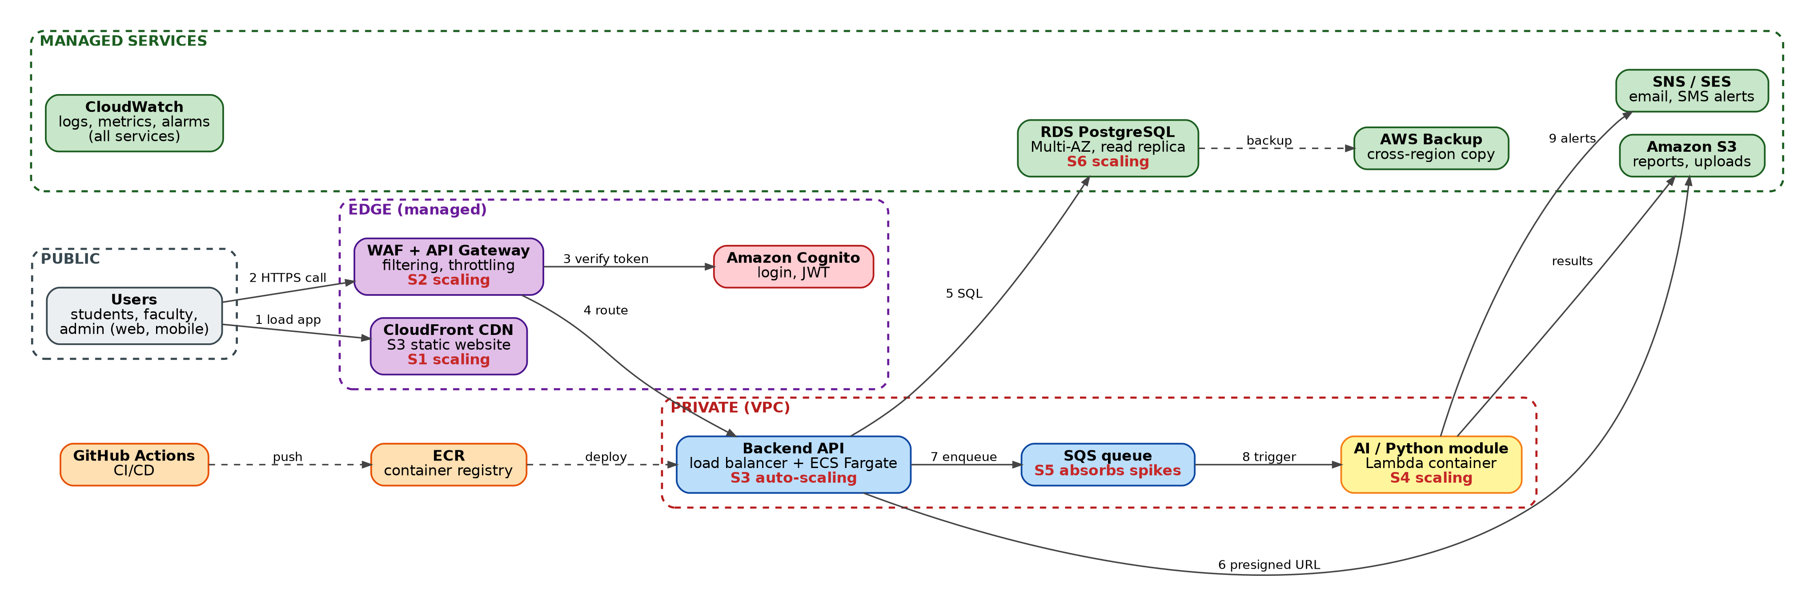
Figure 2: Architecture and API flow for CampusIQ. Numbers show the request path, dashed boxes show security zones, red S-labels mark scaling points and dashed arrows show operational or backup flows. CloudWatch collects logs and metrics from every service.

5.1 Request flow
Step | Component | What happens
1 | CloudFront + S3 | The browser downloads the static React app from the nearest edge location.
2 | WAF + API Gateway | API calls arrive over HTTPS. WAF and Shield filter malicious and volumetric traffic before the gateway accepts the request.
3 | Amazon Cognito | The gateway checks the JWT issued by Cognito. Unauthenticated or unauthorised calls are rejected here, and throttling protects the backend.
4 | Backend API (load balancer + Fargate) | Valid requests are routed into the private subnet and spread across running API containers.
5 | Backend API to RDS | The API runs business logic and queries PostgreSQL over TLS. Reads can go to the replica.
6 | Backend API to S3 | For uploads and report downloads the API issues short-lived presigned URLs, so file bytes bypass the API tier.
7 | Backend API to SQS | Long-running work (risk scoring) is queued instead of blocking the request, which keeps responses fast.
8 | SQS to Lambda AI module | The Python function reads data, scores it, and writes results to S3.
9 | Lambda to SNS / SES | At-risk flags trigger email or SMS notifications to faculty.

5.2 Elasticity and scalability points
Scalability is the ability to handle growth by adding capacity (here, by adding containers, replicas or concurrent functions). Elasticity is doing so automatically and releasing capacity when demand drops. Each marker below is a place where CampusIQ does one or both.
ID | Location | Mechanism | Trigger or metric | Benefit
S1 | CloudFront CDN | Edge caching of static assets | Cache hit ratio, request rate | Offloads most traffic from origin; lower latency
S2 | API Gateway | Managed scaling with throttling and burst limits | Requests per second | Protects backend from overload; fair use per client
S3 | ECS Fargate API tasks | Target-tracking auto-scaling, 2 to N tasks | Average CPU above 60% or requests per task | Scales out on result day; scales in overnight to cut cost
S4 | Lambda AI module | Concurrency scales per queued event | Queue depth | Handles bursts of scoring jobs with no idle server
S5 | SQS queue | Buffer between API and workers | Messages visible | Absorbs spikes so the API never waits for slow jobs
S6 | RDS PostgreSQL | Read replica and storage auto-scaling | Read latency, free storage | Read-heavy dashboards do not slow writes; no manual resizing

5.3 Security boundaries
- Public zone: untrusted clients. Nothing here is trusted until authenticated.
- Edge zone: internet-facing but provider-managed (WAF, CDN, gateway, Cognito). Authentication and throttling are enforced here.
- Private zone: VPC private subnets with no public IPs. Security groups allow only the load balancer to reach the API and only the API to reach the database.
- Managed services zone: encryption at rest with KMS, access limited by IAM roles, audit by CloudTrail.

6. Task 4: Technical Justification
This section explains how the concept map, matrices and architecture together demonstrate CO1: applying cloud technologies (virtualization, web services and service models) to build a cloud-based solution.

Q1. Effectiveness of the concept map
The map is effective because it is hierarchical, labelled and colour-coded. A single anchor node leads to six clusters, so a reader can start at the centre and follow any branch. Three design decisions matter most. First, every arrow has a verb label, which turns the diagram into readable statements and proves the relationships are understood rather than guessed. Second, colour separates service models, characteristics and web-service concepts, so categories are visible at a glance. Third, the project is attached to the central concept and the consumer is named as the CampusIQ team, which ties the theory to a real system and shows applied understanding rather than a glossary.

Q2. Scalability, elasticity and resource management
These three properties shape the whole architecture. Because demand is spiky, each tier scales independently (CDN, gateway, Fargate tasks, Lambda, read replica), and the queue decouples the API from slow work. Resource pooling and measured service let the provider offer this capacity and bill only for what is used. Without these capabilities the team would need to provision for peak load all year, wasting money, or provision for average load and suffer slow responses or outages on result day. A single overloaded server could take login, dashboards and scoring down together, and manual scaling would be too slow to react to a sudden spike.

Q3. Selection of APIs, web services and cloud services
Each service has a clear job. REST over HTTPS with JSON was chosen over SOAP because it is lightweight, stateless and easy for web and mobile clients to call, and statelessness is what allows containers to be added freely. SOAP remains relevant for enterprise integration with strict contracts, but CampusIQ has no such need. API Gateway centralises authentication, throttling and routing. Cognito, RDS, S3, SNS and CloudWatch are managed services that remove undifferentiated work. The effect is a smaller operations burden, faster delivery and higher reliability than running the same components on self-managed VMs.

Q4. Relationships between components
The interactions are designed to improve reliability, performance and user experience. The CDN and cache reduce latency. The gateway and WAF protect the backend, which improves availability. The queue decouples the user-facing API from the AI scoring job, so users get an immediate response while scoring runs in the background. Multi-AZ database failover and automated backups improve reliability. Presigned URLs keep large file transfers away from the API, preserving its performance. Monitoring feeds alarms, which feed notifications and scaling, closing a feedback loop that keeps the system healthy.

Q5. Reflection on the process
Building the map changed my view of cloud from a list of products into a set of layered responsibilities. Drawing the shared-responsibility node made it clear that choosing a service model is really choosing which tasks to hand to the provider. I also saw that virtualization and web services are enabling technologies: virtualization provides the pooled, isolated resources, and APIs provide the programmable control that makes elasticity automatic. If redesigning, I would add a cost dimension (estimated monthly spend per tier), a multi-region failover path, and an explicit data-flow overlay for privacy requirements.

How the evidence proves CO1
CO1 element | Evidence in this report
Service model selection | Matrix 2A (eight categories) and 2B (twelve modules with alternatives and exclusions)
API role | REST via API Gateway as the single controlled entry point (Figure 2, steps 2 to 4)
Elasticity and scalability | Six marked scaling points with mechanisms and triggers (Section 5.2)
Virtualization or managed compute | Hypervisor and VM nodes in Figure 1; Fargate and Lambda chosen in 2B as managed compute built on virtualization
Responsibility boundaries | Matrix 2A columns, shared responsibility node in Figure 1, security zones in Figure 2

Appendix A: README and Repository Layout
Copy this into README.md at the root of the repository.

Title
CSA15 CO1 AT1: Cloud Concept Map and Architecture Design for CampusIQ

Tools used
draw.io (editable diagrams), Python and matplotlib (exports), Microsoft Word (report), GitHub (version control).

Repository structure
Path | Contents
README.md | This description and the CO1 reflection
CSA15_CO1_AT1_<RegNo>_Concept_Map.drawio | Editable concept map source
exports/concept_map.png | Exported concept map
CSA15_CO1_AT1_<RegNo>_Architecture.drawio | Editable architecture source
exports/architecture.png | Exported architecture and API flow
matrices/service_model_matrix.md | Task 2A matrix
matrices/service_decision_matrix.md | Task 2B matrix
report/CSA15_CO1_AT1_<RegNo>_Report.docx | Full Word report

Short CO1 reflection
CampusIQ shows how virtualization, web services and layered service models combine into a scalable, cost-aware solution. Managed compute and data services carry operational work, REST APIs give a controlled entry point, and independent scaling points let the system absorb spiky demand while the responsibility boundary stays clear.

Appendix B: Rubric Self-Check
Criterion | Weight | Evidence
Concept identification | 25% | All expected nodes present (Section 2.3)
Relationship mapping | 25% | Verb-labelled links and relationship table (Section 2.2)
Hierarchy and organisation | 20% | Central anchor with six clusters (Figure 1)
Technical relevance | 20% | CO1 content tied to the CampusIQ project (Sections 3 to 5)
Visual clarity | 10% | Colour legend, uniform shapes, readable labels

Appendix C: Likely Viva Questions
- Why is Fargate classed as PaaS-like rather than IaaS? Because the provider manages the hosts and OS, and you manage only the container and code.
- What is the difference between elasticity and scalability? Scalability is the ability to grow capacity; elasticity is doing it automatically and releasing it again when demand falls.
- Why REST and not SOAP? REST is lightweight and stateless, which suits web and mobile clients and horizontal scaling.
- What does the provider still not do for you in a SaaS model? It does not manage your users, data and access settings.
- What happens if the database fails? Multi-AZ promotes the standby, and backups with cross-region copies cover larger failures.
- Why a queue before the AI module? It decouples slow work from user requests and buffers spikes.

