Documentation Cheapest Path
Class - Computer Architecture
Nihat Allahverdiyev – 46219
Used Language : Java (Console Application)

Overview
This application enables you to find the cheapest path between two points in a matrix which has nonnegative real numbers.

Use case
1.0 Unzip folder cheapest Path.

1.1 After unzipping you’ll have this folder.

1.2 Open an IDE which supports Java applications such as Eclipse, Netbeans. In this example I’ve illustrated it with Netbeans.

1.3 Then you need to open the project in the IDE , here you will use the folder that you have decompressed the zip file into.
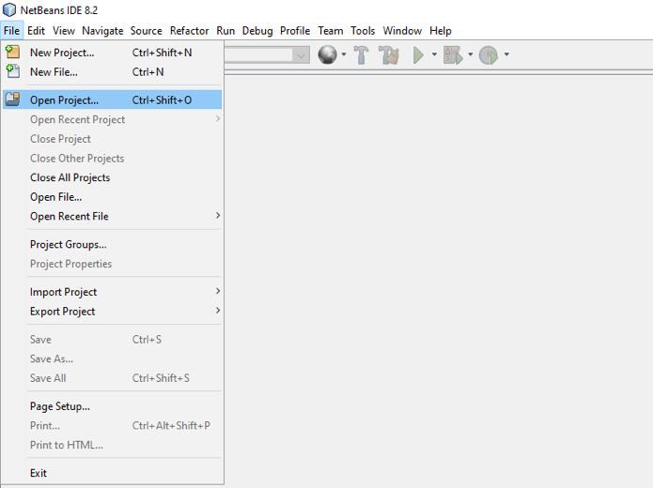

1.4 After clicking “Open Project” you will find the folder and add the project as following.
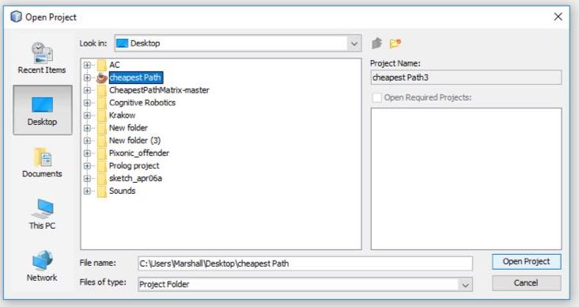

1.5 After adding the project you need to open the java file and run the program.
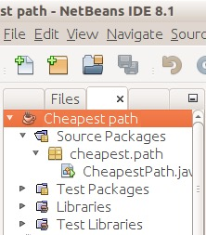


2.0 When you run the program, first you’ll be asked to enter the location of txt file which contains all the numbers. If you see this message box, it means you have entered incorrect location for the container file.

When you add the numbers to txt file please leave a space “ “ between each number and semicolon “;” must be used to separate the dimensions of the matrix. Such as (1 2 3 4;5 6 7 8).

2.1 If you see this message box it means you have entered more than one space between each number in the txt file.
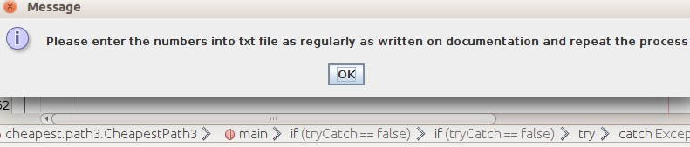

2.2 After completing this process you will be asked to insert initialize and last points as inputs, when you insert these numbers please use space “ ” between 2 numbers. If you see following message box, it means you have inserted the number incorrectly.
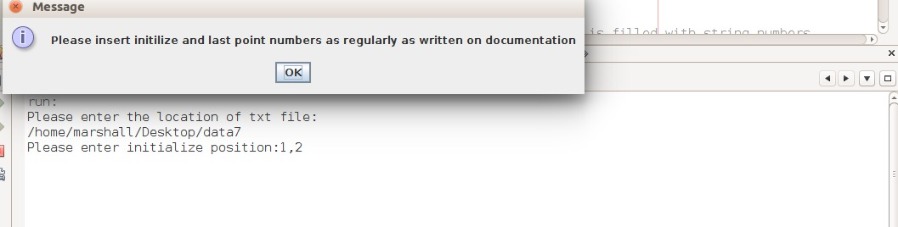

2.3 That’s it, you’ll see the path and the total cost of the path.
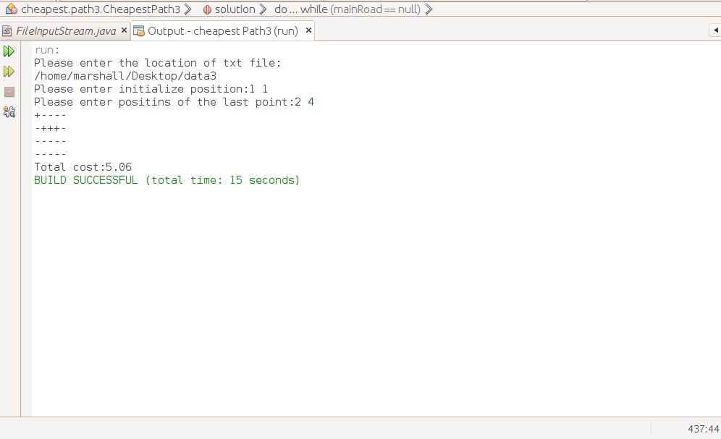

About Code and algorithm
Used algorithm for this task is Dijkstra’s algorithm. You can read more about algorithm on this link https://en.wikipedia.org/wiki/Dijkstra%27s_algorithm .
On method called ‘solution’ first it starts by expanding the points around it which there are 8 points. Each time after expanding if the point is not out of matrix then it stores the cost of that node and also direction of it such as D (down) R (right) into a hashtable and it also checks whether the expanded point is the given goal point with least cost or not. If it’s, it will send the direction (RD) into a method which called convertOutput, this method takes the given direction and converts it into matrix which contains +’s and -’s. If it’s not, after expanding all 8 points and storing them, it starts to compare and gets the the least cost. After getting least cost it finds its directions in the stored hashtable and sends it into method called locationOut. Which receives the directions and starts to look for current location by using initial points. Let’s say initial points are 0,0 in the matrix and if the received directions are RD-R (right, down-right) then it will current point first will be 0,1 for right and 1,2 respect to D-R and it’s the current location. After finding the current location it goes for next iterations and expanding the nodes. I’ll try to explain it better with the following.

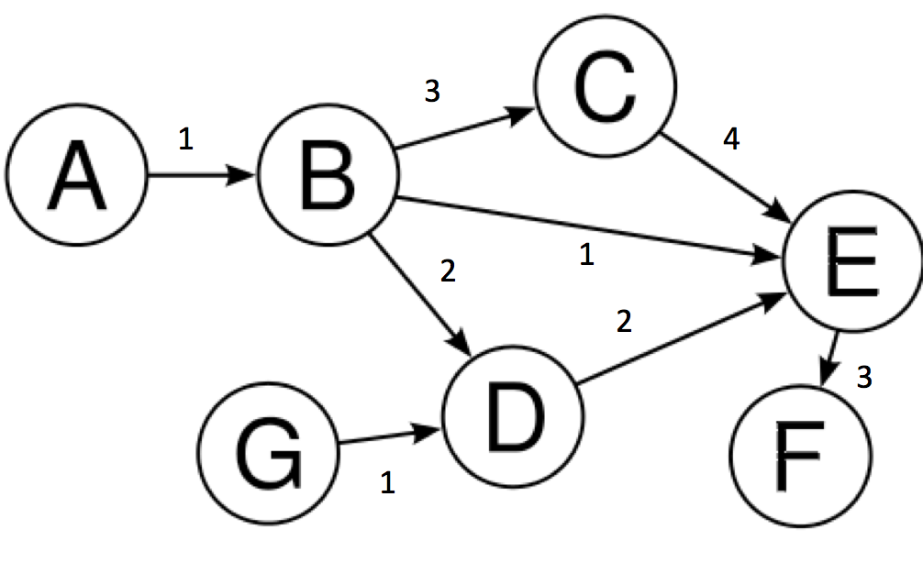
1. Let’s say initialize point is A, and the given last point is F. Starts by expanding B it stores the cost which is 1 and the direction let’s say right.
2. It moves to B and stores B into visited list, then expands C, E and D and first it adds the cost of B to these nodes costs and stores the costs and directions, as an example for C will be (1+3) →RU-R.
3. After expanding it’ll compare the costs and choses node will be E, after moving to E it’ll store (1+1) → RR .
4. After moving to E and adding E to visited list, it’ll expand F which is last point and it’ll store F (2+3) → RRD
5. Then it will compare the costs again and the chosen node will be D here method called previous_path_returner will be used it’ll get the direction from node A to B which is R and then it’ll add the direction from B to D which is D-R and store them as (1+2) → RD-R.
6. Eventually it’ll expand F with the least cost final direction will be RRD and it’ll convert it into matrix that contains +’s and -’s.
For any further questions please contact:
nihatallahverdiyev@gmail.com

