**Wireless Rear Derailleur – Project Status Report**

**Ian Raúl Huerta Gutiérrez**

A01228044

October 30, 2022

Jaime A. Orozco V. & Sergio M. Inzunza C.

MR3016 – Project of Mechatronics Engineering

ITESM

**Introduction**

The project’s objective is to research and develop a mostly universal wireless rear derailleur that can compete with available market options by being a cheaper yet good quality alternative with an added value by being easily serviceable on most of its components. The solution will focus on removing a cable connecting the cockpit to the derailleur and will try to keep the most original components possible, the shifter at the handlebar can be completely replaced if no universal solution can be applied to the existing shifter, however, the rear derailleur must be kept original for the solution to be cost effective.

Furthermore, a working prototype will be manufactured and attached to a bicycle, and the project is intended to be featured on *Expo Ingenierías*. For the project to be considered successful, the drivetrain must be capable of shifting between cassette’s positions and be tunable to compensate for slack on the shifter cable. Documentation to replicate the project and facilitate a mass production model will also be provided as part of the deliverables.

**Project Status**

As a small recapitulation for the solution to be implemented, although the project is being tested on a Shimano Deore derailleur with a 9-speed cassette, the wireless system should be able to shift up to 12-speeds with no major issues nor changes to the mechanical components, perhaps additional tuning and testing on higher speed derailleurs can improve the programming side to be as universal as possible. The original derailleur, as was mentioned at the beginning of the project’s lifetime, will be kept for the solution, however, due to design issues, the shifter controller won’t be implemented reusing the original levers, instead, an additional bracket and controller will be designed and ‘included’ as part of the solution; the main reason for this is that, although all derailleurs share the same functionality and work under the same principle of displacing a correctly tensioned cable, not all shifter levers work the same displacing the cable, thus trying to reuse those for the solution would require to take into consideration all lever designs on the market, which results on an impossible task to be done.

The progress achieved as of October 30, 2022, can be defined as follows:

***Prototype design****.* One of the major delays at first was the lack (because of delivery times) of physical components to begin an exact designing phase for the major parts to be manufactured; however, such components were still designed with an easy way for modifying critical dimensions in case major differences were found between internet documentation and the real components in hand. Despite such delays and adjustments to the Gantt, TABLE I shows what components are fully designed and which are still on progress or yet to be design represented by an approximate percentage value.

|  |  |  |
| --- | --- | --- |
| Component | Status | Percentage |
| SM Plate | Complete | 100% |
| SM Pulley | Complete | 100% |
| SM Cable | Complete | 100% |
| SM Casing | In progress | 10% |
| SC Bracket | In progress | 70% |
| SC Buttons | In progress | 20% |
| SC Casing | Pending | - |
| Power Management System | In progress | 80% |
| PCB | Pending | - |

TABLE I. Design progress for physical components.

***Prototype construction****.* For the prototype construction, the major delay was acquiring the raw materials and finding availability at the school’s workshop to use the lathe and milling machines. Some significant changes made include a change in the SM Plate material from 1023 to a Heat Resistant PMMA, this decision will be further explained further in the document. The project’s Gantt was also modified taking such modifications in consideration, such that TABLE II shows the construction progress, including manufacturing and assembly.

|  |  |  |
| --- | --- | --- |
| Component | Status | Percentage |
| SM Plate | Complete | 100% |
| SM Pulley | Complete | 100% |
| SM Cable | Complete | 100% |
| SM Casing | Pending | - |
| SC Bracket | Pending | - |
| SC Buttons | Pending | - |
| SC Casing | Pending | - |
| Power Management System | In progress | 50% |
| PCB | Pending | - |

TABLE II. Construction progress for physical components.

***Functional status****.* Despite the fact only three components in conjunction have been tested as an assembly, multiple other components have either be tested or, at least, simulated to prove their functionality. The assembly tested was the *motor-pulley-plate attached to the derailleur thought the cable*, the results were not as expected, although some positions in the cassette were shifted, the functionality was not flawless, however, since the plate was mounted with zip ties and rubber to prevent slipping, this issue is expected to be solved with the additional elements such as the shifting module casing and proper mounting hardware.

The first component to be tested was the *stepper motor, with four wired buttons* and an Arduino board, the stepper motor was working as intended for both shifting positions and tuning positions.

The *power management system* was tested on simulations using Multisim, however, due to some inconsistencies with the voltage provided by the original design, this was changed to include a linear voltage regulator and a low-voltage cutoff switch using a MOSFET and a comparator. Since no other issues were encountered and the functionality seemed to be acceptable, the circuit is currently being build on a breadboard to test its functionality once again, then it will be soldered either to a proto-PCB or a proper designed and built PCB.

The *wireless communication system* using the RC transmitter and receiver was one of the last components to be tested, its functionality was straightforward, so no major issues besides the antenna alignment were found.

Once the casings are done with the design and manufacturing stages, the whole shifting module assembly will be tested, probably within the next nine days. The casing and manufacturing for the shifter controller will be tested at the very of the project, since no major mechanical nor electrical designs can be made.

***Documentation****.* Hardware design information, circuit diagrams, and algorithm diagrams can be found appendices at the end of this document. Note that drawings only represent each one of the design parts on an isometric perspective with general dimensions and are yet to be detailed drawings, since this document is not the final deliverable nor is intended to be specific documentation. Algorithms are not included as pieces of code, instead flow diagrams represent their functionality, however, a link to this project’s git repository is included.

***Major issues and changes.*** Some of the major issues and changes to this project were mentioned before on this document, however, a more specific approach to each change will be detailed in this segment.

The first change made was the material for the *SM Plate*, it was originally planned to be made from 1023 steel, however, due to issues with the cutter and material costs, it was re-designed to be made from 2-mm-thick sheet of Heat Resistant PMMA. The tensile strength of this material is 44.1 MPa in the worst-case scenario[1], if the motor won’t exceed forces higher than 0.5 N at each one of the bolts holding it in place, according to its design limitations, it is safe to assume that this change in material will not have a negative impact on the product’s reliability, at least not within the scope of building a working prototype.

Another change was made to the *power management system*, the first designed took into consideration the use of a 5 V battery with minor electrical components, however, after trying to source appropriate components for this design, it was found that 5 V batteries are hard to come by and expensive, also, it did not took into consideration the need for a cutoff switch to prevent damaging the battery in case its charge dropped below its safe level. Thus, a 7.4 V battery replaced the 5 V battery, this extended the need for a voltage regulator, in this case the LM317; the cutoff switch was designed to implement the voltage comparator LM393 along the MOSFET IRF520 to work as the switch. This change represented a new delay on the casing design, however, since there is plenty of ‘spare’ time, the team can easily rearrange the Gantt and other activities to make up for the compromised time.

The last but also not so significative change was that the concept for the *shifter controller* re-using original components was discarded, due to, as mentioned before, the complexity of adapting it to every shifter and lever design on the market, which could compromise the universal compatibility of the project. Since the RC transmitter is pretty much build and tested from the factory, it is only a matter of designing a bracket, casing, and button arrangement to operate it. However, this is not expected to be a significant cost in terms of production, but further analysis should be made to justify such statement.

Thus, for the sake of keeping the universal compatibility the original scope had, that last change was made; however, since the original scope stated that keeping or reusing the original shifter-level assembly, this compromise is still within the original scope.

**Updated Project Plan**

The updated Gantt view is shown in Fig. 1.

Fig. 1. Gantt view as of October 30, 2020.

Additionally, a list defining identified risks and mitigation plans can be found on TABLE III.

|  |  |  |
| --- | --- | --- |
| **Identified risk** | **Definition** | **Mitigation plan** |
| Motor failing | If any mechanical issue were to occur and cause problems or movement limitations that could directly impact the motor’s performance, thus overloading or damaging gearing. | Choosing another motor for this application would mean that a lot of changes on the overall designs will need to be made. This is the least ideal situation; the original mitigation plan was to search for reliable sources of information regarding the motor to make sure it can face the conditions. |
| Casing manufacturing | Some mistake or error while manufacturing the 3D printed enclosure for each of the components. Parts not fitting correctly or assembly being too flimsy. | Double check every CAD design and digital assemblies to make sure it works within a tolerance range that could occurred during the 3D printing process. Double check the 3D printing parameters and filament to be used for its construction. |
| Electronics failing (IC, resistors, etc.) | Some unexpected surge on current that could damage integrated circuits, MOSFETs, or resistors. | Including some protection circuit within the design, either a complex one or just a fuse that can be easily replaced by the user. |
| Something breaking (Casing, cable, etc.) | Errors during the 3D printing process that could represent a weakness for critical points on the enclosure’s structure. Straps or cables could fail due to low quality materials. | Including fins or other structural reinforcements for the enclosure at least on critical points, consider reinforcing with additional materials such as harder plastics or even metals. |
| Not being able to attend *Expo Ingenierías* | I’m afraid some of the components could fail before the presentation date that could compromise the whole project. | I could try to complete a basic prototype during the following week that, with little to no extra modifications, could maintain its working properties before the deadline. |

TABLE III. Risks and mitigation plans.

**APPENDIX A – CAD Models**

Fig. D1. Shifting module plate

Fig. D2. Shifting module pulley

Fig. D3. Shifting controller bracket

**APPENDIX B – Blueprints**

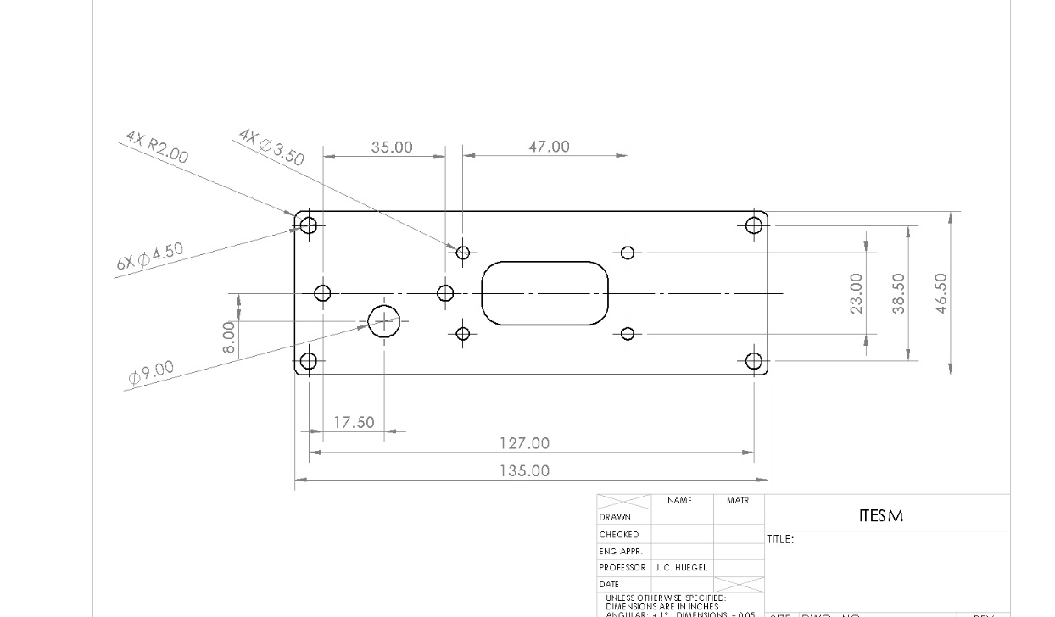

Fig. B1. Shifting module plate

Fig. B2. Shifting module pulley

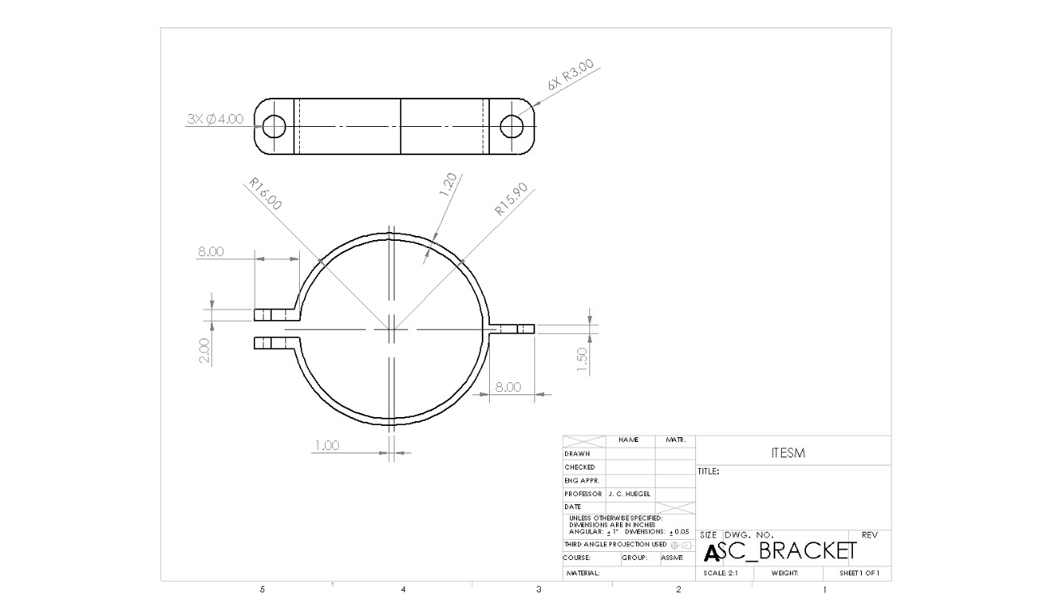

Fig. B3. Shifting controller bracket

**APPENDIX C – Electrical Schematics**

Fig. C1. Power Management System Circuit. The resistor R3 represents the load.

**APPENDIX D – Flow and State Diagram**

Fig. D1. Shifting algorithm diagram.

**APPENDIX E – MATERIALS**

|  |  |
| --- | --- |
| Transmitter | Receiver |
| Stepper motor | Motor pulley |
| Microcontroller ESP-32 | Assembly |

1. https://www.matweb.com/search/DataSheet.aspx?MatGUID=6ba2ca129f0340f89ca6daab21fcb755&ckck=1