DAT601

Assessment 1

Part 2
Liam Scifleet Naughton
Student ID: 13537203

TABLE OF CONTENTS
A.1 Assessment 1 Milestone 1 5
1.0 Description of Data Modelling 5
1.1 Conceptual Modelling 5
1.2 Chen Diagram 5
1.3 Diagram Components 6
1.3.1 Entity 6
1.3.2 Entity Type 6
1.3.3 Entity Instance 6
1.3.4 Weak Entity 6
1.3.5 Attribute 6
1.3.6 Keys 7
1.3.7 Relationship 7
1.3.8 Optionality 7
1.3.9 Cardinality 7
2.0 Coast & Canopy Entity Relationship Model 8
2.1 Diagram 8
2.2 Rationale 8
3.0 Data Dictionary 9
3.1 Document Entities 9
3.2 Document Relationships/Specialisation/Cardinality 11
3.3 Document Attributes 13
3.5 Rationale 25
3.5.1 Subscriber 25
3.5.2 Invoice 25
3.5.3 Subscription 25
3.5.4 SubStandard 25
3.5.5 SubGold 26
3.5.6 SubPlatinum 26
3.5.7 SubSuperPlatinum 26
3.5.8 HARV 26
3.5.9 HARVStoredData 27
3.5.10 HARVPart 27
3.5.11 Maintenance 27
3.5.12 Maintainer 27
3.5.13 Supplier 28
3.5.14 Employee 28
3.5.15 Salesperson 28
3.5.16 AdministrativeExecutive 28
3.5.17 TechnicalEngineer 28
3.5.18 Department 29
3.5.19 Address 29
4.0 Business Rules & Assumptions 29
4.1 Identified Business Rules 29
4.1.1 Subscriptions 29
4.1.2 HARVs 30
4.1.3 Parts & Suppliers 30
4.1.4 Maintenance 30
4.1.5 Zones 30
4.2 Assumptions 30
4.3 Business Rule & Diagram Rationale 31
5.0 Summary & Conclusion 31
A.2 Assessment 2 Milestone 2 31
6.0 Transformation from Conceptual to Logical 31
6.1 Introduction 31
6.2 Mapping Rules Strategy 32
6.2.1 Strong Entities 32
6.2.2 Weak Entities 32
6.2.3 Composite & Multi-valued Attributes 32
6.2.4 One-to-One Relationships 32
6.2.5 One-to-Many Relationships 32
6.2.6 Many-to-Many Relationships 32
7.0 The Logical Database Model 33
7.1 Presentation 33
7.2 Explanation 33
8.0 Normalisation 36
8.1 First Normal Form 36
8.2 Second Normal Form 36
8.3 Third Normal Form 36
8.4 Boyce-Codd Normal Form 36
8.5 Fourth Normal Form 36
9.0 Logical Data Dictionary 37
10.0 NaLER Analysis (Natural Language for Entity Relationships) 37
10.1 The Method 37
10.2 The Analysis 37
10.3 Conclusion 37
A.3 Assessment 2 Milestone 3 37
11.0 Physical Database Design & Sizing 37
11.1 Logical to Physical Transformation 37
20.0 Bibliography 37

A.1 Assessment 1 Milestone 1

1.0 Description of Data Modelling
Data modelling is the methodology of creating visual representations that define data structures, their relationships as well as constraints. There are three processes including conceptual modelling, logical modelling and physical modelling. The conceptual model is the enterprise data separate from all physical considerations, while the logical model takes this data one step further and provides a specific data model while still being separate from the physical model and Database Management System (DBMS). The physical model is the designed description of the data’s storage structures, efficiency and access methods.

1.1 Conceptual Modelling
Conceptual data modelling focuses on the key data that fits within the stakeholder’s business (Kanuri, 2025). It focuses on the entities and their relationships without concerning the finer details. What data do the stakeholders need to store, what is the relationships between the data.
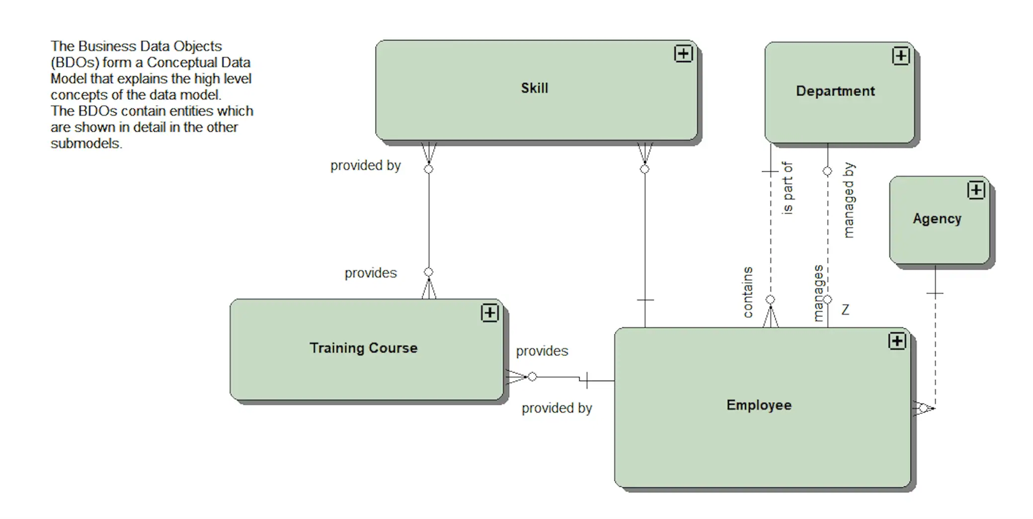
Figure 1: Conceptual Data Model Example (Agar, 2021)

1.2 Chen Diagram
A chen diagrams maintains the logic of conceptual data modelling with entities and their relationships. However, there are some key additions in chen notation; Chen notation includes attributes which is each bit of data an entity holds, chen defines entities that rely on the existence of other entities, it also defines whether an entity must have a relationship with another or if that relationship is optional.

1.3 Diagram Components

1.3.1 Entity
An entity within a chen Entity Relationship Diagram (ERD), represents a concept, a collection of data that shares the same attributes. This could be a teacher, a student or a classroom (Dusan Rodina, 2024).

1.3.2 Entity Type
There are three key types of entities, strong entities, weak entities and associative entities. A strong entity exists on its own, it has no reliance on the existence of other entities, while a weak entity relies on the existence of another entity (Athuraliya, 2025), (eg. A classroom cannot exist without the building the classroom exists in). The last entity type, an associative entity, links to entities together which have a many-to-many relationship (Athuraliya, 2025). These entities usually contain their own attributes which are separate from the two entities they link together. A strong entity contains a primary key, a unique identifying value that is different for every single instance. Weak entities contain a partial key, this is usually a borrowed key from its parent entity (Athuraliya, 2025).

1.3.3 Entity Instance
Entities themselves have many instances, using the example of a student entity, this entity would contain multiple instances of students. Each instance has the same attributes but with different information, different name, different classes, different grades. Name, classes and grade are the same type of information stored across all instances, but each instances data for these three attributes will be different. Each instance uses keys to differentiate themselves from other instances.

1.3.4 Weak Entity
Weak entities were described as a part of entity type. They are entities which cannot exist without the existence of another entity. Without their parent entity, their existence is null and void.

1.3.5 Attribute
An attribute is a piece of information stored in an instance, they define the characteristics of an instance (Athuraliya, 2025). A student has a name, a class, a room, grades. Each bit of information that is required to be stored for an instance is an attribute of that instance (Athuraliya, 2025). Differing types of attributes exist, simple atomic attributes are a basic value that is indivisible. Composite attributes are values that are divisible and can be split up into smaller attributes. Derived attributes are attributes that are derived from other attributes and are not stored directly. Multivalued attributes are attributes that contain more than one value (Athuraliya, 2025).

1.3.6 Keys
Keys themselves are attributes of an instance, each key of an entity instance is completely unique to that entity. Because of their unique value, they are primarily used to identify each instance (Athuraliya, 2025). In chen notation specifically two different key types exist, primary key and partial key.

1.3.7 Relationship
Relationships in chen notation are the link between two entities. They are portrayed in a diamond shape and are often verbs describing the relationship. They help define the relation of two entities (Athuraliya, 2025).

1.3.8 Optionality
Optionality is a constraint of relationships, describing whether a relationship is mandatory or optional. In chen notation this is displayed using either single or double-lines connecting entities to relationships, single representing an optional relationship and double representing a mandatory relationship (Athuraliya, 2025). A person may have a driver license, this is optional, buit a driver license must have a person, this is mandatory.

1.3.9 Cardinality
Cardinality further develops the details of a relationship by describing the relationship further. There are a few types that include one-to-one, one-to-many and many-to-many (Athuraliya, 2025). A one-to-one relationship states that one entities instance relates to one of another entities instances. One-to-many states that one entity instance can relate to one or more of another entities instances. Many-to-many states that one or more of an entities instances relates to one or more of another entities instances (Athuraliya, 2025).

2.0 Coast & Canopy Entity Relationship Model

2.1 Diagram
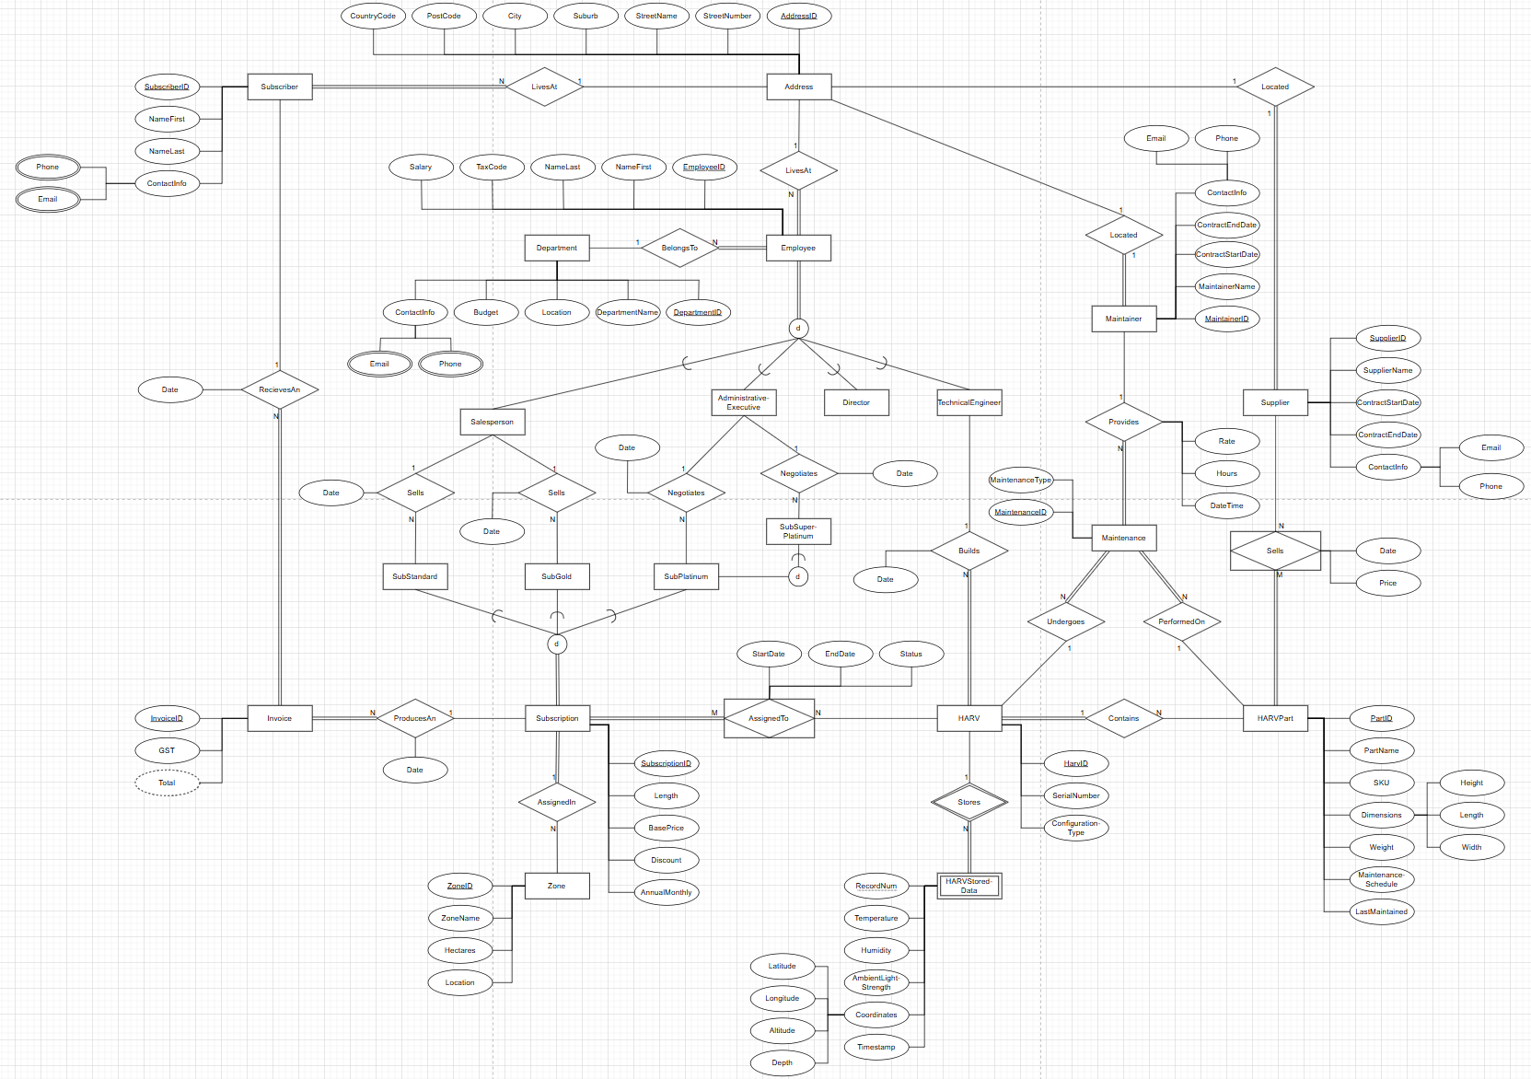
Figure 2: Coast & Canopy Chen Notation ERD

2.2 Rationale
The diagram above shows the logic of how all the data required in the database relates. A subscriber is saved in the database as their information is required for the subscription alongside the invoice. Address is its own entity as this is a common bit of information that is shared across multiple avenues in the database.
Employee doesn’t directly relate to a subscription, but the subtype of employ relates to a subtype of a subscription. This has been laid out as a business rule, only Administrative Executives can negotiate certain types of subscriptions, meanwhile Salespersons sell the two default types of subscriptions. Another business rule was that technical Engineers must relate to a HARV, shown by the direct relationship between a Technical Engineer and a HARV.
Maintainers perform maintenance on a HARV’s HARV Parts and replace HARV Parts, therefore, maintenance must relate to both the HARV and HARV Parts. Suppliers provide and sell Coast & Canopy these HARV Parts, relating to the HARVPart entity.

3.0 Data Dictionary

3.1 Document Entities
Entity Name | Description | Aliases | Occurrence
Subscriber | A/multiple clients of Coast & Canopy. | Customer | A new customer, a new subscription.
Employee | A person who is employed by Coast & Canopy. | Salesperson, Director, Administrative Executive, Technical Engineer | An employee being hired, their pay details and contract.
Department | A specialised division of Coast & Canopy. |  | A new employee put into a department. An existing employee changing departments.
Salesperson | An employee who advertises and sells subscription to new or returning subscribers. |  | A subscription is sold, a new salesperson.
Director | Directors for Coast & Canopy are a part of the executive board. | Board member | Change of base monthly/annual subscription price, a new director.
TechnicalEngineer | Technical Engineers build the companies HARV’s. |  | A new HARV is built, a new Technical Engineer.
AdministrativeExecutive | Administrative Executives are the Senior Management Staff for Coast & Canopy. |  | Modification of contract details, assigning of directors, platinum and super platinum contract negotiations.
Subscription | Subscription are the contracts of each job, these can vary in length of time. | Contract | New subscription sold, invoice created, existing subscription details or price modified.
SubStandard | Subscription Standard is the 1st Tier and standard type of subscription sold. It is one HARV in one zone providing one service. |  | A standard subscription sold/assigned to a HARV, zone and service.
SubGold | Subscription Gold is the 2nd Tier and Gold type of subscription sold. Three HARV’s, three zones, three services. |  | A Gold subscription sold/assigned with HARV’s, zones and services.
SubPlatinum | Subscription Platinum is the 3rd Tier and platinum type of subscription sold. As many HARV’s, zones, and services as required. |  | A Platinum subscription negotiated/assigned with HARV’s, zones and services.
SubSuperPlatinum | Subscription Super Platinum is the 4th Tier and super platinum type of subscription sold. The only subscription that gives the subscriber exclusive control over their HARV’s. |  | A Gold subscription negotiated/assigned with HARV’s, zones and services.
Zone | An area measured within hectares that define what HARv’s are used and where. | Area | A new zone added, size modified, HARV’s assigned.
HARV | The data collecting robot assigned to subscriptions. |  | A new HARV created, maintenance performed, part replaced, data stored, zone assigned, subscription assigned.
HARVStoredData | A HARV records a set of data which is stored locally on the machine and sent to a database. |  | New data stored, new location stored.
HARVPart | HARV’s have multiple parts that can be maintained and replaced. | Part | Maintenance performed, part replaced.
Supplier | Suppliers provide the HARV’s parts. |  | Part sold to Coast & Canopy, part supplied, new supplier, contract created/updated.
Maintainer | A maintainer provides maintenance to the HARV’s and their parts. |  | Maintenance performed, contract created/updated, new maintainer.
Maintenance | Different types of maintenance are performed on the HARV’s and their parts, each time maintenance is performed it is recorded. |  | Maintenance performed on HARV or HARV part, part replaced.

3.2 Document Relationships/Specialisation/Cardinality
Entity Name | Cardinality | Participation | Relationship | Participation | Cardinality | Entity Name
Subscriber | N | Mandatory | LivesAt | Optional | 1 | Address
Subscriber | 1 | Optional | RecievesAn | Mandatory | N | Invoice
Subscription | 1 | Optional | ProducesAn | Mandatory | N | Invoice
Subscription | M | Mandatory | AssignedTo | Optional | N | HARV
Subscription | 1 | Mandatory | AssignedIn | Optional | N | Zone
HARV | 1 | Optional | Stores | Mandatory | N | HARVStoredData
HARV | 1 | Mandatory | Contains | Optional | N | HARVPart
HARV | 1 | Optional | PerformedOn | Mandatory | N | Maintenance
Technical-Engineer | 1 | Optional | Builds | Mandatory | N | HARV
Supplier | N | Optional | Sells | Mandatory | M | HARVPart
Supplier | 1 | Mandatory | Located | Optional | 1 | Address
Maintainer | 1 | Mandatory | Provides | Optional | N | Maintenance
Maintainer | 1 | Mandatory | Located | Optional | 1 | Address
Salesperson | 1 | Optional | Sells | Options | N | SubStandard
Salesperson | 1 | Optional | Sells | Optional | N | SubGold
Administrative-Executive | 1 | Optional | Negotiates | Optional | N | SubPlatinum
Administrative-Executive | 1 | Optional | Negotiates | Optional | N | SubSuperPlatinum
Subscription | 1 | Mandatory | Specialisation | Must be one and only one. | 1 | SubStandard, SubGold, SubPlatinum, SubSuperPlatinum
Employee | 1 | Madatory | Specialisation | Must be one and only one. | 1 | Salesperson, Administrative-Executive, Director, TechnicalEngineer

3.3 Document Attributes

Entity Name | Attributes | Description | Domain | Aliases | Composite | Derived | Nulls | Key? | Default Value
Subscriber | SubscriberID | Primary Key and unique identifier. | INTEGER |  | No | No | No | Yes | N/A
 | NameFirst | First name of each subscriber. | VARCHAR |  | No | No | No | No | N/A
 | NameLast | Last name of each subscriber. | VARCHAR |  | No | No | No | No | N/A
 | ContactInfo |  |  |  | Yes | No | No | No | N/A
 | Phone | Phone number of each subscriber. | VARCHAR |  | No | No | No | No | N/A
 | Email | Email of each subscriber. | VARCHAR |  | No | No | No | No | N/A
Employee | EmployeeID | Primary Key and unique identifier. | INTEGER |  | No | No | No | Yes | N/A
 | NameFirst | First name of each employee. | VARCHAR |  | No | No | No | No | N/A
 | NameLast | Last name of each employee. | VARCHAR |  | No | No | No | No | N/A
 | TaxCode | Each employers TaxCode for use of their payments. | CHAR |  | No | No | No | No | N/A
 | Salary | Each employers annual salary. | DECIMAL |  | No | No | No | No | N/A
 | ContactInfo |  |  |  | Yes | No | No | No | N/A
 | Phone | Phone number of each employee. | VARCHAR |  | No | No | No | No | N/A
 | Email | Email of each employee. | VARCHAR |  | No | No | No | No | N/A
Department | DepartmentID | Primary Key and unique identifier. | INTEGER |  | No | No | No | Yes | N/A
 | DepartmentName | The identifying name for each department. | VARCHAR |  | No | No | No | No | N/A
 | Location | Where each department is based. | VARCHAR |  | No | No | No | No | N/A
 | Budget | Each departments annual budget. | DECIMAL |  | No | No | Yes | No | N/A
 | ContactInfo |  |  |  | Yes | No | No | No | N/A
 | Phone | Phone number of each department. | VARCHAR |  | No | No | No | No | N/A
 | Email | Email of each department. | VARCHAR |  | No | No | No | No | N/A
Address | AddressID | Primary Key and unique identifier. | INTEGER |  | No | No | No | Yes | N/A
 | StreetNumber | An addresses street number. | INTEGER |  | No | No | No | No | N/A
 | StreetName | An addresses street name. | VARCHAR |  | No | No | No | No | N/A
 | Suburb | An addresses suburb. | VARCHAR |  | No | No | No | No | N/A
 | City | The city an address is based. | VARCHAR |  | No | No | No | No | N/A
 | PostCode | An addresses postcode. | CHAR |  | No | No | No | No | N/A
 | CountryCode | An addresses country code. | CHAR |  | No | No | No | No | N/A
Supplier | SupplierID | Primary Key and unique identifier. | INTEGER |  | No | No | No | Yes | N/A
 | SupplierName | The identifying name of each supplier. | VARCHAR |  | No | No | No | No | N/A
 | ContractStart-Date | The date of which the supplier and Coast & Canopy entered into a contract. | DATE |  | No | No | Yes | No | N/A
 | ContractEnd-Date | The date of which the supplier and Coast & Canopy’s agreed contract ends. | DATE |  | No | No | Yes | No | N/A
 | ContactInfo |  |  |  | Yes | No | No | No | N/A
 | Phone | Phone number of each supplier. | VARCHAR |  | No | No | No | No | N/A
 | Email | Email of each supplier. | VARCHAR |  | No | No | No | No | N/A
Maintainer | MaintainerID | Primary Key and unique identifier. | INTEGER |  | No | No | No | Yes | N/A
 | MaintainerName |  |  |  | No | No | No | No | N/A
 | ContractStart-Date | The date of which the maintainer and Coast & Canopy entered into a contract. | DATE |  | No | No | Yes | No | N/A
 | ContractEnd-Date | The date of which the maintainer and Coast & Canopy’s agreed contract ends. | DATE |  | No | No | Yes | No | N/A
 | ContactInfo |  |  |  | Yes | No | No | No | N/A
 | Phone | Phone number of each maintainer. | VARCHAR |  | No |  | No | No | N/A
 | Email | Email of each maintainer. | VARCHAR |  | No | No | No | No | N/A
Maintenance | Maintenance-ReferenceNum | The number used as a reference to a maintenance job. | CHAR |  | No | No | No | Yes | N/A
 | Maintenance-Type | The type of maintenance which was performed. | VARCHAR |  | No | No | No | No | N/A
HARV | HarvID | Primary Key and unique identifier. | INTEGER |  | No | No | No | Yes | N/A
 | SerialNumber | A HARV’s identifying serial number. | CHAR |  | No | No | No | No | N/A
 | Configuration-Type | The type of configuration the HARV has been built and designed for. | VARCHAR |  | No | No | No | No | N/A
HARVPart | PartID | Primary Key and unique identifier. | INTEGER |  | No | No | No | Yes | N/A
 | PartName | The identifying name of a HARV part. | VARCHAR |  | No | No | No | No | N/A
 | SKU | A HARV parts unique identifying SKU number. | INTEGER |  | No | No | No | No | N/A
 | Dimensions |  | DECIMAL |  | Yes | No | No | No | N/A
 | Height | Height of the part. | DECIMAL |  | No | No | No | No | N/A
 | Length | Length of the part. | DECIMAL |  | No | No | No | No | N/A
 | Width | Width of the part. | DECIMAL |  | No | No | No | No | N/A
 | Weight | Weight of the part. | DECIMAL |  | No | No | No | No | N/A
 | Maintenance-Schedule | The schedule for maintenance of the HARV part. | VARCHAR |  | No | No | No | No | 5 Years from LastMaintained date.
 | LastMaintained | The previous maintenance date. | DATE |  | No | No | No | No | Date entered into system.
HARVStored-Data | RecordNum | The unique identifying record number for each record of HARV stored data. | INTEGER |  | No | No | No | Yes | N/A
 | Temperature | Recorded temperature. | DECIMAL |  | No | No | Yes | No | N/A
 | Humidity | Recorded humidity. | DECIMAL |  | No | No | Yes | No | N/A
 | AmbientLight-Strength | Recorded ambient light strength. | FLOAT |  | No | No | Yes | No | N/A
 | Coordinates | Recorded coordinates. | DECIMAL |  | Yes | No | Yes | No | N/A
 | Latitude | Recorded latitude. | DECIMAL |  | No | No | Yes | No | N/A
 | Longitude | Recorded longitude. | DECIMAL |  | No | No | Yes | No | N/A
 | Altitude | Recorded altitude. |  |  | No | No | Yes | No | N/A
 | Depth | Recorded depth. | DECIMAL |  | No | No | Yes | No | N/A
 | Timestamp | The timestamp of when each entry of stored data was made. | DATETIME |  | No | No | No | No | N/A
Invoice | InvoiceID | Primary Key and unique identifier. | INTEGER |  | No | No | No | Yes | N/A
 | GST | General Sales Tax percentage. | DECIMAL |  | No | No | No | No | 15
 | Total | The total price on the invoice after GST. | DECIMAL |  | No | Yes, from BasePrice & Discount in Subscription Entity. | No | No | N/A
Zone | ZoneID | Primary Key and unique identifier. | INTEGER |  | No | No | No | Yes | N/A
 | ZoneName | The unique identifying name of each zone. | VARCHAR |  | No | No | No | No | N/A
 | Hectares | The size in hectares of each zone. | INTEGER |  | No | No | Yes | No | N/A
 | Location | The location of each zone. | VARCHAR |  | No | No | No | No | N/A
Subscription | SubscriptionID | Primary Key and unique identifier. | INTEGER |  | No | No | No | Yes | N/A
 | ContractStart-Date | The date the subscription starts. | DATE |  | No | No | Yes | No | N/A
 | ContractEnd-Date | The date which the subscription ends on. | DATE |  | No | No | Yes | No | N/A
 | BasePrice | The base price of the subscription. | DECIMAL |  | No | No | No | No | N/A
 | Discount | The optional discount rate of a subscription. | DECIMAL |  | No | No | No | No | N/A
 | AnnualMonthly | Whether the subscription is paid annually or monthly. | BOOLEAN |  | No | No | No | No | Monthly

3.5 Rationale

3.5.1 Subscriber
The subscriber entity includes a many-to-one mandatory relationship with address. A subscriber must have an address for mailing/contact purposes, invoices can be sent to the address. Multiple subscribers could live at the same address.
The subscriber also has an optional one-to-may relationship with invoice. A stored subscriber isn’t required to have an invoice. One subscriber can receive more than one invoice, especially if their subscription is monthly based.

3.5.2 Invoice
Invoice has a mandatory many-to-one relationship with subscriber. An invoice must have a subscriber. An invoice only has the one subscriber.
The invoice entity has a mandatory many-to-one relationship with the subscription entity. Along with an invoice needing a subscriber. An invoice must have a subscription, an invoice can only be related to one subscription, if a subscriber has more than one subscription then a second separate invoice must be created for that different subscription.
Invoice includes a derived attribute Total. Total is derived from BasePrice and Discount from Subscription entity, plus GST attribute in Invoice Entity.

3.5.3 Subscription
Subscription has an optional one-to-many relationship with invoice. A subscription can exist without an invoice, but a subscription will at some point produce invoices. A subscription can produce multiple invoices, the frequency of these created invoices depends on subscriptions attribute AnnualMonthly, which is a boolean value describing the frequency of payments.
Subscription has a mandatory one-to-many relationship with zone. A subscription must have at least one zone assigned to the subscription. The number of zones assigned to the subscription depends on the subscriptions subtype.
Subscription has a mandatory many-to-many relationship with HARV. A subscription must have at least one HARV assigned to it. The number of HARV’s assigned depends on the subscription subtype alongside the subscribers needs.
Subscription has a specialisation relationship with its own subtype entities. The subscription must be one of the subtypes and cannot be more than one.

3.5.4 SubStandard
SubStandard is a subtype of subscription, it has an optional many-to-one relationship with salesperson. The SubStandard subtype does not need a salesperson, it exists as a type of subscription independently, however, it is related to the salesperson, who sells this type of subscription to subscribers.

3.5.5 SubGold
SubGold is a subtype of subscription, it has an optional many-to-one relationship with salesperson. The SubGold subtype does not need a salesperson, it exists as a type of subscription independently, however, it is related to the salesperson, who sells this type of subscription to subscribers.

3.5.6 SubPlatinum
SubPlatinum is a subtype of subscription, it has an optional many-to-one relationship with AdministrativeExecutive. The SubPlatinum subtype does not need an administrative executive, it exists as a type of subscription independently, however, it is related to the administrative executive, who negotiates this subscription type with subscribers.

3.5.7 SubSuperPlatinum
SubSuperPlatinum is a subtype of SubPlatinum, it has an optional many-to-one relationship with AdministrativeExecutive. The SubSuperPlatinum subtype does not need an administrative executive, it exists as a special type of SubPlatinum independently, however, it is related to the administrative executive, who negotiates this subscription type with subscribers.

3.5.8 HARV
HARV has an optional many-to-many relationship with subscription. A HARV can exist without being assigned to any subscriptions. A HARV over its lifetime will be assigned to many subscriptions.
A HARV has an optional one-to-many relationship with HARVStoredData. A HARV is required to store data locally that is sent to a database, the HARV does not need any stored data, but it can store multiple instances of data.
HARV has a mandatory many-to-one relationship with TechnicalEngineer. A HARV according to business rules must relate to the technical engineer who built the specific HARV. Many HARV’s can be built by one technical engineer.
HARV has a mandatory one-to-many relationship with HARVPart. A HARV is made up of many different HARV parts and therefore must be a mandatory relationship.
HARV has an optional one-to-many relationship with maintenance. A HARV itself can exist without any maintenance performed such as a brand new HARV. A HARV can have multiple instances of maintenance performed, especially since each of a HARV’s parts must be maintained very 5 years.

3.5.9 HARVStoredData
HARVStoredData has a mandatory many-to-one relationship with HARV. Each instance of stored data must relate to one HARV, it cannot relate to more than one HARV as the instance of stored data is unique to the HARV that recorded it. Alongside that, the entity HARVStoredData cannot exist without the entity HARV, HARVStoredData is not possible without a HARV and therefore it becomes a weak entity, and its parent entity is HARV.

3.5.10 HARVPart
HARVPart has an optional many-to-one relationship with HARV. The HARV part itself can exist without a HARV, for instance, before it has been attached to a HARV unit. The HARV part itself can only be attached to one HARV.
HARVPart has a mandatory many-to-many relationship with Supplier. A HARVPart must come from a supplier, and as specified in the brief, a specific HARV part is supplied by more than one supplier.
HARVPart has an optional one-to-many relationship with Maintenance. A HARV part can exist without any maintenance such as a new part. A HARV part can have one or more lots of maintenance performed on it since it is required every 5 years.

3.5.11 Maintenance
Maintenance has a mandatory many-to-one relationship with HARV. Maintenance performed must exist on a specific HARV and be logged. An instance of maintenance can only belong to one specific HARV.
Maintenance has a mandatory many-to-one relationship with HARVPart. Maintenance performed must be logged for a specific HARV part. An instance of maintenance can only belong to one specific HARV part related to one specific HARV.
Maintenance has a mandatory many-to-one relationship with Maintainer. Maintenance must be provided by a maintainer. One instance of maintenance can only belong to one maintainer.

3.5.12 Maintainer
Maintainer has an optional one-to-many relationship with Maintenance. A maintainer can exist without any maintenance such as a new maintainer who has not yet performed maintenance. A maintainer can have one or more instances of maintenance performed.
Maintainer has a mandatory one-to-one relationship with Address. A maintainer must have an address for contractual purposes. The maintainer themselves can only have one address for mailing purposes, more than one complicates the system.

3.5.13 Supplier
A Supplier has an optional many-to-many relationship with HARVPart. A supplier can exist without having supplied any HARV parts such as a new supplier. The supplier can supply one or more HARV part instances.
Supplier has a mandatory one-to-one relationship with Address. A supplier must have an address for contractual purposes. A supplier can only have one address for mailing purposes, more than one complicates the system.

3.5.14 Employee
Employee has a mandatory many-to-one relationship with Address. An employee must have one address, no more. This is for mailing purposes, more than one address complicates the system.
Employee has a mandatory many-to-one relationship with Department. An employee must belong to a department in the company. Employees can only belong to one department.
Employee has a specialisation relationship with its subtypes. An employee must belong to more than one and no more subtypes.

3.5.15 Salesperson
Salesperson has an optional one-to-many relationship with SubStandard. A salesperson can exist without selling any subscription types such as a new salesperson. A salesperson can sell multiple standard subscriptions.
Salesperson has an optional one-to-many relationship with SubGold. A salesperson can exist without selling any subscription types such as a new salesperson. A salesperson can sell multiple gold subscriptions.

3.5.16 AdministrativeExecutive
AdministrativeExecutive has an optional one-to-many relationship with SubPlatinum. An administrative executive can exist without negotiating any subscription types such as a new administrative executive. An administrative executive can negotiate multiple platinum subscriptions.
AdministrativeExecutive has an optional one-to-many relationship with SubSuperPlatinum. An administrative executive can exist without negotiating any subscription types such as a new administrative executive. An administrative executive can negotiate multiple super platinum subscriptions.

3.5.17 TechnicalEngineer
A TechnicalEngineer has an optional one-to-many relationship with HARV. A technical engineer can exist without having built a HARV such as a new technical engineer or a technical engineer which all HARV’s built were decommissioned. A technical engineer can be the builder of one or more HARV’s.

3.5.18 Department
Department has an optional one-to-many relationship with Employee. A department can exist without any employees such as when a new Department is created or a restructuring/re-hiring process is performed. A department itself can have many employees.

3.5.19 Address
Address has an optional one-to-many relationship with Subscriber. An address instance does not need to belong to a subscriber. An address can belong to more than one subscriber if the subscribers exist at the same address.
Address has an optional one-to-many relationship with Employee. An address instance does not need to belong to an employee. An address can belong to more than one employee if the employees exist at the same address.
Address has an optional one-to-one relationship with Maintainer. An address instance does not need to belong to a maintainer. An address instance can only belong to one maintainer and not multiple.
Address has an optional one-to-one relationship with Supplier. An address instance does not need to belong to a supplier. An address instance can only belong to one supplier and not multiple.

4.0 Business Rules & Assumptions

4.1 Identified Business Rules

4.1.1 Subscriptions
- Each subscription is paid in advance, monthly or annual
- Standard subscriptions are limited to one service, one HARV, one zone, maximum 10 hectares
- Gold subscriptions provide exactly three HARVs, three services, three zones, maximum 100 hectares total
- Platinum subscriptions have no limits on HARVs, zones or services
- Super Platinum is the only subscription with exclusive HARV control
- Platinum and Super Platinum can only be negotiated by an Administrative Executive
- Standard and Gold subscriptions receive a 10% discount for annual payment
- A salesperson can discount a subscription by a maximum of 3%
- Different subscriptions can have overlapping zones
- A HARV may be allocated to more than one contract if zones overlap
- Only Directors can set or change base subscription prices

4.1.2 HARVs
- Every HARV must be directly linked to the Technical Engineer who built it
- The location of every HARV must be logged
- HARVs can be configured for Terraced Vineyards, Flat Orchards, Coastal Net-Pens, Deep-Sea Aquaculture Grids, and Estuary deployment
- HARVs must store cached data for a minimum of a month

4.1.3 Parts & Suppliers
- Each part must have maintenance performed every 5 years
- Each part may be supplied by more than one supplier

4.1.4 Maintenance
- Maintenance is performed by third party maintainers, not internal staff
- Maintainers have access to the maintenance application
- Maintenance records must be kept for each HARV over time

4.1.5 Zones
- Zones exist as geographic regions
- Different contracts can have overlapping zones

4.2 Assumptions
- Suppliers and maintainers only have a single address
- Departments have budgets
- GST is saved as a s ingle stored value to calculate with BasePrice
- Maintenance although is performed on HARV parts, must directly relate to a specific HARV to meet business rule requirements
- Maintainers and Suppliers have contracts with Coast & Canopy
- Department and employee subtypes are separate
- An Invoice is produced for each annual or monthly time period based on the subscription contract
- Employees have both personal and work phone/email
- Maintainers and suppliers only have a single phone/email
- The date is recorded for each subscription sold and negotiated
- Date is recorded for an invoice
- Start and end date recorded for subscriptions
- Date recorded for each HARV part supplied
- Maintainers work of an hourly rate for their maintenance and not a salary
- Only salespersons can sell Standard and Gold subscriptions

4.3 Business Rule & Diagram Rationale
Each business rule and assumption was carefully considered when constructing the chen notation diagram. Subscription business rules that include payments, zones, HARV numbers, discounts, and who negotiated the subscription was integrated into the diagram through its relationships, cardinality, optionality and specialisations.
HARV’s link to technical engineers is direct, their location is reordered and has detailed location attributes. The configuration type is considered as an attribute and the multiple instances of data stored exists in cardinality.
Parts and their suppliers have their 5-year maintenance considered alongside parts being available from multiple suppliers, this is shown through cardinality.
Maintenance includes its own maintainers entity for the third party maintainers, as well as cardinality for multiple instances of maintenance.
Zones directly relate to a subscription, with the cardinality a subscription can have multiple zones, not only for subscription subtypes that have more than one zone, but also those subscriptions with overlapping zones.

5.0 Summary & Conclusion
Coast & Canopy’s, conceptual and data modelling has been thoroughly developed from their data needs, relationships and business requirements. There are assumptions that had to be made as certain things are unclear or not at all discussed in their brief. A chen notation ERD has been designed to diagram and show the conceptual logic of the database, its entities, relationships, attributes, cardinality, optionality and specialisation. Further modelling is required, the next step in the process is the logical data modelling, now the conceptual model is understood, we can move onto logical.

A.2 Assessment 2 Milestone 2

6.0 Transformation from Conceptual to Logical

6.1 Introduction
As described in 1.1, the conceptual model is the blueprint an organisation uses to define the key entities and relationships required for their data. It focuses on the key entities and their relationships without worrying about the finer details. In Assessment 1 we designed a conceptual model for Coast & Canopy, identifying key entities and their relationships though chen notation.

6.2 Mapping Rules Strategy

6.2.1 Strong Entities
The strong entities in the conceptual ERD becomes tables in the logical ERD.

6.2.2 Weak Entities
Weak entities borrow the primary key from their parent entity and include their own partial keys creating a composite key for the table.

6.2.3 Composite & Multi-valued Attributes
Composite attributes from a conceptual model become two or more attributes in the logical model. Multi-valued attributes become their own entity table.

6.2.4 One-to-One Relationships
One-to-one relationships require the primary key of one of the entities to be shared with the other entity. In the logical model this shared primary key can go either way and should be decided on the requirements of the database and queries.

6.2.5 One-to-Many Relationships
In a one-to-many relationship, the primary key from the “one” entity is given to the “many” entity, as a foreign key.

6.2.6 Many-to-Many Relationships
The many-to-many relationships require a bridging relationship/entity. An entity that shares both the entities primary keys are participating foreign keys which become the primary key of the new entity. This new entity can also hold its own attributes that relate to both of the “many” relationships.

7.0 The Logical Database Model

7.1 Presentation
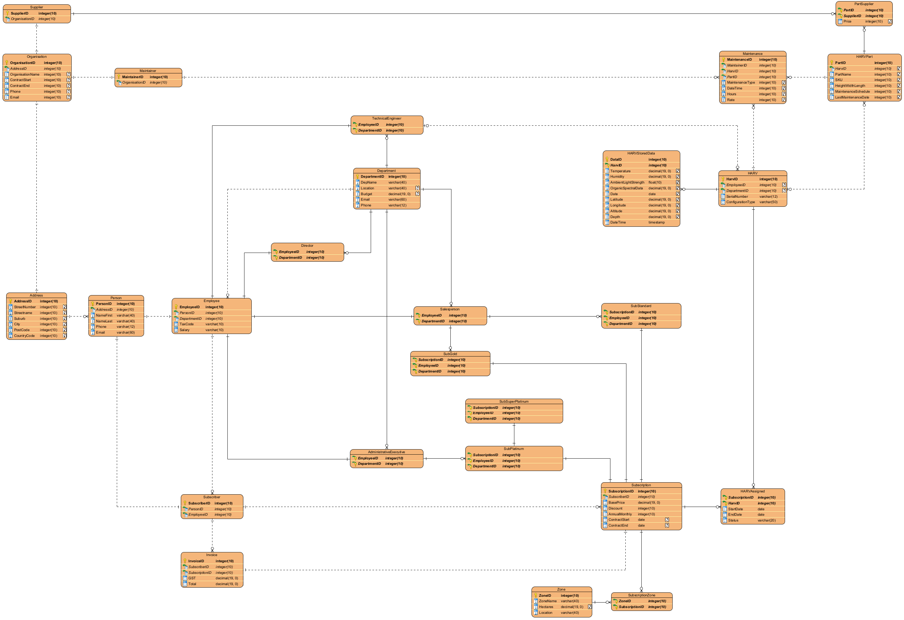

7.2 Explanation
If we analyse the logical ERD in the above screenshot, we notice that the entities from our conceptual model that are one-to-many relationships, follow its mapped rules with foreign keys in the “many” entity, provided by the primary key from the “one” entity.
The entities that will be the focus of the below table are the one-to-one relationship entities and many-to-many relationship entities.
Entity relationship | Keys | Associative Entities | Constraints/Rules
Person to Employee (one-to-one) | Employee gets PersonID as an FK | N/A | No attribute inside Person can be null. Person must have first and last name, plus an email and phone contact. A person can only be one employee, and an employee can only be one person.
Person to Subscriber (one-to-one) | Subscriber gets PersonID as an FK | N/A | “”
Address to Organisation (one-to-one) | Organisation gets AddressID as an FK | N/A | No attribute inside of address can be null. The full address must be stored. An organisation can only have one address and an address can only have one organisation.
Organisation to Maintainer (one-to-one) | Maintainer gets OrganisationID as a foreign key that becomes a composite primary key alongside MaintainerID | N/A | OrganisationName, Phone and Email must not be null as these are required attributes. ContractStart and ContractEnd can be Null incase of a period where a 3rd party contract has not been renewed or is in discussion.
Organisation to Supplier (one-to-one) | Supplier gets OrganisationID as a foreign key that becomes a composite primary key alongside SupplierID | N/A | “”
Invoice to Subscription (one-to-one) | Invoice gets SubscriptionID as an FK | N/A | No attribute inside Invoice can be null. GST and Total are required attributes for an Invoice.
Subscription to SubStandard (one-to-one) | SubStandard inherits SubscriptionID from Subscription as its PK | N/A | The Discount attribute in subscription can not be null since this value will be used for calculations. Its default value will be 0. AnnualMonthly can’t be null either. ContractStart and ContractEnd can be null for rare cases this is irrelevant and where details are still being discussed.
Subscription to SubGold (one-to-one) | SubGold inherits SubscriptionID from Subscription as its PK | N/A | “”
Subscription to SubPlatinum (one-to-one) | SubPlatinum inherits SubscriptionID from Subscription as its PK | N/A | “”
SubPlatinum to SubSuperPlatinum (one-to-one) | SubSuperPlatinum inherits SubscriptionID from SubPlatinum as its PK | N/A | “”
Employee to Administrative-Executive (one-to-one) | Administrative-Executive gets EmployeeID as an FK | N/A | No Employee attributes can be null. TaxCode and Salary are required for paying the employee.
Employee to Salesperson (one-to-one) | Salesperson gets EmployeeID as an FK | N/A | “”
Employee to Director (one-to-one) | Director gets EmployeeID as an FK | N/A | “”
Employee to TechnicalEngineer | TechnicalEngineer EmployeeID as an FK | N/A | “”
HARV to Subscription | An associative table gets HarvID and SubscriptionID as foreign keys which become a composite primary key | HARVAssigned | No HARV attribute can be null. A HARVs EmployeeID, SerialNumber and ConfigurationType must all have values.
Zone to Subscription | An associative table gets ZoneID and SubscriptionID as foreign keys which become a composite primary key | SubscriptionZone | The attributes for Zone, ZoneName and Location cannot be null, however, Hectares can be null as this could be subject to change or even irrelevant to some zones.

8.0 Normalisation

8.1 First Normal Form
According to Kolade (2022), first normal form requires no duplicate rows or columns, there must be a primary key for identification, a cell must not contain more than one value.

8.2 Second Normal Form
Second normal form removes repeating data and there for has no partial dependency (Kolade, 2022).

8.3 Third Normal Form
Third normal form takes second normal form a step further and removes non-prime attributes that are dependent on another non-prime attribute (Kolade, 2022).

8.4 Boyce-Codd Normal Form
This is a slightly stronger version of third normal form. It attempts to remove certain anomalies that third normal form can accidentally permit causing conflicting data. Decomplexify (2022), defines Boyce-Codd Normal form as “With the exception of trivial functional dependencies, every functional dependency in a table must be a dependency on a superkey” (11:30). An attribute dependent on another attribute that is not a superkey (with the exception of trivial functional dependencies), can cause conflicting data issues while still meeting the definition of second and third normal form.

8.5 Fourth Normal Form
Fourth normal form deals with data anomalies that can occur from multivalued attributes. Decomplexify (2021), defines fourth normal form as “Multivalued dependencies in a table must be multivalued dependencies on the key” (23:05). This means if an entity contains a multivalued dependency on another attribute which is not the key, then this should be separated into another table.

9.0 Logical Data Dictionary

10.0 NaLER Analysis (Natural Language for Entity Relationships)

10.1 The Method
A NaLER analysis includes six steps and helps break down the designed Logical Diagram into readable language to identify relationship dependencies clearly and can benefit by identifying any errors in the designed diagram.
Step one is to note and identify the type of diagram convention used and create a legend to easily interpret the diagram. Step two is to check the syntax to ensure step one assumptions are fair and valid. Step three converts entities plus their attributes, attributes that are foreign keys and binary participating relationships into descriptive readable sentences. Step four converts these readable sentences into examples. Step five converts ternary/m-m relationships with composite keys into the same descriptive readable sentences plus examples. Step six is the construction of a produced list of all descriptive sentences with their examples.

10.2 The Analysis

10.3 Conclusion

A.3 Assessment 2 Milestone 3

11.0 Physical Database Design & Sizing

11.1 Logical to Physical Transformation

20.0 Bibliography
Agar, R. (2021, June 11). What is Conceptual Data Modeling? ER/Studio. https://erstudio.com/blog/conceptual-data-modeling/
Athuraliya, A. (2025, May 14). Easy Guide to Chen Notation for Entity-Relationship Diagrams. Creately. https://creately.com/guides/chen-notation-in-erd/
Decomplexify. (2021, November 21). Learn Database Normalization—1NF, 2NF, 3NF, 4NF, 5NF [Video recording]. https://www.youtube.com/watch?v=GFQaEYEc8_8
Decomplexify. (2022, January 26). Learn Boyce-Codd Normal Form (BCNF) [Video recording]. https://www.youtube.com/watch?v=VWnKUKH4tLg
Dusan Rodina. (2024, May 2). Chen ER Diagram—Entity-Relationship Diagram in Chen Notation. Software Ideas Modeler. https://www.softwareideas.net/chen-er-diagram-erd#entity
Kanuri, S. (2025, March 28). The Three Pillars of Data Modeling: Conceptual, Logical, and Physical Models. Medium. https://sutejakanuri.medium.com/the-three-pillars-of-data-modeling-conceptual-logical-and-physical-models-d93652339855
Kolade, C. (2022, December 21). Database Normalization – Normal Forms 1nf 2nf 3nf Table Examples. freeCodeCamp.Org. https://www.freecodecamp.org/news/database-normalization-1nf-2nf-3nf-table-examples/

