Performance Evaluation of Monte Carlo Methods in Off-Policy Reinforcement Learning

Abstract
This study analyzes the performance of Monte Carlo methods in off-policy reinforcement learning (RL) by examining how importance sampling techniques enhance estimation accuracy and stability. Off-policy learning is crucial in RL scenarios where data collection is costly or must rely on pre-existing datasets. However, a major challenge in off-policy learning is the discrepancy between behavior and target policies, leading to high variance and slow convergence. To address this, the study compares Ordinary Importance Sampling (OIS) and Weighted Importance Sampling (WIS). While OIS exhibits high variance and slow error reduction, WIS provides more stable estimates and lower Mean Squared Error (MSE). Additionally, Per-Decision Importance Sampling (PDIS), which applies decision-based weighting to importance sampling, is examined to assess its impact on reducing variance.
Experiments conducted over 50,000 episodes and multiple runs demonstrate that WIS significantly reduces both error rates and variance. The results emphasize the importance of low-variance, reliable predictions, particularly in robotics, healthcare analytics, autonomous systems, and financial forecasting. In conclusion, WIS not only reduces error rates but also stabilizes policy evaluation. The findings suggest that weighted importance sampling improves data efficiency and mitigates high variance issues in off-policy RL. Therefore, WIS emerges as a more effective alternative to OIS, offering both reliability and faster convergence in off-policy RL.
Keywords: Off-Policy Reinforcement Learning, Importance Sampling, Monte Carlo Methods, Weighted Importance Sampling (WIS)

Introduction
Reinforcement Learning (RL) is a powerful method used to develop optimal decision-making mechanisms in complex systems. Particularly in dynamic and uncertain environments, an agent continuously interacts with its environment to maximize long-term rewards. With these characteristics, RL offers applicability in a wide range of fields, including robotic control, autonomous vehicles, financial modeling, and healthcare applications. However, the fundamental policy learning process in RL faces specific challenges, particularly in scenarios where real-world data collection is costly, risky, or time-consuming. For example, training an autonomous vehicle in a real-world traffic environment requires extensive driving experience under different road conditions, weather scenarios, and unpredictable human behaviors. Similarly, in healthcare applications, using RL to optimize treatment strategies necessitates learning from existing patient records rather than experimenting on real patients. In such cases, off-policy learning methods provide a crucial solution by enabling an agent to learn a target policy while utilizing datasets collected under a different behavior policy. Off-policy learning enables an agent to learn a target policy while utilizing datasets collected under a different behavior policy. This approach separates exploration and learning processes, allowing learning from previously collected experiences or expert-generated datasets. For example, data obtained from human experts' movements or traditional control systems can be used to optimize the target policy through off-policy methods. However, a major challenge in this process is the high variance and slow convergence caused by differences between behavior and target policies. Such problems can destabilize the learning process and negatively impact system performance. At this point, a technique known as importance sampling comes into play. Importance
sampling reweights data collected under the behavior policy to ensure accurate estimation of value functions under the target policy [1]. However, traditional importance sampling methods, especially in cases involving long episodes and complex policies, exhibit challenges such as high variance and unstable estimates. Addressing these problems is crucial for broader adoption of RL methods across various domains. In this study, we aim to address these fundamental challenges in off-policy learning. Our work focuses on Monte Carlo methods and techniques such as weighted importance sampling to improve the accuracy and efficiency of the learning process. Specifically, we emphasize reducing variance and developing more stable learning mechanisms. The proposed methods have applicability in a wide range of fields, including robotic systems, healthcare analytics, autonomous vehicles, and financial forecasting models. These contributions aim to bridge an important gap in both theoretical and applied RL research, particularly in scenarios where data is limited or learning must rely on pre-existing datasets.

2. Related Works
Monte Carlo methods have been among the first approaches to eliminate model dependency in reinforcement learning, reducing the need for model-based methods and providing significant flexibility in learning processes. Previously, dynamic programming methods were applicable only to limited problems due to their reliance on a fully known environment model. Levine [2] revisited reinforcement learning and optimal control in the context of probabilistic inference, proposing to model these problems within the framework of probabilistic graphical models. This study presents a structure that integrates dynamic programming and control problems with maximum entropy learning and variational inference techniques. Specifically, exact inference for deterministic dynamics and variational inference for stochastic dynamics form the theoretical foundation of these methods, enabling the development of new algorithms for control problems. This framework aims to reduce model dependency compared to classical dynamic programming methods and provide a broader application scope. George and Powell [3] developed adaptive methods for optimizing step sizes in dynamic programming. This study focused on issues encountered in estimating value functions using Monte Carlo sampling methods. The authors experimentally demonstrated that adaptive step- size formulas provide faster convergence compared to classical fixed or decreasing step-size strategies. Additionally, the use of step sizes optimized to reduce noise effects improved the performance of dynamic programming algorithms. Dynamic programming methods have been effective in determining optimal policies, provided that a complete model and all transition probabilities are known. However, the difficulty of accessing a complete model in many real-world scenarios has led to the development of Monte Carlo methods, which eliminate model dependency by directly learning reward and transition probabilities from experiences. This necessity has resulted in various studies in the field. Vodopivec et al. [4] examined the connections between Monte Carlo Tree Search (MCTS) and RL, demonstrating how RL-inspired planning methods could enhance performance across different domains. Their research showed that integrating RL concepts into MCTS led to innovative algorithms that outperformed traditional MCTS in classical board games and arcade competitions. This study established a foundation for combining learning, planning, and search methodologies. In practical applications where data collection is limited, Fujimoto et al. [5] addressed the limitations of standard off-policy RL algorithms such as DQN and DDPG when learning from fixed datasets. They introduced batch-constrained RL algorithms, which restricted action spaces within fixed dataset subsets to maintain on-policy behavior. Empirical results in continuous control tasks confirmed the effectiveness of these algorithms in overcoming extrapolation errors, marking significant progress in off-policy RL.In quantum Monte Carlo simulations, Nagai et al. [6] introduced the self-learning Monte Carlo method, which trains a diagram construction function to propose global configuration movements. This method, applied to continuous-time quantum impurity models, significantly reduced the computational complexity of simulations and expanded the applicability of Monte Carlo methods to quantum many-body systems. The same authors later investigated sign- problem-free simulations in non-stoquastic Hamiltonians, identifying the conditions under which QMC simulations can operate and providing superior alternatives to address sign- problematic models [7].In the medical field, Jabbari [8] analyzed fast Monte Carlo methods for radiotherapy dose calculations, achieving significant advancements in efficiency and accuracy for clinical applications. The development of fast Monte Carlo codes has enhanced treatment planning precision while reducing computational costs, highlighting the critical role of this method in modern medicine.Finally, Monte Carlo methods have been applied to financial risk management. Papaioannou[9] analyzed foreign exchange rate risk measurement using Monte Carlo simulations. This approach provided practical insights into managing currency risk and demonstrated the method’s applicability to complex financial scenarios.These studies collectively demonstrate the versatility of reinforcement learning, Monte Carlo methods, and statistical modeling across various domains. The explored methodologies, ranging from fixed data constraints and continuous action spaces to quantum simulations and real-world resource optimization, provide a unified framework for improving decision-making, planning, and simulation capabilities.

3. Material and Methods
Monte Carlo methods allow for estimation without requiring a complete model, providing flexibility in decision-making processes, particularly in uncertain or partially unknown environments. In this process, Importance Sampling, a key component of off-policy learning, enables the evaluation of experiences obtained from different behavior policies in alignment with the target policy. However, classical importance sampling methods can suffer from the infinite variance problem, leading to unstable estimates.To address this issue, the Weighted Importance Sampling method was developed, which normalizes rewards to reduce variance and thus produces more stable results. Additionally, Off-Policy Monte Carlo Control supports the learning process by enabling the behavior policy to be updated with a different target policy, facilitating a more efficient policy discovery.These methods provide flexibility in both policy evaluation and control processes, allowing for more accurate predictions in broader applications.

3.1 Off-Policy Learning and Importance Sampling
Off-policy learning refers to situations where the target policy and the behavior policy are different. In this method, the learning process is conducted based on the target policy, while data collection occurs under the behavior policy. Importance Sampling is used to adjust for the differences between these policies,Importance Sampling (IS) is used (Sutton & Barto, 2018) [1].

Importance Sampling Ratio
The importance sampling ratio represents the ratio of the probability of an action sequence occurring under the target policy π compared to the behavior policy b:
$P_{t:T-1}= \prod_{k=t}^{T-1}{\frac{π(A_{k}|S_{k})}{b(A_{k}|S_{k})}}$ (1)
- $P_{t:T-1}$ : The total importance sampling ratio from time steps t to T−1
- $\prod_{k=t}^{T-1}{ }$: The product symbol, multiplying all rations from step t to T-1
- $π(A_{k}|S_{k})$ : The probability of selecting action 𝐴𝑘 in state 𝑆𝑘 under the target policy
- $b(A_{k}|S_{k})$ : The probability of selecting action 𝐴𝑘 in state 𝑆𝑘 under the behavior policy.

Off-Policy Estimation
To estimate the expected return under the target policy:

$E\left[ρ_{t :T-1} G_{t} \right| S_{t}=s]= v_{π}(s)$ (2)
- $E[]$: Expectation operator, denoting the expected value of a random variable.
- $ρ_{t:T-1}$: Importance sampling ratio, adjusting for differences between the behavior and target policies.
- 𝐺𝑡: Return (cumulative discounted reward) starting from time step t.
- 𝑆𝑡 = 𝑠: Given that the state at time t is s, the expectation is conditioned on this.
- 𝑣𝜋(𝑠): The value function under the target policy π\piπ, representing the expected return from state s.
In Equation (2):
  - represents the total reward at that moment.
  - vπ(s) is the value function of the target policy.
  - This formula rescales the rewards to ensure an accurate value function for the target policy.

3.2 Monte Carlo Methods
Monte Carlo methods are a reinforcement learning approach that estimates rewards directly from experiences. This method does not require a complete model and calculates long-term rewards based on previously experienced episodes,making them effective in domains like robotics, finance, and game playing, where full trajectories can be observed (Vodopivec et al., 2017)[4].A key advantage is their ability to learn from episodic tasks without relying on transition probabilities. However, they require complete episodes for updates, making them unsuitable for ongoing tasks. Additionally, high variance in sampled returns can lead to instability, necessitating variance- reduction techniques like Weighted Importance Sampling or Per-Decision Importance Sampling (Fujimoto et al., 2019) [5].

Monte Carlo Return Calculation
In Monte Carlo methods, the return (G) is defined as the sum of discounted rewards over time:

$G_{t}= R_{t+1}+ γR_{t+2}+ γ^{2}R_{t+3}+…+γ^{T-t-1}R_{T}$ (3)
    - 𝐺_{𝑡}: Return (cumulative discounted reward) from time step t
    - 𝑅_{𝑡+1}, 𝑅_{𝑡+2}, 𝑅_{𝑡+3}, 𝑅_{𝑇}: Rewards received at each future time step
    - 𝛾: Discount factor 0 ≤ 𝛾 ≤ 1 determining how future rewards are weighted
    - 𝑇: Final time step (terminal state)

Equation (3) describes the Monte Carlo return calculation, where:
- 𝛾 (gamma) is the discount factor, which determines the significance of future rewards
- $R_{t}$ represents the reward at time step t
- Equation (3) is used to calculate the total future reward
By computing these estimates over multiple episodes, the average return is obtained, allowing for policy evaluation (Vodopivec et al., 2017) [4].

3.3 Weighted Importance Sampling
Traditional Importance Sampling methods can suffer from the infinite variance problem, especially when large differences exist between the target and behavior policies. When importance sampling ratios take extreme values, the estimates can become unstable.To mitigate this issue, Weighted Importance Sampling (WIS) has been introduced (Fujimoto et al., 2019) [5].

Weighted Importance Sampling
Equation (4) defines the weighted importance sampling method, where the computed rewards are weighted according to importance sampling ratios:
$V\left(s\right)= \frac{\sum_{t∈T(s)}{ρ_{t:T\left(t\right)-1}G_{t}}}{\sum_{t∈T(s)}{ρ_{t:T\left(t\right)-1}}}$ (4)
- 𝑉(𝑠): The estimated value function at state s
- $\sum_{t∈T(s)}{ }$: Summation over all time steps t where state s was visited.
- $ρ_{t:T\left(t\right)-1}$ : Importance sampling ratio from time step t to T(t)−1, adjusting for differences between the behavior and target policies.
- 𝐺𝑡: The return (cumulative discounted reward) from time step t.
- $\frac{\sum_{t∈T(s)}{ρ_{t:T\left(t\right)-1}G_{t}}}{\sum_{t∈T(s)}{ρ_{t:T\left(t\right)-1}}}$ : Weighted Importance Sampling (WIS) estimation formula for the value function.
- This formula normalizes reward calculations to prevent high variance
- It is more stable than classical importance sampling methods, which suffer from the infinite variance problem.
- This method normalizes computed rewards by their importance weights, leading to more stable estimates. Studies have shown that Weighted Importance Sampling significantly reduces variance and improves reliability in policy evaluation (Nagai et al., 2017) [6].

3.4 Infinite Variance Problem
Classical importance sampling methods can sometimes suffer from infinite variance. This issue arises particularly in looping episodes, where importance sampling ratios can become excessively large, leading to unstable estimates.This issue negatively impacts the learning process and slows down policy optimization (Jabbari, 2011) [7].To overcome this problem, alternative approaches such as Weighted Importance Sampling (WIS) and Per-Decision Importance Sampling (PDIS) have been developed. Per-Decision Importance Sampling calculates importance weights separately for each time step, reducing the overall variance in long episodes (Papaioannou, 2006) [8].

of Infinite Variance
Equation (5) defines the variance calculation, where variance is determined as follows:
Var[𝑋] = 𝔼[𝑋²] − (𝔼[𝑋])² (5)
- Var[𝑋]: Variance of the random variable XXX, representing how much XXX deviates from its mean.
- 𝔼[𝑋]: Expectation (mean) of the random variable X, denoted as 𝜇 = 𝔼[𝑋].
- 𝔼[𝑋²]: Expectation of the squared values of X, capturing the average squared magnitude.
- 𝔼[𝑋²] − (𝔼[𝑋])²: The variance formula, derived from the definition of expectation.

If 𝔼[𝑋²] → ∞, variance becomes infinite, making the estimates unstable. In such cases, weighted importance sampling provides a more stable alternative.

3.5 Off-Policy Monte Carlo Control
This method is used to improve a different policy while gaining experience under another policy. Specifically, while a greedy policy is used for exploitation, a different policy is employed for exploration.This method allows policy improvement while collecting data from a different behavior policy, making it more efficient for learning in real-world applications (Nagai et al., 2017) [6].

Off-Policy Monte Carlo Control Update
The Q-value function is updated as follows:
$Q\left(S_{t}, A_{t}\right)= Q\left(S_{t}, A_{t}\right)+W\frac{1}{\left(St,At\right)}(G-Q\left(S_{t}, A_{t}\right) )$ (6)
- 𝑄(𝑆_{𝑡}, 𝐴_{𝑡}): The Q-value, representing the estimated reward for taking action 𝐴_{𝑡} in state 𝑆_{𝑡}.
- W : Importance sampling weight, used to correct off-policy learning.
- 𝐶(𝑆_{𝑡}, 𝐴_{𝑡}): A normalization factor (or counter), often tracking the number of times (𝑆_{𝑡}, 𝐴_{𝑡}) has been visited.
- 𝐺: The Monte Carlo return, which is the cumulative discounted reward from state 𝑆_{𝑡}.
- (𝐺 − 𝑄(𝑆_{𝑡}, 𝐴_{𝑡})): The difference between the observed return and the current Q-value estimate (known as the temporal difference error).

Equation (6) defines the update rule for Q-values in Off-Policy Monte Carlo Control, where:
- $C(S_{t}, A_{t})$ : is the counter that tracks how many times an action has been selected.
- W is the importance sampling weight, which stabilizes the update.
This method optimizes Q-values using importance sampling; however, it can result in high variance. Weighted Importance Sampling has been developed as an alternative to mitigate this problem.

4. Finding and Results
In this study, we aim to analyze the performance of importance sampling methods by evaluating the error rates and stability of different approaches. First, we compare Ordinary Importance Sampling (OIS) and Weighted Importance Sampling (WIS) to examine the time-dependent variation of error levels. Then, we assess the impact of decision-based scaling by comparing WIS with Per-Decision Importance Sampling (PDIS).

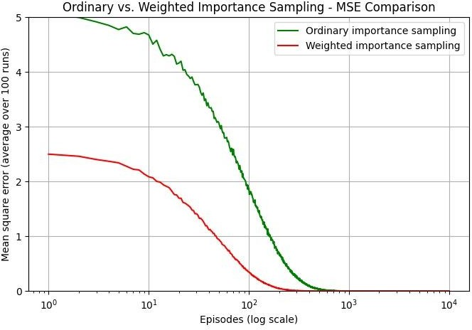
Figure 1: Ordinary vs. Weighted Importance Sampling - MSE Comparison
Figure 1 compares the error rates of ordinary and weighted importance sampling methods in the reinforcement learning process. The X-axis represents the amount of data collected by the agent on a logarithmic scale, while the Y-axis shows the error rates. The dataset consists of actions, states, rewards, and computed importance sampling weights collected by the agent across different segments. The analysis based on this data reveals that the ordinary importance sampling method starts with a high error and decreases slowly, whereas the weighted importance sampling method converges more rapidly with a lower initial error. Notably, weighted sampling reduces variance, providing more stable estimates and enabling a faster reduction in error rates.
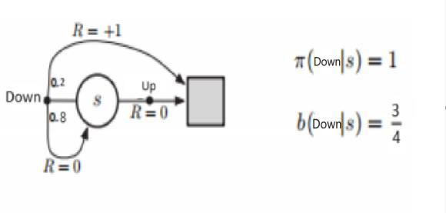
Figure 2:Transition dynamics and action probabilities under the target and behavior policies.

In this study, the performance of the importance sampling method was examined to evaluate reward estimates for a system operating under a given policy. The visual representation in Figure 2 illustrates the process of action selection and reward acquisition in each episode. This process was repeated for 50,000 episodes to compute the average reward. The study was conducted over 10 independent runs, each tested with a different random initialization.The available actions are categorized as "up" and "down." The target policy always selects the "up" action, whereas the behavior policy chooses "up" with a 75% probability and "down" with a 25% probability. Regarding transition probabilities, when the "up" action is selected, there is an 80% chance of moving correctly and receiving a reward of 1, while there is a 20% chance of taking the wrong
transition and receiving a reward of 0. Conversely, for the "down" action, there is a 90% probability of transitioning correctly and receiving a reward of 0, while a 10% probability exists for making an incorrect transition and obtaining a reward of 1.Using the importance sampling method, weights were computed to balance the difference between the policy and the behavior policy. If the selected action was "up," the importance sampling weight was calculated as π(a|s)/b(a|s) = 1/0.75 = 1.33. However, if the selected action was "down," the weight was set to 0 since the target policy does not include this action. As a result, the graph presented in Figure 3 was obtained.
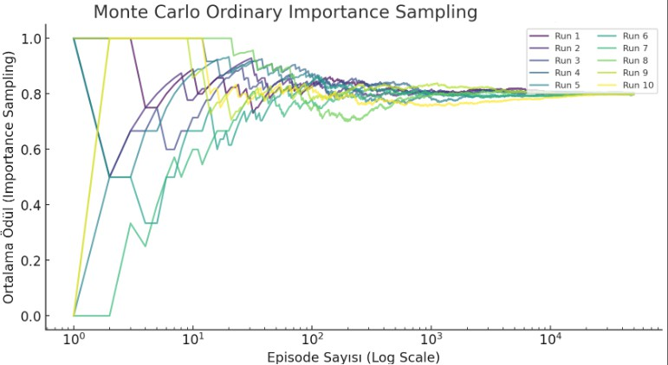
Figure 3: Convergence of Monte Carlo Ordinary Importance Sampling Estimates Over Episodes

Figure 3 presents a graph illustrating how reward estimates obtained using the Monte Carlo Ordinary Importance Sampling method change with the number of episodes. The graph includes results from 10 different runs, where reward estimates are updated over time in each run. Initially, variability is observed due to different random initializations, but as the number of episodes increases, the estimates become more stable. A logarithmic scale is used to analyze the number of episodes over a wide range.

5. Conclusion
In Figure 1, the Monte Carlo Ordinary Importance Sampling method shows high reward variability between 0 and 1 at the 10⁰ episode level but stabilizes within 0.8 to 0.9 after 10² episodes, converging to 0.85 - 0.95 by 10⁴ episodes. This indicates that the method produces consistent and stable reward estimates given a sufficient number of episodes. In Figure 3, Ordinary Importance Sampling (OIS) starts at 5 MSE, while Weighted Importance Sampling (WIS) begins at 2.5 MSE. By the 100th episode, OIS reduces its error below 1, whereas WIS reaches this level by the 10th episode, demonstrating approximately 10 times faster error reduction. These results show that while both methods achieve stability over time, WIS is a more efficient and reliable alternative due to its lower initial error and faster convergence.

6. References
- Sutton, R. S., & Barto, A. G. (2018). Reinforcement Learning: An Introduction. MIT Press.Precup, D., Sutton, R. S., & Dasgupta, S. (2001). Off-policy temporal-difference learning with function approximation. In Proceedings of the International Conference on Machine Learning
- Levine, Sergey. "Reinforcement learning and control as probabilistic inference: Tutorial and review." arXiv preprint arXiv:1805.00909 (2018).
- George, Abraham P., and Warren B. Powell. "Adaptive stepsizes for recursive estimation with applications in approximate dynamic programming." Machine learning 65 (2006): 167- 198.
- Vodopivec, T., Samothrakis, S., & Ster, B. (2017). On monte carlo tree search and reinforcement learning. Journal of Artificial Intelligence Research, 60, 881-936.
- Fujimoto, S., Meger, D., & Precup, D. (2019, May). Off-policy deep reinforcement learning without exploration. In International Conference on Machine Learning (pp. 2052-2062).
PMLR.
- Nagai, Y., Shen, H., Qi, Y., Liu, J., & Fu, L. (2017). Self-learning Monte Carlo method:Continuous-time algorithm. Physical Review B, 96(16), 161102.
- Nagai, Y., Shen, H., Qi, Y., Liu, J., & Fu, L. (2017). Self-learning Monte Carlo method:Continuous-time algorithm. Physical Review B, 96(16), 161102.
- Jabbari, Keyvan. "Reviewof fast Monte Carlo codes for dose calculation in radiation therapy treatment planning." Journal of Medical Signals & Sensors 1.1 (2011): 73-86
- Papaioannou, Michael G. "Exchange rate risk measurement and management: Issues and approaches for firms." (2006).

