网址申请：

<http://www.goldhouse.com/>

邮箱申请：

gm@goldhouse.com

cs@goldhouse.com

**About US**

**Company Name: GOLD HOUSE COMPANY LLC**

**Company Business Type:** Gold, Diamonds & Colored Stones

**Address:**

Gold Souq, Al Fahidi Street

Opposite Rivoli Watches

Dubai, UAE

Telephone Number: 00971-52 238 1601  
E-mail: cs@goldhouse.com

**Vision and Mission:**

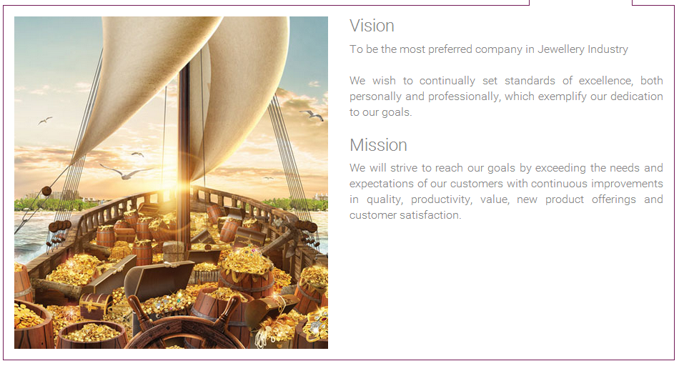

**Map Location of GOLD HOUSE COMPANY LLC**

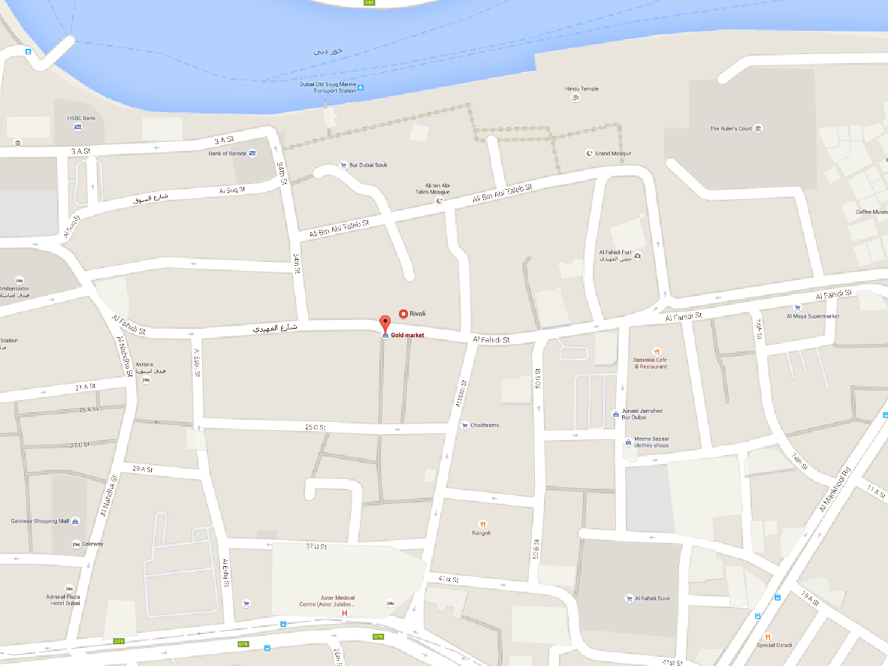

Disclaimer: If you are looking for a job in GOLD HOUSE COMPANY LLC or just looking for salary information in the company then this site is not for you because we does not provide the information that you are looking for. This site is a business directory site and not a recruitment site, if you want apply for a job you may click on the link provided bellow.