INF407: Modern Issues in Databases
Assignment 6A – Encryption Methods
Niharika Jakkula

1.Hashing Student Last Name with md5 algorithm as our password
select name_last, md5(name_last)
from student
limit 1000000;
Hashing Student First Name with des algorithm as our salt
Runtime: 0.016 sec / 1.703 sec
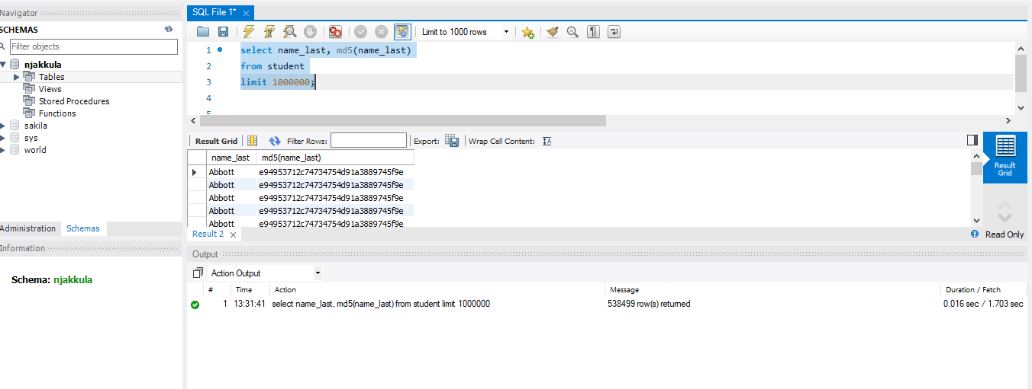
2.Hashing Student Last Name with sha1 as our password
select name_last, sha1(name_last)
from student
limit 1000000;
Runtime: 0.000 sec / 1.484 sec
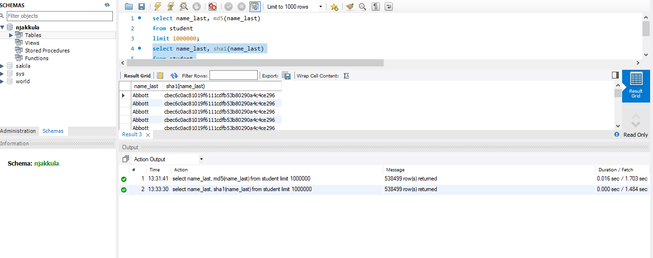
3. Hashing Student First Name with sha2 algorithm as our password
select name_last, sha2(name_last, 512)
from student
limit 1000000;
Runtime: 0.000 sec / 1.984 sec
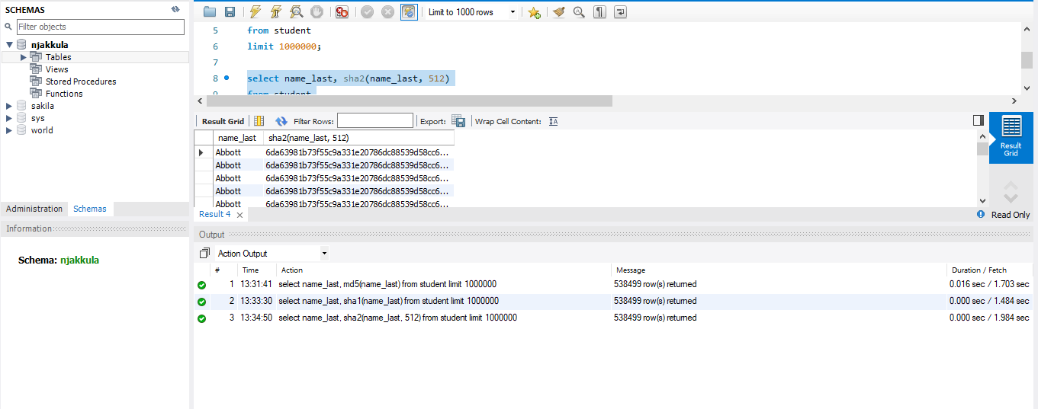 4.Using AES_Encrypt to encrypt the Name_Last
- SET block_encryption_mode = 'aes-256-cbc';
Runtime: 0.000 sec
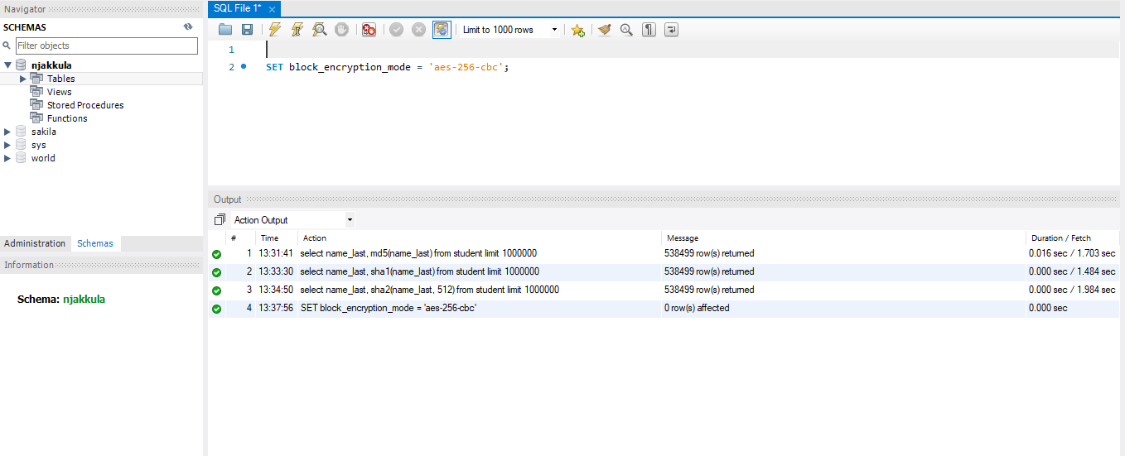

b. Set @iv =Random_Bytes(16);
Runtime: 0.000 sec
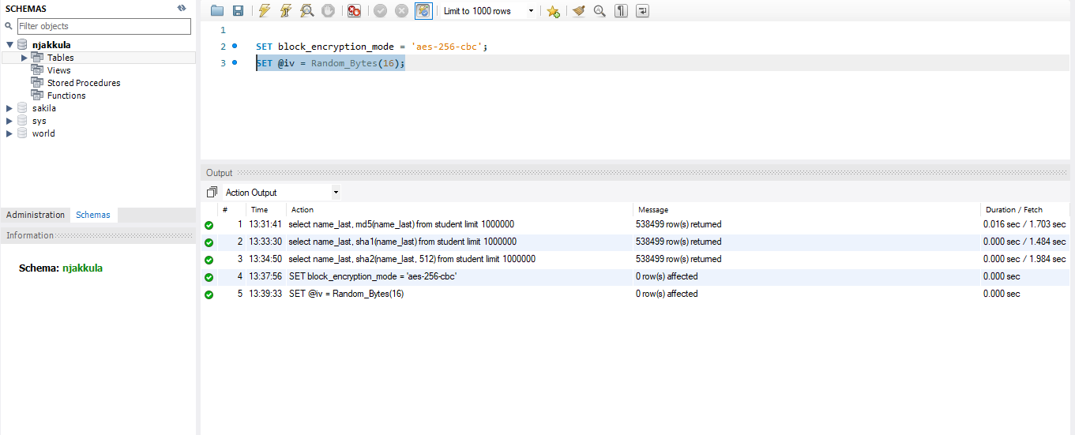
c. select name_last, name_first, aes_encrypt('name_last', 'name_first', @iv)
from student
limit 1000000;
Runtime: 0.016 sec / 1.968 sec
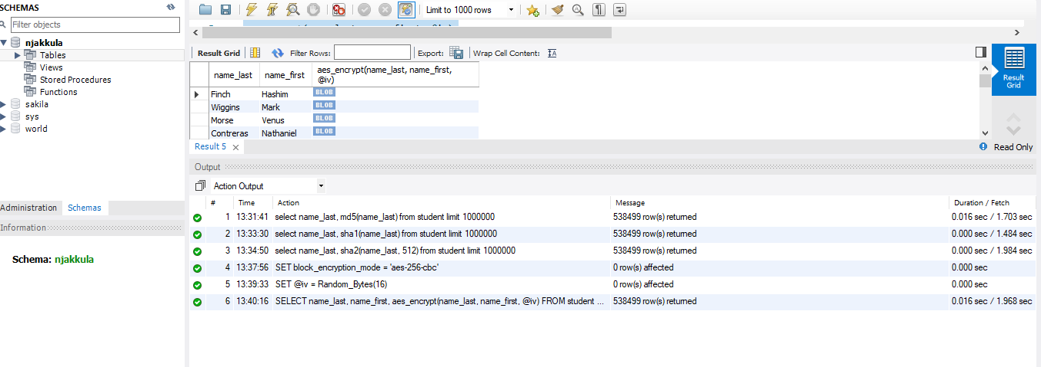
5. Updating our student table to store our secured password – note this is terrible in practice, but for illustrative purposes:
  - Alter table student
add column pword varchar(255);
Runtime: 0.094 sec
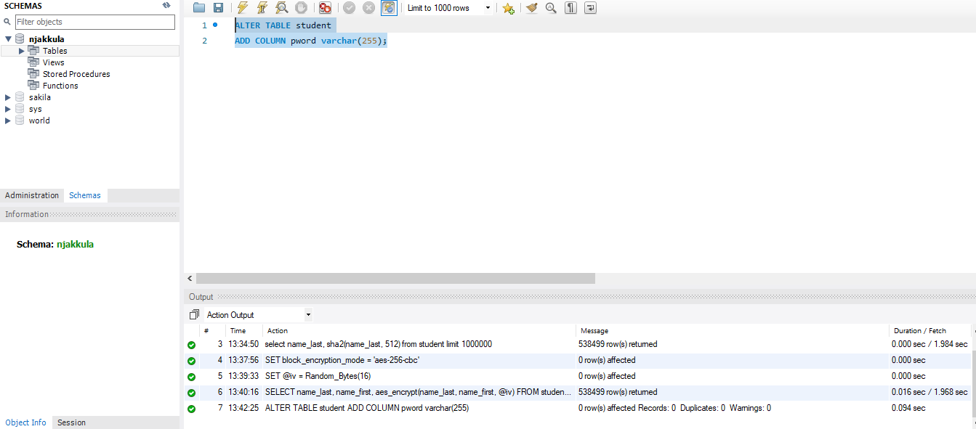

b. Set SQL_SAFE_UPDATES = 0;
Runtime: 0.000 sec
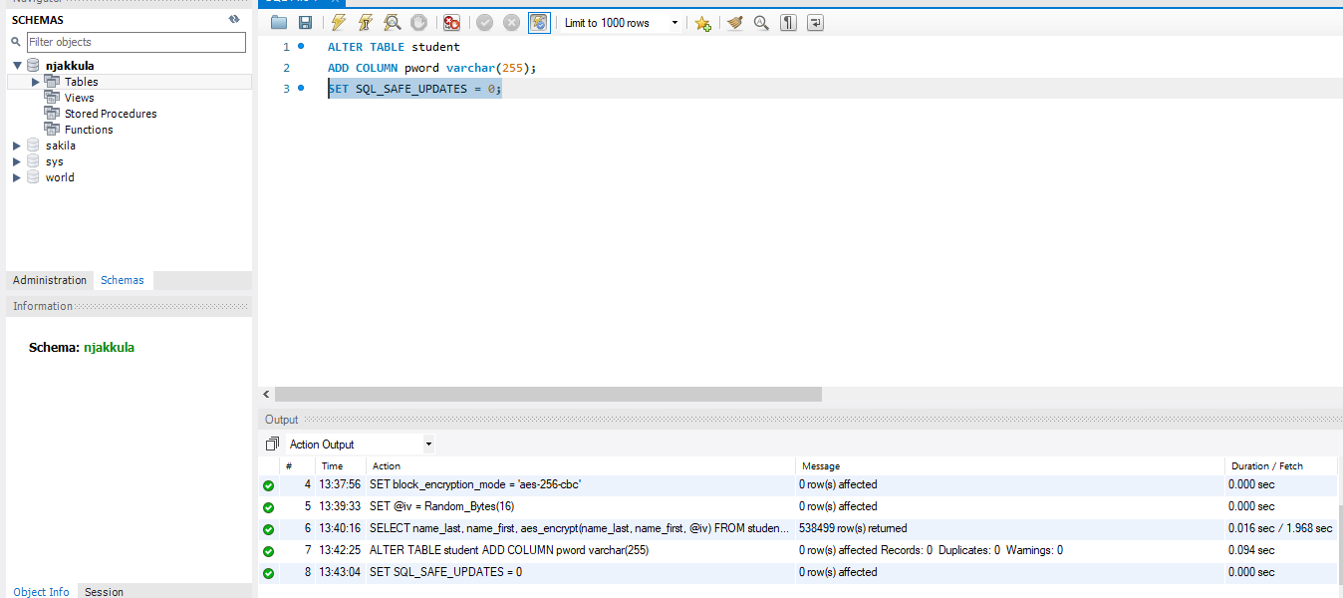

c. update student
set pword = sha2(name_last, 512);
Runtime: 28.125 sec
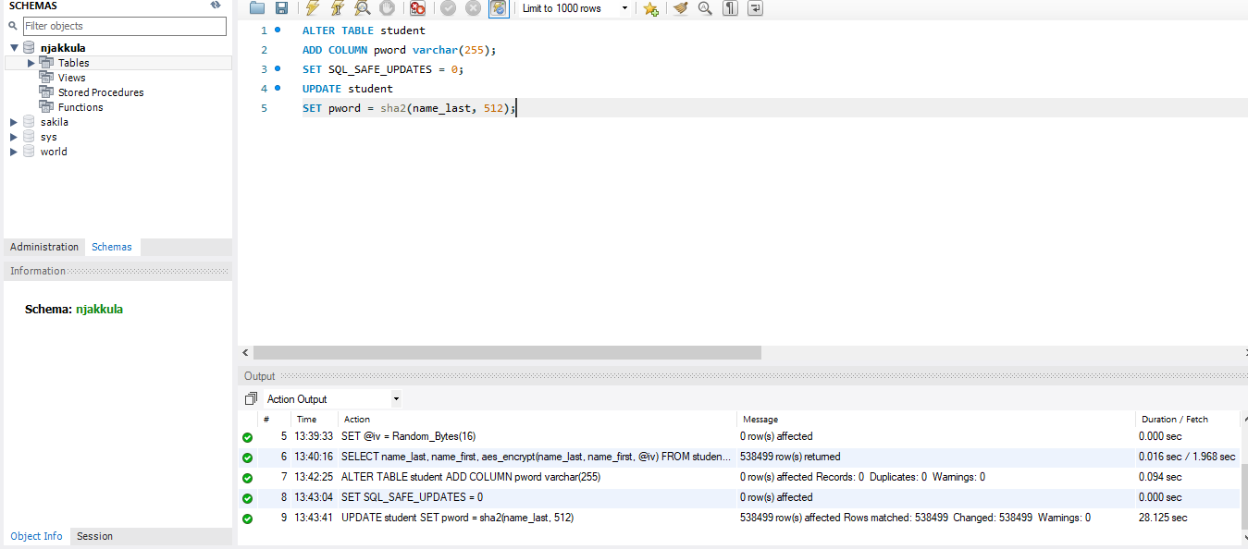

Part C: Questions / Submission
1. Which of the previous queries was the fastest?
If all commands are included, the fastest were queries 4, 5, and 8, which each completed in 0.000 seconds. These were setup or system commands:
- SET block_encryption_mode = 'aes-256-cbc';
- SET @iv = Random_Bytes(16);
- SET SQL_SAFE_UPDATES = 0;
Among the actual hashing and encryption operations, the fastest query was the SHA1 hashing query, which completed in approximately 1.484 seconds.
2. Which was the slowest?
If all commands are included, the slowest query was query 9, the update statement:
UPDATE student
SET pword = sha2(name_last,512);
This completed in approximately 28.125 seconds because it updated all 538,499 rows in the table.
Among the hashing and encryption operations only, the slowest query was the SHA2-512 hashing query, which completed in approximately 1.984 seconds.
3. Why was it beneficial to set block_encryption_mode ahead of running aes_encrypt? What does @iv do?
It was beneficial to set block_encryption_mode before running aes_encrypt because it tells MySQL which AES encryption algorithm and mode to use. In this assignment, the mode was set to aes-256-cbc, which uses a stronger 256-bit key and CBC mode for better security. Setting the mode first ensures that the encryption function uses the correct method consistently.
The @iv variable stores the Initialization Vector (IV). The IV is a random value used during encryption to add randomness so that encrypting the same data multiple times does not always create the same encrypted result. This improves security and helps prevent attackers from identifying patterns.
4. Password Security Recommendation (200–400 words)
For an online store, I would securely store user passwords using a password hashing algorithm designed specifically for passwords, such as bcrypt, Argon2, or PBKDF2. These methods are much safer than simple hashing algorithms like MD5, SHA1, or SHA2 alone because they are intentionally slow and include salting. A salt is a unique random value added to each password before hashing. This means that even if two users have the same password, their stored hashes will still be different.
I believe this gives the best balance between performance and security. Although bcrypt or Argon2 uses more server resources than faster algorithms, login attempts usually happen one user at a time, so the delay is minimal for legitimate users. However, the extra processing time greatly slows brute-force attacks and password cracking attempts. This is important for an online store because customer accounts may contain addresses, saved payment methods, and purchase history.
The worst method to use for storing passwords would be plain text because anyone who gains access to the database could immediately see every password. MD5 and SHA1 are also poor choices because they are outdated and too fast, making them easier to crack using modern hardware. AES encryption is useful for protecting data that needs to be decrypted later, but passwords should not need to be decrypted. Passwords should be hashed, not encrypted. Therefore, salted password hashing methods such as bcrypt or Argon2 are the best choice for secure password storage.

