INF407: Modern Issues in Databases
Assignment: 6B – User Roles
Niharika Jakkula

Part A:
1. Create User
Query used:
CREATE USER 'Tony_Stark'@'localhost'
IDENTIFIED BY '!ronM@n2019';
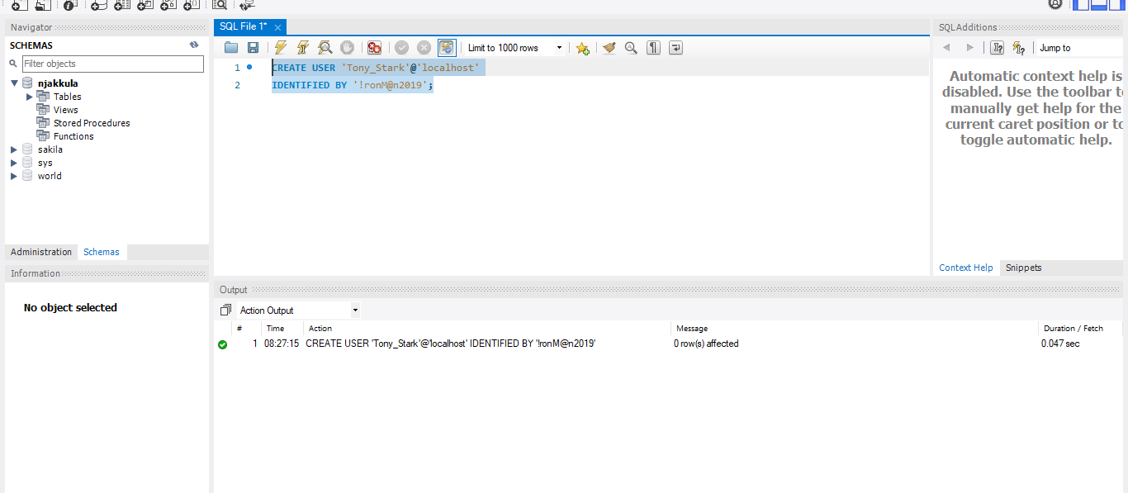
2. Grant Access to Tables
Query:
GRANT SELECT ON njakkula.address TO 'Tony_Stark'@'localhost';
GRANT SELECT ON njakkula.student TO 'Tony_Stark'@'localhost';
FLUSH PRIVILEGES;
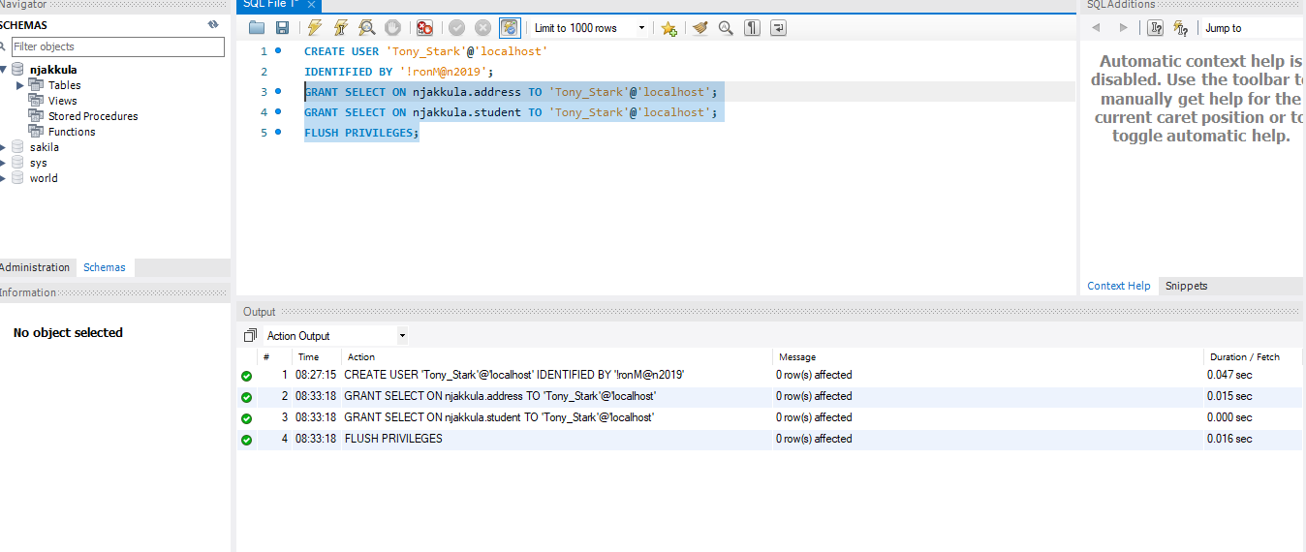
Part B
3–4. Create Connection
A new connection named Test Tony was created using the credentials:
- Username: Tony_Stark
- Password: !ronM@n2019
The connection was successfully tested and established.
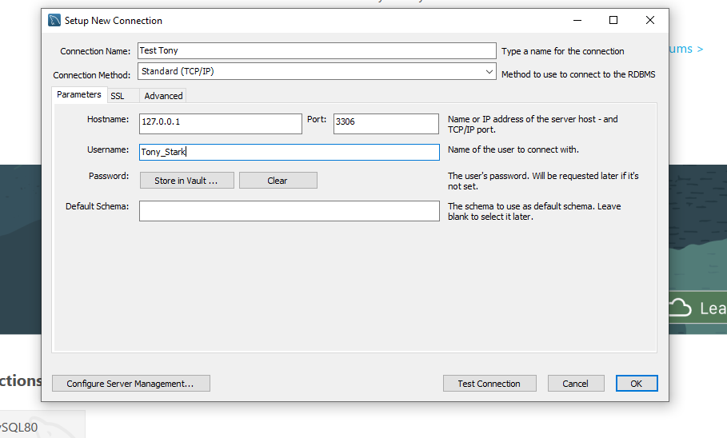
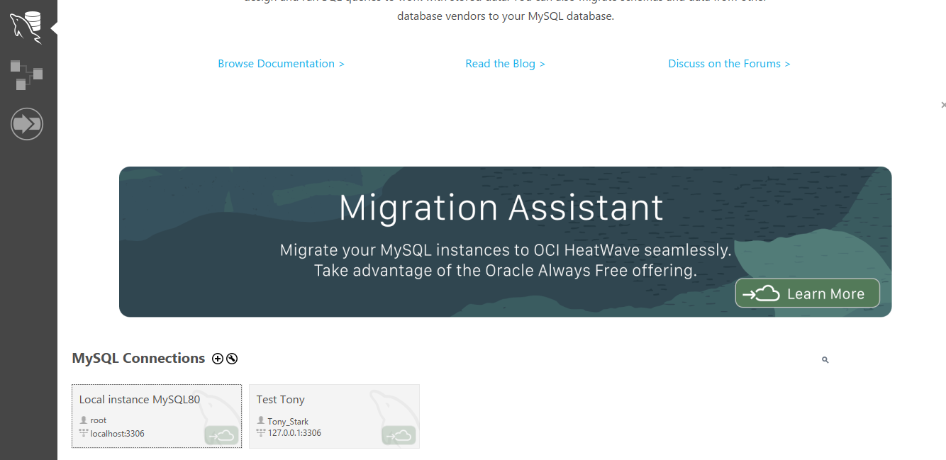
Questions:
1)
Select count(*) from Student;
what is the number that is returned?
Ans: 538499
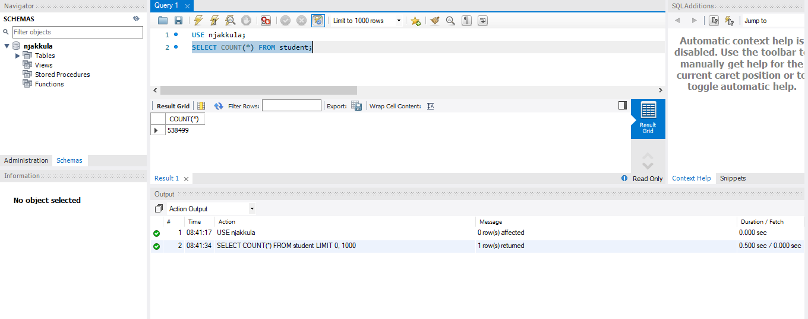
2)
select count(Name_Last)
from student join address on student.address_id = address.id
where address.Country = 'Finland';
what is the outcome?
Ans: The query returns 2452 records where students are located in Finland.

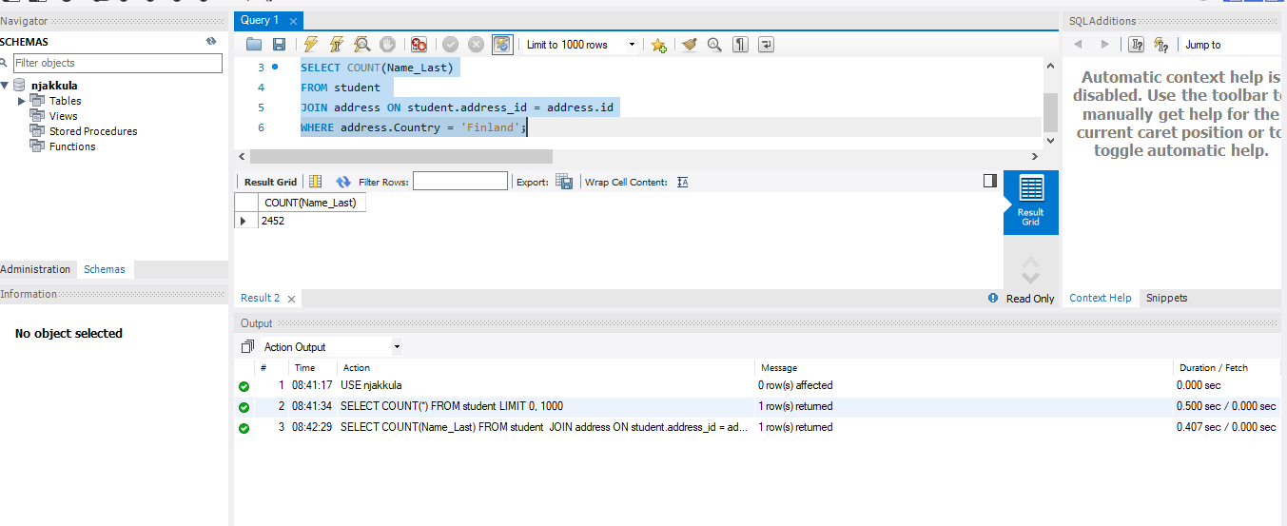
3)
Run Select * from faculty;
what is the outcome?
Ans:
Error: SELECT command denied to user 'Tony_Stark'@'localhost' for table 'faculty'
This error occurs because Tony_Stark was not granted access to the faculty table, demonstrating proper restriction of unauthorized data access.

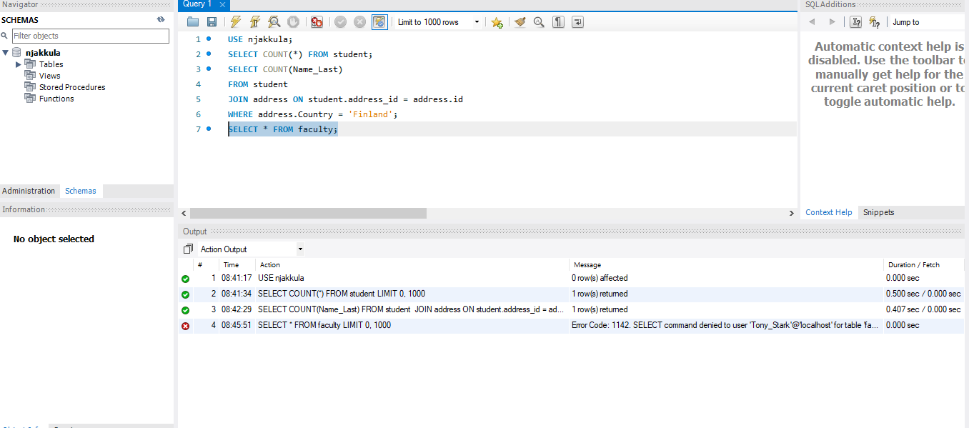
4) We’ve determined that user Tony Stark, needs access to the enrollment table, what is the query that needs to be written to provide him that access?
Ans:
GRANT SELECT ON njakkula.enrollment TO 'Tony_Stark'@'localhost';
FLUSH PRIVILEGES;
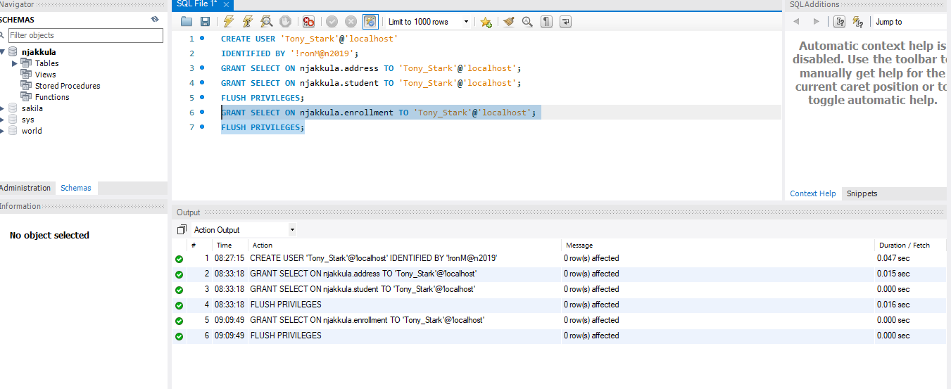
Verification of Enrollment Table Access for Tony_Stark
The access was successfully verified using the SHOW GRANTS command.
The output confirms that the user Tony_Stark has SELECT privileges on the njakkula.enrollment table.
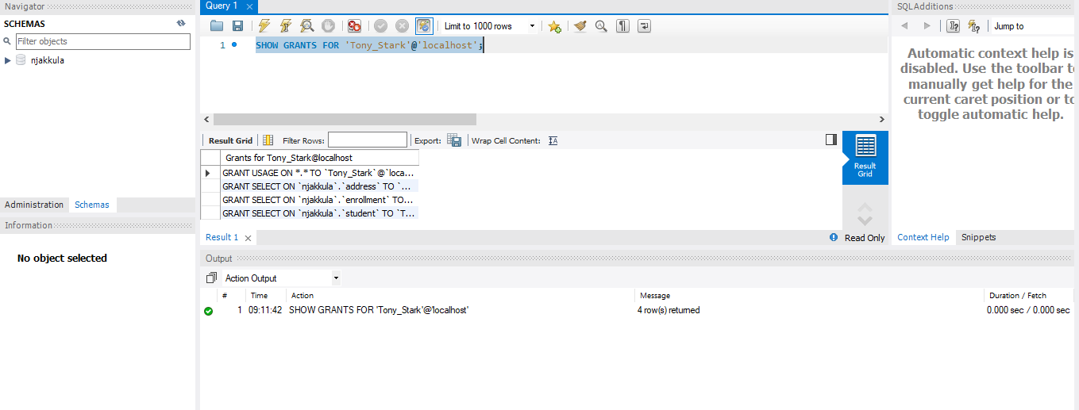
Conclusion
This assignment demonstrates proper role-based access control by granting only the necessary permissions to the user, reducing security risks and preventing unauthorized data access.

