INF407: Modern Issues in Databases
Assignment: 2B – Index Building
Niharika Jakkula

Part A: Creating Baseline Performance Metrics
Part 1
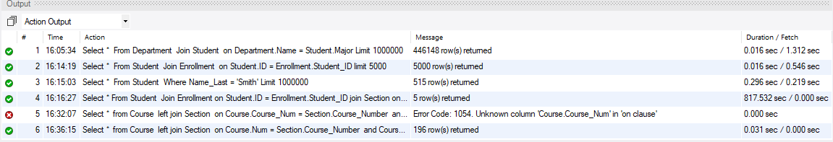
Set the following global settings:
  - SET GLOBAL sort_buffer_size=1000000;
  - SET global max_allowed_packet=1073741824;



Part B: Creating Indexes
- Based on the Module readings Alter each table to add Primary Keys listed below. Creating primary keys automatically creates indexes in MySQL, which improves query performance.

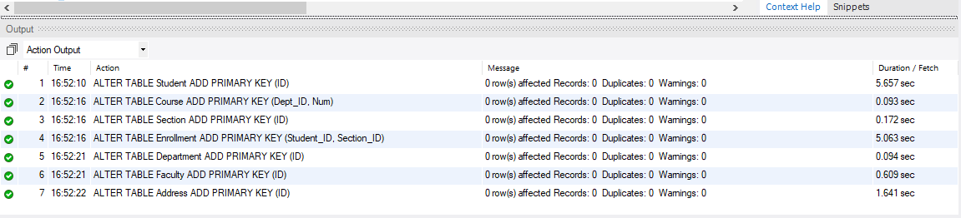
Part C:

Re-Run all 5 queries from Part A

Query | A Time | C Time
1 | 0.016 sec / 1.312 sec | 0.000 sec / 1.234 sec
2 | 0.016 sec / 0.546 sec | 0.016 sec / 0.031 sec
3 | 0.296 sec / 0.219 sec | 0.235 sec / 0.156 sec
4 | 817.532 sec / 0.000 sec | 0.656 sec / 0.000 sec
5 | 0.031 sec / 0.000 sec | 0.031 sec / 0.000 sec

Summary:
In this assignment, I recorded both the execution time and fetch time for each query, before and after creating indexes on the database tables. I noticed a clear improvement in the performance of the queries. The biggest improvement was in Query 4. Before adding indexes, this query took about 817.532 seconds, which is more than 13 minutes to run. After adding indexes, it only took about 0. 656 seconds. This is a huge improvement. The reason is that Query 4 has many joins between tables. Without indexes, MySQL had to scan entire tables to find matching data, which is very slow for large datasets. After adding indexes, the database was able to quickly find matching rows using the indexed columns, which made the query much faster.
Query 2 also showed a strong improvement. The fetch time went from 0.546 seconds to 0.031 seconds. This happened because the join between the student and enrollment tables used indexed columns (Student.ID and Enrollment.Student_ID). Indexes helped MySQL match rows more efficiently instead of scanning all records.
Query 1 and Query 3 showed only small improvements compared to the other queries. Query 3 improved from 0.219 seconds to 0.156 seconds, while Query 1 also showed only a slight change. In both cases, the improvement was limited because the queries used columns that were not indexed. Query 3 filters data based on the Name_Last column, and Query 1 joins tables using Department name and Student major. Since no indexes were created on these columns, MySQL had to perform full table scans. The small improvement in performance is likely due to caching, where data is already stored in memory after the first run, rather than because of indexing. Although I rebooted the system after the first run to reduce caching effects, minor caching or system-level optimizations may still have influenced the results.
Query 5 did not show any change in performance because it is a simple LEFT JOIN between two tables. The NULL values in the result are expected and indicate that some courses do not have matching records in the Section table. Since the query is simple and does not heavily rely on indexed columns, indexing did not make a noticeable difference in execution time.
In addition to indexing, I increased the values of sort_buffer_size and max_allowed_packet. The sort_buffer_size was increased to approximately 1 MB, which allows MySQL to use more memory for sorting operations and improves performance. The max_allowed_packet was increased to approximately 1 GB, which allows MySQL to handle larger query results without errors or delays when working with large datasets.
This assignment shows that indexes are very important for improving database performance. They help queries run faster by reducing full table scans and allowing the database to quickly locate the needed data. This saves time, especially when working with large datasets and complex queries.

