INF407: Modern Issues in Databases
Assignment: 4A – Explain and Reading Execution Plans
Niharika jakkula

- Single Table
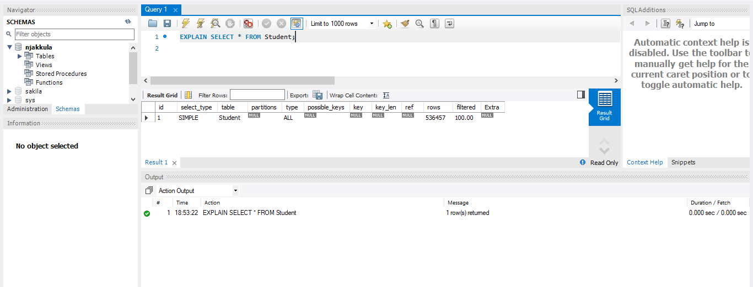
Query 1a Observation:
The execution plan shows a full table scan (type = ALL), which means the database reads every row in the Student table. Since no index is used (key = NULL), the database cannot quickly locate data and must scan the entire table, making the query slow for large datasets.
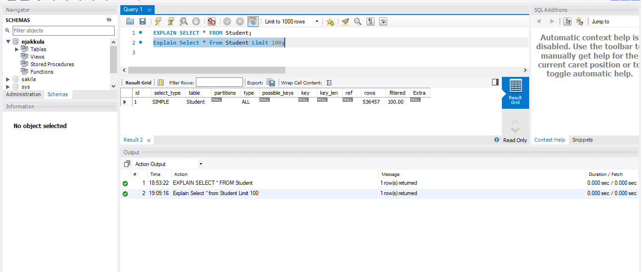
Query 1b Observation:
The execution plan still shows a full table scan (type = ALL), which means the database reads all rows from the Student table. No index is used (key = NULL). The LIMIT 100 only reduces the number of rows returned, but the database still scans the entire table to find those rows.

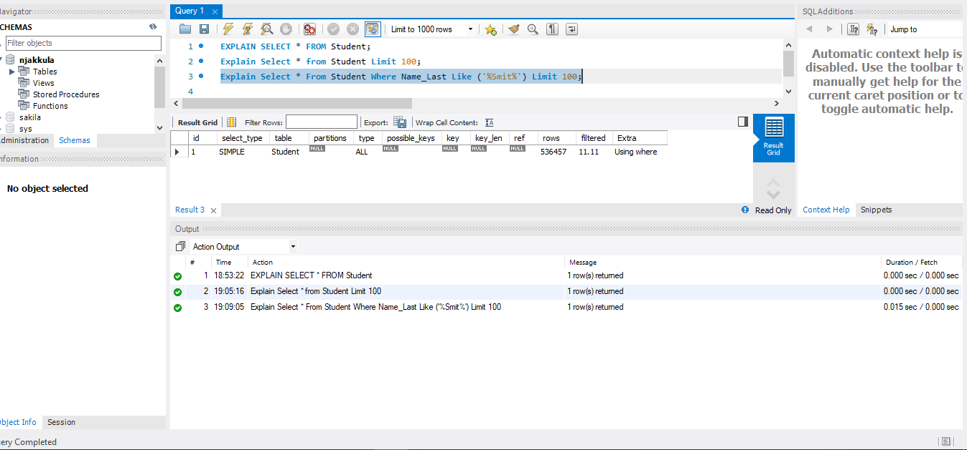 Query 1c Observation:
The execution plan shows a full table scan (type = ALL), so the database reads all rows from the Student table. No index is used (key = NULL). The condition LIKE '%Smit%' cannot use an index because it starts with a wildcard (%), so the database must check every row. "Using where" means the filtering happens after scanning the table.
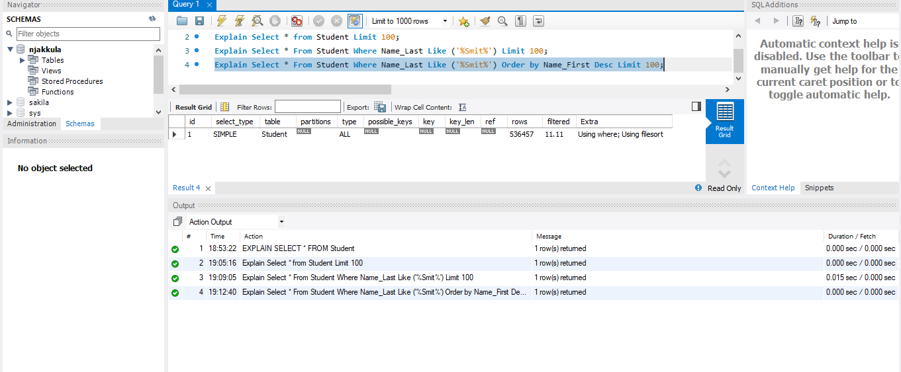 Query 1d Observation:
The execution plan shows a full table scan (type = ALL) with no index usage (key = NULL). The condition LIKE '%Smit%' prevents index usage, and the database scans all rows. The "Using where" indicates filtering, and "Using filesort" shows that an additional sorting operation is performed due to the ORDER BY clause, increasing query cost.
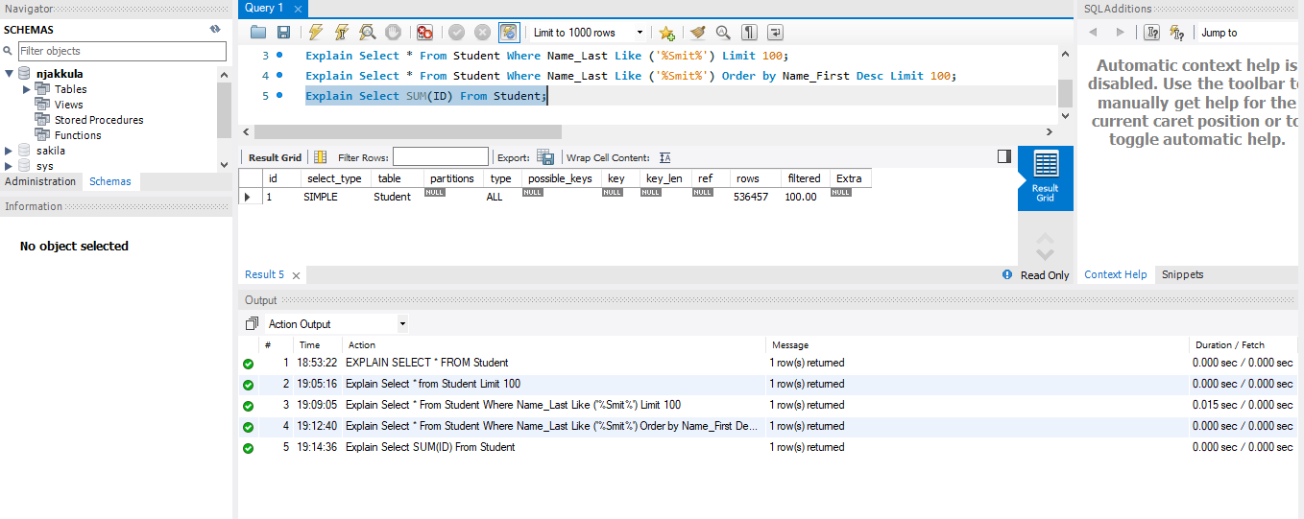 Query 1e Observation:
The execution plan shows a full table scan (type = ALL) with no index usage (key = NULL). The database scans all rows to compute the aggregate function SUM(ID), making it expensive for large datasets.
Section 1
What queries were the fastest to run?
The fastest query was SELECT * FROM Student LIMIT 100 because it returns fewer rows. Based on the execution plan, all queries still performed full table scans (type = ALL), but queries with LIMIT returned fewer rows, making them faster in practice.
What did these queries have in common?
All queries showed type = ALL and key = NULL in the execution plan, which means they performed full table scans and did not use any indexes.
Which queries used an index?
None of the queries used an index. The execution plans show key = NULL for all queries, indicating that no index was applied.
Which queries did not use an index?
All queries (1a–1e) did not use an index. The execution plans show type = ALL, meaning the database scanned the entire Student table for each query.

Section-2_Multiple Table

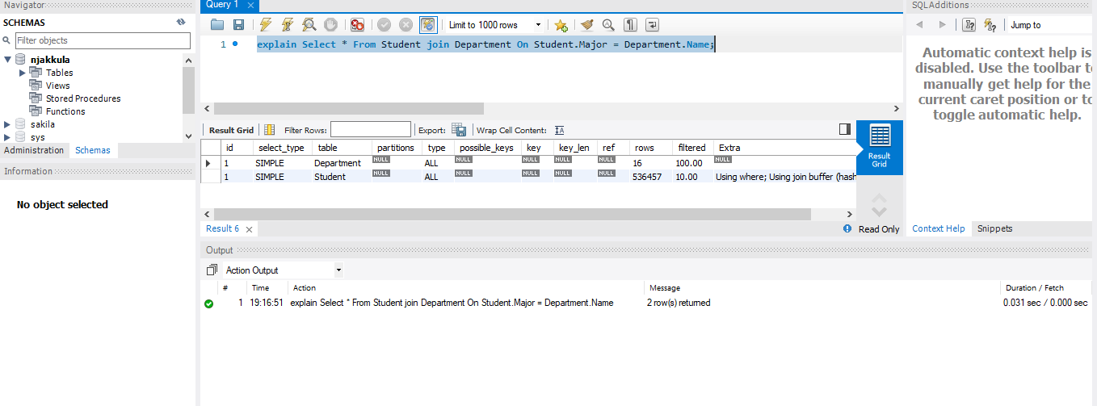Query 2a Observation:
The execution plan shows full table scans (type = ALL) on both Student and Department tables with no index usage (key = NULL). The database uses a join buffer to perform the join operation. Since no indexes are available on the join columns, both tables are scanned, making the query inefficient.
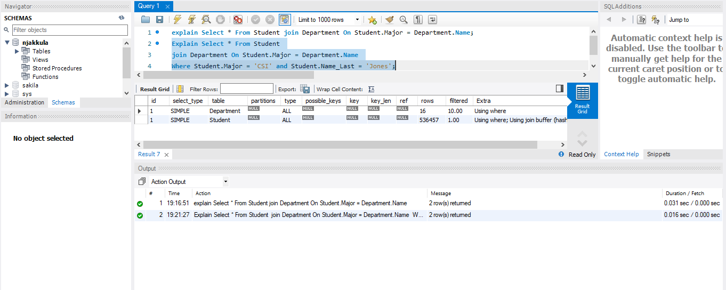
Query 2b Observation:
The execution plan shows full table scans (type = ALL) on both tables with no index usage (key = NULL). The WHERE condition filters rows after scanning, as indicated by "Using where". Although filtering reduces the number of rows processed, the database still performs full scans and uses a join buffer, making it less efficient.
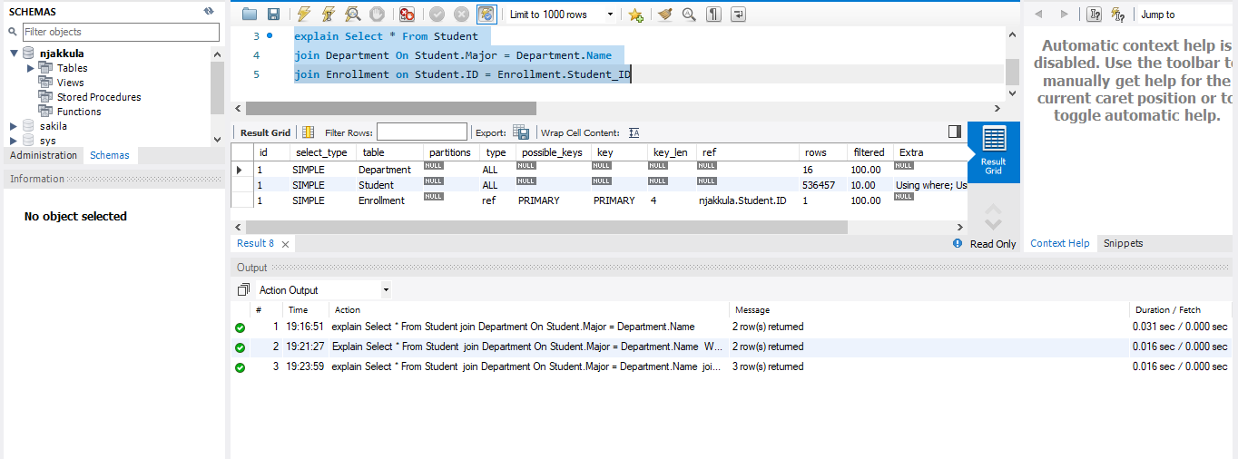 Query 2c Observation:
The execution plan shows full table scans (type = ALL) for the Student and Department tables with no index usage. However, the Enrollment table uses an index (type = ref, key = PRIMARY) for the join on Student.ID = Enrollment.Student_ID. This improves performance for the Enrollment join, while the other tables are still scanned.
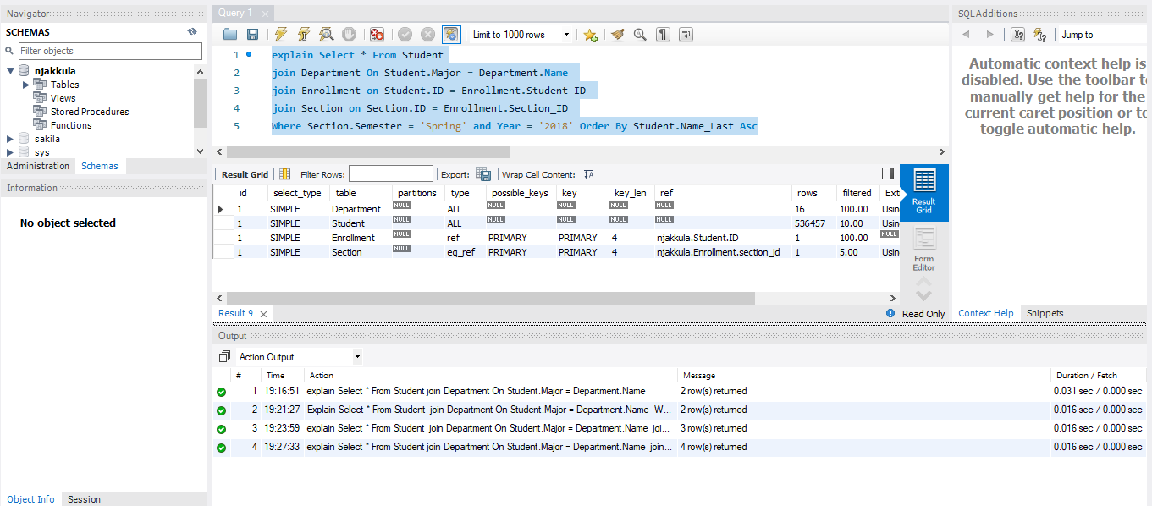
Query 2d Observation:
The execution plan shows that the Student and Department tables are fully scanned (type = ALL), meaning no index is used. The Enrollment table uses an index (type = ref), and the Section table uses a very efficient index (type = eq_ref). However, the query also needs to sort the results because of ORDER BY, which makes it slower.
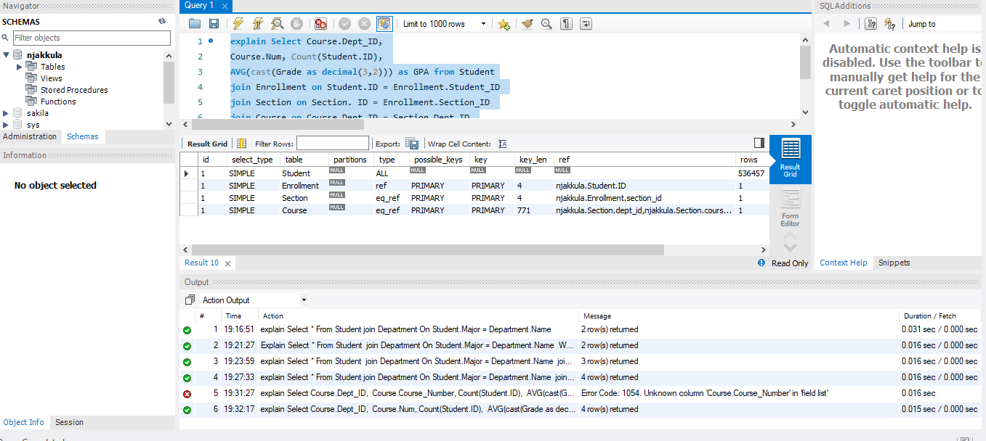
Query 2e Observation:
The execution plan shows that the Student table is fully scanned (type = ALL), meaning no index is used. The Enrollment, Section, and Course tables use indexes (type = ref and eq_ref), which makes those joins faster. However, the query also uses COUNT, AVG, and GROUP BY, which require extra processing and make the query slower.
SECTION 2
1. What queries were the fastest to run?
The fastest query was Query 2b because it uses a WHERE condition to filter the data. Although the execution plan still shows full table scans, fewer rows are processed after filtering, which makes it faster compared to other join queries.
What did these queries have in common?
Most queries performed full table scans (type = ALL) on the Student table and did not use indexes for those joins. Queries that joined using ID columns were able to use indexes, which improved performance.

2. Which queries used an index?
Queries 2c, 2d, and 2e used indexes. The execution plans show index usage (type = ref and eq_ref, key = PRIMARY) for joins involving Enrollment, Section, and Course tables.

3. Which queries did not use an index?
Queries 2a and 2b did not use indexes. The execution plans show type = ALL and key = NULL for the Student and Department tables, indicating full table scans.

Section 3

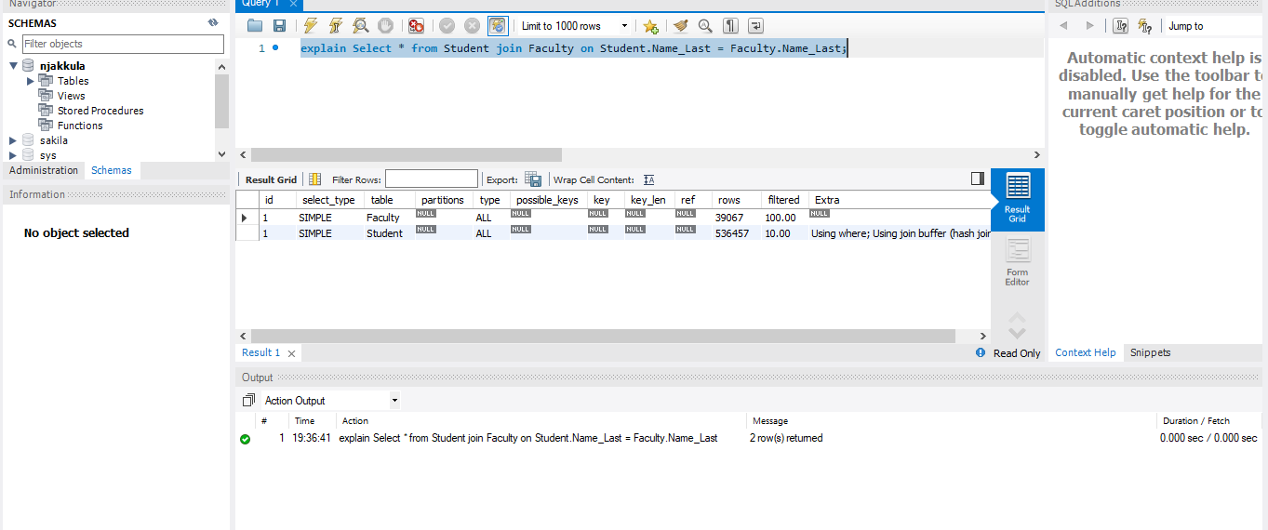 Section 3 Observation:
The execution plan shows full table scans (type = ALL) on both Student and Faculty tables with no index usage (key = NULL). The join is performed using a join buffer (hash join). Since the join is based on Name_Last, which is not indexed, the database scans both tables, making the query inefficient.
1. What queries were the fastest?
Since there is only one query in this section, it is considered the fastest by default. The execution plan shows a full table scan (type = ALL) for both tables, meaning all rows are scanned.
What do they have in common?
The query shows type = ALL and key = NULL, indicating that no index is used and both tables are fully scanned.
2. Which queries used an index?
No index is used in this query. The execution plan shows key = NULL for both Student and Faculty tables.
3. Which queries did not use an index?
The query does not use an index. The execution plan shows type = ALL, indicating full table scans on both tables.

Section 4
a)Performance of the query with the index that existed (primary keys only)

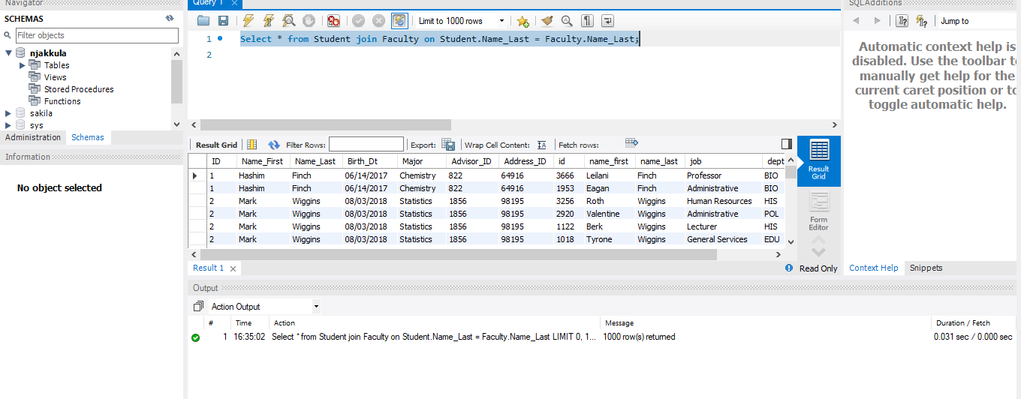
b) Performance of the query with a multiple column index on ID and Name_Last for both the Student and Faculty Table

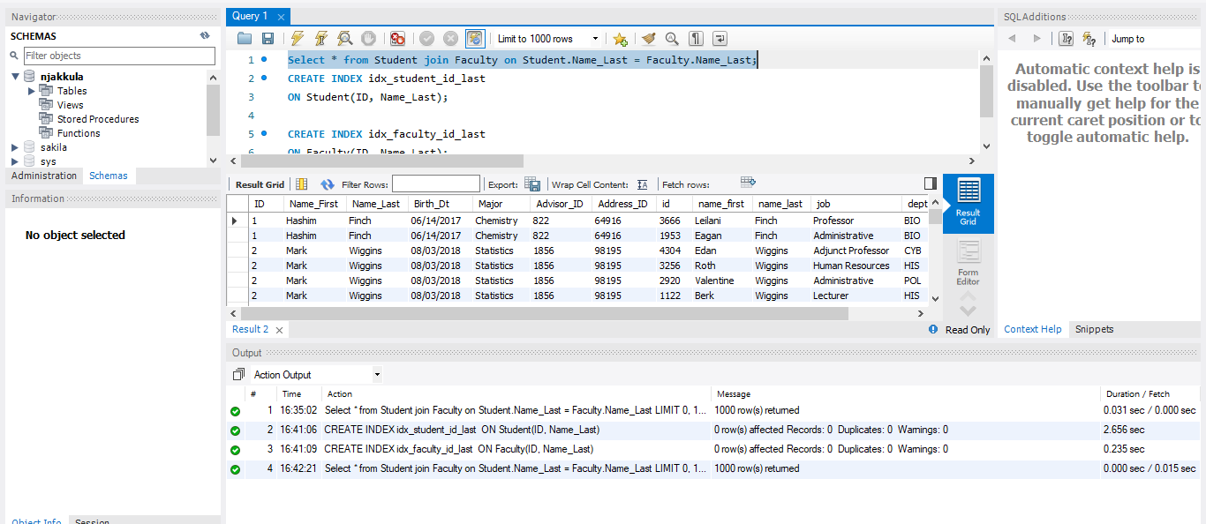

- Performance of the query with an index only on Name_Last in the Student and Faculty tables
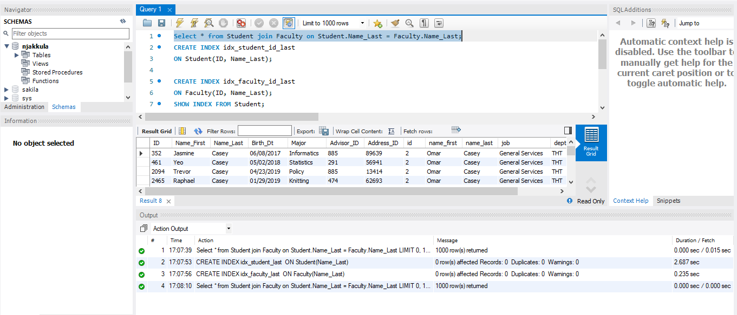

4.a run time | 4.b run time | 4.c run time
0.031 sec / 0.000 sec | 0.000 sec / 0.015 sec | 0.000 sec / 0.000 sec

Section 4: Performance Comparison
This section evaluates how the same query performs under three different indexing strategies.
4a – Primary Key Only
In this case, only the primary keys exist and there is no index on Name_Last, which is used in the join condition. As a result, the database performs a full table scan, checking all rows to find matches. This leads to slower performance, reflected in the runtime of 0.031 sec / 0.000 sec, which is the highest among the three scenarios.
4b – Multi-Column Index (ID, Name_Last)
Here, a composite index is created on (ID, Name_Last). However, since the query filters only on Name_Last and not on ID (the leading column of the index), the database cannot effectively use this index. Therefore, it still performs a full table scan or only partial index usage. The runtime (0.000 sec / 0.015 sec) shows no significant improvement compared to 4a.
4c – Index on Name_Last Only
In this case, an index is created directly on Name_Last, which matches the query condition. This allows the database to quickly locate the required rows without scanning the entire table. As a result, performance improves significantly, with the fastest runtime of 0.000 sec / 0.000 sec.
Overall Conclusion
Although the runtime differences appear small due to system limitations and measurement precision, the execution plans clearly show that:
- Indexing on the correct column (Name_Last) improves query efficiency.
- Composite indexes are only useful when the query uses the leading column.
- Proper indexing reduces the number of rows scanned and enhances performance.

