Simeng.Xiong, HW_5_6
1.
Create Table c as (
Select
m.Member_Number,
m.Number_of_member,
COALESCE(d.Total_Dining_spending, 0) AS Total_Dining_spending,
Latest_dining_Date,
COALESCE(g.Total_Golf_spending, 0) AS Total_Golf_spending,
Latest_golf_Date,
COALESCE(p.Total_Pool_spending, 0) AS Total_Pool_spending,
Latest_pool_Date,
COALESCE(t.Total_Tennis_spending, 0) AS Total_Tennis_spending,
Latest_tennis_Date,
COALESCE(o.Total_Other_spending, 0) AS Total_Other_spending,
(COALESCE(d.Total_Dining_spending, 0) +
COALESCE(g.Total_Golf_spending, 0) +
COALESCE(p.Total_Pool_spending, 0) +
COALESCE(o.Total_Other_spending, 0)) AS Total_Spending,
CASE WHEN p1.Member_Number IS NOT NULL THEN 1 ELSE 0 END AS Participated_Promo1,
CASE WHEN p2.Member_Number IS NOT NULL THEN 1 ELSE 0 END AS Participated_Promo2
From ( Select Member_Number, Count(BirthDate) AS Number_of_member
From members
group by Member_Number) m
left join ( Select Member_Number, sum(Total) AS Total_Dining_spending, MAX(Date) AS Latest_dining_Date
From dining
group by Member_Number) d
on m.Member_Number = d.Member_Number
left join (Select Member_Number, sum(Amount) AS Total_Golf_spending,MAX(Date) AS Latest_golf_Date
From golf
group by Member_Number) g
on m.Member_Number = g.Member_Number
left join ( Select Member_Number, sum(Amount) AS Total_Other_spending
From other
group by Member_Number) o
on m.Member_Number = o.Member_Number
left join ( Select Member_Number, sum(Amount) AS Total_Pool_spending,MAX(Date) AS Latest_pool_Date
From pool
group by Member_Number) p
on m.Member_Number = p.Member_Number
left join ( Select Member_Number, sum(Amount) AS Total_Tennis_spending,MAX(Date) AS Latest_tennis_Date
From tennis
group by Member_Number) t
on m.Member_Number = t.Member_Number
left join promoone p1 on m.Member_Number = p1.Member_Number
left join promotwo p2 on m.Member_Number = p2.Member_Number
Order by m.Member_Number);
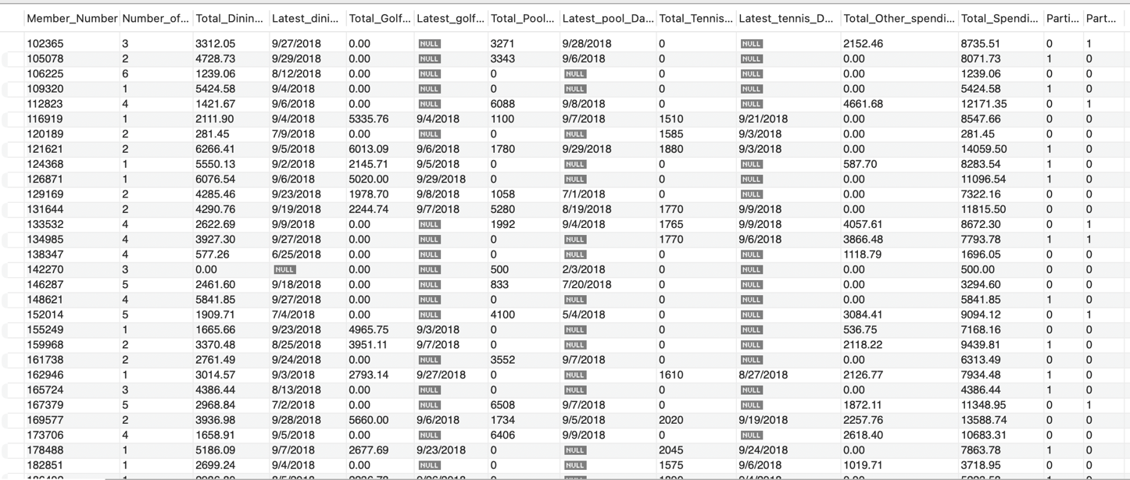

2.
Select Sum(Total_Dining_spending),
sum(Total_Golf_spending),
sum(Total_Pool_spending),
sum(Total_Tennis_spending),
sum(Total_Other_spending)
From c ;
By doing this query, we can see which part of the business is the core business for
Blue Hill CC. Through the output, we find out that the key business for Blue Hill CC is dining.

SELECT *
FROM c
WHERE Total_Spending > 15000
ORDER BY Total_Spending DESC;
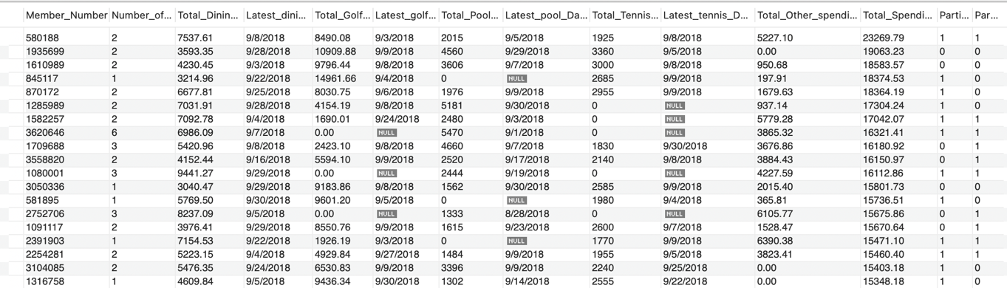
This query makes us select the member who has high spending on Blue Hill CC, and we got 22 members. Blue Hill CC should take more care on those members, and they may upgrade to something like SVIP.

3.
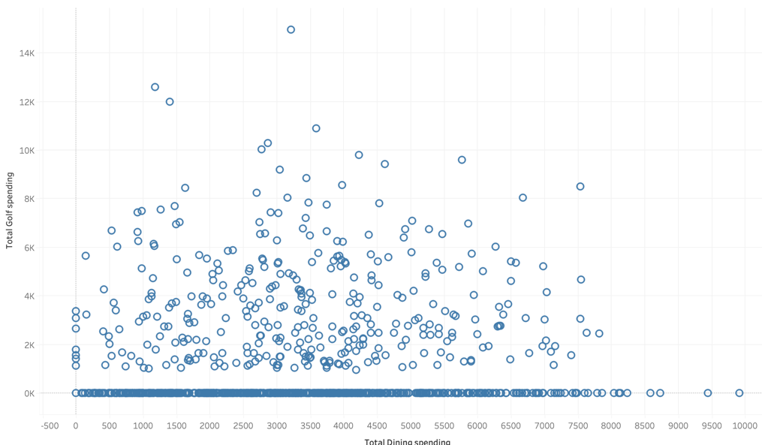
This is a scatter plot between golf spending, and dining spending. By reading this scatterplot, we can see that there is no clear correlation between golf spending and dining spending. Also, through the plot, we can see that majority of the member only spend on dining but no spending on golf.
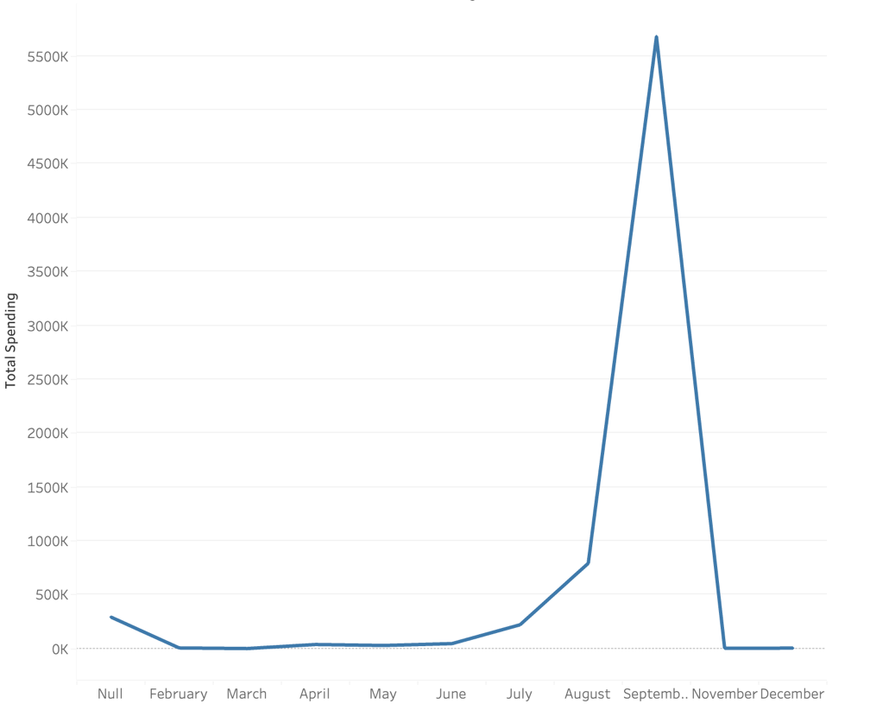
This plot is showing the total spending of members throughout the year. We can see that start from June the spending start increase and reach peak in September, then start to fall. This might be due to the summer; people have more time and more willing to come Blue Hill CC.
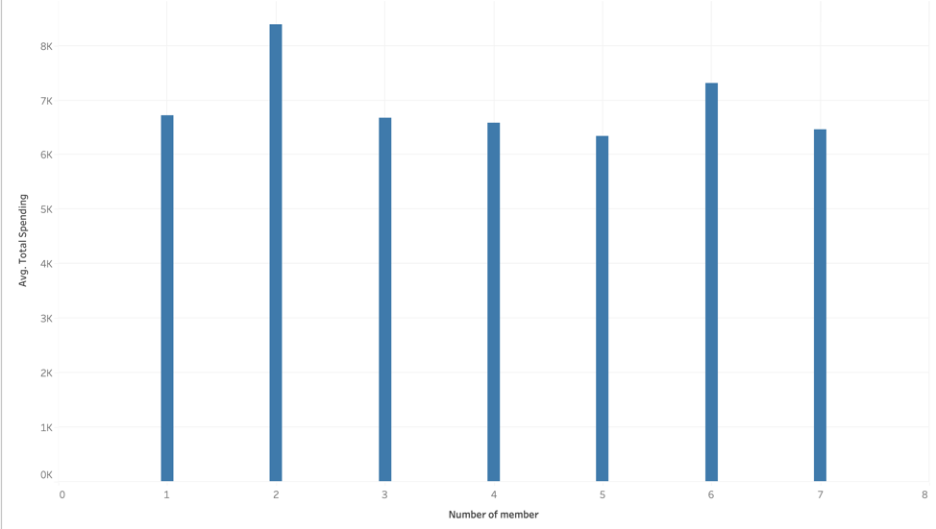
This plot shows the relationship between number of members under one membership and average total spending. Before doing the plot, I will believe more members will have higher spending. But through the plot, we can see that membership with 2 members has highest average spending.

4.
Recommendation: Sending out promotions to those membership with high dining spending and quiet low spending on golf. This group of people has ability to do golf, so sending out promotion will be useful.
SELECT
Member_Number,
Total_Dining_spending,
Total_Golf_spending
FROM c
WHERE Total_Dining_spending > 5000 AND Total_Golf_spending > 0 AND Total_Golf_spending < 3000
ORDER BY Total_Dining_spending DESC;

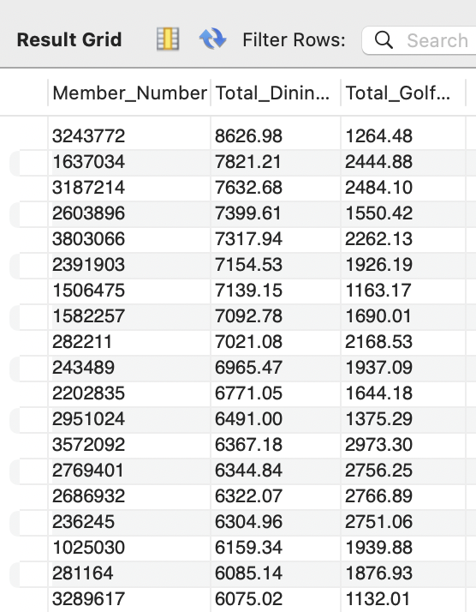
By doing the query filter, we got 46 memberships in this group. We can send the promotion to them to achieve an up-sell, and only sending limited amount of promotion can save marketing fee. Maybe sending them gift for only golf use for those people high spending on dining.
Recommendation 2: Promoting Pool Activities for Families
Members with a larger number of family members are more likely to be interested in family-friendly activities such as using the pool. Offer special family packages, such as reduced membership fees for pool activities or family swim events, targeting members with higher Number_of_member values.
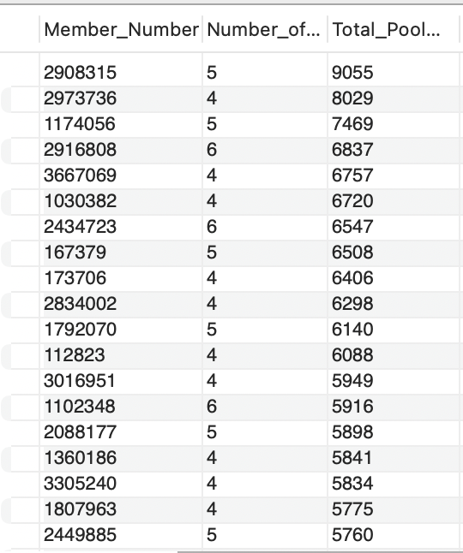
SELECT
Member_Number,
Number_of_member,
Total_Pool_spending
FROM c
WHERE Number_of_member > 3
ORDER BY Total_Pool_spending DESC;

5.
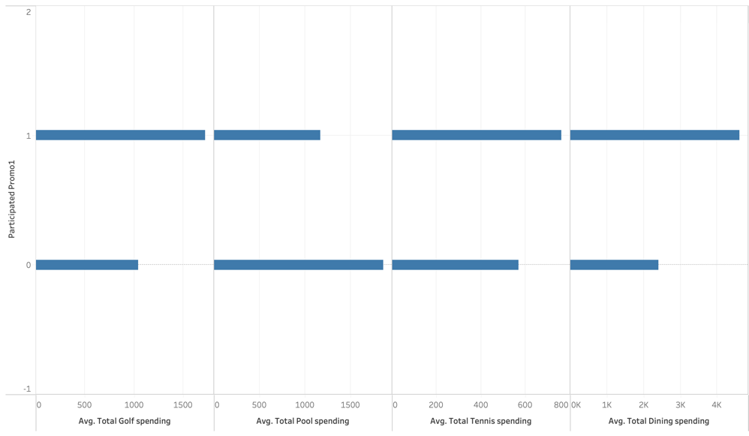
Promotion 1 do increase the average spending for golf, tennis, and dining. This suggests that Promo1 was effective in encouraging spending across these activities, potentially indicating that the promotion was designed to appeal to members who are interested in sports and dining.
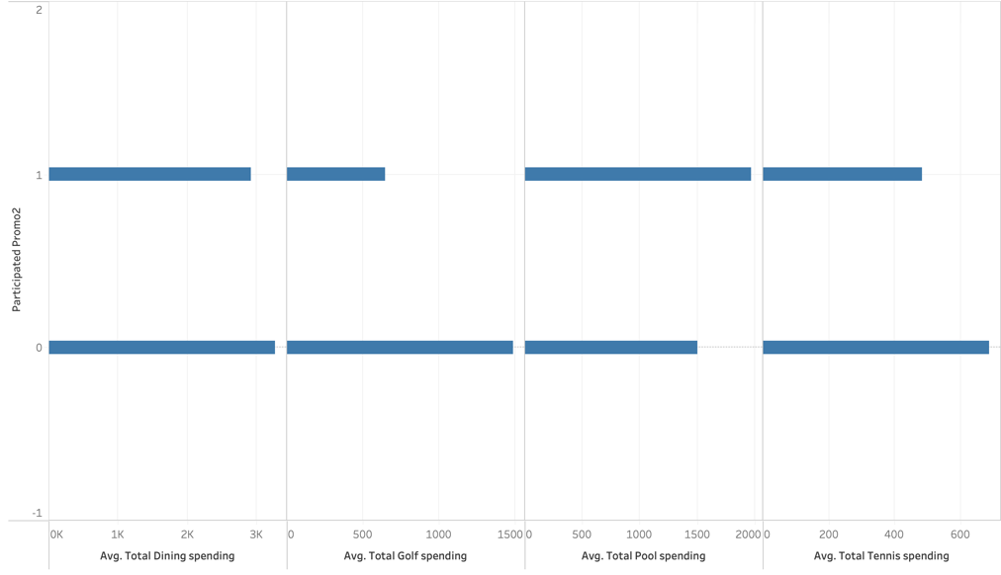
This plot is showing the impact of Promo2 on average spending across different categories. By look at the plot we can find out that Promotion 2 do success increase the average spending on pool. This suggests that Promo2 was successful in promoting pool-related activities, possibly by offering pool-specific deals or packages targeted at families or individuals interested in leisure and relaxation.

