Question 1
- 6 claims policy holder 391 made
Select Count(Claim_Number)
From claims
Where Policy_Holder_Id=391;
- 2015-05-17
Select Claim_Number,STR_TO_DATE(Claim_Date_Filed, "%m/%d/%Y")
From claims
Where Policy_Holder_Id=391
order by Claim_Date_Filed DESC;
- 23301.006902
Select Sum(Claim_Amount)
From claims
Where Policy_Holder_Id=391;

Question 2
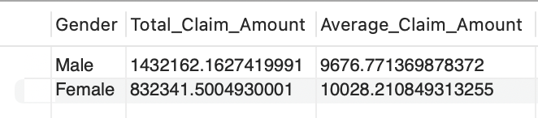
Select Gender, SUM(Claim_Amount) As Total_Claim_Amount, AVG(Claim_Amount) AS Average_Claim_Amount
From policyholders
Left Join claims
ON policyholders.PolicyHolderId = claims.Policy_Holder_Id
WHERE Claim_Type = 'Accident'
Group by policyholders.Gender;

Question 3
32 policy holders in the policyholders table did not file any claims
Select Count(PolicyHolderId)
From policyholders
Left Join claims
ON policyholders.PolicyHolderId = claims.Policy_Holder_Id
Where Claim_Date_Filed is null;

Question 4
Select Claim_Type, 'Claim Time <= 28 Days' AS Category, Count(Claim_Number)
From policyholders
Left Join claims
ON policyholders.PolicyHolderId = claims.Policy_Holder_Id
Where DATEDIFF(STR_TO_DATE(claims.Claim_Date_Settled, "%m/%d/%Y"),STR_TO_DATE(claims.Claim_Date_Filed, "%m/%d/%Y")) <=28
Group By Claim_Type
Order By Claim_Type;

Question 5
Select Count(PolicyHolderId) AS number_policyHolders,number_claims
From(
Select policyholders.PolicyHolderId, Count(Claim_Number) AS number_claims
From policyholders
Left Join claims
ON policyholders.PolicyHolderId = claims.Policy_Holder_Id
Group By PolicyHolderId) AS a
Group by number_claims
Order by number_claims;

Question 6
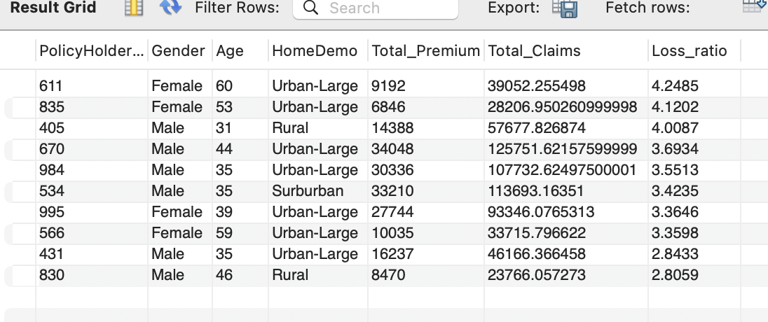
Select PolicyHolderId,Gender,Age,HomeDemo, (2018 - policyholders.YearEnrolled) * policyholders.AnnualPremium AS Total_Premium, IFNULL(SUM(Claim_Amount), 0) AS Total_Claims,
Round((IFNULL(SUM(Claim_Amount), 0))/((2018 - YearEnrolled) * AnnualPremium),4) AS Loss_ratio
From policyholders
Left Join claims
ON policyholders.PolicyHolderId = claims.Policy_Holder_Id
GROUP BY PolicyHolderId
ORDER BY Loss_ratio DESC
Limit 10
;

Question 7
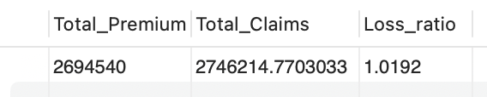
SELECT
SUM(total.Total_Premium) AS Total_Premium,
IFNULL(SUM(total.Total_Claims), 0) AS Total_Claims,
ROUND(IFNULL(SUM(total.Total_Claims) / SUM(total.Total_Premium), 0), 4) AS Loss_ratio
FROM (
SELECT
policyholders.PolicyHolderId,
(2018 - policyholders.YearEnrolled) * policyholders.AnnualPremium AS Total_Premium,
IFNULL(claim_totals.Total_Claims, 0) AS Total_Claims
FROM policyholders
LEFT JOIN (
SELECT
Policy_Holder_Id,
SUM(Claim_Amount) AS Total_Claims
FROM claims
GROUP BY Policy_Holder_Id
) AS claim_totals
ON policyholders.PolicyHolderId = claim_totals.Policy_Holder_Id
) AS total
;

Question 8
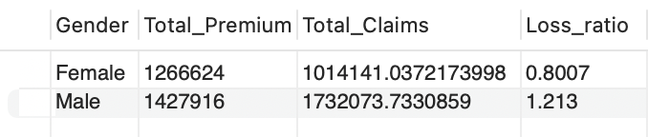
SELECT
SUM(total.Total_Premium) AS Total_Premium,
IFNULL(SUM(total.Total_Claims), 0) AS Total_Claims,
ROUND(IFNULL(SUM(total.Total_Claims) / SUM(total.Total_Premium), 0), 4) AS Loss_ratio
FROM (
SELECT
policyholders.PolicyHolderId,
(2018 - policyholders.YearEnrolled) * policyholders.AnnualPremium AS Total_Premium,
IFNULL(claim_totals.Total_Claims, 0) AS Total_Claims
FROM policyholders
LEFT JOIN (
SELECT
Policy_Holder_Id,
SUM(Claim_Amount) AS Total_Claims
FROM claims
GROUP BY Policy_Holder_Id
) AS claim_totals
ON policyholders.PolicyHolderId = claim_totals.Policy_Holder_Id
) AS total
;

