2. Noisy MNIST Fashion classification

Report classification accuracy for the clean test images



Report classification accuracy for the noisy test images



Define a CNN autoencoder model to denoise the noisy images and train it using noisy training images - plot examples

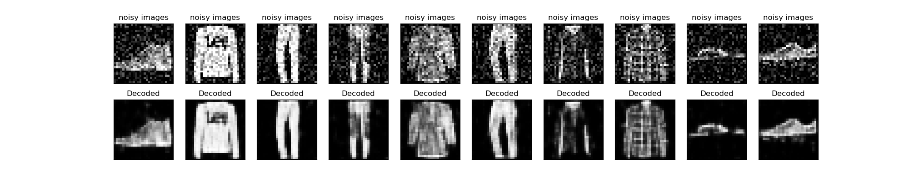

Report classification accuracy for autoencoder denoised test images



Train the original model with noisy train images and report accuracy for noisy test images

