BUILDING A SMARTER AI POWERED SPAM CLASSIFIER

TEAM MEMBER

NIJANTH DERIXON A

PHASE 3

DEVELOPMENT PART 1

TOPIC:BUILDING A SMARTER AI POWERED SPAM CLASSIFIER

INTRODUCTION:

Building a smarter AI-powered spam classifier is a crucial step in our ongoing battle against unwanted and potentially harmful communication. To create an effective solution, one of the foundational tasks is loading and preprocessing the dataset. This process lays the groundwork for training a robust and accurate spam filter capable of distinguishing between legitimate and unsolicited content.

The journey to building a smarter AI-powered spam classifier begins with the acquisition of a well-structured and diverse dataset. This dataset should contain a representative sample of both spam and legitimate messages, reflecting the complexities and nuances of real-world communication. Once we have collected this dataset, the subsequent steps of loading and preprocessing it are essential for the following reasons:

Data Understanding: By loading the dataset, we can gain insights into its structure and characteristics. This is vital in understanding the nature of the data, such as the format of messages, any accompanying metadata, and the distribution of spam versus non-spam content.

Data Cleaning: Spam datasets can be noisy, containing a wide range of text types, formats, and possibly irrelevant information. Preprocessing involves cleaning and sanitizing the data by removing duplicates, irrelevant content, and any inconsistencies that may hinder model training.

Text Normalization: Messages within the dataset may exhibit variations in capitalization, punctuation, and special characters. Text normalization techniques, such as lowercasing and removing punctuation, ensure that the data is consistent and easier for the AI model to process.

Tokenization: To make the text data machine-readable, we tokenize the messages into individual words or subword units. This step is critical for converting raw text into numerical representations that AI models can work with effectively.

Feature Engineering: During preprocessing, we can create additional features like word frequencies, n-grams, or embeddings to provide more context to the AI model, improving its ability to identify spam messages accurately.

GIVEN DATA SET

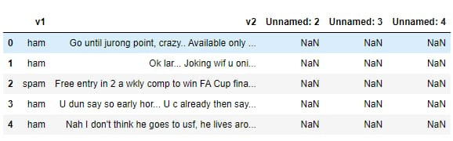

NECESSARY STEPS TO FOLLOW

- IMPORT LIBRARIES:

Start by improving the necessary libraries

PROGRAM:

%matplotlib inline
import matplotlib.pyplot as plt
import csv
import sklearn
import pickle
from wordcloud import WordCloud
import pandas as pd
import numpy as np
import nltk
from nltk.corpus import stopwords
from sklearn.feature_extraction.text import CountVectorizer, TfidfTransformer
from sklearn.tree import DecisionTreeClassifier
from sklearn.model_selection import GridSearchCV,train_test_split,StratifiedKFold,cross_val_score,learning_curve

Loading the Dataset

data = pd.read_csv('dataset/spam.csv', encoding='latin-1')data.head()
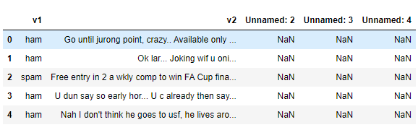

3.Removing unwanted columns
From the above figure, we can see that there are some unnamed columns and the label and text column name is not intuitive so let's fix those in this step.
data = data.drop(["Unnamed: 2", "Unnamed: 3", "Unnamed: 4"], axis=1)data = data.rename(columns={"v2" : "text", "v1":"label"})data[1990:2000]
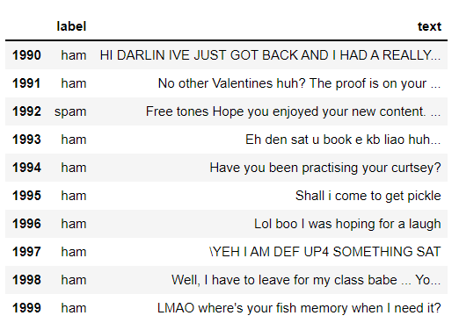
now that the data is looking pretty, let's move on.
data['label'].value_counts()# OUTPUTham 4825spam 747Name: label, dtype: int64

4.Preprocessing and Exploring the Dataset
If you are completely new to NLTK and Natural Language Processing(NLP) I would recommend checking out this short article before continuing.
import nltk packages and Punkt Tokenizer Modelsimport nltknltk.download("punkt")import warningswarnings.filterwarnings('ignore')

5.Removing punctuation and stopwords from the messages
Punctuation and stop words do not contribute anything to our model, so we have to remove them. Using NLTK library we can easily do it.
import nltk
nltk.download('stopwords')
#remove the punctuations and stopwords
import string
def text_process(text):
text = text.translate(str.maketrans('', '', string.punctuation))
text = [word for word in text.split() if word.lower() not in stopwords.words('english')]
return " ".join(text)
data['text'] = data['text'].apply(text_process)
data.head()
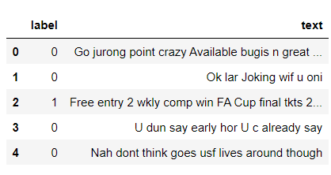
Now, create a data frame from the processed data before moving to the next step.
text = pd.DataFrame(data['text'])label = pd.DataFrame(data['label'])

IMPORTANCE OF LOADING AND DATASET

Loading and preprocessing a dataset is a critical and foundational step in data analysis, machine learning, and artificial intelligence for several important reasons:

Data Understanding: Loading the dataset allows you to familiarize yourself with its structure, contents, and format. This understanding is crucial for making informed decisions throughout the analysis process.

Data Quality Assurance: Preprocessing begins with data quality control. You can identify and rectify missing values, errors, duplicates, and inconsistencies in the data, ensuring that the analysis is based on accurate and reliable information.

Data Cleaning: Datasets are often noisy, and preprocessing helps clean the data by removing irrelevant or redundant information, making it more suitable for analysis.

Data Transformation: Different algorithms require data in specific formats. For example, text data may need to be tokenized, numerical features may require scaling, and categorical variables may need encoding. Preprocessing ensures that the data is in the right format for machine learning algorithms.

Data Consistency: Maintaining consistent data formatting, such as date formats or categorical values, streamlines the analysis and model training process, reducing errors and improving efficiency.

let's use the above functions to create Spam word cloud and ham word cloud.
spam_wordcloud = WordCloud(width=500, height=300).generate(spam_words)ham_wordcloud = WordCloud(width=500, height=300).generate(ham_words)
#Spam Word cloudplt.figure( figsize=(10,8), facecolor='w')plt.imshow(spam_wordcloud)plt.axis("off")plt.tight_layout(pad=0)plt.show()
#Creating Ham wordcloudplt.figure( figsize=(10,8), facecolor='g')plt.imshow(ham_wordcloud)plt.axis("off")plt.tight_layout(pad=0)plt.show()
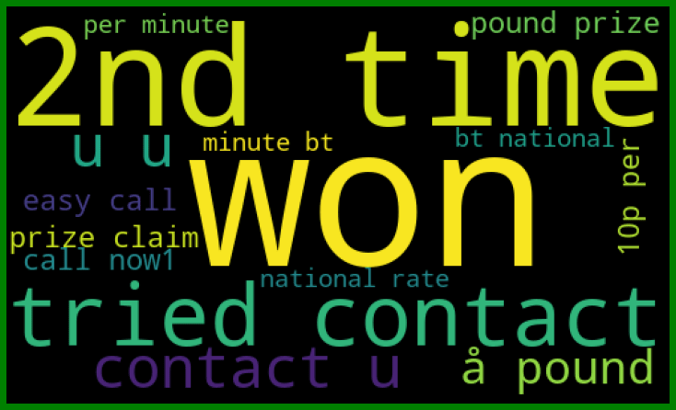
from the spam word cloud, we can see that "free" is most often used in spam.
Now, we can convert the spam and ham into 0 and 1 respectively so that the machine can understand.
data = data.replace(['ham','spam'],[0, 1])data.head(10)
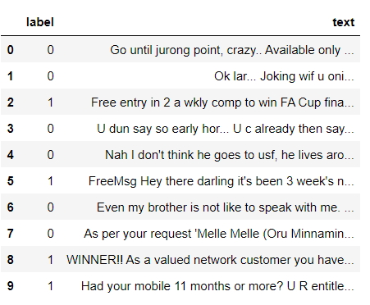

Conclusion

In summary, loading and preprocessing a dataset are indispensable steps in the data analysis and modeling workflow. Properly prepared data is the foundation for building accurate and reliable machine learning and AI models. It enhances the efficiency and effectiveness of the modeling process and plays a pivotal role in various domains, including data science, natural language processing, image recognition, and many others.

