Student: Nijat Alammadov

Subject: Operating Research

Topic: N-Queens Problems(9x9) with GA

Firstly we must understand the problem.It is one of the well-known Operating Research topic.Here we have got one chessboard.We set the size of chessboard.It is not be less than 4.Our chessboard consist 9x9 column and row.Here no two queens threaten each other. The eight queens puzzle is an example of the more general n queens problem of placing n non-attacking queens on an n×n chessboard. There are 92 different solutions to the eight queens puzzle. The puzzle contains 12 solutions if solutions that differ only by the symmetry operations of rotation and reflection of the board are counted as one. Fundamental solutions are what they're called.Here are two of them:

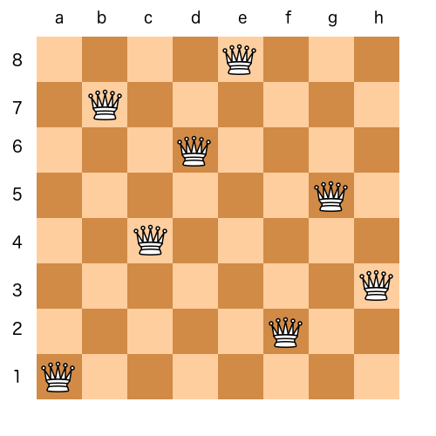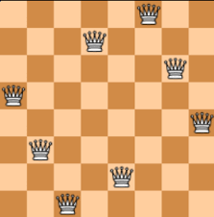

Today we must write this problem on 9x9 chessboard.Im using C++ console for writing this algorithm.I create a chessboard 9x9 iam using random() for everytime check different numbers.We have 92 solutions, so in my console we must waiting 5 or 6 minutes for see all the solutions.In console we can see only 9 numbers that shows the place of every queen on the chessboard.Here are following pictures some main codes from my algorithm:

