**Rubik Board**

This game is a two dimension variant of the Rubik cube. The board of the game consists of *n* x *n* fields. There are *n* different colors, and exactly *n* fields have the same color. The fields are shuffled initially. A player can move cyclically the colors of a row or column (e.g. moving a row to the right, the color of the first field will be the color the last field) to make homogenous rows and columns. The game ends, when each row (or column) contains one color.

Implement this game, and let the board size be selectable (2x2, 4x4, 6x6). The game should recognize if it is ended, and it has to show in a message box how much steps did it take to solve the game. After this, a new game should be started automatically.

**Classes:**

* *Main.java*
* *Board.java*
* *RubikDesign.java*

**Methods:**

returnRandNums(int a,int z): int[]

It takes 2 number and return set between them, I use it for shuffle so making new colors and placement of them

CreateColors ():void

Wirh that method, I am placing different colors to different location.

ShuffleOnBoard():void

I use that method for shuffle board when u win and start second round. Difference from *createColors().*

checkSize2():void

if size of board is 2*2, this method activated by CheckWin() method, it checks win state and if wined it opens Info box and returns the number of steps.

checkSize4():void

if size of board is 4*4, this method activated by CheckWin() method, it checks win state and if wined it opens Info box and returns the number of steps.

checkSize6():void

if size of board is 6*6, this method activated by CheckWin() method, it checks win state and if wined it opens Info box and returns the number of steps.

CheckWin(n):

Check win statements by size of board with using checksize$**N**

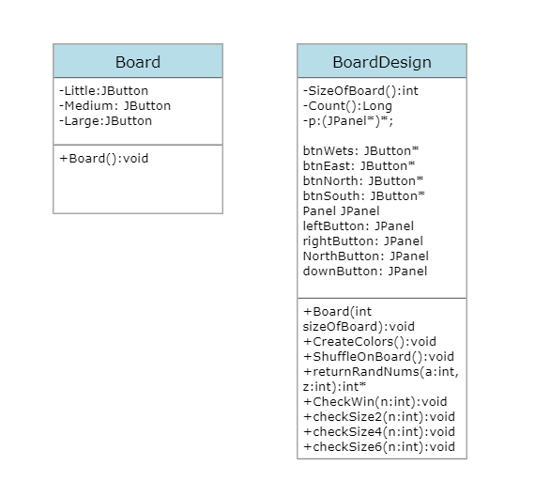

**Test Cases:**

**1)start statement in all sizes**

**2)win statement in all sizes**