

CSE302(Section 2)

Lab Assignment Submission Report

Assignment Title:

**Introduction to Oracle Database XE and SQLPlus Tool for writing SQL queries**

Submitted by:

Mujahidul Islam

2019-2-60-072

**SCREENSHOTS:**

Problem 1(a):

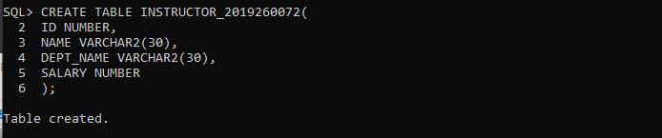

Problem 1(b):

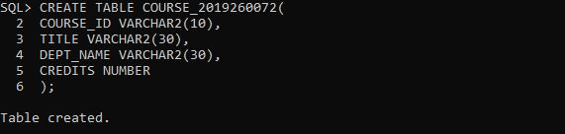

Problem 2(a):

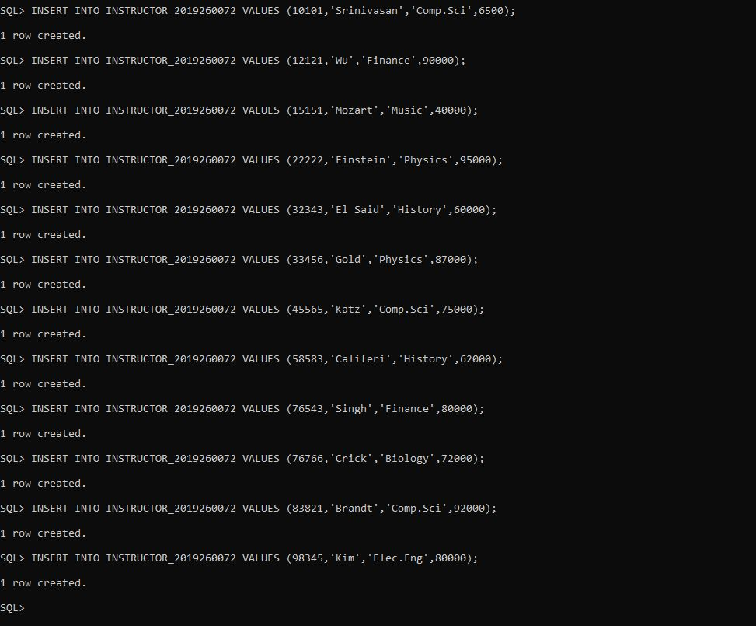

Problem2(b):

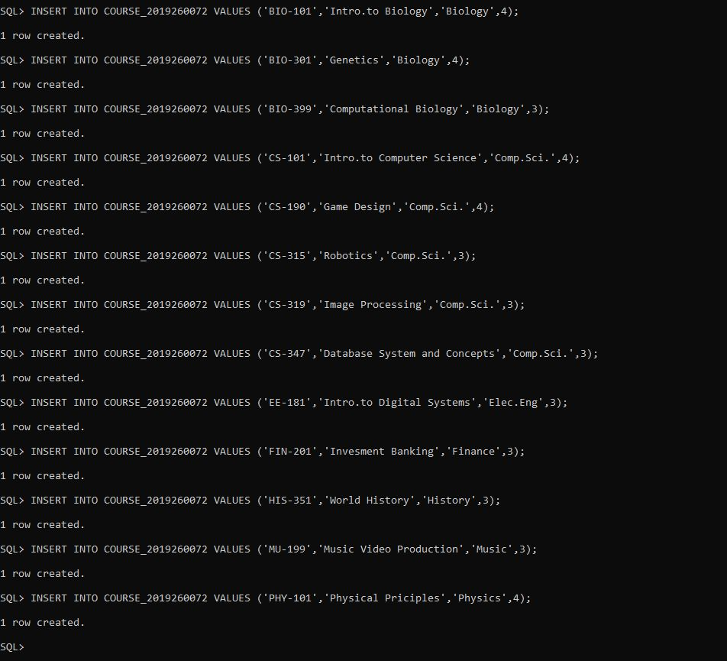

Problem 3:

i)

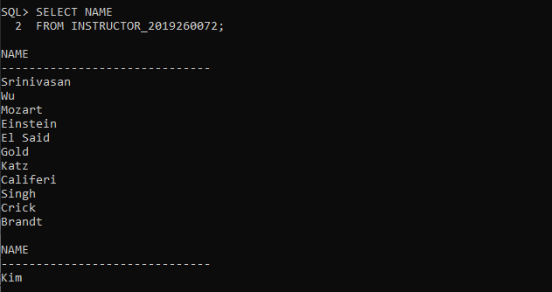

ii)

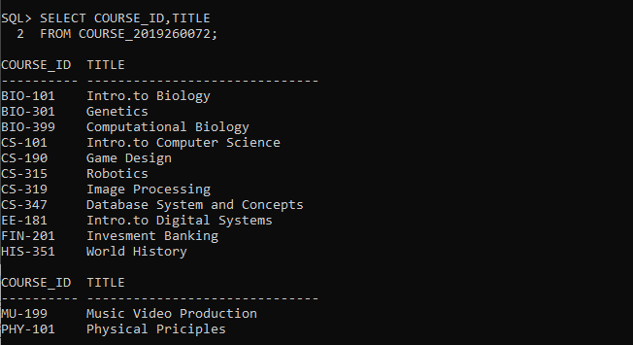iii)

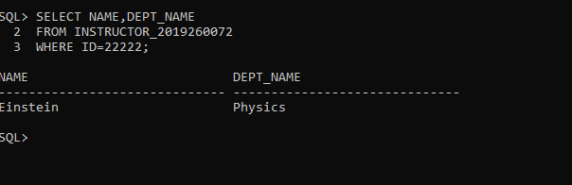

iv)

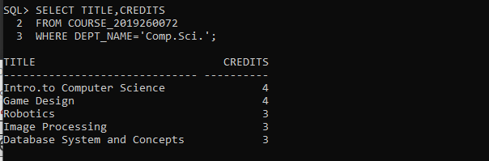

v)

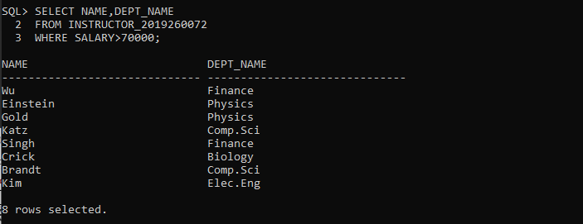

vi)

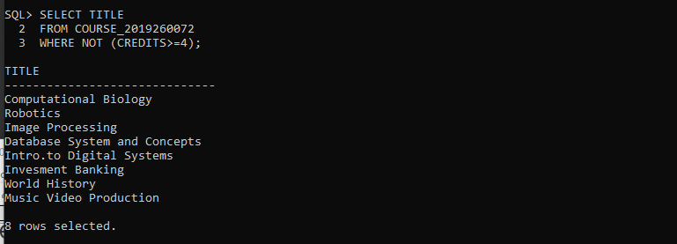

vii)

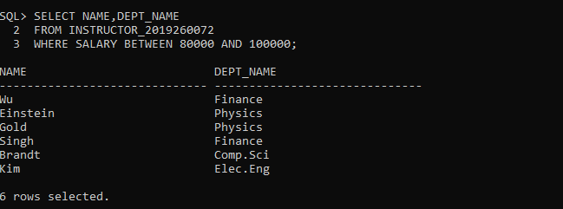

viii)

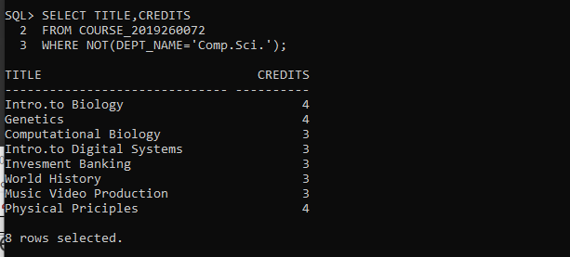

ix)

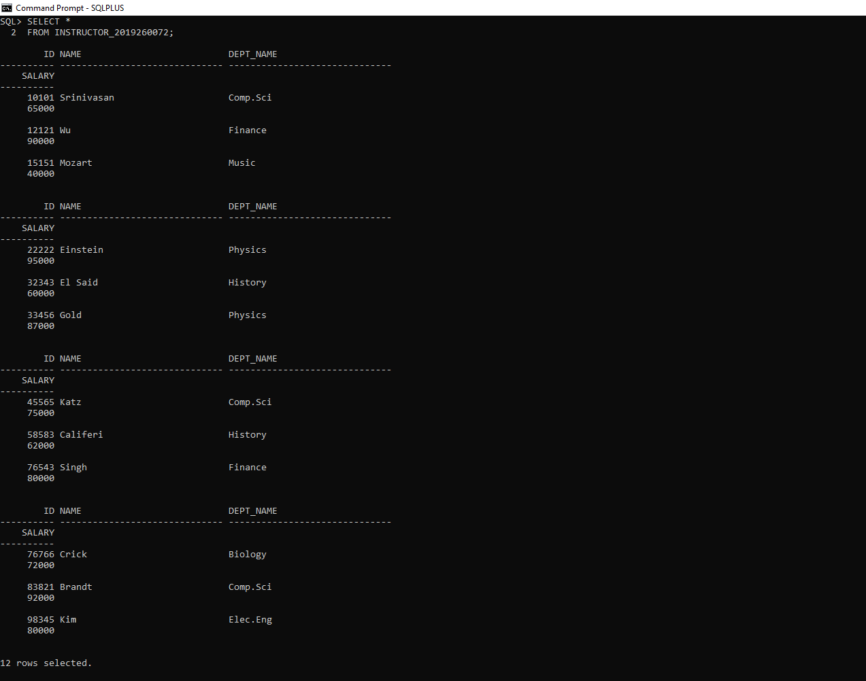

x)

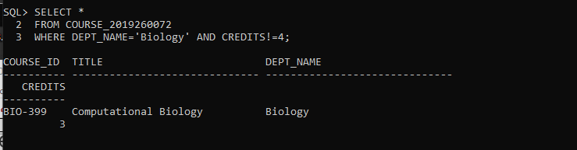

**Learning Outcome:**

From this lab we came to know what is database system. Why database is being used and how. We started learning from the bottom. We came to know that how to create a schema which is table and insert data into the table. We also can write queries and see the output. Additionally, we can see output in terms of some conditions.