

CSE302(Section 2)

Lab Assignment Submission Report

Assignment Title:

**Intermediate level DDL and Simple DML statements**

Submitted by:

Mujahidul Islam

2019-2-60-072

**Screenshots:**

Problem 1:

i)

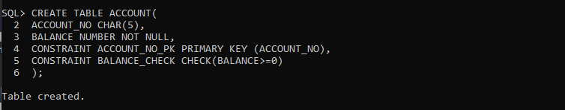

ii)

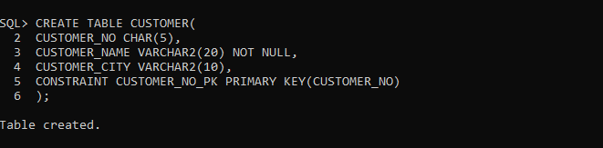

iii)

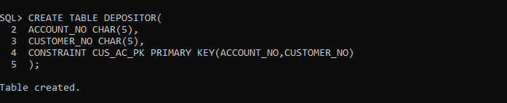

Problem 2:

i)

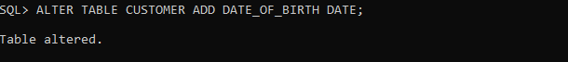

ii)

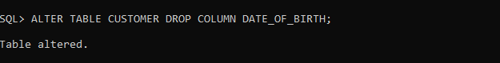

iii)

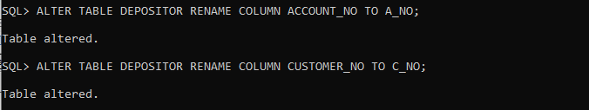

iv)

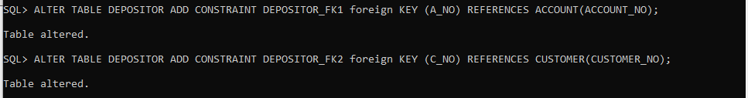

Problem 3:

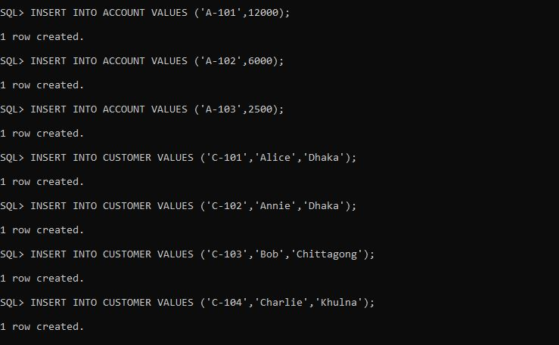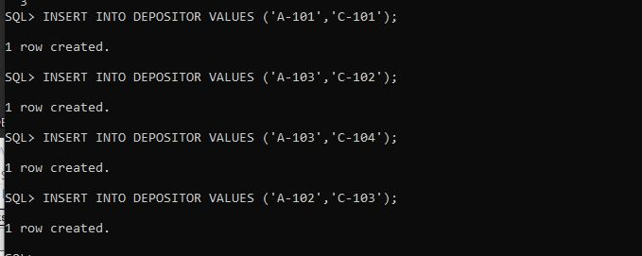

Problem 4:

i)

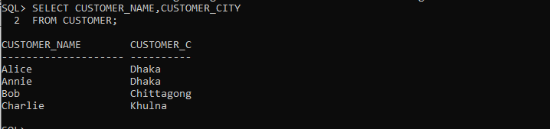

ii)

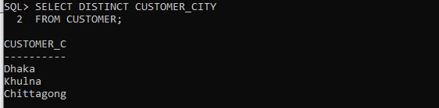

iii)

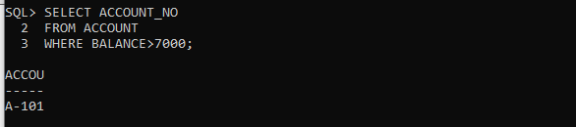

iv)

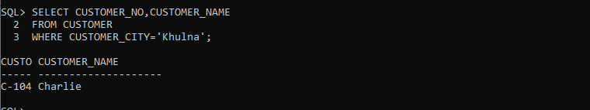

v)

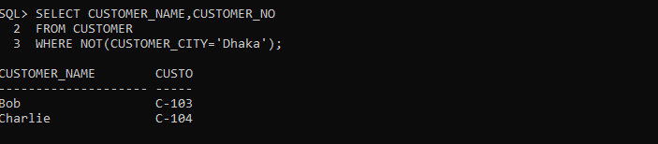

vi)

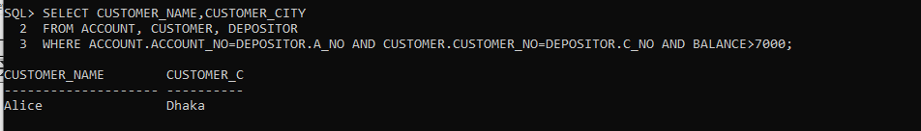

vii)

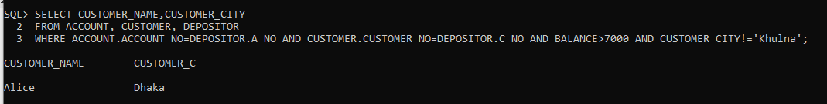

viii)

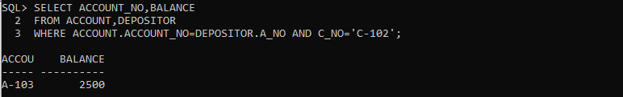

ix)

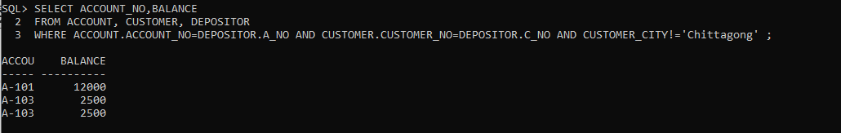

x)

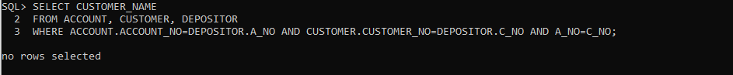

**Learning Outcome:**

In this lab we came to know how to define a primary key, schema definition with integrity constrainsts. Now we know how to modify after a table after we create it by using ALTER TABLE command. We can find out the cartesian product of multiple table and form that table we can do multi-table queries. We can link two tables by using foreign keys.