

CSE302(Section 2)

Lab Assignment Submission Report

Assignment Title:

**Writing SQL Statements for Multi-table, Set and Aggregate queries**

Submitted by:

Mujahidul Islam

2019-2-60-072

**SCREENSHOTS:**

Problem 1:



Problem 2:



Problem 3:

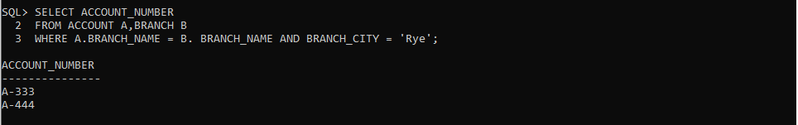

Problem 4:



Problem 5:



Problem 6

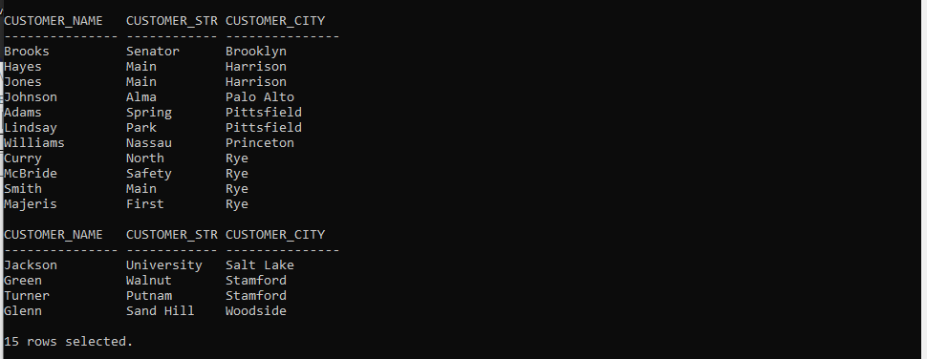

Problem 7



Problem 8:



Problem 9:



Problem 10:



Problem 11:



Problem 12:



Problem 13:



Problem 14:



Problem 15:

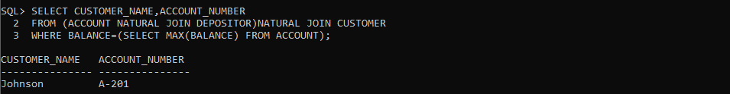

**Learning Outcome:**

By doing this lab we learned how to do multi-table query by using set operators. Learned an alternate usage for cartesian product by using join….on. Introduced with aggregate function. By using this we can calculate sum, max, min or many other statistical terms. Now we can calculate sum, average of the data given to our query.