

CSE302(Section 2)

Lab Assignment Submission Report

Assignment Title:

**Writing SQL Statements for Multi-table, Set and Aggregate queries**

Submitted by:

Mujahidul Islam

2019-2-60-072

**Screenshots:**

**Problem 1 (without subquery):**

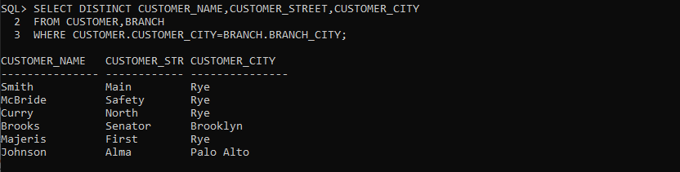

**Problem 1 (with subquery):**

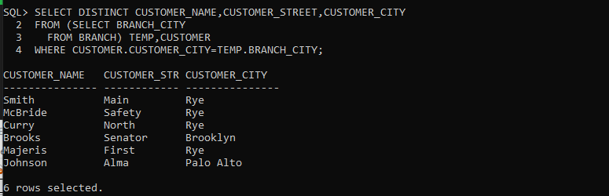

**Problem 2 (without subquery):**

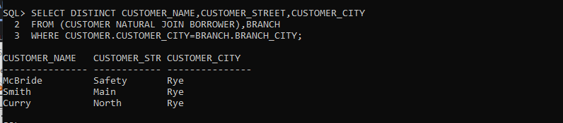

**Problem 2 (with subquery):**

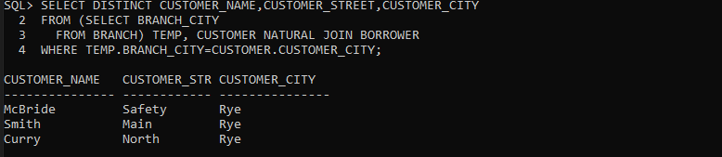

**Problem 3 (without having clause):**

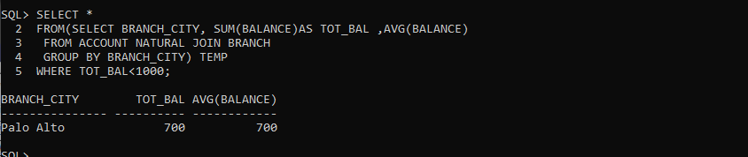

**Problem 3(with having clause):**

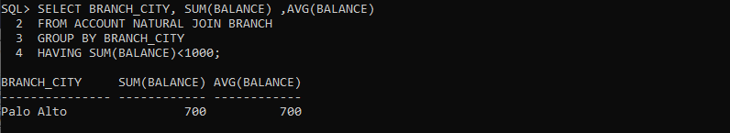

**Problem 4 (without having clause):**

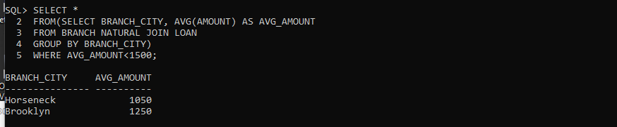

**Problem 4 (with having clause):**

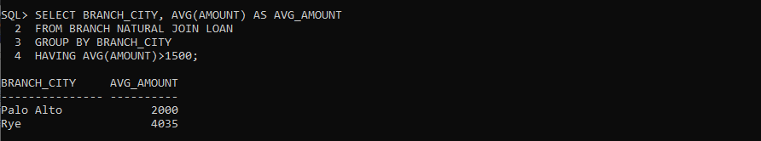

**Problem 5 (without all keyword):**

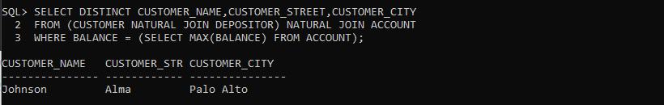

**Problem 5 (with all keyword):**

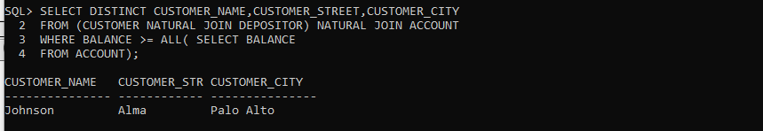

**Problem 6 (without all keyword):**

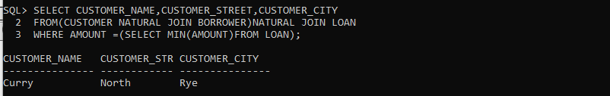

**Problem 6 (with all keyword):**

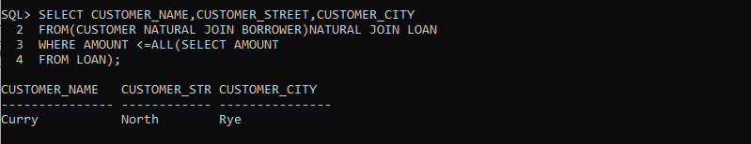

**Problem 7 (with in keyword):**

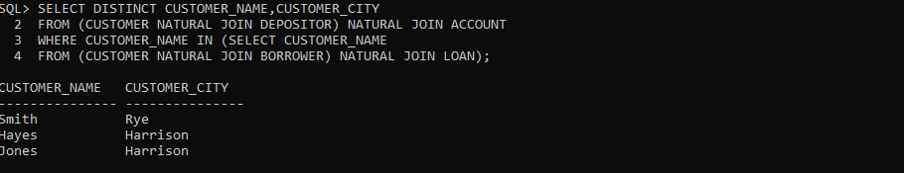

**Problem 7 (with exists keyword):**

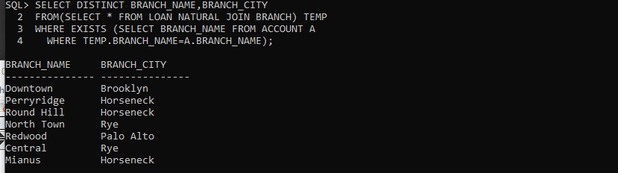

**Problem 8 (with not in keyword):**

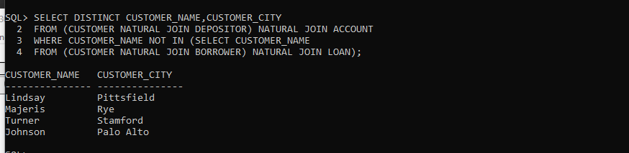

**Problem 8 (with not exist keyword):**

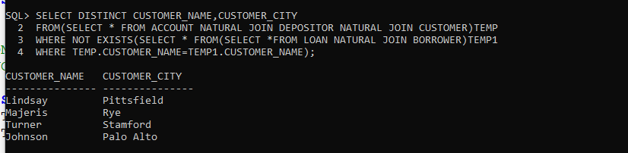

**Problem 9**

**Without with clause:**

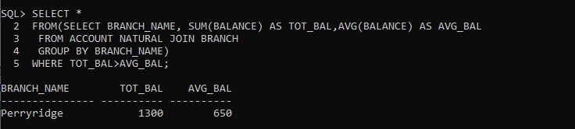

**With with clause:**

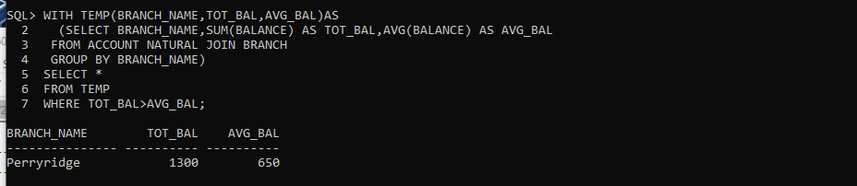

**Problem 10**

**Without with clause:**



**With with clause:**

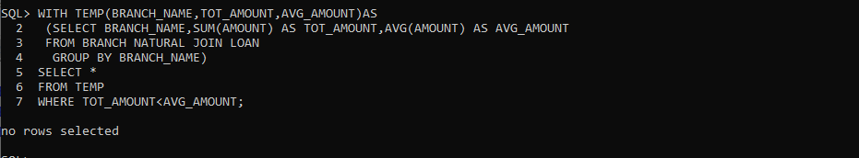

**Learning outcome:**

In this assignment we learned about nested query, a query within query by this we can select very specific attribute to show. Other than that, learned the implementation of some keywords like in/not in, exists/not exists, having with.