## How to extract exception DB?

* When exception occurs, uses adb to pull DB files. File path is in /data/log/aee_exp/

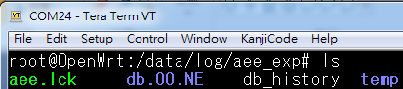

* Drags db.XX.XX.dbg file to aee_extract.exe

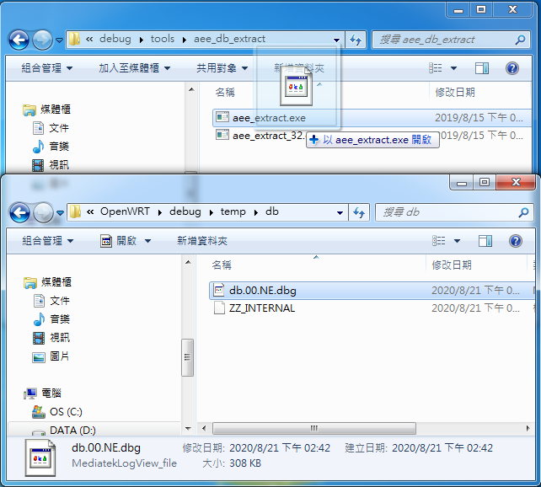

* db.XX.XX.dbg.DEC folder will be generated.

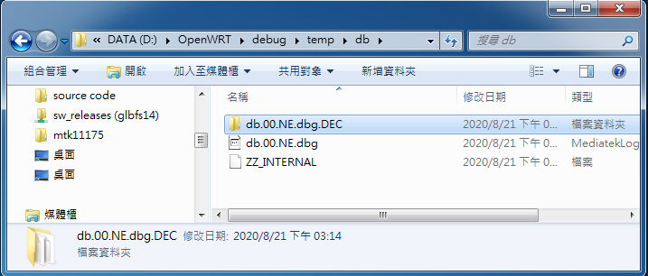

* You can check “__exp_main.txt” in db.XX.XX.dbg.DEC folder for the exception brief description.

