Github repo link:

Practical 1:
File: about.html
Code:
<!DOCTYPE html>
<html lang="en">
<head>
<meta charset="UTF-8">
<meta name="viewport" content="width=device-width, initial-scale=1.0">
<title>Student Hub | About</title>
<link rel="stylesheet" href="style.css">
</head>
<body>
<header>
<div class="header-inner">
<div class="logo">Student<span>Hub</span></div>
<button class="menu-toggle" type="button" aria-label="Open menu">☰</button>
<nav class="nav">
<a href="index.html">Home</a>
<a class="active" href="about.html">About</a>
<a href="courses.html">Courses</a>
<a href="notes.html">Notes</a>
<a href="events.html">Events</a>
<a href="gallery.html">Gallery</a>
<a href="contact.html">Contact</a>
<a href="services.html">Services</a>
<a href="blog.html">Blog</a>
<a href="faq.html">FAQ</a>
</nav>
</div>
</header>
<main class="page-shell">
<section class="page-hero">
<p class="eyebrow">About Student Hub</p>
<h1>Learning made simple, clear, and student-friendly</h1>
<p>We create a supportive environment where students can study with confidence, stay organized, and build practical skills.</p>
</section>
<section class="content-panel">
<p class="page-text">Student Hub is a student-first learning platform designed to make education more practical, motivating, and accessible. We combine useful resources, helpful guidance, and a welcoming learning experience to help students thrive in academics and beyond.</p>
<div class="feature-grid">
<div class="feature-card">
<span class="topic-badge">Mission</span>
<h3>Our mission</h3>
<p>To support learners with clear academic resources and a genuinely helpful environment.</p>
</div>
<div class="feature-card">
<span class="topic-badge">Vision</span>
<h3>Our vision</h3>
<p>To build a digital learning platform that encourages growth, curiosity, and success.</p>
</div>
<div class="feature-card">
<span class="topic-badge">Goal</span>
<h3>Our goal</h3>
<p>To make learning practical, engaging, and easy to follow for every student.</p>
</div>
</div>
</section>
</main>
<footer>
<div class="footer-inner">
<h2>Student Hub</h2>
<p>Learn | Grow | Succeed</p>
<p>© 2026 Student Hub. All Rights Reserved.</p>
</div>
</footer>
<script src="script.js"></script>
</body>
</html>

File: blog.html
Code:
<!DOCTYPE html>
<html lang="en">
<head>
<meta charset="UTF-8">
<meta name="viewport" content="width=device-width, initial-scale=1.0">
<title>Student Hub | Blog</title>
<link rel="stylesheet" href="style.css">
</head>
<body>
<header>
<div class="header-inner">
<div class="logo">Student<span>Hub</span></div>
<button class="menu-toggle" type="button" aria-label="Open menu">☰</button>
<nav class="nav">
<a href="index.html">Home</a>
<a href="about.html">About</a>
<a href="courses.html">Courses</a>
<a href="notes.html">Notes</a>
<a href="events.html">Events</a>
<a href="gallery.html">Gallery</a>
<a href="contact.html">Contact</a>
<a href="services.html">Services</a>
<a class="active" href="blog.html">Blog</a>
<a href="faq.html">FAQ</a>
</nav>
</div>
</header>
<main class="page-shell">
<section class="page-hero">
<p class="eyebrow">Student blog</p>
<h1>Learn from practical student advice</h1>
<p>Read simple, relatable articles that help students organize their time, build habits, and stay motivated.</p>
</section>
<section class="content-panel">
<div class="blog-grid">
<article class="blog-card">
<span class="course-tag">Study tips</span>
<h3>Simple habits that improve learning</h3>
<p>Small daily routines can create strong study habits and better focus over time.</p>
</article>
<article class="blog-card">
<span class="course-tag">Planning</span>
<h3>Time management for students</h3>
<p>Learn how to organize your priorities, reduce distraction, and make progress every day.</p>
</article>
<article class="blog-card">
<span class="course-tag">Growth</span>
<h3>How to set realistic goals</h3>
<p>Break bigger goals into clear steps so you can stay consistent and build confidence.</p>
</article>
</div>
</section>
</main>
<footer>
<div class="footer-inner">
<h2>Student Hub</h2>
<p>Learn | Grow | Succeed</p>
<p>© 2026 Student Hub. All Rights Reserved.</p>
</div>
</footer>
<script src="script.js"></script>
</body>
</html>

File: contact.html
Code:
<!DOCTYPE html>
<html lang="en">
<head>
<meta charset="UTF-8">
<meta name="viewport" content="width=device-width, initial-scale=1.0">
<title>Student Hub | Contact</title>
<link rel="stylesheet" href="style.css">
</head>
<body>
<header>
<div class="header-inner">
<div class="logo">Student<span>Hub</span></div>
<button class="menu-toggle" type="button" aria-label="Open menu">☰</button>
<nav class="nav">
<a href="index.html">Home</a>
<a href="about.html">About</a>
<a href="courses.html">Courses</a>
<a href="notes.html">Notes</a>
<a href="events.html">Events</a>
<a href="gallery.html">Gallery</a>
<a class="active" href="contact.html">Contact</a>
<a href="services.html">Services</a>
<a href="blog.html">Blog</a>
<a href="faq.html">FAQ</a>
</nav>
</div>
</header>
<main class="page-shell">
<section class="page-hero">
<p class="eyebrow">Contact us</p>
<h1>We are here to help you learn better</h1>
<p>Send your questions and our learning team will guide you with the right support and information.</p>
</section>
<section class="content-panel">
<div class="contact-grid" style="margin-bottom: 26px;">
<div class="contact-card">
<h3>Location</h3>
<p>Student Hub Learning Center, Ahmedabad</p>
</div>
<div class="contact-card">
<h3>Email</h3>
<p>hello@studenthub.edu</p>
</div>
<div class="contact-card">
<h3>Phone</h3>
<p>+91 87806 27815</p>
</div>
</div>
<form class="contact-form" data-contact-form novalidate>
<div class="form-row">
<div class="input-wrap">
<label for="name">Full name</label>
<input id="name" name="name" type="text" placeholder="Your name" required>
</div>
<div class="input-wrap">
<label for="email">Email</label>
<input id="email" name="email" type="email" placeholder="Your email" required>
</div>
</div>
<div class="input-wrap">
<label for="subject">Subject</label>
<input id="subject" name="subject" type="text" placeholder="Your subject" required>
</div>
<div class="input-wrap">
<label for="message">Message</label>
<textarea id="message" name="message" placeholder="Write your message here..." required></textarea>
</div>
<div class="form-msg" aria-live="polite"></div>
<button class="form-btn" type="submit">Send message</button>
</form>
</section>
</main>
<footer>
<div class="footer-inner">
<h2>Student Hub</h2>
<p>Learn | Grow | Succeed</p>
<p>© 2026 Student Hub. All Rights Reserved.</p>
</div>
</footer>
<script src="script.js"></script>
</body>
</html>

File: courses.html
Code:
<!DOCTYPE html>
<html lang="en">
<head>
<meta charset="UTF-8">
<meta name="viewport" content="width=device-width, initial-scale=1.0">
<title>Student Hub | Courses</title>
<link rel="stylesheet" href="style.css">
</head>
<body>
<header>
<div class="header-inner">
<div class="logo">Student<span>Hub</span></div>
<button class="menu-toggle" type="button" aria-label="Open menu">☰</button>
<nav class="nav">
<a href="index.html">Home</a>
<a href="about.html">About</a>
<a class="active" href="courses.html">Courses</a>
<a href="notes.html">Notes</a>
<a href="events.html">Events</a>
<a href="gallery.html">Gallery</a>
<a href="contact.html">Contact</a>
<a href="services.html">Services</a>
<a href="blog.html">Blog</a>
<a href="faq.html">FAQ</a>
</nav>
</div>
</header>
<main class="page-shell">
<section class="page-hero">
<p class="eyebrow">Popular courses</p>
<h1>Build practical skills for the future</h1>
<p>Choose the course that matches your goals and learn through clear, structured guidance.</p>
</section>
<section class="content-panel">
<div class="filter-bar">
<button class="filter-btn active" type="button" data-filter="all">All</button>
<button class="filter-btn" type="button" data-filter="web">Web</button>
<button class="filter-btn" type="button" data-filter="programming">Programming</button>
<button class="filter-btn" type="button" data-filter="design">Design</button>
</div>
<div class="course-grid">
<article class="course-card" data-course-category="web">
<span class="course-tag">Web</span>
<h3>HTML & CSS</h3>
<p>Learn to build beautiful, responsive pages using layout, styling, and design principles.</p>
</article>
<article class="course-card" data-course-category="web">
<span class="course-tag">Web</span>
<h3>JavaScript</h3>
<p>Master interactivity, user input handling, and client-side logic for engaging websites.</p>
</article>
<article class="course-card" data-course-category="programming">
<span class="course-tag">Programming</span>
<h3>Python</h3>
<p>Understand programming basics, logic, and automation with a beginner-friendly approach.</p>
</article>
<article class="course-card" data-course-category="programming">
<span class="course-tag">Programming</span>
<h3>Java</h3>
<p>Learn object-oriented programming, problem-solving, and app development fundamentals.</p>
</article>
<article class="course-card" data-course-category="design">
<span class="course-tag">Design</span>
<h3>UI/UX Basics</h3>
<p>Understand user experience, layout thinking, and visual clarity in digital products.</p>
</article>
<article class="course-card" data-course-category="web">
<span class="course-tag">Web</span>
<h3>PHP & MySQL</h3>
<p>Build dynamic websites and learn how data is saved and managed in real projects.</p>
</article>
</div>
</section>
</main>
<footer>
<div class="footer-inner">
<h2>Student Hub</h2>
<p>Learn | Grow | Succeed</p>
<p>© 2026 Student Hub. All Rights Reserved.</p>
</div>
</footer>
<script src="script.js"></script>
</body>
</html>

File: events.html
Code:
<!DOCTYPE html>
<html lang="en">
<head>
<meta charset="UTF-8">
<meta name="viewport" content="width=device-width, initial-scale=1.0">
<title>Student Hub | Events</title>
<link rel="stylesheet" href="style.css">
</head>
<body>
<header>
<div class="header-inner">
<div class="logo">Student<span>Hub</span></div>
<button class="menu-toggle" type="button" aria-label="Open menu">☰</button>
<nav class="nav">
<a href="index.html">Home</a>
<a href="about.html">About</a>
<a href="courses.html">Courses</a>
<a href="notes.html">Notes</a>
<a class="active" href="events.html">Events</a>
<a href="gallery.html">Gallery</a>
<a href="contact.html">Contact</a>
<a href="services.html">Services</a>
<a href="blog.html">Blog</a>
<a href="faq.html">FAQ</a>
</nav>
</div>
</header>
<main class="page-shell">
<section class="page-hero">
<p class="eyebrow">Upcoming events</p>
<h1>Join workshops and opportunities that help you grow</h1>
<p>Explore sessions designed for learning, networking, and building better academic and career confidence.</p>
</section>
<section class="content-panel">
<div class="event-grid">
<article class="event-card">
<span class="course-tag">15 Aug</span>
<h3>Web Development Bootcamp</h3>
<p>Build responsive web pages and improve your front-end skills in a guided workshop.</p>
</article>
<article class="event-card">
<span class="course-tag">28 Aug</span>
<h3>AI Workshop</h3>
<p>Learn how artificial intelligence is used in modern apps and how students can explore it.</p>
</article>
<article class="event-card">
<span class="course-tag">5 Sep</span>
<h3>Career Guidance Seminar</h3>
<p>Understand how to shape your future goals, improve presentation skills, and plan better.</p>
</article>
</div>
</section>
</main>
<footer>
<div class="footer-inner">
<h2>Student Hub</h2>
<p>Learn | Grow | Succeed</p>
<p>© 2026 Student Hub. All Rights Reserved.</p>
</div>
</footer>
<script src="script.js"></script>
</body>
</html>

File: faq.html
Code:
<!DOCTYPE html>
<html lang="en">
<head>
<meta charset="UTF-8">
<meta name="viewport" content="width=device-width, initial-scale=1.0">
<title>Student Hub | FAQ</title>
<link rel="stylesheet" href="style.css">
</head>
<body>
<header>
<div class="header-inner">
<div class="logo">Student<span>Hub</span></div>
<button class="menu-toggle" type="button" aria-label="Open menu">☰</button>
<nav class="nav">
<a href="index.html">Home</a>
<a href="about.html">About</a>
<a href="courses.html">Courses</a>
<a href="notes.html">Notes</a>
<a href="events.html">Events</a>
<a href="gallery.html">Gallery</a>
<a href="contact.html">Contact</a>
<a href="services.html">Services</a>
<a href="blog.html">Blog</a>
<a class="active" href="faq.html">FAQ</a>
</nav>
</div>
</header>
<main class="page-shell">
<section class="page-hero">
<p class="eyebrow">Frequently asked questions</p>
<h1>Everything students usually ask</h1>
<p>Find quick answers about learning, support, events, and how Student Hub helps you succeed.</p>
</section>
<section class="content-panel">
<div class="faq-list">
<div class="faq-item open">
<button class="faq-question" type="button">Is Student Hub free to use?<span>+</span></button>
<div class="faq-answer">
<p>Yes. Most learning resources and academic support tools are available for free so students can access help without extra stress.</p>
</div>
</div>
<div class="faq-item">
<button class="faq-question" type="button">Can I join events online?<span>+</span></button>
<div class="faq-answer">
<p>Yes. Many events are designed for both online and in-person participation, which makes it easier for students to join from anywhere.</p>
</div>
</div>
<div class="faq-item">
<button class="faq-question" type="button">How can I contact support?<span>+</span></button>
<div class="faq-answer">
<p>You can use the contact page to send a message to our team. We are here to help with registration, course guidance, and student questions.</p>
</div>
</div>
<div class="faq-item">
<button class="faq-question" type="button">Do you provide study notes?<span>+</span></button>
<div class="faq-answer">
<p>Yes. Student Hub includes easy-to-follow notes and references for topics such as HTML, CSS, JavaScript, Python, and Java.</p>
</div>
</div>
</div>
</section>
</main>
<footer>
<div class="footer-inner">
<h2>Student Hub</h2>
<p>Learn | Grow | Succeed</p>
<p>© 2026 Student Hub. All Rights Reserved.</p>
</div>
</footer>
<script src="script.js"></script>
</body>
</html>

File: gallery.html
Code:
<!DOCTYPE html>
<html lang="en">
<head>
<meta charset="UTF-8">
<meta name="viewport" content="width=device-width, initial-scale=1.0">
<title>Student Hub | Gallery</title>
<link rel="stylesheet" href="style.css">
</head>
<body>
<header>
<div class="header-inner">
<div class="logo">Student<span>Hub</span></div>
<button class="menu-toggle" type="button" aria-label="Open menu">☰</button>
<nav class="nav">
<a href="index.html">Home</a>
<a href="about.html">About</a>
<a href="courses.html">Courses</a>
<a href="notes.html">Notes</a>
<a href="events.html">Events</a>
<a class="active" href="gallery.html">Gallery</a>
<a href="contact.html">Contact</a>
<a href="services.html">Services</a>
<a href="blog.html">Blog</a>
<a href="faq.html">FAQ</a>
</nav>
</div>
</header>
<main class="page-shell">
<section class="page-hero">
<p class="eyebrow">Student gallery</p>
<h1>Moments from learning, teamwork, and growth</h1>
<p>See how Student Hub creates a motivating environment for study, collaboration, and inspiration.</p>
</section>
<section class="content-panel">
<div class="gallery-grid">
<div class="gallery-item" data-gallery-item="https://images.unsplash.com/photo-1523240795612-9a054b0db644?auto=format&fit=crop&w=1200&q=80" data-title="Students learning together">
<img src="https://images.unsplash.com/photo-1523240795612-9a054b0db644?auto=format&fit=crop&w=800&q=80" alt="Students learning together">
<div class="gallery-caption">Students learning together</div>
</div>
<div class="gallery-item" data-gallery-item="https://images.unsplash.com/photo-1513258496099-48168024aec0?auto=format&fit=crop&w=1200&q=80" data-title="Classroom discussion">
<img src="https://images.unsplash.com/photo-1513258496099-48168024aec0?auto=format&fit=crop&w=800&q=80" alt="Classroom discussion">
<div class="gallery-caption">Classroom discussion</div>
</div>
<div class="gallery-item" data-gallery-item="https://images.unsplash.com/photo-1523050854058-8df90110c9f1?auto=format&fit=crop&w=1200&q=80" data-title="Study group focus">
<img src="https://images.unsplash.com/photo-1523050854058-8df90110c9f1?auto=format&fit=crop&w=800&q=80" alt="Study group focus">
<div class="gallery-caption">Study group focus</div>
</div>
<div class="gallery-item" data-gallery-item="https://images.unsplash.com/photo-1523580494863-6f3031224c94?auto=format&fit=crop&w=1200&q=80" data-title="Learning environment">
<img src="https://images.unsplash.com/photo-1523580494863-6f3031224c94?auto=format&fit=crop&w=800&q=80" alt="Learning environment">
<div class="gallery-caption">Learning environment</div>
</div>
</div>
</section>
</main>
<div class="lightbox" aria-hidden="true">
<div class="lightbox-content">
<button class="lightbox-close" type="button" aria-label="Close">×</button>
<img src="" alt="Expanded gallery item">
</div>
</div>
<footer>
<div class="footer-inner">
<h2>Student Hub</h2>
<p>Learn | Grow | Succeed</p>
<p>© 2026 Student Hub. All Rights Reserved.</p>
</div>
</footer>
<script src="script.js"></script>
</body>
</html>

File: index.html
Code:
<!DOCTYPE html>
<html lang="en">
<head>
<meta charset="UTF-8">
<meta name="viewport" content="width=device-width, initial-scale=1.0">
<title>Student Hub | Home</title>
<link rel="stylesheet" href="style.css">
</head>
<body>
<header>
<div class="header-inner">
<div class="logo">Student<span>Hub</span></div>
<button class="menu-toggle" type="button" aria-label="Open menu">☰</button>
<nav class="nav">
<a class="active" href="index.html">Home</a>
<a href="about.html">About</a>
<a href="courses.html">Courses</a>
<a href="notes.html">Notes</a>
<a href="events.html">Events</a>
<a href="gallery.html">Gallery</a>
<a href="contact.html">Contact</a>
<a href="services.html">Services</a>
<a href="blog.html">Blog</a>
<a href="faq.html">FAQ</a>
</nav>
</div>
</header>
<main>
<section class="hero">
<div class="hero-content">
<p class="eyebrow">Smart learning platform</p>
<h1>Learn better, grow faster, and build your future.</h1>
<p>From study notes and practical courses to events, support, and career guidance, Student Hub helps you stay focused and confident.</p>
<div class="btn-group">
<a href="courses.html" class="btn btn-primary">Explore Courses</a>
<a href="contact.html" class="btn btn-secondary">Join Community</a>
</div>
</div>
</section>
<section class="section">
<div class="container">
<div class="section-heading">
<p class="eyebrow" style="color: var(--primary-dark); background: #e7f0ff; border-color: transparent;">Why students choose us</p>
<h2>Everything you need to succeed</h2>
<p>Student Hub brings together quality content, practical learning, and the support students need to stay motivated.</p>
</div>
<div class="stats-grid">
<div class="stat-card"><strong>10+</strong><span>Learning resources</span></div>
<div class="stat-card"><strong>4</strong><span>Skill tracks</span></div>
<div class="stat-card"><strong>24/7</strong><span>Student support</span></div>
<div class="stat-card"><strong>100%</strong><span>Student focus</span></div>
</div>
</div>
</section>
<section class="section" style="background: #f9fbff;">
<div class="container">
<div class="section-heading">
<p class="eyebrow" style="color: var(--primary-dark); background: #e7f0ff; border-color: transparent;">Featured programs</p>
<h2>Learning designed for real progress</h2>
</div>
<div class="feature-grid">
<div class="feature-card">
<span class="topic-badge">Easy learning</span>
<h3>Clear lessons</h3>
<p>Simple explanations and step-by-step guidance make even difficult topics easier to understand.</p>
</div>
<div class="feature-card">
<span class="topic-badge">Practice focus</span>
<h3>Hands-on growth</h3>
<p>Build confidence with regular tasks, revision material, and learning activities.</p>
</div>
<div class="feature-card">
<span class="topic-badge">Career support</span>
<h3>Future skills</h3>
<p>Prepare for coursework, interviews, and projects with practical academic support.</p>
</div>
</div>
</div>
</section>
<section class="section">
<div class="container">
<div class="section-heading">
<p class="eyebrow" style="color: var(--primary-dark); background: #e7f0ff; border-color: transparent;">Quick links</p>
<h2>Explore more of the platform</h2>
</div>
<div class="feature-grid">
<div class="feature-card">
<span class="topic-badge">Notes</span>
<h3><a href="notes.html">Study notes</a></h3>
<p>Browse subject-based notes and revision resources that help you learn better.</p>
</div>
<div class="feature-card">
<span class="topic-badge">Events</span>
<h3><a href="events.html">Upcoming events</a></h3>
<p>Join workshops, seminars, and learning opportunities with real-time guidance.</p>
</div>
<div class="feature-card">
<span class="topic-badge">Support</span>
<h3><a href="contact.html">Contact us</a></h3>
<p>Send your queries and get help from our support and learning team.</p>
</div>
</div>
</div>
</section>
<section class="cta-strip">
<div class="cta-inner">
<div>
<h3>Start your learning journey today</h3>
<p>Explore practical resources, skill-building courses, and a supportive academic community.</p>
</div>
<a href="courses.html" class="btn btn-primary">View Courses</a>
</div>
</section>
</main>
<footer>
<div class="footer-inner">
<h2>Student Hub</h2>
<p>Learn | Grow | Succeed</p>
<p>© 2026 Student Hub. All Rights Reserved.</p>
</div>
</footer>
<script src="script.js"></script>
</body>
</html>

File: notes.html
Code:
<!DOCTYPE html>
<html lang="en">
<head>
<meta charset="UTF-8">
<meta name="viewport" content="width=device-width, initial-scale=1.0">
<title>Student Hub | Notes</title>
<link rel="stylesheet" href="style.css">
</head>
<body>
<header>
<div class="header-inner">
<div class="logo">Student<span>Hub</span></div>
<button class="menu-toggle" type="button" aria-label="Open menu">☰</button>
<nav class="nav">
<a href="index.html">Home</a>
<a href="about.html">About</a>
<a href="courses.html">Courses</a>
<a class="active" href="notes.html">Notes</a>
<a href="events.html">Events</a>
<a href="gallery.html">Gallery</a>
<a href="contact.html">Contact</a>
<a href="services.html">Services</a>
<a href="blog.html">Blog</a>
<a href="faq.html">FAQ</a>
</nav>
</div>
</header>
<main class="page-shell">
<section class="page-hero">
<p class="eyebrow">Study notes</p>
<h1>Simple notes for better understanding</h1>
<p>Find helpful revision resources and subject notes that are easy to read, organize, and apply.</p>
</section>
<section class="content-panel">
<input type="text" data-note-search placeholder="Search notes..." style="max-width: 420px; margin: 0 auto 22px; display: block;">
<ul class="note-list">
<li data-note-item>HTML Complete Notes</li>
<li data-note-item>CSS Interview Notes</li>
<li data-note-item>JavaScript PDF Notes</li>
<li data-note-item>Python Programming Notes</li>
<li data-note-item>Java OOP Notes</li>
<li data-note-item>Database Basics Revision Guide</li>
<li data-note-item>Web Development Summary Handout</li>
</ul>
</section>
</main>
<footer>
<div class="footer-inner">
<h2>Student Hub</h2>
<p>Learn | Grow | Succeed</p>
<p>© 2026 Student Hub. All Rights Reserved.</p>
</div>
</footer>
<script src="script.js"></script>
</body>
</html>

File: script.js
Code:
document.addEventListener('DOMContentLoaded', () => {
const menuToggle = document.querySelector('.menu-toggle');
const nav = document.querySelector('.nav');
if (menuToggle && nav) {
menuToggle.addEventListener('click', () => {
nav.classList.toggle('open');
});
}
const currentPage = window.location.pathname.split('/').pop() || 'index.html';
document.querySelectorAll('.nav a').forEach((link) => {
const href = link.getAttribute('href');
if (href === currentPage) {
link.classList.add('active');
}
});
const filters = document.querySelectorAll('.filter-btn');
const courseCards = document.querySelectorAll('.course-card');
filters.forEach((button) => {
button.addEventListener('click', () => {
const category = button.dataset.filter;
filters.forEach((item) => item.classList.toggle('active', item === button));
courseCards.forEach((card) => {
const match = category === 'all' || card.dataset.courseCategory === category;
card.classList.toggle('hidden', !match);
});
});
});
const form = document.querySelector('[data-contact-form]');
if (form) {
form.addEventListener('submit', (event) => {
event.preventDefault();
const name = form.querySelector('#name');
const email = form.querySelector('#email');
const subject = form.querySelector('#subject');
const message = form.querySelector('#message');
const result = form.querySelector('.form-msg');
if (!name.value.trim() || !email.value.trim() || !subject.value.trim() || !message.value.trim()) {
result.textContent = 'Please fill in all fields before submitting.';
result.className = 'form-msg show error';
return;
}
const emailPattern = /^[^\s@]+@[^\s@]+\.[^\s@]+$/;
if (!emailPattern.test(email.value.trim())) {
result.textContent = 'Please enter a valid email address.';
result.className = 'form-msg show error';
return;
}
result.textContent = 'Thank you! Your message has been sent successfully.';
result.className = 'form-msg show success';
form.reset();
});
}
const faqItems = document.querySelectorAll('.faq-item');
faqItems.forEach((item) => {
const button = item.querySelector('.faq-question');
if (!button) return;
button.addEventListener('click', () => {
const isOpen = item.classList.contains('open');
faqItems.forEach((faq) => faq.classList.remove('open'));
if (!isOpen) item.classList.add('open');
});
});
const noteSearch = document.querySelector('[data-note-search]');
const noteItems = document.querySelectorAll('[data-note-item]');
if (noteSearch) {
noteSearch.addEventListener('input', () => {
const term = noteSearch.value.trim().toLowerCase();
noteItems.forEach((item) => {
const text = item.textContent.toLowerCase();
item.classList.toggle('hidden', term && !text.includes(term));
});
});
}
const galleryItems = document.querySelectorAll('[data-gallery-item]');
const lightbox = document.querySelector('.lightbox');
const lightboxImage = lightbox?.querySelector('img');
const closeButton = document.querySelector('.lightbox-close');
galleryItems.forEach((item) => {
item.addEventListener('click', () => {
if (!lightbox || !lightboxImage) return;
lightboxImage.src = item.dataset.galleryItem;
lightbox.classList.add('show');
lightbox.setAttribute('aria-hidden', 'false');
});
});
closeButton?.addEventListener('click', () => {
lightbox.classList.remove('show');
lightbox.setAttribute('aria-hidden', 'true');
});
lightbox?.addEventListener('click', (event) => {
if (event.target === lightbox) {
lightbox.classList.remove('show');
lightbox.setAttribute('aria-hidden', 'true');
}
});
});

File: services.html
Code:
<!DOCTYPE html>
<html lang="en">
<head>
<meta charset="UTF-8">
<meta name="viewport" content="width=device-width, initial-scale=1.0">
<title>Student Hub | Services</title>
<link rel="stylesheet" href="style.css">
</head>
<body>
<header>
<div class="header-inner">
<div class="logo">Student<span>Hub</span></div>
<button class="menu-toggle" type="button" aria-label="Open menu">☰</button>
<nav class="nav">
<a href="index.html">Home</a>
<a href="about.html">About</a>
<a href="courses.html">Courses</a>
<a href="notes.html">Notes</a>
<a href="events.html">Events</a>
<a href="gallery.html">Gallery</a>
<a href="contact.html">Contact</a>
<a class="active" href="services.html">Services</a>
<a href="blog.html">Blog</a>
<a href="faq.html">FAQ</a>
</nav>
</div>
</header>
<main class="page-shell">
<section class="page-hero">
<p class="eyebrow">Our services</p>
<h1>Support that helps students succeed</h1>
<p>We offer practical support for learning, revision, and personal growth at every stage of the student journey.</p>
</section>
<section class="content-panel">
<div class="service-grid">
<article class="service-card">
<span class="course-tag">Study help</span>
<h3>Study materials</h3>
<p>Access notes, resources, and quick references to make studying easier and more organized.</p>
</article>
<article class="service-card">
<span class="course-tag">Live sessions</span>
<h3>Interactive workshops</h3>
<p>Participate in focused learning sessions and hands-on training experiences.</p>
</article>
<article class="service-card">
<span class="course-tag">Preparation</span>
<h3>Exam support</h3>
<p>Build confidence with revision material, guidance, and structured study planning.</p>
</article>
</div>
</section>
</main>
<footer>
<div class="footer-inner">
<h2>Student Hub</h2>
<p>Learn | Grow | Succeed</p>
<p>© 2026 Student Hub. All Rights Reserved.</p>
</div>
</footer>
<script src="script.js"></script>
</body>
</html>

File: style.css
Code:
:root {
--primary: #1d4ed8;
--primary-dark: #163cad;
--secondary: #f59e0b;
--dark: #0f172a;
--text: #1f2937;
--muted: #64748b;
--bg-soft: #f4f8ff;
--card: #ffffff;
--line: #dfeaf8;
--success: #166534;
--success-bg: #dcfce7;
--danger: #991b1b;
--danger-bg: #fee2e2;
--shadow: 0 18px 40px rgba(15, 23, 42, 0.1);
}
* {
margin: 0;
padding: 0;
box-sizing: border-box;
font-family: "Segoe UI", Arial, sans-serif;
scroll-behavior: smooth;
}
body {
background: linear-gradient(180deg, #fafcff 0%, #edf4ff 100%);
color: var(--text);
line-height: 1.7;
}
img {
max-width: 100%;
display: block;
}
a {
color: inherit;
text-decoration: none;
}
button, input, textarea, select {
font: inherit;
}
header {
position: sticky;
top: 0;
z-index: 20;
background: rgba(15, 23, 42, 0.94);
backdrop-filter: blur(10px);
box-shadow: 0 10px 25px rgba(15, 23, 42, 0.12);
}
.header-inner {
max-width: 1200px;
margin: 0 auto;
padding: 18px 24px;
display: flex;
align-items: center;
justify-content: space-between;
gap: 18px;
}
.logo {
color: #fff;
font-size: clamp(1.5rem, 2vw, 2rem);
font-weight: 800;
letter-spacing: 0.04em;
}
.logo span {
color: #fbbf24;
}
.nav {
display: flex;
align-items: center;
justify-content: center;
flex-wrap: wrap;
gap: 8px;
}
.nav a {
color: rgba(255, 255, 255, 0.88);
padding: 8px 12px;
border-radius: 999px;
font-weight: 600;
transition: 0.25s ease;
}
.nav a:hover,
.nav a.active {
background: rgba(255, 255, 255, 0.12);
color: #fcd34d;
}
.menu-toggle {
display: none;
background: transparent;
border: 1px solid rgba(255, 255, 255, 0.3);
border-radius: 10px;
color: #fff;
width: 46px;
height: 46px;
padding: 0;
font-size: 1.4rem;
}
.hero {
position: relative;
min-height: 88vh;
display: flex;
align-items: center;
justify-content: center;
padding: 32px 24px;
background:
linear-gradient(120deg, rgba(15, 23, 42, 0.82), rgba(29, 78, 216, 0.6)),
url("https://images.unsplash.com/photo-1522202176988-66273c2fd55f?auto=format&fit=crop&w=1600&q=80") center/cover no-repeat;
}
.hero-content {
max-width: 980px;
background: rgba(15, 23, 42, 0.25);
border: 1px solid rgba(255, 255, 255, 0.2);
backdrop-filter: blur(4px);
border-radius: 28px;
padding: clamp(30px, 5vw, 60px);
text-align: center;
color: #fff;
box-shadow: var(--shadow);
}
.eyebrow {
display: inline-block;
padding: 7px 14px;
background: rgba(251, 191, 36, 0.18);
border: 1px solid rgba(251, 191, 36, 0.3);
border-radius: 999px;
color: #fef3c7;
letter-spacing: 0.08em;
text-transform: uppercase;
font-size: 0.76rem;
font-weight: 700;
margin-bottom: 18px;
}
.hero h1 {
font-size: clamp(2.2rem, 5vw, 4.4rem);
line-height: 1.08;
margin-bottom: 16px;
}
.hero p {
max-width: 720px;
margin: 0 auto 26px;
font-size: 1.08rem;
color: rgba(255, 255, 255, 0.84);
}
.btn-group {
display: flex;
flex-wrap: wrap;
justify-content: center;
gap: 14px;
}
.btn {
display: inline-flex;
align-items: center;
justify-content: center;
min-height: 48px;
padding: 12px 22px;
border-radius: 999px;
font-weight: 700;
transition: transform 0.25s ease, box-shadow 0.25s ease;
}
.btn:hover {
transform: translateY(-2px);
}
.btn-primary {
background: var(--secondary);
color: #111827;
box-shadow: 0 12px 30px rgba(245, 158, 11, 0.22);
}
.btn-secondary {
background: transparent;
border: 1.5px solid rgba(255, 255, 255, 0.8);
color: #fff;
}
.section {
padding: 88px 24px;
}
.container {
max-width: 1200px;
margin: 0 auto;
}
.section-heading {
text-align: center;
max-width: 760px;
margin: 0 auto 42px;
}
.section-heading h2 {
font-size: clamp(2rem, 3vw, 2.7rem);
color: var(--primary-dark);
margin-bottom: 12px;
}
.section-heading p {
color: var(--muted);
}
.stats-grid,
.feature-grid,
.course-grid,
.event-grid,
.blog-grid,
.service-grid,
.contact-grid,
.gallery-grid {
display: grid;
grid-template-columns: repeat(auto-fit, minmax(220px, 1fr));
gap: 24px;
}
.stat-card,
.feature-card,
.course-card,
.event-card,
.blog-card,
.service-card,
.contact-card,
.gallery-item {
background: var(--card);
border: 1px solid var(--line);
border-radius: 22px;
box-shadow: 0 12px 28px rgba(15, 23, 42, 0.06);
transition: transform 0.25s ease, box-shadow 0.25s ease;
}
.stat-card:hover,
.feature-card:hover,
.course-card:hover,
.event-card:hover,
.blog-card:hover,
.service-card:hover,
.contact-card:hover,
.gallery-item:hover {
transform: translateY(-6px);
box-shadow: 0 16px 30px rgba(15, 23, 42, 0.09);
}
.stat-card {
padding: 28px 18px;
text-align: center;
}
.stat-card strong {
display: block;
font-size: clamp(1.8rem, 3vw, 2.5rem);
color: var(--primary);
margin-bottom: 10px;
}
.stat-card span {
color: var(--muted);
font-weight: 600;
}
.feature-card,
.course-card,
.event-card,
.blog-card,
.service-card {
padding: 26px 22px;
}
.feature-card h3,
.course-card h3,
.event-card h3,
.blog-card h3,
.service-card h3,
.contact-card h3 {
margin-bottom: 10px;
color: var(--dark);
font-size: 1.35rem;
}
.feature-card p,
.course-card p,
.event-card p,
.blog-card p,
.service-card p,
.contact-card p {
color: var(--muted);
}
.topic-badge,
.course-tag {
display: inline-block;
background: #e0ecff;
color: var(--primary-dark);
border-radius: 999px;
padding: 7px 12px;
font-size: 0.76rem;
font-weight: 700;
margin-bottom: 14px;
letter-spacing: 0.04em;
text-transform: uppercase;
}
.cta-strip {
background: linear-gradient(135deg, #0f172a 0%, #1d4ed8 100%);
padding: 60px 24px;
color: #fff;
}
.cta-inner {
max-width: 1200px;
margin: 0 auto;
display: flex;
justify-content: space-between;
align-items: center;
gap: 20px;
flex-wrap: wrap;
}
.cta-inner h3 {
font-size: clamp(1.6rem, 3vw, 2.4rem);
margin-bottom: 8px;
}
.cta-inner p {
color: rgba(255, 255, 255, 0.8);
}
.page-shell {
padding: 66px 24px 80px;
}
.page-hero {
max-width: 1200px;
margin: 0 auto 28px;
background: linear-gradient(135deg, var(--primary-dark), var(--primary));
color: #fff;
padding: 42px 28px;
text-align: center;
border-radius: 26px;
box-shadow: 0 16px 36px rgba(29, 78, 216, 0.18);
}
.page-hero h1 {
font-size: clamp(2rem, 4vw, 3rem);
margin-bottom: 10px;
}
.page-hero p {
color: rgba(255, 255, 255, 0.84);
max-width: 700px;
margin: 0 auto;
}
.content-panel {
max-width: 1200px;
margin: 0 auto;
background: var(--card);
border: 1px solid var(--line);
border-radius: 24px;
box-shadow: var(--shadow);
padding: clamp(24px, 3vw, 40px);
}
.text-center {
text-align: center;
}
.page-text {
max-width: 840px;
margin: 0 auto 30px;
color: var(--muted);
font-size: 1.05rem;
}
.note-list,
.mini-list {
list-style: none;
display: grid;
gap: 14px;
}
.note-list li,
.mini-list li {
background: #f8fbff;
border: 1px solid var(--line);
border-left: 5px solid var(--primary);
padding: 14px 16px;
border-radius: 12px;
color: var(--text);
}
.contact-form {
max-width: 680px;
margin: 0 auto;
display: grid;
gap: 16px;
}
.form-row {
display: grid;
grid-template-columns: repeat(2, minmax(0, 1fr));
gap: 16px;
}
.input-wrap {
display: grid;
gap: 8px;
}
label {
font-weight: 700;
color: var(--dark);
}
input,
textarea,
select {
width: 100%;
border: 1px solid #cbd5e1;
border-radius: 12px;
padding: 13px 14px;
background: #fff;
color: var(--text);
}
input:focus,
textarea:focus,
select:focus {
outline: 3px solid rgba(29, 78, 216, 0.12);
border-color: var(--primary);
}
textarea {
min-height: 170px;
resize: vertical;
}
.form-btn {
width: 100%;
border: none;
border-radius: 12px;
background: linear-gradient(135deg, var(--primary), var(--primary-dark));
color: #fff;
min-height: 52px;
font-weight: 700;
cursor: pointer;
}
.form-msg {
display: none;
border-radius: 12px;
padding: 14px 16px;
font-weight: 600;
}
.form-msg.show {
display: block;
}
.form-msg.success {
background: var(--success-bg);
color: var(--success);
border: 1px solid #86efac;
}
.form-msg.error {
background: var(--danger-bg);
color: var(--danger);
border: 1px solid #fca5a5;
}
.filter-bar {
display: flex;
flex-wrap: wrap;
justify-content: center;
gap: 10px;
margin-bottom: 30px;
}
.filter-btn {
background: #e9f0ff;
color: var(--primary-dark);
border: 1px solid var(--line);
border-radius: 999px;
padding: 10px 18px;
font-weight: 700;
cursor: pointer;
}
.filter-btn.active {
background: var(--primary);
color: white;
border-color: var(--primary);
}
.hidden {
display: none !important;
}
.faq-list {
display: grid;
gap: 16px;
}
.faq-item {
border: 1px solid var(--line);
border-radius: 16px;
background: #fff;
overflow: hidden;
}
.faq-question {
width: 100%;
border: none;
background: transparent;
text-align: left;
padding: 18px 20px;
font-size: 1.05rem;
font-weight: 700;
color: var(--dark);
cursor: pointer;
display: flex;
justify-content: space-between;
align-items: center;
}
.faq-answer {
max-height: 0;
overflow: hidden;
transition: max-height 0.3s ease;
background: #f8fbff;
}
.faq-answer p {
padding: 0 20px 18px;
color: var(--muted);
}
.faq-item.open .faq-answer {
max-height: 200px;
}
.gallery-item {
overflow: hidden;
cursor: pointer;
}
.gallery-item img {
width: 100%;
height: 230px;
object-fit: cover;
}
.gallery-caption {
padding: 16px;
font-weight: 600;
color: var(--dark);
}
.lightbox {
position: fixed;
inset: 0;
background: rgba(15, 23, 42, 0.82);
display: none;
place-items: center;
z-index: 80;
padding: 24px;
}
.lightbox.show {
display: grid;
}
.lightbox-content {
max-width: 860px;
width: 100%;
background: #fff;
border-radius: 18px;
overflow: hidden;
position: relative;
}
.lightbox-content img {
width: 100%;
max-height: 70vh;
object-fit: cover;
}
.lightbox-close {
position: absolute;
top: 14px;
right: 14px;
background: rgba(15, 23, 42, 0.7);
color: white;
border: none;
width: 38px;
height: 38px;
border-radius: 50%;
cursor: pointer;
font-size: 1.3rem;
}
footer {
background: var(--dark);
color: #fff;
padding: 34px 24px;
}
.footer-inner {
max-width: 1200px;
margin: 0 auto;
text-align: center;
}
.footer-inner h2 {
margin-bottom: 8px;
}
.footer-inner p {
color: rgba(255, 255, 255, 0.75);
}
@media (max-width: 880px) {
.menu-toggle {
display: inline-flex;
align-items: center;
justify-content: center;
}
.nav {
display: none;
position: absolute;
top: 100%;
left: 0;
right: 0;
background: rgba(15, 23, 42, 0.98);
padding: 16px 24px 20px;
border-top: 1px solid rgba(255, 255, 255, 0.12);
flex-direction: column;
align-items: flex-start;
}
.nav.open {
display: flex;
}
.form-row {
grid-template-columns: 1fr;
}
.cta-inner {
flex-direction: column;
align-items: flex-start;
}
}
nav {
justify-content: center;
}
.hero-content {
padding: 28px;
}
.page-hero {
padding: 28px;
}
.content-panel {
padding: 24px;
}
}

Output:
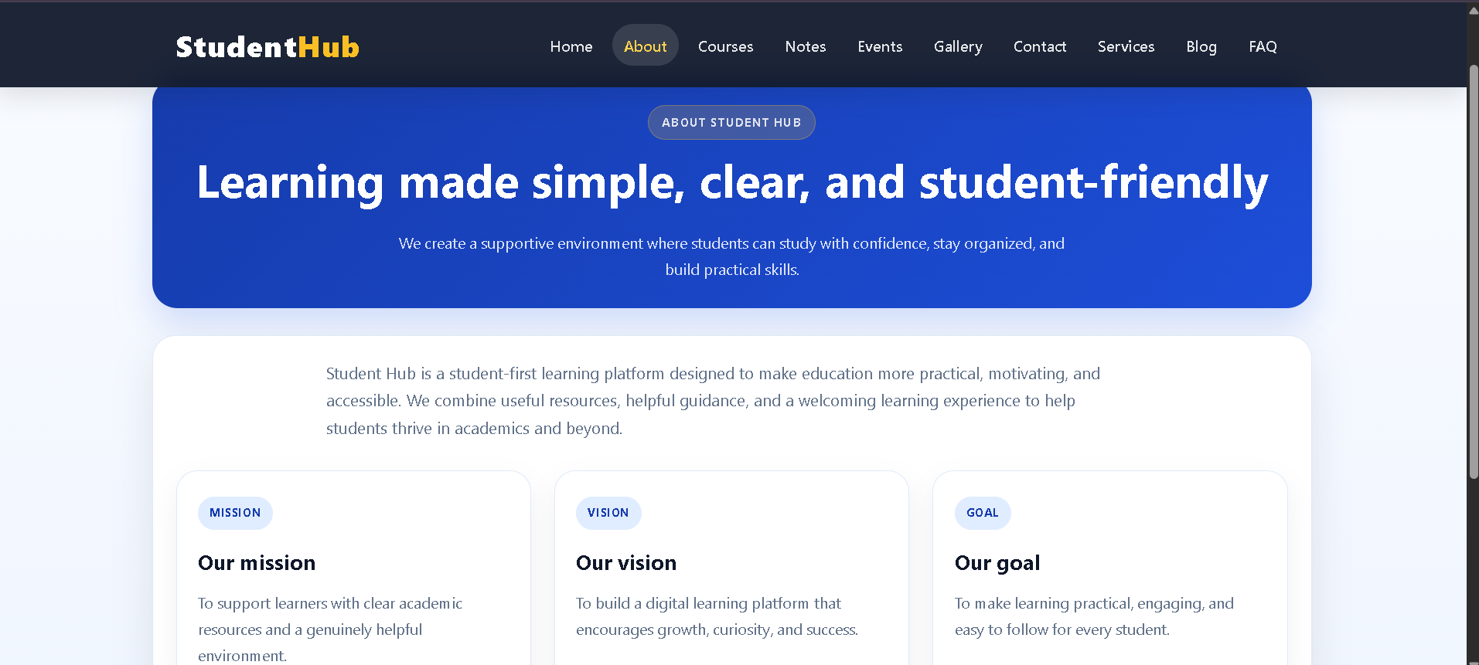

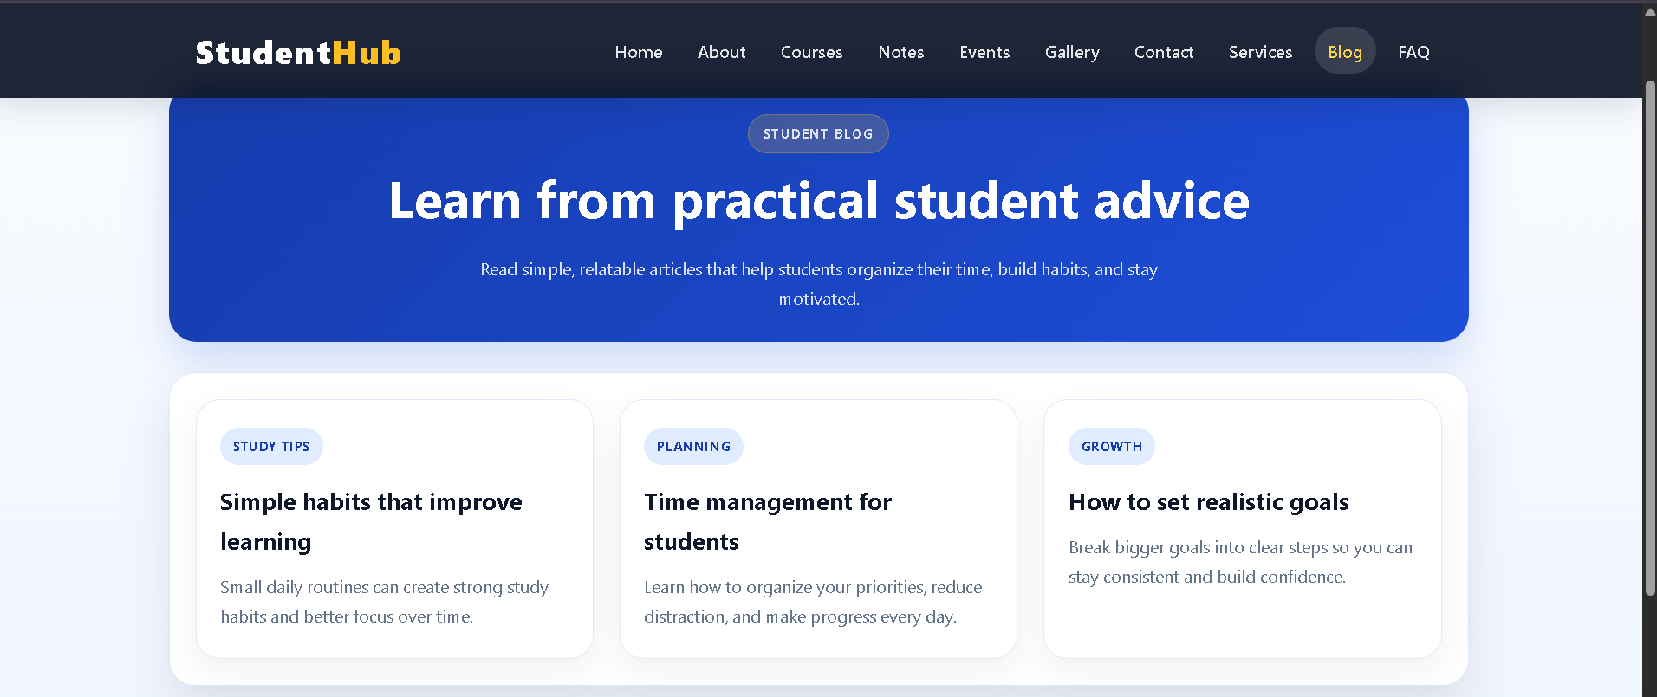
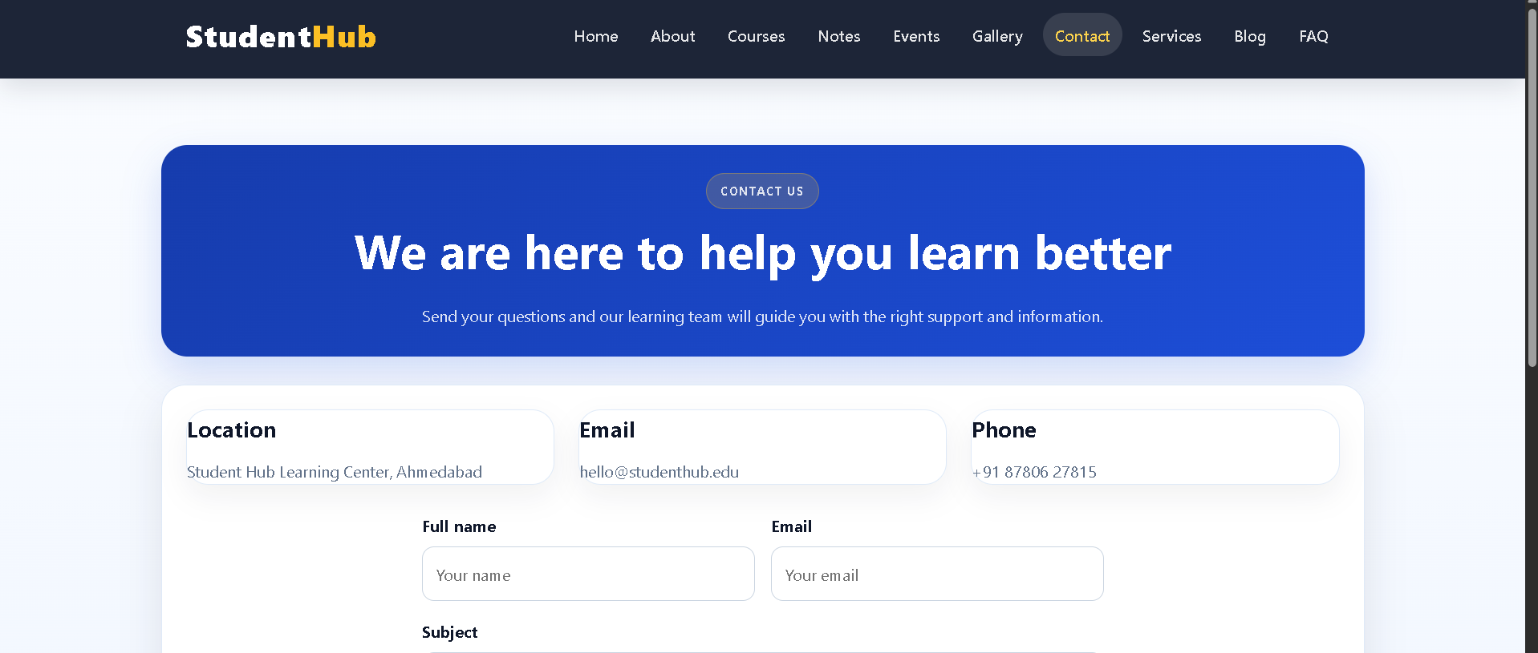
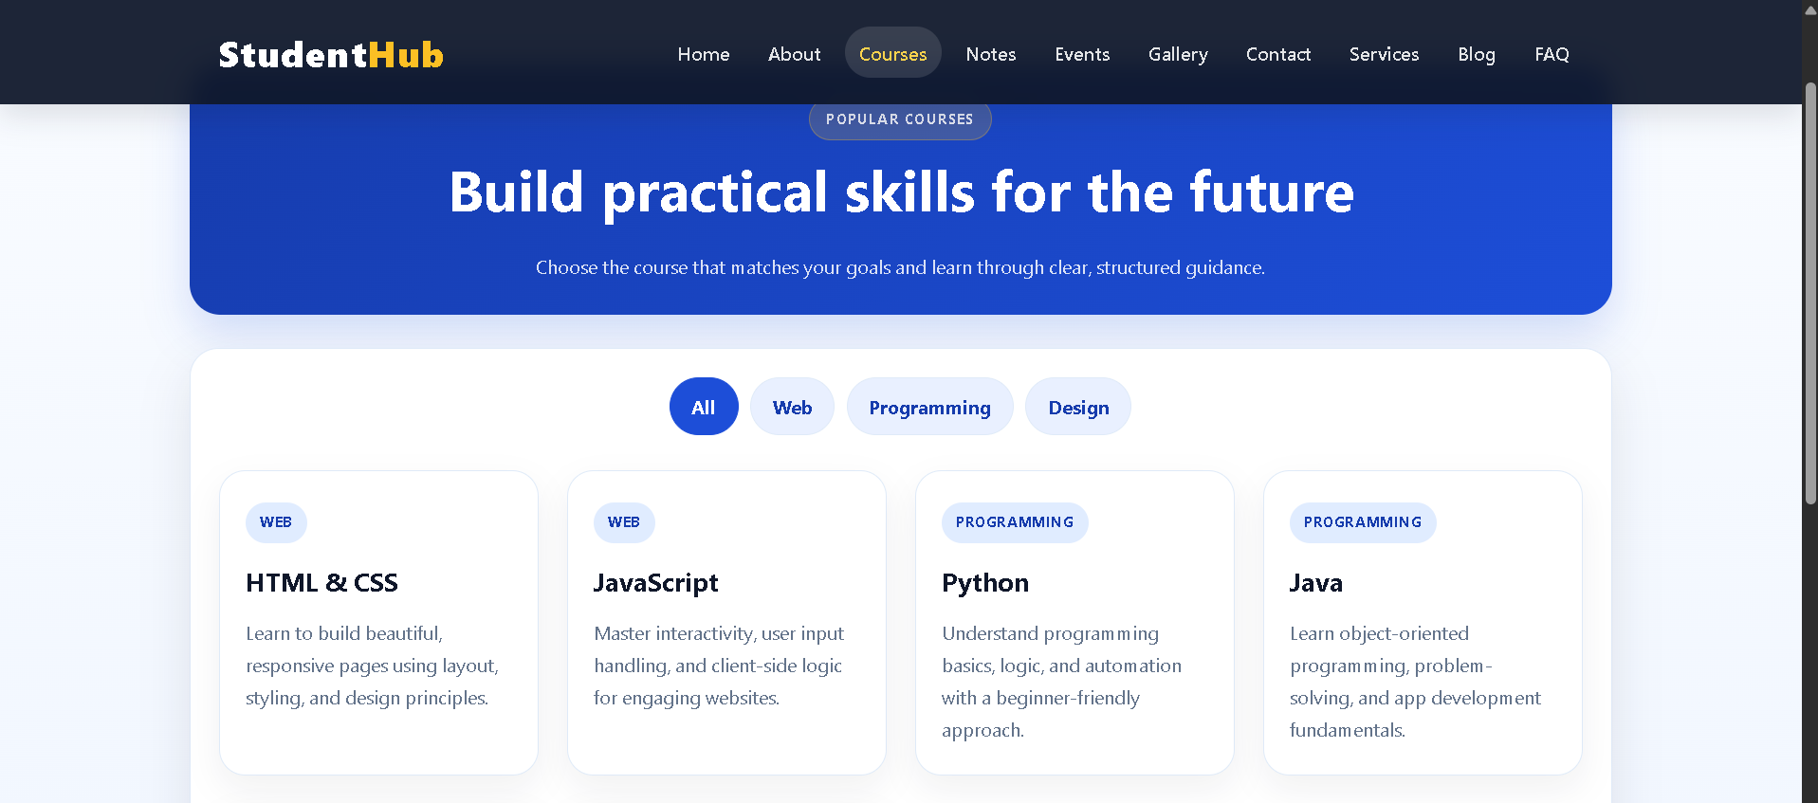
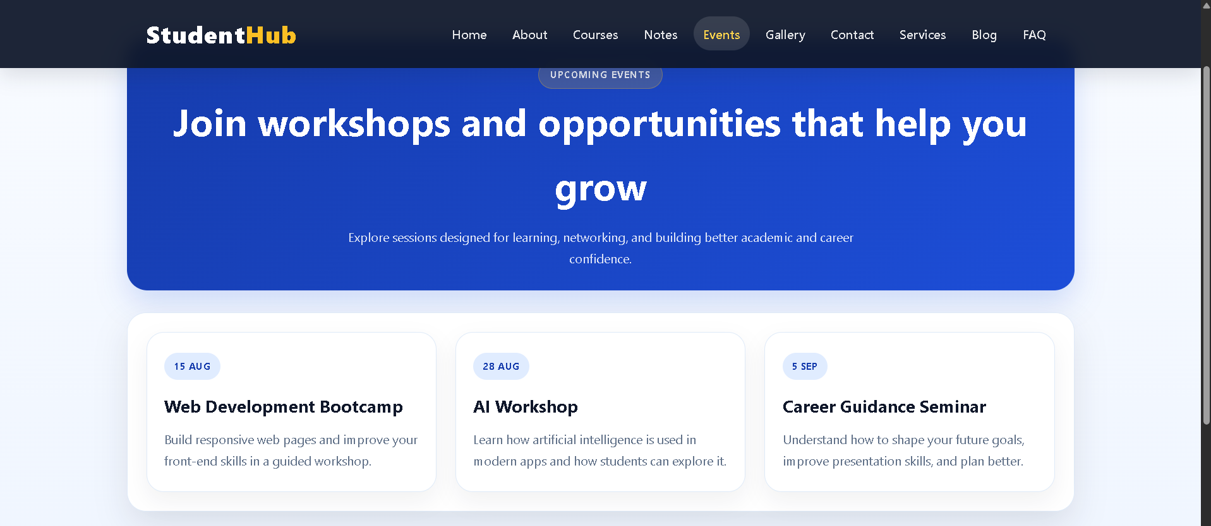
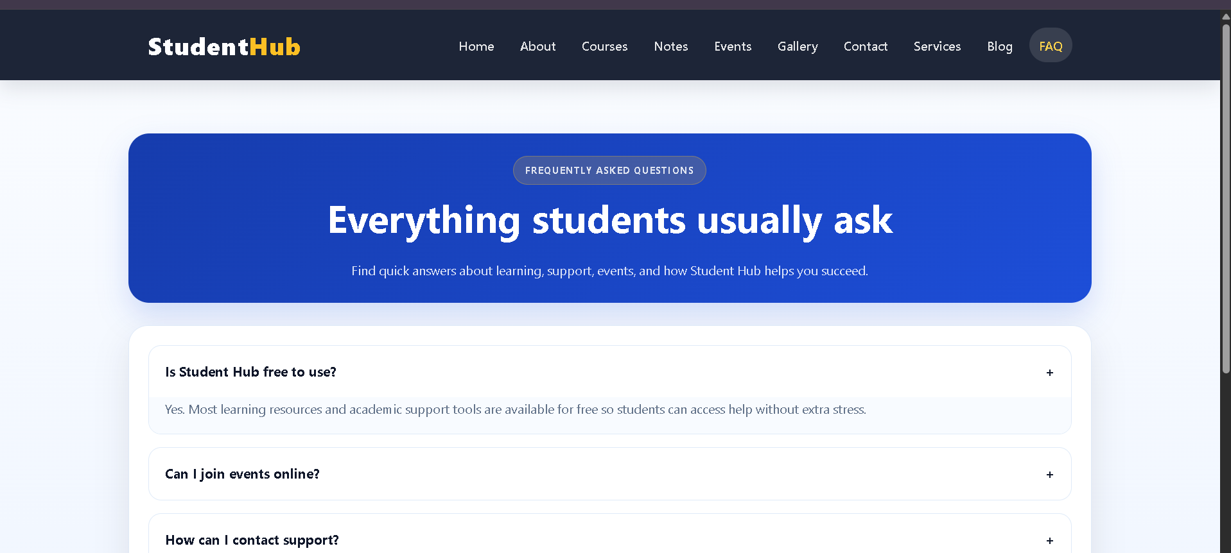
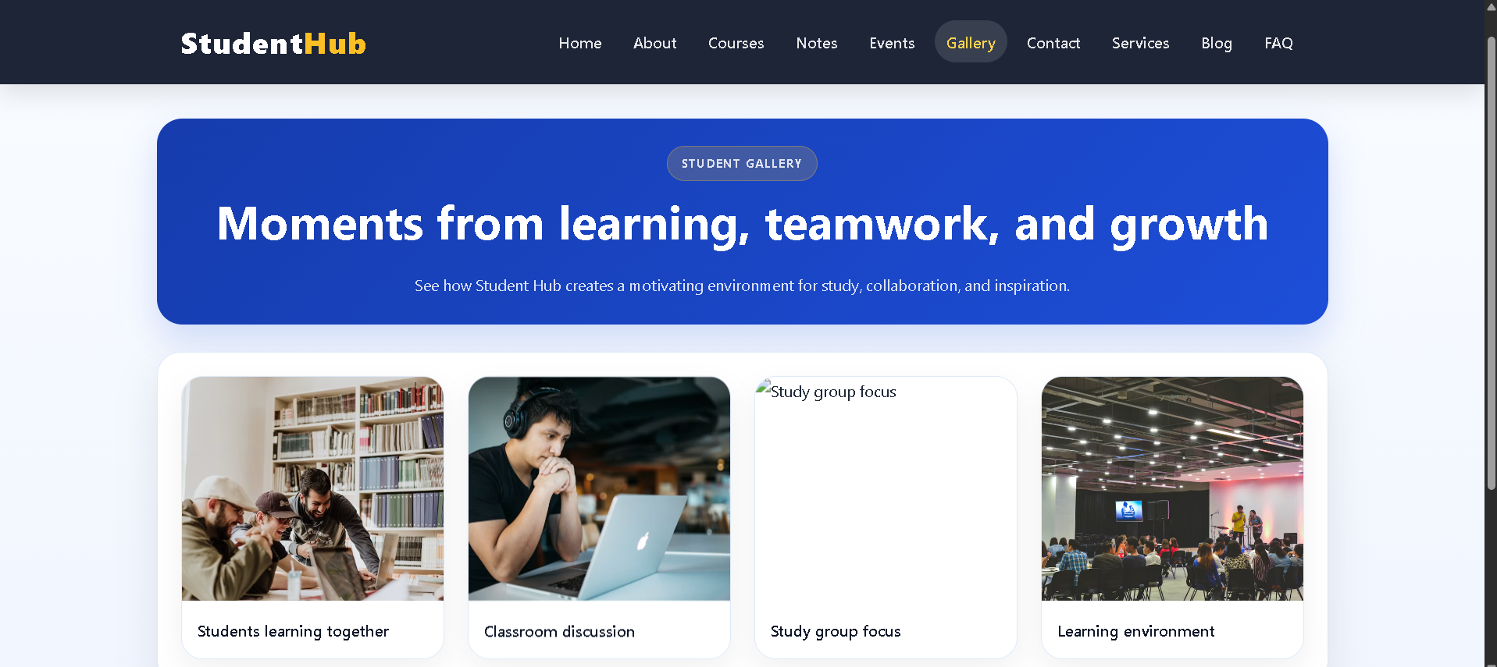
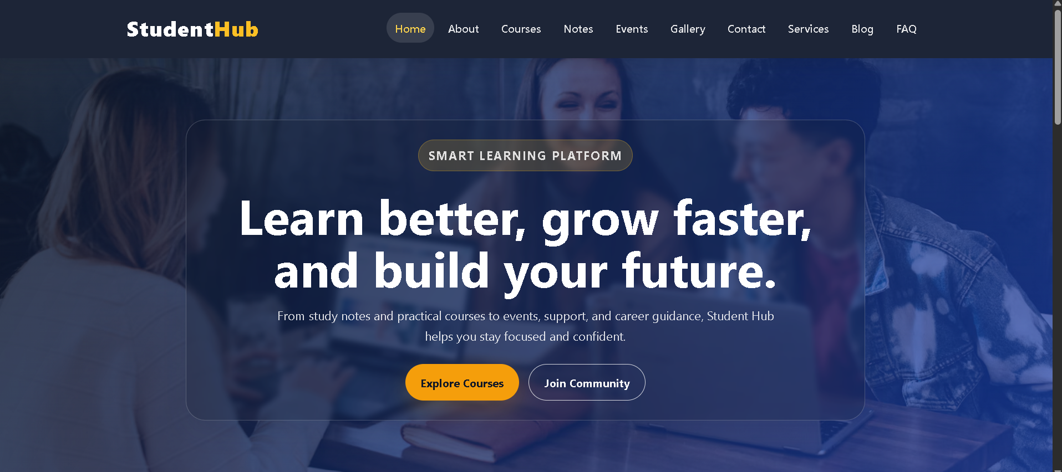
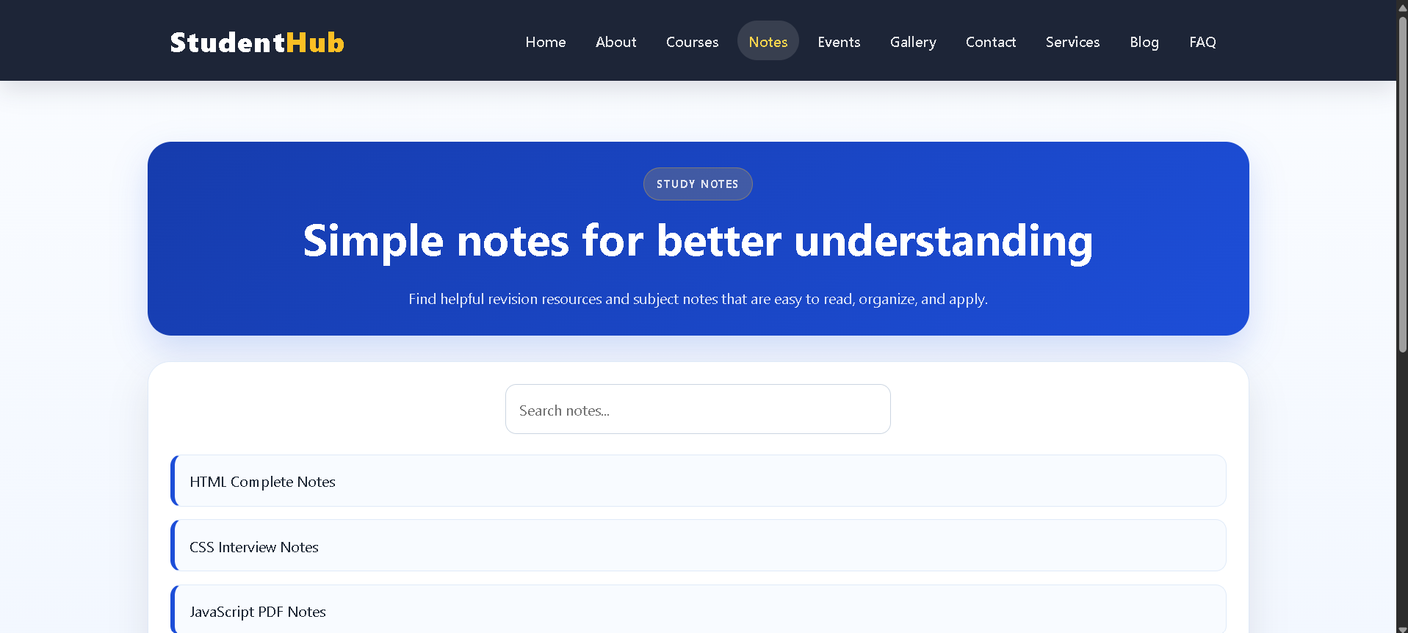

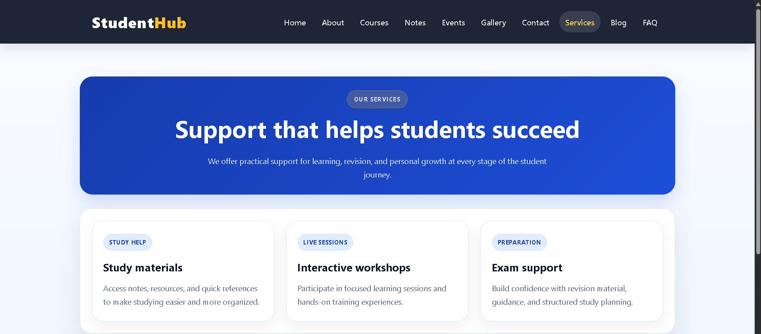

Practical 2:
File: about.html
Code:
<!DOCTYPE html>
<html lang="en">
<head>
<meta charset="UTF-8">
<meta name="viewport" content="width=device-width, initial-scale=1.0">
<title>StudentHub | About</title>
<meta name="description" content="Learn about StudentHub, our mission, and the student-first learning experience." />
<link rel="stylesheet" href="style.css">
</head>
<body>
<a class="skip-link" href="#main-content">Skip to main content</a>
<header class="site-header">
<div class="brand-block">
<p class="brand-name">StudentHub</p>
<p class="brand-subtitle">Smart campus portal</p>
</div>
<nav aria-label="Primary navigation">
<ul class="nav-list">
<li><a href="index.html">Home</a></li>
<li><a href="about.html" aria-current="page">About</a></li>
<li><a href="courses.html">Courses</a></li>
<li><a href="events.html">Events</a></li>
<li><a href="register.html">Register</a></li>
<li><a href="login.html">Login</a></li>
<li><a href="dashboard.html">Dashboard</a></li>
<li><a href="profile.html">Profile</a></li>
<li><a href="faq.html">FAQ</a></li>
<li><a href="contact.html">Contact</a></li>
</ul>
</nav>
</header>
<main id="main-content">
<nav class="breadcrumb" aria-label="Breadcrumb">
<ol>
<li><a href="index.html">Home</a></li>
<li aria-current="page">About</li>
</ol>
</nav>
<section class="page-shell" aria-labelledby="about-title">
<div class="content-panel">
<h1 id="about-title">About StudentHub</h1>
<p>StudentHub is a student-centered learning portal designed to make academic life easier, more organized, and more connected.</p>
<p>We focus on accessible design, clear communication, and practical digital tools so students can find support, manage their work, and participate in campus life without confusion.</p>
</div>
</section>
<section class="section" aria-labelledby="mission-title">
<div class="section-heading">
<h2 id="mission-title">Our mission</h2>
</div>
<div class="card-grid three-columns">
<article class="card">
<h3>Accessible learning</h3>
<p>We build easy-to-use pages for all students, including keyboard and screen-reader friendly navigation.</p>
</article>
<article class="card">
<h3>Student engagement</h3>
<p>We connect students to academic events, resources, support groups, and meaningful feedback loops.</p>
</article>
<article class="card">
<h3>Progress tracking</h3>
<p>We help students monitor attendance, progress, and upcoming academic milestones with clarity.</p>
</article>
</div>
</section>
</main>
<footer class="site-footer">
<p>© 2026 StudentHub. All rights reserved.</p>
</footer>
</body>
</html>

File: admin.html
Code:
<!DOCTYPE html>
<html lang="en">
<head>
<meta charset="UTF-8">
<meta name="viewport" content="width=device-width, initial-scale=1.0">
<title>StudentHub | Admin</title>
<meta name="description" content="Admin page for StudentHub management and reports." />
<link rel="stylesheet" href="style.css">
</head>
<body>
<a class="skip-link" href="#main-content">Skip to main content</a>
<header class="site-header">
<div class="brand-block">
<p class="brand-name">StudentHub</p>
<p class="brand-subtitle">Smart campus portal</p>
</div>
<nav aria-label="Primary navigation">
<ul class="nav-list">
<li><a href="index.html">Home</a></li>
<li><a href="about.html">About</a></li>
<li><a href="courses.html">Courses</a></li>
<li><a href="events.html">Events</a></li>
<li><a href="register.html">Register</a></li>
<li><a href="login.html">Login</a></li>
<li><a href="dashboard.html">Dashboard</a></li>
<li><a href="profile.html">Profile</a></li>
<li><a href="faq.html">FAQ</a></li>
<li><a href="contact.html">Contact</a></li>
</ul>
</nav>
</header>
<main id="main-content">
<nav class="breadcrumb" aria-label="Breadcrumb">
<ol>
<li><a href="index.html">Home</a></li>
<li aria-current="page">Admin</li>
</ol>
</nav>
<section class="page-shell" aria-labelledby="admin-title">
<div class="content-panel">
<h1 id="admin-title">Admin panel</h1>
<div class="summary-grid">
<article class="summary-tile">
<h3>Total students</h3>
<strong>1420</strong>
<p>Registered learners</p>
</article>
<article class="summary-tile">
<h3>Active courses</h3>
<strong>18</strong>
<p>Current academic programs</p>
</article>
<article class="summary-tile">
<h3>Pending requests</h3>
<strong>09</strong>
<p>Support queries</p>
</article>
</div>
</div>
</section>
</main>
<footer class="site-footer">
<p>© 2026 StudentHub. All rights reserved.</p>
</footer>
</body>
</html>

File: contact.html
Code:
<!DOCTYPE html>
<html lang="en">
<head>
<meta charset="UTF-8">
<meta name="viewport" content="width=device-width, initial-scale=1.0">
<title>StudentHub | Contact</title>
<meta name="description" content="Contact StudentHub for support, academic queries, and student portal assistance." />
<link rel="stylesheet" href="style.css">
</head>
<body>
<a class="skip-link" href="#main-content">Skip to main content</a>
<header class="site-header">
<div class="brand-block">
<p class="brand-name">StudentHub</p>
<p class="brand-subtitle">Smart campus portal</p>
</div>
<nav aria-label="Primary navigation">
<ul class="nav-list">
<li><a href="index.html">Home</a></li>
<li><a href="about.html">About</a></li>
<li><a href="courses.html">Courses</a></li>
<li><a href="events.html">Events</a></li>
<li><a href="register.html">Register</a></li>
<li><a href="login.html">Login</a></li>
<li><a href="dashboard.html">Dashboard</a></li>
<li><a href="profile.html">Profile</a></li>
<li><a href="faq.html">FAQ</a></li>
<li><a href="contact.html" aria-current="page">Contact</a></li>
</ul>
</nav>
</header>
<main id="main-content">
<nav class="breadcrumb" aria-label="Breadcrumb">
<ol>
<li><a href="index.html">Home</a></li>
<li aria-current="page">Contact</li>
</ol>
</nav>
<section class="page-shell" aria-labelledby="contact-title">
<div class="content-panel">
<h1 id="contact-title">Contact us</h1>
<div class="contact-grid">
<aside class="info-box">
<h2>Support center</h2>
<p><strong>Email:</strong> support@studenthub.edu</p>
<p><strong>Phone:</strong> +91 87806 27815</p>
<p><strong>Office hours:</strong> Mon-Sat, 9:00 AM - 5:00 PM</p>
</aside>
<form>
<div class="form-group">
<label for="name">Full name</label>
<input type="text" id="name" name="name" placeholder="Enter your full name">
</div>
<div class="form-group">
<label for="email">Email address</label>
<input type="email" id="email" name="email" placeholder="Enter your email">
</div>
<div class="form-group">
<label for="subject">Subject</label>
<input type="text" id="subject" name="subject" placeholder="Why are you contacting us?">
</div>
<div class="form-group">
<label for="message">Message</label>
<textarea id="message" name="message" placeholder="Write your message here"></textarea>
</div>
<button type="submit">Send message</button>
</form>
</div>
</div>
</section>
</main>
<footer class="site-footer">
<p>© 2026 StudentHub. All rights reserved.</p>
</footer>
</body>
</html>

File: courses.html
Code:
<!DOCTYPE html>
<html lang="en">
<head>
<meta charset="UTF-8">
<meta name="viewport" content="width=device-width, initial-scale=1.0">
<title>StudentHub | Courses</title>
<meta name="description" content="Explore StudentHub courses, study tracks, and academic learning support." />
<link rel="stylesheet" href="style.css">
</head>
<body>
<a class="skip-link" href="#main-content">Skip to main content</a>
<header class="site-header">
<div class="brand-block">
<p class="brand-name">StudentHub</p>
<p class="brand-subtitle">Smart campus portal</p>
</div>
<nav aria-label="Primary navigation">
<ul class="nav-list">
<li><a href="index.html">Home</a></li>
<li><a href="about.html">About</a></li>
<li><a href="courses.html" aria-current="page">Courses</a></li>
<li><a href="events.html">Events</a></li>
<li><a href="register.html">Register</a></li>
<li><a href="login.html">Login</a></li>
<li><a href="dashboard.html">Dashboard</a></li>
<li><a href="profile.html">Profile</a></li>
<li><a href="faq.html">FAQ</a></li>
<li><a href="contact.html">Contact</a></li>
</ul>
</nav>
</header>
<main id="main-content">
<nav class="breadcrumb" aria-label="Breadcrumb">
<ol>
<li><a href="index.html">Home</a></li>
<li aria-current="page">Courses</li>
</ol>
</nav>
<section class="page-shell" aria-labelledby="courses-title">
<div class="content-panel">
<h1 id="courses-title">Course catalog</h1>
<p>Explore the main academic programs and learning tracks available through StudentHub.</p>
<div class="card-grid three-columns">
<article class="card">
<h3>HTML5 Foundations</h3>
<p>Learn semantic structure, heading hierarchy, and content accessibility practices.</p>
</article>
<article class="card">
<h3>Web Design Basics</h3>
<p>Understand layouts, spacing, contrast, and user-friendly visual hierarchy.</p>
</article>
<article class="card">
<h3>Responsive UI</h3>
<p>Create pages that adapt elegantly across mobile, tablet, and desktop screens.</p>
</article>
</div>
</div>
</section>
</main>
<footer class="site-footer">
<p>© 2026 StudentHub. All rights reserved.</p>
</footer>
</body>
</html>

File: dashboard.html
Code:
<!DOCTYPE html>
<html lang="en">
<head>
<meta charset="UTF-8">
<meta name="viewport" content="width=device-width, initial-scale=1.0">
<title>StudentHub | Dashboard</title>
<meta name="description" content="Student dashboard page for academic overview and notices." />
<link rel="stylesheet" href="style.css">
</head>
<body>
<a class="skip-link" href="#main-content">Skip to main content</a>
<header class="site-header">
<div class="brand-block">
<p class="brand-name">StudentHub</p>
<p class="brand-subtitle">Smart campus portal</p>
</div>
<nav aria-label="Primary navigation">
<ul class="nav-list">
<li><a href="index.html">Home</a></li>
<li><a href="about.html">About</a></li>
<li><a href="courses.html">Courses</a></li>
<li><a href="events.html">Events</a></li>
<li><a href="register.html">Register</a></li>
<li><a href="login.html">Login</a></li>
<li><a href="dashboard.html" aria-current="page">Dashboard</a></li>
<li><a href="profile.html">Profile</a></li>
<li><a href="faq.html">FAQ</a></li>
<li><a href="contact.html">Contact</a></li>
</ul>
</nav>
</header>
<main id="main-content">
<nav class="breadcrumb" aria-label="Breadcrumb">
<ol>
<li><a href="index.html">Home</a></li>
<li aria-current="page">Dashboard</li>
</ol>
</nav>
<section class="page-shell" aria-labelledby="dashboard-title">
<div class="content-panel">
<h1 id="dashboard-title">Student dashboard</h1>
<div class="summary-grid">
<article class="summary-tile">
<h3>Attendance</h3>
<strong>92%</strong>
<p>Across current semester courses.</p>
</article>
<article class="summary-tile">
<h3>Assignments</h3>
<strong>06</strong>
<p>Pending and submitted this week.</p>
</article>
<article class="summary-tile">
<h3>Events</h3>
<strong>04</strong>
<p>Upcoming campus activities.</p>
</article>
</div>
</div>
</section>
<section class="section" aria-labelledby="notifications-title">
<div class="section-heading">
<h2 id="notifications-title">Notifications</h2>
</div>
<ul class="class-list">
<li>Web Design project submission due on Friday.</li>
<li>Career workshop registration open for this week.</li>
<li>Library access extended for exam preparation.</li>
</ul>
</section>
</main>
<footer class="site-footer">
<p>© 2026 StudentHub. All rights reserved.</p>
</footer>
</body>
</html>

File: events.html
Code:
<!DOCTYPE html>
<html lang="en">
<head>
<meta charset="UTF-8">
<meta name="viewport" content="width=device-width, initial-scale=1.0">
<title>StudentHub | Events</title>
<meta name="description" content="StudentHub events and workshops page for campus learning activities." />
<link rel="stylesheet" href="style.css">
</head>
<body>
<a class="skip-link" href="#main-content">Skip to main content</a>
<header class="site-header">
<div class="brand-block">
<p class="brand-name">StudentHub</p>
<p class="brand-subtitle">Smart campus portal</p>
</div>
<button class="menu-toggle" type="button" aria-label="Open menu" aria-expanded="false">☰</button>
<nav aria-label="Primary navigation" class="nav">
<ul class="nav-list">
<li><a href="index.html">Home</a></li>
<li><a href="about.html">About</a></li>
<li><a href="courses.html">Courses</a></li>
<li><a href="events.html" aria-current="page">Events</a></li>
<li><a href="register.html">Register</a></li>
<li><a href="login.html">Login</a></li>
<li><a href="dashboard.html">Dashboard</a></li>
<li><a href="profile.html">Profile</a></li>
<li><a href="faq.html">FAQ</a></li>
<li><a href="contact.html">Contact</a></li>
</ul>
</nav>
</header>
<main id="main-content">
<nav class="breadcrumb" aria-label="Breadcrumb">
<ol>
<li><a href="index.html">Home</a></li>
<li aria-current="page">Events</li>
</ol>
</nav>
<section class="section" aria-labelledby="events-title">
<div class="section-heading">
<p class="eyebrow">Upcoming events</p>
<h1 id="events-title">Join workshops and opportunities that help you grow</h1>
<p>Explore sessions designed for learning, networking, and building stronger academic and career confidence.</p>
</div>
<div class="card-grid three-columns">
<article class="card">
<span class="course-tag">15 Aug</span>
<h3>Web Development Bootcamp</h3>
<p>Build responsive web pages and improve your front-end skills in a guided workshop.</p>
</article>
<article class="card">
<span class="course-tag">28 Aug</span>
<h3>AI Workshop</h3>
<p>Learn how artificial intelligence is used in modern applications and student projects.</p>
</article>
<article class="card">
<span class="course-tag">5 Sep</span>
<h3>Career Guidance Seminar</h3>
<p>Understand future goals, presentation skills, and smart planning for your academic journey.</p>
</article>
</div>
</section>
</main>
<footer class="site-footer">
<p>© 2026 StudentHub. All rights reserved.</p>
</footer>
<script src="script.js"></script>
</body>
</html>

File: faq.html
Code:
<!DOCTYPE html>
<html lang="en">
<head>
<meta charset="UTF-8">
<meta name="viewport" content="width=device-width, initial-scale=1.0">
<title>StudentHub | FAQ</title>
<meta name="description" content="Frequently asked questions for StudentHub students and visitors." />
<link rel="stylesheet" href="style.css">
</head>
<body>
<a class="skip-link" href="#main-content">Skip to main content</a>
<header class="site-header">
<div class="brand-block">
<p class="brand-name">StudentHub</p>
<p class="brand-subtitle">Smart campus portal</p>
</div>
<button class="menu-toggle" type="button" aria-label="Open menu" aria-expanded="false">☰</button>
<nav aria-label="Primary navigation" class="nav">
<ul class="nav-list">
<li><a href="index.html">Home</a></li>
<li><a href="about.html">About</a></li>
<li><a href="courses.html">Courses</a></li>
<li><a href="events.html">Events</a></li>
<li><a href="register.html">Register</a></li>
<li><a href="login.html">Login</a></li>
<li><a href="dashboard.html">Dashboard</a></li>
<li><a href="profile.html">Profile</a></li>
<li><a href="faq.html" aria-current="page">FAQ</a></li>
<li><a href="contact.html">Contact</a></li>
</ul>
</nav>
</header>
<main id="main-content">
<nav class="breadcrumb" aria-label="Breadcrumb">
<ol>
<li><a href="index.html">Home</a></li>
<li aria-current="page">FAQ</li>
</ol>
</nav>
<section class="section" aria-labelledby="faq-title">
<div class="section-heading">
<p class="eyebrow">Frequently asked questions</p>
<h1 id="faq-title">Everything students usually ask</h1>
<p>Find quick answers about learning, support, events, and the StudentHub portal.</p>
</div>
<div class="faq-list">
<div class="faq-item active">
<button class="faq-question" type="button" aria-expanded="true">
Is StudentHub free to use?<span>+</span>
</button>
<div class="faq-answer">
<p>Yes. Most learning resources and academic support are available free of cost so students can get help without extra stress.</p>
</div>
</div>
<div class="faq-item">
<button class="faq-question" type="button" aria-expanded="false">
Can I join events online?<span>+</span>
</button>
<div class="faq-answer">
<p>Yes. Many events support both online and in-person participation, making it easier for students to join from anywhere.</p>
</div>
</div>
<div class="faq-item">
<button class="faq-question" type="button" aria-expanded="false">
How can I contact support?<span>+</span>
</button>
<div class="faq-answer">
<p>You can use the contact page to send a message to our team. We help with registration, course guidance, and student questions.</p>
</div>
</div>
<div class="faq-item">
<button class="faq-question" type="button" aria-expanded="false">
Do you provide study notes?<span>+</span>
</button>
<div class="faq-answer">
<p>Yes. StudentHub includes notes and learning references for topics such as HTML, CSS, JavaScript, and web development basics.</p>
</div>
</div>
</div>
</section>
</main>
<footer class="site-footer">
<p>© 2026 StudentHub. All rights reserved.</p>
</footer>
<script src="script.js"></script>
</body>
</html>

File: feedback.html
Code:
<!DOCTYPE html>
<html lang="en">
<head>
<meta charset="UTF-8">
<meta name="viewport" content="width=device-width, initial-scale=1.0">
<title>StudentHub | Feedback</title>
<meta name="description" content="Student feedback form for StudentHub portal." />
<link rel="stylesheet" href="style.css">
</head>
<body>
<a class="skip-link" href="#main-content">Skip to main content</a>
<header class="site-header">
<div class="brand-block">
<p class="brand-name">StudentHub</p>
<p class="brand-subtitle">Smart campus portal</p>
</div>
<nav aria-label="Primary navigation">
<ul class="nav-list">
<li><a href="index.html">Home</a></li>
<li><a href="about.html">About</a></li>
<li><a href="courses.html">Courses</a></li>
<li><a href="events.html">Events</a></li>
<li><a href="register.html">Register</a></li>
<li><a href="login.html">Login</a></li>
<li><a href="dashboard.html">Dashboard</a></li>
<li><a href="profile.html">Profile</a></li>
<li><a href="faq.html">FAQ</a></li>
<li><a href="contact.html">Contact</a></li>
</ul>
</nav>
</header>
<main id="main-content">
<nav class="breadcrumb" aria-label="Breadcrumb">
<ol>
<li><a href="index.html">Home</a></li>
<li aria-current="page">Feedback</li>
</ol>
</nav>
<section class="page-shell" aria-labelledby="feedback-title">
<div class="content-panel form-panel">
<div class="info-box">
<h1 id="feedback-title">We value your feedback</h1>
<p>Share your thoughts about our portal, course experience, or student support.</p>
</div>
<form>
<div class="form-group">
<label for="feedback-name">Name</label>
<input type="text" id="feedback-name" name="feedback-name" placeholder="Your name">
</div>
<div class="form-group">
<label for="feedback-course">Course/Department</label>
<input type="text" id="feedback-course" name="feedback-course" placeholder="Your course or department">
</div>
<div class="form-group">
<label for="feedback-type">Feedback type</label>
<select id="feedback-type" name="feedback-type">
<option selected>Choose one</option>
<option>Website usability</option>
<option>Academic support</option>
<option>Event experience</option>
<option>General suggestion</option>
</select>
</div>
<div class="form-group">
<label for="feedback-message">Message</label>
<textarea id="feedback-message" name="feedback-message" placeholder="Write your feedback here"></textarea>
</div>
<button type="submit">Submit feedback</button>
</form>
</div>
</section>
</main>
<footer class="site-footer">
<p>© 2026 StudentHub. All rights reserved.</p>
</footer>
</body>
</html>

File: index.html
Code:
<!DOCTYPE html>
<html lang="en">
<head>
<meta charset="UTF-8">
<meta name="viewport" content="width=device-width, initial-scale=1.0">
<title>StudentHub | Home</title>
<meta name="description" content="StudentHub portal for learning, events, registration, support, and student services." />
<link rel="stylesheet" href="style.css">
</head>
<body>
<a class="skip-link" href="#main-content">Skip to main content</a>
<header class="site-header">
<div class="brand-block">
<p class="brand-name">StudentHub</p>
<p class="brand-subtitle">Smart campus portal</p>
</div>
<nav aria-label="Primary navigation">
<ul class="nav-list">
<li><a href="index.html" aria-current="page">Home</a></li>
<li><a href="about.html">About</a></li>
<li><a href="courses.html">Courses</a></li>
<li><a href="events.html">Events</a></li>
<li><a href="register.html">Register</a></li>
<li><a href="login.html">Login</a></li>
<li><a href="dashboard.html">Dashboard</a></li>
<li><a href="profile.html">Profile</a></li>
<li><a href="faq.html">FAQ</a></li>
<li><a href="contact.html">Contact</a></li>
</ul>
</nav>
</header>
<main id="main-content">
<section class="hero" aria-labelledby="hero-title">
<div class="hero-copy">
<p class="eyebrow">Student portal</p>
<h1 id="hero-title">Learn better. Grow faster. Stay connected.</h1>
<p>StudentHub helps students manage courses, track progress, join events, and stay updated with campus support.</p>
<div class="button-row">
<a class="button" href="register.html">Register Now</a>
<a class="button secondary" href="dashboard.html">View Dashboard</a>
</div>
</div>
<aside class="info-panel" aria-label="Portal summary">
<h2>Portal highlights</h2>
<ul class="check-list">
<li>Course updates and notices</li>
<li>Live event and workshop access</li>
<li>Student profile and attendance</li>
<li>Support and feedback services</li>
</ul>
</aside>
</section>
<section class="section" aria-labelledby="features-title">
<div class="section-heading">
<h2 id="features-title">Everything students need</h2>
<p>Simple, accessible, and designed for campus success.</p>
</div>
<div class="card-grid">
<article class="card">
<h3>Academic Support</h3>
<p>Access notes, study resources, and guidance from faculty support teams.</p>
</article>
<article class="card">
<h3>Learning Dashboard</h3>
<p>Track attendance, assignments, schedules, and current academic goals.</p>
</article>
<article class="card">
<h3>Campus Life</h3>
<p>Explore events, workshops, student clubs, and extracurricular opportunities.</p>
</article>
</div>
</section>
<section class="section" aria-labelledby="quick-links-title">
<div class="section-heading">
<h2 id="quick-links-title">Quick access</h2>
</div>
<div class="quick-links">
<a href="login.html">Login</a>
<a href="profile.html">Profile</a>
<a href="events.html">Events</a>
<a href="feedback.html">Feedback</a>
<a href="faq.html">FAQ</a>
<a href="admin.html">Admin</a>
</div>
</section>
</main>
<footer class="site-footer">
<p>© 2026 StudentHub. All rights reserved.</p>
</footer>
</body>
</html>

File: login.html
Code:
<!DOCTYPE html>
<html lang="en">
<head>
<meta charset="UTF-8">
<meta name="viewport" content="width=device-width, initial-scale=1.0">
<title>StudentHub | Login</title>
<meta name="description" content="Student login page for the StudentHub portal." />
<link rel="stylesheet" href="style.css">
</head>
<body>
<a class="skip-link" href="#main-content">Skip to main content</a>
<header class="site-header">
<div class="brand-block">
<p class="brand-name">StudentHub</p>
<p class="brand-subtitle">Smart campus portal</p>
</div>
<nav aria-label="Primary navigation">
<ul class="nav-list">
<li><a href="index.html">Home</a></li>
<li><a href="about.html">About</a></li>
<li><a href="courses.html">Courses</a></li>
<li><a href="events.html">Events</a></li>
<li><a href="register.html">Register</a></li>
<li><a href="login.html" aria-current="page">Login</a></li>
<li><a href="dashboard.html">Dashboard</a></li>
<li><a href="profile.html">Profile</a></li>
<li><a href="faq.html">FAQ</a></li>
<li><a href="contact.html">Contact</a></li>
</ul>
</nav>
</header>
<main id="main-content">
<nav class="breadcrumb" aria-label="Breadcrumb">
<ol>
<li><a href="index.html">Home</a></li>
<li aria-current="page">Login</li>
</ol>
</nav>
<section class="page-shell" aria-labelledby="login-title">
<div class="content-panel form-panel">
<div class="info-box">
<h1 id="login-title">Welcome back</h1>
<p>Log in to continue with your coursework, notes, and student portal services.</p>
<ul class="detail-list">
<li>Access your dashboard</li>
<li>Review event schedules</li>
<li>Check your profile and updates</li>
</ul>
</div>
<form>
<div class="form-group">
<label for="login-email">Email address</label>
<input type="email" id="login-email" name="login-email" placeholder="Enter your email">
</div>
<div class="form-group">
<label for="login-password">Password</label>
<input type="password" id="login-password" name="login-password" placeholder="Enter your password">
</div>
<div class="form-group">
<label for="remember-me">
<input type="checkbox" id="remember-me" name="remember-me">
Remember me
</label>
</div>
<button type="submit">Login</button>
</form>
</div>
</section>
</main>
<footer class="site-footer">
<p>© 2026 StudentHub. All rights reserved.</p>
</footer>
</body>
</html>

File: profile.html
Code:
<!DOCTYPE html>
<html lang="en">
<head>
<meta charset="UTF-8">
<meta name="viewport" content="width=device-width, initial-scale=1.0">
<title>StudentHub | Profile</title>
<meta name="description" content="Student profile page for StudentHub." />
<link rel="stylesheet" href="style.css">
</head>
<body>
<a class="skip-link" href="#main-content">Skip to main content</a>
<header class="site-header">
<div class="brand-block">
<p class="brand-name">StudentHub</p>
<p class="brand-subtitle">Smart campus portal</p>
</div>
<nav aria-label="Primary navigation">
<ul class="nav-list">
<li><a href="index.html">Home</a></li>
<li><a href="about.html">About</a></li>
<li><a href="courses.html">Courses</a></li>
<li><a href="events.html">Events</a></li>
<li><a href="register.html">Register</a></li>
<li><a href="login.html">Login</a></li>
<li><a href="dashboard.html">Dashboard</a></li>
<li><a href="profile.html" aria-current="page">Profile</a></li>
<li><a href="faq.html">FAQ</a></li>
<li><a href="contact.html">Contact</a></li>
</ul>
</nav>
</header>
<main id="main-content">
<nav class="breadcrumb" aria-label="Breadcrumb">
<ol>
<li><a href="index.html">Home</a></li>
<li aria-current="page">Profile</li>
</ol>
</nav>
<section class="page-shell" aria-labelledby="profile-title">
<div class="content-panel profile-grid">
<aside class="info-box">
<h1 id="profile-title">Student profile</h1>
<p><strong>Name:</strong> Neel Patel</p>
<p><strong>Course:</strong> BCA</p>
<p><strong>Semester:</strong> 5</p>
<p><strong>Email:</strong> neelp1169@gmail.com</p>
<p><strong>Phone:</strong> 8780627815</p>
</aside>
<div>
<h2>Academic summary</h2>
<ul class="detail-list">
<li>Current CGPA: 8.7</li>
<li>Attendance: 92%</li>
<li>Active projects: 3</li>
<li>Mentor: Dr. Mehta</li>
</ul>
</div>
</div>
</section>
</main>
<footer class="site-footer">
<p>© 2026 StudentHub. All rights reserved.</p>
</footer>
</body>
</html>

File: register.html
Code:
<!DOCTYPE html>
<html lang="en">
<head>
<meta charset="UTF-8">
<meta name="viewport" content="width=device-width, initial-scale=1.0">
<title>StudentHub | Register</title>
<meta name="description" content="Student registration page for the StudentHub portal." />
<link rel="stylesheet" href="style.css">
</head>
<body>
<a class="skip-link" href="#main-content">Skip to main content</a>
<header class="site-header">
<div class="brand-block">
<p class="brand-name">StudentHub</p>
<p class="brand-subtitle">Smart campus portal</p>
</div>
<nav aria-label="Primary navigation">
<ul class="nav-list">
<li><a href="index.html">Home</a></li>
<li><a href="about.html">About</a></li>
<li><a href="courses.html">Courses</a></li>
<li><a href="events.html">Events</a></li>
<li><a href="register.html" aria-current="page">Register</a></li>
<li><a href="login.html">Login</a></li>
<li><a href="dashboard.html">Dashboard</a></li>
<li><a href="profile.html">Profile</a></li>
<li><a href="faq.html">FAQ</a></li>
<li><a href="contact.html">Contact</a></li>
</ul>
</nav>
</header>
<main id="main-content">
<nav class="breadcrumb" aria-label="Breadcrumb">
<ol>
<li><a href="index.html">Home</a></li>
<li aria-current="page">Register</li>
</ol>
</nav>
<section class="page-shell" aria-labelledby="register-title">
<div class="content-panel form-panel">
<div class="info-box">
<h1 id="register-title">Create your student account</h1>
<p>Register here to access notices, events, assignments, and academic resources.</p>
<ul class="detail-list">
<li>Simple online sign-up</li>
<li>Secure student profile</li>
<li>Ready for academic updates</li>
</ul>
</div>
<form>
<div class="form-group">
<label for="full-name">Full name</label>
<input type="text" id="full-name" name="full-name" placeholder="Enter your full name">
</div>
<div class="form-group">
<label for="student-email">Email address</label>
<input type="email" id="student-email" name="student-email" placeholder="name@example.com">
</div>
<div class="form-group">
<label for="student-id">Student ID</label>
<input type="text" id="student-id" name="student-id" placeholder="e.g. STU2024001">
</div>
<div class="form-group">
<label for="course">Course</label>
<select id="course" name="course">
<option selected>Select a course</option>
<option>BCA</option>
<option>B.Sc. IT</option>
<option>BBA</option>
<option>Diploma in Web Design</option>
</select>
</div>
<div class="form-group">
<label for="password">Password</label>
<input type="password" id="password" name="password" placeholder="Create a password">
</div>
<button type="submit">Register</button>
</form>
</div>
</section>
</main>
<footer class="site-footer">
<p>© 2026 StudentHub. All rights reserved.</p>
</footer>
</body>
</html>

File: script.js
Code:
document.addEventListener('DOMContentLoaded', () => {
const nav = document.querySelector('.nav');
const menuButton = document.querySelector('.menu-toggle');
if (menuButton && nav) {
menuButton.addEventListener('click', () => {
nav.classList.toggle('nav-open');
const expanded = menuButton.getAttribute('aria-expanded') === 'true';
menuButton.setAttribute('aria-expanded', String(!expanded));
});
}
const faqItems = document.querySelectorAll('.faq-item');
faqItems.forEach((item) => {
const button = item.querySelector('.faq-question');
const answer = item.querySelector('.faq-answer');
if (!button || !answer) return;
if (item.classList.contains('active')) {
answer.style.maxHeight = answer.scrollHeight + 'px';
button.setAttribute('aria-expanded', 'true');
} else {
answer.style.maxHeight = '0px';
button.setAttribute('aria-expanded', 'false');
}
button.addEventListener('click', () => {
const isOpen = item.classList.contains('active');
faqItems.forEach((faqItem) => {
const faqButton = faqItem.querySelector('.faq-question');
const faqAnswer = faqItem.querySelector('.faq-answer');
if (!faqButton || !faqAnswer) return;
faqItem.classList.remove('active');
faqButton.setAttribute('aria-expanded', 'false');
faqAnswer.style.maxHeight = '0px';
});
if (!isOpen) {
item.classList.add('active');
button.setAttribute('aria-expanded', 'true');
answer.style.maxHeight = answer.scrollHeight + 'px';
}
});
});
});

File: style.css
Code:
:root {
--primary: #1d4ed8;
--primary-dark: #1e3a8a;
--accent: #e0f2fe;
--surface: #ffffff;
--bg: #f3f6fb;
--text: #1f2937;
--muted: #526074;
--border: #d7dfeb;
--success: #166534;
--warning: #92400e;
--shadow: 0 12px 28px rgba(15, 23, 42, 0.08);
}
* {
box-sizing: border-box;
}
html {
scroll-behavior: smooth;
}
body {
margin: 0;
font-family: Arial, Helvetica, sans-serif;
line-height: 1.6;
background: var(--bg);
color: var(--text);
}
img {
max-width: 100%;
display: block;
}
.skip-link {
position: absolute;
left: -9999px;
top: auto;
}
.skip-link:focus {
left: 16px;
top: 16px;
z-index: 1000;
background: var(--primary);
color: #fff;
padding: 10px 14px;
border-radius: 8px;
}
.site-header {
background: linear-gradient(135deg, var(--primary), var(--primary-dark));
color: #fff;
padding: 18px 24px;
display: flex;
justify-content: space-between;
align-items: center;
gap: 16px;
flex-wrap: wrap;
position: relative;
}
.menu-toggle {
display: none;
background: transparent;
color: #fff;
border: 1px solid rgba(255,255,255,0.4);
border-radius: 8px;
font-size: 1.4rem;
padding: 6px 10px;
cursor: pointer;
}
.brand-block {
display: flex;
flex-direction: column;
}
.brand-name {
margin: 0;
font-size: 1.6rem;
font-weight: 700;
}
.brand-subtitle {
margin: 0;
opacity: 0.9;
font-size: 0.9rem;
}
.nav-list {
list-style: none;
display: flex;
gap: 8px;
flex-wrap: wrap;
padding: 0;
margin: 0;
}
.nav-list a,
.quick-links a,
.breadcrumb a {
text-decoration: none;
}
.nav-list a {
color: #fff;
padding: 8px 10px;
border-radius: 999px;
font-weight: 600;
}
.nav-list a:hover,
.nav-list a:focus-visible,
.quick-links a:hover,
.quick-links a:focus-visible,
.breadcrumb a:hover,
.breadcrumb a:focus-visible {
background: rgba(255, 255, 255, 0.12);
outline: none;
}
main {
max-width: 1200px;
margin: 0 auto;
padding: 24px;
}
.hero {
display: grid;
grid-template-columns: 1.4fr 0.8fr;
gap: 24px;
align-items: center;
background: linear-gradient(135deg, #eef5ff, #ffffff);
border: 1px solid var(--border);
border-radius: 18px;
padding: 32px;
box-shadow: var(--shadow);
}
.eyebrow {
display: inline-block;
background: var(--accent);
color: var(--primary-dark);
font-size: 0.78rem;
font-weight: 700;
letter-spacing: 0.08em;
padding: 6px 12px;
border-radius: 999px;
text-transform: uppercase;
}
.hero h1,
.content-panel h1,
.section-heading h2,
.info-box h2 {
margin-top: 0;
color: var(--text);
}
.hero h1 {
font-size: clamp(2rem, 4vw, 3rem);
line-height: 1.2;
margin-bottom: 12px;
}
.hero-copy p,
.content-panel p,
.card p,
.info-box p,
.check-list li,
.quick-links a,
.detail-list li {
color: var(--muted);
}
.button-row {
display: flex;
gap: 12px;
flex-wrap: wrap;
margin-top: 16px;
}
.button {
display: inline-block;
background: var(--primary);
color: #fff;
padding: 12px 18px;
border-radius: 8px;
text-decoration: none;
font-weight: 700;
}
.button.secondary {
background: #fff;
color: var(--primary);
border: 1px solid var(--primary);
}
.button:hover,
.button:focus-visible,
button:hover,
button:focus-visible {
filter: brightness(0.96);
outline: none;
}
.course-tag {
display: inline-block;
background: var(--accent);
color: var(--primary-dark);
border-radius: 999px;
padding: 6px 10px;
font-weight: 700;
margin-bottom: 12px;
}
.info-panel {
background: #fff;
border: 1px solid var(--border);
border-radius: 14px;
padding: 24px;
}
.check-list {
margin: 0;
padding-left: 18px;
}
.check-list li + li {
margin-top: 8px;
}
.section {
margin-top: 32px;
}
.section-heading {
text-align: center;
margin-bottom: 20px;
}
.card-grid {
display: grid;
grid-template-columns: repeat(auto-fit, minmax(220px, 1fr));
gap: 18px;
}
.card-grid.three-columns {
grid-template-columns: repeat(3, minmax(220px, 1fr));
}
.card,
.content-panel,
.info-panel,
.info-box,
.summary-tile,
.list-card {
background: var(--surface);
border: 1px solid var(--border);
border-radius: 16px;
padding: 20px;
box-shadow: var(--shadow);
}
.card h3 {
margin-top: 0;
}
.quick-links {
display: grid;
grid-template-columns: repeat(auto-fit, minmax(140px, 1fr));
gap: 14px;
}
.quick-links a {
display: block;
background: #fff;
border: 1px solid var(--border);
border-radius: 12px;
padding: 16px;
text-align: center;
color: var(--primary-dark);
font-weight: 700;
}
.page-shell {
margin-top: 24px;
}
.content-panel {
padding: 28px;
}
.breadcrumb {
margin: 12px 0 18px;
}
.breadcrumb ol {
list-style: none;
display: flex;
gap: 10px;
padding: 0;
margin: 0;
color: var(--muted);
flex-wrap: wrap;
}
.breadcrumb li + li::before {
content: ">";
margin-right: 10px;
color: var(--muted);
}
.breadcrumb a {
color: var(--primary-dark);
font-weight: 600;
}
.contact-grid,
.form-panel {
display: grid;
grid-template-columns: 0.9fr 1.1fr;
gap: 22px;
}
.form-group {
margin-bottom: 14px;
}
label {
display: block;
margin-bottom: 6px;
font-weight: 700;
}
input,
textarea,
select {
width: 100%;
padding: 11px 12px;
border: 1px solid var(--border);
border-radius: 10px;
background: #fff;
font: inherit;
color: var(--text);
}
textarea {
min-height: 120px;
resize: vertical;
}
button {
background: var(--primary);
color: #fff;
border: none;
border-radius: 10px;
padding: 12px 18px;
font: inherit;
font-weight: 700;
cursor: pointer;
}
.detail-list {
list-style: none;
padding: 0;
margin: 0;
}
.detail-list li {
padding: 10px 0;
border-bottom: 1px solid var(--border);
}
.detail-list li:last-child {
border-bottom: none;
}
.summary-grid {
display: grid;
grid-template-columns: repeat(auto-fit, minmax(180px, 1fr));
gap: 18px;
}
.summary-tile h3 {
margin-top: 0;
}
.summary-tile strong {
display: block;
font-size: 1.7rem;
color: var(--primary-dark);
}
.class-list,
.event-list,
.faq-list {
list-style: none;
padding: 0;
margin: 0;
}
.class-list li,
.event-list li {
padding: 12px 0;
border-bottom: 1px solid var(--border);
}
.class-list li:last-child,
.event-list li:last-child {
border-bottom: none;
}
.profile-grid {
display: grid;
grid-template-columns: 1fr 1.3fr;
gap: 24px;
}
.info-box {
background: #f8fbff;
}
.faq-list {
max-width: 900px;
margin: 0 auto;
}
.faq-item {
background: #fff;
border: 1px solid var(--border);
border-radius: 12px;
margin-bottom: 12px;
overflow: hidden;
}
.faq-question {
width: 100%;
border: none;
background: transparent;
color: var(--text);
font: inherit;
font-weight: 700;
text-align: left;
padding: 16px 18px;
display: flex;
justify-content: space-between;
align-items: center;
cursor: pointer;
}
.faq-question span {
font-size: 1.3rem;
}
.faq-answer {
max-height: 0;
overflow: hidden;
transition: max-height 0.25s ease;
}
.faq-answer p {
margin: 0;
padding: 0 18px 18px;
color: var(--muted);
}
.faq-item.active .faq-answer {
max-height: 200px;
}
.faq-item.active .faq-question span {
transform: rotate(45deg);
}
.site-footer {
background: #fff;
text-align: center;
padding: 24px;
color: var(--muted);
border-top: 1px solid var(--border);
margin-top: 36px;
}
@media (max-width: 760px) {
.menu-toggle {
display: inline-block;
}
.nav {
display: none;
width: 100%;
}
.nav.nav-open {
display: block;
}
.nav-list {
flex-direction: column;
width: 100%;
}
.nav-list a {
display: block;
width: 100%;
}
.hero,
.contact-grid,
.profile-grid,
.form-panel,
.card-grid.three-columns {
grid-template-columns: 1fr;
}
.site-header {
flex-direction: column;
align-items: flex-start;
}
main {
padding: 18px;
}
}
@media (prefers-reduced-motion: reduce) {
* {
transition: none !important;
scroll-behavior: auto !important;
}
}

Output:
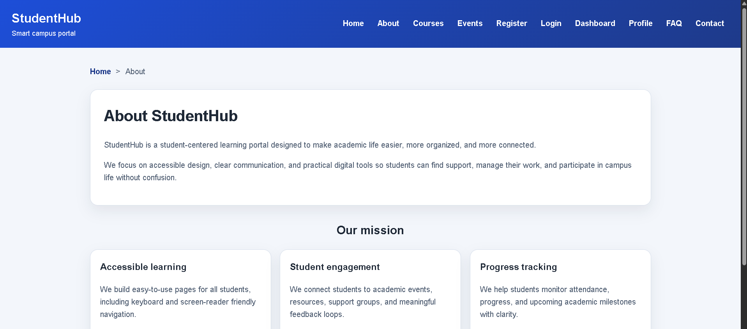
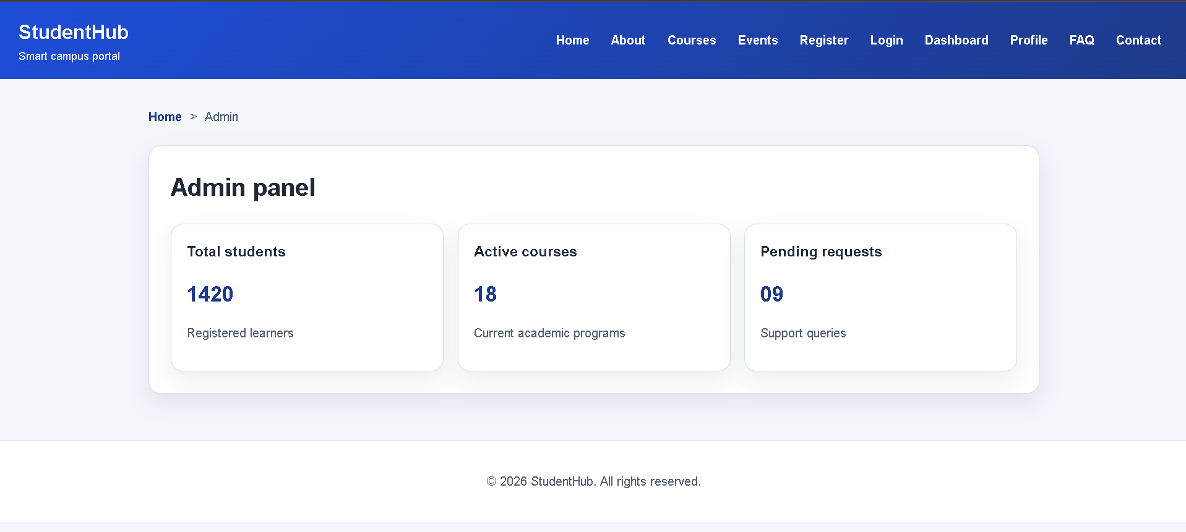
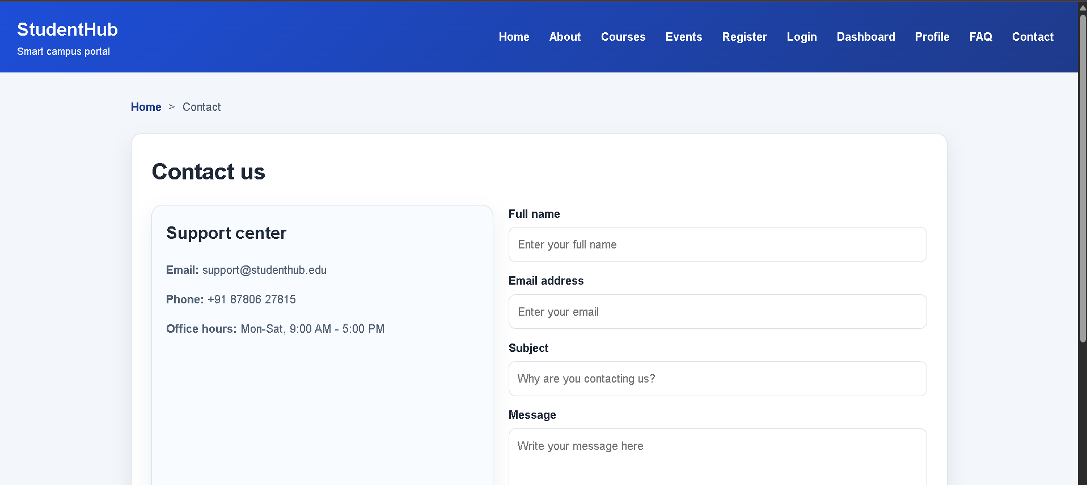
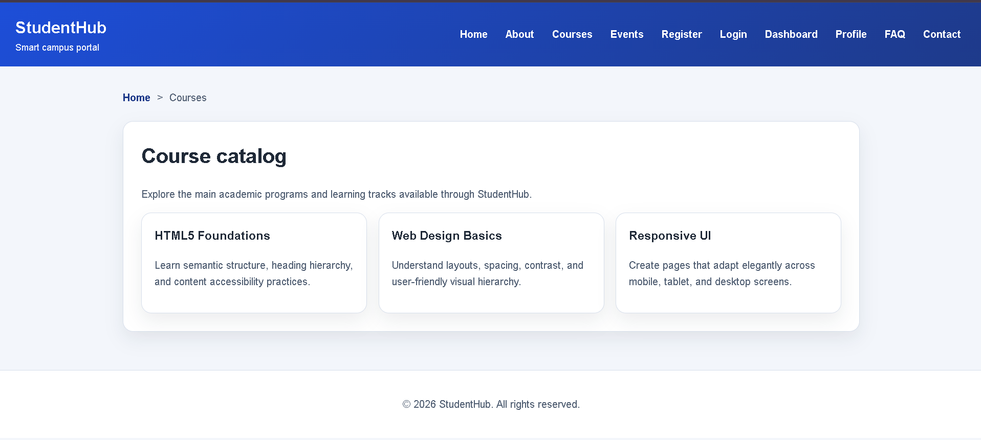
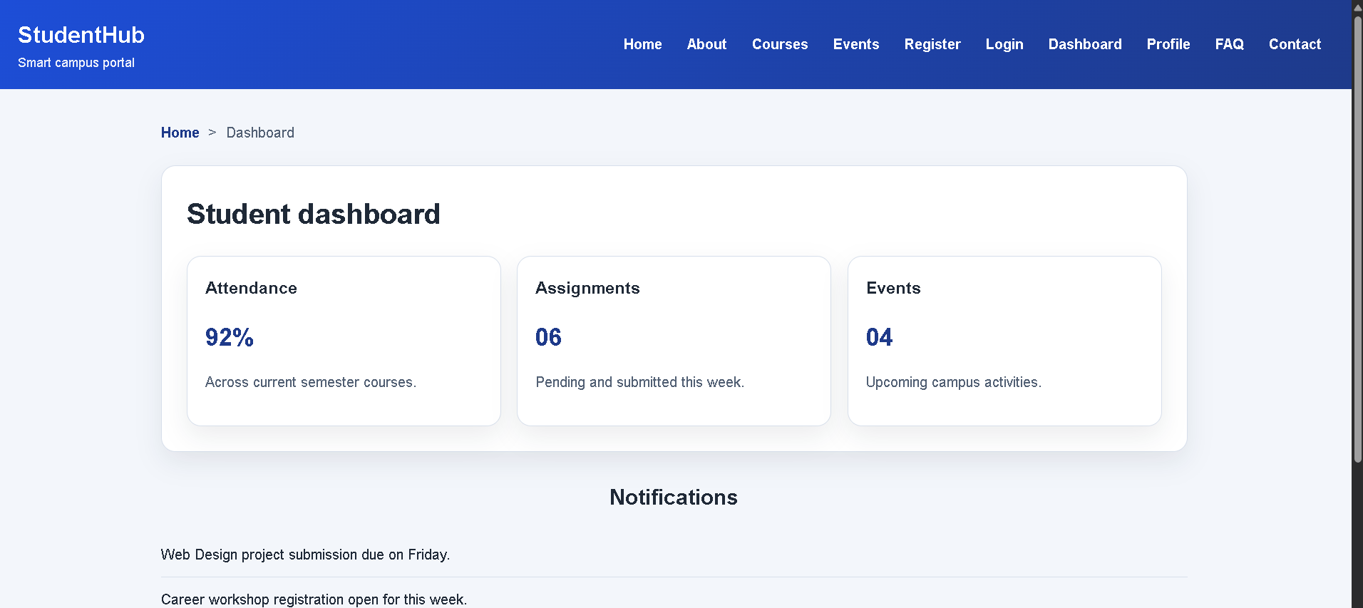
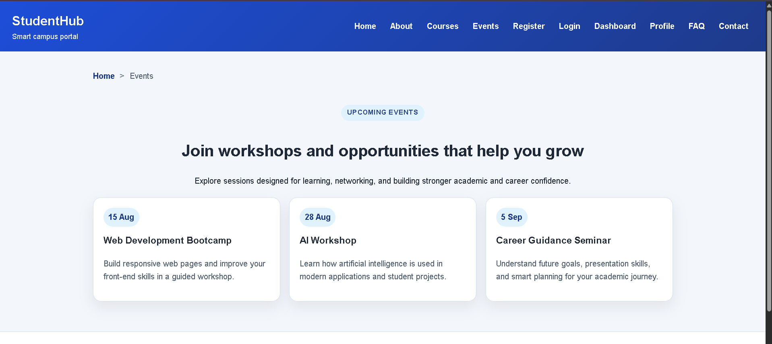
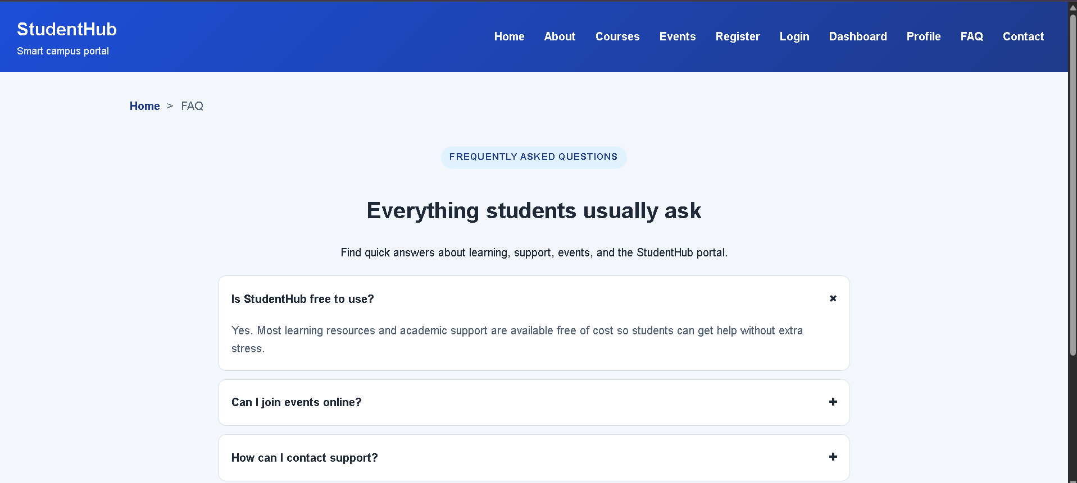
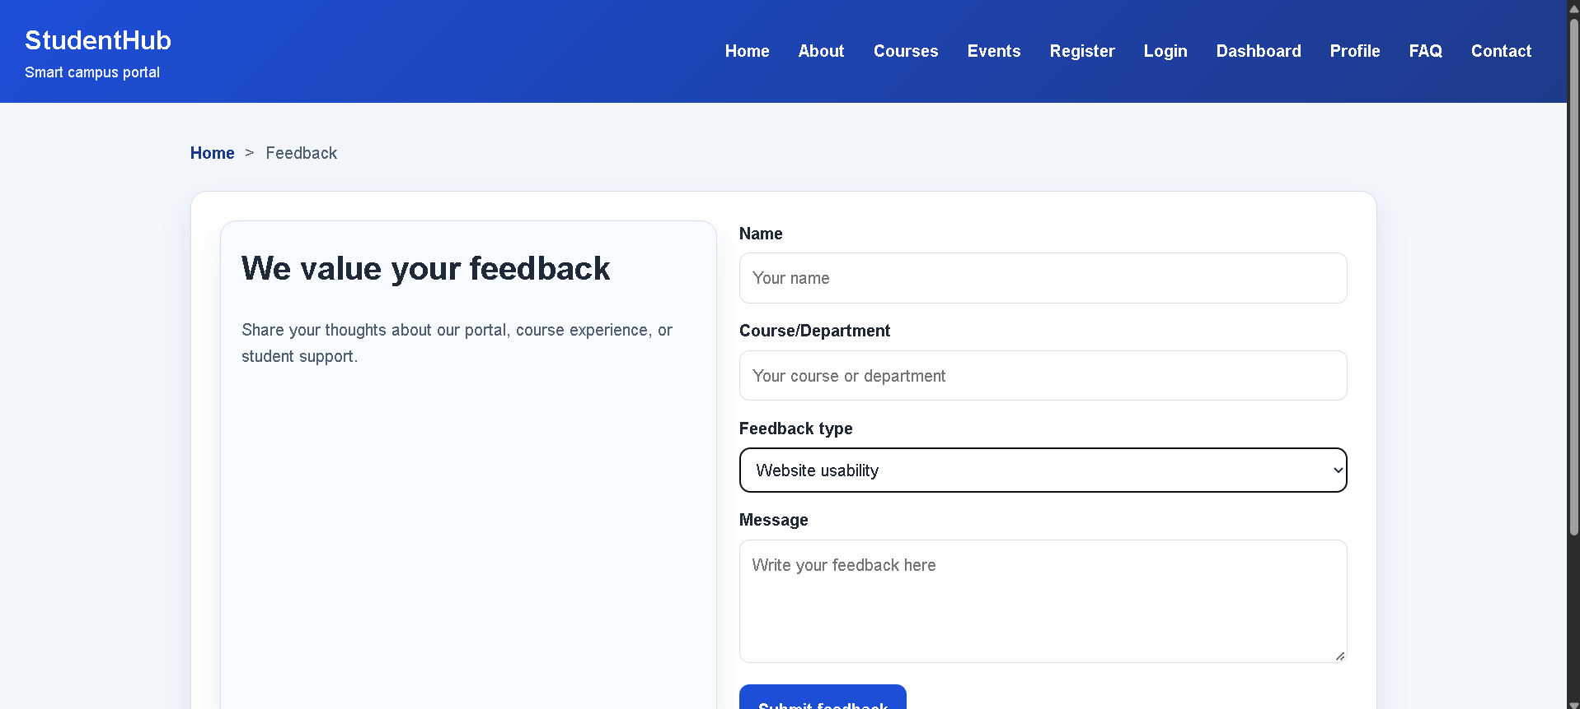
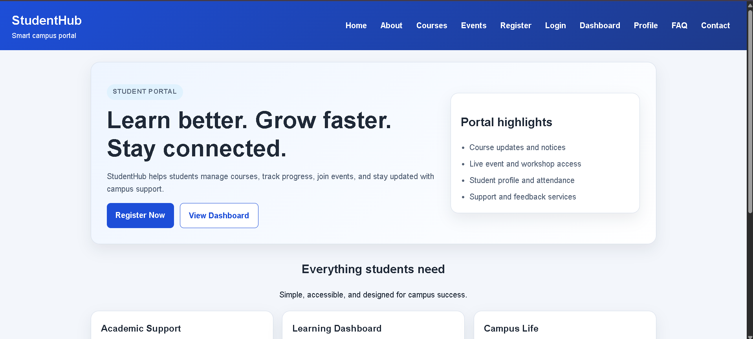
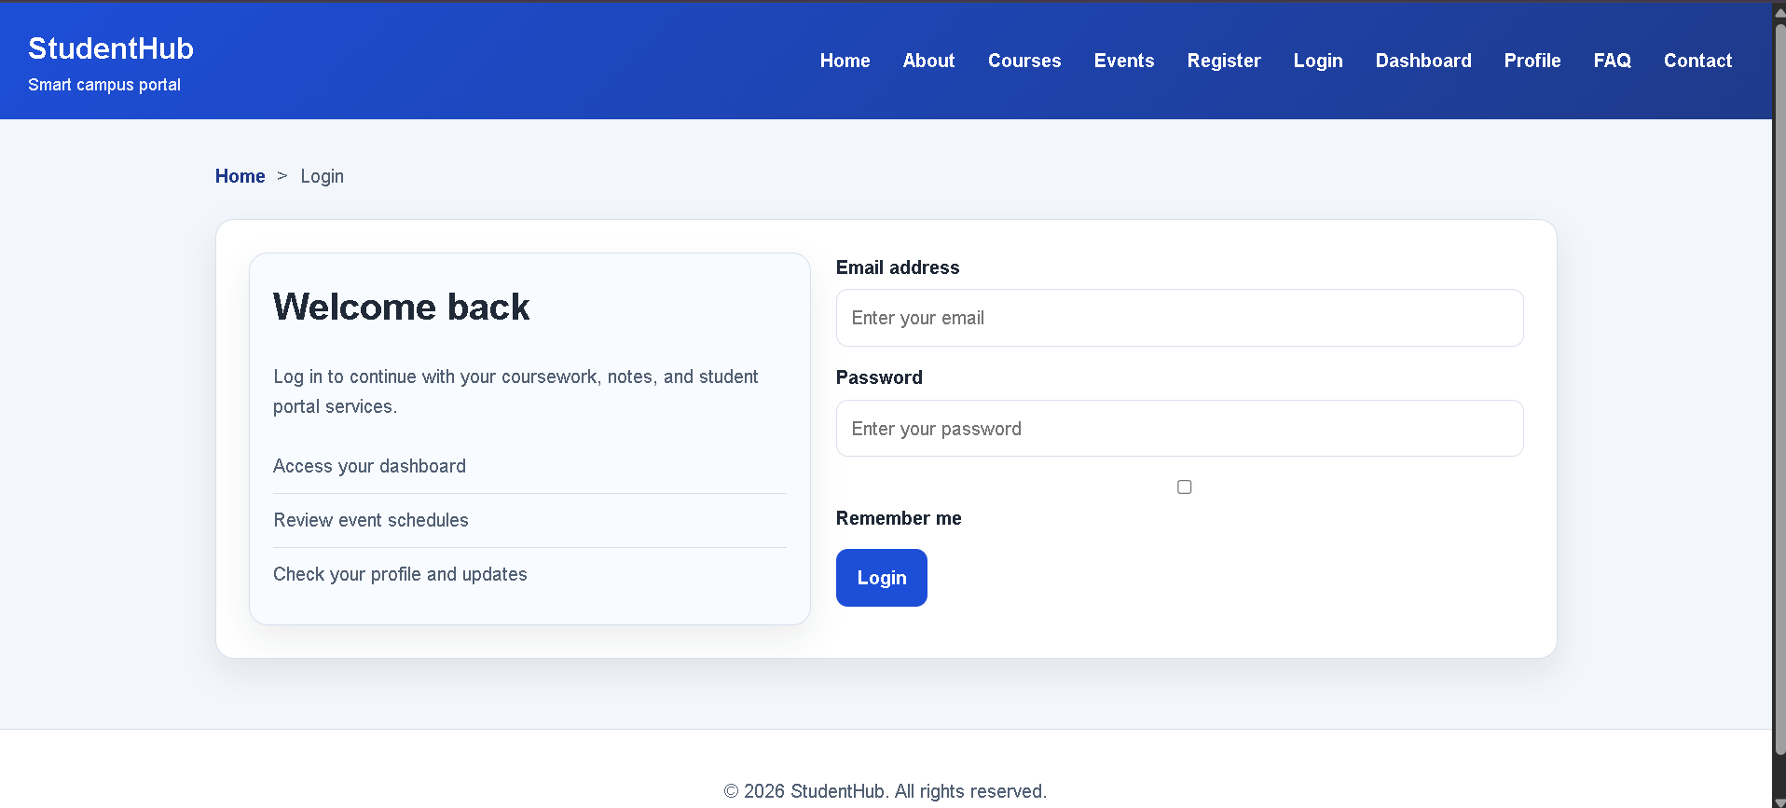
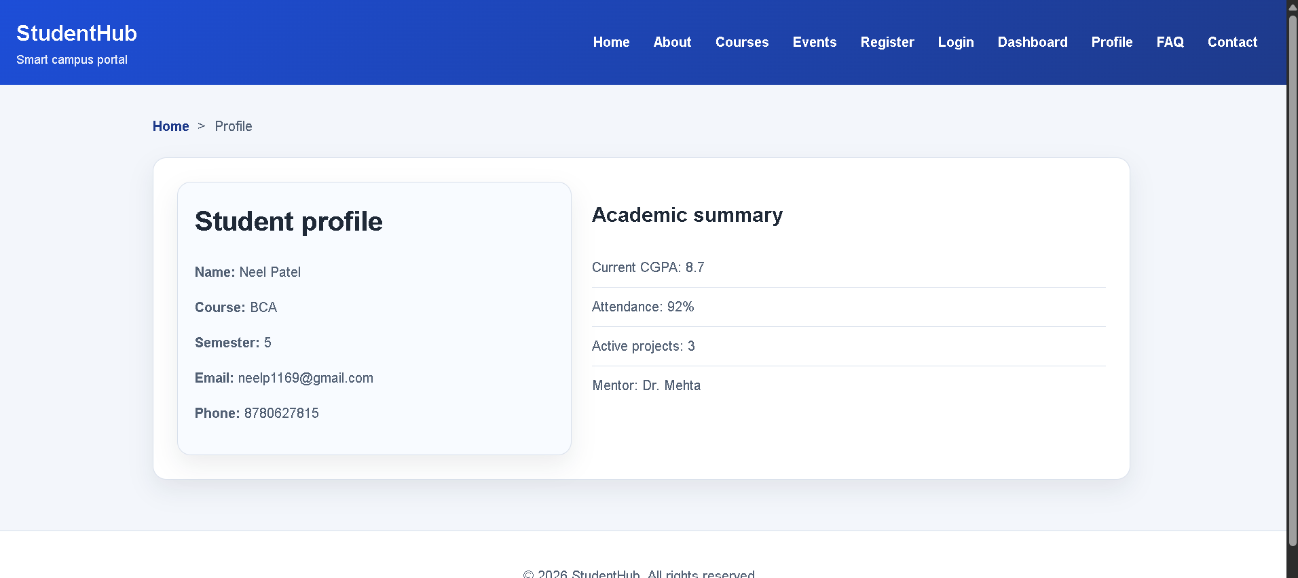
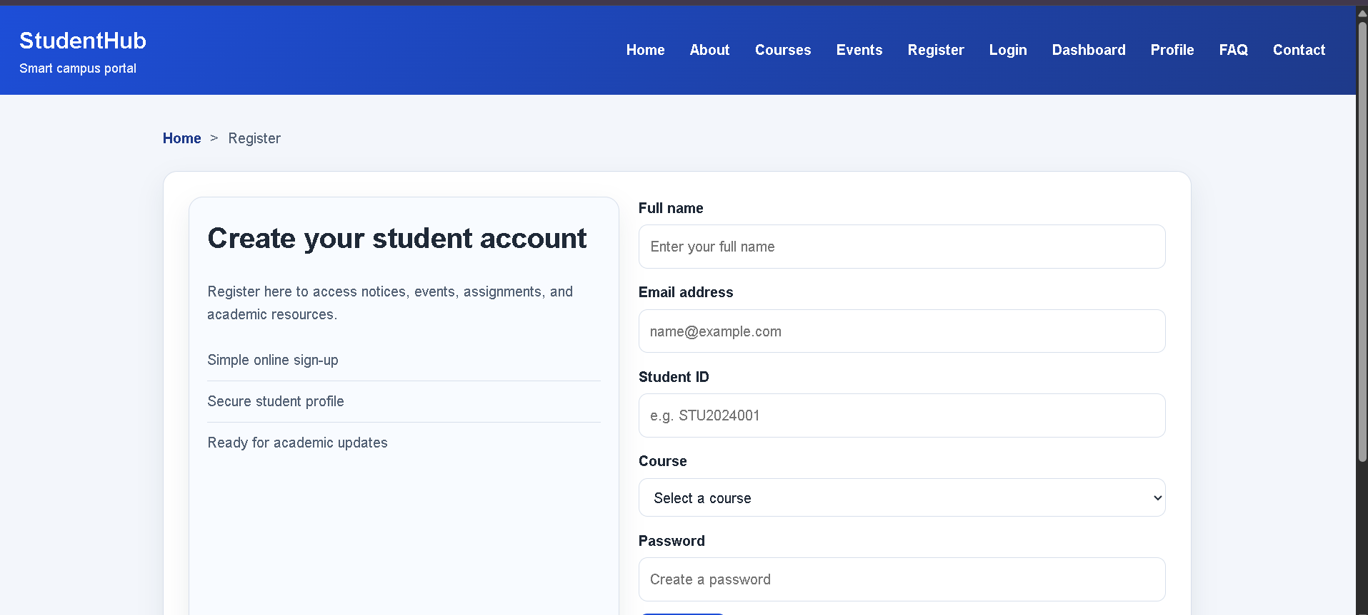

Practical 3:
File: about.html
Code:
<!DOCTYPE html>
<html lang="en">
<head>
<meta charset="UTF-8">
<meta name="viewport" content="width=device-width, initial-scale=1.0">
<title>StudentHub | About</title>
<meta name="description" content="About StudentHub and the student-first responsive learning portal." />
<link rel="stylesheet" href="style.css">
</head>
<body>
<a class="skip-link" href="#main-content">Skip to main content</a>
<header class="site-header">
<div class="brand-block">
<span class="brand-name">StudentHub</span>
<span class="brand-subtitle">Smart campus portal</span>
</div>
<button class="nav-toggle" type="button" aria-label="Toggle navigation" aria-expanded="false">☰</button>
<nav aria-label="Primary navigation">
<ul class="nav-list">
<li><a href="index.html">Home</a></li>
<li><a href="about.html" class="active">About</a></li>
<li><a href="registration.html">Registration</a></li>
<li><a href="dashboard.html">Dashboard</a></li>
<li><a href="events.html">Events</a></li>
<li><a href="contact.html">Contact</a></li>
<li><a href="feedback.html">Feedback</a></li>
</ul>
</nav>
</header>
<main id="main-content">
<nav class="breadcrumb" aria-label="Breadcrumb">
<ol>
<li><a href="index.html">Home</a></li>
<li aria-current="page">About</li>
</ol>
</nav>
<section class="page-shell">
<div class="content-panel">
<h1 class="page-title">About StudentHub</h1>
<p class="page-copy">StudentHub is a modern student portal created to support learning, communication, and campus participation through clear, responsive digital experiences.</p>
</div>
</section>
<section class="section" aria-labelledby="mission-title">
<div class="section-heading">
<h2 id="mission-title">Our mission</h2>
<p>We focus on accessible design, student support, and organized digital services.</p>
</div>
<div class="value-grid">
<article class="value-card">
<h3>Accessible learning</h3>
<p>Layouts are simple, readable, and easy to navigate across mobile, tablet, and desktop screens.</p>
</article>
<article class="value-card">
<h3>Student engagement</h3>
<p>Students can quickly view notices, events, and academic updates in one place.</p>
</article>
<article class="value-card">
<h3>Responsive design</h3>
<p>Using CSS Grid and Flexbox helps create clean and reusable page structures.</p>
</article>
<article class="value-card">
<h3>Career growth</h3>
<p>Our tools support academic goals, skills development, and stronger student participation.</p>
</article>
</div>
</section>
</main>
<footer class="site-footer">
<p>© 2026 StudentHub. All rights reserved.</p>
</footer>
<script src="script.js"></script>
</body>
</html>

File: contact.html
Code:
<!DOCTYPE html>
<html lang="en">
<head>
<meta charset="UTF-8">
<meta name="viewport" content="width=device-width, initial-scale=1.0">
<title>StudentHub | Contact</title>
<meta name="description" content="Student support and contact page for the StudentHub portal." />
<link rel="stylesheet" href="style.css">
</head>
<body>
<a class="skip-link" href="#main-content">Skip to main content</a>
<header class="site-header">
<div class="brand-block">
<span class="brand-name">StudentHub</span>
<span class="brand-subtitle">Smart campus portal</span>
</div>
<button class="nav-toggle" type="button" aria-label="Toggle navigation" aria-expanded="false">☰</button>
<nav aria-label="Primary navigation">
<ul class="nav-list">
<li><a href="index.html">Home</a></li>
<li><a href="about.html">About</a></li>
<li><a href="registration.html">Registration</a></li>
<li><a href="dashboard.html">Dashboard</a></li>
<li><a href="events.html">Events</a></li>
<li><a href="contact.html" class="active">Contact</a></li>
<li><a href="feedback.html">Feedback</a></li>
</ul>
</nav>
</header>
<main id="main-content">
<nav class="breadcrumb" aria-label="Breadcrumb">
<ol>
<li><a href="index.html">Home</a></li>
<li aria-current="page">Contact</li>
</ol>
</nav>
<section class="page-shell contact-grid">
<article class="contact-card">
<h3>Campus support</h3>
<p>Email: support@studenthub.edu</p>
<p>Phone: +91 87806 27815</p>
<p>Office Hours: 9:00 AM - 5:00 PM</p>
</article>
<article class="contact-card">
<h3>Need help?</h3>
<p>Reach out for registration, course queries, and student support needs.</p>
</article>
</section>
<section class="section feedback-grid">
<div class="form-panel">
<h2>Send a message</h2>
<form class="form-grid">
<div class="form-group">
<label for="name">Your name</label>
<input id="name" type="text" placeholder="Full name">
</div>
<div class="form-group">
<label for="subject">Subject</label>
<input id="subject" type="text" placeholder="How can we help?">
</div>
<div class="form-group">
<label for="message">Message</label>
<textarea id="message" rows="5" placeholder="Write your message..."></textarea>
</div>
<button type="submit">Send message</button>
</form>
</div>
<aside class="panel">
<h2>Quick response</h2>
<p class="panel-copy">Our student support desk responds to most academic concerns within 24 hours.</p>
<ul class="list-check">
<li>Course guidance</li>
<li>Portal access concerns</li>
<li>Academic support</li>
</ul>
</aside>
</section>
</main>
<footer class="site-footer">
<p>© 2026 StudentHub. All rights reserved.</p>
</footer>
<script src="script.js"></script>
</body>
</html>

File: dashboard.html
Code:
<!DOCTYPE html>
<html lang="en">
<head>
<meta charset="UTF-8">
<meta name="viewport" content="width=device-width, initial-scale=1.0">
<title>StudentHub | Dashboard</title>
<meta name="description" content="Responsive student dashboard layout for academics and notifications." />
<link rel="stylesheet" href="style.css">
</head>
<body>
<a class="skip-link" href="#main-content">Skip to main content</a>
<header class="site-header">
<div class="brand-block">
<span class="brand-name">StudentHub</span>
<span class="brand-subtitle">Smart campus portal</span>
</div>
<button class="nav-toggle" type="button" aria-label="Toggle navigation" aria-expanded="false">☰</button>
<nav aria-label="Primary navigation">
<ul class="nav-list">
<li><a href="index.html">Home</a></li>
<li><a href="about.html">About</a></li>
<li><a href="registration.html">Registration</a></li>
<li><a href="dashboard.html" class="active">Dashboard</a></li>
<li><a href="events.html">Events</a></li>
<li><a href="contact.html">Contact</a></li>
<li><a href="feedback.html">Feedback</a></li>
</ul>
</nav>
</header>
<main id="main-content">
<nav class="breadcrumb" aria-label="Breadcrumb">
<ol>
<li><a href="index.html">Home</a></li>
<li aria-current="page">Dashboard</li>
</ol>
</nav>
<section class="page-shell">
<div class="content-panel">
<h1 class="page-title">Student dashboard</h1>
<div class="summary-grid">
<article class="summary-card">
<h3>Attendance</h3>
<strong>92%</strong>
<p>Strong engagement in classes this semester.</p>
</article>
<article class="summary-card">
<h3>Assignments</h3>
<strong>06</strong>
<p>Upcoming and submitted tasks this week.</p>
</article>
<article class="summary-card">
<h3>Events</h3>
<strong>04</strong>
<p>Workshops and seminars to attend.</p>
</article>
<article class="summary-card">
<h3>CGPA</h3>
<strong>8.9</strong>
<p>Consistent academic performance.</p>
</article>
</div>
</div>
</section>
<section class="section dashboard-grid">
<div class="panel">
<h2>Upcoming tasks</h2>
<ul class="timeline">
<li>Web Design assignment due on Friday.</li>
<li>Career guidance seminar registration open.</li>
<li>Programming lab practical review next Monday.</li>
</ul>
</div>
<div class="panel">
<h2>Notice board</h2>
<ul class="notice-list">
<li>Exam hall ticket distribution begins this week.</li>
<li>Library timing extended for final revision.</li>
<li>Monthly feedback form is now live.</li>
</ul>
</div>
</section>
</main>
<footer class="site-footer">
<p>© 2026 StudentHub. All rights reserved.</p>
</footer>
<script src="script.js"></script>
</body>
</html>

File: events.html
Code:
<!DOCTYPE html>
<html lang="en">
<head>
<meta charset="UTF-8">
<meta name="viewport" content="width=device-width, initial-scale=1.0">
<title>StudentHub | Events</title>
<meta name="description" content="Responsive events and campus activity page." />
<link rel="stylesheet" href="style.css">
</head>
<body>
<a class="skip-link" href="#main-content">Skip to main content</a>
<header class="site-header">
<div class="brand-block">
<span class="brand-name">StudentHub</span>
<span class="brand-subtitle">Smart campus portal</span>
</div>
<button class="nav-toggle" type="button" aria-label="Toggle navigation" aria-expanded="false">☰</button>
<nav aria-label="Primary navigation">
<ul class="nav-list">
<li><a href="index.html">Home</a></li>
<li><a href="about.html">About</a></li>
<li><a href="registration.html">Registration</a></li>
<li><a href="dashboard.html">Dashboard</a></li>
<li><a href="events.html" class="active">Events</a></li>
<li><a href="contact.html">Contact</a></li>
<li><a href="feedback.html">Feedback</a></li>
</ul>
</nav>
</header>
<main id="main-content">
<nav class="breadcrumb" aria-label="Breadcrumb">
<ol>
<li><a href="index.html">Home</a></li>
<li aria-current="page">Events</li>
</ol>
</nav>
<section class="page-shell">
<div class="content-panel">
<h1 class="page-title">Upcoming events</h1>
<p class="page-copy">Join workshops, learning sessions, and campus events designed to support your academic growth.</p>
</div>
</section>
<section class="section event-grid" aria-label="Event cards">
<article class="event-card">
<h3>Web Design Bootcamp</h3>
<p>Learn responsive interfaces and modern design thinking with live examples.</p>
</article>
<article class="event-card">
<h3>AI Innovation Workshop</h3>
<p>Discover how AI can support research, productivity, and future-ready careers.</p>
</article>
<article class="event-card">
<h3>Career Guidance Seminar</h3>
<p>Prepare for internships, interviews, and long-term academic planning.</p>
</article>
<article class="event-card">
<h3>Hackathon Sprint</h3>
<p>Work in teams, build prototypes, and improve problem-solving skills.</p>
</article>
<article class="event-card">
<h3>Student Leadership Forum</h3>
<p>Explore communication, responsibility, and peer collaboration opportunities.</p>
</article>
<article class="event-card">
<h3>Industry Talk</h3>
<p>Neel professionals and learn how academia connects with real-world digital goals.</p>
</article>
</section>
</main>
<footer class="site-footer">
<p>© 2026 StudentHub. All rights reserved.</p>
</footer>
<script src="script.js"></script>
</body>
</html>

File: feedback.html
Code:
<!DOCTYPE html>
<html lang="en">
<head>
<meta charset="UTF-8">
<meta name="viewport" content="width=device-width, initial-scale=1.0">
<title>StudentHub | Feedback</title>
<meta name="description" content="Responsive student feedback form for campus services and learning experience." />
<link rel="stylesheet" href="style.css">
</head>
<body>
<a class="skip-link" href="#main-content">Skip to main content</a>
<header class="site-header">
<div class="brand-block">
<span class="brand-name">StudentHub</span>
<span class="brand-subtitle">Smart campus portal</span>
</div>
<button class="nav-toggle" type="button" aria-label="Toggle navigation" aria-expanded="false">☰</button>
<nav aria-label="Primary navigation">
<ul class="nav-list">
<li><a href="index.html">Home</a></li>
<li><a href="about.html">About</a></li>
<li><a href="registration.html">Registration</a></li>
<li><a href="dashboard.html">Dashboard</a></li>
<li><a href="events.html">Events</a></li>
<li><a href="contact.html">Contact</a></li>
<li><a href="feedback.html" class="active">Feedback</a></li>
</ul>
</nav>
</header>
<main id="main-content">
<nav class="breadcrumb" aria-label="Breadcrumb">
<ol>
<li><a href="index.html">Home</a></li>
<li aria-current="page">Feedback</li>
</ol>
</nav>
<section class="page-shell feedback-grid">
<div class="form-panel">
<h2>Share your feedback</h2>
<form class="form-grid">
<div class="form-group">
<label for="feedback-name">Name</label>
<input id="feedback-name" type="text" placeholder="Enter your name">
</div>
<div class="form-group">
<label for="feedback-type">Feedback type</label>
<select id="feedback-type">
<option selected>Select type</option>
<option>Course</option>
<option>Campus service</option>
<option>Event</option>
<option>Website</option>
</select>
</div>
<div class="form-group">
<label for="feedback-message">Your comments</label>
<textarea id="feedback-message" rows="6" placeholder="Tell us how we can improve..."></textarea>
</div>
<button type="submit">Submit feedback</button>
</form>
</div>
<aside class="panel">
<h2>Why feedback matters</h2>
<p class="panel-copy">Your suggestions help improve student support, learning experiences, and campus services.</p>
<ul class="list-check">
<li>Improve course experience</li>
<li>Enhance student services</li>
<li>Support future campus growth</li>
</ul>
</aside>
</section>
</main>
<footer class="site-footer">
<p>© 2026 StudentHub. All rights reserved.</p>
</footer>
<script src="script.js"></script>
</body>
</html>

File: index.html
Code:
<!DOCTYPE html>
<html lang="en">
<head>
<meta charset="UTF-8">
<meta name="viewport" content="width=device-width, initial-scale=1.0">
<title>StudentHub | Home</title>
<meta name="description" content="Responsive StudentHub portal using CSS Grid, Flexbox, and mobile-first design." />
<link rel="stylesheet" href="style.css">
</head>
<body>
<a class="skip-link" href="#main-content">Skip to main content</a>
<header class="site-header">
<div class="brand-block">
<span class="brand-name">StudentHub</span>
<span class="brand-subtitle">Smart campus portal</span>
</div>
<button class="nav-toggle" type="button" aria-label="Toggle navigation" aria-expanded="false">
☰
</button>
<nav aria-label="Primary navigation">
<ul class="nav-list">
<li><a href="index.html" class="active">Home</a></li>
<li><a href="about.html">About</a></li>
<li><a href="registration.html">Registration</a></li>
<li><a href="dashboard.html">Dashboard</a></li>
<li><a href="events.html">Events</a></li>
<li><a href="contact.html">Contact</a></li>
<li><a href="feedback.html">Feedback</a></li>
</ul>
</nav>
</header>
<main id="main-content">
<section class="hero" aria-labelledby="hero-title">
<div class="hero-copy">
<p class="eyebrow">Responsive learning portal</p>
<h1 id="hero-title">A student-first interface built for every device.</h1>
<p>StudentHub brings together academic updates, registration, events, and student support in a clean and responsive layout.</p>
<div class="button-row">
<a class="button primary" href="registration.html">Register Now</a>
<a class="button secondary" href="dashboard.html">View Dashboard</a>
</div>
</div>
<aside class="info-panel" aria-label="Portal summary">
<h2>Why students choose it</h2>
<ul class="check-list">
<li>Mobile-first layout</li>
<li>Consistent responsive design</li>
<li>Easy academic navigation</li>
<li>Modern dashboard experience</li>
</ul>
</aside>
</section>
<section class="section" aria-labelledby="stats-title">
<div class="section-heading">
<h2 id="stats-title">Daily campus overview</h2>
<p>Simple, readable, and useful information at a glance.</p>
</div>
<div class="stats-grid">
<article class="stat-card accent">
<span>4.8k+</span>
<p>Active learners</p>
</article>
<article class="stat-card">
<span>32</span>
<p>Live sessions</p>
</article>
<article class="stat-card">
<span>96%</span>
<p>Student satisfaction</p>
</article>
<article class="stat-card accent">
<span>18</span>
<p>Upcoming events</p>
</article>
</div>
</section>
<section class="section" aria-labelledby="feature-title">
<div class="section-heading">
<h2 id="feature-title">Key features</h2>
<p>Designed using CSS Grid, Flexbox, and responsive media queries.</p>
</div>
<div class="feature-grid">
<article class="feature-card">
<h3>CSS Grid Layout</h3>
<p>Organizes sections and cards cleanly across desktop, tablet, and mobile screens.</p>
</article>
<article class="feature-card">
<h3>Flexbox Components</h3>
<p>Builds smooth navigation bars, button rows, and aligned dashboard panels.</p>
</article>
<article class="feature-card">
<h3>Responsive Design</h3>
<p>Uses media queries so every page remains readable, clean, and easy to use.</p>
</article>
</div>
</section>
</main>
<footer class="site-footer">
<p>© 2026 StudentHub. All rights reserved.</p>
</footer>
<script src="script.js"></script>
</body>
</html>

File: registration.html
Code:
<!DOCTYPE html>
<html lang="en">
<head>
<meta charset="UTF-8">
<meta name="viewport" content="width=device-width, initial-scale=1.0">
<title>StudentHub | Registration</title>
<meta name="description" content="Responsive student registration form design." />
<link rel="stylesheet" href="style.css">
</head>
<body>
<a class="skip-link" href="#main-content">Skip to main content</a>
<header class="site-header">
<div class="brand-block">
<span class="brand-name">StudentHub</span>
<span class="brand-subtitle">Smart campus portal</span>
</div>
<button class="nav-toggle" type="button" aria-label="Toggle navigation" aria-expanded="false">☰</button>
<nav aria-label="Primary navigation">
<ul class="nav-list">
<li><a href="index.html">Home</a></li>
<li><a href="about.html">About</a></li>
<li><a href="registration.html" class="active">Registration</a></li>
<li><a href="dashboard.html">Dashboard</a></li>
<li><a href="events.html">Events</a></li>
<li><a href="contact.html">Contact</a></li>
<li><a href="feedback.html">Feedback</a></li>
</ul>
</nav>
</header>
<main id="main-content">
<nav class="breadcrumb" aria-label="Breadcrumb">
<ol>
<li><a href="index.html">Home</a></li>
<li aria-current="page">Registration</li>
</ol>
</nav>
<section class="page-shell registration-layout">
<aside class="panel">
<h2>Student registration</h2>
<p class="panel-copy">Complete your profile and start accessing notes, announcements, and student support services.</p>
<ul class="list-check">
<li>Quick sign-up process</li>
<li>Academic course access</li>
<li>Personal student dashboard</li>
</ul>
</aside>
<div class="form-panel">
<h2>Create account</h2>
<form class="form-grid">
<div class="form-group">
<label for="full-name">Full name</label>
<input id="full-name" type="text" placeholder="Enter full name">
</div>
<div class="form-group">
<label for="email">Email address</label>
<input id="email" type="email" placeholder="student@email.com">
</div>
<div class="form-group">
<label for="student-id">Student ID</label>
<input id="student-id" type="text" placeholder="STU2026001">
</div>
<div class="form-group">
<label for="course">Course</label>
<select id="course">
<option selected>Select course</option>
<option>BCA</option>
<option>Web Development</option>
<option>B.Sc. IT</option>
<option>BBA</option>
</select>
</div>
<div class="form-group">
<label for="password">Password</label>
<input id="password" type="password" placeholder="Create password">
</div>
<button type="submit">Register now</button>
</form>
</div>
</section>
</main>
<footer class="site-footer">
<p>© 2026 StudentHub. All rights reserved.</p>
</footer>
<script src="script.js"></script>
</body>
</html>

File: script.js
Code:
document.addEventListener('DOMContentLoaded', () => {
const toggleButton = document.querySelector('.nav-toggle');
const navList = document.querySelector('.nav-list');
if (toggleButton && navList) {
toggleButton.addEventListener('click', () => {
const isOpen = navList.classList.toggle('open');
toggleButton.setAttribute('aria-expanded', String(isOpen));
});
}
});

File: style.css
Code:
:root {
--bg: #f4f7fb;
--surface: #ffffff;
--surface-soft: #eef4ff;
--primary: #1d4ed8;
--primary-dark: #173a9a;
--accent: #f59e0b;
--accent-soft: #fff2cf;
--text: #1f2937;
--muted: #6b7280;
--border: #dbe4f0;
--shadow: 0 18px 40px rgba(15, 23, 42, 0.08);
--radius: 18px;
}
* {
box-sizing: border-box;
}
html {
scroll-behavior: smooth;
}
body {
margin: 0;
font-family: Arial, Helvetica, sans-serif;
background: var(--bg);
color: var(--text);
line-height: 1.6;
}
img {
max-width: 100%;
display: block;
}
a {
color: inherit;
text-decoration: none;
}
button,
input,
select,
textarea {
font: inherit;
}
.skip-link {
position: absolute;
left: -9999px;
top: auto;
}
.skip-link:focus {
left: 1rem;
top: 1rem;
background: var(--primary);
color: #fff;
padding: 0.75rem 1rem;
border-radius: 8px;
z-index: 1000;
}
.site-header {
display: flex;
align-items: center;
justify-content: space-between;
flex-wrap: wrap;
gap: 1rem;
padding: 1rem 1.25rem;
background: linear-gradient(135deg, var(--primary), var(--primary-dark));
color: #fff;
position: sticky;
top: 0;
z-index: 40;
box-shadow: 0 10px 24px rgba(23, 58, 154, 0.2);
}
.brand-block {
display: flex;
flex-direction: column;
line-height: 1.1;
}
.brand-name {
font-size: clamp(1.3rem, 2vw, 1.8rem);
font-weight: 700;
}
.brand-subtitle {
font-size: 0.8rem;
opacity: 0.9;
letter-spacing: 0.04em;
text-transform: uppercase;
}
.nav-toggle {
display: none;
border: 1px solid rgba(255, 255, 255, 0.35);
background: rgba(255, 255, 255, 0.08);
color: #fff;
border-radius: 10px;
padding: 0.45rem 0.75rem;
cursor: pointer;
}
.nav-list {
list-style: none;
display: flex;
flex-wrap: wrap;
gap: 0.6rem;
margin: 0;
padding: 0;
}
.nav-list a {
display: inline-block;
color: #fff;
padding: 0.55rem 0.8rem;
border-radius: 999px;
font-size: 0.95rem;
transition: 0.2s ease;
}
.nav-list a:hover,
.nav-list a.active {
background: rgba(255, 255, 255, 0.12);
}
main {
max-width: 1200px;
margin: 0 auto;
padding: 1.5rem 1.1rem 3rem;
}
.section,
.page-section {
margin-top: 2rem;
}
.hero {
display: grid;
grid-template-columns: 1fr;
gap: 1.5rem;
background: linear-gradient(135deg, #1a73e8, #1748a5);
color: #fff;
padding: clamp(1.5rem, 4vw, 3rem);
border-radius: var(--radius);
box-shadow: var(--shadow);
}
.hero-copy {
display: flex;
flex-direction: column;
justify-content: center;
}
.eyebrow {
margin: 0 0 0.9rem;
display: inline-block;
font-size: 0.76rem;
letter-spacing: 0.08em;
text-transform: uppercase;
background: rgba(255, 255, 255, 0.12);
padding: 0.5rem 0.8rem;
border-radius: 999px;
width: max-content;
}
.hero h1 {
margin: 0 0 0.8rem;
font-size: clamp(2rem, 4vw, 3.2rem);
line-height: 1.12;
}
.hero-copy p {
margin: 0;
max-width: 58ch;
font-size: 1.03rem;
color: rgba(255, 255, 255, 0.96);
}
.button-row {
display: flex;
flex-wrap: wrap;
gap: 0.9rem;
margin-top: 1.4rem;
}
.button {
display: inline-flex;
align-items: center;
justify-content: center;
border-radius: 999px;
padding: 0.8rem 1.2rem;
font-weight: 700;
transition: 0.2s ease;
}
.button.primary {
background: #fff;
color: var(--primary-dark);
}
.button.secondary {
background: rgba(255, 255, 255, 0.08);
color: #fff;
border: 1px solid rgba(255, 255, 255, 0.22);
}
.button:hover {
transform: translateY(-2px);
}
.info-panel {
background: rgba(255, 255, 255, 0.08);
border: 1px solid rgba(255, 255, 255, 0.2);
border-radius: var(--radius);
padding: 1.1rem 1.2rem;
}
.info-panel h2 {
margin-top: 0;
margin-bottom: 0.9rem;
font-size: 1.2rem;
}
.check-list {
list-style: none;
margin: 0;
padding: 0;
display: grid;
gap: 0.7rem;
}
.check-list li {
position: relative;
padding-left: 1.4rem;
color: rgba(255,255,255,0.95);
}
.check-list li::before {
content: "✓";
position: absolute;
left: 0;
color: #9ce7ff;
font-weight: 700;
}
.section-heading {
margin-bottom: 1.2rem;
}
.section-heading h2,
.page-title {
margin: 0 0 0.5rem;
font-size: clamp(1.5rem, 2.5vw, 2.2rem);
}
.section-heading p,
.page-copy,
.panel-copy,
.card p,
.summary-card p,
.event-card p,
.meta-copy {
color: var(--muted);
}
.stats-grid,
.feature-grid,
.summary-grid,
.event-grid,
.contact-grid,
.feedback-grid,
.value-grid {
display: grid;
gap: 1rem;
}
.stat-card,
.feature-card,
.summary-card,
.event-card,
.contact-card,
.value-card,
.panel,
.form-panel {
background: var(--surface);
border: 1px solid var(--border);
border-radius: var(--radius);
box-shadow: var(--shadow);
}
.stat-card {
padding: 1.2rem 1rem;
text-align: center;
}
.stat-card span {
display: block;
font-size: clamp(1.5rem, 3vw, 2.4rem);
font-weight: 700;
color: var(--primary-dark);
}
.stat-card.accent {
background: linear-gradient(135deg, var(--accent-soft), #fff);
}
.feature-card,
.summary-card,
.event-card,
.contact-card,
.value-card {
padding: 1.2rem;
}
.feature-card h3,
.summary-card h3,
.value-card h3,
.contact-card h3 {
margin-top: 0;
margin-bottom: 0.6rem;
}
.page-shell {
padding: 0.5rem 0 1rem;
}
.content-panel {
background: var(--surface);
border-radius: var(--radius);
box-shadow: var(--shadow);
border: 1px solid var(--border);
padding: clamp(1.2rem, 3vw, 2rem);
}
.breadcrumb {
margin: 0.5rem 0 1.2rem;
}
.breadcrumb ol {
list-style: none;
display: flex;
flex-wrap: wrap;
gap: 0.5rem;
padding: 0;
margin: 0;
color: var(--muted);
}
.breadcrumb li + li::before {
content: "/";
margin-right: 0.5rem;
}
.registration-layout,
.dashboard-grid,
.feedback-grid {
display: grid;
gap: 1rem;
}
.panel {
padding: 1.2rem;
}
.panel h2,
.form-panel h2 {
margin-top: 0;
}
.list-check {
list-style: none;
padding: 0;
margin: 1rem 0 0;
display: grid;
gap: 0.75rem;
}
.list-check li {
position: relative;
padding-left: 1.4rem;
}
.list-check li::before {
content: "•";
position: absolute;
left: 0;
color: var(--primary);
font-size: 1.3rem;
line-height: 1;
}
.form-panel {
padding: 1.2rem;
}
.form-grid {
display: grid;
gap: 1rem;
}
.form-group {
display: flex;
flex-direction: column;
gap: 0.45rem;
}
.form-group label {
font-weight: 700;
}
.form-group input,
.form-group select,
.form-group textarea {
width: 100%;
border: 1px solid var(--border);
border-radius: 12px;
padding: 0.8rem 0.9rem;
background: #fff;
color: var(--text);
}
.form-group input:focus,
.form-group select:focus,
.form-group textarea:focus {
outline: 2px solid rgba(29, 78, 216, 0.18);
border-color: var(--primary);
}
.form-panel button,
button[type="submit"] {
margin-top: 0.5rem;
border: none;
background: var(--primary);
color: white;
border-radius: 12px;
padding: 0.8rem 1.2rem;
font-weight: 700;
cursor: pointer;
}
.summary-grid {
grid-template-columns: repeat(1, minmax(0, 1fr));
}
.summary-card strong {
display: block;
color: var(--primary-dark);
font-size: clamp(1.5rem, 3vw, 2rem);
margin: 0.5rem 0;
}
.timeline,
.notice-list,
.event-list,
.quick-links {
list-style: none;
padding: 0;
margin: 0;
display: grid;
gap: 0.9rem;
}
.timeline li,
.notice-list li,
.event-list li {
background: var(--surface-soft);
border: 1px solid var(--border);
border-radius: 12px;
padding: 0.85rem 1rem;
}
.quick-links {
grid-template-columns: repeat(auto-fit, minmax(150px, 1fr));
}
.quick-links a {
display: block;
background: var(--surface);
text-align: center;
padding: 0.9rem;
border: 1px solid var(--border);
border-radius: 12px;
font-weight: 700;
}
.contact-grid {
grid-template-columns: 1fr;
}
.contact-card {
display: flex;
flex-direction: column;
gap: 0.4rem;
}
.site-footer {
padding: 1.5rem 1rem 2rem;
text-align: center;
color: var(--muted);
}
@media (min-width: 700px) {
.hero {
grid-template-columns: 1.3fr 0.7fr;
}
.stats-grid,
.feature-grid,
.summary-grid,
.event-grid,
.value-grid {
grid-template-columns: repeat(2, minmax(0, 1fr));
}
.dashboard-grid,
.registration-layout,
.feedback-grid {
grid-template-columns: 1.1fr 0.9fr;
}
.contact-grid {
grid-template-columns: repeat(2, minmax(0, 1fr));
}
}
@media (min-width: 980px) {
.stats-grid,
.feature-grid,
.summary-grid,
.event-grid,
.value-grid {
grid-template-columns: repeat(4, minmax(0, 1fr));
}
.feature-grid {
grid-template-columns: repeat(3, minmax(0, 1fr));
}
.event-grid {
grid-template-columns: repeat(3, minmax(0, 1fr));
}
}
@media (max-width: 699px) {
.site-header {
align-items: flex-start;
}
.nav-toggle {
display: inline-flex;
align-items: center;
justify-content: center;
}
.nav-list {
display: none;
width: 100%;
flex-direction: column;
padding-top: 0.4rem;
}
.nav-list.open {
display: flex;
}
.button-row {
flex-direction: column;
}
.button {
width: 100%;
}
}

Output:
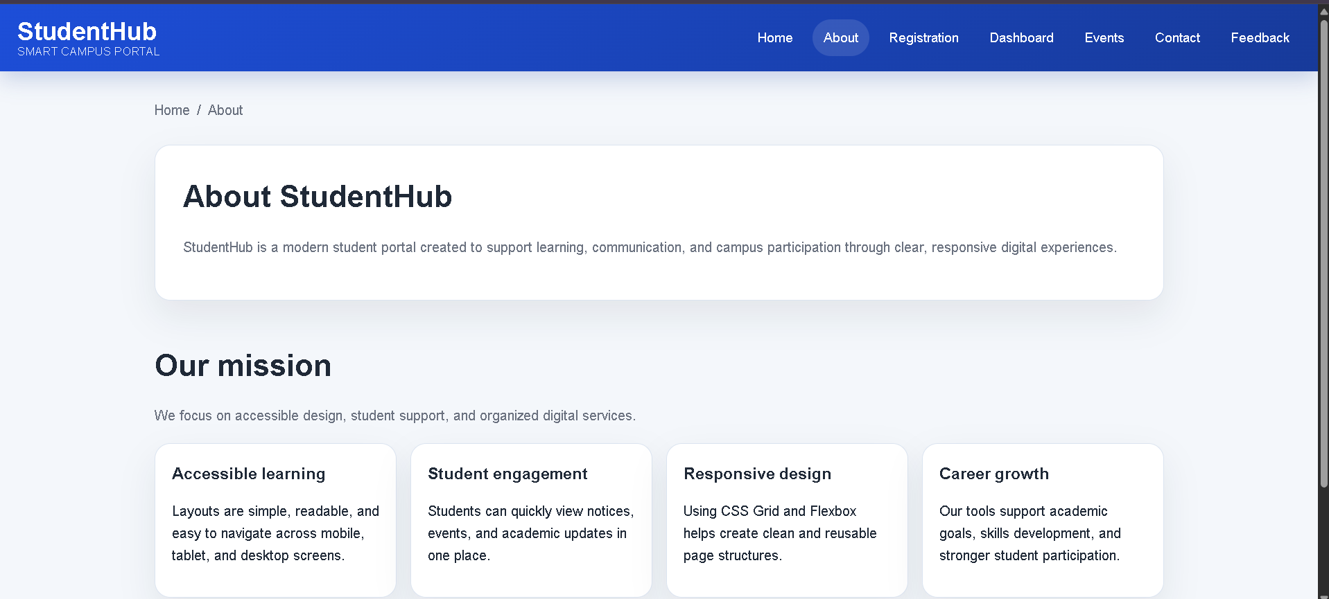
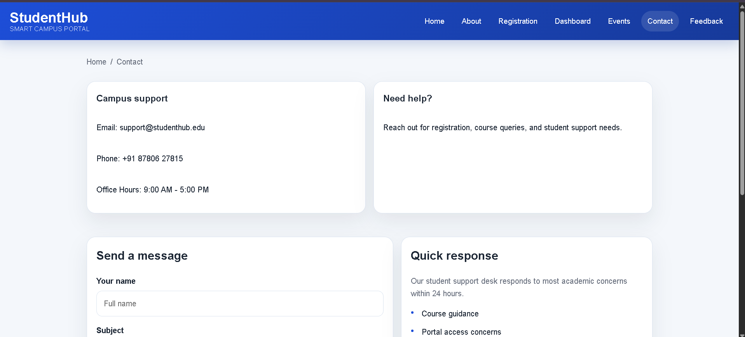
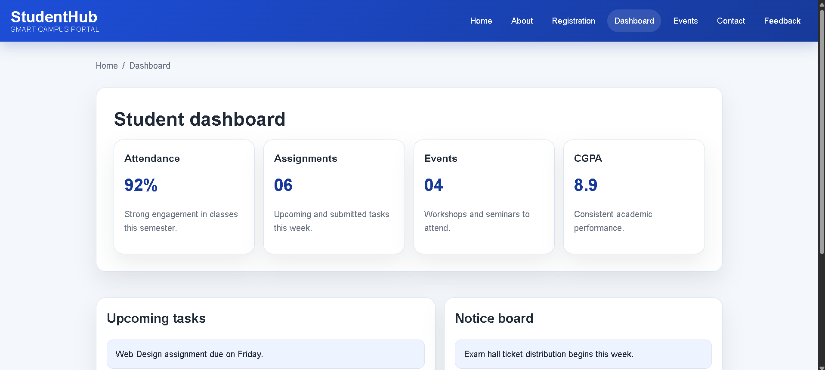
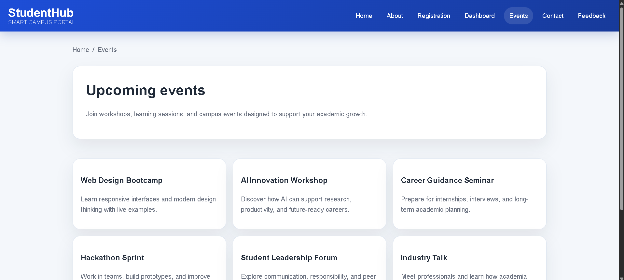
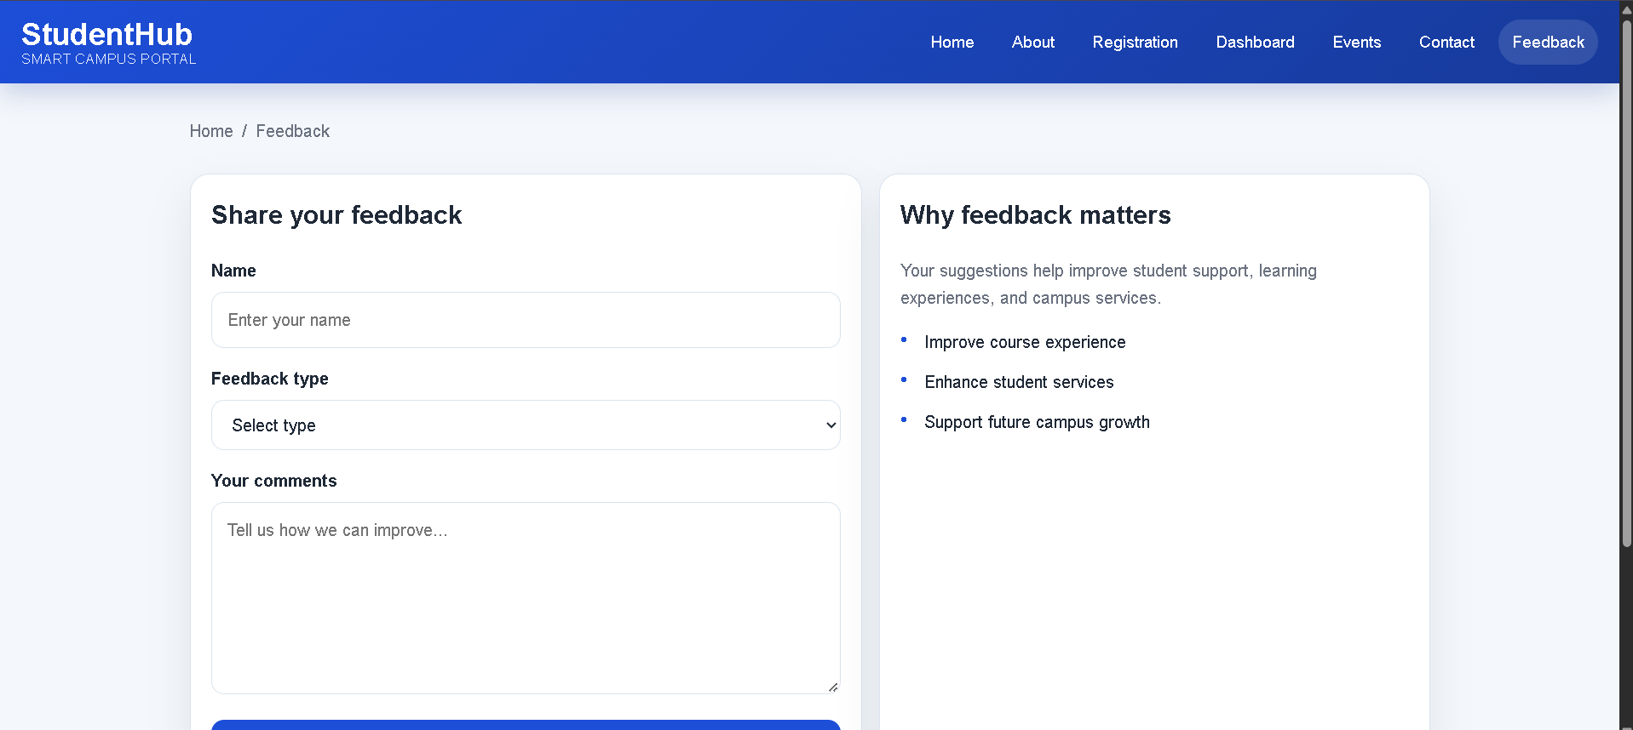
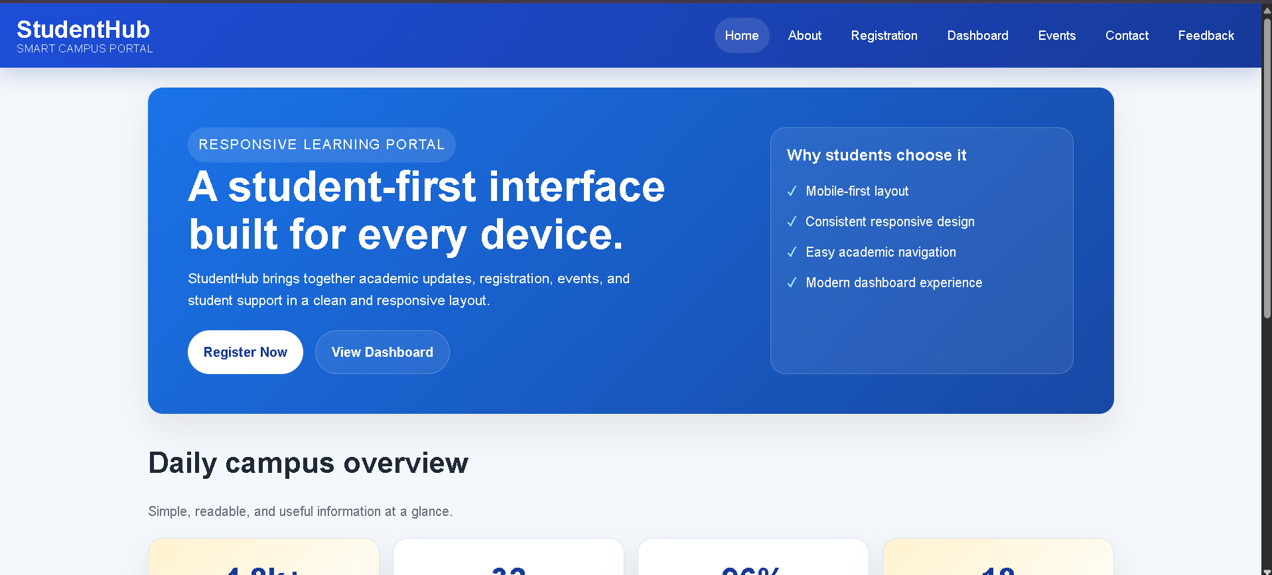
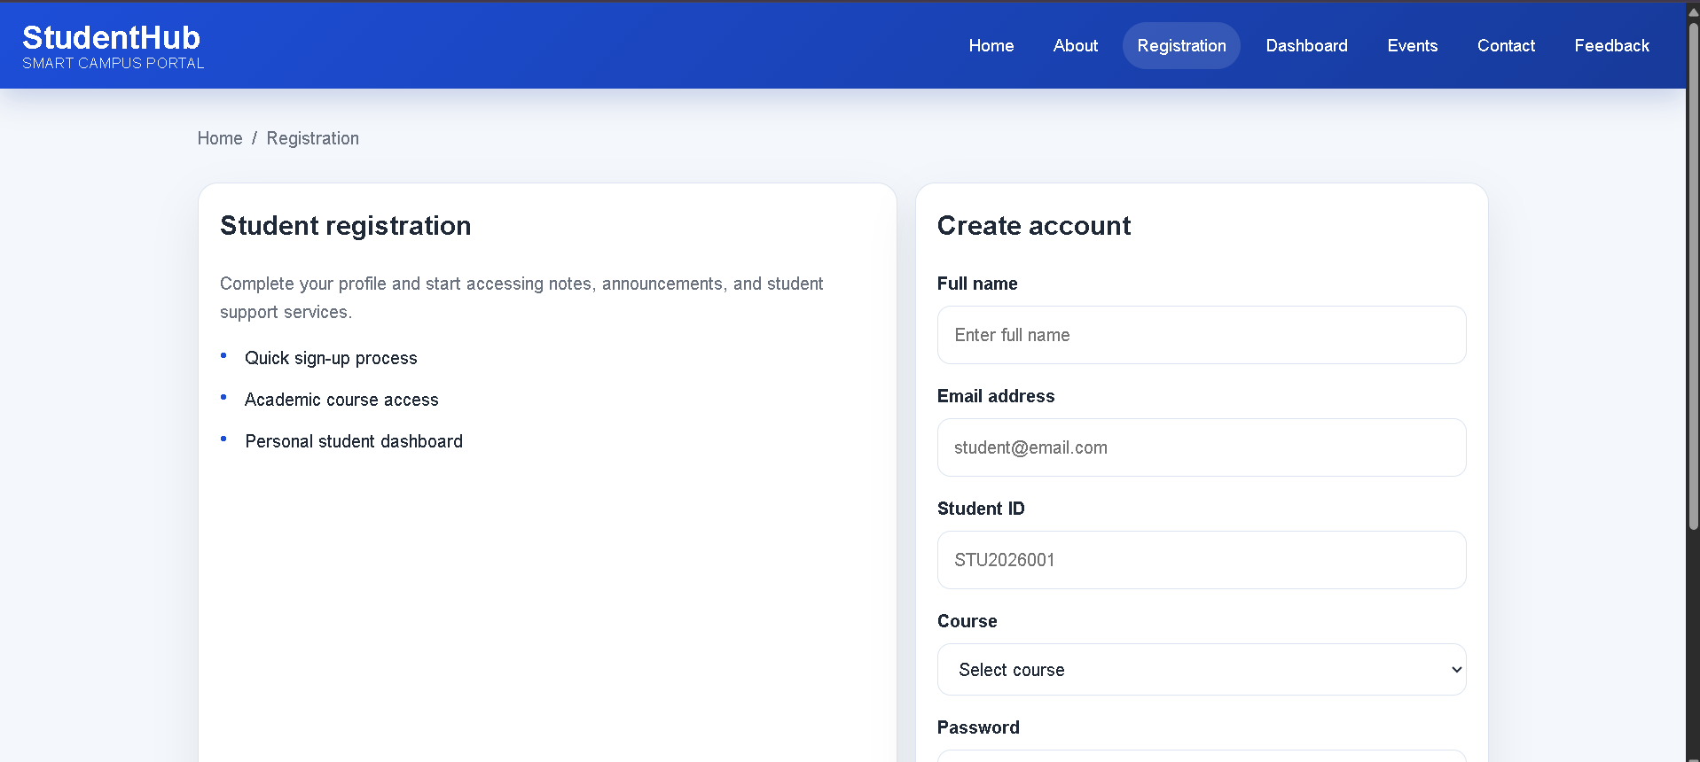

Practical 4:
File: about.html
Code:
<!DOCTYPE html>
<html lang="en">
<head>
<meta charset="UTF-8">
<meta name="viewport" content="width=device-width, initial-scale=1.0">
<title>Student Hub | About</title>
<link rel="stylesheet" href="style.css">
</head>
<body>
<header>
<div class="header-inner">
<div class="logo">Student<span>Hub</span></div>
<button class="menu-toggle" type="button" aria-label="Open menu">☰</button>
<nav class="nav">
<a href="index.html">Home</a>
<a class="active" href="about.html">About</a>
<a href="courses.html">Courses</a>
<a href="notes.html">Notes</a>
<a href="events.html">Events</a>
<a href="gallery.html">Gallery</a>
<a href="contact.html">Contact</a>
<a href="services.html">Services</a>
<a href="blog.html">Blog</a>
<a href="faq.html">FAQ</a>
</nav>
</div>
</header>
<main class="page-shell">
<section class="page-hero">
<p class="eyebrow">About Student Hub</p>
<h1>Learning made simple, clear, and student-friendly</h1>
<p>We create a supportive environment where students can study with confidence, stay organized, and build practical skills.</p>
</section>
<section class="content-panel">
<p class="page-text">Student Hub is a student-first learning platform designed to make education more practical, motivating, and accessible. We combine useful resources, helpful guidance, and a welcoming learning experience to help students thrive in academics and beyond.</p>
<div class="feature-grid">
<div class="feature-card">
<span class="topic-badge">Mission</span>
<h3>Our mission</h3>
<p>To support learners with clear academic resources and a genuinely helpful environment.</p>
</div>
<div class="feature-card">
<span class="topic-badge">Vision</span>
<h3>Our vision</h3>
<p>To build a digital learning platform that encourages growth, curiosity, and success.</p>
</div>
<div class="feature-card">
<span class="topic-badge">Goal</span>
<h3>Our goal</h3>
<p>To make learning practical, engaging, and easy to follow for every student.</p>
</div>
</div>
</section>
</main>
<footer>
<div class="footer-inner">
<h2>Student Hub</h2>
<p>Learn | Grow | Succeed</p>
<p>© 2026 Student Hub. All Rights Reserved.</p>
</div>
</footer>
<script src="script.js"></script>
</body>
</html>

File: blog.html
Code:
<!DOCTYPE html>
<html lang="en">
<head>
<meta charset="UTF-8">
<meta name="viewport" content="width=device-width, initial-scale=1.0">
<title>Student Hub | Blog</title>
<link rel="stylesheet" href="style.css">
</head>
<body>
<header>
<div class="header-inner">
<div class="logo">Student<span>Hub</span></div>
<button class="menu-toggle" type="button" aria-label="Open menu">☰</button>
<nav class="nav">
<a href="index.html">Home</a>
<a href="about.html">About</a>
<a href="courses.html">Courses</a>
<a href="notes.html">Notes</a>
<a href="events.html">Events</a>
<a href="gallery.html">Gallery</a>
<a href="contact.html">Contact</a>
<a href="services.html">Services</a>
<a class="active" href="blog.html">Blog</a>
<a href="faq.html">FAQ</a>
</nav>
</div>
</header>
<main class="page-shell">
<section class="page-hero">
<p class="eyebrow">Student blog</p>
<h1>Learn from practical student advice</h1>
<p>Read simple, relatable articles that help students organize their time, build habits, and stay motivated.</p>
</section>
<section class="content-panel">
<div class="blog-grid">
<article class="blog-card">
<span class="course-tag">Study tips</span>
<h3>Simple habits that improve learning</h3>
<p>Small daily routines can create strong study habits and better focus over time.</p>
</article>
<article class="blog-card">
<span class="course-tag">Planning</span>
<h3>Time management for students</h3>
<p>Learn how to organize your priorities, reduce distraction, and make progress every day.</p>
</article>
<article class="blog-card">
<span class="course-tag">Growth</span>
<h3>How to set realistic goals</h3>
<p>Break bigger goals into clear steps so you can stay consistent and build confidence.</p>
</article>
</div>
</section>
</main>
<footer>
<div class="footer-inner">
<h2>Student Hub</h2>
<p>Learn | Grow | Succeed</p>
<p>© 2026 Student Hub. All Rights Reserved.</p>
</div>
</footer>
<script src="script.js"></script>
</body>
</html>

File: contact.html
Code:
<!DOCTYPE html>
<html lang="en">
<head>
<meta charset="UTF-8">
<meta name="viewport" content="width=device-width, initial-scale=1.0">
<title>Student Hub | Contact</title>
<link rel="stylesheet" href="style.css">
</head>
<body>
<header>
<div class="header-inner">
<div class="logo">Student<span>Hub</span></div>
<button class="menu-toggle" type="button" aria-label="Open menu">☰</button>
<nav class="nav">
<a href="index.html">Home</a>
<a href="about.html">About</a>
<a href="courses.html">Courses</a>
<a href="notes.html">Notes</a>
<a href="events.html">Events</a>
<a href="gallery.html">Gallery</a>
<a class="active" href="contact.html">Contact</a>
<a href="services.html">Services</a>
<a href="blog.html">Blog</a>
<a href="faq.html">FAQ</a>
</nav>
</div>
</header>
<main class="page-shell">
<section class="page-hero">
<p class="eyebrow">Contact us</p>
<h1>We are here to help you learn better</h1>
<p>Send your questions and our learning team will guide you with the right support and information.</p>
</section>
<section class="content-panel">
<div class="contact-grid" style="margin-bottom: 26px;">
<div class="contact-card">
<h3>Location</h3>
<p>Student Hub Learning Center, Ahmedabad</p>
</div>
<div class="contact-card">
<h3>Email</h3>
<p>hello@studenthub.edu</p>
</div>
<div class="contact-card">
<h3>Phone</h3>
<p>+91 87806 27815</p>
</div>
</div>
<form class="contact-form" data-contact-form novalidate>
<div class="form-row">
<div class="input-wrap">
<label for="name">Full name</label>
<input id="name" name="name" type="text" placeholder="Your name" required>
</div>
<div class="input-wrap">
<label for="email">Email</label>
<input id="email" name="email" type="email" placeholder="Your email" required>
</div>
</div>
<div class="input-wrap">
<label for="subject">Subject</label>
<input id="subject" name="subject" type="text" placeholder="Your subject" required>
</div>
<div class="input-wrap">
<label for="message">Message</label>
<textarea id="message" name="message" placeholder="Write your message here..." required></textarea>
</div>
<div class="form-msg" aria-live="polite"></div>
<button class="form-btn" type="submit">Send message</button>
</form>
</section>
</main>
<footer>
<div class="footer-inner">
<h2>Student Hub</h2>
<p>Learn | Grow | Succeed</p>
<p>© 2026 Student Hub. All Rights Reserved.</p>
</div>
</footer>
<script src="script.js"></script>
</body>
</html>

File: courses.html
Code:
<!DOCTYPE html>
<html lang="en">
<head>
<meta charset="UTF-8">
<meta name="viewport" content="width=device-width, initial-scale=1.0">
<title>Student Hub | Courses</title>
<link rel="stylesheet" href="style.css">
</head>
<body>
<header>
<div class="header-inner">
<div class="logo">Student<span>Hub</span></div>
<button class="menu-toggle" type="button" aria-label="Open menu">☰</button>
<nav class="nav">
<a href="index.html">Home</a>
<a href="about.html">About</a>
<a class="active" href="courses.html">Courses</a>
<a href="notes.html">Notes</a>
<a href="events.html">Events</a>
<a href="gallery.html">Gallery</a>
<a href="contact.html">Contact</a>
<a href="services.html">Services</a>
<a href="blog.html">Blog</a>
<a href="faq.html">FAQ</a>
</nav>
</div>
</header>
<main class="page-shell">
<section class="page-hero">
<p class="eyebrow">Popular courses</p>
<h1>Build practical skills for the future</h1>
<p>Choose the course that matches your goals and learn through clear, structured guidance.</p>
</section>
<section class="content-panel">
<div class="filter-bar">
<button class="filter-btn active" type="button" data-filter="all">All</button>
<button class="filter-btn" type="button" data-filter="web">Web</button>
<button class="filter-btn" type="button" data-filter="programming">Programming</button>
<button class="filter-btn" type="button" data-filter="design">Design</button>
</div>
<div class="course-grid">
<article class="course-card" data-course-category="web">
<span class="course-tag">Web</span>
<h3>HTML & CSS</h3>
<p>Learn to build beautiful, responsive pages using layout, styling, and design principles.</p>
</article>
<article class="course-card" data-course-category="web">
<span class="course-tag">Web</span>
<h3>JavaScript</h3>
<p>Master interactivity, user input handling, and client-side logic for engaging websites.</p>
</article>
<article class="course-card" data-course-category="programming">
<span class="course-tag">Programming</span>
<h3>Python</h3>
<p>Understand programming basics, logic, and automation with a beginner-friendly approach.</p>
</article>
<article class="course-card" data-course-category="programming">
<span class="course-tag">Programming</span>
<h3>Java</h3>
<p>Learn object-oriented programming, problem-solving, and app development fundamentals.</p>
</article>
<article class="course-card" data-course-category="design">
<span class="course-tag">Design</span>
<h3>UI/UX Basics</h3>
<p>Understand user experience, layout thinking, and visual clarity in digital products.</p>
</article>
<article class="course-card" data-course-category="web">
<span class="course-tag">Web</span>
<h3>PHP & MySQL</h3>
<p>Build dynamic websites and learn how data is saved and managed in real projects.</p>
</article>
</div>
</section>
</main>
<footer>
<div class="footer-inner">
<h2>Student Hub</h2>
<p>Learn | Grow | Succeed</p>
<p>© 2026 Student Hub. All Rights Reserved.</p>
</div>
</footer>
<script src="script.js"></script>
</body>
</html>

File: events.html
Code:
<!DOCTYPE html>
<html lang="en">
<head>
<meta charset="UTF-8">
<meta name="viewport" content="width=device-width, initial-scale=1.0">
<title>Student Hub | Events</title>
<link rel="stylesheet" href="style.css">
</head>
<body>
<header>
<div class="header-inner">
<div class="logo">Student<span>Hub</span></div>
<button class="menu-toggle" type="button" aria-label="Open menu">☰</button>
<nav class="nav">
<a href="index.html">Home</a>
<a href="about.html">About</a>
<a href="courses.html">Courses</a>
<a href="notes.html">Notes</a>
<a class="active" href="events.html">Events</a>
<a href="gallery.html">Gallery</a>
<a href="contact.html">Contact</a>
<a href="services.html">Services</a>
<a href="blog.html">Blog</a>
<a href="faq.html">FAQ</a>
</nav>
</div>
</header>
<main class="page-shell">
<section class="page-hero">
<p class="eyebrow">Upcoming events</p>
<h1>Join workshops and opportunities that help you grow</h1>
<p>Explore sessions designed for learning, networking, and building better academic and career confidence.</p>
</section>
<section class="content-panel">
<div class="event-grid">
<article class="event-card">
<span class="course-tag">15 Aug</span>
<h3>Web Development Bootcamp</h3>
<p>Build responsive web pages and improve your front-end skills in a guided workshop.</p>
</article>
<article class="event-card">
<span class="course-tag">28 Aug</span>
<h3>AI Workshop</h3>
<p>Learn how artificial intelligence is used in modern apps and how students can explore it.</p>
</article>
<article class="event-card">
<span class="course-tag">5 Sep</span>
<h3>Career Guidance Seminar</h3>
<p>Understand how to shape your future goals, improve presentation skills, and plan better.</p>
</article>
</div>
</section>
</main>
<footer>
<div class="footer-inner">
<h2>Student Hub</h2>
<p>Learn | Grow | Succeed</p>
<p>© 2026 Student Hub. All Rights Reserved.</p>
</div>
</footer>
<script src="script.js"></script>
</body>
</html>

File: faq.html
Code:
<!DOCTYPE html>
<html lang="en">
<head>
<meta charset="UTF-8">
<meta name="viewport" content="width=device-width, initial-scale=1.0">
<title>Student Hub | FAQ</title>
<link rel="stylesheet" href="style.css">
</head>
<body>
<header>
<div class="header-inner">
<div class="logo">Student<span>Hub</span></div>
<button class="menu-toggle" type="button" aria-label="Open menu">☰</button>
<nav class="nav">
<a href="index.html">Home</a>
<a href="about.html">About</a>
<a href="courses.html">Courses</a>
<a href="notes.html">Notes</a>
<a href="events.html">Events</a>
<a href="gallery.html">Gallery</a>
<a href="contact.html">Contact</a>
<a href="services.html">Services</a>
<a href="blog.html">Blog</a>
<a class="active" href="faq.html">FAQ</a>
</nav>
</div>
</header>
<main class="page-shell">
<section class="page-hero">
<p class="eyebrow">Frequently asked questions</p>
<h1>Everything students usually ask</h1>
<p>Find quick answers about learning, support, events, and how Student Hub helps you succeed.</p>
</section>
<section class="content-panel">
<div class="faq-list">
<div class="faq-item open">
<button class="faq-question" type="button">Is Student Hub free to use?<span>+</span></button>
<div class="faq-answer">
<p>Yes. Most learning resources and academic support tools are available for free so students can access help without extra stress.</p>
</div>
</div>
<div class="faq-item">
<button class="faq-question" type="button">Can I join events online?<span>+</span></button>
<div class="faq-answer">
<p>Yes. Many events are designed for both online and in-person participation, which makes it easier for students to join from anywhere.</p>
</div>
</div>
<div class="faq-item">
<button class="faq-question" type="button">How can I contact support?<span>+</span></button>
<div class="faq-answer">
<p>You can use the contact page to send a message to our team. We are here to help with registration, course guidance, and student questions.</p>
</div>
</div>
<div class="faq-item">
<button class="faq-question" type="button">Do you provide study notes?<span>+</span></button>
<div class="faq-answer">
<p>Yes. Student Hub includes easy-to-follow notes and references for topics such as HTML, CSS, JavaScript, Python, and Java.</p>
</div>
</div>
</div>
</section>
</main>
<footer>
<div class="footer-inner">
<h2>Student Hub</h2>
<p>Learn | Grow | Succeed</p>
<p>© 2026 Student Hub. All Rights Reserved.</p>
</div>
</footer>
<script src="script.js"></script>
</body>
</html>

File: gallery.html
Code:
<!DOCTYPE html>
<html lang="en">
<head>
<meta charset="UTF-8">
<meta name="viewport" content="width=device-width, initial-scale=1.0">
<title>Student Hub | Gallery</title>
<link rel="stylesheet" href="style.css">
</head>
<body>
<header>
<div class="header-inner">
<div class="logo">Student<span>Hub</span></div>
<button class="menu-toggle" type="button" aria-label="Open menu">☰</button>
<nav class="nav">
<a href="index.html">Home</a>
<a href="about.html">About</a>
<a href="courses.html">Courses</a>
<a href="notes.html">Notes</a>
<a href="events.html">Events</a>
<a class="active" href="gallery.html">Gallery</a>
<a href="contact.html">Contact</a>
<a href="services.html">Services</a>
<a href="blog.html">Blog</a>
<a href="faq.html">FAQ</a>
</nav>
</div>
</header>
<main class="page-shell">
<section class="page-hero">
<p class="eyebrow">Student gallery</p>
<h1>Moments from learning, teamwork, and growth</h1>
<p>See how Student Hub creates a motivating environment for study, collaboration, and inspiration.</p>
</section>
<section class="content-panel">
<div class="gallery-grid">
<div class="gallery-item" data-gallery-item="https://images.unsplash.com/photo-1523240795612-9a054b0db644?auto=format&fit=crop&w=1200&q=80" data-title="Students learning together">
<img src="https://images.unsplash.com/photo-1523240795612-9a054b0db644?auto=format&fit=crop&w=800&q=80" alt="Students learning together">
<div class="gallery-caption">Students learning together</div>
</div>
<div class="gallery-item" data-gallery-item="https://images.unsplash.com/photo-1513258496099-48168024aec0?auto=format&fit=crop&w=1200&q=80" data-title="Classroom discussion">
<img src="https://images.unsplash.com/photo-1513258496099-48168024aec0?auto=format&fit=crop&w=800&q=80" alt="Classroom discussion">
<div class="gallery-caption">Classroom discussion</div>
</div>
<div class="gallery-item" data-gallery-item="https://images.unsplash.com/photo-1523050854058-8df90110c9f1?auto=format&fit=crop&w=1200&q=80" data-title="Study group focus">
<img src="https://images.unsplash.com/photo-1523050854058-8df90110c9f1?auto=format&fit=crop&w=800&q=80" alt="Study group focus">
<div class="gallery-caption">Study group focus</div>
</div>
<div class="gallery-item" data-gallery-item="https://images.unsplash.com/photo-1523580494863-6f3031224c94?auto=format&fit=crop&w=1200&q=80" data-title="Learning environment">
<img src="https://images.unsplash.com/photo-1523580494863-6f3031224c94?auto=format&fit=crop&w=800&q=80" alt="Learning environment">
<div class="gallery-caption">Learning environment</div>
</div>
</div>
</section>
</main>
<div class="lightbox" aria-hidden="true">
<div class="lightbox-content">
<button class="lightbox-close" type="button" aria-label="Close">×</button>
<img src="" alt="Expanded gallery item">
</div>
</div>
<footer>
<div class="footer-inner">
<h2>Student Hub</h2>
<p>Learn | Grow | Succeed</p>
<p>© 2026 Student Hub. All Rights Reserved.</p>
</div>
</footer>
<script src="script.js"></script>
</body>
</html>

File: index.html
Code:
<!DOCTYPE html>
<html lang="en">
<head>
<meta charset="UTF-8">
<meta name="viewport" content="width=device-width, initial-scale=1.0">
<title>Student Hub | Home</title>
<link rel="stylesheet" href="style.css">
</head>
<body>
<header>
<div class="header-inner">
<div class="logo">Student<span>Hub</span></div>
<button class="menu-toggle" type="button" aria-label="Open menu">☰</button>
<nav class="nav">
<a class="active" href="index.html">Home</a>
<a href="about.html">About</a>
<a href="courses.html">Courses</a>
<a href="notes.html">Notes</a>
<a href="events.html">Events</a>
<a href="gallery.html">Gallery</a>
<a href="contact.html">Contact</a>
<a href="services.html">Services</a>
<a href="blog.html">Blog</a>
<a href="faq.html">FAQ</a>
</nav>
</div>
</header>
<main>
<section class="hero">
<div class="hero-content">
<p class="eyebrow">Smart learning platform</p>
<h1>Learn better, grow faster, and build your future.</h1>
<p>From study notes and practical courses to events, support, and career guidance, Student Hub helps you stay focused and confident.</p>
<div class="btn-group">
<a href="courses.html" class="btn btn-primary">Explore Courses</a>
<a href="contact.html" class="btn btn-secondary">Join Community</a>
</div>
</div>
</section>
<section class="section">
<div class="container">
<div class="section-heading">
<p class="eyebrow" style="color: var(--primary-dark); background: #e7f0ff; border-color: transparent;">Why students choose us</p>
<h2>Everything you need to succeed</h2>
<p>Student Hub brings together quality content, practical learning, and the support students need to stay motivated.</p>
</div>
<div class="stats-grid">
<div class="stat-card"><strong>10+</strong><span>Learning resources</span></div>
<div class="stat-card"><strong>4</strong><span>Skill tracks</span></div>
<div class="stat-card"><strong>24/7</strong><span>Student support</span></div>
<div class="stat-card"><strong>100%</strong><span>Student focus</span></div>
</div>
</div>
</section>
<section class="section" style="background: #f9fbff;">
<div class="container">
<div class="section-heading">
<p class="eyebrow" style="color: var(--primary-dark); background: #e7f0ff; border-color: transparent;">Featured programs</p>
<h2>Learning designed for real progress</h2>
</div>
<div class="feature-grid">
<div class="feature-card">
<span class="topic-badge">Easy learning</span>
<h3>Clear lessons</h3>
<p>Simple explanations and step-by-step guidance make even difficult topics easier to understand.</p>
</div>
<div class="feature-card">
<span class="topic-badge">Practice focus</span>
<h3>Hands-on growth</h3>
<p>Build confidence with regular tasks, revision material, and learning activities.</p>
</div>
<div class="feature-card">
<span class="topic-badge">Career support</span>
<h3>Future skills</h3>
<p>Prepare for coursework, interviews, and projects with practical academic support.</p>
</div>
</div>
</div>
</section>
<section class="section">
<div class="container">
<div class="section-heading">
<p class="eyebrow" style="color: var(--primary-dark); background: #e7f0ff; border-color: transparent;">Quick links</p>
<h2>Explore more of the platform</h2>
</div>
<div class="feature-grid">
<div class="feature-card">
<span class="topic-badge">Notes</span>
<h3><a href="notes.html">Study notes</a></h3>
<p>Browse subject-based notes and revision resources that help you learn better.</p>
</div>
<div class="feature-card">
<span class="topic-badge">Events</span>
<h3><a href="events.html">Upcoming events</a></h3>
<p>Join workshops, seminars, and learning opportunities with real-time guidance.</p>
</div>
<div class="feature-card">
<span class="topic-badge">Support</span>
<h3><a href="contact.html">Contact us</a></h3>
<p>Send your queries and get help from our support and learning team.</p>
</div>
</div>
</div>
</section>
<section class="cta-strip">
<div class="cta-inner">
<div>
<h3>Start your learning journey today</h3>
<p>Explore practical resources, skill-building courses, and a supportive academic community.</p>
</div>
<a href="courses.html" class="btn btn-primary">View Courses</a>
</div>
</section>
</main>
<footer>
<div class="footer-inner">
<h2>Student Hub</h2>
<p>Learn | Grow | Succeed</p>
<p>© 2026 Student Hub. All Rights Reserved.</p>
</div>
</footer>
<script src="script.js"></script>
</body>
</html>

File: notes.html
Code:
<!DOCTYPE html>
<html lang="en">
<head>
<meta charset="UTF-8">
<meta name="viewport" content="width=device-width, initial-scale=1.0">
<title>Student Hub | Notes</title>
<link rel="stylesheet" href="style.css">
</head>
<body>
<header>
<div class="header-inner">
<div class="logo">Student<span>Hub</span></div>
<button class="menu-toggle" type="button" aria-label="Open menu">☰</button>
<nav class="nav">
<a href="index.html">Home</a>
<a href="about.html">About</a>
<a href="courses.html">Courses</a>
<a class="active" href="notes.html">Notes</a>
<a href="events.html">Events</a>
<a href="gallery.html">Gallery</a>
<a href="contact.html">Contact</a>
<a href="services.html">Services</a>
<a href="blog.html">Blog</a>
<a href="faq.html">FAQ</a>
</nav>
</div>
</header>
<main class="page-shell">
<section class="page-hero">
<p class="eyebrow">Study notes</p>
<h1>Simple notes for better understanding</h1>
<p>Find helpful revision resources and subject notes that are easy to read, organize, and apply.</p>
</section>
<section class="content-panel">
<input type="text" data-note-search placeholder="Search notes..." style="max-width: 420px; margin: 0 auto 22px; display: block;">
<ul class="note-list">
<li data-note-item>HTML Complete Notes</li>
<li data-note-item>CSS Interview Notes</li>
<li data-note-item>JavaScript PDF Notes</li>
<li data-note-item>Python Programming Notes</li>
<li data-note-item>Java OOP Notes</li>
<li data-note-item>Database Basics Revision Guide</li>
<li data-note-item>Web Development Summary Handout</li>
</ul>
</section>
</main>
<footer>
<div class="footer-inner">
<h2>Student Hub</h2>
<p>Learn | Grow | Succeed</p>
<p>© 2026 Student Hub. All Rights Reserved.</p>
</div>
</footer>
<script src="script.js"></script>
</body>
</html>

File: script.js
Code:
document.addEventListener('DOMContentLoaded', () => {
const menuToggle = document.querySelector('.menu-toggle');
const nav = document.querySelector('.nav');
if (menuToggle && nav) {
menuToggle.addEventListener('click', () => {
nav.classList.toggle('open');
});
}
const currentPage = window.location.pathname.split('/').pop() || 'index.html';
document.querySelectorAll('.nav a').forEach((link) => {
const href = link.getAttribute('href');
if (href === currentPage) {
link.classList.add('active');
}
});
const filters = document.querySelectorAll('.filter-btn');
const courseCards = document.querySelectorAll('.course-card');
filters.forEach((button) => {
button.addEventListener('click', () => {
const category = button.dataset.filter;
filters.forEach((item) => item.classList.toggle('active', item === button));
courseCards.forEach((card) => {
const match = category === 'all' || card.dataset.courseCategory === category;
card.classList.toggle('hidden', !match);
});
});
});
const form = document.querySelector('[data-contact-form]');
if (form) {
form.addEventListener('submit', (event) => {
event.preventDefault();
const name = form.querySelector('#name');
const email = form.querySelector('#email');
const subject = form.querySelector('#subject');
const message = form.querySelector('#message');
const result = form.querySelector('.form-msg');
if (!name.value.trim() || !email.value.trim() || !subject.value.trim() || !message.value.trim()) {
result.textContent = 'Please fill in all fields before submitting.';
result.className = 'form-msg show error';
return;
}
const emailPattern = /^[^\s@]+@[^\s@]+\.[^\s@]+$/;
if (!emailPattern.test(email.value.trim())) {
result.textContent = 'Please enter a valid email address.';
result.className = 'form-msg show error';
return;
}
result.textContent = 'Thank you! Your message has been sent successfully.';
result.className = 'form-msg show success';
form.reset();
});
}
const faqItems = document.querySelectorAll('.faq-item');
faqItems.forEach((item) => {
const button = item.querySelector('.faq-question');
if (!button) return;
button.addEventListener('click', () => {
const isOpen = item.classList.contains('open');
faqItems.forEach((faq) => faq.classList.remove('open'));
if (!isOpen) item.classList.add('open');
});
});
const noteSearch = document.querySelector('[data-note-search]');
const noteItems = document.querySelectorAll('[data-note-item]');
if (noteSearch) {
noteSearch.addEventListener('input', () => {
const term = noteSearch.value.trim().toLowerCase();
noteItems.forEach((item) => {
const text = item.textContent.toLowerCase();
item.classList.toggle('hidden', term && !text.includes(term));
});
});
}
const galleryItems = document.querySelectorAll('[data-gallery-item]');
const lightbox = document.querySelector('.lightbox');
const lightboxImage = lightbox?.querySelector('img');
const closeButton = document.querySelector('.lightbox-close');
galleryItems.forEach((item) => {
item.addEventListener('click', () => {
if (!lightbox || !lightboxImage) return;
lightboxImage.src = item.dataset.galleryItem;
lightbox.classList.add('show');
lightbox.setAttribute('aria-hidden', 'false');
});
});
closeButton?.addEventListener('click', () => {
lightbox.classList.remove('show');
lightbox.setAttribute('aria-hidden', 'true');
});
lightbox?.addEventListener('click', (event) => {
if (event.target === lightbox) {
lightbox.classList.remove('show');
lightbox.setAttribute('aria-hidden', 'true');
}
});
});

File: services.html
Code:
<!DOCTYPE html>
<html lang="en">
<head>
<meta charset="UTF-8">
<meta name="viewport" content="width=device-width, initial-scale=1.0">
<title>Student Hub | Services</title>
<link rel="stylesheet" href="style.css">
</head>
<body>
<header>
<div class="header-inner">
<div class="logo">Student<span>Hub</span></div>
<button class="menu-toggle" type="button" aria-label="Open menu">☰</button>
<nav class="nav">
<a href="index.html">Home</a>
<a href="about.html">About</a>
<a href="courses.html">Courses</a>
<a href="notes.html">Notes</a>
<a href="events.html">Events</a>
<a href="gallery.html">Gallery</a>
<a href="contact.html">Contact</a>
<a class="active" href="services.html">Services</a>
<a href="blog.html">Blog</a>
<a href="faq.html">FAQ</a>
</nav>
</div>
</header>
<main class="page-shell">
<section class="page-hero">
<p class="eyebrow">Our services</p>
<h1>Support that helps students succeed</h1>
<p>We offer practical support for learning, revision, and personal growth at every stage of the student journey.</p>
</section>
<section class="content-panel">
<div class="service-grid">
<article class="service-card">
<span class="course-tag">Study help</span>
<h3>Study materials</h3>
<p>Access notes, resources, and quick references to make studying easier and more organized.</p>
</article>
<article class="service-card">
<span class="course-tag">Live sessions</span>
<h3>Interactive workshops</h3>
<p>Participate in focused learning sessions and hands-on training experiences.</p>
</article>
<article class="service-card">
<span class="course-tag">Preparation</span>
<h3>Exam support</h3>
<p>Build confidence with revision material, guidance, and structured study planning.</p>
</article>
</div>
</section>
</main>
<footer>
<div class="footer-inner">
<h2>Student Hub</h2>
<p>Learn | Grow | Succeed</p>
<p>© 2026 Student Hub. All Rights Reserved.</p>
</div>
</footer>
<script src="script.js"></script>
</body>
</html>

File: style.css
Code:
:root {
--primary: #1d4ed8;
--primary-dark: #163cad;
--secondary: #f59e0b;
--dark: #0f172a;
--text: #1f2937;
--muted: #64748b;
--bg-soft: #f4f8ff;
--card: #ffffff;
--line: #dfeaf8;
--success: #166534;
--success-bg: #dcfce7;
--danger: #991b1b;
--danger-bg: #fee2e2;
--shadow: 0 18px 40px rgba(15, 23, 42, 0.1);
}
* {
margin: 0;
padding: 0;
box-sizing: border-box;
font-family: "Segoe UI", Arial, sans-serif;
scroll-behavior: smooth;
}
body {
background: linear-gradient(180deg, #fafcff 0%, #edf4ff 100%);
color: var(--text);
line-height: 1.7;
}
img {
max-width: 100%;
display: block;
}
a {
color: inherit;
text-decoration: none;
}
button, input, textarea, select {
font: inherit;
}
header {
position: sticky;
top: 0;
z-index: 20;
background: rgba(15, 23, 42, 0.94);
backdrop-filter: blur(10px);
box-shadow: 0 10px 25px rgba(15, 23, 42, 0.12);
}
.header-inner {
max-width: 1200px;
margin: 0 auto;
padding: 18px 24px;
display: flex;
align-items: center;
justify-content: space-between;
gap: 18px;
}
.logo {
color: #fff;
font-size: clamp(1.5rem, 2vw, 2rem);
font-weight: 800;
letter-spacing: 0.04em;
}
.logo span {
color: #fbbf24;
}
.nav {
display: flex;
align-items: center;
justify-content: center;
flex-wrap: wrap;
gap: 8px;
}
.nav a {
color: rgba(255, 255, 255, 0.88);
padding: 8px 12px;
border-radius: 999px;
font-weight: 600;
transition: 0.25s ease;
}
.nav a:hover,
.nav a.active {
background: rgba(255, 255, 255, 0.12);
color: #fcd34d;
}
.menu-toggle {
display: none;
background: transparent;
border: 1px solid rgba(255, 255, 255, 0.3);
border-radius: 10px;
color: #fff;
width: 46px;
height: 46px;
padding: 0;
font-size: 1.4rem;
}
.hero {
position: relative;
min-height: 88vh;
display: flex;
align-items: center;
justify-content: center;
padding: 32px 24px;
background:
linear-gradient(120deg, rgba(15, 23, 42, 0.82), rgba(29, 78, 216, 0.6)),
url("https://images.unsplash.com/photo-1522202176988-66273c2fd55f?auto=format&fit=crop&w=1600&q=80") center/cover no-repeat;
}
.hero-content {
max-width: 980px;
background: rgba(15, 23, 42, 0.25);
border: 1px solid rgba(255, 255, 255, 0.2);
backdrop-filter: blur(4px);
border-radius: 28px;
padding: clamp(30px, 5vw, 60px);
text-align: center;
color: #fff;
box-shadow: var(--shadow);
}
.eyebrow {
display: inline-block;
padding: 7px 14px;
background: rgba(251, 191, 36, 0.18);
border: 1px solid rgba(251, 191, 36, 0.3);
border-radius: 999px;
color: #fef3c7;
letter-spacing: 0.08em;
text-transform: uppercase;
font-size: 0.76rem;
font-weight: 700;
margin-bottom: 18px;
}
.hero h1 {
font-size: clamp(2.2rem, 5vw, 4.4rem);
line-height: 1.08;
margin-bottom: 16px;
}
.hero p {
max-width: 720px;
margin: 0 auto 26px;
font-size: 1.08rem;
color: rgba(255, 255, 255, 0.84);
}
.btn-group {
display: flex;
flex-wrap: wrap;
justify-content: center;
gap: 14px;
}
.btn {
display: inline-flex;
align-items: center;
justify-content: center;
min-height: 48px;
padding: 12px 22px;
border-radius: 999px;
font-weight: 700;
transition: transform 0.25s ease, box-shadow 0.25s ease;
}
.btn:hover {
transform: translateY(-2px);
}
.btn-primary {
background: var(--secondary);
color: #111827;
box-shadow: 0 12px 30px rgba(245, 158, 11, 0.22);
}
.btn-secondary {
background: transparent;
border: 1.5px solid rgba(255, 255, 255, 0.8);
color: #fff;
}
.section {
padding: 88px 24px;
}
.container {
max-width: 1200px;
margin: 0 auto;
}
.section-heading {
text-align: center;
max-width: 760px;
margin: 0 auto 42px;
}
.section-heading h2 {
font-size: clamp(2rem, 3vw, 2.7rem);
color: var(--primary-dark);
margin-bottom: 12px;
}
.section-heading p {
color: var(--muted);
}
.stats-grid,
.feature-grid,
.course-grid,
.event-grid,
.blog-grid,
.service-grid,
.contact-grid,
.gallery-grid {
display: grid;
grid-template-columns: repeat(auto-fit, minmax(220px, 1fr));
gap: 24px;
}
.stat-card,
.feature-card,
.course-card,
.event-card,
.blog-card,
.service-card,
.contact-card,
.gallery-item {
background: var(--card);
border: 1px solid var(--line);
border-radius: 22px;
box-shadow: 0 12px 28px rgba(15, 23, 42, 0.06);
transition: transform 0.25s ease, box-shadow 0.25s ease;
}
.stat-card:hover,
.feature-card:hover,
.course-card:hover,
.event-card:hover,
.blog-card:hover,
.service-card:hover,
.contact-card:hover,
.gallery-item:hover {
transform: translateY(-6px);
box-shadow: 0 16px 30px rgba(15, 23, 42, 0.09);
}
.stat-card {
padding: 28px 18px;
text-align: center;
}
.stat-card strong {
display: block;
font-size: clamp(1.8rem, 3vw, 2.5rem);
color: var(--primary);
margin-bottom: 10px;
}
.stat-card span {
color: var(--muted);
font-weight: 600;
}
.feature-card,
.course-card,
.event-card,
.blog-card,
.service-card {
padding: 26px 22px;
}
.feature-card h3,
.course-card h3,
.event-card h3,
.blog-card h3,
.service-card h3,
.contact-card h3 {
margin-bottom: 10px;
color: var(--dark);
font-size: 1.35rem;
}
.feature-card p,
.course-card p,
.event-card p,
.blog-card p,
.service-card p,
.contact-card p {
color: var(--muted);
}
.topic-badge,
.course-tag {
display: inline-block;
background: #e0ecff;
color: var(--primary-dark);
border-radius: 999px;
padding: 7px 12px;
font-size: 0.76rem;
font-weight: 700;
margin-bottom: 14px;
letter-spacing: 0.04em;
text-transform: uppercase;
}
.cta-strip {
background: linear-gradient(135deg, #0f172a 0%, #1d4ed8 100%);
padding: 60px 24px;
color: #fff;
}
.cta-inner {
max-width: 1200px;
margin: 0 auto;
display: flex;
justify-content: space-between;
align-items: center;
gap: 20px;
flex-wrap: wrap;
}
.cta-inner h3 {
font-size: clamp(1.6rem, 3vw, 2.4rem);
margin-bottom: 8px;
}
.cta-inner p {
color: rgba(255, 255, 255, 0.8);
}
.page-shell {
padding: 66px 24px 80px;
}
.page-hero {
max-width: 1200px;
margin: 0 auto 28px;
background: linear-gradient(135deg, var(--primary-dark), var(--primary));
color: #fff;
padding: 42px 28px;
text-align: center;
border-radius: 26px;
box-shadow: 0 16px 36px rgba(29, 78, 216, 0.18);
}
.page-hero h1 {
font-size: clamp(2rem, 4vw, 3rem);
margin-bottom: 10px;
}
.page-hero p {
color: rgba(255, 255, 255, 0.84);
max-width: 700px;
margin: 0 auto;
}
.content-panel {
max-width: 1200px;
margin: 0 auto;
background: var(--card);
border: 1px solid var(--line);
border-radius: 24px;
box-shadow: var(--shadow);
padding: clamp(24px, 3vw, 40px);
}
.text-center {
text-align: center;
}
.page-text {
max-width: 840px;
margin: 0 auto 30px;
color: var(--muted);
font-size: 1.05rem;
}
.note-list,
.mini-list {
list-style: none;
display: grid;
gap: 14px;
}
.note-list li,
.mini-list li {
background: #f8fbff;
border: 1px solid var(--line);
border-left: 5px solid var(--primary);
padding: 14px 16px;
border-radius: 12px;
color: var(--text);
}
.contact-form {
max-width: 680px;
margin: 0 auto;
display: grid;
gap: 16px;
}
.form-row {
display: grid;
grid-template-columns: repeat(2, minmax(0, 1fr));
gap: 16px;
}
.input-wrap {
display: grid;
gap: 8px;
}
label {
font-weight: 700;
color: var(--dark);
}
input,
textarea,
select {
width: 100%;
border: 1px solid #cbd5e1;
border-radius: 12px;
padding: 13px 14px;
background: #fff;
color: var(--text);
}
input:focus,
textarea:focus,
select:focus {
outline: 3px solid rgba(29, 78, 216, 0.12);
border-color: var(--primary);
}
textarea {
min-height: 170px;
resize: vertical;
}
.form-btn {
width: 100%;
border: none;
border-radius: 12px;
background: linear-gradient(135deg, var(--primary), var(--primary-dark));
color: #fff;
min-height: 52px;
font-weight: 700;
cursor: pointer;
}
.form-msg {
display: none;
border-radius: 12px;
padding: 14px 16px;
font-weight: 600;
}
.form-msg.show {
display: block;
}
.form-msg.success {
background: var(--success-bg);
color: var(--success);
border: 1px solid #86efac;
}
.form-msg.error {
background: var(--danger-bg);
color: var(--danger);
border: 1px solid #fca5a5;
}
.filter-bar {
display: flex;
flex-wrap: wrap;
justify-content: center;
gap: 10px;
margin-bottom: 30px;
}
.filter-btn {
background: #e9f0ff;
color: var(--primary-dark);
border: 1px solid var(--line);
border-radius: 999px;
padding: 10px 18px;
font-weight: 700;
cursor: pointer;
}
.filter-btn.active {
background: var(--primary);
color: white;
border-color: var(--primary);
}
.hidden {
display: none !important;
}
.faq-list {
display: grid;
gap: 16px;
}
.faq-item {
border: 1px solid var(--line);
border-radius: 16px;
background: #fff;
overflow: hidden;
}
.faq-question {
width: 100%;
border: none;
background: transparent;
text-align: left;
padding: 18px 20px;
font-size: 1.05rem;
font-weight: 700;
color: var(--dark);
cursor: pointer;
display: flex;
justify-content: space-between;
align-items: center;
}
.faq-answer {
max-height: 0;
overflow: hidden;
transition: max-height 0.3s ease;
background: #f8fbff;
}
.faq-answer p {
padding: 0 20px 18px;
color: var(--muted);
}
.faq-item.open .faq-answer {
max-height: 200px;
}
.gallery-item {
overflow: hidden;
cursor: pointer;
}
.gallery-item img {
width: 100%;
height: 230px;
object-fit: cover;
}
.gallery-caption {
padding: 16px;
font-weight: 600;
color: var(--dark);
}
.lightbox {
position: fixed;
inset: 0;
background: rgba(15, 23, 42, 0.82);
display: none;
place-items: center;
z-index: 80;
padding: 24px;
}
.lightbox.show {
display: grid;
}
.lightbox-content {
max-width: 860px;
width: 100%;
background: #fff;
border-radius: 18px;
overflow: hidden;
position: relative;
}
.lightbox-content img {
width: 100%;
max-height: 70vh;
object-fit: cover;
}
.lightbox-close {
position: absolute;
top: 14px;
right: 14px;
background: rgba(15, 23, 42, 0.7);
color: white;
border: none;
width: 38px;
height: 38px;
border-radius: 50%;
cursor: pointer;
font-size: 1.3rem;
}
footer {
background: var(--dark);
color: #fff;
padding: 34px 24px;
}
.footer-inner {
max-width: 1200px;
margin: 0 auto;
text-align: center;
}
.footer-inner h2 {
margin-bottom: 8px;
}
.footer-inner p {
color: rgba(255, 255, 255, 0.75);
}
@media (max-width: 880px) {
.menu-toggle {
display: inline-flex;
align-items: center;
justify-content: center;
}
.nav {
display: none;
position: absolute;
top: 100%;
left: 0;
right: 0;
background: rgba(15, 23, 42, 0.98);
padding: 16px 24px 20px;
border-top: 1px solid rgba(255, 255, 255, 0.12);
flex-direction: column;
align-items: flex-start;
}
.nav.open {
display: flex;
}
.form-row {
grid-template-columns: 1fr;
}
.cta-inner {
flex-direction: column;
align-items: flex-start;
}
}
nav {
justify-content: center;
}
.hero-content {
padding: 28px;
}
.page-hero {
padding: 28px;
}
.content-panel {
padding: 24px;
}
}
Output:
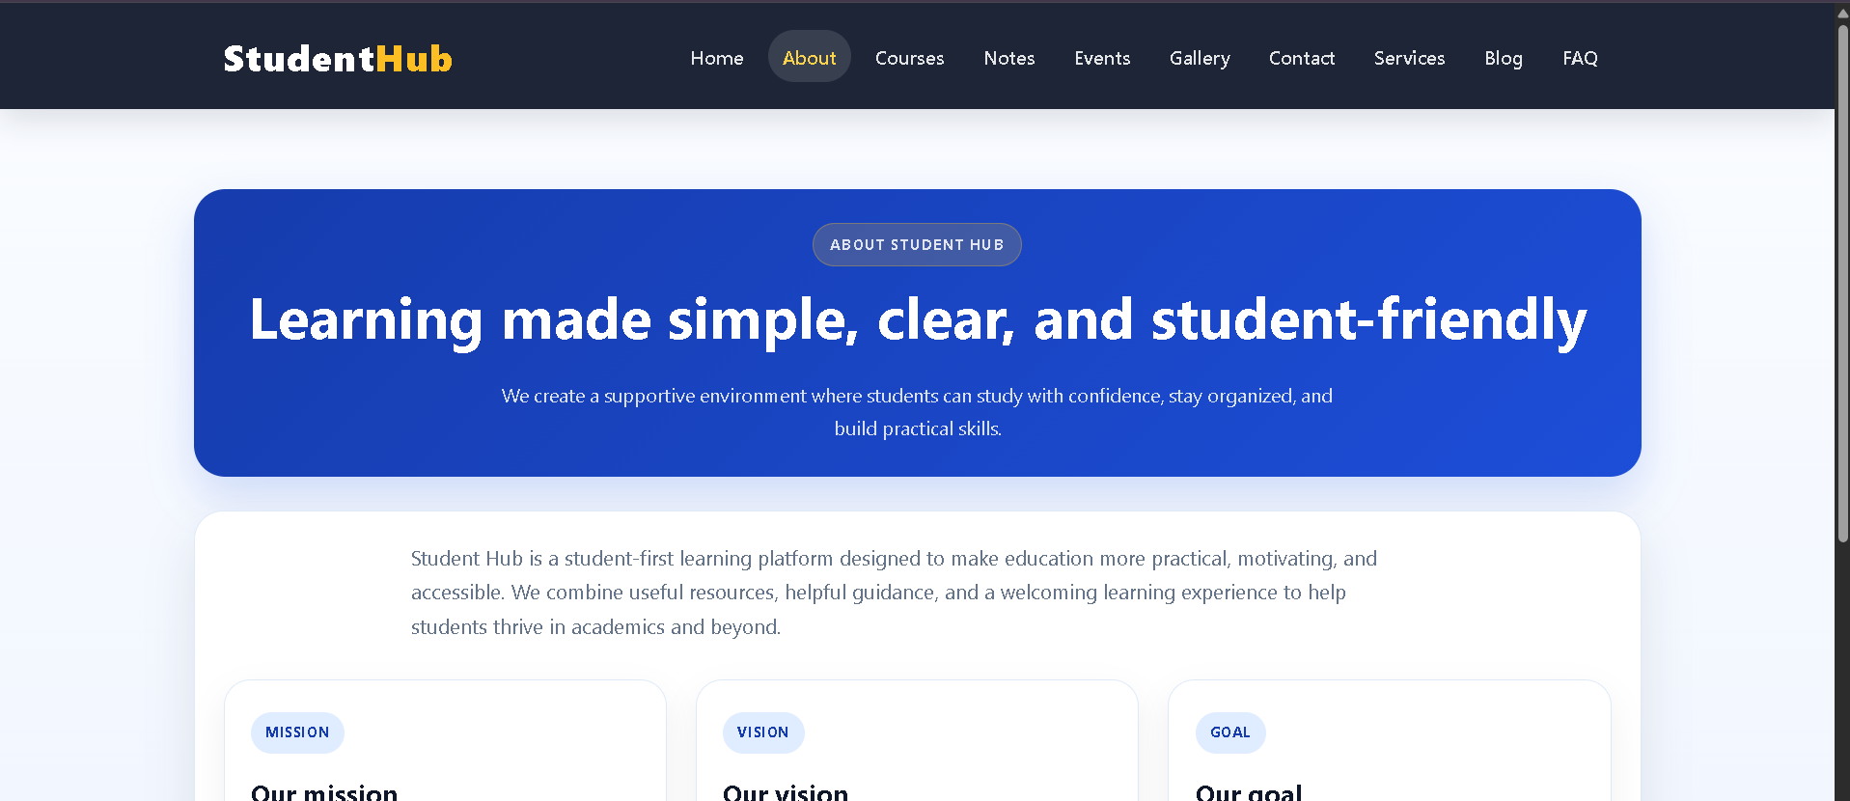
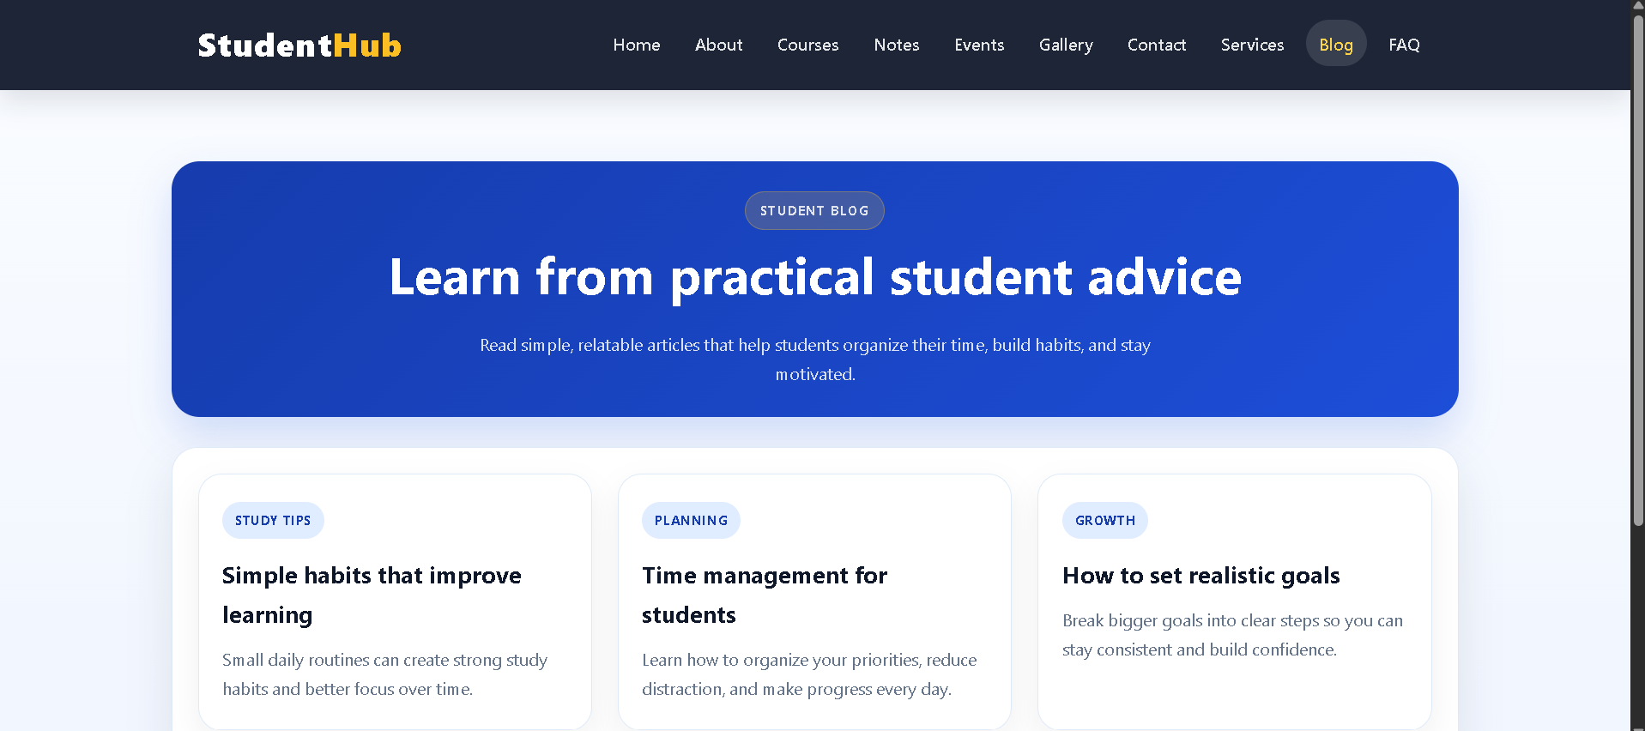
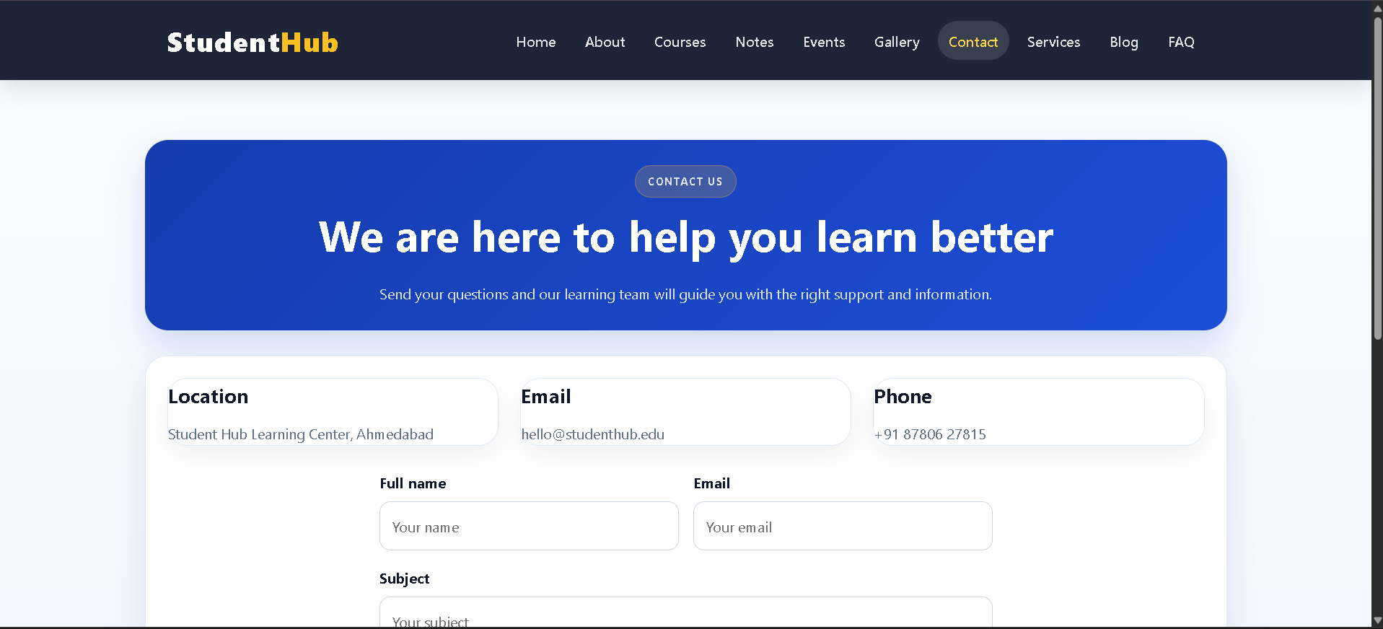
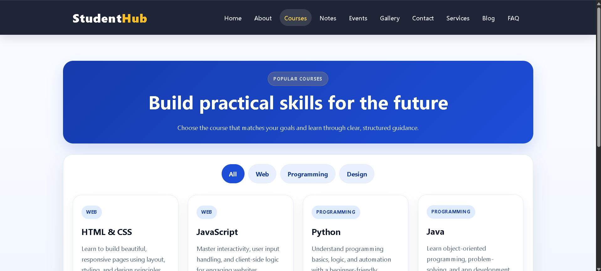
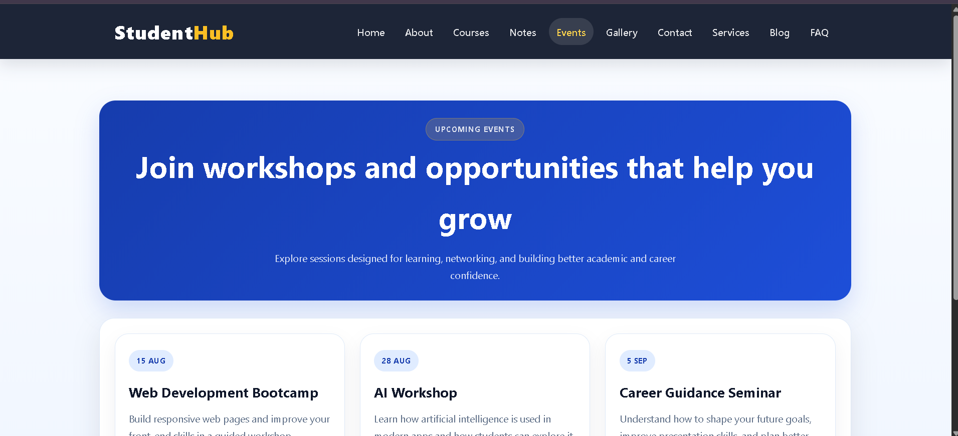
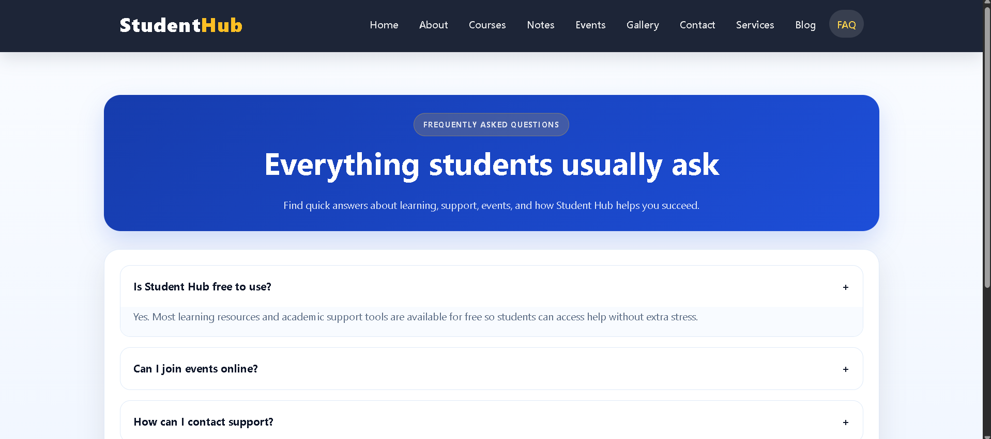
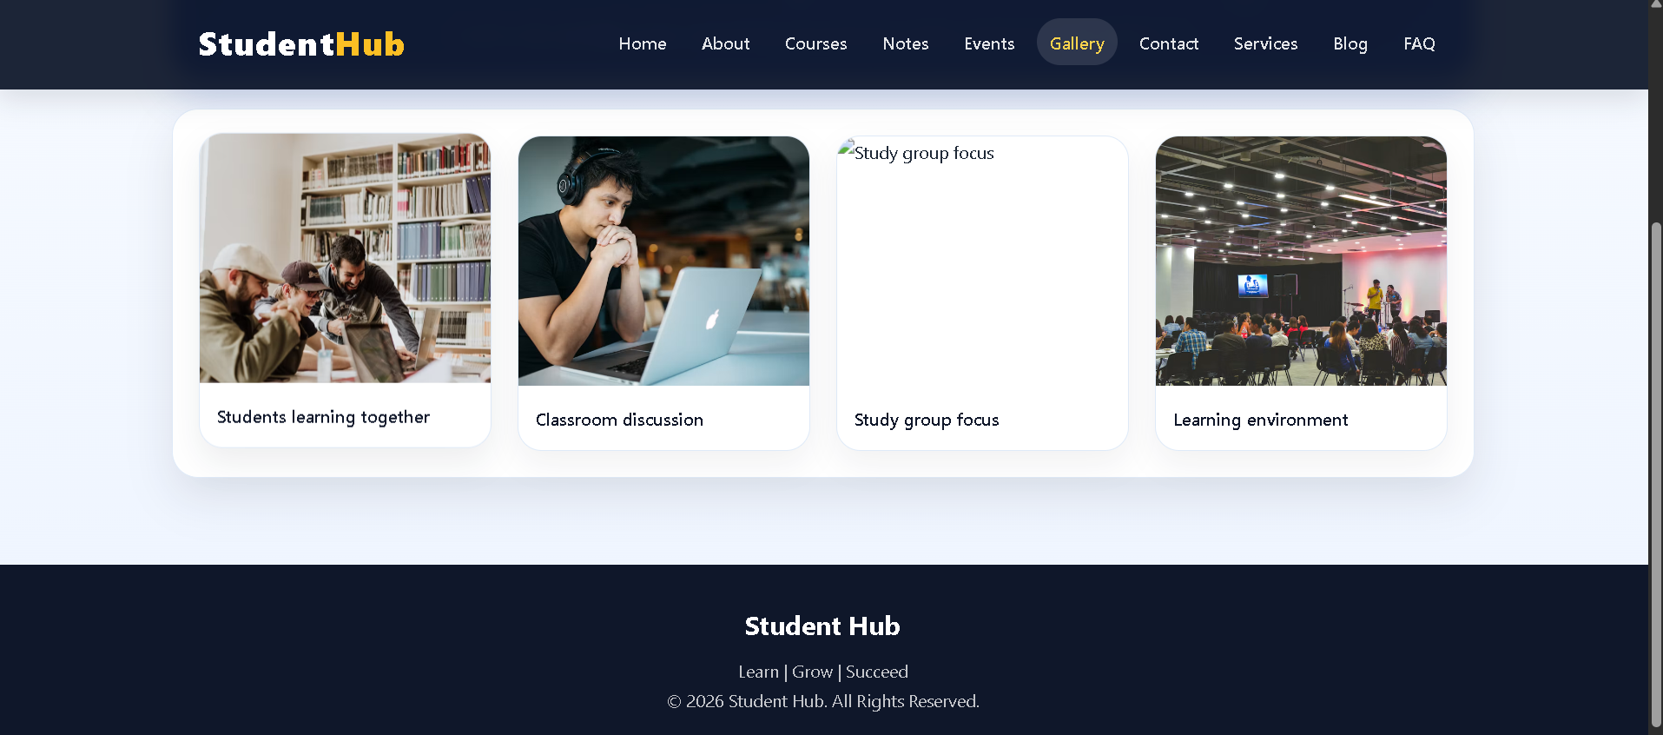
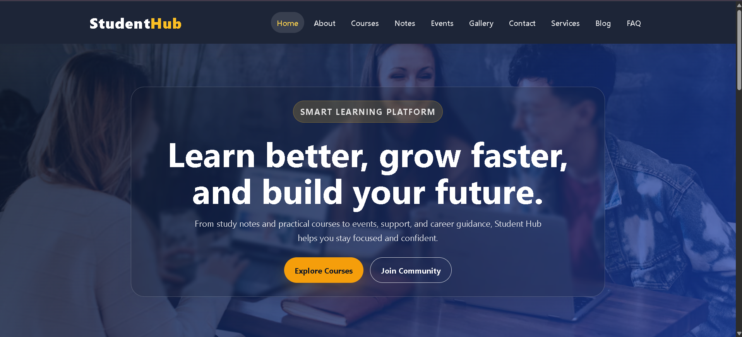
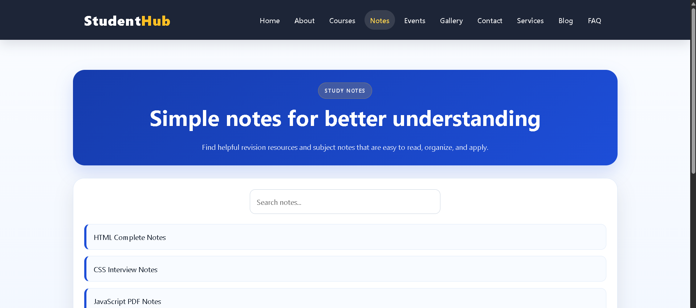
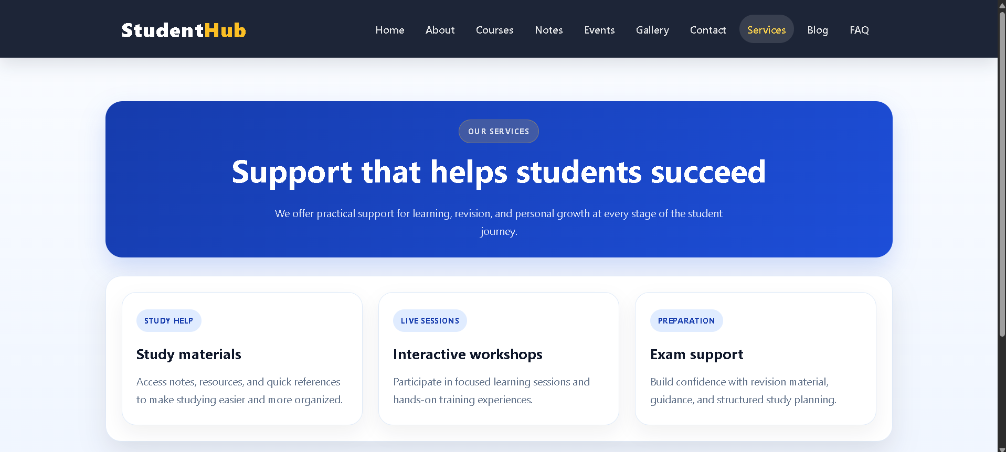

Practical 5:
File: index.html
Code:
<!DOCTYPE html>
<html lang="en">
<head>
<meta charset="UTF-8" />
<meta name="viewport" content="width=device-width, initial-scale=1.0" />
<title>Student Registration Form</title>
<link rel="stylesheet" href="style.css" />
</head>
<body>
<div class="container">
<div class="form-wrapper">
<h1>Student Registration</h1>
<p class="subtitle">Create your account to enroll in the upcoming batch.</p>
<form id="registrationForm" novalidate>
<div class="form-grid">
<div class="field-group">
<label for="fullName">Full Name</label>
<input type="text" id="fullName" name="fullName" placeholder="Enter your full name" />
<small class="error" id="fullNameError"></small>
</div>
<div class="field-group">
<label for="email">Email Address</label>
<input type="email" id="email" name="email" placeholder="you@example.com" />
<small class="error" id="emailError"></small>
</div>
<div class="field-group">
<label for="mobile">Mobile Number</label>
<input type="tel" id="mobile" name="mobile" placeholder="9876543210" maxlength="10" />
<small class="error" id="mobileError"></small>
</div>
<div class="field-group">
<label for="password">Password</label>
<input type="password" id="password" name="password" placeholder="Create a strong password" />
<div class="strength-meter" aria-live="polite">
<span id="strengthBar"></span>
</div>
<small id="strengthText">Password strength: -</small>
<small class="error" id="passwordError"></small>
</div>
<div class="field-group">
<label for="confirmPassword">Confirm Password</label>
<input type="password" id="confirmPassword" name="confirmPassword" placeholder="Re-enter your password" />
<small class="error" id="confirmPasswordError"></small>
</div>
<div class="field-group">
<label for="course">Course</label>
<select id="course" name="course">
<option value="">Select your course</option>
<option value="BCA">BCA</option>
<option value="BSC-CS">B.Sc. Computer Science</option>
<option value="BTech">B.Tech</option>
<option value="MCA">MCA</option>
<option value="Diploma">Diploma</option>
</select>
<small class="error" id="courseError"></small>
</div>
<div class="field-group">
<label for="year">Year</label>
<select id="year" name="year">
<option value="">Select year</option>
<option value="1">1st Year</option>
<option value="2">2nd Year</option>
<option value="3">3rd Year</option>
<option value="4">4th Year</option>
</select>
<small class="error" id="yearError"></small>
</div>
<div class="field-group radio-group">
<span class="label-title">Gender</span>
<div class="radio-options">
<label><input type="radio" name="gender" value="Male" /> Male</label>
<label><input type="radio" name="gender" value="Female" /> Female</label>
<label><input type="radio" name="gender" value="Other" /> Other</label>
</div>
<small class="error" id="genderError"></small>
</div>
</div>
<div class="terms">
<label class="checkbox-wrap">
<input type="checkbox" id="terms" name="terms" />
<span>I agree to the terms and conditions.</span>
</label>
<small class="error" id="termsError"></small>
</div>
<button type="submit" class="submit-btn">Register</button>
</form>
</div>
</div>
<script src="script.js"></script>
</body>
</html>

File: script.js
Code:
const form = document.getElementById('registrationForm');
const fullName = document.getElementById('fullName');
const email = document.getElementById('email');
const mobile = document.getElementById('mobile');
const password = document.getElementById('password');
const confirmPassword = document.getElementById('confirmPassword');
const course = document.getElementById('course');
const year = document.getElementById('year');
const terms = document.getElementById('terms');
const setError = (field, message) => {
const errorElement = document.getElementById(`${field.id}Error`);
if (errorElement) {
errorElement.textContent = message;
}
field.classList.add('invalid');
};
const clearError = (field) => {
const errorElement = document.getElementById(`${field.id}Error`);
if (errorElement) {
errorElement.textContent = '';
}
field.classList.remove('invalid');
};
const validateName = () => {
const value = fullName.value.trim();
const pattern = /^[A-Za-z ]{3,50}$/;
if (!value) {
setError(fullName, 'Name is required.');
return false;
}
if (!pattern.test(value)) {
setError(fullName, 'Name must contain only letters and spaces (3-50 chars).');
return false;
}
clearError(fullName);
return true;
};
const validateEmail = () => {
const value = email.value.trim();
const pattern = /^[a-zA-Z0-9._%+-]+@[a-zA-Z0-9.-]+\.[a-zA-Z]{2,}$/;
if (!value) {
setError(email, 'Email is required.');
return false;
}
if (!pattern.test(value)) {
setError(email, 'Please enter a valid email address.');
return false;
}
clearError(email);
return true;
};
const validateMobile = () => {
const value = mobile.value.trim();
const pattern = /^[6-9]\d{9}$/;
if (!value) {
setError(mobile, 'Mobile number is required.');
return false;
}
if (!pattern.test(value)) {
setError(mobile, 'Mobile number must be 10 digits starting with 6-9.');
return false;
}
clearError(mobile);
return true;
};
const getPasswordStrength = (value) => {
let score = 0;
if (value.length >= 8) score += 1;
if (/[A-Z]/.test(value)) score += 1;
if (/[0-9]/.test(value)) score += 1;
if (/[^A-Za-z0-9]/.test(value)) score += 1;
if (value.length === 0) return { score: 0, label: 'Password strength: -', color: '#d1d5db' };
if (score <= 1) return { score: 1, label: 'Password strength: Weak', color: '#ef4444' };
if (score === 2) return { score: 2, label: 'Password strength: Medium', color: '#f59e0b' };
if (score >= 3) return { score: 3, label: 'Password strength: Strong', color: '#22c55e' };
return { score: 0, label: 'Password strength: -', color: '#d1d5db' };
};
const updatePasswordStrength = () => {
const value = password.value;
const strength = getPasswordStrength(value);
const bar = document.getElementById('strengthBar');
const text = document.getElementById('strengthText');
const widths = ['0%', '33%', '66%', '100%'];
bar.style.width = widths[strength.score];
bar.style.background = strength.color;
text.textContent = strength.label;
text.style.color = strength.color;
};
const validatePassword = () => {
const value = password.value;
const pattern = /^(?=.*[A-Z])(?=.*\d)(?=.*[^A-Za-z0-9]).{8,}$/;
if (!value) {
setError(password, 'Password is required.');
return false;
}
if (!pattern.test(value)) {
setError(password, 'Password must be at least 8 chars, with 1 uppercase, 1 number, and 1 special character.');
return false;
}
clearError(password);
return true;
};
const validateConfirmPassword = () => {
const value = confirmPassword.value;
if (!value) {
setError(confirmPassword, 'Please confirm your password.');
return false;
}
if (value !== password.value) {
setError(confirmPassword, 'Passwords do not match.');
return false;
}
clearError(confirmPassword);
return true;
};
const validateCourse = () => {
if (!course.value) {
setError(course, 'Please select a course.');
return false;
}
clearError(course);
return true;
};
const validateYear = () => {
if (!year.value) {
setError(year, 'Please select your year.');
return false;
}
clearError(year);
return true;
};
const validateGender = () => {
const selected = document.querySelector('input[name="gender"]:checked');
if (!selected) {
document.getElementById('genderError').textContent = 'Please select a gender.';
return false;
}
document.getElementById('genderError').textContent = '';
return true;
};
const validateTerms = () => {
if (!terms.checked) {
document.getElementById('termsError').textContent = 'You must accept the terms and conditions.';
return false;
}
document.getElementById('termsError').textContent = '';
return true;
};
const validateForm = () => {
const checks = [
validateName(),
validateEmail(),
validateMobile(),
validatePassword(),
validateConfirmPassword(),
validateCourse(),
validateYear(),
validateGender(),
validateTerms()
];
return checks.every(Boolean);
};
fullName.addEventListener('input', validateName);
email.addEventListener('input', validateEmail);
mobile.addEventListener('input', validateMobile);
password.addEventListener('input', () => {
updatePasswordStrength();
if (confirmPassword.value) {
validateConfirmPassword();
}
if (password.value) {
validatePassword();
}
});
confirmPassword.addEventListener('input', validateConfirmPassword);
course.addEventListener('change', validateCourse);
year.addEventListener('change', validateYear);
terms.addEventListener('change', validateTerms);
document.querySelectorAll('input[name="gender"]').forEach((radio) => {
radio.addEventListener('change', validateGender);
});
form.addEventListener('submit', (event) => {
event.preventDefault();
if (validateForm()) {
const submitButton = form.querySelector('button[type="submit"]');
submitButton.disabled = true;
submitButton.textContent = 'Registered Successfully ✓';
alert('Registration successful!');
}
});
updatePasswordStrength();

File: style.css
Code:
:root {
--bg: #f4f7ff;
--panel: #ffffff;
--primary: #4f46e5;
--primary-dark: #3730a3;
--danger: #dc2626;
--success: #16a34a;
--text: #1f2937;
--muted: #6b7280;
--border: #dbe1ef;
--shadow: 0 20px 35px rgba(79, 70, 229, 0.12);
--weak: #ef4444;
--medium: #f59e0b;
--strong: #22c55e;
}
* {
box-sizing: border-box;
margin: 0;
padding: 0;
}
body {
font-family: Arial, Helvetica, sans-serif;
background: linear-gradient(135deg, #eef2ff, #f9fafb);
color: var(--text);
min-height: 100vh;
display: grid;
place-items: center;
padding: 2rem 1rem;
}
.container {
width: min(980px, 100%);
}
.form-wrapper {
background: var(--panel);
border: 1px solid var(--border);
border-radius: 18px;
box-shadow: var(--shadow);
padding: 2rem;
}
h1 {
font-size: clamp(2rem, 4vw, 2.6rem);
margin-bottom: 0.4rem;
}
.subtitle {
color: var(--muted);
margin-bottom: 1.5rem;
}
.form-grid {
display: grid;
grid-template-columns: repeat(2, minmax(0, 1fr));
gap: 1.2rem 1.5rem;
}
.field-group {
display: flex;
flex-direction: column;
gap: 0.45rem;
}
label,
.label-title {
font-weight: 600;
color: var(--text);
}
input,
select,
button {
font: inherit;
}
input[type="text"],
input[type="email"],
input[type="tel"],
input[type="password"],
select {
width: 100%;
border: 1px solid var(--border);
border-radius: 10px;
padding: 0.8rem 0.9rem;
background: #f9fafb;
transition: border-color 0.2s ease, box-shadow 0.2s ease;
}
input:focus,
select:focus {
border-color: var(--primary);
box-shadow: 0 0 0 3px rgba(79, 70, 229, 0.12);
outline: none;
}
input.invalid,
select.invalid {
border-color: var(--danger);
background: #fff5f5;
}
.error {
min-height: 18px;
color: var(--danger);
font-size: 0.8rem;
}
.strength-meter {
width: 100%;
height: 10px;
border-radius: 999px;
background: #eef2f7;
overflow: hidden;
}
.strength-meter span {
display: block;
height: 100%;
width: 0;
border-radius: inherit;
transition: width 0.25s ease, background 0.25s ease;
}
#strengthText {
color: var(--muted);
font-size: 0.8rem;
}
.radio-group {
grid-column: span 2;
}
.radio-options {
display: flex;
flex-wrap: wrap;
gap: 1rem;
padding-top: 0.2rem;
}
.radio-options label {
display: inline-flex;
align-items: center;
gap: 0.5rem;
font-weight: 500;
}
.terms {
margin-top: 1.2rem;
}
.checkbox-wrap {
display: flex;
align-items: center;
gap: 0.7rem;
font-weight: 500;
}
.checkbox-wrap input {
width: 18px;
height: 18px;
}
.submit-btn {
margin-top: 1.5rem;
width: 100%;
background: linear-gradient(135deg, var(--primary), var(--primary-dark));
color: white;
border: none;
border-radius: 12px;
padding: 0.95rem 1.25rem;
font-weight: 700;
cursor: pointer;
transition: transform 0.2s ease, opacity 0.2s ease;
}
.submit-btn:hover {
transform: translateY(-1px);
}
.submit-btn:disabled {
opacity: 0.7;
cursor: not-allowed;
}
@media (max-width: 640px) {
.form-wrapper {
padding: 1.25rem;
}
.form-grid {
grid-template-columns: 1fr;
}
.radio-group {
grid-column: auto;
}
}
Output:
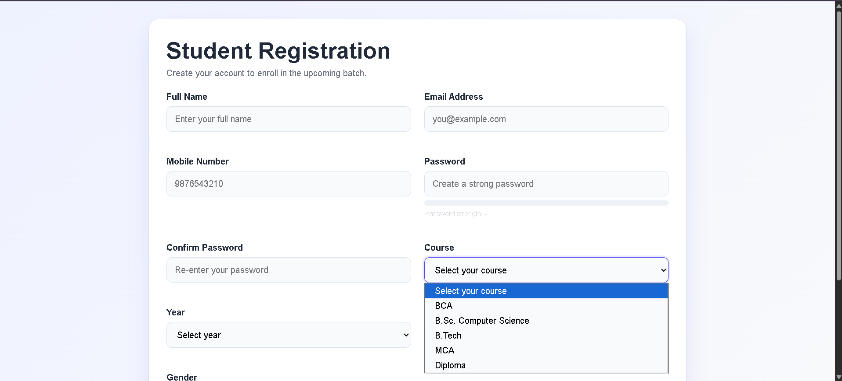

Practical 6:
File: index.html
Code:
<!DOCTYPE html>
<html lang="en">
<head>
<meta charset="UTF-8" />
<meta name="viewport" content="width=device-width, initial-scale=1.0" />
<title>Campus Events Directory</title>
<link rel="stylesheet" href="style.css" />
</head>
<body>
<div class="page-shell">
<header class="topbar">
<div class="container">
<div class="brand-wrap">
<div class="logo">CE</div>
<div>
<p class="eyebrow">Student portal</p>
<h1>Campus Events</h1>
</div>
</div>
</div>
</header>
<main class="container main-content">
<section class="toolbar">
<div class="search-box">
<label for="searchInput" class="sr-only">Search events</label>
<input id="searchInput" type="search" placeholder="Search by title, category, or venue..." />
</div>
<div class="filter-row">
<label>
Category
<select id="categoryFilter">
<option value="all">All categories</option>
</select>
</label>
<label>
Sort by
<select id="sortSelect">
<option value="date-asc">Date: Earliest</option>
<option value="date-desc">Date: Latest</option>
<option value="title-asc">Title: A-Z</option>
<option value="title-desc">Title: Z-A</option>
</select>
</label>
</div>
</section>
<div id="statusMessage" class="status-message" aria-live="polite"></div>
<section id="eventsList" class="events-grid" aria-live="polite"></section>
<nav id="pagination" class="pagination" aria-label="Pagination"></nav>
</main>
</div>
<script src="script.js"></script>
</body>
</html>

File: script.js
Code:
const state = {
events: [],
filteredEvents: [],
currentPage: 1,
pageSize: 6,
searchTerm: '',
category: 'all',
sortBy: 'date-asc',
cachedData: null,
};
const elements = {
statusMessage: document.getElementById('statusMessage'),
eventsList: document.getElementById('eventsList'),
searchInput: document.getElementById('searchInput'),
categoryFilter: document.getElementById('categoryFilter'),
sortSelect: document.getElementById('sortSelect'),
pagination: document.getElementById('pagination'),
};
const setStatus = (message, isError = false) => {
elements.statusMessage.textContent = message;
elements.statusMessage.classList.toggle('error', isError);
};
const formatDate = (dateString) => {
const date = new Date(dateString);
return new Intl.DateTimeFormat('en-IN', {
day: 'numeric',
month: 'short',
year: 'numeric',
}).format(date);
};
const getSavedData = () => {
try {
const cached = localStorage.getItem('campus-events-cache');
return cached ? JSON.parse(cached) : null;
} catch (error) {
return null;
}
};
const saveDataToCache = (data) => {
try {
localStorage.setItem('campus-events-cache', JSON.stringify(data));
} catch (error) {
console.warn('Unable to cache data:', error);
}
};
const populateCategoryFilter = () => {
const categories = [...new Set(state.events.map((event) => event.category))].sort();
elements.categoryFilter.innerHTML = '<option value="all">All categories</option>' +
categories
.map((category) => `<option value="${category}">${category}</option>`)
.join('');
};
const applyFiltersAndSort = () => {
let result = [...state.events];
if (state.searchTerm) {
const term = state.searchTerm.toLowerCase();
result = result.filter((event) => {
const searchableText = `${event.title} ${event.category} ${event.venue}`.toLowerCase();
return searchableText.includes(term);
});
}
if (state.category !== 'all') {
result = result.filter((event) => event.category === state.category);
}
switch (state.sortBy) {
case 'title-asc':
result.sort((a, b) => a.title.localeCompare(b.title));
break;
case 'title-desc':
result.sort((a, b) => b.title.localeCompare(a.title));
break;
case 'date-desc':
result.sort((a, b) => new Date(b.date) - new Date(a.date));
break;
case 'date-asc':
default:
result.sort((a, b) => new Date(a.date) - new Date(b.date));
break;
}
state.filteredEvents = result;
state.currentPage = 1;
render();
};
const renderEvents = () => {
const startIndex = (state.currentPage - 1) * state.pageSize;
const paginatedData = state.filteredEvents.slice(startIndex, startIndex + state.pageSize);
if (paginatedData.length === 0) {
elements.eventsList.innerHTML = `
<div class="empty-state">
<h3>No events found</h3>
<p>Try a different search term or category filter.</p>
</div>
`;
return;
}
elements.eventsList.innerHTML = paginatedData
.map(
(event) => `
<article class="event-card">
<img class="event-image" src="${event.image}" alt="${event.title}" />
<div class="event-body">
<div class="event-badges">
<span class="category-pill">${event.category}</span>
<span class="event-date">${formatDate(event.date)}</span>
</div>
<h3>${event.title}</h3>
<p>${event.description}</p>
<div class="meta">
<span>📍 ${event.venue}</span>
<span>🎯 ${event.category}</span>
</div>
</div>
</article>
`
)
.join('');
};
const renderPagination = () => {
const totalPages = Math.max(1, Math.ceil(state.filteredEvents.length / state.pageSize));
const buttons = [];
buttons.push(`
<button class="page-btn" data-page="prev" ${state.currentPage === 1 ? 'disabled' : ''}>Prev</button>
`);
for (let page = 1; page <= totalPages; page += 1) {
buttons.push(`
<button class="page-btn ${page === state.currentPage ? 'active' : ''}" data-page="${page}">${page}</button>
`);
}
buttons.push(`
<button class="page-btn" data-page="next" ${state.currentPage === totalPages ? 'disabled' : ''}>Next</button>
`);
elements.pagination.innerHTML = buttons.join('');
elements.pagination.querySelectorAll('.page-btn').forEach((button) => {
button.addEventListener('click', () => {
const target = button.dataset.page;
if (target === 'prev') {
state.currentPage = Math.max(1, state.currentPage - 1);
} else if (target === 'next') {
state.currentPage = Math.min(totalPages, state.currentPage + 1);
} else {
state.currentPage = Number(target);
}
render();
});
});
};
const render = () => {
renderEvents();
renderPagination();
};
const fetchEvents = async () => {
const cachedData = getSavedData();
if (cachedData && Array.isArray(cachedData) && cachedData.length) {
state.events = cachedData;
populateCategoryFilter();
applyFiltersAndSort();
setStatus('Showing cached event data.');
}
try {
setStatus('Loading events...');
const response = await fetch('./data/events.json');
if (!response.ok) {
throw new Error(`Network error: ${response.status}`);
}
const data = await response.json();
state.events = data;
saveDataToCache(data);
populateCategoryFilter();
applyFiltersAndSort();
setStatus(`Loaded ${data.length} events successfully.`);
} catch (error) {
if (!state.events.length) {
setStatus('Unable to load event data. Please check the JSON file.', true);
} else {
setStatus('Showing cached data because the live data could not be fetched.', true);
}
console.error(error);
}
};
elements.searchInput.addEventListener('input', (event) => {
state.searchTerm = event.target.value.trim();
applyFiltersAndSort();
});
elements.categoryFilter.addEventListener('change', (event) => {
state.category = event.target.value;
applyFiltersAndSort();
});
elements.sortSelect.addEventListener('change', (event) => {
state.sortBy = event.target.value;
applyFiltersAndSort();
});
fetchEvents();

File: style.css
Code:
:root {
--bg: #f5f7ff;
--panel: #ffffff;
--panel-alt: #eef2ff;
--primary: #4f46e5;
--primary-dark: #312e81;
--text: #1f2937;
--muted: #6b7280;
--border: #dfe7f5;
--shadow: 0 18px 45px rgba(79, 70, 229, 0.12);
--danger: #dc2626;
--success: #16a34a;
--warning: #f59e0b;
}
* {
box-sizing: border-box;
margin: 0;
padding: 0;
}
body {
font-family: Arial, Helvetica, sans-serif;
background: linear-gradient(180deg, #eef3ff, #f8faff);
color: var(--text);
}
.container {
width: min(1100px, calc(100% - 2rem));
margin: 0 auto;
}
.page-shell {
min-height: 100vh;
}
.topbar {
background: linear-gradient(135deg, var(--primary), var(--primary-dark));
color: white;
padding: 1.5rem 0;
}
.brand-wrap {
display: flex;
align-items: center;
gap: 1rem;
}
.logo {
width: 52px;
height: 52px;
border-radius: 15px;
display: grid;
place-items: center;
background: rgba(255, 255, 255, 0.16);
font-weight: 700;
font-size: 1.2rem;
}
.eyebrow {
font-size: 0.72rem;
text-transform: uppercase;
letter-spacing: 0.08em;
opacity: 0.8;
}
h1 {
font-size: clamp(1.8rem, 3vw, 2.5rem);
}
.main-content {
padding: 2rem 0 3rem;
}
.toolbar {
display: grid;
gap: 1rem;
margin-bottom: 1.5rem;
}
.search-box input,
.filter-row select {
width: 100%;
border: 1px solid var(--border);
background: var(--panel);
border-radius: 12px;
padding: 0.85rem 1rem;
font-size: 1rem;
}
.filter-row {
display: grid;
grid-template-columns: repeat(2, minmax(0, 1fr));
gap: 1rem;
}
.filter-row label {
display: grid;
gap: 0.5rem;
font-weight: 600;
}
.status-message {
border-radius: 12px;
padding: 0.9rem 1rem;
background: #ecfeff;
color: #0f172a;
margin-bottom: 1rem;
border: 1px solid #bae6fd;
min-height: 50px;
display: flex;
align-items: center;
}
.status-message.error {
background: #fef2f2;
border-color: #fecaca;
color: var(--danger);
}
.events-grid {
display: grid;
grid-template-columns: repeat(3, minmax(0, 1fr));
gap: 1.3rem;
}
.event-card {
background: var(--panel);
border: 1px solid var(--border);
border-radius: 18px;
overflow: hidden;
box-shadow: var(--shadow);
transition: transform 0.2s ease, box-shadow 0.2s ease;
}
.event-card:hover {
transform: translateY(-2px);
}
.event-image {
height: 180px;
object-fit: cover;
width: 100%;
display: block;
}
.event-body {
padding: 1.2rem;
}
.event-badges {
display: flex;
justify-content: space-between;
align-items: center;
gap: 0.75rem;
margin-bottom: 0.85rem;
}
.category-pill {
display: inline-flex;
align-items: center;
padding: 0.35rem 0.75rem;
border-radius: 999px;
background: var(--panel-alt);
color: var(--primary);
font-size: 0.72rem;
font-weight: 700;
}
.event-date {
font-size: 0.8rem;
color: var(--muted);
}
.event-card h3 {
margin-bottom: 0.6rem;
font-size: 1.2rem;
}
.event-card p {
color: var(--muted);
line-height: 1.6;
margin-bottom: 0.9rem;
}
.meta {
display: flex;
justify-content: space-between;
gap: 1rem;
padding-top: 0.9rem;
border-top: 1px solid var(--border);
color: var(--text);
font-size: 0.9rem;
}
.pagination {
display: flex;
justify-content: center;
flex-wrap: wrap;
gap: 0.55rem;
margin-top: 2rem;
}
.page-btn {
border: 1px solid var(--border);
background: var(--panel);
color: var(--text);
border-radius: 10px;
padding: 0.7rem 0.9rem;
cursor: pointer;
font-weight: 600;
}
.page-btn.active {
background: var(--primary);
color: white;
border-color: var(--primary);
}
.page-btn:disabled {
opacity: 0.5;
cursor: not-allowed;
}
.sr-only {
position: absolute;
width: 1px;
height: 1px;
padding: 0;
margin: -1px;
overflow: hidden;
clip: rect(0, 0, 0, 0);
white-space: nowrap;
border: 0;
}
@media (max-width: 820px) {
.events-grid {
grid-template-columns: repeat(2, minmax(0, 1fr));
}
}
@media (max-width: 600px) {
.filter-row,
.events-grid {
grid-template-columns: 1fr;
}
}

Output:
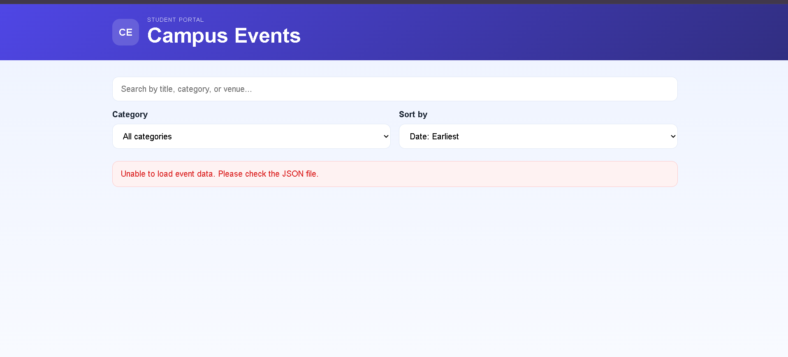

Practical 7:
File: index.php
Code:
<?php
session_start();
$baseDir = __DIR__;
$dataDir = $baseDir . DIRECTORY_SEPARATOR . 'data';
$csvFile = $dataDir . DIRECTORY_SEPARATOR . 'records.csv';
$jsonFile = $dataDir . DIRECTORY_SEPARATOR . 'records.json';
if (!is_dir($dataDir)) {
mkdir($dataDir, 0777, true);
}
if (!file_exists($csvFile)) {
$header = ['name', 'email', 'phone', 'course', 'message', 'submitted_at'];
$handle = fopen($csvFile, 'w');
if ($handle !== false) {
fputcsv($handle, $header);
fclose($handle);
}
}
if (!file_exists($jsonFile)) {
file_put_contents($jsonFile, json_encode([], JSON_PRETTY_PRINT | JSON_UNESCAPED_SLASHES));
}
function sanitizeText($value)
{
return trim(htmlspecialchars(strip_tags($value), ENT_QUOTES, 'UTF-8'));
}
function getStoredRecords(): array
{
global $jsonFile;
if (!file_exists($jsonFile)) {
return [];
}
$content = file_get_contents($jsonFile);
if ($content === false || trim($content) === '') {
return [];
}
$decoded = json_decode($content, true);
return is_array($decoded) ? $decoded : [];
}
function generateCsrfToken(): string
{
if (empty($_SESSION['csrf_token'])) {
$_SESSION['csrf_token'] = bin2hex(random_bytes(32));
}
return $_SESSION['csrf_token'];
}
$errors = [];
$successMessage = '';
$formValues = [
'name' => '',
'email' => '',
'phone' => '',
'course' => '',
'message' => '',
];
if ($_SERVER['REQUEST_METHOD'] === 'POST') {
$csrfToken = $_POST['csrf_token'] ?? '';
if (!hash_equals($_SESSION['csrf_token'] ?? '', $csrfToken)) {
$errors[] = 'Invalid CSRF token. Please submit the form again.';
}
$formValues['name'] = sanitizeText($_POST['name'] ?? '');
$formValues['email'] = sanitizeText($_POST['email'] ?? '');
$formValues['phone'] = sanitizeText($_POST['phone'] ?? '');
$formValues['course'] = sanitizeText($_POST['course'] ?? '');
$formValues['message'] = sanitizeText($_POST['message'] ?? '');
if ($formValues['name'] === '' || strlen($formValues['name']) < 2) {
$errors[] = 'Name is required and must be at least 2 characters long.';
}
if (!filter_var($formValues['email'], FILTER_VALIDATE_EMAIL)) {
$errors[] = 'Please enter a valid email address.';
}
if (!preg_match('/^[0-9+\-()\s]{10,15}$/', $formValues['phone'])) {
$errors[] = 'Please enter a valid phone number with 10 to 15 characters.';
}
if ($formValues['course'] === '') {
$errors[] = 'Please select a course.';
}
if ($formValues['message'] === '' || strlen($formValues['message']) < 10) {
$errors[] = 'Message is required and must be at least 10 characters long.';
}
if (empty($errors)) {
$record = [
'name' => $formValues['name'],
'email' => $formValues['email'],
'phone' => $formValues['phone'],
'course' => $formValues['course'],
'message' => $formValues['message'],
'submitted_at' => date('Y-m-d H:i:s'),
];
$csvHandle = fopen($csvFile, 'a');
if ($csvHandle !== false) {
fputcsv($csvHandle, [
$record['name'],
$record['email'],
$record['phone'],
$record['course'],
$record['message'],
$record['submitted_at'],
]);
fclose($csvHandle);
}
$records = getStoredRecords();
$records[] = $record;
file_put_contents($jsonFile, json_encode($records, JSON_PRETTY_PRINT | JSON_UNESCAPED_SLASHES));
$successMessage = 'Form submitted successfully. Your record has been stored.';
$formValues = ['name' => '', 'email' => '', 'phone' => '', 'course' => '', 'message' => ''];
$_SESSION['csrf_token'] = bin2hex(random_bytes(32));
}
} else {
$_SESSION['csrf_token'] = bin2hex(random_bytes(32));
}
$csrfToken = generateCsrfToken();
$storedRecords = getStoredRecords();
?>
<!DOCTYPE html>
<html lang="en">
<head>
<meta charset="UTF-8">
<meta name="viewport" content="width=device-width, initial-scale=1.0">
<title>PHP Registration Form</title>
<style>
body {
font-family: Arial, sans-serif;
background: #f4f6f8;
margin: 0;
padding: 30px;
}
.container {
max-width: 900px;
margin: 0 auto;
background: #fff;
padding: 30px;
border-radius: 12px;
box-shadow: 0 10px 25px rgba(0,0,0,0.08);
}
h1 {
text-align: center;
color: #1f2937;
}
form {
display: grid;
gap: 18px;
}
.form-row {
display: grid;
grid-template-columns: 1fr 1fr;
gap: 18px;
}
label {
display: block;
margin-bottom: 8px;
font-weight: bold;
color: #374151;
}
input, select, textarea {
width: 100%;
padding: 12px;
border: 1px solid #d1d5db;
border-radius: 8px;
font-size: 16px;
box-sizing: border-box;
}
textarea {
min-height: 120px;
resize: vertical;
}
button {
background: #2563eb;
color: #fff;
border: none;
padding: 12px 18px;
border-radius: 8px;
font-size: 16px;
cursor: pointer;
}
.alert {
padding: 12px 16px;
border-radius: 8px;
margin-bottom: 20px;
font-weight: bold;
}
.alert-success {
background: #dcfce7;
color: #166534;
border: 1px solid #86efac;
}
.alert-error {
background: #fee2e2;
color: #991b1b;
border: 1px solid #fca5a5;
}
.error-list {
margin: 0;
padding-left: 18px;
}
.records {
margin-top: 30px;
border-top: 2px solid #e5e7eb;
padding-top: 20px;
}
table {
width: 100%;
border-collapse: collapse;
margin-top: 15px;
}
th, td {
border: 1px solid #d1d5db;
padding: 10px;
text-align: left;
vertical-align: top;
}
th {
background: #f3f4f6;
}
@media (max-width: 600px) {
.form-row {
grid-template-columns: 1fr;
}
body {
padding: 15px;
}
}
</style>
</head>
<body>
<div class="container">
<h1>Student Registration Form</h1>
<?php if (!empty($successMessage)): ?>
<div class="alert alert-success"><?php echo $successMessage; ?></div>
<?php endif; ?>
<?php if (!empty($errors)): ?>
<div class="alert alert-error">
<ul class="error-list">
<?php foreach ($errors as $error): ?>
<li><?php echo $error; ?></li>
<?php endforeach; ?>
</ul>
</div>
<?php endif; ?>
<form method="POST" action="<?php echo htmlspecialchars($_SERVER['PHP_SELF']); ?>">
<input type="hidden" name="csrf_token" value="<?php echo htmlspecialchars($csrfToken); ?>">
<div class="form-row">
<div>
<label for="name">Full Name</label>
<input type="text" id="name" name="name" value="<?php echo $formValues['name']; ?>" required>
</div>
<div>
<label for="email">Email</label>
<input type="email" id="email" name="email" value="<?php echo $formValues['email']; ?>" required>
</div>
</div>
<div class="form-row">
<div>
<label for="phone">Phone</label>
<input type="tel" id="phone" name="phone" value="<?php echo $formValues['phone']; ?>" required>
</div>
<div>
<label for="course">Course</label>
<select id="course" name="course" required>
<option value="">Select Course</option>
<option value="Web Development" <?php echo ($formValues['course'] === 'Web Development') ? 'selected' : ''; ?>>Web Development</option>
<option value="Database Management" <?php echo ($formValues['course'] === 'Database Management') ? 'selected' : ''; ?>>Database Management</option>
<option value="PHP Programming" <?php echo ($formValues['course'] === 'PHP Programming') ? 'selected' : ''; ?>>PHP Programming</option>
<option value="UI/UX Design" <?php echo ($formValues['course'] === 'UI/UX Design') ? 'selected' : ''; ?>>UI/UX Design</option>
</select>
</div>
</div>
<div>
<label for="message">Message</label>
<textarea id="message" name="message" required><?php echo $formValues['message']; ?></textarea>
</div>
<button type="submit">Submit Form</button>
</form>
<div class="records">
<h2>Stored Records</h2>
<?php if (!empty($storedRecords)): ?>
<table>
<thead>
<tr>
<th>Name</th>
<th>Email</th>
<th>Phone</th>
<th>Course</th>
<th>Message</th>
<th>Submitted At</th>
</tr>
</thead>
<tbody>
<?php foreach ($storedRecords as $record): ?>
<tr>
<td><?php echo htmlspecialchars($record['name'] ?? ''); ?></td>
<td><?php echo htmlspecialchars($record['email'] ?? ''); ?></td>
<td><?php echo htmlspecialchars($record['phone'] ?? ''); ?></td>
<td><?php echo htmlspecialchars($record['course'] ?? ''); ?></td>
<td><?php echo htmlspecialchars($record['message'] ?? ''); ?></td>
<td><?php echo htmlspecialchars($record['submitted_at'] ?? ''); ?></td>
</tr>
<?php endforeach; ?>
</tbody>
</table>
<?php else: ?>
<p>No records stored yet.</p>
<?php endif; ?>
</div>
</div>
</body>
</html>
Output:
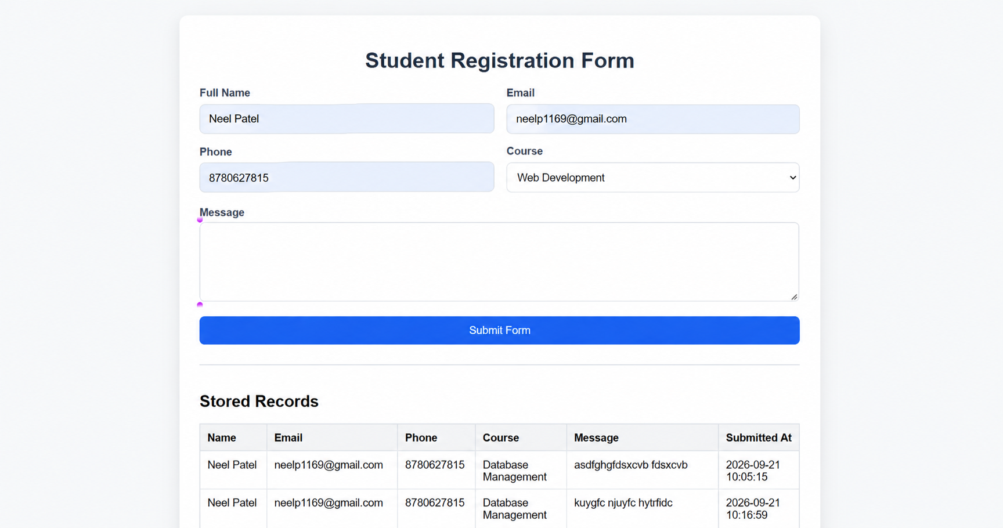
Practical 8 and 9:
File: db.php
Code:
<?php
declare(strict_types=1);
$host = '127.0.0.1';
$dbname = 'studenthub';
$dbuser = 'root';
$dbpass = '';
$charset = 'utf8mb4';
$dsn = "mysql:host={$host};dbname={$dbname};charset={$charset}";
$options = [
PDO::ATTR_ERRMODE => PDO::ERRMODE_EXCEPTION,
PDO::ATTR_DEFAULT_FETCH_MODE => PDO::FETCH_ASSOC,
PDO::ATTR_EMULATE_PREPARES => false,
];
try {
$pdo = new PDO($dsn, $dbuser, $dbpass, $options);
} catch (PDOException $e) {
throw new RuntimeException('Database connection failed. Please start MySQL in XAMPP and import studenthub.sql first.');
}
function fetchStudents(PDO $pdo): array
{
$sql = 'SELECT student_id, first_name, last_name, email, department, year_of_study
FROM students
ORDER BY student_id ASC';
$stmt = $pdo->query($sql);
return $stmt->fetchAll();
}
function fetchRegistrations(PDO $pdo): array
{
$sql = 'SELECT r.registration_id, s.first_name, s.last_name, e.title AS event_title,
r.registration_date, r.status
FROM registrations r
INNER JOIN students s ON r.student_id = s.student_id
INNER JOIN events e ON r.event_id = e.event_id
ORDER BY r.registration_id ASC';
$stmt = $pdo->query($sql);
return $stmt->fetchAll();
}
function registerStudentForEvent(PDO $pdo, int $studentId, int $eventId, string $status = 'Registered'): bool
{
try {
$sql = 'INSERT INTO registrations (student_id, event_id, status)
VALUES (:student_id, :event_id, :status)';
$stmt = $pdo->prepare($sql);
$stmt->execute([
':student_id' => $studentId,
':event_id' => $eventId,
':status' => $status,
]);
return $stmt->rowCount() > 0;
} catch (PDOException $e) {
if ($e->getCode() === '23000') {
return false;
}
throw $e;
}
}

File: index.php
Code:
<?php
require __DIR__ . '/db.php';
try {
$students = fetchStudents($pdo);
$registrations = fetchRegistrations($pdo);
$sampleInsert = registerStudentForEvent($pdo, 1, 3, 'Registered');
} catch (Throwable $e) {
$errorMessage = $e->getMessage();
}
?>
<!DOCTYPE html>
<html lang="en">
<head>
<meta charset="UTF-8">
<meta name="viewport" content="width=device-width, initial-scale=1.0">
<title>StudentHub Database Test</title>
<style>
body {
font-family: Arial, sans-serif;
margin: 40px;
background: #f4f7fb;
color: #222;
}
.container {
background: #fff;
padding: 25px;
border-radius: 10px;
box-shadow: 0 2px 8px rgba(0,0,0,0.08);
max-width: 1000px;
margin: auto;
}
h1, h2 {
color: #1a3d6d;
}
table {
width: 100%;
border-collapse: collapse;
margin-top: 15px;
}
th, td {
border: 1px solid #d9dfe8;
padding: 10px;
text-align: left;
}
th {
background: #eaf2ff;
}
.success {
color: green;
font-weight: bold;
}
.error {
color: #b00020;
font-weight: bold;
}
</style>
</head>
<body>
<div class="container">
<h1>StudentHub - PDO Connection Test</h1>
<p><a href="register.php">Create a StudentHub account</a></p>
<?php if (isset($errorMessage)): ?>
<p class="error">Database error: <?= htmlspecialchars($errorMessage) ?></p>
<?php else: ?>
<p class="success">Connection successful using PDO and prepared statements.</p>
<?php if ($sampleInsert): ?>
<p class="success">Sample registration inserted successfully.</p>
<?php else: ?>
<p>Sample registration already existed, so no new row was inserted.</p>
<?php endif; ?>
<h2>Students</h2>
<table>
<thead>
<tr>
<th>ID</th>
<th>Name</th>
<th>Email</th>
<th>Department</th>
<th>Year</th>
</tr>
</thead>
<tbody>
<?php foreach ($students as $student): ?>
<tr>
<td><?= htmlspecialchars((string)$student['student_id']) ?></td>
<td><?= htmlspecialchars($student['first_name'] . ' ' . $student['last_name']) ?></td>
<td><?= htmlspecialchars($student['email']) ?></td>
<td><?= htmlspecialchars($student['department']) ?></td>
<td><?= htmlspecialchars((string)$student['year_of_study']) ?></td>
</tr>
<?php endforeach; ?>
</tbody>
</table>
<h2>Registrations</h2>
<table>
<thead>
<tr>
<th>Registration ID</th>
<th>Student</th>
<th>Event</th>
<th>Date</th>
<th>Status</th>
</tr>
</thead>
<tbody>
<?php foreach ($registrations as $registration): ?>
<tr>
<td><?= htmlspecialchars((string)$registration['registration_id']) ?></td>
<td><?= htmlspecialchars($registration['first_name'] . ' ' . $registration['last_name']) ?></td>
<td><?= htmlspecialchars($registration['event_title']) ?></td>
<td><?= htmlspecialchars($registration['registration_date']) ?></td>
<td><?= htmlspecialchars($registration['status']) ?></td>
</tr>
<?php endforeach; ?>
</tbody>
</table>
<?php endif; ?>
</div>
</body>
</html>

File: register.php
Code:
<?php
declare(strict_types=1);
session_set_cookie_params([
'httponly' => true,
'secure' => isset($_SERVER['HTTPS']) && $_SERVER['HTTPS'] !== 'off',
'samesite' => 'Lax',
]);
session_start();
if (!isset($_SESSION['csrf_token'])) {
$_SESSION['csrf_token'] = bin2hex(random_bytes(32));
}
$message = '';
$messageType = '';
$fullName = '';
$username = '';
$email = '';
function escapeHtml(string $value): string
{
return htmlspecialchars($value, ENT_QUOTES | ENT_SUBSTITUTE, 'UTF-8');
}
function hasLength(string $value, int $minimum, int $maximum): bool
{
$length = preg_match_all('/./us', $value);
return $length !== false && $length >= $minimum && $length <= $maximum;
}
if ($_SERVER['REQUEST_METHOD'] === 'POST') {
$fullName = trim((string)($_POST['full_name'] ?? ''));
$username = strtolower(trim((string)($_POST['username'] ?? '')));
$email = strtolower(trim((string)($_POST['email'] ?? '')));
$password = (string)($_POST['password'] ?? '');
$confirmPassword = (string)($_POST['confirm_password'] ?? '');
$submittedToken = (string)($_POST['csrf_token'] ?? '');
if (!hash_equals($_SESSION['csrf_token'], $submittedToken)) {
$message = 'Your session token is invalid. Refresh the page and try again.';
$messageType = 'error';
} elseif (!hasLength($fullName, 1, 120)) {
$message = 'Enter a name with no more than 120 characters.';
$messageType = 'error';
} elseif (!preg_match('/\A[a-z0-9_]{3,30}\z/', $username)) {
$message = 'Username must be 3-30 characters and use only letters, numbers, or underscores.';
$messageType = 'error';
} elseif (strlen($email) > 254 || !filter_var($email, FILTER_VALIDATE_EMAIL)) {
$message = 'Enter a valid email address.';
$messageType = 'error';
} elseif (!hasLength($password, 8, 128)) {
$message = 'Password must be between 8 and 128 characters.';
$messageType = 'error';
} elseif (!hash_equals($password, $confirmPassword)) {
$message = 'The password confirmation does not match.';
$messageType = 'error';
} else {
mysqli_report(MYSQLI_REPORT_ERROR | MYSQLI_REPORT_STRICT);
try {
$mysqli = new mysqli('127.0.0.1', 'root', '', 'studenthub');
$mysqli->set_charset('utf8mb4');
$check = $mysqli->prepare(
'SELECT user_id FROM app_users WHERE username = ? OR email = ? LIMIT 1'
);
$check->bind_param('ss', $username, $email);
$check->execute();
$duplicate = $check->get_result()->num_rows > 0;
$check->close();
if ($duplicate) {
$message = 'That email address or username is already registered.';
$messageType = 'error';
} else {
$passwordHash = password_hash($password, PASSWORD_DEFAULT);
$mysqli->begin_transaction();
try {
$insert = $mysqli->prepare(
'INSERT INTO app_users (full_name, username, email, password_hash) VALUES (?, ?, ?, ?)'
);
$insert->bind_param('ssss', $fullName, $username, $email, $passwordHash);
$insert->execute();
$userId = $mysqli->insert_id;
$insert->close();
$audit = $mysqli->prepare(
"INSERT INTO registration_audit_log (user_id, action) VALUES (?, 'user_registered')"
);
$audit->bind_param('i', $userId);
$audit->execute();
$audit->close();
$mysqli->commit();
$message = 'Your account has been created successfully.';
$messageType = 'success';
$fullName = '';
$username = '';
$email = '';
$_SESSION['csrf_token'] = bin2hex(random_bytes(32));
} catch (mysqli_sql_exception $e) {
$mysqli->rollback();
if ((int)$e->getCode() === 1062) {
$message = 'That email address or username is already registered.';
$messageType = 'error';
} else {
throw $e;
}
}
}
$mysqli->close();
} catch (mysqli_sql_exception $e) {
$message = 'Registration is temporarily unavailable. Check the database setup and try again.';
$messageType = 'error';
}
}
}
?>
<!DOCTYPE html>
<html lang="en">
<head>
<meta charset="UTF-8">
<meta name="viewport" content="width=device-width, initial-scale=1.0">
<title>StudentHub | Create account</title>
<style>
:root {
color-scheme: light;
--ink: #172b36;
--muted: #52656e;
--line: #c8d4d5;
--paper: #fffefa;
--canvas: #e7f0ed;
--accent: #14685e;
--accent-dark: #0c5048;
--error: #9d312d;
--success: #176347;
}
* { box-sizing: border-box; }
body {
min-height: 100vh;
margin: 0;
padding: 32px 18px;
display: grid;
place-items: center;
color: var(--ink);
background-color: var(--canvas);
background-image: radial-gradient(#9ab8b0 0.7px, transparent 0.7px);
background-size: 18px 18px;
font-family: Georgia, 'Times New Roman', serif;
}
main {
width: min(100%, 510px);
padding: clamp(24px, 6vw, 46px);
background: var(--paper);
border: 1px solid var(--line);
border-top: 5px solid var(--accent);
box-shadow: 12px 12px 0 rgba(23, 43, 54, 0.08);
animation: arrive 450ms ease-out both;
}
.eyebrow {
margin: 0 0 10px;
color: var(--accent);
font: 700 0.76rem/1.4 Arial, sans-serif;
letter-spacing: 0.08em;
text-transform: uppercase;
}
h1 { margin: 0; font-size: clamp(2rem, 8vw, 2.65rem); line-height: 1.05; }
.intro { margin: 12px 0 26px; color: var(--muted); font: 1rem/1.5 Arial, sans-serif; }
form { display: grid; gap: 16px; }
label { display: grid; gap: 7px; font: 700 0.9rem/1.3 Arial, sans-serif; }
input {
width: 100%;
min-height: 46px;
padding: 10px 12px;
border: 1px solid var(--line);
border-radius: 2px;
background: #fff;
color: var(--ink);
font: 1rem Arial, sans-serif;
}
input:focus { outline: 3px solid rgba(20, 104, 94, 0.2); border-color: var(--accent); }
button {
min-height: 48px;
margin-top: 4px;
border: 0;
border-radius: 2px;
background: var(--accent);
color: #fff;
cursor: pointer;
font: 700 1rem Arial, sans-serif;
}
button:hover { background: var(--accent-dark); }
.message { margin: 0 0 18px; padding: 12px; font: 0.95rem/1.45 Arial, sans-serif; }
.message.error { color: var(--error); background: #fff0ed; }
.message.success { color: var(--success); background: #e8f5eb; }
.back { display: inline-block; margin-top: 20px; color: var(--accent-dark); font: 0.9rem Arial, sans-serif; }
@keyframes arrive { from { opacity: 0; transform: translateY(10px); } to { opacity: 1; transform: translateY(0); } }
@media (prefers-reduced-motion: reduce) { *, *::before, *::after { animation-duration: 0.01ms !important; } }
</style>
</head>
<body>
<main>
<p class="eyebrow">StudentHub / Account access</p>
<h1>Create your account</h1>
<p class="intro">Register with a unique username and email address.</p>
<?php if ($message !== ''): ?>
<p class="message <?= escapeHtml($messageType) ?>" role="status"><?= escapeHtml($message) ?></p>
<?php endif; ?>
<form method="post" action="register.php">
<input type="hidden" name="csrf_token" value="<?= escapeHtml($_SESSION['csrf_token']) ?>">
<label for="full_name">Full name
<input id="full_name" name="full_name" type="text" maxlength="120" autocomplete="name" required value="<?= escapeHtml($fullName) ?>">
</label>
<label for="username">Username
<input id="username" name="username" type="text" minlength="3" maxlength="30" pattern="[A-Za-z0-9_]{3,30}" autocomplete="username" required value="<?= escapeHtml($username) ?>">
</label>
<label for="email">Email address
<input id="email" name="email" type="email" maxlength="254" autocomplete="email" required value="<?= escapeHtml($email) ?>">
</label>
<label for="password">Password
<input id="password" name="password" type="password" minlength="8" maxlength="128" autocomplete="new-password" required>
</label>
<label for="confirm_password">Confirm password
<input id="confirm_password" name="confirm_password" type="password" minlength="8" maxlength="128" autocomplete="new-password" required>
</label>
<button type="submit">Create account</button>
</form>
<a class="back" href="index.php">Back to StudentHub database demo</a>
</main>
<script>
const passwordField = document.getElementById('password');
const confirmationField = document.getElementById('confirm_password');
const validateConfirmation = () => {
confirmationField.setCustomValidity(
confirmationField.value === passwordField.value ? '' : 'Passwords do not match.'
);
};
passwordField.addEventListener('input', validateConfirmation);
confirmationField.addEventListener('input', validateConfirmation);
</script>
</body>
</html>

File: registration.sql
Code:
USE studenthub;
CREATE TABLE IF NOT EXISTS app_users (
user_id INT AUTO_INCREMENT PRIMARY KEY,
full_name VARCHAR(120) NOT NULL,
username VARCHAR(30) NOT NULL,
email VARCHAR(254) NOT NULL,
password_hash VARCHAR(255) NOT NULL,
created_at TIMESTAMP NOT NULL DEFAULT CURRENT_TIMESTAMP,
CONSTRAINT uq_app_users_username UNIQUE (username),
CONSTRAINT uq_app_users_email UNIQUE (email)
) ENGINE=InnoDB DEFAULT CHARSET=utf8mb4 COLLATE=utf8mb4_unicode_ci;
CREATE TABLE IF NOT EXISTS registration_audit_log (
audit_id BIGINT AUTO_INCREMENT PRIMARY KEY,
user_id INT NULL,
action VARCHAR(40) NOT NULL,
created_at TIMESTAMP NOT NULL DEFAULT CURRENT_TIMESTAMP,
CONSTRAINT fk_registration_audit_user FOREIGN KEY (user_id)
REFERENCES app_users(user_id)
ON DELETE SET NULL
) ENGINE=InnoDB DEFAULT CHARSET=utf8mb4 COLLATE=utf8mb4_unicode_ci;

File: studenthub.sql
Code:
CREATE DATABASE IF NOT EXISTS studenthub;
USE studenthub;
DROP TABLE IF EXISTS registrations;
DROP TABLE IF EXISTS events;
DROP TABLE IF EXISTS students;
CREATE TABLE students (
student_id INT AUTO_INCREMENT PRIMARY KEY,
first_name VARCHAR(50) NOT NULL,
last_name VARCHAR(50) NOT NULL,
email VARCHAR(100) NOT NULL UNIQUE,
phone VARCHAR(20) DEFAULT NULL,
department VARCHAR(60) NOT NULL,
year_of_study INT NOT NULL,
created_at TIMESTAMP DEFAULT CURRENT_TIMESTAMP
);
CREATE TABLE events (
event_id INT AUTO_INCREMENT PRIMARY KEY,
title VARCHAR(120) NOT NULL,
event_date DATE NOT NULL,
venue VARCHAR(120) NOT NULL,
organizer VARCHAR(80) NOT NULL,
description TEXT,
created_at TIMESTAMP DEFAULT CURRENT_TIMESTAMP
);
CREATE TABLE registrations (
registration_id INT AUTO_INCREMENT PRIMARY KEY,
student_id INT NOT NULL,
event_id INT NOT NULL,
registration_date TIMESTAMP DEFAULT CURRENT_TIMESTAMP,
status VARCHAR(20) NOT NULL DEFAULT 'Registered',
CONSTRAINT fk_reg_student FOREIGN KEY (student_id)
REFERENCES students(student_id)
ON DELETE CASCADE,
CONSTRAINT fk_reg_event FOREIGN KEY (event_id)
REFERENCES events(event_id)
ON DELETE CASCADE,
CONSTRAINT uq_registration UNIQUE (student_id, event_id)
);
INSERT INTO students (first_name, last_name, email, phone, department, year_of_study)
VALUES
('Aarav', 'Patel', 'aarav.patel@studenthub.edu', '9876543210', 'Computer Science', 2),
('Meera', 'Sharma', 'meera.sharma@studenthub.edu', '9988776655', 'Information Technology', 3),
('Rohit', 'Verma', 'rohit.verma@studenthub.edu', '9123456780', 'Electronics', 1),
('Sana', 'Iqbal', 'sana.iqbal@studenthub.edu', '9765432109', 'Mechanical', 2),
('Karan', 'Singh', 'karan.singh@studenthub.edu', '9898989898', 'Civil', 4);
INSERT INTO events (title, event_date, venue, organizer, description)
VALUES
('Tech Fest 2026', '2026-10-05', 'Main Auditorium', 'Student Council', 'Annual technology festival with coding and project exhibitions.'),
('Career Guidance Seminar', '2026-10-12', 'Conference Hall', 'Placement Cell', 'Seminar on campus placements and skill development.'),
('Cultural Night', '2026-10-18', 'Open Stage', 'Cultural Committee', 'Performances, dance, drama and music events.'),
('Hackathon Bootcamp', '2026-10-22', 'Innovation Lab', 'Computer Science Dept.', 'Hands-on coding challenge and team-building workshop.');
INSERT INTO registrations (student_id, event_id, status)
VALUES
(1, 1, 'Registered'),
(1, 2, 'Confirmed'),
(2, 1, 'Registered'),
(2, 3, 'Confirmed'),
(3, 4, 'Registered'),
(4, 2, 'Confirmed'),
(5, 3, 'Registered');
DELIMITER //
CREATE PROCEDURE GetStudentEventReport()
BEGIN
SELECT s.student_id, CONCAT(s.first_name, ' ', s.last_name) AS student_name,
e.title AS event_title, r.status, r.registration_date
FROM registrations r
INNER JOIN students s ON r.student_id = s.student_id
INNER JOIN events e ON r.event_id = e.event_id
ORDER BY s.student_id, e.event_id;
END //
DELIMITER ;
SELECT 'StudentHub schema created successfully.' AS status;
Output:
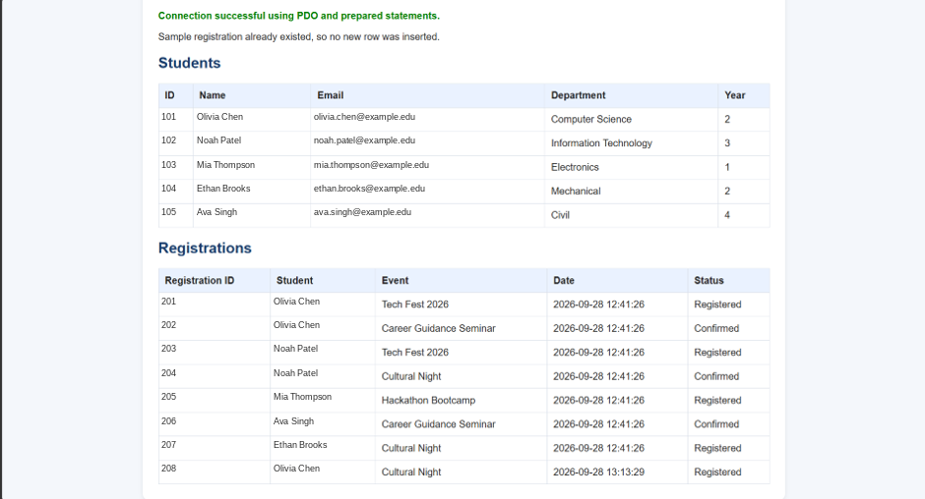

Practical 10:
File: admin.php
Code:
<?php
require __DIR__ . '/auth.php';
requireRole('admin');
?>
<!doctype html>
<html lang="en"><head><meta charset="utf-8"><meta name="viewport" content="width=device-width, initial-scale=1"><title>Admin dashboard</title><link rel="stylesheet" href="style.css"></head>
<body><main><h1>Admin Dashboard</h1><p>Welcome, <?= h($_SESSION['username']) ?>.</p><p>Last login: <?= h((string)($_SESSION['last_login'] ?? 'See database')) ?></p><form method="post" action="logout.php"><input type="hidden" name="csrf" value="<?= h(csrfToken()) ?>"><button>Sign out</button></form></main></body></html>

File: auth.php
Code:
<?php
declare(strict_types=1);
require_once __DIR__ . '/db.php';
ini_set('session.use_strict_mode', '1');
session_name('PRACTICAL10');
session_set_cookie_params([
'lifetime' => 0,
'path' => '/',
'secure' => isset($_SERVER['HTTPS']) && $_SERVER['HTTPS'] !== 'off',
'httponly' => true,
'samesite' => 'Strict',
]);
session_start();
function csrfToken(): string
{
return $_SESSION['csrf'] ??= bin2hex(random_bytes(32));
}
function validCsrf(): bool
{
return hash_equals(csrfToken(), (string)($_POST['csrf'] ?? ''));
}
function cookieOptions(int $expires): array
{
return [
'expires' => $expires,
'path' => '/',
'secure' => isset($_SERVER['HTTPS']) && $_SERVER['HTTPS'] !== 'off',
'httponly' => true,
'samesite' => 'Strict',
];
}
function issueRememberToken(mysqli $db, int $userId): void
{
$selector = bin2hex(random_bytes(16));
$validator = bin2hex(random_bytes(32));
$hash = hash('sha256', $validator);
$expires = time() + 30 * 24 * 60 * 60;
$date = date('Y-m-d H:i:s', $expires);
$stmt = $db->prepare('UPDATE users SET remember_selector = ?, remember_hash = ?, remember_expires = ? WHERE id = ?');
$stmt->bind_param('sssi', $selector, $hash, $date, $userId);
$stmt->execute();
setcookie('remember_login', $selector . '.' . $validator, cookieOptions($expires));
}
function forgetRemember(mysqli $db, ?int $userId = null): void
{
if ($userId !== null) {
$stmt = $db->prepare('UPDATE users SET remember_selector = NULL, remember_hash = NULL, remember_expires = NULL WHERE id = ?');
$stmt->bind_param('i', $userId);
$stmt->execute();
}
setcookie('remember_login', '', cookieOptions(time() - 3600));
}
function logoutUser(mysqli $db): void
{
forgetRemember($db, isset($_SESSION['uid']) ? (int)$_SESSION['uid'] : null);
$_SESSION = [];
$cookie = session_get_cookie_params();
setcookie(session_name(), '', [
'expires' => time() - 3600,
'path' => $cookie['path'],
'secure' => $cookie['secure'],
'httponly' => $cookie['httponly'],
'samesite' => $cookie['samesite'],
]);
session_destroy();
}
function restoreRemember(mysqli $db): bool
{
$parts = explode('.', (string)($_COOKIE['remember_login'] ?? ''), 2);
if (count($parts) !== 2 || !ctype_xdigit($parts[0]) || !ctype_xdigit($parts[1])) {
return false;
}
$stmt = $db->prepare('SELECT id, username, role, remember_hash FROM users WHERE remember_selector = ? AND remember_expires > NOW()');
$stmt->bind_param('s', $parts[0]);
$stmt->execute();
$user = $stmt->get_result()->fetch_assoc();
if (!$user || !hash_equals($user['remember_hash'], hash('sha256', $parts[1]))) {
return false;
}
session_regenerate_id(true);
$_SESSION['uid'] = (int)$user['id'];
$_SESSION['username'] = $user['username'];
$_SESSION['role'] = $user['role'];
$_SESSION['last_activity'] = time();
$update = $db->prepare('UPDATE users SET last_login = NOW() WHERE id = ?');
$update->bind_param('i', $user['id']);
$update->execute();
$_SESSION['last_login'] = date('Y-m-d H:i:s');
issueRememberToken($db, (int)$user['id']);
return true;
}
function redirectByRole(): void
{
header('Location: ' . (($_SESSION['role'] ?? '') === 'admin' ? 'admin.php' : 'student.php'));
exit;
}
function requireRole(string $role): void
{
global $db;
if (!isset($_SESSION['uid']) && !restoreRemember($db)) {
header('Location: login.php');
exit;
}
if (time() - (int)($_SESSION['last_activity'] ?? 0) > 900) {
logoutUser($db);
header('Location: login.php?timeout=1');
exit;
}
if ($_SESSION['role'] !== $role) {
redirectByRole();
}
$_SESSION['last_activity'] = time();
}
function h(string $value): string
{
return htmlspecialchars($value, ENT_QUOTES | ENT_SUBSTITUTE, 'UTF-8');
}

File: db.php
Code:
<?php
declare(strict_types=1);
mysqli_report(MYSQLI_REPORT_ERROR | MYSQLI_REPORT_STRICT);
$db = new mysqli('127.0.0.1', 'root', '', 'practical10');
$db->set_charset('utf8mb4');

File: index.php
Code:
<?php
header('Location: login.php');
exit;

File: login.php
Code:
<?php
require __DIR__ . '/auth.php';
if (isset($_SESSION['uid'])) {
redirectByRole();
}
$message = isset($_GET['timeout']) ? 'Session expired. Please sign in again.' : '';
$username = '';
if ($_SERVER['REQUEST_METHOD'] === 'POST') {
$username = trim((string)($_POST['username'] ?? ''));
$password = (string)($_POST['password'] ?? '');
if (!validCsrf()) {
$message = 'Invalid request. Refresh and try again.';
} else {
$stmt = $db->prepare('SELECT id, username, password_hash, role FROM users WHERE username = ?');
$stmt->bind_param('s', $username);
$stmt->execute();
$user = $stmt->get_result()->fetch_assoc();
if (!$user || !password_verify($password, $user['password_hash'])) {
$message = 'Invalid username or password.';
} else {
session_regenerate_id(true);
$_SESSION['uid'] = (int)$user['id'];
$_SESSION['username'] = $user['username'];
$_SESSION['role'] = $user['role'];
$_SESSION['last_activity'] = time();
$_SESSION['csrf'] = bin2hex(random_bytes(32));
$update = $db->prepare('UPDATE users SET last_login = NOW() WHERE id = ?');
$update->bind_param('i', $_SESSION['uid']);
$update->execute();
$_SESSION['last_login'] = date('Y-m-d H:i:s');
if (isset($_POST['remember'])) {
issueRememberToken($db, $_SESSION['uid']);
} else {
forgetRemember($db, $_SESSION['uid']);
}
redirectByRole();
}
}
}
?>
<!doctype html>
<html lang="en">
<head>
<meta charset="utf-8">
<meta name="viewport" content="width=device-width, initial-scale=1">
<title>Practical 10 | Sign in</title>
<link rel="stylesheet" href="style.css">
</head>
<body>
<main>
<h1>Sign in</h1>
<?php if ($message !== ''): ?><p class="message" id="login-message"><?= h($message) ?></p><?php endif; ?>
<?php if (isset($_GET['logout'])): ?><p class="message">You have signed out.</p><?php endif; ?>
<form method="post">
<input type="hidden" name="csrf" value="<?= h(csrfToken()) ?>">
<label>Username<input name="username" value="<?= h($username) ?>" required autocomplete="username"></label>
<label>Password<input type="password" name="password" required autocomplete="current-password"></label>
<label class="check"><input type="checkbox" name="remember" value="1"> Remember me</label>
<button>Sign in</button>
</form>
</main>
<script>
document.querySelectorAll('input[name="username"], input[name="password"]').forEach((input) => {
input.addEventListener('input', () => document.getElementById('login-message')?.remove());
});
</script>
</body>
</html>

File: logout.php
Code:
<?php
require __DIR__ . '/auth.php';
if ($_SERVER['REQUEST_METHOD'] !== 'POST' || !validCsrf()) {
http_response_code(400);
exit('Invalid request.');
}
logoutUser($db);
header('Location: login.php?logout=1');
exit;

File: schema.sql
Code:
CREATE DATABASE IF NOT EXISTS practical10 CHARACTER SET utf8mb4 COLLATE utf8mb4_unicode_ci;
USE practical10;
CREATE TABLE IF NOT EXISTS users (
id INT AUTO_INCREMENT PRIMARY KEY,
username VARCHAR(50) NOT NULL UNIQUE,
password_hash VARCHAR(255) NOT NULL,
role ENUM('admin', 'student') NOT NULL,
last_login DATETIME NULL,
remember_selector CHAR(32) NULL UNIQUE,
remember_hash CHAR(64) NULL,
remember_expires DATETIME NULL
);
INSERT INTO users (username, password_hash, role) VALUES
('admin', '$2y$10$W/qM1DnZDtOGcw6WwvICIeY/CJtabHs7OhT7OlhTW79T7gAnZ5xly', 'admin'),
('student', '$2y$10$cLu6afL/JAARKJO4oUpt4..H8ONZ5IagMXAJRsGKC8/JDU7GpLkuK', 'student')
ON DUPLICATE KEY UPDATE password_hash = VALUES(password_hash), role = VALUES(role);

File: student.php
Code:
<?php
require __DIR__ . '/auth.php';
requireRole('student');
?>
<!doctype html>
<html lang="en"><head><meta charset="utf-8"><meta name="viewport" content="width=device-width, initial-scale=1"><title>Student dashboard</title><link rel="stylesheet" href="style.css"></head>
<body><main><h1>Student Dashboard</h1><p>Welcome, <?= h($_SESSION['username']) ?>.</p><form method="post" action="logout.php"><input type="hidden" name="csrf" value="<?= h(csrfToken()) ?>"><button>Sign out</button></form></main></body></html>

File: style.css
Code:
* { box-sizing: border-box; }
body { min-height: 100vh; margin: 0; display: grid; place-items: center; padding: 20px; background: #e8f0ed; color: #18333a; font: 16px Arial, sans-serif; }
main { width: min(100%, 420px); padding: 32px; background: #fff; border-top: 5px solid #17685e; box-shadow: 0 10px 30px #18333a18; }
h1 { margin-top: 0; font-family: Georgia, serif; }
form, label { display: grid; gap: 12px; }
label { gap: 6px; font-weight: 700; }
input:not([type=checkbox]) { width: 100%; padding: 11px; border: 1px solid #bdccca; font: inherit; }
.check { display: flex; align-items: center; font-weight: 400; }
button { padding: 12px; border: 0; background: #17685e; color: white; font-weight: 700; cursor: pointer; }
.message { padding: 10px; background: #fff1ed; color: #96352c; }
Output:
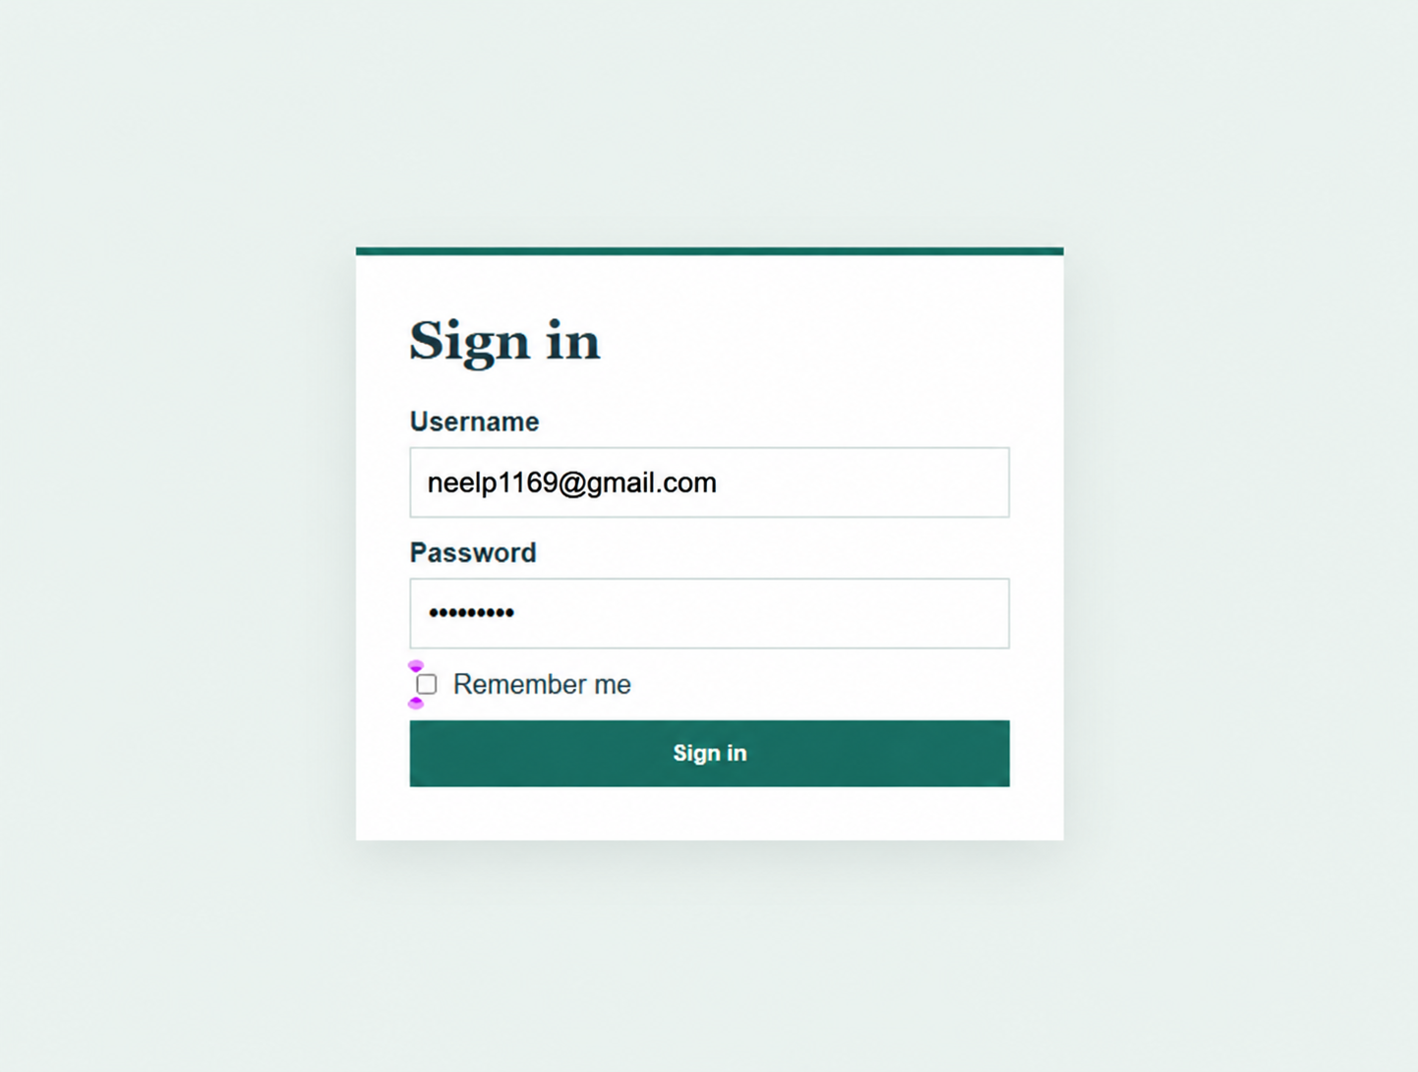

Practical 11:
File: db.php
Code:
<?php
// Database connection using MySQLi
$host = "127.0.0.1";
$user = "root";
$pass = "";
$dbname = "practical11";
$conn = new mysqli($host, $user, $pass, $dbname);
if ($conn->connect_error) {
die("Connection failed: " . $conn->connect_error);
}
$conn->set_charset("utf8mb4");
?>

File: index.php
Code:
<?php
require_once __DIR__ . '/db.php';
$message = '';
$message_type = '';
// ==========================================
// 1. INTERMEDIATE EXTENSION: Export to CSV
// ==========================================
if (isset($_GET['export']) && $_GET['export'] === 'csv') {
$search = trim($_GET['search'] ?? '');
$course = trim($_GET['course'] ?? '');
$sql = "SELECT id, student_code, first_name, last_name, email, phone, course, status, created_at FROM students WHERE 1=1";
$types = "";
$params = [];
if ($search !== '') {
$sql .= " AND (first_name LIKE ? OR last_name LIKE ? OR email LIKE ? OR course LIKE ?)";
$searchTerm = "%$search%";
$types .= "ssss";
$params[] = $searchTerm;
$params[] = $searchTerm;
$params[] = $searchTerm;
$params[] = $searchTerm;
}
if ($course !== '') {
$sql .= " AND course = ?";
$types .= "s";
$params[] = $course;
}
$stmt = $conn->prepare($sql);
if (!empty($params)) {
$stmt->bind_param($types, ...$params);
}
$stmt->execute();
$result = $stmt->get_result();
header('Content-Type: text/csv');
header('Content-Disposition: attachment; filename="students_list.csv"');
$output = fopen('php://output', 'w');
fputcsv($output, ['ID', 'Student Code', 'First Name', 'Last Name', 'Email', 'Phone', 'Course', 'Status', 'Date Added']);
while ($row = $result->fetch_assoc()) {
fputcsv($output, $row);
}
fclose($output);
exit;
}
// ==========================================
// 2. DELETE (Permanent Delete)
// ==========================================
if (isset($_GET['delete'])) {
$id = (int)$_GET['delete'];
$stmt = $conn->prepare("DELETE FROM students WHERE id = ?");
$stmt->bind_param("i", $id);
if ($stmt->execute()) {
$message = "Student record deleted successfully.";
$message_type = "success";
} else {
$message = "Error deleting student: " . $conn->error;
$message_type = "danger";
}
$stmt->close();
}
// ==========================================
// 3. ADVANCED EXTENSION: Soft Delete & Restore
// ==========================================
if (isset($_GET['soft_delete'])) {
$id = (int)$_GET['soft_delete'];
$stmt = $conn->prepare("UPDATE students SET status = 'Deleted' WHERE id = ?");
$stmt->bind_param("i", $id);
if ($stmt->execute()) {
$message = "Student marked as Deleted (Soft Delete).";
$message_type = "success";
}
$stmt->close();
}
if (isset($_GET['restore'])) {
$id = (int)$_GET['restore'];
$stmt = $conn->prepare("UPDATE students SET status = 'Active' WHERE id = ?");
$stmt->bind_param("i", $id);
if ($stmt->execute()) {
$message = "Student restored to Active status.";
$message_type = "success";
}
$stmt->close();
}
// ==========================================
// 4. INSERT (Add Student)
// ==========================================
if ($_SERVER['REQUEST_METHOD'] === 'POST' && isset($_POST['add_student'])) {
$code = trim($_POST['student_code']);
$first_name = trim($_POST['first_name']);
$last_name = trim($_POST['last_name']);
$email = trim($_POST['email']);
$phone = trim($_POST['phone']);
$course = trim($_POST['course']);
$status = trim($_POST['status'] ?? 'Active');
if ($code !== '' && $first_name !== '' && $last_name !== '' && $email !== '' && $course !== '') {
$stmt = $conn->prepare("INSERT INTO students (student_code, first_name, last_name, email, phone, course, status) VALUES (?, ?, ?, ?, ?, ?, ?)");
$stmt->bind_param("sssssss", $code, $first_name, $last_name, $email, $phone, $course, $status);
if ($stmt->execute()) {
$message = "Student '$first_name $last_name' added successfully!";
$message_type = "success";
} else {
$message = "Failed to add student: " . $conn->error;
$message_type = "danger";
}
$stmt->close();
} else {
$message = "Please fill in all required fields.";
$message_type = "danger";
}
}
// ==========================================
// 5. UPDATE (Edit Student)
// ==========================================
if ($_SERVER['REQUEST_METHOD'] === 'POST' && isset($_POST['update_student'])) {
$id = (int)$_POST['id'];
$code = trim($_POST['student_code']);
$first_name = trim($_POST['first_name']);
$last_name = trim($_POST['last_name']);
$email = trim($_POST['email']);
$phone = trim($_POST['phone']);
$course = trim($_POST['course']);
$status = trim($_POST['status']);
$stmt = $conn->prepare("UPDATE students SET student_code = ?, first_name = ?, last_name = ?, email = ?, phone = ?, course = ?, status = ? WHERE id = ?");
$stmt->bind_param("sssssssi", $code, $first_name, $last_name, $email, $phone, $course, $status, $id);
if ($stmt->execute()) {
$message = "Student details updated successfully!";
$message_type = "success";
} else {
$message = "Failed to update student: " . $conn->error;
$message_type = "danger";
}
$stmt->close();
}
// ==========================================
// 6. FETCH STUDENT FOR EDITING (if requested)
// ==========================================
$edit_student = null;
if (isset($_GET['edit'])) {
$edit_id = (int)$_GET['edit'];
$stmt = $conn->prepare("SELECT * FROM students WHERE id = ?");
$stmt->bind_param("i", $edit_id);
$stmt->execute();
$edit_student = $stmt->get_result()->fetch_assoc();
$stmt->close();
}
// ==========================================
// 7. SEARCH & FILTER (SELECT Students)
// ==========================================
$search = trim($_GET['search'] ?? '');
$course = trim($_GET['course'] ?? '');
$status_filter = trim($_GET['status'] ?? 'All');
$sql = "SELECT * FROM students WHERE 1=1";
$types = "";
$params = [];
if ($search !== '') {
$sql .= " AND (first_name LIKE ? OR last_name LIKE ? OR email LIKE ? OR course LIKE ?)";
$searchTerm = "%$search%";
$types .= "ssss";
$params[] = $searchTerm;
$params[] = $searchTerm;
$params[] = $searchTerm;
$params[] = $searchTerm;
}
if ($course !== '') {
$sql .= " AND course = ?";
$types .= "s";
$params[] = $course;
}
if ($status_filter !== '' && $status_filter !== 'All') {
$sql .= " AND status = ?";
$types .= "s";
$params[] = $status_filter;
}
$sql .= " ORDER BY id DESC";
$stmt = $conn->prepare($sql);
if (!empty($params)) {
$stmt->bind_param($types, ...$params);
}
$stmt->execute();
$students = $stmt->get_result();
// Get list of courses for dropdown
$courses_result = $conn->query("SELECT DISTINCT course FROM students ORDER BY course ASC");
?>
<!DOCTYPE html>
<html lang="en">
<head>
<meta charset="UTF-8">
<meta name="viewport" content="width=device-width, initial-scale=1.0">
<title>Practical 11: Student Management CRUD</title>
<link rel="stylesheet" href="style.css">
</head>
<body>
<div class="container">
<h1>Student Management System</h1>
<!-- Feedback Message -->
<?php if ($message !== ''): ?>
<div class="alert alert-<?= $message_type ?>">
<?= htmlspecialchars($message) ?>
</div>
<?php endif; ?>
<!-- Student Form: Add or Edit -->
<div class="card">
<h2><?= $edit_student ? 'Edit Student' : 'Add New Student' ?></h2>
<form method="POST" action="index.php">
<?php if ($edit_student): ?>
<input type="hidden" name="id" value="<?= $edit_student['id'] ?>">
<?php endif; ?>
<div class="form-row">
<div class="form-group">
<label>Student Code *</label>
<input type="text" name="student_code" required value="<?= htmlspecialchars($edit_student['student_code'] ?? '') ?>" placeholder="e.g. STU001">
</div>
<div class="form-group">
<label>First Name *</label>
<input type="text" name="first_name" required value="<?= htmlspecialchars($edit_student['first_name'] ?? '') ?>" placeholder="First Name">
</div>
<div class="form-group">
<label>Last Name *</label>
<input type="text" name="last_name" required value="<?= htmlspecialchars($edit_student['last_name'] ?? '') ?>" placeholder="Last Name">
</div>
</div>
<div class="form-row">
<div class="form-group">
<label>Email *</label>
<input type="email" name="email" required value="<?= htmlspecialchars($edit_student['email'] ?? '') ?>" placeholder="email@example.com">
</div>
<div class="form-group">
<label>Phone *</label>
<input type="text" name="phone" required value="<?= htmlspecialchars($edit_student['phone'] ?? '') ?>" placeholder="Phone number">
</div>
<div class="form-group">
<label>Course *</label>
<input type="text" name="course" required value="<?= htmlspecialchars($edit_student['course'] ?? '') ?>" placeholder="e.g. Computer Science">
</div>
<div class="form-group">
<label>Status</label>
<select name="status">
<option value="Active" <?= (($edit_student['status'] ?? '') === 'Active') ? 'selected' : '' ?>>Active</option>
<option value="Inactive" <?= (($edit_student['status'] ?? '') === 'Inactive') ? 'selected' : '' ?>>Inactive</option>
<option value="Deleted" <?= (($edit_student['status'] ?? '') === 'Deleted') ? 'selected' : '' ?>>Deleted</option>
</select>
</div>
</div>
<div>
<?php if ($edit_student): ?>
<button type="submit" name="update_student" class="btn btn-primary">Update Student</button>
<a href="index.php" class="btn btn-secondary">Cancel</a>
<?php else: ?>
<button type="submit" name="add_student" class="btn btn-success">+ Add Student</button>
<?php endif; ?>
</div>
</form>
</div>
<!-- Search & Filter Card -->
<div class="card">
<h2>Search and Filter</h2>
<form method="GET" action="index.php" class="filter-bar">
<input type="text" name="search" placeholder="Search by name, email, or course..." value="<?= htmlspecialchars($search) ?>">
<select name="course">
<option value="">All Courses</option>
<?php while ($c = $courses_result->fetch_assoc()): ?>
<option value="<?= htmlspecialchars($c['course']) ?>" <?= ($course === $c['course']) ? 'selected' : '' ?>>
<?= htmlspecialchars($c['course']) ?>
</option>
<?php endwhile; ?>
</select>
<select name="status">
<option value="All" <?= ($status_filter === 'All') ? 'selected' : '' ?>>All Statuses</option>
<option value="Active" <?= ($status_filter === 'Active') ? 'selected' : '' ?>>Active Only</option>
<option value="Inactive" <?= ($status_filter === 'Inactive') ? 'selected' : '' ?>>Inactive Only</option>
<option value="Deleted" <?= ($status_filter === 'Deleted') ? 'selected' : '' ?>>Deleted Only</option>
</select>
<button type="submit" class="btn btn-primary btn-sm">Search / Filter</button>
<a href="index.php" class="btn btn-secondary btn-sm">Reset</a>
<a href="index.php?export=csv<?= ($search ? '&search=' . urlencode($search) : '') ?><?= ($course ? '&course=' . urlencode($course) : '') ?>" class="btn btn-warning btn-sm" style="margin-left: auto;">Export to CSV</a>
</form>
</div>
<!-- Students Records Table -->
<div class="card">
<h2>Student Records (<?= $students->num_rows ?> Found)</h2>
<div class="table-responsive">
<table>
<thead>
<tr>
<th>ID</th>
<th>Code</th>
<th>Name</th>
<th>Email</th>
<th>Phone</th>
<th>Course</th>
<th>Status</th>
<th>Actions</th>
</tr>
</thead>
<tbody>
<?php if ($students->num_rows === 0): ?>
<tr>
<td colspan="8" style="text-align: center; color: #6b7280; padding: 20px;">
No student records found.
</td>
</tr>
<?php else: ?>
<?php while ($row = $students->fetch_assoc()): ?>
<tr>
<td><?= $row['id'] ?></td>
<td><strong><?= htmlspecialchars($row['student_code']) ?></strong></td>
<td><?= htmlspecialchars($row['first_name'] . ' ' . $row['last_name']) ?></td>
<td><?= htmlspecialchars($row['email']) ?></td>
<td><?= htmlspecialchars($row['phone']) ?></td>
<td><?= htmlspecialchars($row['course']) ?></td>
<td>
<span class="badge badge-<?= strtolower($row['status']) ?>">
<?= htmlspecialchars($row['status']) ?>
</span>
</td>
<td class="actions-cell">
<!-- Edit -->
<a href="index.php?edit=<?= $row['id'] ?>" class="btn btn-primary btn-sm">Edit</a>
<!-- Soft Delete / Restore -->
<?php if ($row['status'] !== 'Deleted'): ?>
<a href="index.php?soft_delete=<?= $row['id'] ?>" class="btn btn-warning btn-sm" onclick="return confirm('Mark this student as deleted (Soft Delete)?');">Soft Delete</a>
<?php else: ?>
<a href="index.php?restore=<?= $row['id'] ?>" class="btn btn-success btn-sm">Restore</a>
<?php endif; ?>
<!-- Permanent Delete -->
<a href="index.php?delete=<?= $row['id'] ?>" class="btn btn-danger btn-sm" onclick="return confirm('Are you sure you want to permanently delete this student record?');">Delete</a>
</td>
</tr>
<?php endwhile; ?>
<?php endif; ?>
</tbody>
</table>
</div>
</div>
</div>
</body>
</html>

File: schema.sql
Code:
-- Practical 11: Student Management CRUD with Search and Filter
-- Database Schema and Seed Data
CREATE DATABASE IF NOT EXISTS practical11 CHARACTER SET utf8mb4 COLLATE utf8mb4_unicode_ci;
USE practical11;
DROP TABLE IF EXISTS students;
CREATE TABLE IF NOT EXISTS students (
id INT AUTO_INCREMENT PRIMARY KEY,
student_code VARCHAR(20) NOT NULL UNIQUE,
first_name VARCHAR(50) NOT NULL,
last_name VARCHAR(50) NOT NULL,
email VARCHAR(100) NOT NULL UNIQUE,
phone VARCHAR(20) NOT NULL,
gender ENUM('Male', 'Female', 'Other') NOT NULL DEFAULT 'Male',
course VARCHAR(60) NOT NULL,
department VARCHAR(60) NOT NULL,
year_of_study TINYINT UNSIGNED NOT NULL DEFAULT 1,
gpa DECIMAL(3,2) NOT NULL DEFAULT 3.00,
status ENUM('Active', 'Inactive', 'Deleted') NOT NULL DEFAULT 'Active',
created_at TIMESTAMP DEFAULT CURRENT_TIMESTAMP,
updated_at TIMESTAMP DEFAULT CURRENT_TIMESTAMP ON UPDATE CURRENT_TIMESTAMP,
INDEX idx_status (status),
INDEX idx_course (course),
INDEX idx_email (email),
INDEX idx_name (first_name, last_name)
) ENGINE=InnoDB DEFAULT CHARSET=utf8mb4 COLLATE=utf8mb4_unicode_ci;
-- Seed Data (25 Realistic Student Records)
INSERT INTO students (student_code, first_name, last_name, email, phone, gender, course, department, year_of_study, gpa, status) VALUES
('STU2026001', 'Aarav', 'Patel', 'aarav.patel@studenthub.edu', '+91 9876543210', 'Male', 'Computer Science', 'Computer Engineering', 3, 3.85, 'Active'),
('STU2026002', 'Meera', 'Sharma', 'meera.sharma@studenthub.edu', '+91 9876543211', 'Female', 'Data Science', 'Computer Engineering', 2, 3.92, 'Active'),
('STU2026003', 'Rohit', 'Verma', 'rohit.verma@studenthub.edu', '+91 9876543212', 'Male', 'Cyber Security', 'Information Technology', 4, 3.65, 'Active'),
('STU2026004', 'Sana', 'Iqbal', 'sana.iqbal@studenthub.edu', '+91 9876543213', 'Female', 'Artificial Intelligence', 'Computer Engineering', 3, 3.98, 'Active'),
('STU2026005', 'Karan', 'Singh', 'karan.singh@studenthub.edu', '+91 9876543214', 'Male', 'Information Technology', 'Information Technology', 1, 3.40, 'Active'),
('STU2026006', 'Diya', 'Joshi', 'diya.joshi@studenthub.edu', '+91 9876543215', 'Female', 'Computer Science', 'Computer Engineering', 2, 3.78, 'Active'),
('STU2026007', 'Aditya', 'Deshmukh', 'aditya.deshmukh@studenthub.edu', '+91 9876543216', 'Male', 'Data Science', 'Computer Engineering', 3, 3.55, 'Inactive'),
('STU2026008', 'Ananya', 'Rao', 'ananya.rao@studenthub.edu', '+91 9876543217', 'Female', 'Cloud Computing', 'Information Technology', 4, 3.88, 'Active'),
('STU2026009', 'Varun', 'Nair', 'varun.nair@studenthub.edu', '+91 9876543218', 'Male', 'Cyber Security', 'Information Technology', 2, 3.25, 'Active'),
('STU2026010', 'Ishita', 'Gupta', 'ishita.gupta@studenthub.edu', '+91 9876543219', 'Female', 'Artificial Intelligence', 'Computer Engineering', 1, 3.70, 'Active'),
('STU2026011', 'Kabir', 'Mehta', 'kabir.mehta@studenthub.edu', '+91 9876543220', 'Male', 'Computer Science', 'Computer Engineering', 3, 3.60, 'Active'),
('STU2026012', 'Rhea', 'Menon', 'rhea.menon@studenthub.edu', '+91 9876543221', 'Female', 'Information Technology', 'Information Technology', 2, 3.82, 'Active'),
('STU2026013', 'Dev', 'Chopra', 'dev.chopra@studenthub.edu', '+91 9876543222', 'Male', 'Data Science', 'Computer Engineering', 4, 3.45, 'Active'),
('STU2026014', 'Pooja', 'Hegde', 'pooja.hegde@studenthub.edu', '+91 9876543223', 'Female', 'Cloud Computing', 'Information Technology', 1, 3.90, 'Active'),
('STU2026015', 'Siddharth', 'Bose', 'siddharth.bose@studenthub.edu', '+91 9876543224', 'Male', 'Computer Science', 'Computer Engineering', 2, 3.15, 'Inactive'),
('STU2026016', 'Tanvi', 'Shah', 'tanvi.shah@studenthub.edu', '+91 9876543225', 'Female', 'Cyber Security', 'Information Technology', 3, 3.75, 'Active'),
('STU2026017', 'Yash', 'Malhotra', 'yash.malhotra@studenthub.edu', '+91 9876543226', 'Male', 'Artificial Intelligence', 'Computer Engineering', 4, 3.95, 'Active'),
('STU2026018', 'Kavya', 'Reddy', 'kavya.reddy@studenthub.edu', '+91 9876543227', 'Female', 'Information Technology', 'Information Technology', 3, 3.62, 'Active'),
('STU2026019', 'Manish', 'Kulkarni', 'manish.kulkarni@studenthub.edu', '+91 9876543228', 'Male', 'Data Science', 'Computer Engineering', 1, 3.30, 'Active'),
('STU2026020', 'Neha', 'Pandey', 'neha.pandey@studenthub.edu', '+91 9876543229', 'Female', 'Computer Science', 'Computer Engineering', 2, 3.89, 'Active'),
('STU2026021', 'Arjun', 'Venkatesh', 'arjun.v@studenthub.edu', '+91 9876543230', 'Male', 'Cyber Security', 'Information Technology', 4, 3.52, 'Active'),
('STU2026022', 'Simran', 'Kaur', 'simran.kaur@studenthub.edu', '+91 9876543231', 'Female', 'Artificial Intelligence', 'Computer Engineering', 2, 3.80, 'Active'),
('STU2026023', 'Pranav', 'Bhat', 'pranav.bhat@studenthub.edu', '+91 9876543232', 'Male', 'Cloud Computing', 'Information Technology', 3, 3.48, 'Inactive'),
('STU2026024', 'Shreya', 'Ghosh', 'shreya.ghosh@studenthub.edu', '+91 9876543233', 'Female', 'Data Science', 'Computer Engineering', 1, 3.94, 'Active'),
('STU2026025', 'Nikhil', 'Saxena', 'nikhil.saxena@studenthub.edu', '+91 9876543234', 'Male', 'Computer Science', 'Computer Engineering', 3, 3.20, 'Deleted');

File: style.css
Code:
/* Simple & Clean Styling for Practical 11 */
* {
box-sizing: border-box;
margin: 0;
padding: 0;
}
body {
font-family: 'Segoe UI', Tahoma, Geneva, Verdana, sans-serif;
background-color: #f3f4f6;
color: #1f2937;
padding: 30px 20px;
}
.container {
max-width: 1100px;
margin: 0 auto;
}
h1 {
font-size: 26px;
color: #1e3a8a;
margin-bottom: 20px;
text-align: center;
}
h2 {
font-size: 18px;
color: #374151;
margin-bottom: 15px;
border-bottom: 2px solid #e5e7eb;
padding-bottom: 8px;
}
/* Alert Messages */
.alert {
padding: 12px 16px;
border-radius: 6px;
margin-bottom: 20px;
font-weight: 500;
}
.alert-success {
background-color: #d1fae5;
color: #065f46;
border: 1px solid #a7f3d0;
}
.alert-danger {
background-color: #fee2e2;
color: #991b1b;
border: 1px solid #fecaca;
}
/* Card Box */
.card {
background: #ffffff;
border: 1px solid #e5e7eb;
border-radius: 8px;
padding: 20px;
margin-bottom: 25px;
box-shadow: 0 2px 6px rgba(0, 0, 0, 0.05);
}
/* Forms */
.form-row {
display: flex;
flex-wrap: wrap;
gap: 15px;
margin-bottom: 12px;
}
.form-group {
flex: 1 1 200px;
display: flex;
flex-direction: column;
}
.form-group label {
font-size: 13px;
font-weight: 600;
margin-bottom: 5px;
color: #4b5563;
}
.form-group input,
.form-group select {
padding: 9px 12px;
border: 1px solid #d1d5db;
border-radius: 6px;
font-size: 14px;
font-family: inherit;
}
.form-group input:focus,
.form-group select:focus {
outline: none;
border-color: #2563eb;
}
/* Buttons */
.btn {
display: inline-block;
padding: 8px 14px;
font-size: 13px;
font-weight: 600;
border-radius: 6px;
border: none;
cursor: pointer;
text-decoration: none;
text-align: center;
}
.btn-primary { background: #2563eb; color: #fff; }
.btn-primary:hover { background: #1d4ed8; }
.btn-secondary { background: #6b7280; color: #fff; }
.btn-secondary:hover { background: #4b5563; }
.btn-success { background: #10b981; color: #fff; }
.btn-success:hover { background: #059669; }
.btn-warning { background: #f59e0b; color: #fff; }
.btn-warning:hover { background: #d97706; }
.btn-danger { background: #ef4444; color: #fff; }
.btn-danger:hover { background: #dc2626; }
.btn-sm {
padding: 5px 8px;
font-size: 12px;
border-radius: 4px;
}
/* Search and Filter Form */
.filter-bar {
display: flex;
flex-wrap: wrap;
gap: 10px;
align-items: center;
}
.filter-bar input[type="text"] {
flex: 1 1 220px;
padding: 8px 12px;
border: 1px solid #d1d5db;
border-radius: 6px;
font-size: 14px;
}
.filter-bar select {
padding: 8px 12px;
border: 1px solid #d1d5db;
border-radius: 6px;
font-size: 14px;
}
/* Table */
.table-responsive {
overflow-x: auto;
}
table {
width: 100%;
border-collapse: collapse;
font-size: 14px;
margin-top: 10px;
}
th, td {
padding: 10px 12px;
border: 1px solid #e5e7eb;
text-align: left;
}
th {
background-color: #f9fafb;
font-weight: 600;
color: #374151;
}
tr:hover {
background-color: #f8fafc;
}
/* Status Badges */
.badge {
display: inline-block;
padding: 3px 8px;
font-size: 12px;
font-weight: 600;
border-radius: 12px;
}
.badge-active { background: #d1fae5; color: #065f46; }
.badge-inactive { background: #fef3c7; color: #92400e; }
.badge-deleted { background: #fee2e2; color: #991b1b; }
.actions-cell {
white-space: nowrap;
display: flex;
gap: 5px;
}

Output:
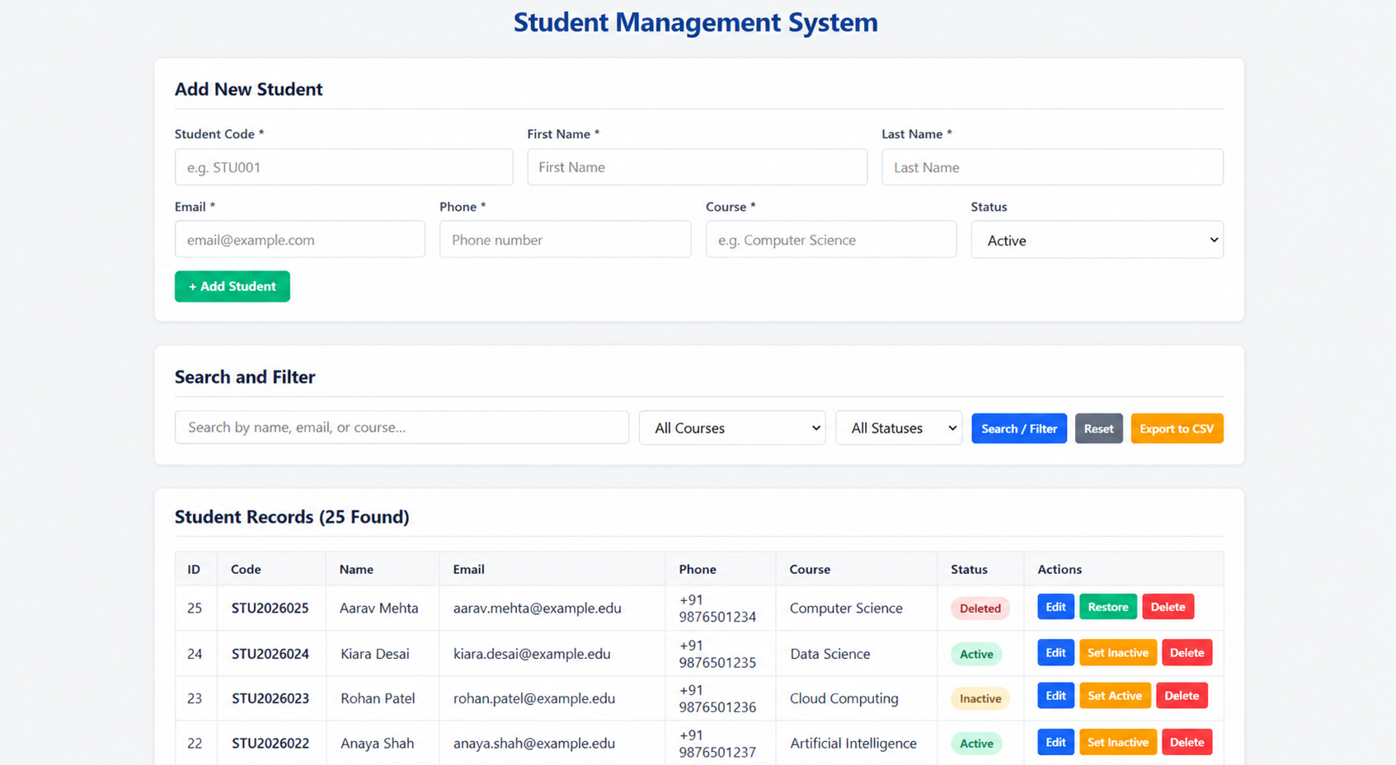

Practical 12:
File: db.php
Code:
<?php
// Database connection using MySQLi
$host = "127.0.0.1";
$user = "root";
$pass = "";
$dbname = "practical12";
$conn = new mysqli($host, $user, $pass, $dbname);
if ($conn->connect_error) {
die("Database connection failed: " . $conn->connect_error);
}
$conn->set_charset("utf8mb4");
// Helper function to log event actions (Advanced Extension: Audit Log)
function logAuditEvent($conn, $event_id, $action, $details) {
$stmt = $conn->prepare("INSERT INTO event_audit_log (event_id, action, details) VALUES (?, ?, ?)");
if ($stmt) {
$stmt->bind_param("iss", $event_id, $action, $details);
$stmt->execute();
$stmt->close();
}
}
?>

File: index.php
Code:
<?php
require_once __DIR__ . '/db.php';
$message = '';
$message_type = '';
$upload_dir = __DIR__ . '/uploads/';
if (!is_dir($upload_dir)) {
mkdir($upload_dir, 0755, true);
}
// ========================================================
// POSTER VALIDATION & UPLOAD FUNCTION
// Validates: File presence, upload error, file size, MIME type, extension
// Advanced Extension: Safe image renaming
// ========================================================
function validateAndUploadPoster(array $file, string $upload_dir, string &$error): string|null|false
{
// If no file was selected
if (!isset($file['error']) || $file['error'] === UPLOAD_ERR_NO_FILE) {
return null;
}
if ($file['error'] !== UPLOAD_ERR_OK) {
$error = "File upload failed with error code: " . $file['error'];
return false;
}
// 1. File Size Validation (Max 2MB)
$max_size = 2 * 1024 * 1024; // 2MB
if ($file['size'] > $max_size) {
$fileSizeMB = round($file['size'] / (1024 * 1024), 2);
$error = "Poster size ($fileSizeMB MB) exceeds maximum allowed size of 2MB.";
return false;
}
// 2. MIME Type Validation
$allowed_mimes = ['image/jpeg', 'image/png', 'image/webp'];
$finfo = finfo_open(FILEINFO_MIME_TYPE);
$mime = finfo_file($finfo, $file['tmp_name']);
finfo_close($finfo);
if (!in_array($mime, $allowed_mimes, true)) {
$error = "Invalid file type ($mime). Only JPG, PNG, and WEBP images are allowed.";
return false;
}
// 3. Extension Validation
$ext = strtolower(pathinfo($file['name'], PATHINFO_EXTENSION));
$allowed_exts = ['jpg', 'jpeg', 'png', 'webp'];
if (!in_array($ext, $allowed_exts, true)) {
$error = "Invalid file extension (.$ext). Only JPG, PNG, and WEBP files are allowed.";
return false;
}
// 4. Advanced Extension: Safe Image Renaming
$new_filename = 'poster_' . time() . '_' . bin2hex(random_bytes(4)) . '.' . $ext;
$destination = $upload_dir . $new_filename;
if (move_uploaded_file($file['tmp_name'], $destination)) {
return $new_filename;
} else {
$error = "Failed to save uploaded poster file.";
return false;
}
}
// ========================================================
// 1. DELETE EVENT
// ========================================================
if (isset($_GET['delete'])) {
$id = (int)$_GET['delete'];
// Get event details and poster to remove file
$stmt = $conn->prepare("SELECT title, poster FROM events WHERE id = ?");
$stmt->bind_param("i", $id);
$stmt->execute();
$event = $stmt->get_result()->fetch_assoc();
$stmt->close();
if ($event) {
if (!empty($event['poster']) && file_exists($upload_dir . $event['poster'])) {
unlink($upload_dir . $event['poster']);
}
$del = $conn->prepare("DELETE FROM events WHERE id = ?");
$del->bind_param("i", $id);
if ($del->execute()) {
logAuditEvent($conn, $id, 'DELETED', "Event '{$event['title']}' (ID: $id) was deleted.");
$message = "Event '{$event['title']}' deleted successfully.";
$message_type = "success";
} else {
$message = "Error deleting event: " . $conn->error;
$message_type = "danger";
}
$del->close();
}
}
// ========================================================
// 2. TOGGLE STATUS (Open / Closed)
// ========================================================
if (isset($_GET['toggle_status'])) {
$id = (int)$_GET['toggle_status'];
$stmt = $conn->prepare("SELECT title, status FROM events WHERE id = ?");
$stmt->bind_param("i", $id);
$stmt->execute();
$event = $stmt->get_result()->fetch_assoc();
$stmt->close();
if ($event) {
$new_status = ($event['status'] === 'Open') ? 'Closed' : 'Open';
$up = $conn->prepare("UPDATE events SET status = ? WHERE id = ?");
$up->bind_param("si", $new_status, $id);
if ($up->execute()) {
logAuditEvent($conn, $id, 'UPDATED', "Status of '{$event['title']}' changed to $new_status.");
$message = "Event status updated to <strong>$new_status</strong>.";
$message_type = "success";
}
$up->close();
}
}
// ========================================================
// 3. INSERT (Add Event with Poster Upload)
// ========================================================
if ($_SERVER['REQUEST_METHOD'] === 'POST' && isset($_POST['add_event'])) {
$title = trim($_POST['title'] ?? '');
$category = trim($_POST['category'] ?? '');
$event_date = trim($_POST['event_date'] ?? '');
$venue = trim($_POST['venue'] ?? '');
$status = trim($_POST['status'] ?? 'Open');
$description = trim($_POST['description'] ?? '');
if ($title === '' || $category === '' || $event_date === '' || $venue === '') {
$message = "Please fill in all required fields (Title, Category, Date, Venue).";
$message_type = "danger";
} else {
$upload_error = '';
$poster_filename = validateAndUploadPoster($_FILES['poster'], $upload_dir, $upload_error);
if ($poster_filename === false) {
$message = $upload_error;
$message_type = "danger";
} else {
$stmt = $conn->prepare("INSERT INTO events (title, category, event_date, venue, poster, status, description) VALUES (?, ?, ?, ?, ?, ?, ?)");
$stmt->bind_param("sssssss", $title, $category, $event_date, $venue, $poster_filename, $status, $description);
if ($stmt->execute()) {
$new_id = $conn->insert_id;
logAuditEvent($conn, $new_id, 'CREATED', "Event '$title' was created with status $status.");
$message = "Event '<strong>$title</strong>' created successfully!";
$message_type = "success";
} else {
$message = "Failed to add event: " . $conn->error;
$message_type = "danger";
}
$stmt->close();
}
}
}
// ========================================================
// 4. UPDATE (Edit Event)
// ========================================================
if ($_SERVER['REQUEST_METHOD'] === 'POST' && isset($_POST['update_event'])) {
$id = (int)$_POST['id'];
$title = trim($_POST['title'] ?? '');
$category = trim($_POST['category'] ?? '');
$event_date = trim($_POST['event_date'] ?? '');
$venue = trim($_POST['venue'] ?? '');
$status = trim($_POST['status'] ?? 'Open');
$description = trim($_POST['description'] ?? '');
$old_poster = trim($_POST['old_poster'] ?? '');
if ($title === '' || $category === '' || $event_date === '' || $venue === '') {
$message = "Please fill in all required fields.";
$message_type = "danger";
} else {
$upload_error = '';
$new_poster = validateAndUploadPoster($_FILES['poster'], $upload_dir, $upload_error);
if ($new_poster === false) {
$message = $upload_error;
$message_type = "danger";
} else {
// Determine final poster file
$final_poster = $old_poster;
if ($new_poster !== null) {
// Remove old poster file if replacement succeeded
if (!empty($old_poster) && file_exists($upload_dir . $old_poster)) {
unlink($upload_dir . $old_poster);
}
$final_poster = $new_poster;
}
$stmt = $conn->prepare("UPDATE events SET title = ?, category = ?, event_date = ?, venue = ?, poster = ?, status = ?, description = ? WHERE id = ?");
$stmt->bind_param("sssssssi", $title, $category, $event_date, $venue, $final_poster, $status, $description, $id);
if ($stmt->execute()) {
logAuditEvent($conn, $id, 'UPDATED', "Event '$title' was updated.");
$message = "Event '<strong>$title</strong>' updated successfully!";
$message_type = "success";
} else {
$message = "Failed to update event: " . $conn->error;
$message_type = "danger";
}
$stmt->close();
}
}
}
// ========================================================
// 5. FETCH EVENT FOR EDITING (if requested)
// ========================================================
$edit_event = null;
if (isset($_GET['edit'])) {
$edit_id = (int)$_GET['edit'];
$stmt = $conn->prepare("SELECT * FROM events WHERE id = ?");
$stmt->bind_param("i", $edit_id);
$stmt->execute();
$edit_event = $stmt->get_result()->fetch_assoc();
$stmt->close();
}
// ========================================================
// 6. SEARCH & FILTER (SELECT Events) - Intermediate Extension
// ========================================================
$search = trim($_GET['search'] ?? '');
$filter_category = trim($_GET['category'] ?? '');
$filter_status = trim($_GET['status'] ?? 'All');
$sql = "SELECT * FROM events WHERE 1=1";
$types = "";
$params = [];
if ($search !== '') {
$sql .= " AND (title LIKE ? OR venue LIKE ? OR description LIKE ?)";
$term = "%$search%";
$types .= "sss";
$params[] = $term;
$params[] = $term;
$params[] = $term;
}
if ($filter_category !== '') {
$sql .= " AND category = ?";
$types .= "s";
$params[] = $filter_category;
}
if ($filter_status !== '' && $filter_status !== 'All') {
$sql .= " AND status = ?";
$types .= "s";
$params[] = $filter_status;
}
$sql .= " ORDER BY event_date ASC, id DESC";
$stmt = $conn->prepare($sql);
if (!empty($params)) {
$stmt->bind_param($types, ...$params);
}
$stmt->execute();
$events = $stmt->get_result();
// Get recent audit logs (Advanced Extension)
$audit_logs = $conn->query("SELECT * FROM event_audit_log ORDER BY id DESC LIMIT 5");
// Predefined categories
$categories = ['Technical', 'Workshop', 'Cultural', 'Sports', 'Seminar'];
?>
<!DOCTYPE html>
<html lang="en">
<head>
<meta charset="UTF-8">
<meta name="viewport" content="width=device-width, initial-scale=1.0">
<title>Practical 12: Event Management CRUD & Poster Upload</title>
<link rel="stylesheet" href="style.css">
</head>
<body>
<div class="container">
<h1>Event Management System</h1>
<!-- Feedback Alert Messages -->
<?php if ($message !== ''): ?>
<div class="alert alert-<?= $message_type ?>">
<?= $message ?>
</div>
<?php endif; ?>
<!-- Event Form (Add or Edit) -->
<div class="card">
<h2><?= $edit_event ? 'Edit Event Details' : 'Add New Event' ?></h2>
<form method="POST" action="index.php" enctype="multipart/form-data">
<?php if ($edit_event): ?>
<input type="hidden" name="id" value="<?= $edit_event['id'] ?>">
<input type="hidden" name="old_poster" value="<?= htmlspecialchars($edit_event['poster'] ?? '') ?>">
<?php endif; ?>
<div class="form-row">
<div class="form-group" style="flex: 2 1 300px;">
<label>Event Title *</label>
<input type="text" name="title" required value="<?= htmlspecialchars($edit_event['title'] ?? '') ?>" placeholder="e.g. Annual Tech Symposium">
</div>
<div class="form-group">
<label>Category *</label>
<select name="category" required>
<option value="">Select Category</option>
<?php foreach ($categories as $cat): ?>
<option value="<?= $cat ?>" <?= (($edit_event['category'] ?? '') === $cat) ? 'selected' : '' ?>><?= $cat ?></option>
<?php endforeach; ?>
</select>
</div>
<div class="form-group">
<label>Event Date *</label>
<input type="date" name="event_date" required value="<?= htmlspecialchars($edit_event['event_date'] ?? '') ?>">
</div>
</div>
<div class="form-row">
<div class="form-group" style="flex: 2 1 300px;">
<label>Venue / Location *</label>
<input type="text" name="venue" required value="<?= htmlspecialchars($edit_event['venue'] ?? '') ?>" placeholder="e.g. Main Auditorium">
</div>
<div class="form-group">
<label>Status</label>
<select name="status">
<option value="Open" <?= (($edit_event['status'] ?? '') === 'Open') ? 'selected' : '' ?>>Open</option>
<option value="Closed" <?= (($edit_event['status'] ?? '') === 'Closed') ? 'selected' : '' ?>>Closed</option>
</select>
</div>
<div class="form-group" style="flex: 2 1 300px;">
<label>Event Poster (JPG, PNG, WEBP - Max 2MB)</label>
<input type="file" name="poster" accept=".jpg,.jpeg,.png,.webp">
<div class="file-hint">Allowed: JPG, PNG, WEBP. Maximum size: 2MB.</div>
<?php if ($edit_event && !empty($edit_event['poster']) && file_exists($upload_dir . $edit_event['poster'])): ?>
<div class="current-poster-preview">
<img src="uploads/<?= htmlspecialchars($edit_event['poster']) ?>" alt="Current Poster" class="poster-thumb">
<div>
<small><strong>Current Poster:</strong> <?= htmlspecialchars($edit_event['poster']) ?></small><br>
<small style="color: #6b7280;">Upload a new image to replace it, or leave blank to keep current.</small>
</div>
</div>
<?php endif; ?>
</div>
</div>
<div class="form-row">
<div class="form-group full">
<label>Description</label>
<textarea name="description" placeholder="Brief event summary and agenda..."><?= htmlspecialchars($edit_event['description'] ?? '') ?></textarea>
</div>
</div>
<div>
<?php if ($edit_event): ?>
<button type="submit" name="update_event" class="btn btn-primary">Update Event</button>
<a href="index.php" class="btn btn-secondary">Cancel</a>
<?php else: ?>
<button type="submit" name="add_event" class="btn btn-success">+ Add Event</button>
<?php endif; ?>
</div>
</form>
</div>
<!-- Search & Filter Card (Intermediate Extension) -->
<div class="card">
<h2>Search & Filter Events</h2>
<form method="GET" action="index.php" class="filter-bar">
<input type="text" name="search" placeholder="Search by title, venue, or description..." value="<?= htmlspecialchars($search) ?>">
<select name="category">
<option value="">All Categories</option>
<?php foreach ($categories as $cat): ?>
<option value="<?= $cat ?>" <?= ($filter_category === $cat) ? 'selected' : '' ?>><?= $cat ?></option>
<?php endforeach; ?>
</select>
<select name="status">
<option value="All" <?= ($filter_status === 'All') ? 'selected' : '' ?>>All Statuses</option>
<option value="Open" <?= ($filter_status === 'Open') ? 'selected' : '' ?>>Open Only</option>
<option value="Closed" <?= ($filter_status === 'Closed') ? 'selected' : '' ?>>Closed Only</option>
</select>
<button type="submit" class="btn btn-primary btn-sm">Filter</button>
<a href="index.php" class="btn btn-secondary btn-sm">Reset</a>
</form>
</div>
<!-- Events List Table -->
<div class="card">
<h2>Scheduled Events (<?= $events->num_rows ?> Found)</h2>
<div class="table-responsive">
<table>
<thead>
<tr>
<th>Poster</th>
<th>Title & Description</th>
<th>Category</th>
<th>Date</th>
<th>Venue</th>
<th>Status</th>
<th>Actions</th>
</tr>
</thead>
<tbody>
<?php if ($events->num_rows === 0): ?>
<tr>
<td colspan="7" style="text-align: center; color: #6b7280; padding: 20px;">
No events found matching your search.
</td>
</tr>
<?php else: ?>
<?php while ($row = $events->fetch_assoc()): ?>
<tr>
<td>
<?php if (!empty($row['poster']) && file_exists($upload_dir . $row['poster'])): ?>
<a href="uploads/<?= htmlspecialchars($row['poster']) ?>" target="_blank" title="View Full Poster">
<img src="uploads/<?= htmlspecialchars($row['poster']) ?>" alt="Poster" class="poster-thumb">
</a>
<?php else: ?>
<div class="poster-placeholder">No Poster</div>
<?php endif; ?>
</td>
<td>
<strong><?= htmlspecialchars($row['title']) ?></strong>
<?php if (!empty($row['description'])): ?>
<div style="font-size: 12px; color: #6b7280; margin-top: 3px;">
<?= htmlspecialchars(mb_strimwidth($row['description'], 0, 75, '...')) ?>
</div>
<?php endif; ?>
</td>
<td>
<span class="category-tag"><?= htmlspecialchars($row['category']) ?></span>
</td>
<td><?= htmlspecialchars($row['event_date']) ?></td>
<td><?= htmlspecialchars($row['venue']) ?></td>
<td>
<span class="badge badge-<?= strtolower($row['status']) ?>">
<?= htmlspecialchars($row['status']) ?>
</span>
</td>
<td class="actions-cell">
<!-- Edit -->
<a href="index.php?edit=<?= $row['id'] ?>" class="btn btn-primary btn-sm">Edit</a>
<!-- Toggle Status (Open/Closed) -->
<a href="index.php?toggle_status=<?= $row['id'] ?>" class="btn btn-warning btn-sm" title="Toggle Open/Closed">
<?= ($row['status'] === 'Open') ? 'Close' : 'Reopen' ?>
</a>
<!-- Delete with Confirmation -->
<a href="index.php?delete=<?= $row['id'] ?>" class="btn btn-danger btn-sm" onclick="return confirm('Are you sure you want to permanently delete this event and its poster?');">Delete</a>
</td>
</tr>
<?php endwhile; ?>
<?php endif; ?>
</tbody>
</table>
</div>
</div>
<!-- Recent Activity / Audit Log (Advanced Extension) -->
<div class="card">
<h2>Recent Event Activity (Audit Log)</h2>
<ul class="audit-list">
<?php if ($audit_logs && $audit_logs->num_rows > 0): ?>
<?php while ($log = $audit_logs->fetch_assoc()): ?>
<li class="audit-item">
<div>
<span class="audit-badge audit-<?= htmlspecialchars($log['action']) ?>">
<?= htmlspecialchars($log['action']) ?>
</span>
<span style="margin-left: 8px;"><?= htmlspecialchars($log['details']) ?></span>
</div>
<small style="color: #6b7280;"><?= htmlspecialchars($log['created_at']) ?></small>
</li>
<?php endwhile; ?>
<?php else: ?>
<li style="color: #6b7280; padding: 8px;">No activity logged yet.</li>
<?php endif; ?>
</ul>
</div>
</div>
</body>
</html>

File: schema.sql
Code:
-- Practical 12: Event Management CRUD with Poster Upload and File Validation
-- Database Schema and Sample Data
CREATE DATABASE IF NOT EXISTS practical12 CHARACTER SET utf8mb4 COLLATE utf8mb4_unicode_ci;
USE practical12;
DROP TABLE IF EXISTS event_audit_log;
DROP TABLE IF EXISTS events;
CREATE TABLE IF NOT EXISTS events (
id INT AUTO_INCREMENT PRIMARY KEY,
title VARCHAR(150) NOT NULL,
category VARCHAR(50) NOT NULL,
event_date DATE NOT NULL,
venue VARCHAR(150) NOT NULL,
poster VARCHAR(255) NULL,
status ENUM('Open', 'Closed') DEFAULT 'Open',
description TEXT NULL,
created_at TIMESTAMP DEFAULT CURRENT_TIMESTAMP
) ENGINE=InnoDB DEFAULT CHARSET=utf8mb4 COLLATE=utf8mb4_unicode_ci;
CREATE TABLE IF NOT EXISTS event_audit_log (
id INT AUTO_INCREMENT PRIMARY KEY,
event_id INT NULL,
action VARCHAR(50) NOT NULL,
details TEXT NULL,
created_at TIMESTAMP DEFAULT CURRENT_TIMESTAMP
) ENGINE=InnoDB DEFAULT CHARSET=utf8mb4 COLLATE=utf8mb4_unicode_ci;
-- Sample Seed Data
INSERT INTO events (title, category, event_date, venue, poster, status, description) VALUES
('Tech Fest 2026', 'Technical', '2026-11-15', 'Main Auditorium', NULL, 'Open', 'Annual national-level technical symposium with coding and robotics competitions.'),
('AI & Machine Learning Workshop', 'Workshop', '2026-11-20', 'Seminar Hall B', NULL, 'Open', 'Hands-on practical workshop covering deep learning models and PyTorch basics.'),
('Cultural Night & Dance Fest', 'Cultural', '2026-12-05', 'University Amphitheatre', NULL, 'Open', 'Inter-college musical and dance performances showcasing cultural diversity.'),
('Annual Cricket Tournament', 'Sports', '2026-12-10', 'University Sports Complex', NULL, 'Closed', 'Intra-department 20-over knock-out cricket tournament.'),
('Career Guidance & Placement Seminar', 'Seminar', '2026-12-18', 'Conference Room 1', NULL, 'Open', 'Industry leaders speak about software engineering roles and interview preparation.');
-- Seed Audit Log
INSERT INTO event_audit_log (event_id, action, details) VALUES
(1, 'CREATED', 'Event "Tech Fest 2026" created with status Open.'),
(2, 'CREATED', 'Event "AI & Machine Learning Workshop" created with status Open.'),
(3, 'CREATED', 'Event "Cultural Night & Dance Fest" created with status Open.'),
(4, 'CREATED', 'Event "Annual Cricket Tournament" created with status Closed.'),
(5, 'CREATED', 'Event "Career Guidance & Placement Seminar" created with status Open.');

File: style.css
Code:
/* Simple & Clean Styling for Practical 12: Event Management CRUD */
* {
box-sizing: border-box;
margin: 0;
padding: 0;
}
body {
font-family: 'Segoe UI', Tahoma, Geneva, Verdana, sans-serif;
background-color: #f3f4f6;
color: #1f2937;
padding: 30px 20px;
}
.container {
max-width: 1100px;
margin: 0 auto;
}
h1 {
font-size: 26px;
color: #1e3a8a;
margin-bottom: 20px;
text-align: center;
}
h2 {
font-size: 18px;
color: #374151;
margin-bottom: 15px;
border-bottom: 2px solid #e5e7eb;
padding-bottom: 8px;
}
/* Alerts */
.alert {
padding: 12px 16px;
border-radius: 6px;
margin-bottom: 20px;
font-weight: 500;
}
.alert-success {
background-color: #d1fae5;
color: #065f46;
border: 1px solid #a7f3d0;
}
.alert-danger {
background-color: #fee2e2;
color: #991b1b;
border: 1px solid #fecaca;
}
/* Cards */
.card {
background: #ffffff;
border: 1px solid #e5e7eb;
border-radius: 8px;
padding: 20px;
margin-bottom: 25px;
box-shadow: 0 2px 6px rgba(0, 0, 0, 0.05);
}
/* Form Styles */
.form-row {
display: flex;
flex-wrap: wrap;
gap: 15px;
margin-bottom: 12px;
}
.form-group {
flex: 1 1 220px;
display: flex;
flex-direction: column;
}
.form-group.full {
flex: 1 1 100%;
}
.form-group label {
font-size: 13px;
font-weight: 600;
margin-bottom: 5px;
color: #4b5563;
}
.form-group input,
.form-group select,
.form-group textarea {
padding: 9px 12px;
border: 1px solid #d1d5db;
border-radius: 6px;
font-size: 14px;
font-family: inherit;
}
.form-group textarea {
resize: vertical;
min-height: 70px;
}
.form-group input:focus,
.form-group select:focus,
.form-group textarea:focus {
outline: none;
border-color: #2563eb;
}
.file-hint {
font-size: 12px;
color: #6b7280;
margin-top: 4px;
}
/* Current poster preview in edit mode */
.current-poster-preview {
display: flex;
align-items: center;
gap: 12px;
margin-top: 8px;
padding: 8px 12px;
background: #f9fafb;
border: 1px dashed #d1d5db;
border-radius: 6px;
}
/* Buttons */
.btn {
display: inline-block;
padding: 8px 14px;
font-size: 13px;
font-weight: 600;
border-radius: 6px;
border: none;
cursor: pointer;
text-decoration: none;
text-align: center;
}
.btn-primary { background: #2563eb; color: #fff; }
.btn-primary:hover { background: #1d4ed8; }
.btn-secondary { background: #6b7280; color: #fff; }
.btn-secondary:hover { background: #4b5563; }
.btn-success { background: #10b981; color: #fff; }
.btn-success:hover { background: #059669; }
.btn-warning { background: #f59e0b; color: #fff; }
.btn-warning:hover { background: #d97706; }
.btn-danger { background: #ef4444; color: #fff; }
.btn-danger:hover { background: #dc2626; }
.btn-sm {
padding: 5px 8px;
font-size: 12px;
border-radius: 4px;
}
/* Filter Bar */
.filter-bar {
display: flex;
flex-wrap: wrap;
gap: 10px;
align-items: center;
}
.filter-bar input[type="text"],
.filter-bar select {
padding: 8px 12px;
border: 1px solid #d1d5db;
border-radius: 6px;
font-size: 14px;
}
.filter-bar input[type="text"] {
flex: 1 1 200px;
}
/* Table */
.table-responsive {
overflow-x: auto;
}
table {
width: 100%;
border-collapse: collapse;
font-size: 14px;
margin-top: 10px;
}
th, td {
padding: 10px 12px;
border: 1px solid #e5e7eb;
text-align: left;
vertical-align: middle;
}
th {
background-color: #f9fafb;
font-weight: 600;
color: #374151;
}
tr:hover {
background-color: #f8fafc;
}
/* Posters */
.poster-thumb {
width: 55px;
height: 55px;
object-fit: cover;
border-radius: 6px;
border: 1px solid #d1d5db;
box-shadow: 0 1px 3px rgba(0,0,0,0.1);
}
.poster-placeholder {
width: 55px;
height: 55px;
background: #e5e7eb;
color: #6b7280;
display: flex;
align-items: center;
justify-content: center;
font-size: 11px;
text-align: center;
border-radius: 6px;
border: 1px dashed #9ca3af;
}
/* Status Badges */
.badge {
display: inline-block;
padding: 3px 8px;
font-size: 12px;
font-weight: 600;
border-radius: 12px;
}
.badge-open { background: #d1fae5; color: #065f46; }
.badge-closed { background: #fee2e2; color: #991b1b; }
.category-tag {
display: inline-block;
padding: 2px 7px;
font-size: 12px;
background: #eff6ff;
color: #1d4ed8;
border-radius: 4px;
font-weight: 500;
}
.actions-cell {
white-space: nowrap;
display: flex;
gap: 5px;
}
/* Audit Log List */
.audit-list {
list-style: none;
max-height: 180px;
overflow-y: auto;
font-size: 13px;
}
.audit-item {
padding: 8px 10px;
border-bottom: 1px solid #f3f4f6;
display: flex;
justify-content: space-between;
}
.audit-item:last-child {
border-bottom: none;
}
.audit-badge {
font-weight: 700;
font-size: 11px;
padding: 2px 6px;
border-radius: 4px;
}
.audit-CREATED { background: #d1fae5; color: #065f46; }
.audit-UPDATED { background: #fef3c7; color: #92400e; }
.audit-DELETED { background: #fee2e2; color: #991b1b; }
Output:
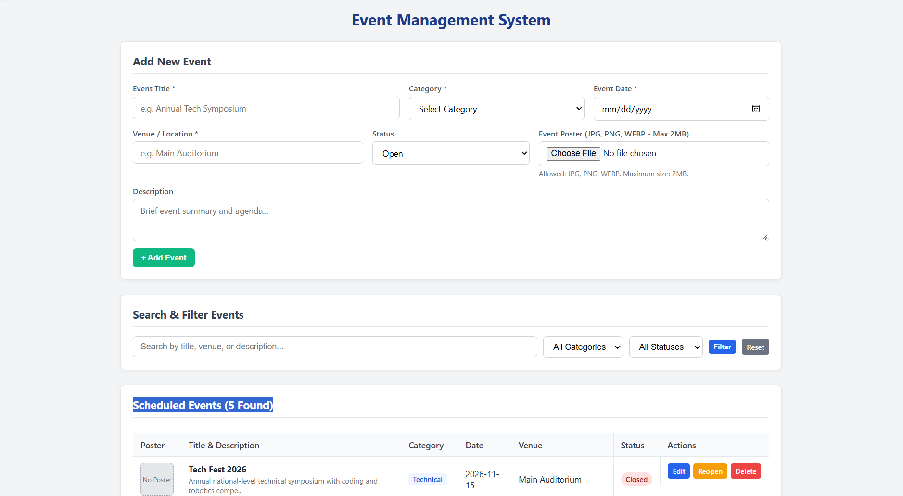
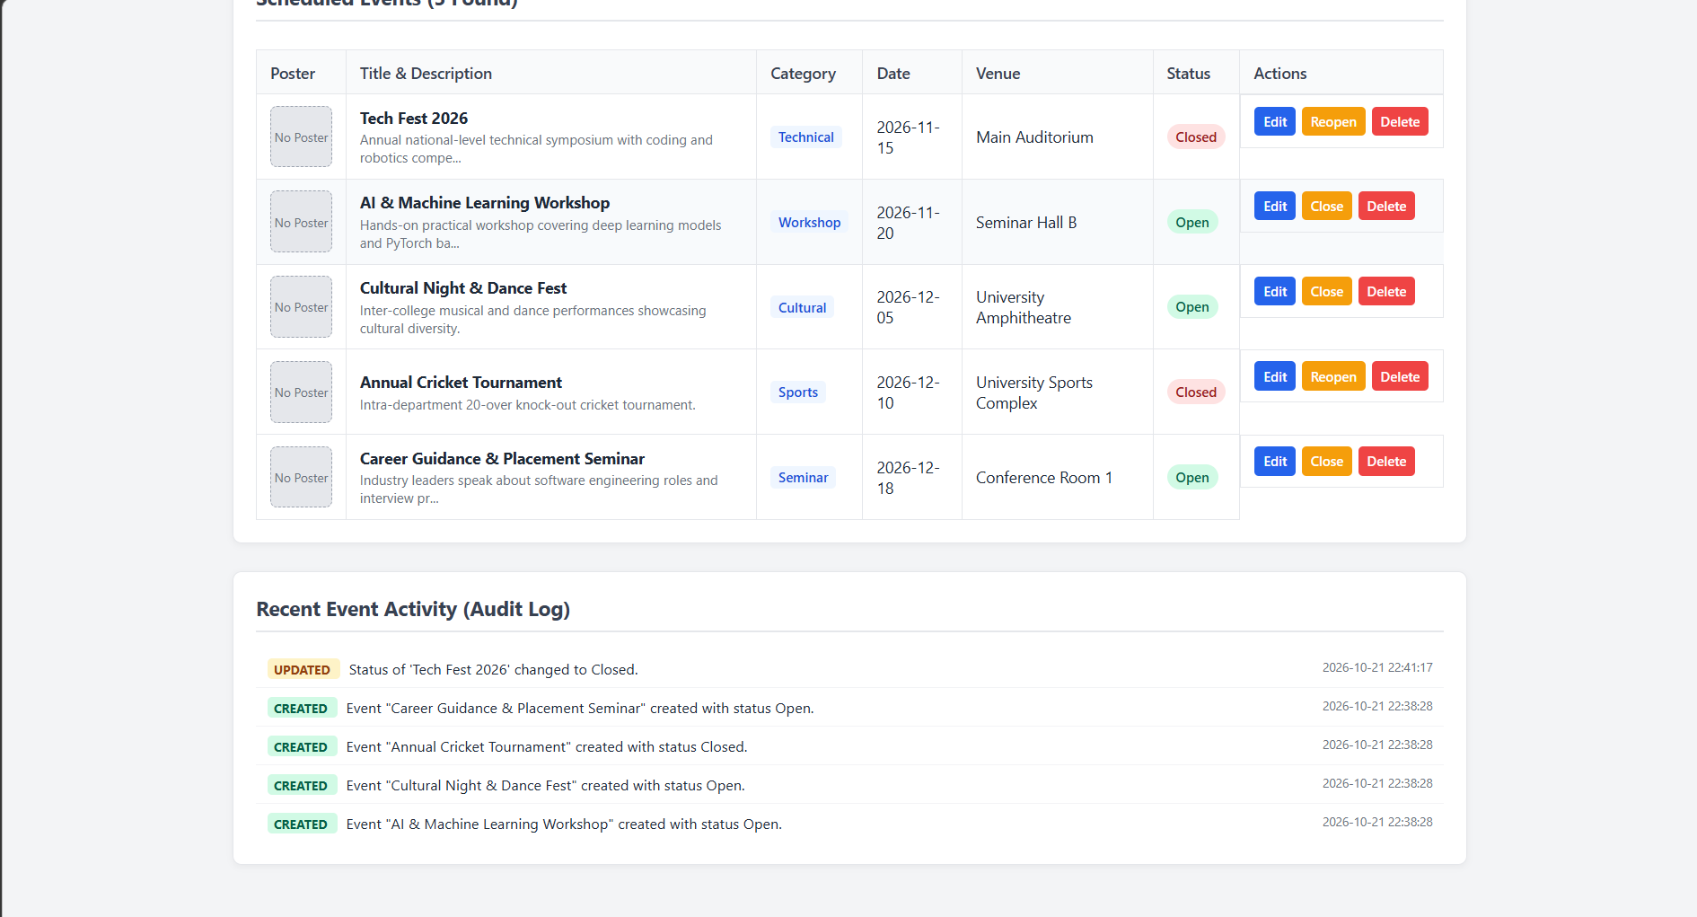

Practical 13:
File: api.php
Code:
<?php
header('Content-Type: application/json; charset=utf-8');
require_once __DIR__ . '/db.php';
// ========================================================
// ADVANCED EXTENSION: Centralized Error Handling & Status Codes
// ========================================================
function sendResponse(bool $success, string $message, $data = null, int $statusCode = 200): void
{
http_response_code($statusCode);
echo json_encode([
'success' => $success,
'message' => $message,
'data' => $data
]);
exit;
}
// Support both form-data and JSON request body
$rawInput = file_get_contents('php://input');
$jsonBody = json_decode($rawInput, true);
$requestData = is_array($jsonBody) ? array_merge($_POST, $jsonBody) : $_POST;
$method = $_SERVER['REQUEST_METHOD'];
$action = $_GET['action'] ?? $requestData['action'] ?? '';
// ========================================================
// 1. GET: Fetch List, Search, or Single Event
// ========================================================
if ($method === 'GET') {
// Fetch single event
if (isset($_GET['id'])) {
$id = (int)$_GET['id'];
$stmt = $conn->prepare("SELECT * FROM events WHERE id = ?");
$stmt->bind_param("i", $id);
$stmt->execute();
$event = $stmt->get_result()->fetch_assoc();
$stmt->close();
if ($event) {
sendResponse(true, "Event fetched successfully.", $event, 200);
} else {
sendResponse(false, "Event not found.", null, 404);
}
}
// Search or List All (with Intermediate Extension: Search)
$search = trim($_GET['search'] ?? '');
$category = trim($_GET['category'] ?? '');
$sql = "SELECT * FROM events WHERE 1=1";
$types = "";
$params = [];
if ($search !== '') {
$sql .= " AND (title LIKE ? OR venue LIKE ? OR description LIKE ?)";
$searchTerm = "%$search%";
$types .= "sss";
$params[] = $searchTerm;
$params[] = $searchTerm;
$params[] = $searchTerm;
}
if ($category !== '') {
$sql .= " AND category = ?";
$types .= "s";
$params[] = $category;
}
$sql .= " ORDER BY event_date ASC, id DESC";
$stmt = $conn->prepare($sql);
if (!empty($params)) {
$stmt->bind_param($types, ...$params);
}
$stmt->execute();
$result = $stmt->get_result();
$events = [];
while ($row = $result->fetch_assoc()) {
$events[] = $row;
}
$stmt->close();
sendResponse(true, "Events fetched successfully.", $events, 200);
}
// ========================================================
// 2. POST: Add New Event (CREATE)
// ========================================================
if ($method === 'POST' && ($action === 'create' || empty($action))) {
$title = trim($requestData['title'] ?? '');
$category = trim($requestData['category'] ?? '');
$event_date = trim($requestData['event_date'] ?? '');
$venue = trim($requestData['venue'] ?? '');
$status = trim($requestData['status'] ?? 'Open');
$description = trim($requestData['description'] ?? '');
// Server-side input validation
if ($title === '' || $category === '' || $event_date === '' || $venue === '') {
sendResponse(false, "Validation Error: Title, Category, Date, and Venue are required.", null, 400);
}
$stmt = $conn->prepare("INSERT INTO events (title, category, event_date, venue, status, description) VALUES (?, ?, ?, ?, ?, ?)");
$stmt->bind_param("ssssss", $title, $category, $event_date, $venue, $status, $description);
if ($stmt->execute()) {
$newId = $conn->insert_id;
$stmt->close();
sendResponse(true, "Event '{$title}' created successfully!", ['id' => $newId], 201);
} else {
$error = $conn->error;
$stmt->close();
sendResponse(false, "Database insert failed: " . $error, null, 500);
}
}
// ========================================================
// 3. POST / PUT: Update Event (UPDATE)
// ========================================================
if ($method === 'POST' && $action === 'update') {
$id = (int)($requestData['id'] ?? 0);
$title = trim($requestData['title'] ?? '');
$category = trim($requestData['category'] ?? '');
$event_date = trim($requestData['event_date'] ?? '');
$venue = trim($requestData['venue'] ?? '');
$status = trim($requestData['status'] ?? 'Open');
$description = trim($requestData['description'] ?? '');
if ($id <= 0) {
sendResponse(false, "Invalid or missing Event ID for update.", null, 400);
}
if ($title === '' || $category === '' || $event_date === '' || $venue === '') {
sendResponse(false, "Validation Error: All required fields must be filled.", null, 400);
}
$stmt = $conn->prepare("UPDATE events SET title = ?, category = ?, event_date = ?, venue = ?, status = ?, description = ? WHERE id = ?");
$stmt->bind_param("ssssssi", $title, $category, $event_date, $venue, $status, $description, $id);
if ($stmt->execute()) {
$stmt->close();
sendResponse(true, "Event '{$title}' updated successfully!", ['id' => $id], 200);
} else {
$error = $conn->error;
$stmt->close();
sendResponse(false, "Database update failed: " . $error, null, 500);
}
}
// ========================================================
// 4. POST / DELETE: Delete Event (DELETE)
// ========================================================
if ($action === 'delete' || $method === 'DELETE') {
$id = (int)($requestData['id'] ?? $_GET['id'] ?? 0);
if ($id <= 0) {
sendResponse(false, "Invalid or missing Event ID for deletion.", null, 400);
}
$stmt = $conn->prepare("DELETE FROM events WHERE id = ?");
$stmt->bind_param("i", $id);
if ($stmt->execute()) {
$stmt->close();
sendResponse(true, "Event #{$id} deleted successfully!", null, 200);
} else {
$error = $conn->error;
$stmt->close();
sendResponse(false, "Database deletion failed: " . $error, null, 500);
}
}
sendResponse(false, "Invalid request method or action.", null, 405);
?>

File: db.php
Code:
<?php
$host = "127.0.0.1";
$user = "root";
$pass = "";
$dbname = "practical13";
$conn = new mysqli($host, $user, $pass, $dbname);
if ($conn->connect_error) {
http_response_code(500);
echo json_encode([
'success' => false,
'message' => 'Database connection failed: ' . $conn->connect_error
]);
exit;
}
$conn->set_charset("utf8mb4");
?>

File: index.html
Code:
<!DOCTYPE html>
<html lang="en">
<head>
<meta charset="UTF-8">
<meta name="viewport" content="width=device-width, initial-scale=1.0">
<title>Practical 13: PHP JSON API & Fetch CRUD</title>
<link rel="stylesheet" href="style.css">
</head>
<body>
<div class="container">
<h1>Event Management (AJAX / Fetch API CRUD)</h1>
<!-- Feedback Alert Banner (Success / Error State) -->
<div id="alert-banner" class="alert"></div>
<!-- Loading Indicator State -->
<div id="loading-box" class="loading-box">
⏳ Processing request, please wait...
</div>
<!-- Event Form Card (Add / Edit Event) -->
<div class="card">
<h2 id="form-heading">Add New Event</h2>
<form id="event-form">
<input type="hidden" id="event-id" name="id" value="">
<div class="form-row">
<div class="form-group" style="flex: 2 1 300px;">
<label for="title">Event Title *</label>
<input type="text" id="title" required placeholder="e.g. AI & Robotics Symposium">
</div>
<div class="form-group">
<label for="category">Category *</label>
<select id="category" required>
<option value="">Select Category</option>
<option value="Technical">Technical</option>
<option value="Workshop">Workshop</option>
<option value="Seminar">Seminar</option>
<option value="Cultural">Cultural</option>
<option value="Sports">Sports</option>
</select>
</div>
<div class="form-group">
<label for="event_date">Event Date *</label>
<input type="date" id="event_date" required>
</div>
</div>
<div class="form-row">
<div class="form-group" style="flex: 2 1 300px;">
<label for="venue">Venue *</label>
<input type="text" id="venue" required placeholder="e.g. Main Auditorium">
</div>
<div class="form-group">
<label for="status">Status</label>
<select id="status">
<option value="Open">Open</option>
<option value="Closed">Closed</option>
</select>
</div>
</div>
<div class="form-row">
<div class="form-group full">
<label for="description">Description</label>
<textarea id="description" placeholder="Brief event description..."></textarea>
</div>
</div>
<div>
<button type="submit" id="submit-btn" class="btn btn-success">+ Add Event</button>
<button type="button" id="cancel-btn" class="btn btn-secondary" style="display: none;" onclick="resetForm()">Cancel Edit</button>
</div>
</form>
</div>
<!-- Search & Filter Card (Intermediate Extension: Debounce Search) -->
<div class="card">
<h2>Search and Filter (Asynchronous)</h2>
<div class="filter-bar">
<input type="text" id="search-input" placeholder="Type to search (debounced)...">
<select id="category-filter" onchange="applyFilter()">
<option value="">All Categories</option>
<option value="Technical">Technical</option>
<option value="Workshop">Workshop</option>
<option value="Seminar">Seminar</option>
<option value="Cultural">Cultural</option>
<option value="Sports">Sports</option>
</select>
<button type="button" class="btn btn-secondary btn-sm" onclick="clearFilters()">Reset</button>
</div>
<div class="search-hint">💡 Search query fires automatically with <strong>300ms debounce</strong> as you type.</div>
</div>
<!-- Dynamic Events Table Card -->
<div class="card">
<h2>Scheduled Events (<span id="event-count">0</span>)</h2>
<div class="table-responsive">
<table>
<thead>
<tr>
<th>ID</th>
<th>Title & Description</th>
<th>Category</th>
<th>Date</th>
<th>Venue</th>
<th>Status</th>
<th>Actions</th>
</tr>
</thead>
<tbody id="events-tbody">
<tr>
<td colspan="7" style="text-align: center; color: #6b7280; padding: 20px;">
Loading events via Fetch API...
</td>
</tr>
</tbody>
</table>
</div>
</div>
</div>
<!-- JavaScript Consuming the JSON API via Fetch API -->
<script>
const API_URL = 'api.php';
const alertBanner = document.getElementById('alert-banner');
const loadingBox = document.getElementById('loading-box');
const eventForm = document.getElementById('event-form');
const formHeading = document.getElementById('form-heading');
const submitBtn = document.getElementById('submit-btn');
const cancelBtn = document.getElementById('cancel-btn');
const eventsTbody = document.getElementById('events-tbody');
const eventCount = document.getElementById('event-count');
const searchInput = document.getElementById('search-input');
const categoryFilter = document.getElementById('category-filter');
let debounceTimer = null;
// Display flash notification
function showAlert(message, type = 'success') {
alertBanner.className = `alert alert-${type} show`;
alertBanner.innerHTML = message;
setTimeout(() => {
alertBanner.className = 'alert';
}, 4000);
}
// Show/Hide Loading Indicator
function setLoading(isLoading) {
if (isLoading) {
loadingBox.classList.add('show');
} else {
loadingBox.classList.remove('show');
}
}
// 1. Fetch Events List (GET API)
async function fetchEvents(search = '', category = '') {
setLoading(true);
try {
let url = `${API_URL}?search=${encodeURIComponent(search)}&category=${encodeURIComponent(category)}`;
const response = await fetch(url);
const result = await response.json();
if (result.success) {
renderTable(result.data);
} else {
showAlert(result.message || 'Failed to fetch events', 'danger');
}
} catch (err) {
showAlert('Network or API server error: ' + err.message, 'danger');
} finally {
setLoading(false);
}
}
// Render Table Rows Dynamically
function renderTable(events) {
eventCount.textContent = events.length;
if (events.length === 0) {
eventsTbody.innerHTML = `
<tr>
<td colspan="7" style="text-align:center; padding:20px; color:#6b7280;">
No events found matching your search.
</td>
</tr>
`;
return;
}
let rows = '';
events.forEach(evt => {
const badgeClass = evt.status.toLowerCase() === 'open' ? 'badge-open' : 'badge-closed';
const descSnippet = evt.description ? `<div style="font-size:12px; color:#6b7280; margin-top:3px;">${escapeHtml(evt.description)}</div>` : '';
rows += `
<tr>
<td>${evt.id}</td>
<td>
<strong>${escapeHtml(evt.title)}</strong>
${descSnippet}
</td>
<td><span class="category-tag">${escapeHtml(evt.category)}</span></td>
<td>${escapeHtml(evt.event_date)}</td>
<td>${escapeHtml(evt.venue)}</td>
<td><span class="badge ${badgeClass}">${escapeHtml(evt.status)}</span></td>
<td class="actions-cell">
<button class="btn btn-primary btn-sm" onclick="editEvent(${evt.id})">Edit</button>
<button class="btn btn-danger btn-sm" onclick="deleteEvent(${evt.id}, '${escapeHtml(evt.title)}')">Delete</button>
</td>
</tr>
`;
});
eventsTbody.innerHTML = rows;
}
// Helper to escape HTML characters
function escapeHtml(str) {
if (!str) return '';
return str.toString()
.replace(/&/g, '&amp;')
.replace(/</g, '&lt;')
.replace(/>/g, '&gt;')
.replace(/"/g, '&quot;')
.replace(/'/g, '&#039;');
}
// 2. Add or Update Event (POST API)
eventForm.addEventListener('submit', async (e) => {
e.preventDefault();
const id = document.getElementById('event-id').value;
const payload = {
title: document.getElementById('title').value.trim(),
category: document.getElementById('category').value,
event_date: document.getElementById('event_date').value,
venue: document.getElementById('venue').value.trim(),
status: document.getElementById('status').value,
description: document.getElementById('description').value.trim()
};
const isEdit = id !== '';
if (isEdit) {
payload.id = parseInt(id, 10);
}
const action = isEdit ? 'update' : 'create';
setLoading(true);
try {
const response = await fetch(`${API_URL}?action=${action}`, {
method: 'POST',
headers: { 'Content-Type': 'application/json' },
body: JSON.stringify(payload)
});
const result = await response.json();
if (result.success) {
showAlert(result.message, 'success');
resetForm();
fetchEvents(searchInput.value, categoryFilter.value);
} else {
showAlert(result.message || 'Action failed', 'danger');
}
} catch (err) {
showAlert('Network error: ' + err.message, 'danger');
} finally {
setLoading(false);
}
});
// 3. Edit Event (GET single record by ID)
async function editEvent(id) {
setLoading(true);
try {
const response = await fetch(`${API_URL}?id=${id}`);
const result = await response.json();
if (result.success && result.data) {
const evt = result.data;
document.getElementById('event-id').value = evt.id;
document.getElementById('title').value = evt.title;
document.getElementById('category').value = evt.category;
document.getElementById('event_date').value = evt.event_date;
document.getElementById('venue').value = evt.venue;
document.getElementById('status').value = evt.status;
document.getElementById('description').value = evt.description || '';
formHeading.textContent = `Edit Event #${evt.id}`;
submitBtn.textContent = 'Update Event';
submitBtn.className = 'btn btn-primary';
cancelBtn.style.display = 'inline-block';
window.scrollTo({ top: 0, behavior: 'smooth' });
} else {
showAlert(result.message || 'Could not fetch event details', 'danger');
}
} catch (err) {
showAlert('Error loading event for editing: ' + err.message, 'danger');
} finally {
setLoading(false);
}
}
// Cancel Edit & Reset Form
function resetForm() {
eventForm.reset();
document.getElementById('event-id').value = '';
formHeading.textContent = 'Add New Event';
submitBtn.textContent = '+ Add Event';
submitBtn.className = 'btn btn-success';
cancelBtn.style.display = 'none';
}
// 4. Delete Event (POST / DELETE API)
async function deleteEvent(id, title) {
if (!confirm(`Are you sure you want to delete event "${title}"?`)) {
return;
}
setLoading(true);
try {
const response = await fetch(`${API_URL}?action=delete`, {
method: 'POST',
headers: { 'Content-Type': 'application/json' },
body: JSON.stringify({ id: id })
});
const result = await response.json();
if (result.success) {
showAlert(result.message, 'success');
fetchEvents(searchInput.value, categoryFilter.value);
} else {
showAlert(result.message || 'Deletion failed', 'danger');
}
} catch (err) {
showAlert('Error deleting event: ' + err.message, 'danger');
} finally {
setLoading(false);
}
}
// 5. Intermediate Extension: Debounce Search Input (300ms)
searchInput.addEventListener('input', (e) => {
clearTimeout(debounceTimer);
debounceTimer = setTimeout(() => {
fetchEvents(e.target.value, categoryFilter.value);
}, 300);
});
function applyFilter() {
fetchEvents(searchInput.value, categoryFilter.value);
}
function clearFilters() {
searchInput.value = '';
categoryFilter.value = '';
fetchEvents();
}
// Initial Load on Page Open
document.addEventListener('DOMContentLoaded', () => {
fetchEvents();
});
</script>
</body>
</html>

File: index.php
Code:
<?php
include __DIR__ . '/index.html';

File: schema.sql
Code:
-- Practical 13: PHP JSON API and AJAX/Fetch-Based CRUD without Page Reload
-- Database Schema and Sample Data
CREATE DATABASE IF NOT EXISTS practical13 CHARACTER SET utf8mb4 COLLATE utf8mb4_unicode_ci;
USE practical13;
DROP TABLE IF EXISTS events;
CREATE TABLE IF NOT EXISTS events (
id INT AUTO_INCREMENT PRIMARY KEY,
title VARCHAR(150) NOT NULL,
category VARCHAR(50) NOT NULL,
event_date DATE NOT NULL,
venue VARCHAR(150) NOT NULL,
status ENUM('Open', 'Closed') DEFAULT 'Open',
description TEXT NULL,
created_at TIMESTAMP DEFAULT CURRENT_TIMESTAMP
) ENGINE=InnoDB DEFAULT CHARSET=utf8mb4 COLLATE=utf8mb4_unicode_ci;
-- Sample Seed Data
INSERT INTO events (title, category, event_date, venue, status, description) VALUES
('Tech Fest 2026', 'Technical', '2026-11-15', 'Main Auditorium', 'Open', 'National level coding and robotics competition.'),
('Web Development BootCamp', 'Workshop', '2026-11-22', 'Lab 3, IT Department', 'Open', 'Hands-on session on PHP, REST APIs, and modern frontend tools.'),
('Cyber Security Seminar', 'Seminar', '2026-12-02', 'Conference Hall A', 'Open', 'Expert lecture on ethical hacking and secure application design.'),
('Annual Cultural Fest', 'Cultural', '2026-12-10', 'University Amphitheatre', 'Open', 'Music, dance, and drama performances across all departments.'),
('Inter-College Chess Championship', 'Sports', '2026-12-15', 'Indoor Sports Complex', 'Closed', 'Rapid and blitz chess tournament with trophy awards.');

File: style.css
Code:
/* Simple & Clean Styling for Practical 13: Fetch API CRUD */
* {
box-sizing: border-box;
margin: 0;
padding: 0;
}
body {
font-family: 'Segoe UI', Tahoma, Geneva, Verdana, sans-serif;
background-color: #f3f4f6;
color: #1f2937;
padding: 30px 20px;
}
.container {
max-width: 1050px;
margin: 0 auto;
}
h1 {
font-size: 26px;
color: #1e3a8a;
margin-bottom: 20px;
text-align: center;
}
h2 {
font-size: 18px;
color: #374151;
margin-bottom: 15px;
border-bottom: 2px solid #e5e7eb;
padding-bottom: 8px;
}
/* Alert Notification Banner */
.alert {
padding: 12px 16px;
border-radius: 6px;
margin-bottom: 20px;
font-weight: 500;
display: none;
transition: all 0.3s ease;
}
.alert.show {
display: block;
}
.alert-success {
background-color: #d1fae5;
color: #065f46;
border: 1px solid #a7f3d0;
}
.alert-danger {
background-color: #fee2e2;
color: #991b1b;
border: 1px solid #fecaca;
}
/* Loading Indicator Bar */
.loading-box {
display: none;
background: #e0f2fe;
color: #0369a1;
border: 1px solid #bae6fd;
padding: 10px 14px;
border-radius: 6px;
margin-bottom: 15px;
font-size: 14px;
font-weight: 600;
text-align: center;
}
.loading-box.show {
display: block;
}
/* Card Box */
.card {
background: #ffffff;
border: 1px solid #e5e7eb;
border-radius: 8px;
padding: 20px;
margin-bottom: 25px;
box-shadow: 0 2px 6px rgba(0, 0, 0, 0.05);
}
/* Form Styles */
.form-row {
display: flex;
flex-wrap: wrap;
gap: 15px;
margin-bottom: 12px;
}
.form-group {
flex: 1 1 200px;
display: flex;
flex-direction: column;
}
.form-group.full {
flex: 1 1 100%;
}
.form-group label {
font-size: 13px;
font-weight: 600;
margin-bottom: 5px;
color: #4b5563;
}
.form-group input,
.form-group select,
.form-group textarea {
padding: 9px 12px;
border: 1px solid #d1d5db;
border-radius: 6px;
font-size: 14px;
font-family: inherit;
}
.form-group textarea {
resize: vertical;
min-height: 60px;
}
.form-group input:focus,
.form-group select:focus,
.form-group textarea:focus {
outline: none;
border-color: #2563eb;
}
/* Buttons */
.btn {
display: inline-block;
padding: 8px 14px;
font-size: 13px;
font-weight: 600;
border-radius: 6px;
border: none;
cursor: pointer;
text-decoration: none;
text-align: center;
}
.btn-primary { background: #2563eb; color: #fff; }
.btn-primary:hover { background: #1d4ed8; }
.btn-secondary { background: #6b7280; color: #fff; }
.btn-secondary:hover { background: #4b5563; }
.btn-success { background: #10b981; color: #fff; }
.btn-success:hover { background: #059669; }
.btn-danger { background: #ef4444; color: #fff; }
.btn-danger:hover { background: #dc2626; }
.btn-sm {
padding: 5px 8px;
font-size: 12px;
border-radius: 4px;
}
/* Search Bar (Debounced) */
.filter-bar {
display: flex;
flex-wrap: wrap;
gap: 10px;
align-items: center;
}
.filter-bar input[type="text"],
.filter-bar select {
padding: 8px 12px;
border: 1px solid #d1d5db;
border-radius: 6px;
font-size: 14px;
}
.filter-bar input[type="text"] {
flex: 1 1 240px;
}
.search-hint {
font-size: 12px;
color: #6b7280;
margin-top: 6px;
}
/* Table */
.table-responsive {
overflow-x: auto;
}
table {
width: 100%;
border-collapse: collapse;
font-size: 14px;
margin-top: 10px;
}
th, td {
padding: 10px 12px;
border: 1px solid #e5e7eb;
text-align: left;
vertical-align: middle;
}
th {
background-color: #f9fafb;
font-weight: 600;
color: #374151;
}
tr:hover {
background-color: #f8fafc;
}
/* Badges */
.badge {
display: inline-block;
padding: 3px 8px;
font-size: 12px;
font-weight: 600;
border-radius: 12px;
}
.badge-open { background: #d1fae5; color: #065f46; }
.badge-closed { background: #fee2e2; color: #991b1b; }
.category-tag {
display: inline-block;
padding: 2px 7px;
font-size: 12px;
background: #eff6ff;
color: #1d4ed8;
border-radius: 4px;
font-weight: 500;
}
.actions-cell {
white-space: nowrap;
display: flex;
gap: 5px;
}
Output:
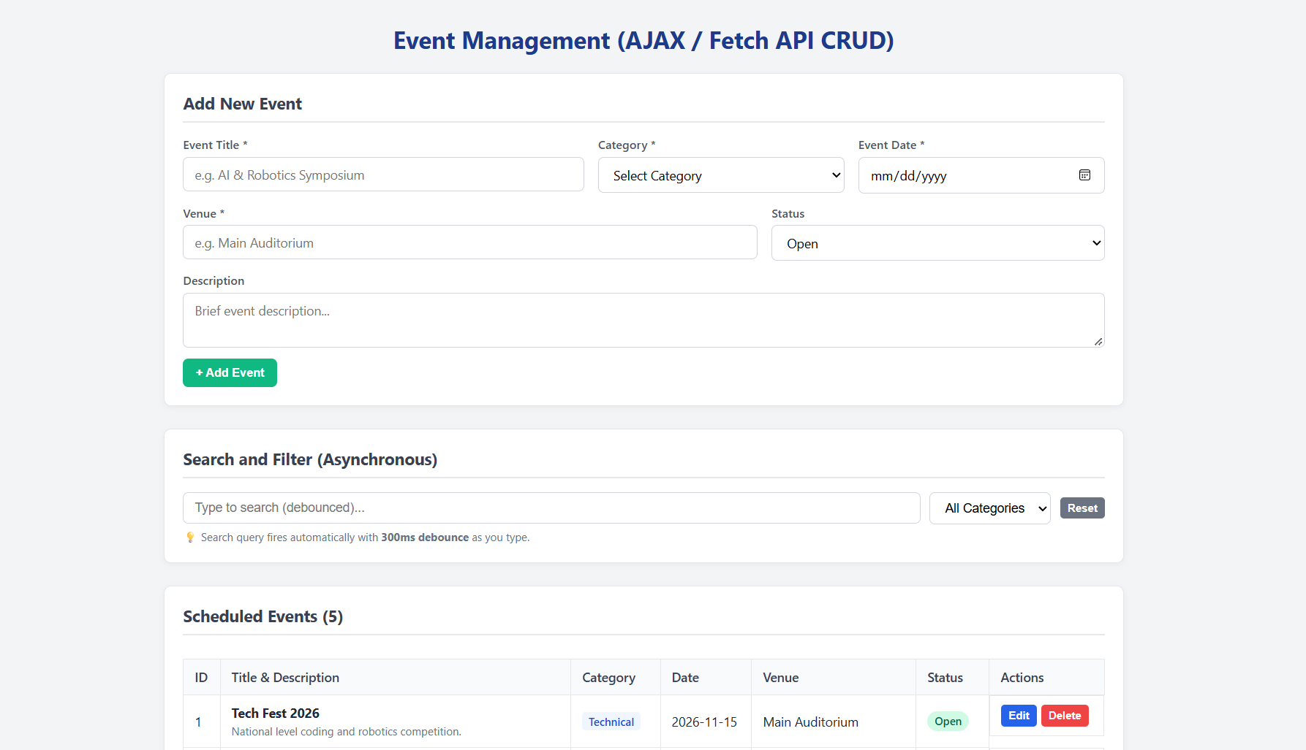
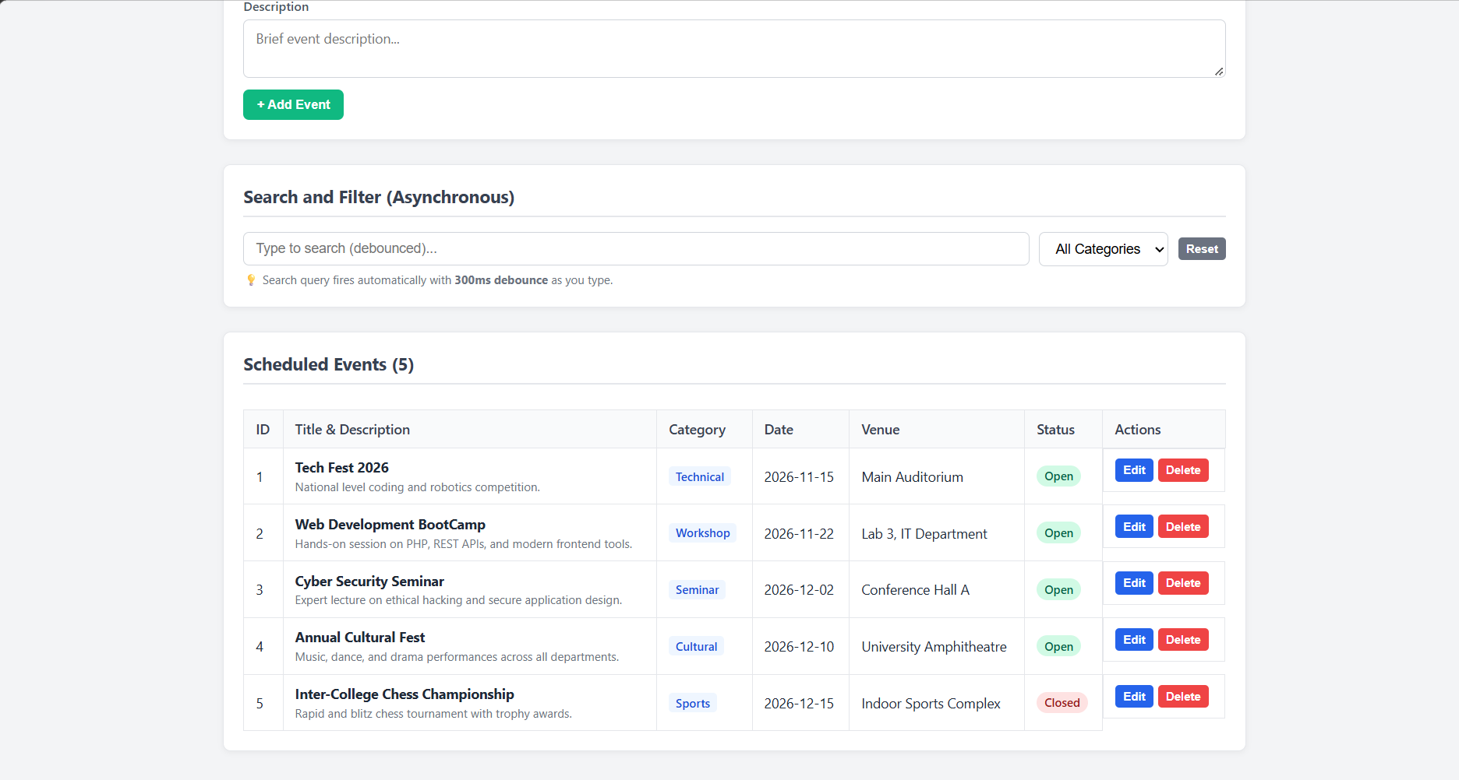

Practical 14:
File: db.php
Code:
<?php
$conn = new mysqli("127.0.0.1", "root", "", "practical14");
if ($conn->connect_error) {
die("Database connection failed: " . $conn->connect_error);
}
$conn->set_charset("utf8mb4");
// Helper to log admin actions
function addAudit($conn, $user, $action) {
$stmt = $conn->prepare("INSERT INTO audit_logs (user, action) VALUES (?, ?)");
$stmt->bind_param("ss", $user, $action);
$stmt->execute();
$stmt->close();
}
?>

File: index.php
Code:
<?php
session_start();
require_once __DIR__ . '/db.php';
// Access Control: Redirect to login if unauthenticated
if (!isset($_SESSION['user'])) {
header('Location: login.php');
exit;
}
$current_user = $_SESSION['user'];
$current_role = $_SESSION['role'] ?? 'student';
$message = '';
// Intermediate Extension: Toggle User Status (Admin Only)
if (isset($_GET['toggle_user']) && $current_role === 'admin') {
$uid = (int)$_GET['toggle_user'];
$stmt = $conn->prepare("SELECT username, status FROM users WHERE id = ?");
$stmt->bind_param("i", $uid);
$stmt->execute();
$target_user = $stmt->get_result()->fetch_assoc();
$stmt->close();
if ($target_user) {
$new_status = ($target_user['status'] === 'Active') ? 'Inactive' : 'Active';
$up = $conn->prepare("UPDATE users SET status = ? WHERE id = ?");
$up->bind_param("si", $new_status, $uid);
$up->execute();
$up->close();
addAudit($conn, $current_user, "Toggled status of user '{$target_user['username']}' to $new_status.");
$message = "User '{$target_user['username']}' status changed to <strong>$new_status</strong>.";
}
}
// 1. Dynamic Menu based on Role (RBAC)
$menu = ($current_role === 'admin')
? ['Dashboard' => '#top', 'Users' => '#users-sec', 'Registrations' => '#reg-sec', 'Analytics' => '#chart-sec', 'Audit Logs' => '#audit-sec']
: ['Dashboard' => '#top', 'My Registrations' => '#reg-sec'];
// 2. SQL Aggregations for Dashboard Metrics
$user_count = $conn->query("SELECT COUNT(*) AS c FROM users")->fetch_assoc()['c'] ?? 0;
$student_count = $conn->query("SELECT COUNT(*) AS c FROM students")->fetch_assoc()['c'] ?? 0;
$event_count = $conn->query("SELECT COUNT(*) AS c FROM events")->fetch_assoc()['c'] ?? 0;
$reg_count = $conn->query("SELECT COUNT(*) AS c FROM registrations")->fetch_assoc()['c'] ?? 0;
// 3. Latest Registrations Query
$latest_regs = $conn->query("SELECT * FROM registrations ORDER BY id DESC LIMIT 5");
// 4. Advanced Extension: Event Registrations by Month Analytics
$monthly_chart = $conn->query("SELECT DATE_FORMAT(registered_at, '%b %Y') as month, COUNT(*) as count FROM registrations GROUP BY month ORDER BY MIN(registered_at) ASC");
$max_monthly = 1;
$chart_data = [];
while ($m = $monthly_chart->fetch_assoc()) {
$chart_data[] = $m;
if ($m['count'] > $max_monthly) {
$max_monthly = $m['count'];
}
}
// 5. Users List (for Intermediate Extension: Toggle Status)
$users_list = $conn->query("SELECT id, username, role, status FROM users ORDER BY id ASC");
// 6. Recent Audit Logs
$audit_logs = $conn->query("SELECT * FROM audit_logs ORDER BY id DESC LIMIT 5");
?>
<!DOCTYPE html>
<html lang="en">
<head>
<meta charset="UTF-8">
<meta name="viewport" content="width=device-width, initial-scale=1.0">
<title>Practical 14: Admin Dashboard & RBAC</title>
<link rel="stylesheet" href="style.css">
</head>
<body id="top">
<!-- Navbar with Dynamic Role-Based Menu -->
<header class="navbar">
<div class="nav-brand">Admin Portal</div>
<ul class="nav-menu">
<?php foreach ($menu as $label => $link): ?>
<li><a href="<?= $link ?>"><?= $label ?></a></li>
<?php endforeach; ?>
<li>
<span class="user-badge"><?= htmlspecialchars($current_user) ?> (<?= htmlspecialchars($current_role) ?>)</span>
</li>
<li><a href="logout.php" style="color: #fca5a5;">Logout</a></li>
</ul>
</header>
<div class="container">
<!-- Access Restriction Alert for Non-Admin -->
<?php if ($current_role !== 'admin'): ?>
<div class="alert alert-danger" style="margin-top: 15px;">
⚠️ <strong>Access Restricted:</strong> You are signed in with the <strong><?= htmlspecialchars($current_role) ?></strong> role. Administrative actions and user moderation tools are restricted to Admin accounts.
</div>
<?php endif; ?>
<?php if ($message !== ''): ?>
<div class="alert alert-success"><?= $message ?></div>
<?php endif; ?>
<!-- 1. Dynamic Metric Cards (SQL Aggregations) -->
<h2 style="margin: 20px 0 10px;">System Overview</h2>
<div class="stats-grid">
<div class="stat-card">
<div class="val"><?= $user_count ?></div>
<div class="label">Total System Users</div>
</div>
<div class="stat-card">
<div class="val"><?= $student_count ?></div>
<div class="label">Total Students</div>
</div>
<div class="stat-card">
<div class="val"><?= $event_count ?></div>
<div class="label">Active Events</div>
</div>
<div class="stat-card">
<div class="val"><?= $reg_count ?></div>
<div class="label">Total Registrations</div>
</div>
</div>
<!-- 2. Advanced Extension: Event Registrations Analytics Chart -->
<div class="card" id="chart-sec">
<h2>Monthly Event Registrations (Analytics Chart)</h2>
<div class="chart-container">
<?php foreach ($chart_data as $point): ?>
<?php $bar_height = max(15, round(($point['count'] / $max_monthly) * 110)); ?>
<div class="chart-col">
<div class="chart-val"><?= $point['count'] ?></div>
<div class="chart-bar" style="height: <?= $bar_height ?>px;"></div>
<div class="chart-label"><?= $point['month'] ?></div>
</div>
<?php endforeach; ?>
</div>
</div>
<!-- 3. Latest Registrations Table -->
<div class="card" id="reg-sec">
<h2>Latest Event Registrations</h2>
<table>
<thead>
<tr>
<th>ID</th>
<th>Student Name</th>
<th>Event Title</th>
<th>Registration Date</th>
</tr>
</thead>
<tbody>
<?php while ($reg = $latest_regs->fetch_assoc()): ?>
<tr>
<td><?= $reg['id'] ?></td>
<td><?= htmlspecialchars($reg['student_name']) ?></td>
<td><?= htmlspecialchars($reg['event_title']) ?></td>
<td><?= htmlspecialchars($reg['registered_at']) ?></td>
</tr>
<?php endwhile; ?>
</tbody>
</table>
</div>
<!-- 4. User Management with Status Toggle (Intermediate Extension - Admin Only) -->
<?php if ($current_role === 'admin'): ?>
<div class="card" id="users-sec">
<h2>User Management (Active / Inactive Status Toggle)</h2>
<table>
<thead>
<tr>
<th>User ID</th>
<th>Username</th>
<th>Role</th>
<th>Status</th>
<th>Action</th>
</tr>
</thead>
<tbody>
<?php while ($u = $users_list->fetch_assoc()): ?>
<tr>
<td><?= $u['id'] ?></td>
<td><strong><?= htmlspecialchars($u['username']) ?></strong></td>
<td><?= htmlspecialchars($u['role']) ?></td>
<td>
<span class="badge badge-<?= strtolower($u['status']) ?>">
<?= htmlspecialchars($u['status']) ?>
</span>
</td>
<td>
<a href="index.php?toggle_user=<?= $u['id'] ?>" class="btn btn-warning">
Toggle Status
</a>
</td>
</tr>
<?php endwhile; ?>
</tbody>
</table>
</div>
<!-- 5. Audit Log Table -->
<div class="card" id="audit-sec">
<h2>Recent Admin Audit Logs</h2>
<table>
<thead>
<tr>
<th>Log ID</th>
<th>User</th>
<th>Action Recorded</th>
<th>Timestamp</th>
</tr>
</thead>
<tbody>
<?php while ($log = $audit_logs->fetch_assoc()): ?>
<tr>
<td><?= $log['id'] ?></td>
<td><strong><?= htmlspecialchars($log['user']) ?></strong></td>
<td><?= htmlspecialchars($log['action']) ?></td>
<td><?= htmlspecialchars($log['created_at']) ?></td>
</tr>
<?php endwhile; ?>
</tbody>
</table>
</div>
<?php endif; ?>
</div>
</body>
</html>

File: login.php
Code:
<?php
session_start();
require_once __DIR__ . '/db.php';
$error = '';
if ($_SERVER['REQUEST_METHOD'] === 'POST') {
$username = trim($_POST['username'] ?? '');
$password = trim($_POST['password'] ?? '');
$stmt = $conn->prepare("SELECT id, username, password, role, status FROM users WHERE username = ?");
$stmt->bind_param("s", $username);
$stmt->execute();
$user = $stmt->get_result()->fetch_assoc();
$stmt->close();
if ($user && $password === $user['password']) {
if ($user['status'] !== 'Active') {
$error = "Account is inactive. Contact administrator.";
} else {
$_SESSION['user'] = $user['username'];
$_SESSION['role'] = $user['role'];
addAudit($conn, $user['username'], "User logged in successfully (Role: {$user['role']}).");
header('Location: index.php');
exit;
}
} else {
$error = "Invalid username or password.";
}
}
?>
<!DOCTYPE html>
<html lang="en">
<head>
<meta charset="UTF-8">
<meta name="viewport" content="width=device-width, initial-scale=1.0">
<title>Practical 14: Sign In</title>
<link rel="stylesheet" href="style.css">
</head>
<body>
<div class="login-box">
<h2>Sign In</h2>
<?php if ($error !== ''): ?>
<div class="alert alert-danger"><?= htmlspecialchars($error) ?></div>
<?php endif; ?>
<form method="POST">
<div class="form-group" style="margin-bottom: 12px;">
<label>Username</label>
<input type="text" name="username" required placeholder="admin or student_aarav" value="admin">
</div>
<div class="form-group" style="margin-bottom: 16px;">
<label>Password</label>
<input type="password" name="password" required placeholder="admin123 or student123" value="admin123">
</div>
<button type="submit" class="btn btn-primary" style="width: 100%;">Sign In</button>
</form>
<div style="margin-top: 15px; font-size: 12px; color: #6b7280; text-align: center;">
Demo credentials: <strong>admin</strong> / <code>admin123</code> | <strong>student_aarav</strong> / <code>student123</code>
</div>
</div>
</body>
</html>

File: logout.php
Code:
<?php
session_start();
require_once __DIR__ . '/db.php';
if (!empty($_SESSION['user'])) {
addAudit($conn, $_SESSION['user'], "User logged out.");
}
session_destroy();
header('Location: login.php');
exit;
?>

File: schema.sql
Code:
-- Practical 14: Admin Dashboard with RBAC, Dynamic Menu, and Audit Log
CREATE DATABASE IF NOT EXISTS practical14 CHARACTER SET utf8mb4 COLLATE utf8mb4_unicode_ci;
USE practical14;
DROP TABLE IF EXISTS audit_logs;
DROP TABLE IF EXISTS registrations;
DROP TABLE IF EXISTS events;
DROP TABLE IF EXISTS students;
DROP TABLE IF EXISTS users;
-- 1. Users Table (with RBAC role and status toggle)
CREATE TABLE users (
id INT AUTO_INCREMENT PRIMARY KEY,
username VARCHAR(50) NOT NULL UNIQUE,
password VARCHAR(100) NOT NULL,
role ENUM('admin', 'staff', 'student') NOT NULL DEFAULT 'student',
status ENUM('Active', 'Inactive') NOT NULL DEFAULT 'Active'
);
-- 2. Students Table
CREATE TABLE students (
id INT AUTO_INCREMENT PRIMARY KEY,
name VARCHAR(100) NOT NULL,
email VARCHAR(100) NOT NULL,
course VARCHAR(50) NOT NULL
);
-- 3. Events Table
CREATE TABLE events (
id INT AUTO_INCREMENT PRIMARY KEY,
title VARCHAR(100) NOT NULL,
event_date DATE NOT NULL
);
-- 4. Registrations Table
CREATE TABLE registrations (
id INT AUTO_INCREMENT PRIMARY KEY,
student_name VARCHAR(100) NOT NULL,
event_title VARCHAR(100) NOT NULL,
registered_at DATE NOT NULL
);
-- 5. Audit Logs Table
CREATE TABLE audit_logs (
id INT AUTO_INCREMENT PRIMARY KEY,
user VARCHAR(50) NOT NULL,
action VARCHAR(255) NOT NULL,
created_at TIMESTAMP DEFAULT CURRENT_TIMESTAMP
);
-- Seed Users (Passwords: admin123, student123)
INSERT INTO users (username, password, role, status) VALUES
('admin', 'admin123', 'admin', 'Active'),
('staff_user', 'staff123', 'staff', 'Active'),
('student_aarav', 'student123', 'student', 'Active'),
('student_meera', 'student123', 'student', 'Inactive');
-- Seed Students
INSERT INTO students (name, email, course) VALUES
('Aarav Patel', 'aarav@example.com', 'Computer Science'),
('Meera Sharma', 'meera@example.com', 'Data Science'),
('Rohit Verma', 'rohit@example.com', 'Cyber Security'),
('Sana Iqbal', 'sana@example.com', 'AI & ML');
-- Seed Events
INSERT INTO events (title, event_date) VALUES
('Tech Fest 2026', '2026-11-15'),
('AI & Robotics Workshop', '2026-11-25'),
('Annual Cultural Fest', '2026-12-10');
-- Seed Registrations (Spread across months for analytics chart)
INSERT INTO registrations (student_name, event_title, registered_at) VALUES
('Aarav Patel', 'Tech Fest 2026', '2026-09-10'),
('Meera Sharma', 'Tech Fest 2026', '2026-09-18'),
('Rohit Verma', 'Tech Fest 2026', '2026-09-22'),
('Sana Iqbal', 'AI & Robotics Workshop', '2026-10-05'),
('Aarav Patel', 'AI & Robotics Workshop', '2026-10-15'),
('Karan Singh', 'Annual Cultural Fest', '2026-11-01');
-- Seed Audit Log
INSERT INTO audit_logs (user, action) VALUES
('admin', 'System initialized and seeded.'),
('admin', 'Admin logged in.');

File: style.css
Code:
/* Simple & Low-Code CSS for Practical 14 */
* {
box-sizing: border-box;
margin: 0;
padding: 0;
}
body {
font-family: 'Segoe UI', Tahoma, Geneva, Verdana, sans-serif;
background-color: #f3f4f6;
color: #1f2937;
}
.container {
max-width: 1100px;
margin: 25px auto;
padding: 0 15px;
}
/* Navbar & Dynamic Menu */
.navbar {
background: #1e3a8a;
color: #fff;
padding: 12px 24px;
display: flex;
justify-content: space-between;
align-items: center;
flex-wrap: wrap;
gap: 10px;
}
.nav-brand {
font-size: 18px;
font-weight: 700;
}
.nav-menu {
display: flex;
gap: 15px;
list-style: none;
align-items: center;
}
.nav-menu a {
color: #e0e7ff;
text-decoration: none;
font-size: 14px;
font-weight: 500;
}
.nav-menu a:hover {
color: #ffffff;
text-decoration: underline;
}
.user-badge {
background: #3b82f6;
padding: 4px 10px;
border-radius: 12px;
font-size: 12px;
font-weight: 600;
}
/* Stat Cards */
.stats-grid {
display: grid;
grid-template-columns: repeat(auto-fit, minmax(220px, 1fr));
gap: 15px;
margin-bottom: 25px;
}
.stat-card {
background: #ffffff;
border: 1px solid #e5e7eb;
border-radius: 8px;
padding: 18px;
box-shadow: 0 1px 3px rgba(0,0,0,0.05);
}
.stat-card .val {
font-size: 28px;
font-weight: 700;
color: #1e3a8a;
}
.stat-card .label {
font-size: 13px;
color: #6b7280;
margin-top: 4px;
}
/* Cards & Tables */
.card {
background: #ffffff;
border: 1px solid #e5e7eb;
border-radius: 8px;
padding: 20px;
margin-bottom: 25px;
box-shadow: 0 1px 3px rgba(0,0,0,0.05);
}
.card h2 {
font-size: 17px;
color: #374151;
margin-bottom: 12px;
border-bottom: 2px solid #f3f4f6;
padding-bottom: 6px;
}
table {
width: 100%;
border-collapse: collapse;
font-size: 14px;
margin-top: 8px;
}
th, td {
padding: 9px 12px;
border: 1px solid #e5e7eb;
text-align: left;
}
th {
background-color: #f9fafb;
font-weight: 600;
color: #374151;
}
tr:hover {
background-color: #f8fafc;
}
/* Simple CSS Bar Chart (Advanced Extension) */
.chart-container {
display: flex;
align-items: flex-end;
gap: 25px;
height: 160px;
padding: 20px 10px 10px;
border-bottom: 2px solid #9ca3af;
background: #fafafa;
border-radius: 6px;
}
.chart-col {
display: flex;
flex-direction: column;
align-items: center;
flex: 1;
height: 100%;
justify-content: flex-end;
}
.chart-bar {
width: 45px;
background: linear-gradient(180deg, #3b82f6, #1d4ed8);
border-radius: 4px 4px 0 0;
transition: height 0.3s ease;
min-height: 5px;
}
.chart-val {
font-size: 12px;
font-weight: bold;
color: #1e3a8a;
margin-bottom: 4px;
}
.chart-label {
font-size: 12px;
color: #4b5563;
margin-top: 8px;
font-weight: 500;
}
/* Badges & Buttons */
.badge {
padding: 3px 8px;
font-size: 12px;
font-weight: 600;
border-radius: 12px;
display: inline-block;
}
.badge-active { background: #d1fae5; color: #065f46; }
.badge-inactive { background: #fee2e2; color: #991b1b; }
.btn {
display: inline-block;
padding: 6px 12px;
font-size: 12px;
font-weight: 600;
border-radius: 4px;
border: none;
cursor: pointer;
text-decoration: none;
}
.btn-primary { background: #2563eb; color: #fff; }
.btn-warning { background: #f59e0b; color: #fff; }
.alert {
padding: 10px 14px;
border-radius: 6px;
margin-bottom: 18px;
font-size: 13px;
font-weight: 500;
}
.alert-success { background: #d1fae5; color: #065f46; border: 1px solid #a7f3d0; }
.alert-danger { background: #fee2e2; color: #991b1b; border: 1px solid #fecaca; }
/* Login Box */
.login-box {
max-width: 360px;
margin: 80px auto;
background: #fff;
padding: 25px;
border-radius: 8px;
box-shadow: 0 4px 10px rgba(0,0,0,0.08);
}
.login-box h2 {
text-align: center;
color: #1e3a8a;
margin-bottom: 18px;
}
.login-box input {
width: 100%;
padding: 9px 12px;
border: 1px solid #d1d5db;
border-radius: 6px;
font-size: 14px;
}

Output:
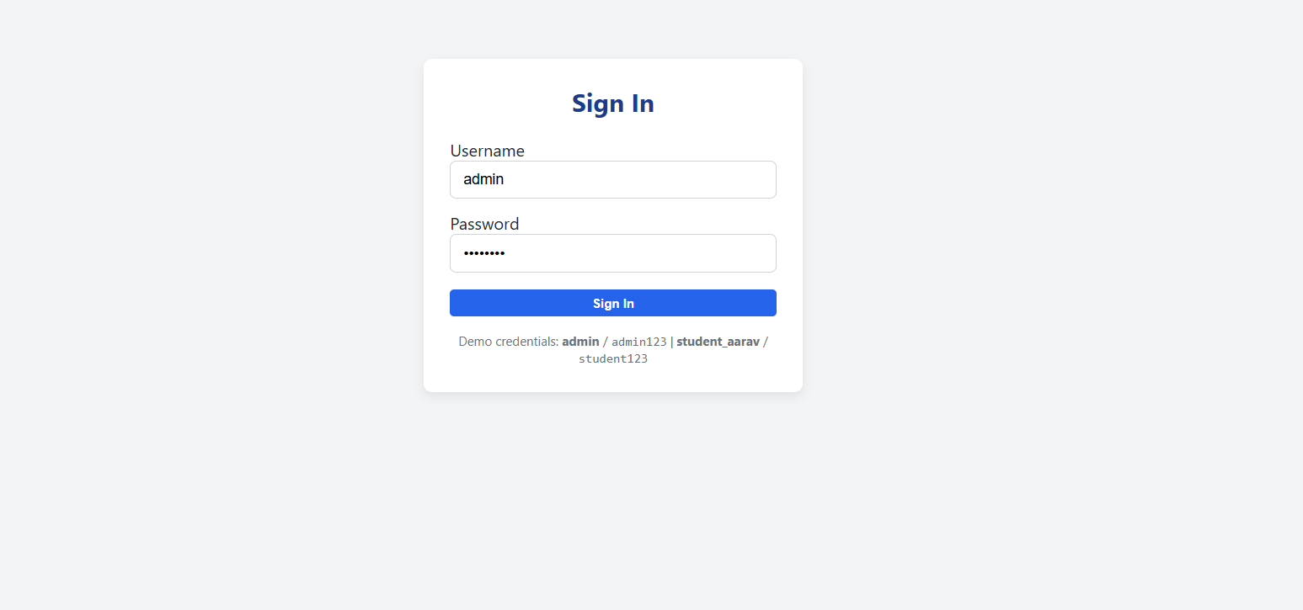
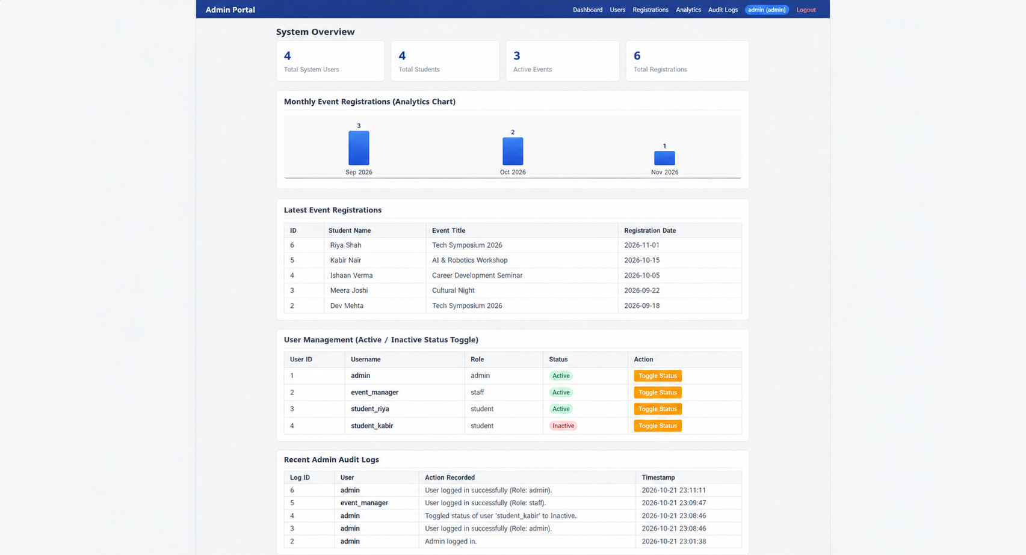
Practical 15:
File: api.php
Code:
<?php
header('Content-Type: application/json; charset=utf-8');
require_once __DIR__ . '/db.php';
$student_count = $conn->query("SELECT COUNT(*) as c FROM students WHERE status = 'Active'")->fetch_assoc()['c'] ?? 0;
$event_count = $conn->query("SELECT COUNT(*) as c FROM events WHERE status = 'Open'")->fetch_assoc()['c'] ?? 0;
$events = [];
$res = $conn->query("SELECT id, title, category, event_date, venue, status FROM events ORDER BY event_date ASC");
while ($row = $res->fetch_assoc()) {
$events[] = $row;
}
echo json_encode([
'success' => true,
'portal' => 'StudentHub Unified API',
'stats' => [
'active_students' => (int)$student_count,
'open_events' => (int)$event_count
],
'events' => $events
]);
exit;
?>

File: db.php
Code:
<?php
$conn = new mysqli("127.0.0.1", "root", "", "studenthub_portal");
if ($conn->connect_error) {
die("Database connection failed: " . $conn->connect_error);
}
$conn->set_charset("utf8mb4");
// Helper to log administrative actions
function addAudit($conn, $user, $action) {
$stmt = $conn->prepare("INSERT INTO audit_logs (user, action) VALUES (?, ?)");
$stmt->bind_param("ss", $user, $action);
$stmt->execute();
$stmt->close();
}
?>

File: index.php
Code:
<?php
session_start();
require_once __DIR__ . '/db.php';
// Access Control
if (!isset($_SESSION['user'])) {
header('Location: login.php');
exit;
}
$current_user = $_SESSION['user'];
$current_role = $_SESSION['role'] ?? 'student';
$message = '';
$upload_dir = __DIR__ . '/uploads/';
// ==========================================
// 1. STUDENT CRUD ACTIONS
// ==========================================
if ($_SERVER['REQUEST_METHOD'] === 'POST' && isset($_POST['add_student'])) {
$code = trim($_POST['student_code']);
$name = trim($_POST['name']);
$email = trim($_POST['email']);
$course = trim($_POST['course']);
if ($code !== '' && $name !== '' && $email !== '' && $course !== '') {
$stmt = $conn->prepare("INSERT INTO students (student_code, name, email, course) VALUES (?, ?, ?, ?)");
$stmt->bind_param("ssss", $code, $name, $email, $course);
if ($stmt->execute()) {
addAudit($conn, $current_user, "Added student '$name' ($code).");
$message = "Student '$name' added successfully!";
} else {
$message = "Failed to add student: " . $conn->error;
}
$stmt->close();
}
}
if (isset($_GET['del_student']) && $current_role === 'admin') {
$id = (int)$_GET['del_student'];
$stmt = $conn->prepare("DELETE FROM students WHERE id = ?");
$stmt->bind_param("i", $id);
if ($stmt->execute()) {
addAudit($conn, $current_user, "Deleted student ID #$id.");
$message = "Student #$id deleted successfully.";
}
$stmt->close();
}
// ==========================================
// 2. EVENT CRUD ACTIONS (WITH POSTER UPLOAD)
// ==========================================
if ($_SERVER['REQUEST_METHOD'] === 'POST' && isset($_POST['add_event'])) {
$title = trim($_POST['title']);
$category = trim($_POST['category']);
$event_date = trim($_POST['event_date']);
$venue = trim($_POST['venue']);
$poster_file = null;
// File Upload Validation (Max 2MB, JPG/PNG/WEBP)
if (!empty($_FILES['poster']['name']) && $_FILES['poster']['error'] === UPLOAD_ERR_OK) {
$max_size = 2 * 1024 * 1024; // 2MB
$allowed = ['jpg', 'jpeg', 'png', 'webp'];
$ext = strtolower(pathinfo($_FILES['poster']['name'], PATHINFO_EXTENSION));
if ($_FILES['poster']['size'] <= $max_size && in_array($ext, $allowed, true)) {
$poster_file = 'event_' . time() . '.' . $ext;
move_uploaded_file($_FILES['poster']['tmp_name'], $upload_dir . $poster_file);
}
}
if ($title !== '' && $category !== '' && $event_date !== '') {
$stmt = $conn->prepare("INSERT INTO events (title, category, event_date, venue, poster) VALUES (?, ?, ?, ?, ?)");
$stmt->bind_param("sssss", $title, $category, $event_date, $venue, $poster_file);
if ($stmt->execute()) {
addAudit($conn, $current_user, "Created event '$title'.");
$message = "Event '$title' scheduled successfully!";
}
$stmt->close();
}
}
if (isset($_GET['del_event']) && $current_role === 'admin') {
$id = (int)$_GET['del_event'];
$stmt = $conn->prepare("DELETE FROM events WHERE id = ?");
$stmt->bind_param("i", $id);
if ($stmt->execute()) {
addAudit($conn, $current_user, "Deleted event ID #$id.");
$message = "Event #$id deleted.";
}
$stmt->close();
}
// ==========================================
// 3. AGGREGATION METRICS (DASHBOARD)
// ==========================================
$total_students = $conn->query("SELECT COUNT(*) as c FROM students")->fetch_assoc()['c'] ?? 0;
$total_events = $conn->query("SELECT COUNT(*) as c FROM events WHERE status = 'Open'")->fetch_assoc()['c'] ?? 0;
$total_users = $conn->query("SELECT COUNT(*) as c FROM users")->fetch_assoc()['c'] ?? 0;
$audit_count = $conn->query("SELECT COUNT(*) as c FROM audit_logs")->fetch_assoc()['c'] ?? 0;
// Search for Students
$search = trim($_GET['search'] ?? '');
$sql_students = "SELECT * FROM students WHERE 1=1";
if ($search !== '') {
$search_safe = "%$search%";
$stmt_stu = $conn->prepare("SELECT * FROM students WHERE name LIKE ? OR email LIKE ? OR course LIKE ? ORDER BY id DESC");
$stmt_stu->bind_param("sss", $search_safe, $search_safe, $search_safe);
$stmt_stu->execute();
$students = $stmt_stu->get_result();
} else {
$students = $conn->query("SELECT * FROM students ORDER BY id DESC");
}
$events = $conn->query("SELECT * FROM events ORDER BY event_date ASC");
$audit_logs = $conn->query("SELECT * FROM audit_logs ORDER BY id DESC LIMIT 5");
?>
<!DOCTYPE html>
<html lang="en">
<head>
<meta charset="UTF-8">
<meta name="viewport" content="width=device-width, initial-scale=1.0">
<title>Practical 15: StudentHub Final Integrated Portal</title>
<link rel="stylesheet" href="style.css">
</head>
<body>
<!-- Top Navigation -->
<header class="navbar">
<div class="nav-brand">🎓 StudentHub Portal</div>
<ul class="nav-menu">
<li><a href="#overview">Overview</a></li>
<li><a href="#students-sec">Students</a></li>
<li><a href="#events-sec">Events</a></li>
<li><a href="#deployment-sec">Deployment</a></li>
<li><a href="api.php" target="_blank">JSON API</a></li>
<li><span class="user-badge"><?= htmlspecialchars($current_user) ?> (<?= htmlspecialchars($current_role) ?>)</span></li>
<li><a href="logout.php" style="color: #fca5a5;">Logout</a></li>
</ul>
</header>
<div class="container">
<?php if ($message !== ''): ?>
<div class="alert alert-success"><?= htmlspecialchars($message) ?></div>
<?php endif; ?>
<!-- Section 1: Dashboard Overview & Metrics -->
<h2 id="overview" style="margin-top: 20px;">System Overview</h2>
<div class="stats-grid">
<div class="stat-card">
<div class="val"><?= $total_students ?></div>
<div class="label">Total Students</div>
</div>
<div class="stat-card">
<div class="val"><?= $total_events ?></div>
<div class="label">Open Events</div>
</div>
<div class="stat-card">
<div class="val"><?= $total_users ?></div>
<div class="label">Portal Users</div>
</div>
<div class="stat-card">
<div class="val"><?= $audit_count ?></div>
<div class="label">Audited Actions</div>
</div>
</div>
<!-- Section 2: Student Management Module (CRUD + Search) -->
<div class="card" id="students-sec">
<h2>Student Management Module</h2>
<?php if ($current_role === 'admin'): ?>
<form method="POST" style="margin-bottom: 20px;">
<div class="form-row">
<div class="form-group">
<label>Student Code *</label>
<input type="text" name="student_code" required placeholder="e.g. STU202610">
</div>
<div class="form-group">
<label>Full Name *</label>
<input type="text" name="name" required placeholder="Student Name">
</div>
<div class="form-group">
<label>Email *</label>
<input type="email" name="email" required placeholder="student@example.com">
</div>
<div class="form-group">
<label>Course *</label>
<input type="text" name="course" required placeholder="Computer Science">
</div>
</div>
<button type="submit" name="add_student" class="btn btn-success">+ Add Student</button>
</form>
<?php endif; ?>
<!-- Search Bar -->
<form method="GET" style="display:flex; gap:10px; margin-bottom:15px;">
<input type="text" name="search" placeholder="Search students by name, email, course..." value="<?= htmlspecialchars($search) ?>" style="flex:1; padding:8px 12px; border:1px solid #d1d5db; border-radius:6px;">
<button type="submit" class="btn btn-primary">Search</button>
<?php if ($search !== ''): ?>
<a href="index.php" class="btn btn-secondary">Reset</a>
<?php endif; ?>
</form>
<div class="table-responsive">
<table>
<thead>
<tr>
<th>Code</th>
<th>Name</th>
<th>Email</th>
<th>Course</th>
<th>Status</th>
<?php if ($current_role === 'admin'): ?><th>Action</th><?php endif; ?>
</tr>
</thead>
<tbody>
<?php while ($s = $students->fetch_assoc()): ?>
<tr>
<td><strong><?= htmlspecialchars($s['student_code']) ?></strong></td>
<td><?= htmlspecialchars($s['name']) ?></td>
<td><?= htmlspecialchars($s['email']) ?></td>
<td><?= htmlspecialchars($s['course']) ?></td>
<td><span class="badge badge-<?= strtolower($s['status']) ?>"><?= htmlspecialchars($s['status']) ?></span></td>
<?php if ($current_role === 'admin'): ?>
<td>
<a href="index.php?del_student=<?= $s['id'] ?>" class="btn btn-danger btn-sm" onclick="return confirm('Delete student?');">Delete</a>
</td>
<?php endif; ?>
</tr>
<?php endwhile; ?>
</tbody>
</table>
</div>
</div>
<!-- Section 3: Event Management Module (Poster Upload) -->
<div class="card" id="events-sec">
<h2>Event Management Module (Poster Upload)</h2>
<?php if ($current_role === 'admin'): ?>
<form method="POST" enctype="multipart/form-data" style="margin-bottom: 20px;">
<div class="form-row">
<div class="form-group" style="flex: 2 1 250px;">
<label>Event Title *</label>
<input type="text" name="title" required placeholder="Event Title">
</div>
<div class="form-group">
<label>Category *</label>
<select name="category" required>
<option value="Technical">Technical</option>
<option value="Workshop">Workshop</option>
<option value="Cultural">Cultural</option>
<option value="Sports">Sports</option>
</select>
</div>
<div class="form-group">
<label>Date *</label>
<input type="date" name="event_date" required>
</div>
</div>
<div class="form-row">
<div class="form-group" style="flex: 2 1 250px;">
<label>Venue *</label>
<input type="text" name="venue" required placeholder="e.g. Auditorium">
</div>
<div class="form-group">
<label>Poster Image (Max 2MB)</label>
<input type="file" name="poster" accept=".jpg,.jpeg,.png,.webp">
</div>
</div>
<button type="submit" name="add_event" class="btn btn-primary">+ Add Event</button>
</form>
<?php endif; ?>
<div class="table-responsive">
<table>
<thead>
<tr>
<th>Poster</th>
<th>Title</th>
<th>Category</th>
<th>Date</th>
<th>Venue</th>
<th>Status</th>
<?php if ($current_role === 'admin'): ?><th>Action</th><?php endif; ?>
</tr>
</thead>
<tbody>
<?php while ($ev = $events->fetch_assoc()): ?>
<tr>
<td>
<?php if (!empty($ev['poster']) && file_exists($upload_dir . $ev['poster'])): ?>
<a href="uploads/<?= htmlspecialchars($ev['poster']) ?>" target="_blank">
<img src="uploads/<?= htmlspecialchars($ev['poster']) ?>" alt="Poster" style="width:40px; height:40px; object-fit:cover; border-radius:4px;">
</a>
<?php else: ?>
<span style="font-size: 11px; color: #9ca3af;">None</span>
<?php endif; ?>
</td>
<td><strong><?= htmlspecialchars($ev['title']) ?></strong></td>
<td><?= htmlspecialchars($ev['category']) ?></td>
<td><?= htmlspecialchars($ev['event_date']) ?></td>
<td><?= htmlspecialchars($ev['venue']) ?></td>
<td><span class="badge badge-<?= strtolower($ev['status']) ?>"><?= htmlspecialchars($ev['status']) ?></span></td>
<?php if ($current_role === 'admin'): ?>
<td>
<a href="index.php?del_event=<?= $ev['id'] ?>" class="btn btn-danger btn-sm" onclick="return confirm('Delete event?');">Delete</a>
</td>
<?php endif; ?>
</tr>
<?php endwhile; ?>
</tbody>
</table>
</div>
</div>
<!-- Section 4: Audit Trail -->
<div class="card">
<h2>Recent Audit Log</h2>
<table>
<thead>
<tr>
<th>User</th>
<th>Action</th>
<th>Timestamp</th>
</tr>
</thead>
<tbody>
<?php while ($log = $audit_logs->fetch_assoc()): ?>
<tr>
<td><strong><?= htmlspecialchars($log['user']) ?></strong></td>
<td><?= htmlspecialchars($log['action']) ?></td>
<td><?= htmlspecialchars($log['created_at']) ?></td>
</tr>
<?php endwhile; ?>
</tbody>
</table>
</div>
<!-- Section 5: Deployment, Security & Accessibility Verification (Key Questions 3, 4, 5) -->
<div class="card" id="deployment-sec">
<h2>Security & Accessibility Checklist & Virtual Host Deployment</h2>
<div class="checklist-item">
<span class="check-icon">✔</span>
<div><strong>SQL Injection Protection:</strong> All database mutations use parameterized MySQLi prepared statements.</div>
</div>
<div class="checklist-item">
<span class="check-icon">✔</span>
<div><strong>Cross-Site Scripting (XSS) Prevention:</strong> All dynamic browser outputs sanitized via <code>htmlspecialchars()</code>.</div>
</div>
<div class="checklist-item">
<span class="check-icon">✔</span>
<div><strong>Upload Security:</strong> File extensions, MIME types, and sizes validated server-side; script execution prevented in <code>uploads/.htaccess</code>.</div>
</div>
<div class="checklist-item">
<span class="check-icon">✔</span>
<div><strong>Role-Based Access Control (RBAC):</strong> Admin privileges required for student/event modifications.</div>
</div>
<div class="checklist-item">
<span class="check-icon">✔</span>
<div><strong>Accessibility (WCAG 2.1):</strong> Semantic HTML tags (<code>&lt;header&gt;</code>, <code>&lt;table&gt;</code>, <code>&lt;label&gt;</code>) with high-contrast text and alt text on media.</div>
</div>
<h3 style="font-size: 14px; margin-top: 15px; color: #1e3a8a;">Intermediate Extension: Local Apache Virtual Host Setup</h3>
<p style="font-size: 13px; color: #4b5563;">Add the following block to your XAMPP Apache configuration (<code>C:\xampp\apache\conf\extra\httpd-vhosts.conf</code>):</p>
<pre class="code-box">&lt;VirtualHost *:80&gt;
ServerName studenthub.local
DocumentRoot "C:/Users/jikad/OneDrive/Desktop/WDF precticals/Prectical15"
&lt;Directory "C:/Users/jikad/OneDrive/Desktop/WDF precticals/Prectical15"&gt;
AllowOverride All
Require all granted
&lt;/Directory&gt;
&lt;/VirtualHost&gt;</pre>
<p style="font-size: 12px; color: #6b7280; margin-top: 6px;">
Then map <code>127.0.0.1 studenthub.local</code> in <code>C:\Windows\System32\drivers\etc\hosts</code> to access via <strong>http://studenthub.local</strong>.
</p>
</div>
</div>
</body>
</html>

File: login.php
Code:
<?php
session_start();
require_once __DIR__ . '/db.php';
$error = '';
if ($_SERVER['REQUEST_METHOD'] === 'POST') {
$username = trim($_POST['username'] ?? '');
$password = trim($_POST['password'] ?? '');
$stmt = $conn->prepare("SELECT id, username, password, role, status FROM users WHERE username = ?");
$stmt->bind_param("s", $username);
$stmt->execute();
$user = $stmt->get_result()->fetch_assoc();
$stmt->close();
if ($user && $password === $user['password']) {
if ($user['status'] !== 'Active') {
$error = "Account is inactive. Contact the administrator.";
} else {
$_SESSION['user'] = $user['username'];
$_SESSION['role'] = $user['role'];
addAudit($conn, $user['username'], "Logged in to StudentHub Portal ({$user['role']}).");
header('Location: index.php');
exit;
}
} else {
$error = "Invalid username or password.";
}
}
?>
<!DOCTYPE html>
<html lang="en">
<head>
<meta charset="UTF-8">
<meta name="viewport" content="width=device-width, initial-scale=1.0">
<title>StudentHub Portal: Login</title>
<link rel="stylesheet" href="style.css">
</head>
<body>
<div class="login-box">
<h2>StudentHub Login</h2>
<?php if ($error !== ''): ?>
<div class="alert alert-danger"><?= htmlspecialchars($error) ?></div>
<?php endif; ?>
<form method="POST">
<div class="form-group" style="margin-bottom: 12px;">
<label>Username</label>
<input type="text" name="username" required value="admin">
</div>
<div class="form-group" style="margin-bottom: 16px;">
<label>Password</label>
<input type="password" name="password" required value="admin123">
</div>
<button type="submit" class="btn btn-primary" style="width: 100%;">Sign In</button>
</form>
<div style="margin-top: 15px; font-size: 12px; color: #6b7280; text-align: center;">
Demo: <strong>admin</strong> / <code>admin123</code> &bull; <strong>student_aarav</strong> / <code>student123</code>
</div>
</div>
</body>
</html>

File: logout.php
Code:
<?php
session_start();
require_once __DIR__ . '/db.php';
if (!empty($_SESSION['user'])) {
addAudit($conn, $_SESSION['user'], "Logged out from StudentHub Portal.");
}
session_destroy();
header('Location: login.php');
exit;
?>

File: schema.sql
Code:
-- Practical 15: StudentHub Final Integration Portal
CREATE DATABASE IF NOT EXISTS studenthub_portal CHARACTER SET utf8mb4 COLLATE utf8mb4_unicode_ci;
USE studenthub_portal;
DROP TABLE IF EXISTS audit_logs;
DROP TABLE IF EXISTS events;
DROP TABLE IF EXISTS students;
DROP TABLE IF EXISTS users;
-- 1. Users Table (RBAC)
CREATE TABLE users (
id INT AUTO_INCREMENT PRIMARY KEY,
username VARCHAR(50) NOT NULL UNIQUE,
password VARCHAR(100) NOT NULL,
role ENUM('admin', 'student') NOT NULL DEFAULT 'student',
status ENUM('Active', 'Inactive') NOT NULL DEFAULT 'Active'
);
-- 2. Students Table (CRUD & Search/Filter)
CREATE TABLE students (
id INT AUTO_INCREMENT PRIMARY KEY,
student_code VARCHAR(20) NOT NULL UNIQUE,
name VARCHAR(100) NOT NULL,
email VARCHAR(100) NOT NULL UNIQUE,
course VARCHAR(60) NOT NULL,
status ENUM('Active', 'Inactive', 'Deleted') NOT NULL DEFAULT 'Active',
created_at TIMESTAMP DEFAULT CURRENT_TIMESTAMP
);
-- 3. Events Table (CRUD & Poster Upload)
CREATE TABLE events (
id INT AUTO_INCREMENT PRIMARY KEY,
title VARCHAR(150) NOT NULL,
category VARCHAR(50) NOT NULL,
event_date DATE NOT NULL,
venue VARCHAR(150) NOT NULL,
poster VARCHAR(255) NULL,
status ENUM('Open', 'Closed') DEFAULT 'Open',
created_at TIMESTAMP DEFAULT CURRENT_TIMESTAMP
);
-- 4. Audit Logs Table
CREATE TABLE audit_logs (
id INT AUTO_INCREMENT PRIMARY KEY,
user VARCHAR(50) NOT NULL,
action VARCHAR(255) NOT NULL,
created_at TIMESTAMP DEFAULT CURRENT_TIMESTAMP
);
-- Seed Data
INSERT INTO users (username, password, role, status) VALUES
('admin', 'admin123', 'admin', 'Active'),
('student_aarav', 'student123', 'student', 'Active');
INSERT INTO students (student_code, name, email, course, status) VALUES
('STU2026001', 'Aarav Patel', 'aarav.patel@studenthub.edu', 'Computer Science', 'Active'),
('STU2026002', 'Meera Sharma', 'meera.sharma@studenthub.edu', 'Data Science', 'Active'),
('STU2026003', 'Rohit Verma', 'rohit.verma@studenthub.edu', 'Cyber Security', 'Active'),
('STU2026004', 'Sana Iqbal', 'sana.iqbal@studenthub.edu', 'Artificial Intelligence', 'Active');
INSERT INTO events (title, category, event_date, venue, poster, status) VALUES
('Annual Tech Fest 2026', 'Technical', '2026-11-15', 'Main Auditorium', NULL, 'Open'),
('AI & Deep Learning Workshop', 'Workshop', '2026-11-25', 'Lab 3, IT Dept', NULL, 'Open'),
('Inter-College Cultural Night', 'Cultural', '2026-12-10', 'University Amphitheatre', NULL, 'Open');
INSERT INTO audit_logs (user, action) VALUES
('admin', 'StudentHub integrated database seeded and verified.');

File: style.css
Code:
/* Simple & Clean CSS for Practical 15: StudentHub Final Integration Portal */
* {
box-sizing: border-box;
margin: 0;
padding: 0;
}
body {
font-family: 'Segoe UI', Tahoma, Geneva, Verdana, sans-serif;
background-color: #f3f4f6;
color: #1f2937;
}
/* Navbar */
.navbar {
background: #1e3a8a;
color: #fff;
padding: 12px 24px;
display: flex;
justify-content: space-between;
align-items: center;
flex-wrap: wrap;
gap: 12px;
}
.nav-brand {
font-size: 18px;
font-weight: 700;
}
.nav-menu {
display: flex;
gap: 15px;
list-style: none;
align-items: center;
}
.nav-menu a {
color: #e0e7ff;
text-decoration: none;
font-size: 14px;
font-weight: 500;
}
.nav-menu a:hover {
color: #ffffff;
text-decoration: underline;
}
.user-badge {
background: #3b82f6;
padding: 4px 10px;
border-radius: 12px;
font-size: 12px;
font-weight: 600;
}
/* Container */
.container {
max-width: 1100px;
margin: 25px auto;
padding: 0 15px;
}
/* Stat Cards */
.stats-grid {
display: grid;
grid-template-columns: repeat(auto-fit, minmax(220px, 1fr));
gap: 15px;
margin-bottom: 25px;
}
.stat-card {
background: #ffffff;
border: 1px solid #e5e7eb;
border-radius: 8px;
padding: 18px;
box-shadow: 0 1px 3px rgba(0,0,0,0.05);
}
.stat-card .val {
font-size: 28px;
font-weight: 700;
color: #1e3a8a;
}
.stat-card .label {
font-size: 13px;
color: #6b7280;
margin-top: 4px;
}
/* Cards & Tables */
.card {
background: #ffffff;
border: 1px solid #e5e7eb;
border-radius: 8px;
padding: 20px;
margin-bottom: 25px;
box-shadow: 0 1px 3px rgba(0,0,0,0.05);
}
.card h2 {
font-size: 17px;
color: #374151;
margin-bottom: 12px;
border-bottom: 2px solid #f3f4f6;
padding-bottom: 6px;
}
/* Forms */
.form-row {
display: flex;
flex-wrap: wrap;
gap: 12px;
margin-bottom: 12px;
}
.form-group {
flex: 1 1 200px;
display: flex;
flex-direction: column;
}
.form-group label {
font-size: 13px;
font-weight: 600;
margin-bottom: 5px;
color: #4b5563;
}
.form-group input,
.form-group select {
padding: 8px 12px;
border: 1px solid #d1d5db;
border-radius: 6px;
font-size: 14px;
}
/* Buttons */
.btn {
display: inline-block;
padding: 6px 14px;
font-size: 13px;
font-weight: 600;
border-radius: 5px;
border: none;
cursor: pointer;
text-decoration: none;
text-align: center;
}
.btn-primary { background: #2563eb; color: #fff; }
.btn-success { background: #10b981; color: #fff; }
.btn-warning { background: #f59e0b; color: #fff; }
.btn-danger { background: #ef4444; color: #fff; }
.btn-secondary { background: #6b7280; color: #fff; }
.btn-sm { padding: 4px 8px; font-size: 12px; }
/* Table */
.table-responsive {
overflow-x: auto;
}
table {
width: 100%;
border-collapse: collapse;
font-size: 14px;
margin-top: 8px;
}
th, td {
padding: 9px 12px;
border: 1px solid #e5e7eb;
text-align: left;
}
th {
background-color: #f9fafb;
font-weight: 600;
color: #374151;
}
tr:hover {
background-color: #f8fafc;
}
/* Badges */
.badge {
padding: 3px 8px;
font-size: 12px;
font-weight: 600;
border-radius: 12px;
display: inline-block;
}
.badge-active, .badge-open { background: #d1fae5; color: #065f46; }
.badge-inactive, .badge-closed { background: #fee2e2; color: #991b1b; }
/* Alerts */
.alert {
padding: 10px 14px;
border-radius: 6px;
margin-bottom: 18px;
font-size: 13px;
font-weight: 500;
}
.alert-success { background: #d1fae5; color: #065f46; border: 1px solid #a7f3d0; }
.alert-danger { background: #fee2e2; color: #991b1b; border: 1px solid #fecaca; }
/* Checklist */
.checklist-item {
display: flex;
align-items: center;
gap: 10px;
padding: 8px 0;
border-bottom: 1px solid #f3f4f6;
font-size: 14px;
}
.check-icon {
color: #10b981;
font-weight: bold;
}
/* Virtual Host Code Box */
pre.code-box {
background: #1e293b;
color: #f8fafc;
padding: 14px;
border-radius: 6px;
font-size: 13px;
overflow-x: auto;
font-family: Consolas, monospace;
margin-top: 8px;
}
/* Login Box */
.login-box {
max-width: 360px;
margin: 80px auto;
background: #fff;
padding: 25px;
border-radius: 8px;
box-shadow: 0 4px 10px rgba(0,0,0,0.08);
}
.login-box h2 {
text-align: center;
color: #1e3a8a;
margin-bottom: 18px;
}
.login-box input {
width: 100%;
padding: 9px 12px;
border: 1px solid #d1d5db;
border-radius: 6px;
font-size: 14px;
}
Output:
