Blog Application Task
Step 1:- To design blog application task in Perform in Curd Operation.
Language:- 1. React
2. Node.js
3. HTML
4. CSS
Tools:- 1. VS Code
Database:- 1. MySQL.

Step 2:- To create 3 tables in MySQL Database
1. Users
2. Posts
3. Comments
MySQL Query:-

CREATE DATABASE blog_app;

USE blog_app;

-- Users Table
CREATE TABLE users (
id INT AUTO_INCREMENT PRIMARY KEY,
username VARCHAR(50) NOT NULL,
email VARCHAR(100) NOT NULL UNIQUE,
password VARCHAR(255) NOT NULL
);

-- Posts Table
CREATE TABLE posts (
id INT AUTO_INCREMENT PRIMARY KEY,
title VARCHAR(255) NOT NULL,
content TEXT NOT NULL,
author_id INT NOT NULL,
created_at TIMESTAMP DEFAULT CURRENT_TIMESTAMP,
updated_at TIMESTAMP DEFAULT CURRENT_TIMESTAMP ON UPDATE CURRENT_TIMESTAMP,
FOREIGN KEY (author_id) REFERENCES users(id)
);

-- Comments Table
CREATE TABLE comments (
id INT PRIMARY KEY AUTO_INCREMENT,
post_id INT NOT NULL,
content TEXT NOT NULL,
author_id INT NOT NULL,
created_at TIMESTAMP DEFAULT CURRENT_TIMESTAMP
);

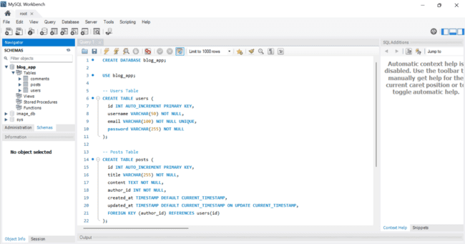

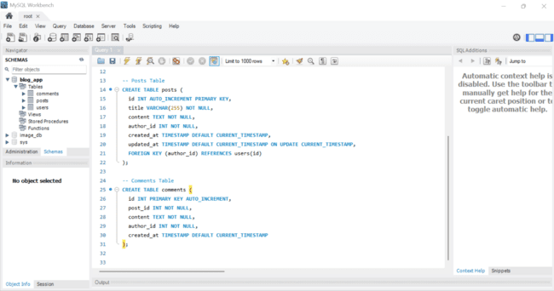

Step 3:- To design blog application task in HTML, CSS, React and Node.js.

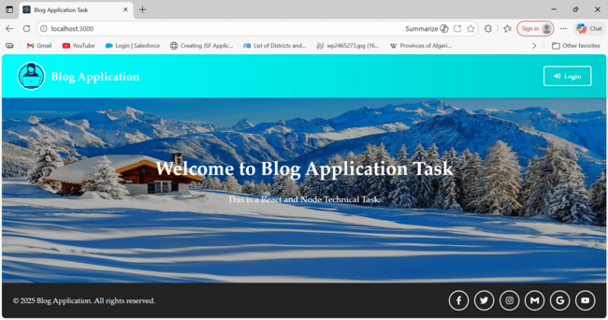

Step 4:- To click Login Button display Login Modal Box.

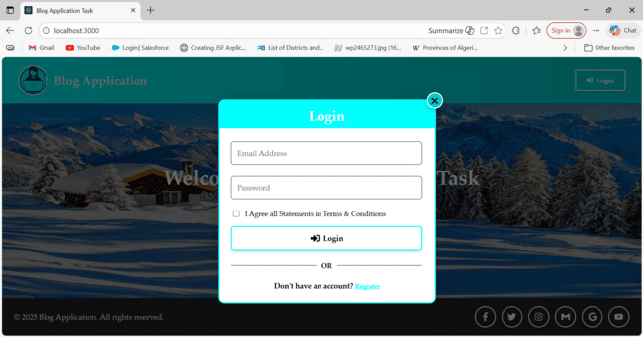

Step 4:- Firstly you click on Register Link button then enter your Username, Email Address, Password Correctly otherwise you enter any blank or wrong input field show Swal error message you fill complete details correctly click register button then User Resister Successfully and data insert in database table Users.
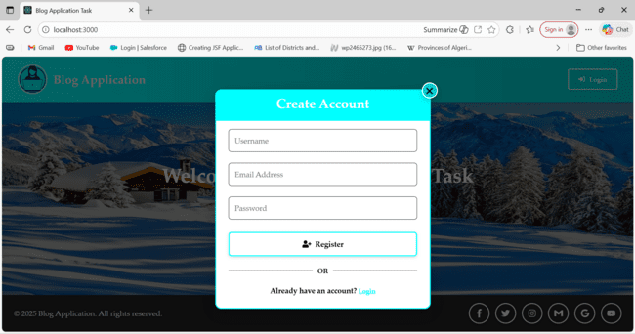

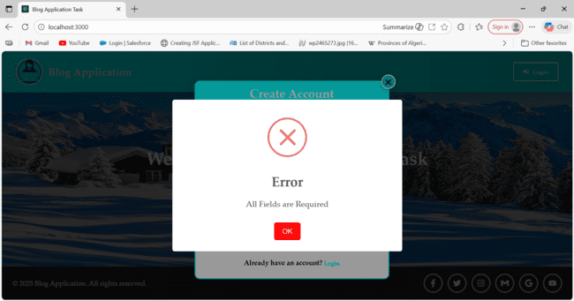

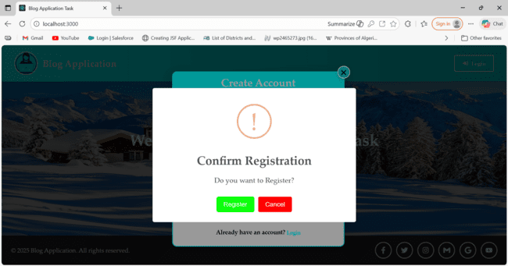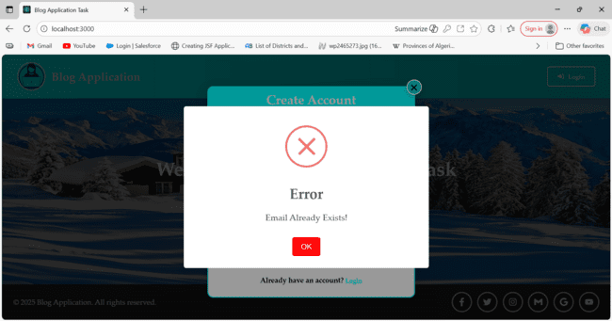
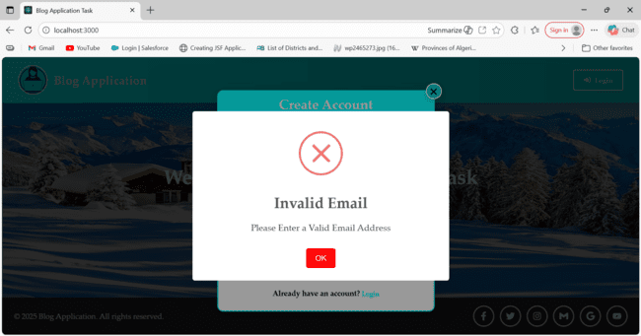
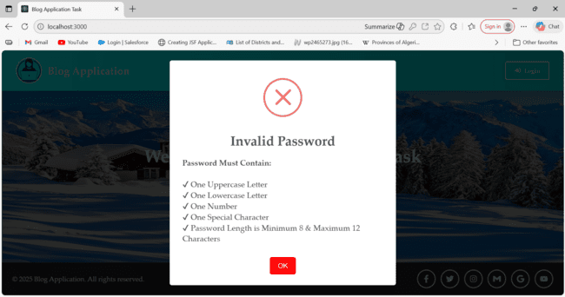

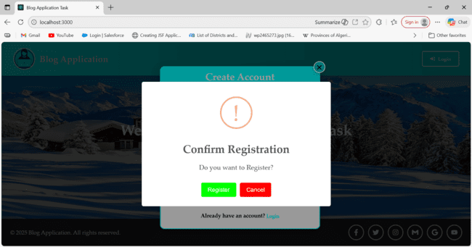
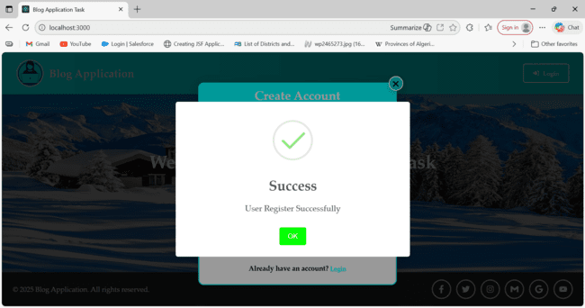

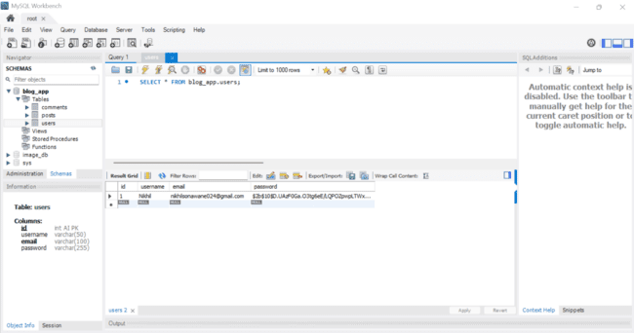

Step 5:- Firstly User Resister Successfully then open Login page you can enter correct details in email address and password otherwise display Swal error message then click checkbox Login Successfully.

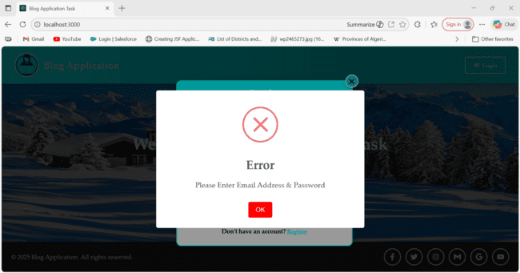

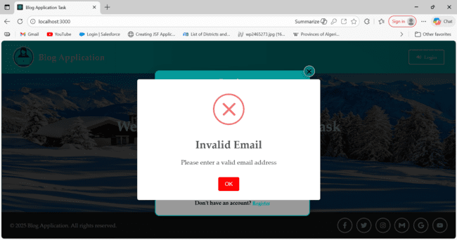

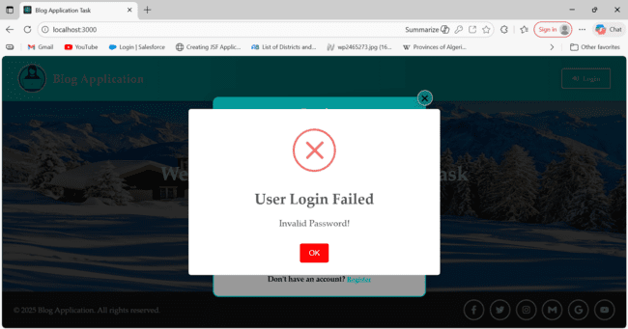

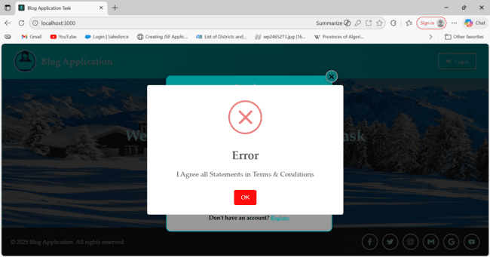

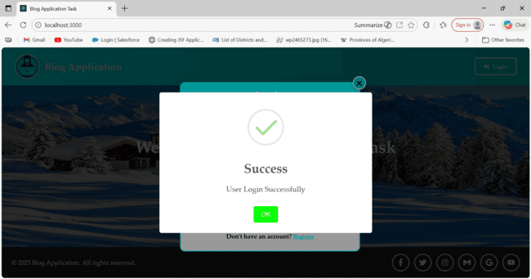

Step 6:- Firstly Login Successfully then open Posts page you can click create New Post display create New Post modal Form enter correct details in Title and Content otherwise display Swal error message then click create button display Post Create Successfully and data insert in database table Posts.
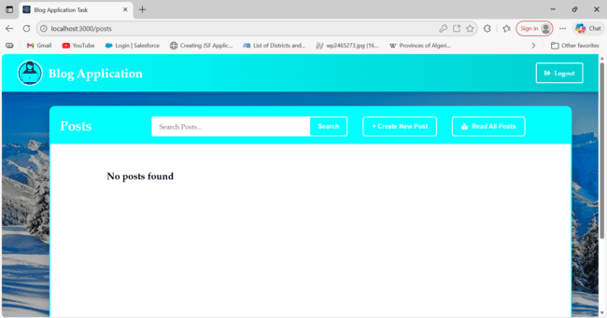

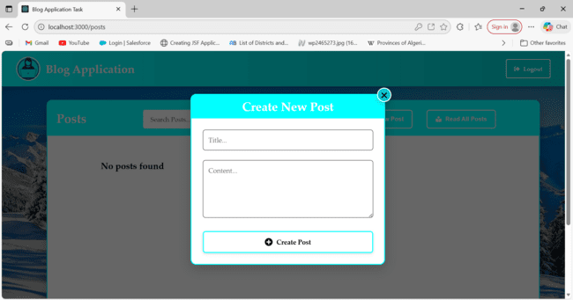

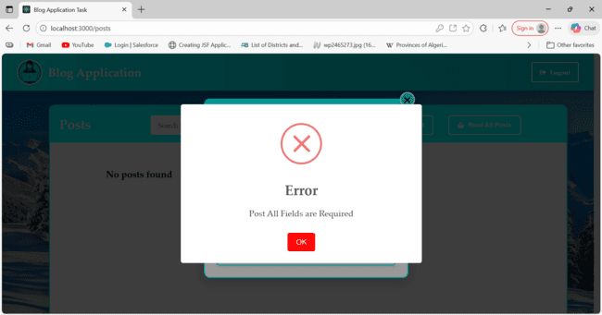

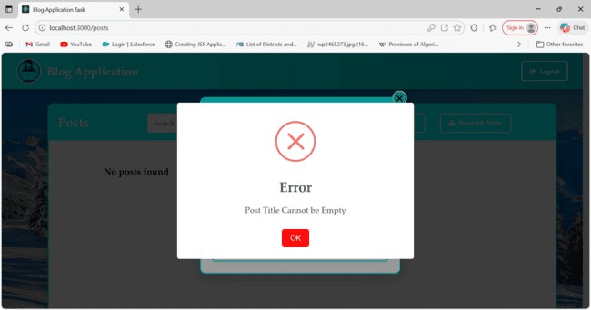

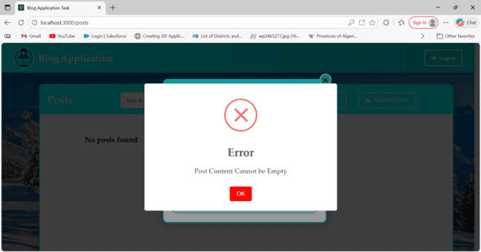

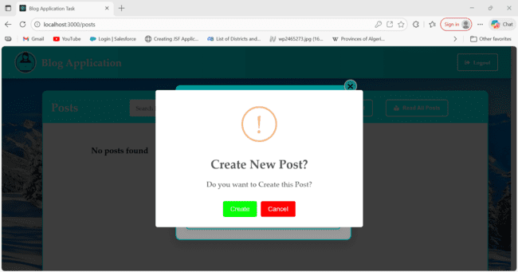

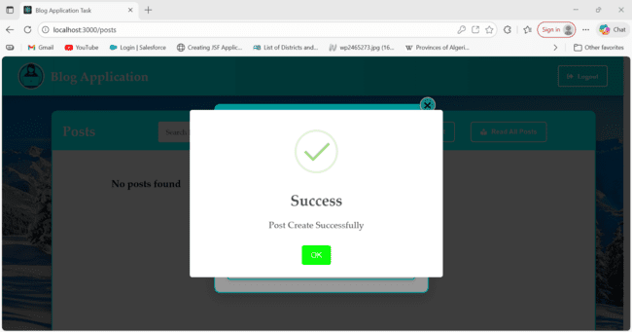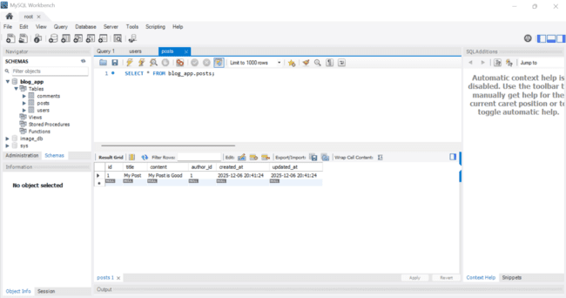

Step 7:- Firstly Post Create Successfully then display Posts card in container and details and three button Read, Update and Delete.

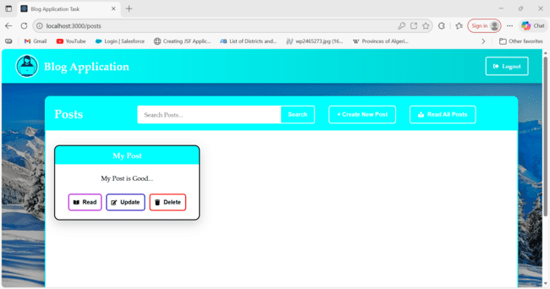

Step 7:- you can create many post cards then display Posts card in container and display Pagination and search your content.

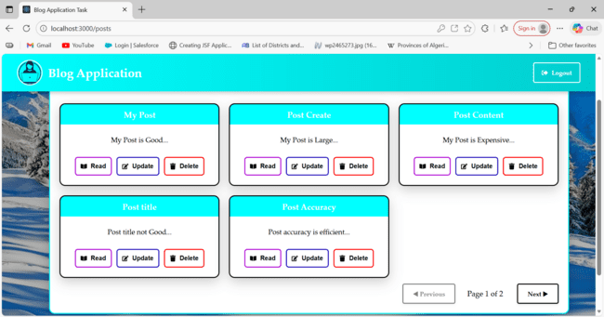

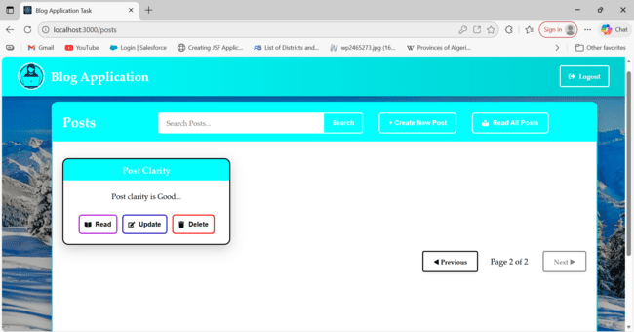

Step 8:- you can create many post cards then click on Read All button then display Posts card details in container and search your content with Pagination.

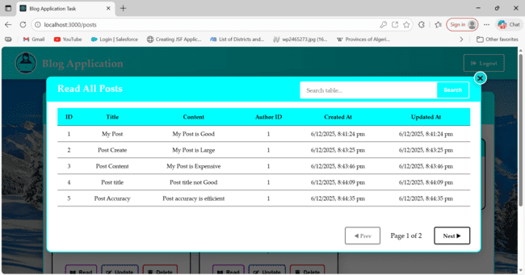

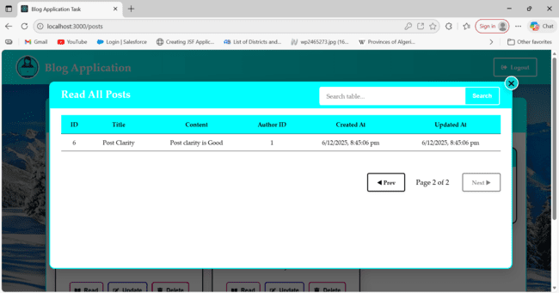

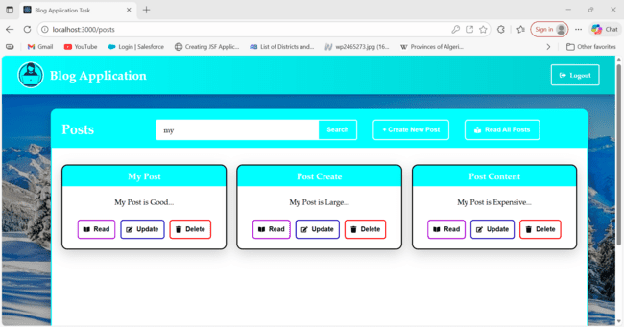

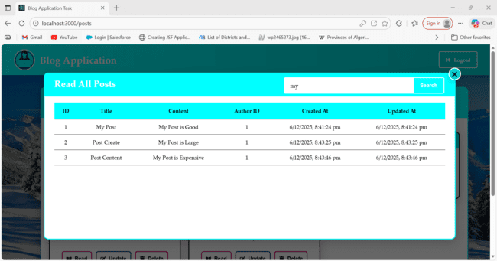

Step 9:- you can create many post cards then click on Read button then display Posts card Read Single details in container.

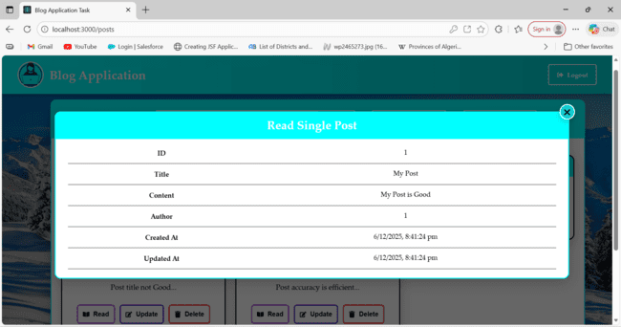
Step 10:- you can create many post cards then click on Update button then display Posts card Update Single details in container and you can edit any input details and click Update button display Post Update Successfully.

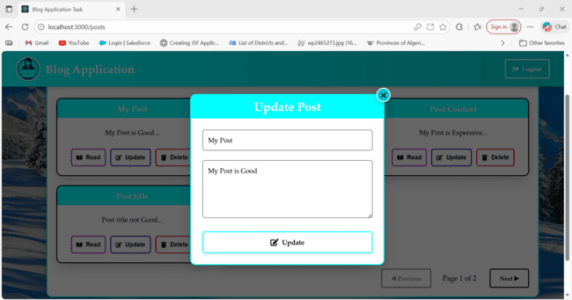

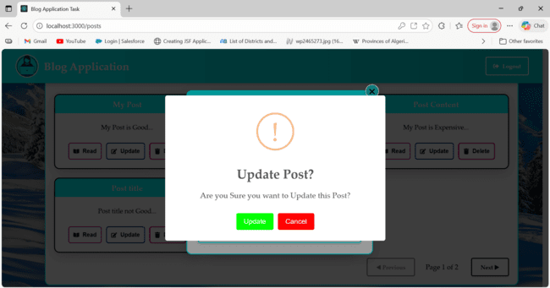

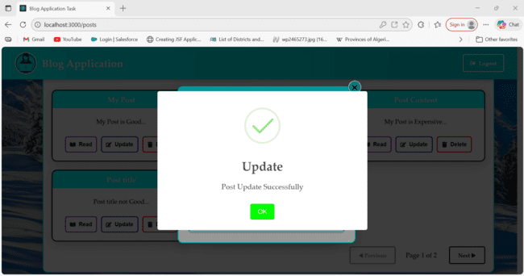

Step 11:- you can selected post card click delete button then Delete Post Card Successfully.

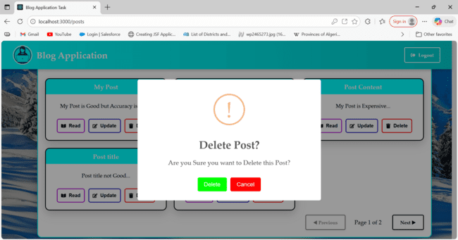

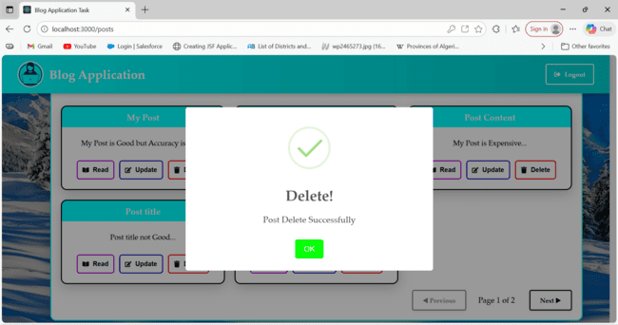

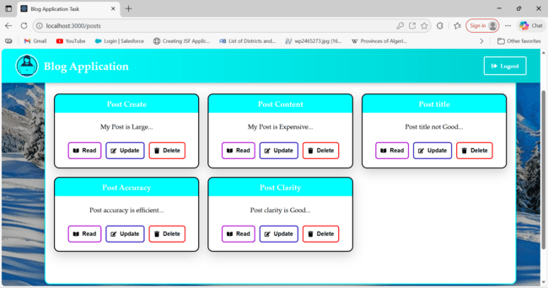

Step 12:- You can selected post card click then open Comments Container.

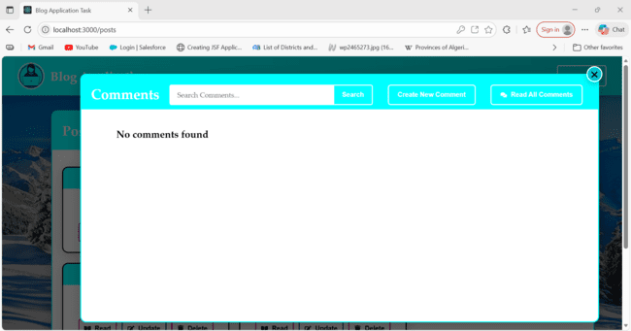

Step 13:- You can click Create New Comments button then open Create New Comments Form Author id is automatically display and then input field is blank click Create Comments button display Swal error message and write a comments click Create Comments button display Create Comments Successfully and data insert in database table comments.

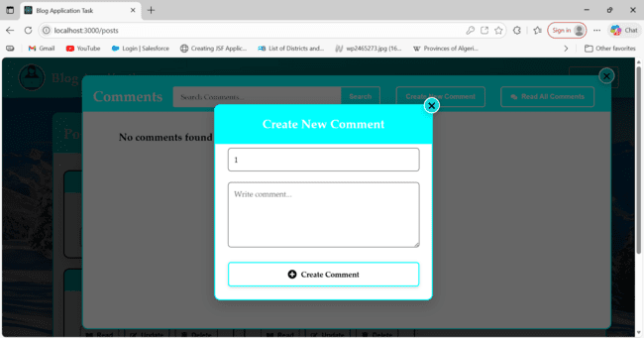

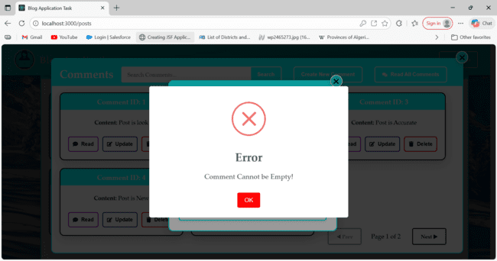

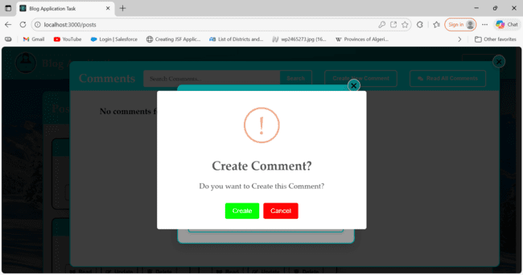

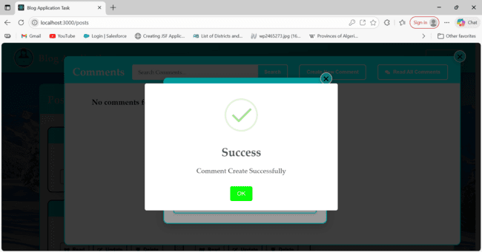

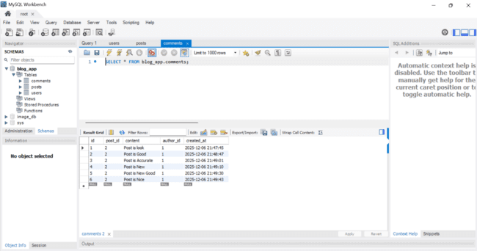

Step 14:- Then Comments Same Workflow as Posts and display Comments in selected Post card.

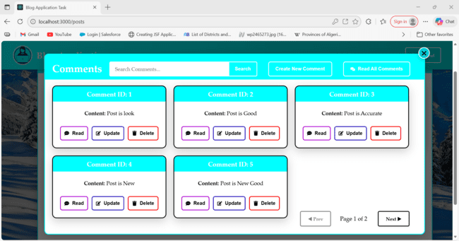

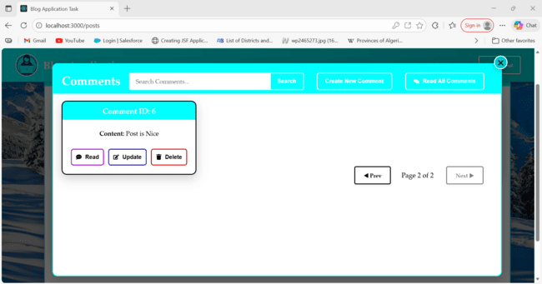

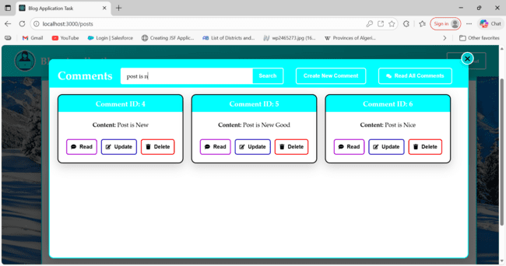

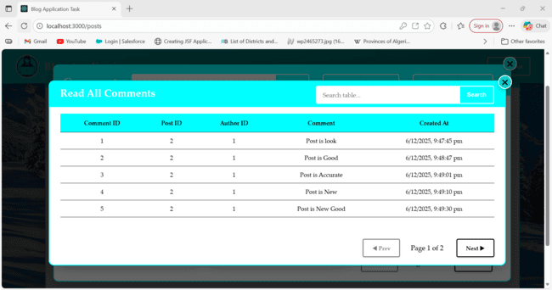

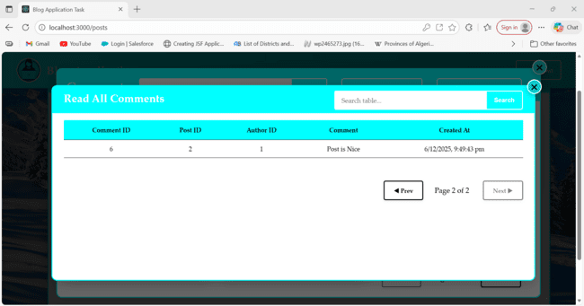

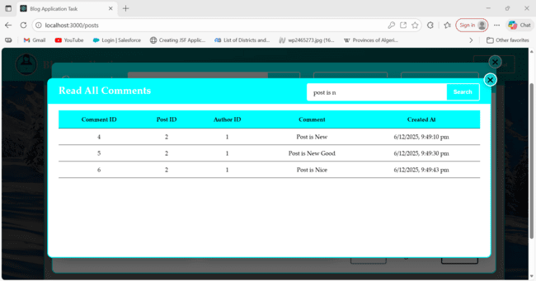

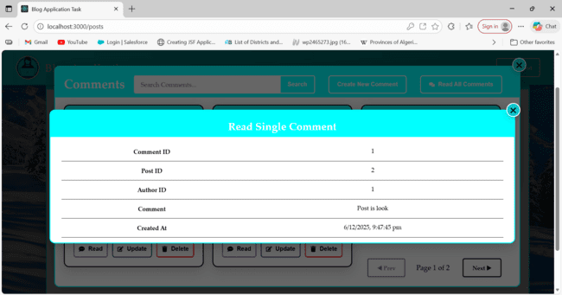

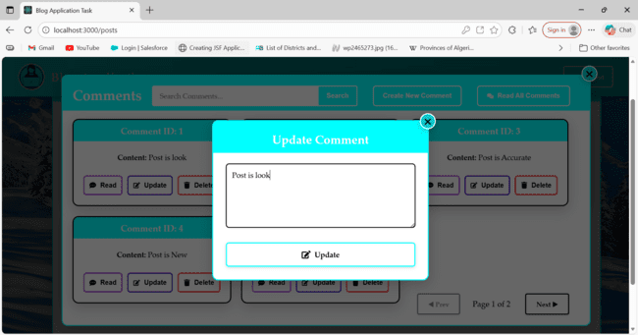

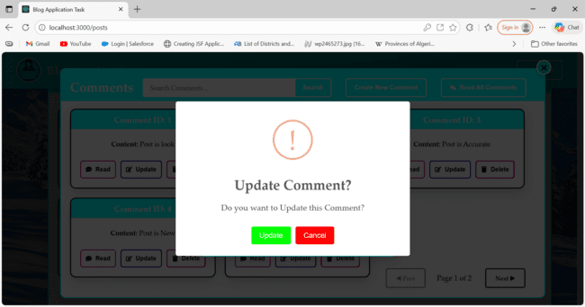

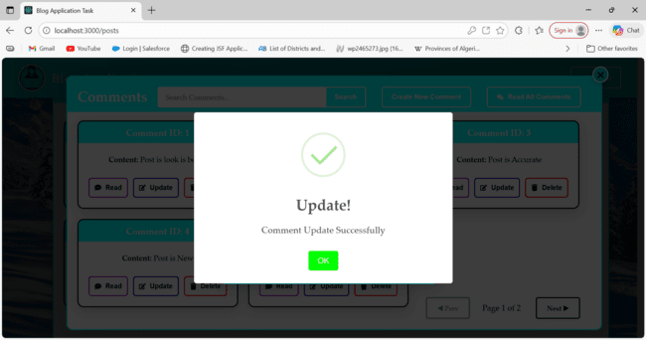

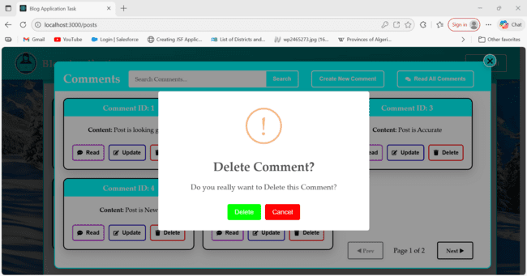

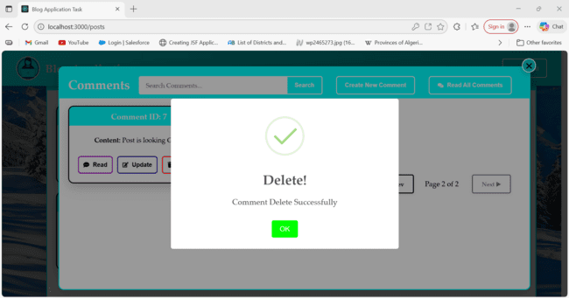

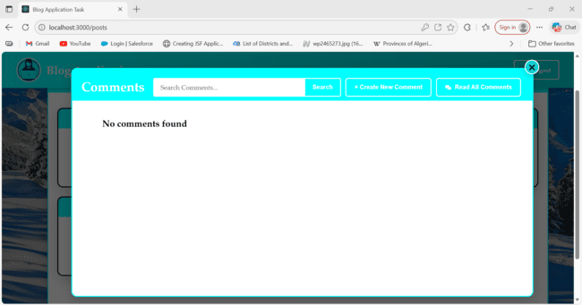

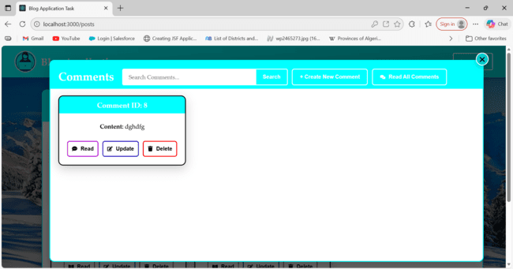

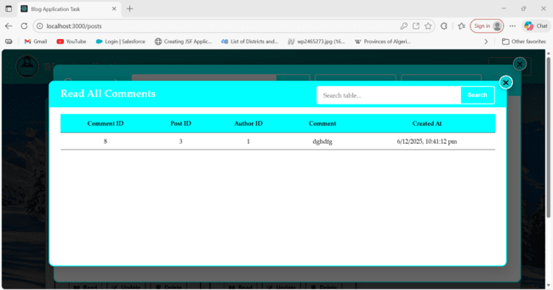

Step 15:- Then click Logout button display Logout Successfully and page redirect in Home Page.

