Job Search Workflow Report
Collecting job listings automatically into a Google Sheet using n8n
17 October 2026

1. Overview
This report shows, step by step, how to build a small automation in n8n. With one click, it looks up job openings on Google Jobs for any job title and place you choose, tidies the results, and saves them in a Google Sheet.
In this example the search is for "software developer" in the United States. The workflow found 10 job openings and listed each one with its title and location in the sheet.
The workflow has five parts, in this order:
Part | What it does
Manual Trigger | Starts the workflow when you click Execute
Edit Fields | Holds what you want to search for (job title and place)
HTTP Request | Asks the SerpApi service for Google Jobs results
Code | Picks out the useful details from the results
Google Sheets | Writes each job as a new row in your sheet

2. What You Need Before Starting
- An n8n account (the screenshots use the free trial).
- A SerpApi key. This is a personal code from serpapi.com that lets the workflow fetch Google Jobs results.
- A Google account with a Google Sheet ready to receive the jobs.

3. Step-by-Step Guide

Part A: Start the Workflow

Step 1: Create a new workflow
Open the n8n Overview page. You will see your existing workflows listed. Click the orange Create workflow button at the top right.
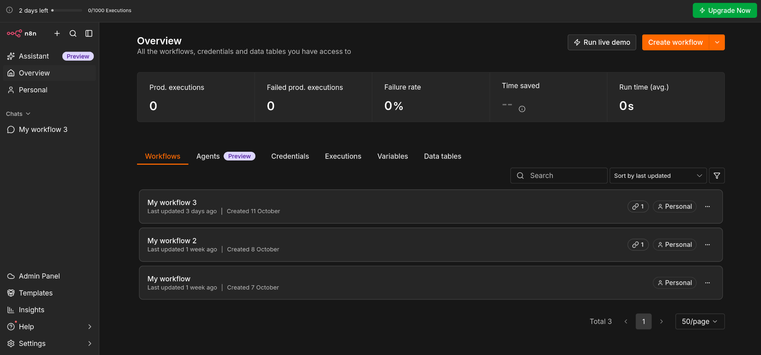
Figure 1: The n8n Overview page with the Create workflow button

Step 2: Choose the manual trigger
A trigger decides how the workflow begins. Choose the manual option, so the workflow runs whenever you click Execute workflow. It appears as a node named "When clicking Execute workflow".
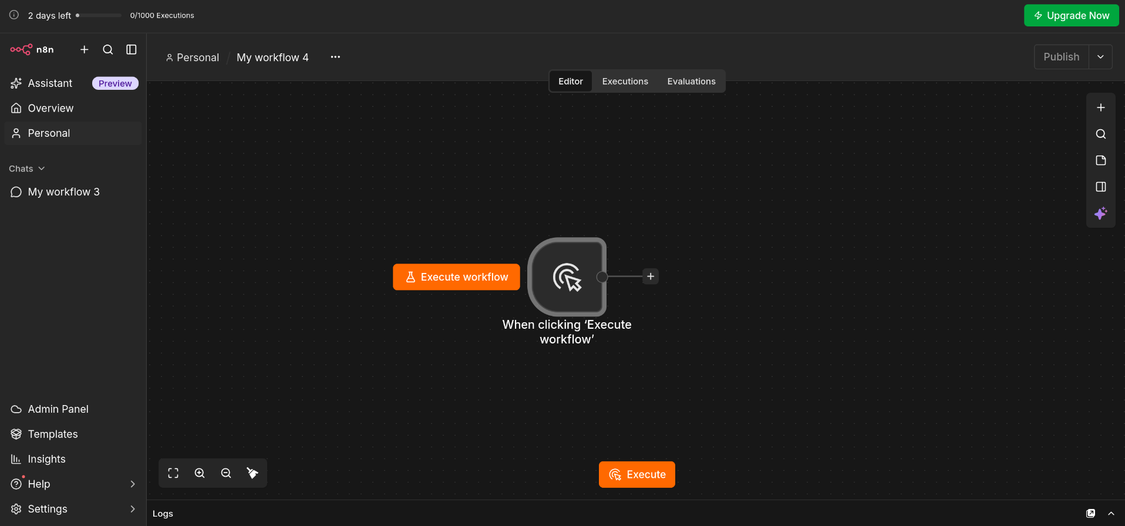
Figure 2: The manual trigger on a blank canvas
Next, click the + sign on the right side of the node to add the next step.

Part B: Set What to Search For

Step 3: Add the Edit Fields node
A panel called "What happens next?" opens on the right. Type "edi" in the search box and pick Edit Fields (Set). This node stores the details of your search.
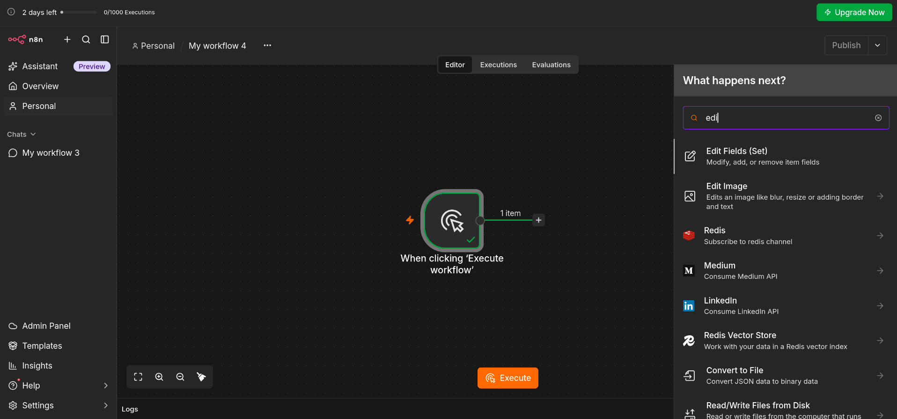
Figure 3: Searching for the Edit Fields node

Step 4: Click Add Field
Inside the Edit Fields window, click Add Field to create a new box for your information.
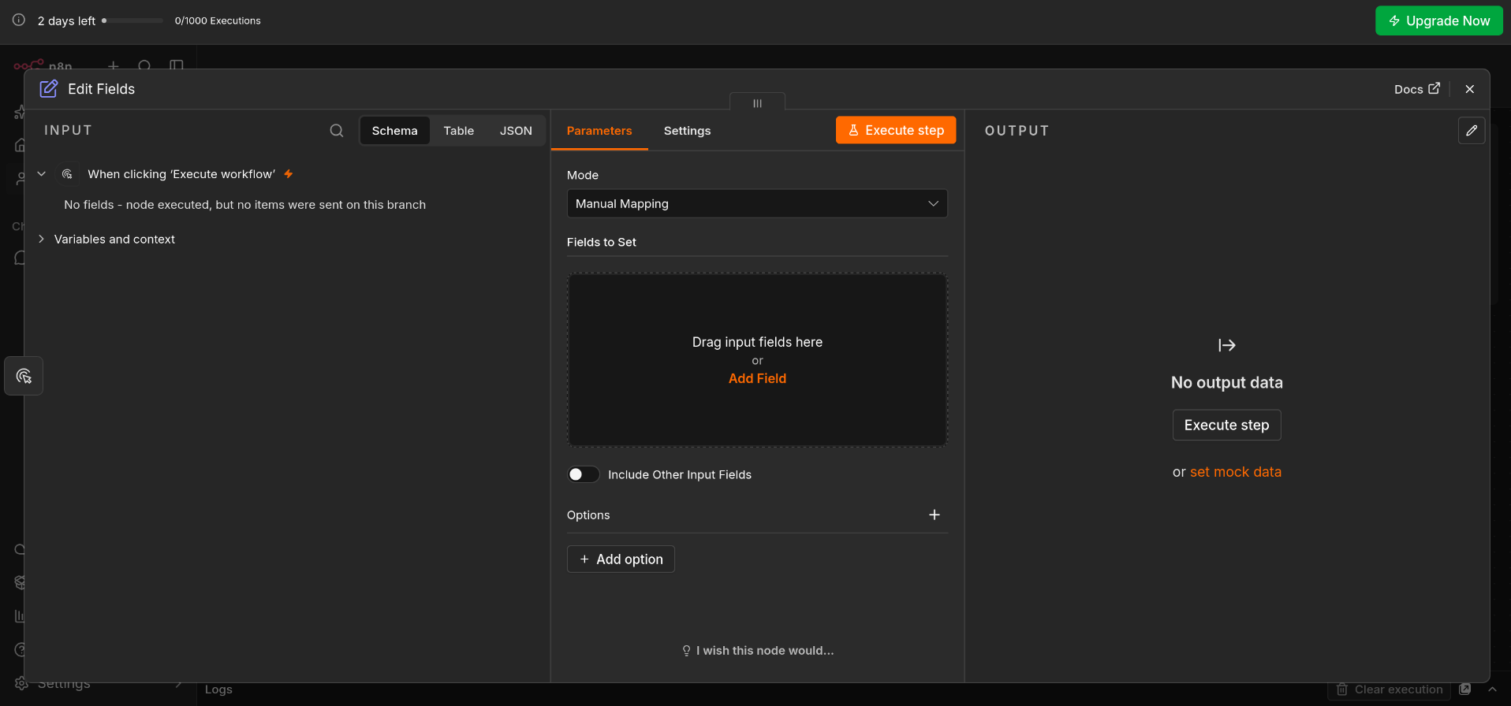
Figure 4: The Edit Fields window before any field is added

Step 5: Type your job title and place
Create two fields:
Field name | Example value
type query | software developer
type location | us

You can change these two values at any time to search for a different job or place.
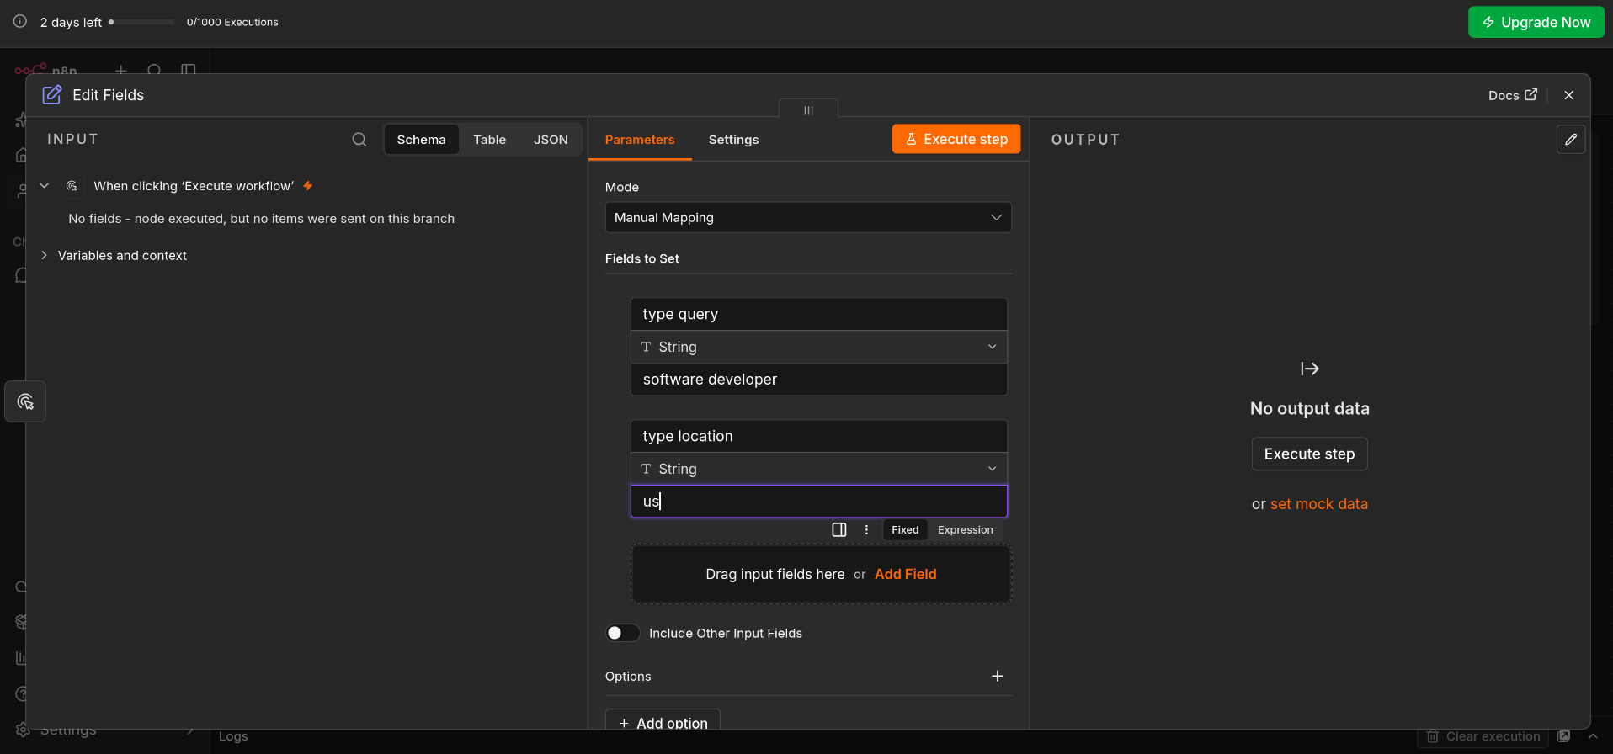
Figure 5: The two fields filled in
Close the window. Your workflow now has two connected nodes.
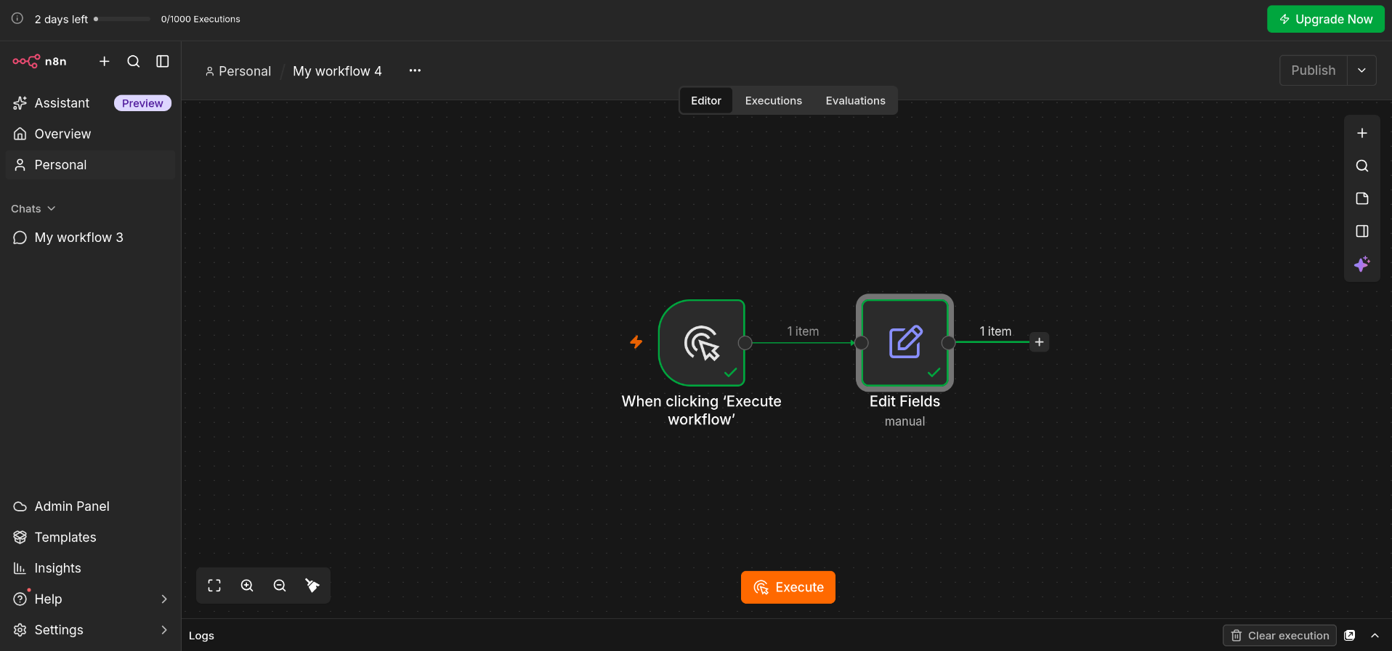
Figure 6: The trigger connected to Edit Fields

Part C: Fetch the Jobs

Step 6: Add an HTTP Request node
Click the + sign again, type "http" in the search box, and choose HTTP Request. This node connects to SerpApi and brings back the job results.
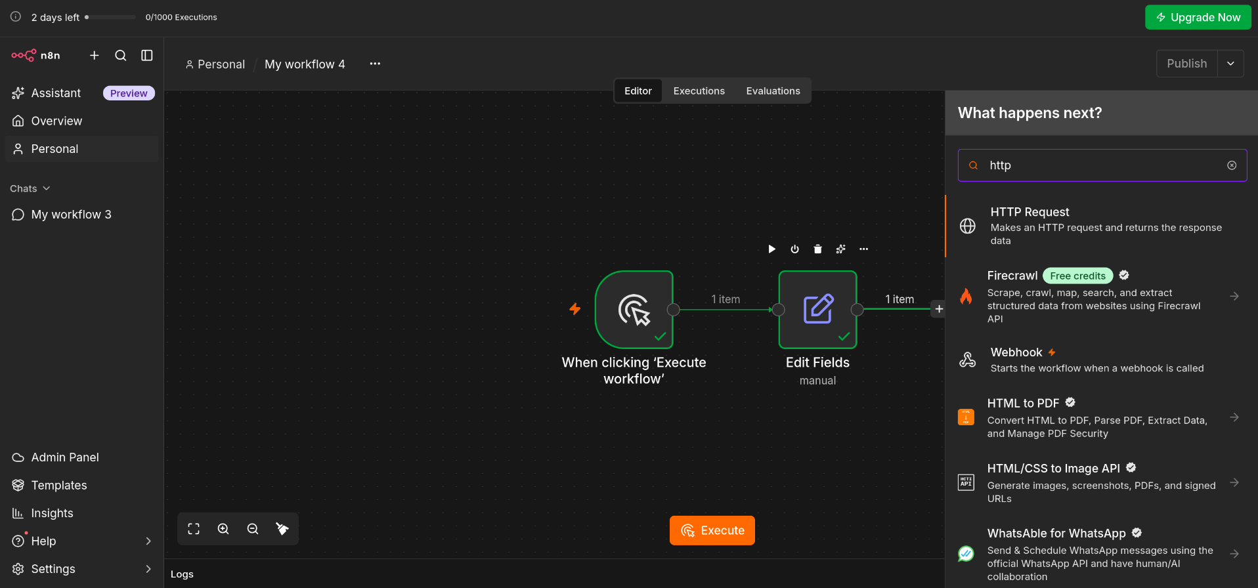
Figure 7: Choosing the HTTP Request node

Step 7: Enter the web address
In the HTTP Request window, set the following:
- Method: GET
- URL: https://serpapi.com/search.json
- Send Query Parameters: switch it on, and choose "Using Fields Below"
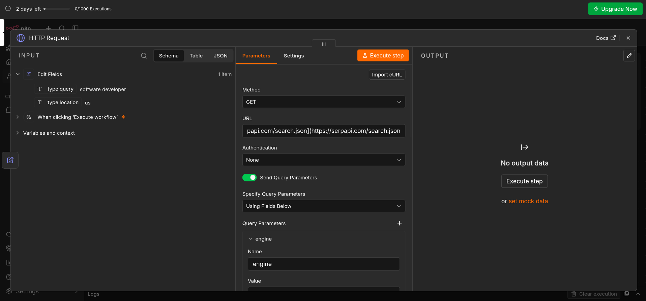
Figure 8: The HTTP Request settings

Step 8: Add the search details
Under Query Parameters, add the items below. The two values that look like {{ ... }} pull in what you typed in Step 5, so you only change them in one place.
Name | Value | Meaning
engine | google_jobs | Search the Google Jobs service
q | {{ $json["type query"] }} | The job title from Step 5
location | {{ $json["type location"] }} | The place from Step 5
api_key | Your SerpApi key | Your personal access code

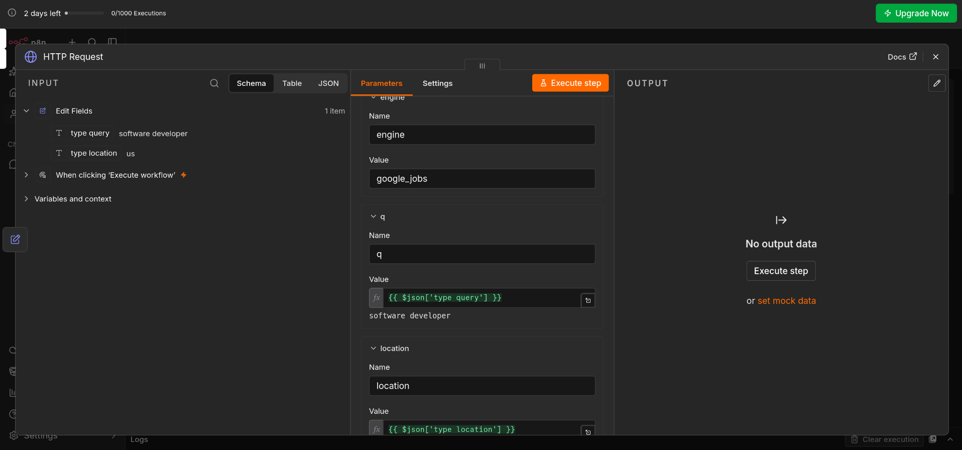
Figure 9: The engine, q and location settings
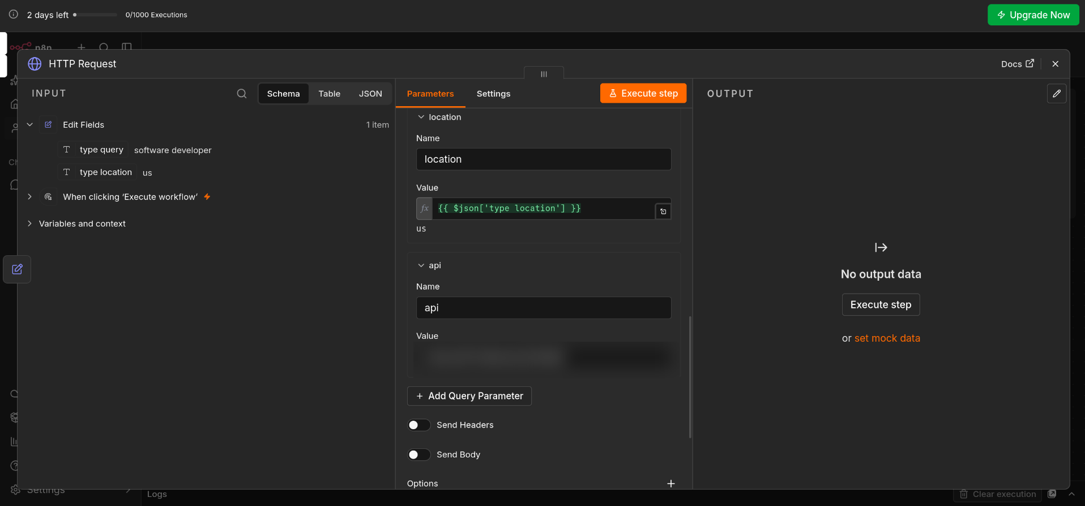
Figure 10: The location and key settings (the key is hidden here)
Tip: Keep your key private. Hide it when you share screenshots, and never post it publicly.

Step 9: Run the step
Click Execute step. A green message says "Workflow executed successfully", and the right side fills with information such as the status ("Success"), the search used ("software developer") and the place ("United States").
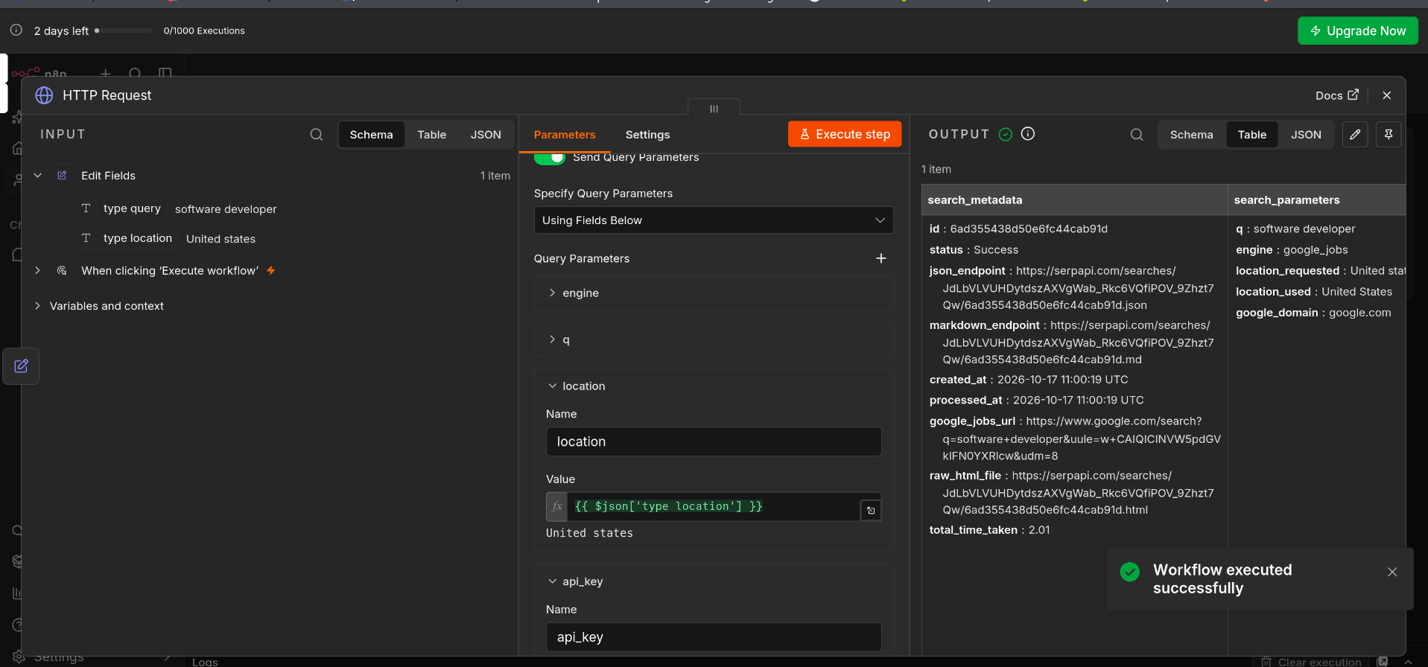
Figure 11: A successful result from the HTTP Request

Part D: Pick Out the Useful Details

Step 10: Add a Code node
The results contain a lot of information. A Code node keeps only what you need. Click the + sign, type "code", and choose Code (Run custom JavaScript or Python code).
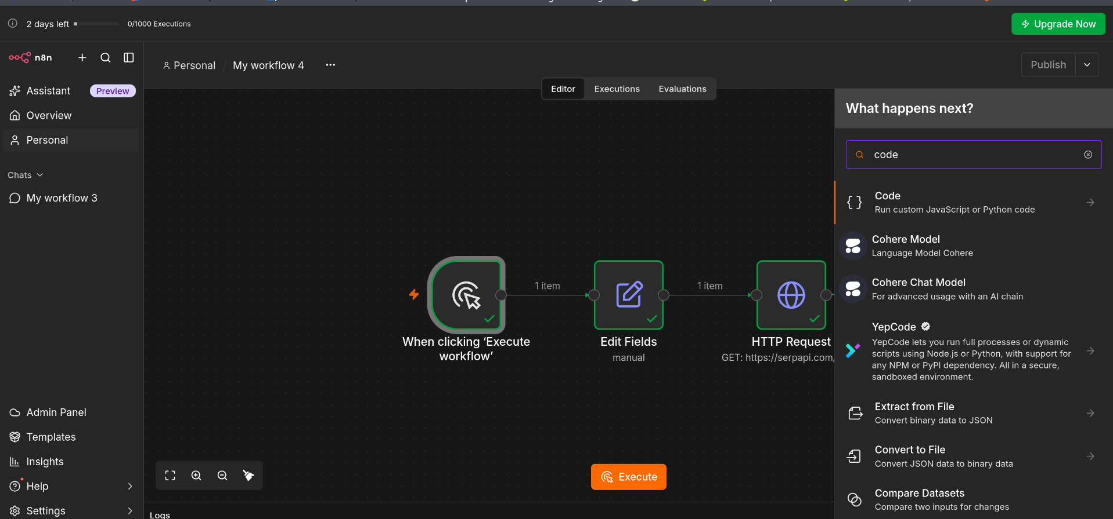
Figure 12: Choosing the Code node

Step 11: Paste the code
Set Mode to "Run Once for All Items" and Language to JavaScript, then paste this code:
const response = $input.first().json;
const jobs = response.jobs_results || [];

return jobs.map(job => {
return {
json: {
title: job.title || 'N/A',
company: job.company_name || 'N/A',
location: job.location || 'N/A',
salary: job.detected_extensions?.salary || 'Not specified',
link: job.related_links?.[0]?.link || job.thumbnail || 'N/A',
dateAdded: new Date().toISOString().split('T')[0]
}
};
});

What the code does, in plain words:
- It takes the list of jobs that came back from the search.
- For each job, it keeps the title, company, location, salary, a link, and today’s date.
- If a detail is missing, it fills in "N/A" or "Not specified" so no cell is left blank.
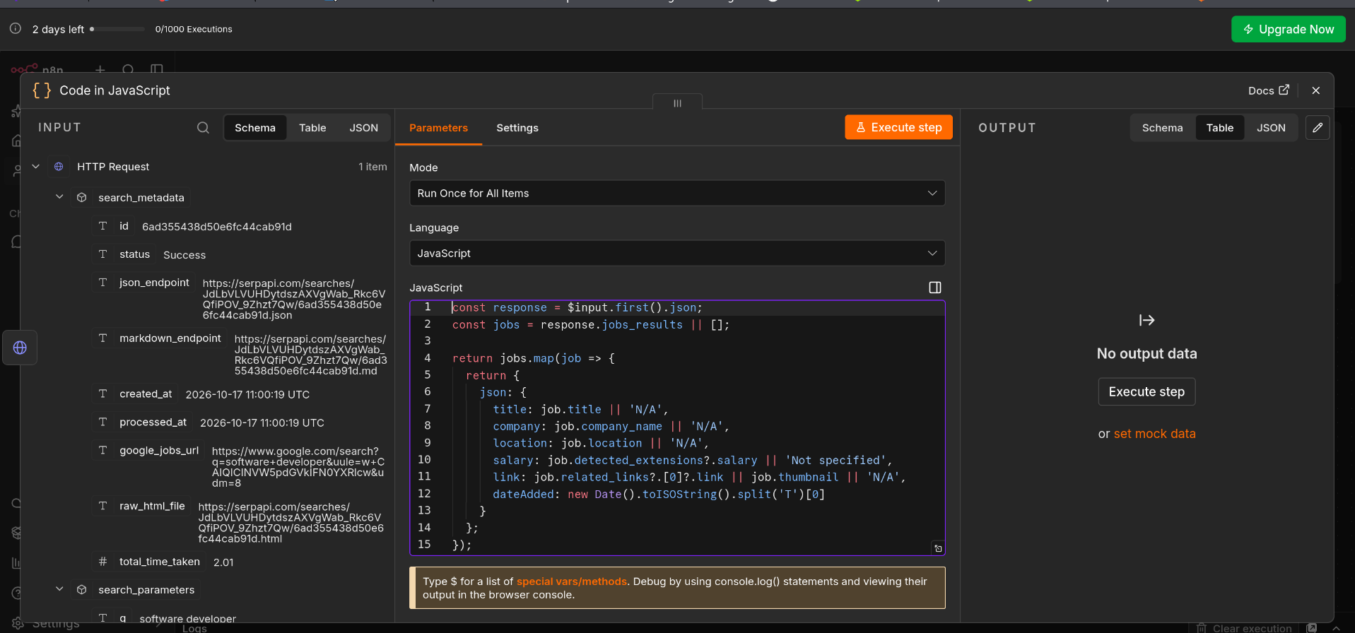
Figure 13: The code pasted into the Code node

Step 12: Run the step
Click Execute step. The output shows 10 items, one for each job, in a neat table with title, company, location, salary and link.
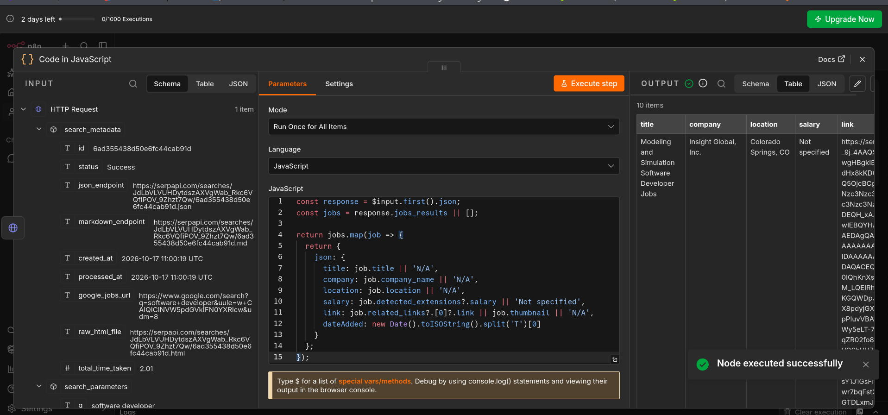
Figure 14: The Code node output with 10 job items
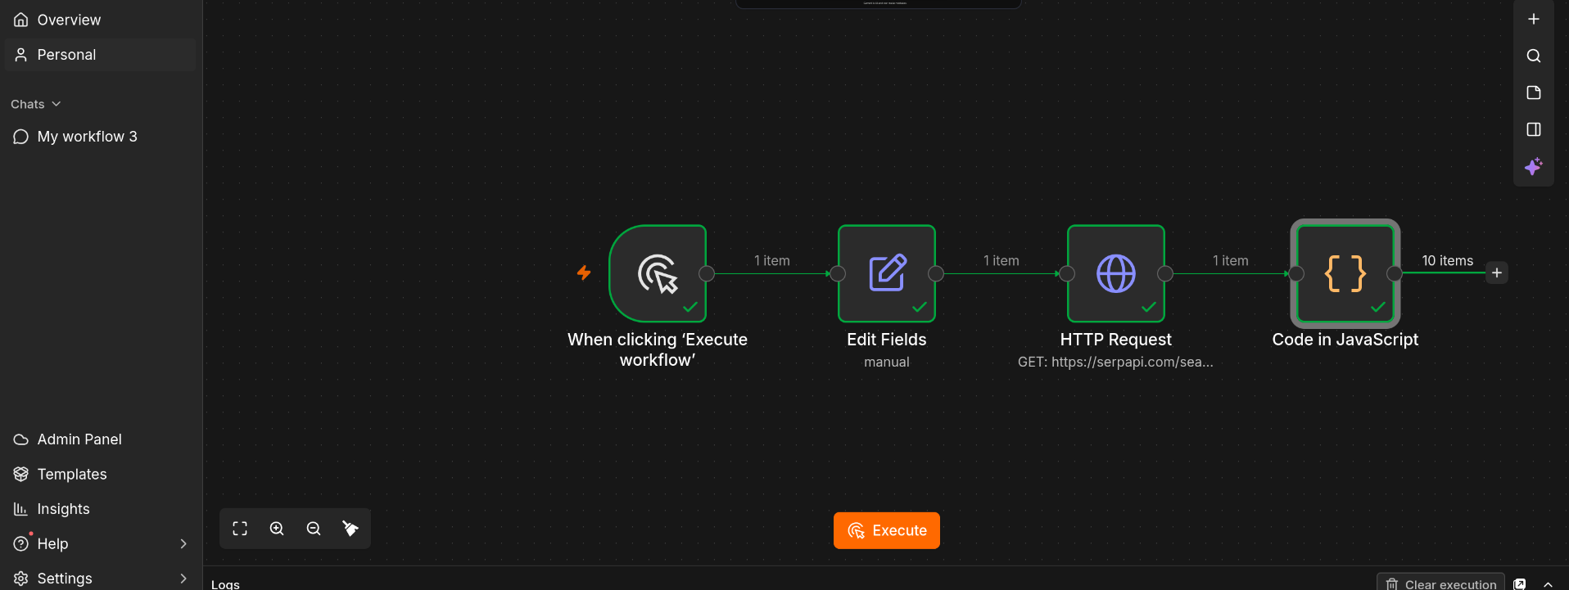
Figure 15: The workflow now has four nodes

Part E: Save the Jobs in Google Sheets

Step 13: Prepare your Google Sheet
Create a new Google Sheet and type the column names in the first row. Use these names so they match the next steps: jobs, location and salary. You can add a company column too if you would like to save it as well.
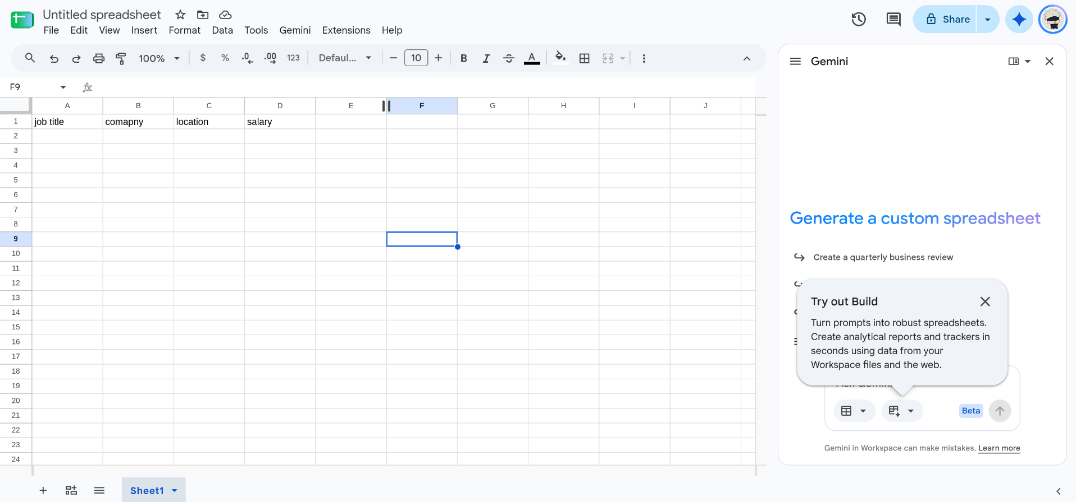
Figure 16: A new sheet with column names in the first row

Step 14: Add the Google Sheets node
Click the + sign after the Code node and choose Google Sheets. Then fill in the settings:
Setting | What to choose
Credential | Your Google Sheets account
Resource | Sheet Within Document
Operation | Append Row
Document | Your sheet, picked "From list" (here: n8n)
Sheet | Sheet1
Mapping Column Mode | Map Each Column Manually

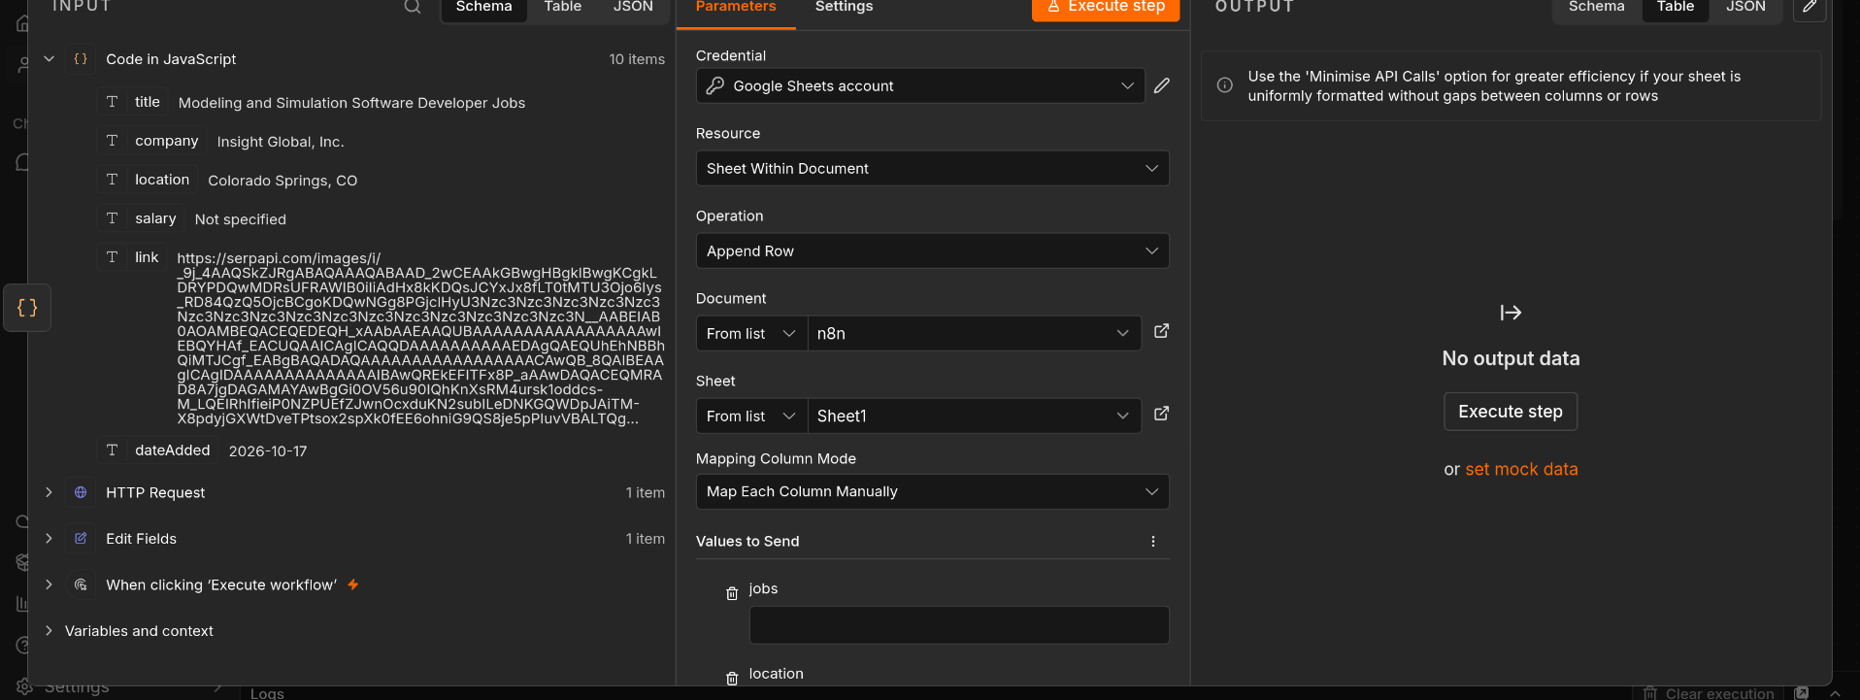
Figure 17: The Google Sheets settings

Step 15: Match each column to its value
Under Values to Send, link each column to the matching item from the Code node:
Column | Value
jobs | {{ $json.title }}
location | {{ $json.location }}
salary | {{ $json.salary }}

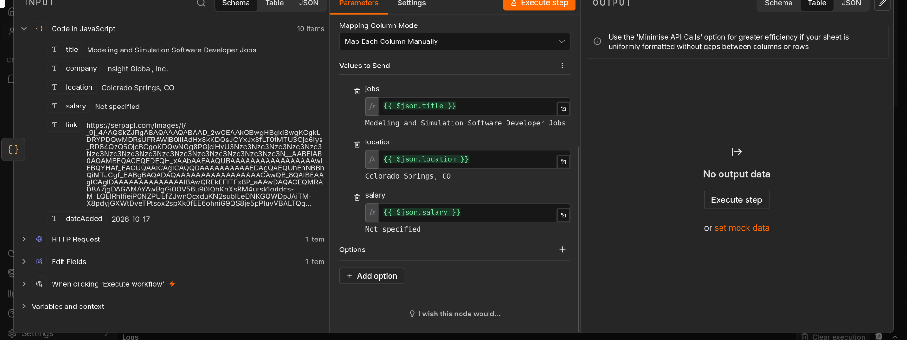
Figure 18: Each column matched to its value

Step 16: Run it and check your sheet
Click Execute step. The output lists all 10 jobs with their places and salaries.
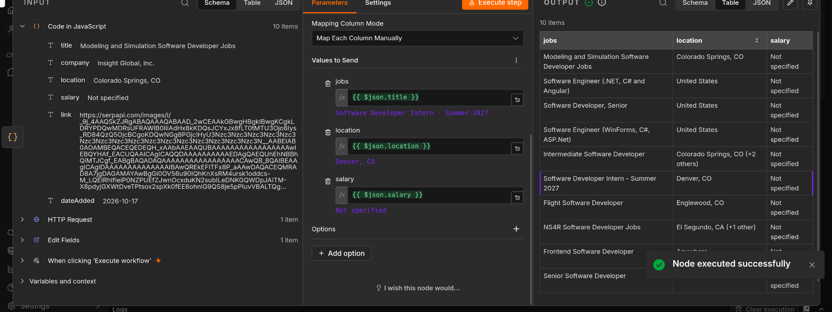
Figure 19: The Google Sheets node output
Now open your Google Sheet. Each job has its own row, filled in automatically.
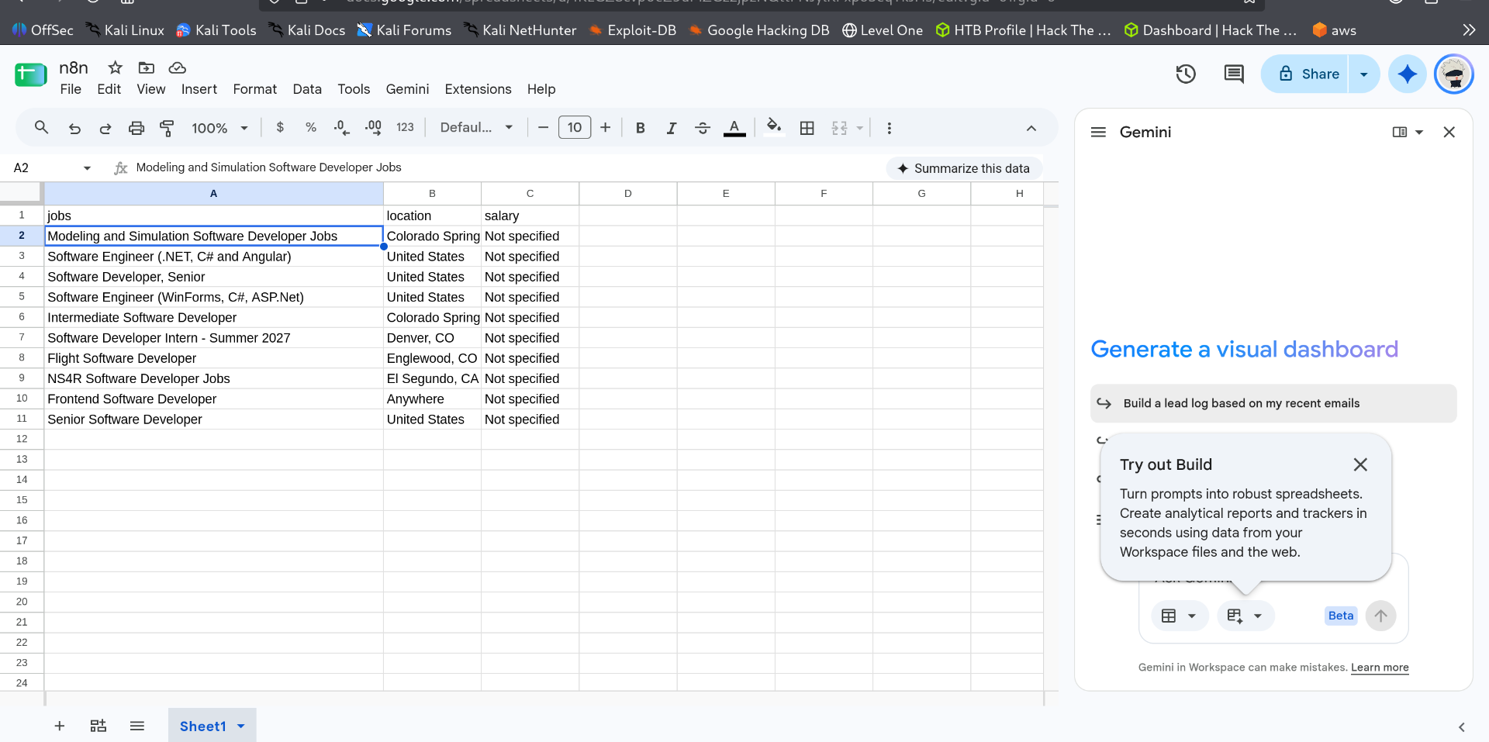
Figure 20: The finished Google Sheet with 10 jobs

4. Result
With one click on Execute, the workflow searched Google Jobs for "software developer" in the United States and saved 10 openings into a Google Sheet. Each row shows the job title, location and salary (or "Not specified" when the listing has no salary).

5. Ideas for Using It
- Change the job title or place in Step 5 to search for any other role or city.
- Add the company and link columns to the sheet to keep more details for each job.
- Use the Schedule trigger in place of the manual one to collect new jobs every day on its own.
- Share the sheet with your team so everyone sees the latest openings.

