TryHackMe "Lookup" — Walkthrough Report
Target: lookup.thm
Platform: TryHackMe
Difficulty: Boot-to-root (enumeration focused)

Overview
This report documents the full process of enumerating, gaining access to, and escalating privileges on the "Lookup" machine, from initial scan through to root access.
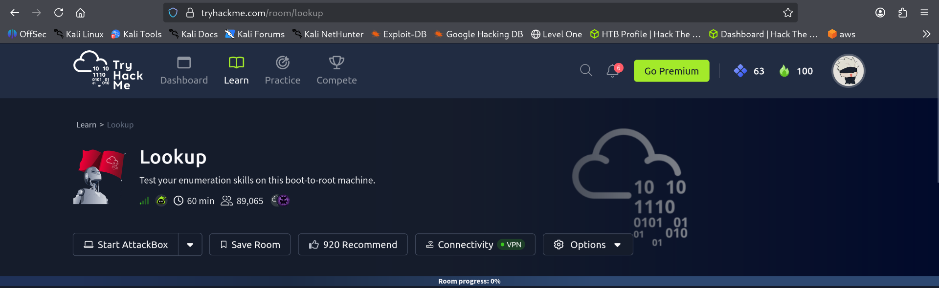
The TryHackMe "Lookup" room page

1. Initial Scan
A full port scan was run to find out what services were running on the target:
nmap <ip> -p- -vv -sV
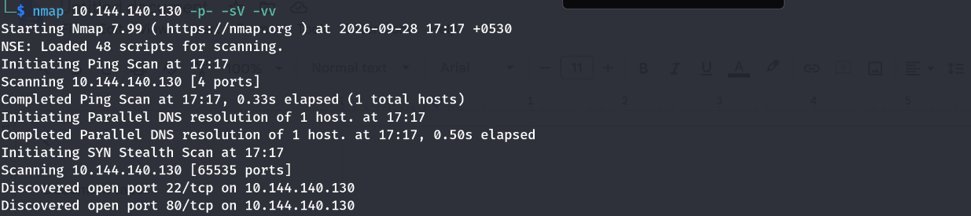
Nmap scan showing ports 22 and 80 open
Result: Two open ports were found — Port 22 (SSH) and Port 80 (HTTP).

2. Accessing the Web Service
The web page did not load directly through the IP address, so the machine's hostname was added to the local hosts file:
sudo nano /etc/hosts
The target IP was mapped to lookup.thm. Opening the site in a browser then displayed a login page.
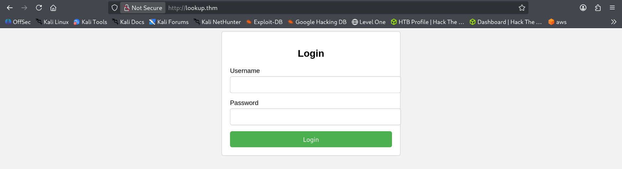
Login page at http://lookup.thm

3. Initial Enumeration
- Checked robots.txt — returned "Not Found," no useful information.
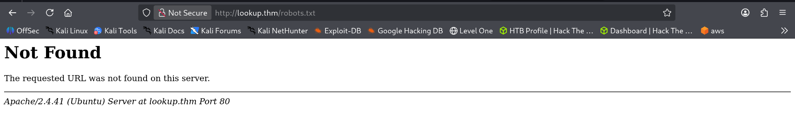
robots.txt — Not Found
- Viewed the page source — revealed a standard login form (login.php) with username and password fields, posting via POST.
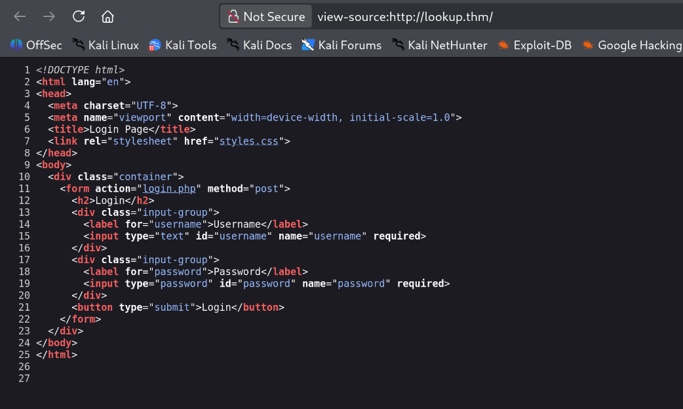
Page source of the login form
- Attempted a SQL injection payload on the login form — this did not succeed.
- Viewed the source of login.php directly, which hinted that two pieces of information were needed to log in (a valid username and password had to be found).

4. Username Enumeration
Used ffuf to brute-force valid usernames against the login form:
ffuf -w /usr/share/wordlists/seclists/Usernames/xato-net-10-million-usernames.txt -X POST -u http://lookup.thm/login.php -d "username=FUZZ&password=pwned" -H "Content-Type: application/x-www-form-urlencoded"
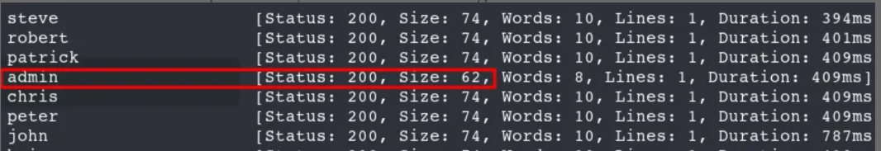
The "admin" response stands out from the rest
Result: The response for username "admin" returned a different size/word count than the rest, indicating it was a valid account.

5. Password Enumeration
Attempted admin:admin — failed:
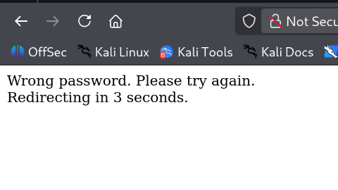
"Wrong password" response
Brute-forced the password field for the admin account:
ffuf -w /usr/share/wordlists/seclists/Passwords/xato-net-10-million-passwords-1000000.txt -X POST -u http://lookup.thm/login.php -d "username=admin&password=FUZZ" -H "Content-Type: application/x-www-form-urlencoded"
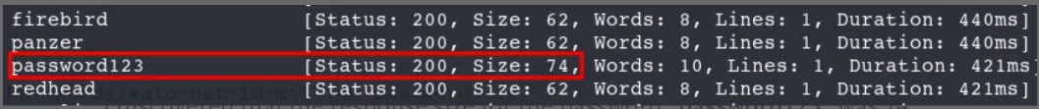
"password123" stands out from the rest
Result: "password123" stood out with a different response size, but logging in as admin:password123 still failed:
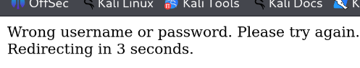
"Wrong username or password" response

6. Re-checking the Username
Since the password was valid for some account, the username field was brute-forced again, this time paired with the known password:
ffuf -w /usr/share/wordlists/seclists/Usernames/xato-net-10-million-usernames.txt -X POST -u http://lookup.thm/login.php -d "username=FUZZ&password=password123" -H "Content-Type: application/x-www-form-urlencoded"
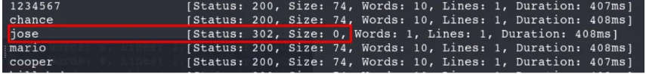
"jose" returns a 302 redirect — valid login
Result: The username "jose" returned a 302 redirect (success), confirming the valid credentials: jose / password123.

7. Discovering a Second Subdomain
After logging in, a new subdomain, files.lookup.thm, was found. At first it did not resolve:
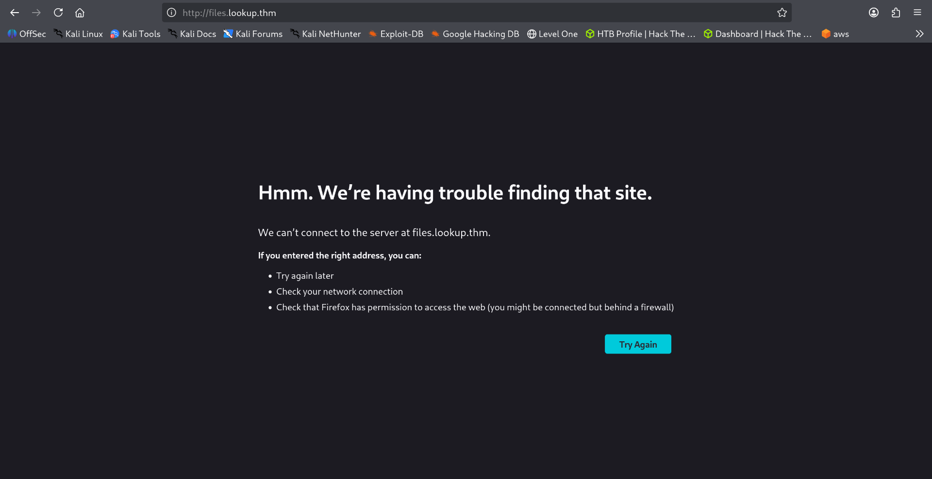
files.lookup.thm not resolving before the hosts-file edit
This was added to /etc/hosts as well. Browsing to it revealed a file manager interface (elFinder) listing several text files (e.g. admin.txt, root.txt, credentials.txt, ftp.txt, etc.):
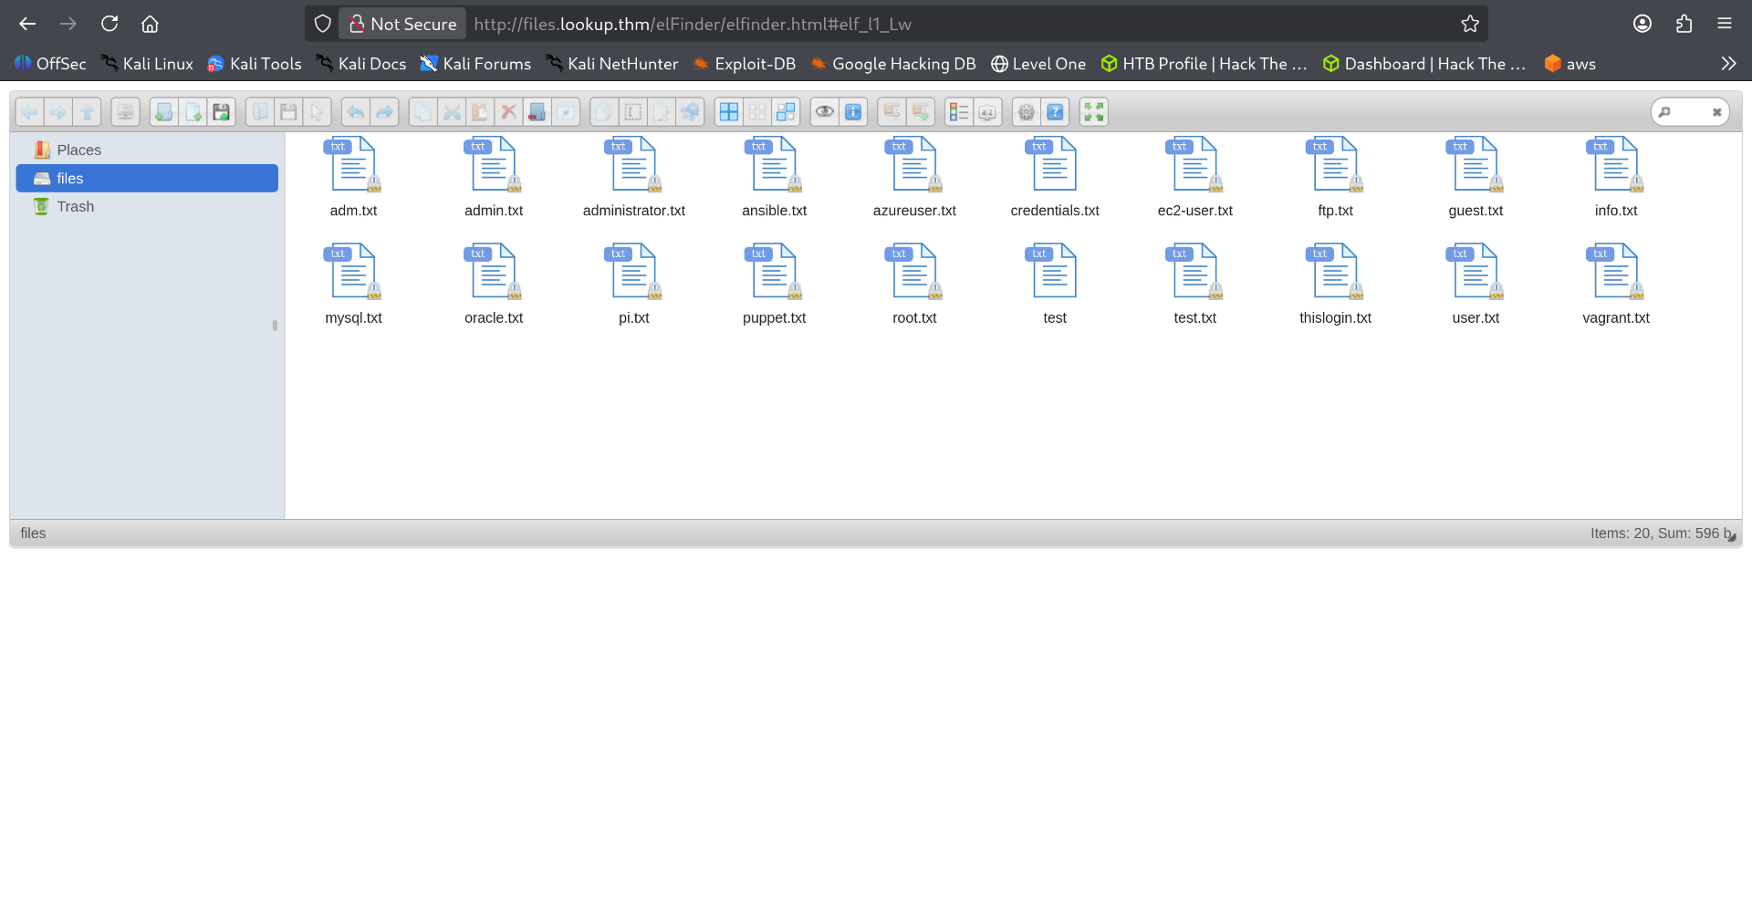
elFinder file listing on files.lookup.thm

8. Identifying the File Manager Version
The "About" panel inside elFinder revealed the software and version: elFinder, version 2.1.47.
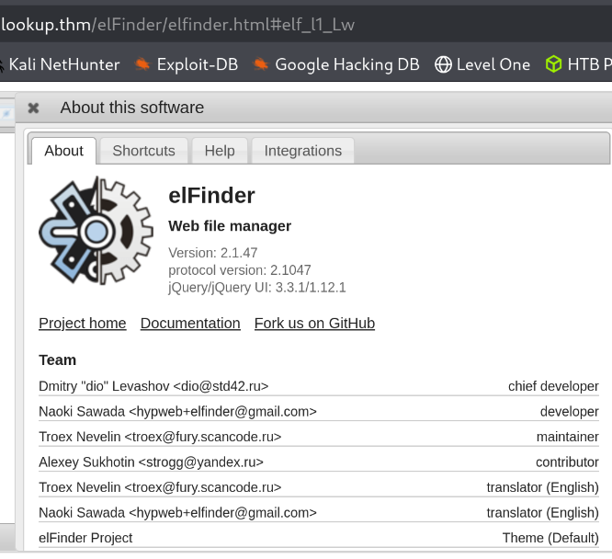
elFinder version 2.1.47
A search was run for known exploits against this version:
searchsploit -m elFinder v2.1.47
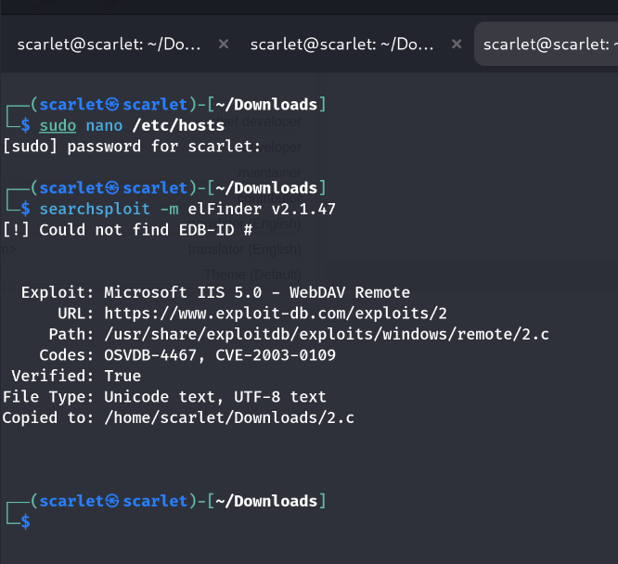
Setting up /etc/hosts and searching exploit-db

9. Exploiting elFinder
A public PHP connector exploit for elFinder 2.1.47 was downloaded. The exploit works by uploading a file (disguised as an image) through the upload dialog, then triggering command execution through a crafted request:
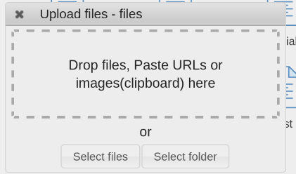
elFinder upload dialog
/elFinder/php/SecSignal.php?c=<command>
This was used to run "id" and confirm remote code execution.

10. Gaining a Reverse Shell
A listener was started locally, and the crafted request was used to trigger a reverse shell connection back to it, resulting in a shell as the www-data user:
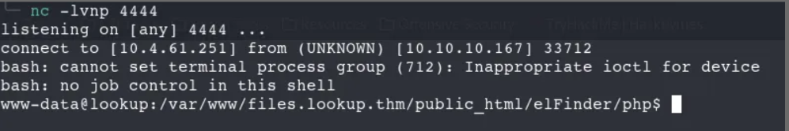
Reverse shell received as www-data

11. Post-Exploitation Enumeration
Exploring the home directories revealed a "think" user with a user.txt file that could not yet be read:
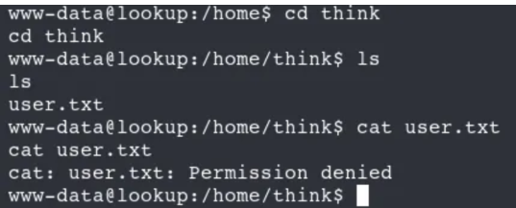
user.txt — permission denied as www-data
Listing hidden files showed a protected .passwords file owned by root:
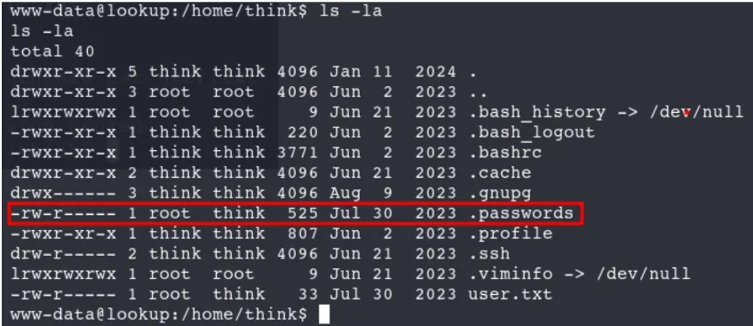
A hidden .passwords file readable only by root and think
A search for SUID binaries was run:
find / -perm -4000 -type f 2>/dev/null
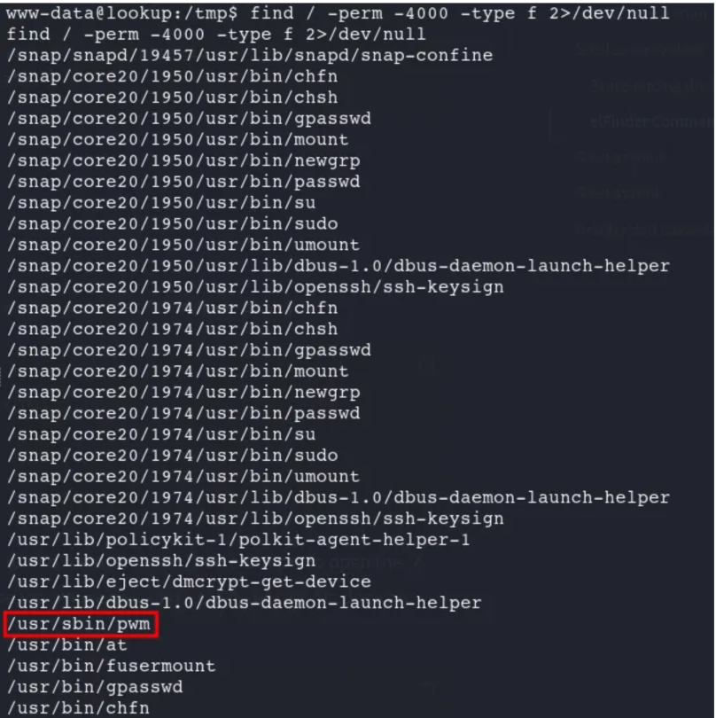
SUID search revealing a custom binary: /usr/sbin/pwm

12. Abusing the Custom SUID Binary
Running /usr/sbin/pwm showed that it executes the "id" command internally and tries to read a password file matching the current user's name:
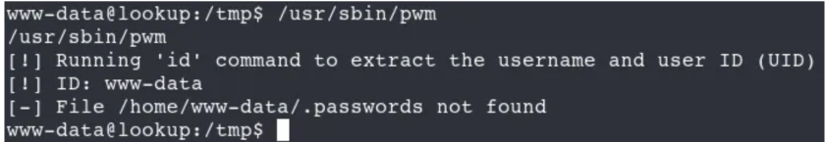
pwm looks for a password file matching the current user
By placing a fake "id" script earlier in the PATH:
echo -e '#!/bin/bash\necho "uid=1000(think) gid=1000(think) groups=1000(think)"' > /tmp/id
chmod +x /tmp/id
...the binary was tricked into believing the current user was "think", causing it to output the contents of think's hidden password list:
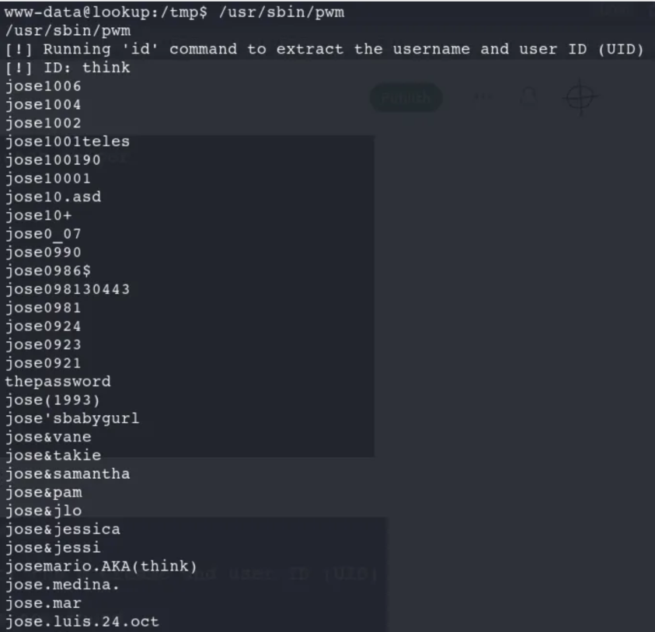
Password candidates leaked by the tricked pwm binary

13. Cracking the Password
The list of candidate passwords produced by pwm was used with hydra to brute-force a valid password for the think account, successfully returning shell access as the think user.

14. Privilege Escalation to Root
Checking sudo permissions (via GTFOBins guidance) showed that the think user could run the "look" command as root without restriction. look is a GTFOBins entry that can be abused to read arbitrary files as root:
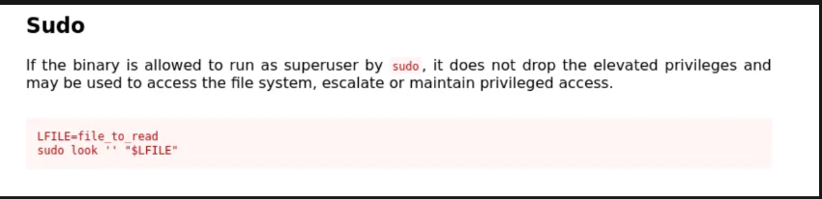
GTFOBins entry for the "look" sudo abuse
LFILE=/root/.ssh/id_rsa
sudo look '' "$LFILE"
This dumped the contents of root's private SSH key. The key was saved locally, permissions were restricted, and it was used to SSH in directly as root:
chmod 600 savedfilename
ssh -i savedfilename root@<machine-ip>
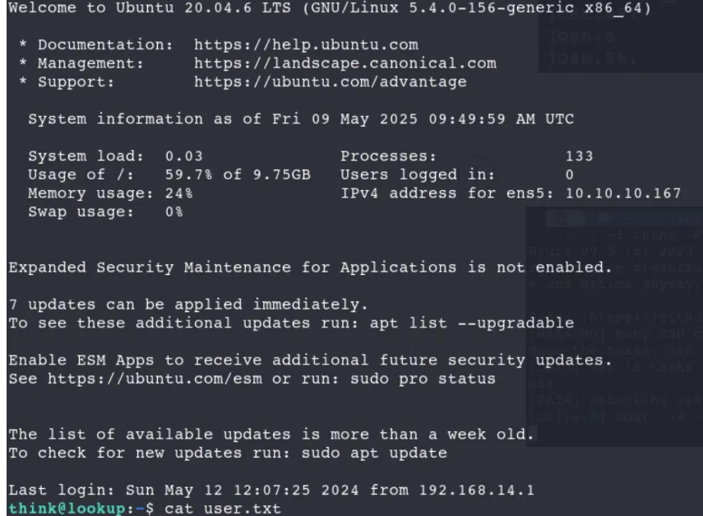
Logged in to the box as the think user

15. Root Access Confirmed
Logging in with the stolen key granted a root shell. Running "id" confirmed uid=0(root), and both root.txt and user.txt flags were successfully read.
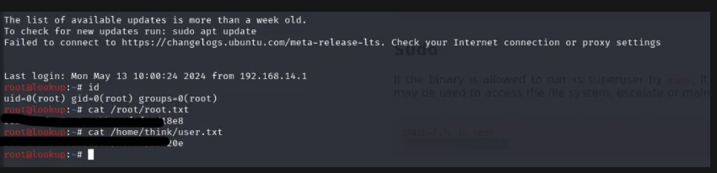
Root access confirmed — flags captured

Summary of Attack Chain
- Port scan found HTTP and SSH open.
- Found a login page; brute-forced valid username and password separately, then combined them correctly.
- Discovered a hidden file-manager subdomain running an outdated elFinder version.
- Exploited a known elFinder vulnerability to get remote code execution and a reverse shell.
- Found a custom SUID binary that leaked another user's password list when tricked via a fake command in PATH.
- Cracked the password with hydra to get a foothold as think.
- Abused a sudo misconfiguration (look command) to read root's SSH key.
- Logged in as root using the stolen key.

Key Lessons
- Weak separation between username/password validation can leak which part of a login is correct, making brute-forcing far easier.
- Running outdated third-party software (elFinder) exposes known, public exploits.
- Custom scripts that call system commands without a safe PATH can be hijacked (PATH injection).
- Overly broad sudo permissions for file-reading utilities can lead directly to full root compromise.

