TryHackMe — Lo-Fi Room Walkthrough
Local File Inclusion (LFI) Exploitation Report

Overview
This report documents a walkthrough of the "Lo-Fi" room on TryHackMe, a machine that runs a simple music-themed website. The goal of the room is to identify and exploit a Local File Inclusion (LFI) vulnerability in the site's page-loading feature, and use it to read a flag file stored on the server.

Step 1: Start the Machine
The target virtual machine is started from the TryHackMe room page, which assigns a target IP address.

Step 2: Copy the IP Address
The target IP address shown on the room page is copied for use in the following steps.

Step 3: Scan the Target
An Nmap port scan is run against the target to discover open ports and services:
nmap <TARGET_IP> -p-

Step 4: Open the Website
With a web server confirmed to be running, the site is opened in a browser:
http://<TARGET_IP>
The following "Lo-Fi Music" website is displayed:
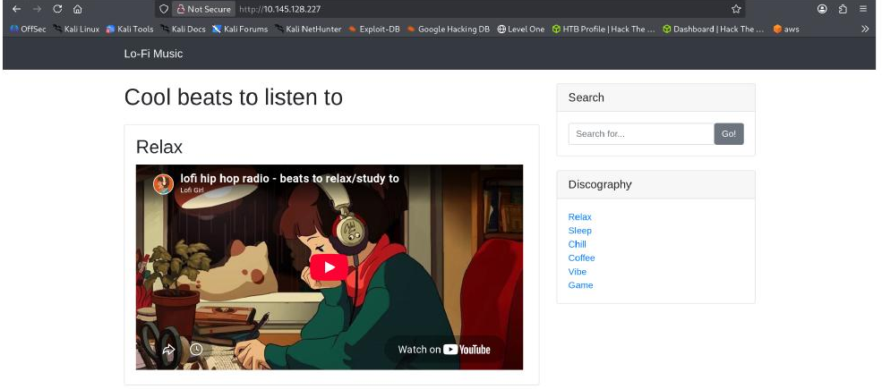
Figure 1 — The Lo-Fi Music homepage, with a Discography menu listing several pages.

Step 5: Inspect a Discography Link
Clicking one of the Discography links ("Relax") reveals how the site loads content — through a page parameter in the URL:
Figure 2 — The URL shows the site loading content via ?page=relax.php.
This kind of parameter, which tells the server which file to include and display, is a common source of Local File Inclusion vulnerabilities when the input is not properly restricted.

Step 6: Test for Local File Inclusion
To test whether the page parameter can be abused to read arbitrary files, the value is replaced with a traversal path pointing to a well-known system file:
Figure 3 — Modified URL: page=../../../../../../../../etc/passwd
The server responds by displaying the contents of the system's password file, confirming the vulnerability:
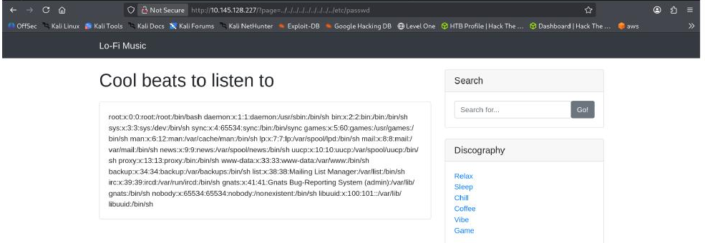
Figure 4 — Contents of /etc/passwd returned by the vulnerable page parameter.
Because an ordinary, restricted system file was successfully retrieved through the page parameter, this confirms the site has a Local File Inclusion (LFI) vulnerability.

Step 7: Retrieve the Flag
With LFI confirmed, the same traversal technique is used to look for the room's flag file:
page=../../../../../../../flag.txt
Figure 5 — Requesting flag.txt through the vulnerable parameter.
The flag is returned on the page. Its value has been blurred in this report:
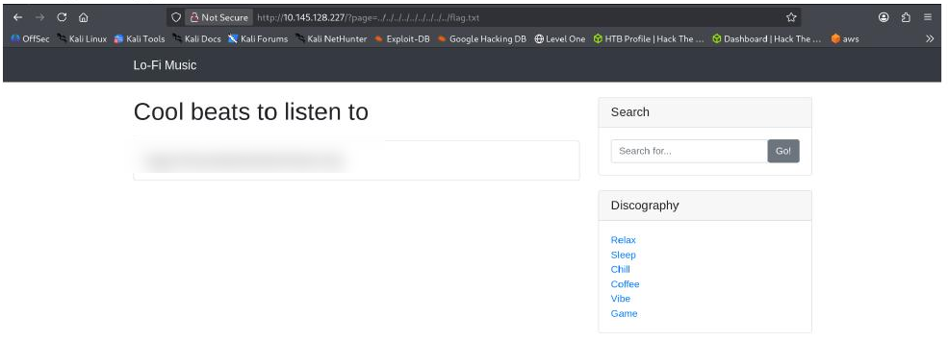
Figure 6 — The flag is successfully retrieved (value blurred for this report).

Summary
This walkthrough showed how an unvalidated "page" parameter allowed arbitrary local files to be read from the server. Reading /etc/passwd confirmed the vulnerability, and the same path-traversal technique was then used to retrieve the room's flag file, completing the challenge.
Basic prevention for this type of issue includes: validating and whitelisting allowed page names instead of accepting raw file paths, avoiding direct use of user input when including files, and restricting the web server's file-system access permissions.

