Problem Title:
System Calls, VM Detection, and File System Operations using Python
Problem Statement:
Operating systems expose low-level interfaces like system calls to allow interaction between user programs and the OS kernel. This lab simulates system-level OS tasks such as process creation (using fork and exec), file and memory operations, VM detection, and CPU scheduling. Learners will develop shell, C, and Python scripts to model batch execution, inter-process communication, and basic file system behaviors.
Tools/Technology Used:
Python 3.x
Linux OS (for system-level calls)
OS, platform, subprocess modules
Bash shell, C programming (for fork/exec/wait)
Learning Objectives:
1. Execute Python scripts in a batch processing environment
2. Simulate system startup and process termination logging
3. Demonstrate use of system calls (fork(), exec(), wait(), pipe())
4. Detect virtual machine environments programmatically
5. Simulate basic file system operations using Python

Sub Tasks
Task 1: Batch Processing Simulation (Python)
Write a Python script to execute multiple .py files sequentially, mimicking batch processing.
import subprocess
# List of scripts to execute in sequence
scripts = ['script1.py', 'script2.py', 'script3.py']
# Run each script one by one (batch processing)
for script in scripts:
print(f"Executing {script}...")
# subprocess.call runs the script as a separate process
subprocess.call(['python3', script])

Output
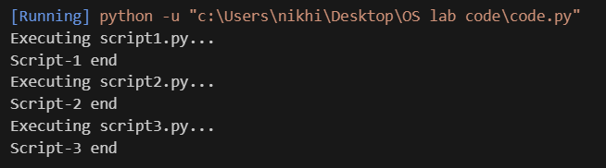

Task 2: System Startup and Logging
Simulate system startup using Python by creating multiple processes and logging their start and end into a log file.
import multiprocessing
import logging
import time
# Configure the log file and format
logging.basicConfig(filename='system_log.txt', level=logging.INFO,
format='%(asctime)s - %(processName)s - %(message)s')
# Function executed by each process
def process_task(name):
logging.info(f"{name} started") # Log process start
time.sleep(2) # Simulate work
logging.info(f"{name} terminated") # Log process end
if __name__ == '__main__':
print("System Booting...")
# Create two processes
p1 = multiprocessing.Process(target=process_task, args=("Process-1",))
p2 = multiprocessing.Process(target=process_task, args=("Process-2",))
# Start processes
p1.start()
p2.start()
# Wait for both to finish
p1.join()
p2.join()
print("System Shutdown.")

Output
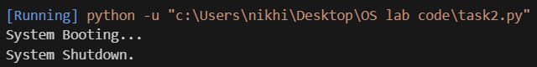
System_log.txt
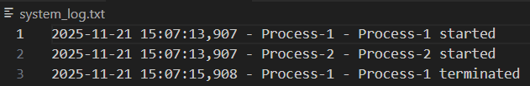
Task 3: System Calls and IPC (Python - fork, exec, pipe)
Use system calls (fork(), exec(), wait()) and implement basic Inter-Process Communication using pipes in C or Python.
import os
# Create a pipe: r = read end, w = write end
r, w = os.pipe()
pid = os.fork()
if pid > 0:
# Parent process
os.close(r) # close unused read end in parent
msg = b"Hello from parent\n"
os.write(w, msg) # write to pipe
os.close(w) # close write end to send EOF to child

# Wait for child to finish and reap it (avoid zombie)
os.waitpid(pid, 0)
print("Parent: child has terminated.")

else:
# Child process
os.close(w) # close unused write end in child
# Read up to 1024 bytes from the pipe
data = os.read(r, 1024)
os.close(r)
print("Child received:", data.decode(), end='') # decode and print
Output
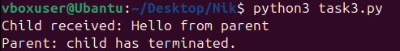
Task 4: VM Detection and Shell Interaction
Create a shell script to print system details and a Python script to detect if the system is running inside a virtual machine.
#!/bin/bash
# Print the kernel version
echo "Kernel Version:"
uname -r
# Print the current logged-in user
echo "User:"
whoami
# Print hardware / virtualization details
echo "Hardware Info:"
lscpu | grep 'Virtualization'

Output
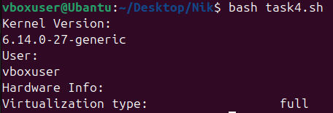
Task 5: CPU Scheduling Algorithms
Implement FCFS, SJF, Round Robin, and Priority Scheduling algorithms in Python to calculate WT and TAT.
def fcfs(processes):
# processes = [(pid, burst_time)]
wt = [0] * len(processes)
tat = [0] * len(processes)

# Waiting Time calculation
for i in range(1, len(processes)):
wt[i] = wt[i-1] + processes[i-1][1]

# Turn Around Time
for i in range(len(processes)):
tat[i] = wt[i] + processes[i][1]

print("\nFCFS Scheduling")
print("PID\tBT\tWT\tTAT")
for i, p in enumerate(processes):
print(f"{p[0]}\t{p[1]}\t{wt[i]}\t{tat[i]}")

def sjf(processes):
# processes = [(pid, burst_time)]
# Sort by burst time
processes.sort(key=lambda x: x[1])

wt = [0] * len(processes)
tat = [0] * len(processes)

# Waiting time
for i in range(1, len(processes)):
wt[i] = wt[i-1] + processes[i-1][1]

# Turn around time
for i in range(len(processes)):
tat[i] = wt[i] + processes[i][1]

print("\nSJF Scheduling")
print("PID\tBT\tWT\tTAT")
for i, p in enumerate(processes):
print(f"{p[0]}\t{p[1]}\t{wt[i]}\t{tat[i]}")

def priority_sched(processes):
# processes = [(pid, burst_time, priority)]
# Lower priority value = higher priority
processes.sort(key=lambda x: x[2])

wt = [0] * len(processes)
tat = [0] * len(processes)

for i in range(1, len(processes)):
wt[i] = wt[i-1] + processes[i-1][1]

for i in range(len(processes)):
tat[i] = wt[i] + processes[i][1]

print("\nPriority Scheduling")
print("PID\tBT\tPR\tWT\tTAT")
for i, p in enumerate(processes):
print(f"{p[0]}\t{p[1]}\t{p[2]}\t{wt[i]}\t{tat[i]}")

def round_robin(processes, quantum):
# processes = [(pid, burst_time)]
rem_bt = [p[1] for p in processes]
wt = [0] * len(processes)
t = 0 # current time

while True:
done = True
for i in range(len(processes)):
if rem_bt[i] > 0:
done = False

if rem_bt[i] > quantum:
t += quantum
rem_bt[i] -= quantum
else:
t += rem_bt[i]
wt[i] = t - processes[i][1]
rem_bt[i] = 0

if done:
break

tat = [wt[i] + processes[i][1] for i in range(len(processes))]

print("\nRound Robin Scheduling")
print("PID\tBT\tWT\tTAT")
for i, p in enumerate(processes):
print(f"{p[0]}\t{p[1]}\t{wt[i]}\t{tat[i]}")

if __name__ == "__main__":

# FCFS / SJF / RR input → (PID, BT)
procs1 = [(1, 6), (2, 8), (3, 7), (4, 3)]

# Priority input → (PID, BT, PRIORITY)
procs2 = [(1, 10, 3), (2, 1, 1), (3, 2, 4), (4, 1, 2)]

fcfs(procs1.copy())
sjf(procs1.copy())
priority_sched(procs2.copy())
round_robin(procs1.copy(), quantum=2)

Output
