Problem Title:
Simulation of File Allocation, Memory Management, and Scheduling in Python
Problem Statement:
Operating systems rely on robust memory management techniques, efficient CPU scheduling policies, and optimized file allocation strategies to manage hardware resources effectively. This lab aims to simulate various such components using Python. Students will implement and analyze Priority and Round Robin scheduling, simulate file allocation techniques (Sequential and Indexed), and explore memory management strategies (MFT, MVT, Worst-fit, Best-fit, First-fit). These implementations will reinforce theoretical OS concepts through hands-on coding experience.

Tools/Technology Used:
• Python 3.x
• Built-in Python libraries: os, multiprocessing, time
• Linux OS (optional for simulation)
Learning Objectives:
1. Simulate and analyze CPU scheduling algorithms.
2. Implement file allocation techniques in Python.
3. Demonstrate memory management strategies including MFT and MVT.

Assignment Tasks:
Task 1: CPU Scheduling with Gantt Chart
Write a Python program to simulate Priority and Round Robin scheduling algorithms. Compute average waiting and turnaround times.
# PART 1: PRIORITY SCHEDULING
processes = []
n = int(input("Enter number of processes: "))
burst_times = []
# Input burst time and priority for each process
for i in range(n):
bt = int(input(f"Enter Burst Time for P{i+1}: "))
pr = int(input(f"Enter Priority (lower number = higher priority) for P{i+1}: "))
processes.append((i+1, bt, pr))
burst_times.append(bt)
# Sort processes based on priority value
processes.sort(key=lambda x: x[2])
wt = 0
total_wt = 0
total_tt = 0
gantt_priority = [] # To store Gantt chart intervals
print("\nPriority Scheduling:")
print("PID\tBT\tPriority\tWT\tTAT")
# Generate waiting time, turnaround time and Gantt entries
for pid, bt, pr in processes:
tat = wt + bt # Turnaround time = waiting time + burst time
print(f"{pid}\t{bt}\t{pr}\t\t{wt}\t{tat}")
total_wt += wt
total_tt += tat
gantt_priority.append((pid, wt, tat)) # (PID, start, end)
wt += bt # Increase waiting time for next process
# Display averages
print(f"\nAverage Waiting Time: {total_wt / n}")
print(f"Average Turnaround Time: {total_tt / n}")
# Print Gantt chart for Priority Scheduling
print("\nGantt Chart (Priority Scheduling):")
for pid, start, end in gantt_priority:
print(f"| P{pid} ({start}-{end}) ", end="")
print("|\n")

# PART 2: ROUND ROBIN SCHEDULING
print("\n--- ROUND ROBIN SCHEDULING ---")
quantum = int(input("Enter Time Quantum: "))
remaining_bt = burst_times.copy()
time = 0
waiting_time = [0] * n # Waiting time per process
turnaround_time = [0] * n # Turnaround time per process
gantt_rr = [] # Gantt chart entries for RR
start_time_recorded = [False] * n # For tracking first execution time
start_times = [0] * n # First start time of each process
# Round Robin loop (continues until all processes finish)
while True:
done = True
for i in range(n):
# Skip finished processes
if remaining_bt[i] > 0:
done = False
# Record first time the process gets CPU
if not start_time_recorded[i]:
start_times[i] = time
start_time_recorded[i] = True
# Process executes for either full quantum or remaining time
exec_time = min(quantum, remaining_bt[i])
# Add to Gantt Chart
gantt_rr.append((i+1, time, time + exec_time))
time += exec_time # Move global time forward
remaining_bt[i] -= exec_time # Decrease remaining burst time
# Process just finished
if remaining_bt[i] == 0:
turnaround_time[i] = time
waiting_time[i] = turnaround_time[i] - burst_times[i]
if done:
break
# Calculate averages
avg_wt = sum(waiting_time) / n
avg_tat = sum(turnaround_time) / n
# Show Round Robin results
print("\nRound Robin Results:")
print("PID\tBT\tWT\tTAT")
for i in range(n):
print(f"{i+1}\t{burst_times[i]}\t{waiting_time[i]}\t{turnaround_time[i]}")
print(f"\nAverage Waiting Time: {avg_wt}")
print(f"Average Turnaround Time: {avg_tat}")
# Print Gantt chart for Round Robin
print("\nGantt Chart (Round Robin):")
for pid, start, end in gantt_rr:
print(f"| P{pid} ({start}-{end}) ", end="")
print("|")
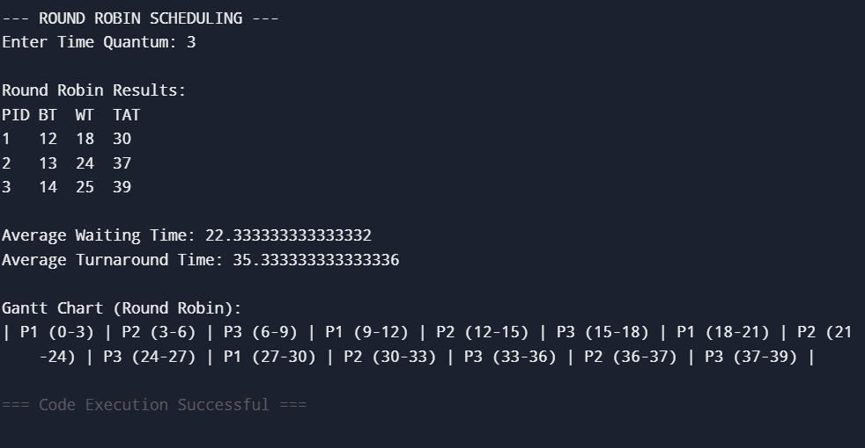
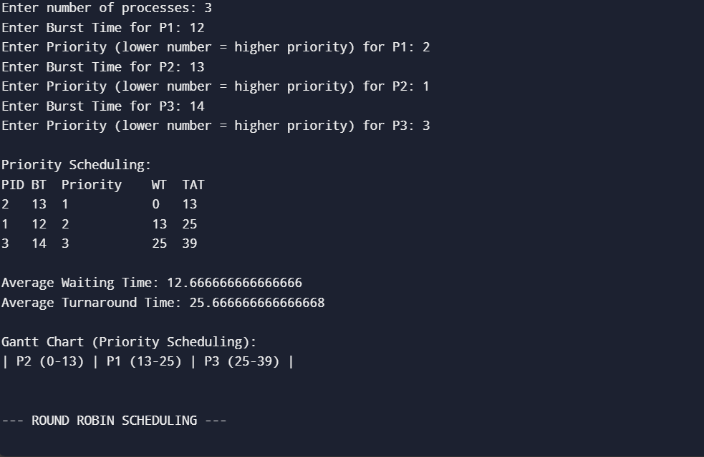
OUTPUT

Task 2: Sequential File Allocation
Write a Python program to simulate sequential file allocation strategy.
total_blocks = int(input("Enter total number of blocks: "))
block_status = [0] * total_blocks
# Number of files to allocate
n = int(input("Enter number of files: "))
# FILE ALLOCATION PROCESS
for i in range(n):
# Input starting block number for file
start = int(input(f"Enter starting block for file {i+1}: "))
# Input how many continuous blocks the file needs
length = int(input(f"Enter length of file {i+1}: "))
allocated = True # Assume allocation is possible
# Check if all required blocks are free and within limit
for j in range(start, start + length):
# Out-of-range OR already allocated
if j >= total_blocks or block_status[j] == 1:
allocated = False
break
# ALLOCATE IF POSSIBLE
if allocated:
# Mark the blocks as allocated
for j in range(start, start + length):
block_status[j] = 1
print(f"File {i+1} allocated from block {start} to {start + length - 1}")
# DEALLOCATION FAILED
else:
print(f"File {i+1} cannot be allocated.")

OUTPUT
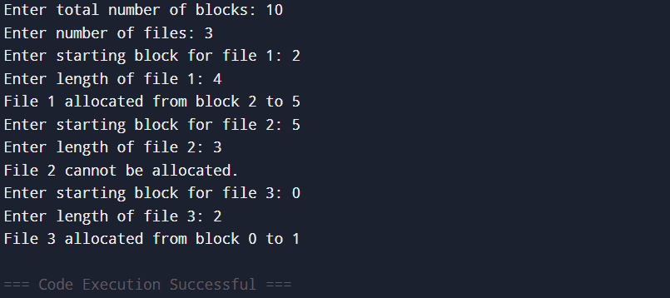

Task 3: Indexed File Allocation
Write a Python program to simulate indexed file allocation strategy.
# Total number of physical disk blocks
total_blocks = int(input("Enter total number of blocks: "))
# 0 → free block
# 1 → allocated block
block_status = [0] * total_blocks
# Number of files to simulate
n = int(input("Enter number of files: "))
# FILE ALLOCATION PROCESS
for i in range(n):
# Ask for index block of current file
index = int(input(f"Enter index block for file {i+1}: "))
# Check if index block is already used
if block_status[index] == 1:
print("Index block already allocated.")
continue
# Number of data blocks needed
count = int(input("Enter number of data blocks: "))
# User enters block numbers separated by spaces
data_blocks = list(map(int, input("Enter block numbers: ").split()))
# Validate:
# 1. Count matches number of blocks given
# 2. No data block is already allocated
if len(data_blocks) != count or any(block_status[blk] == 1 for blk in data_blocks):
print("Block(s) already allocated or invalid input.")
continue
# ALLOCATE INDEX BLOCK AND DATA BLOCKS
block_status[index] = 1
# Allocate all data blocks
for blk in data_blocks:
block_status[blk] = 1
# Print successful allocation
print(f"File {i+1} allocated with index block {index} -> {data_blocks}")

OUTPUT
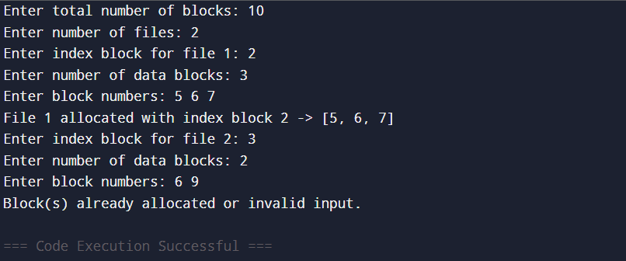
Task 4: Contiguous Memory Allocation
Simulate Worst-fit, Best-fit, and First-fit memory allocation strategies.
def allocate_memory(strategy):
# Input memory partitions
partitions = list(map(int, input("Enter partition sizes: ").split()))
# Input process sizes to be allocated
processes = list(map(int, input("Enter process sizes: ").split()))
allocation = [-1] * len(processes)
# Allocation Logic (same logic you provided, only commented)
for i, psize in enumerate(processes): # For each process
idx = -1 # Index of selected partition
# FIRST FIT STRATEGY
if strategy == "first":
for j, part in enumerate(partitions):
if part >= psize: # First partition large enough
idx = j
break
# BEST FIT STRATEGY
elif strategy == "best":
best_fit = float("inf")
for j, part in enumerate(partitions):
if part >= psize and part < best_fit:
best_fit = part
idx = j
# WORST FIT STRATEGY
elif strategy == "worst":
worst_fit = -1
for j, part in enumerate(partitions):
if part >= psize and part > worst_fit:
worst_fit = part
idx = j
# If a suitable partition is found
if idx != -1:
allocation[i] = idx
partitions[idx] -= psize
# Output Allocation Results
print(f"\n{strategy.upper()} FIT ALLOCATION:")
for i, a in enumerate(allocation):
if a != -1:
print(f"Process {i+1} allocated in Partition {a+1}")
else:
print(f"Process {i+1} cannot be allocated")
allocate_memory("first")
allocate_memory("best")
allocate_memory("worst")
OUTPUT
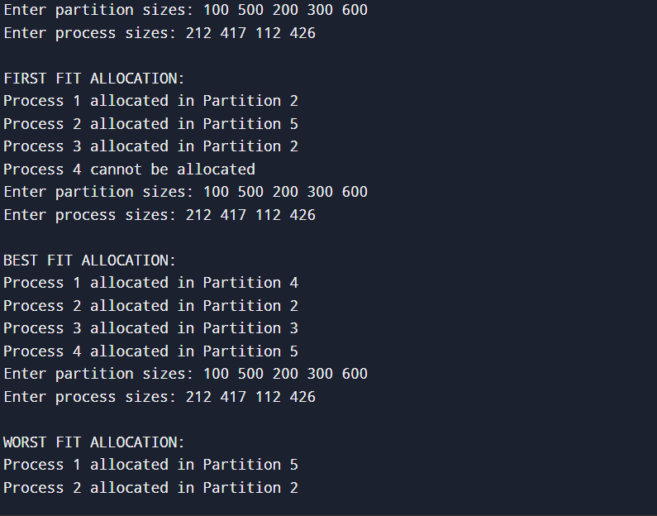
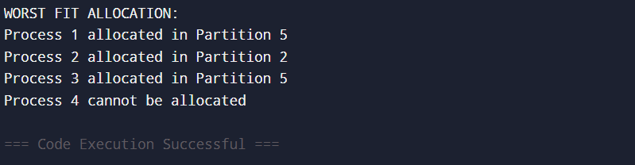

Task 5: MFT & MVT Memory Management
Implement MFT (fixed partitions) and MVT (variable partitions) strategies in Python.
# MFT: Fixed Partition Memory Management
def MFT():
mem_size = int(input("Enter total memory size: "))
part_size = int(input("Enter partition size: "))
n = int(input("Enter number of processes: "))
# Number of fixed partitions that can be created
partitions = mem_size // part_size
print(f"Memory divided into {partitions} partitions of size {part_size} each.")
# For each process, check if it fits in a partition
for i in range(n):
psize = int(input(f"Enter size of Process {i+1}: "))

if psize <= part_size:
print(f"Process {i+1} allocated in a fixed partition.")
else:
print(f"Process {i+1} too large for the fixed partition.")
# MVT: Variable Partition Memory Management
def MVT():
mem_size = int(input("Enter total memory size: "))
n = int(input("Enter number of processes: "))
# For each process, allocate memory if enough space remains
for i in range(n):
psize = int(input(f"Enter size of Process {i+1}: "))

if psize <= mem_size:
print(f"Process {i+1} allocated with {psize} memory.")
mem_size -= psize # Reduce available memory
else:
print(f"Process {i+1} cannot be allocated. Not enough memory.")
# MAIN EXECUTION
print("MFT Simulation:")
MFT()
print("\nMVT Simulation:")
MVT()

OUTPUT
