Work Sample Analysis and Clustering
Summary
Using the 4 CSV files (Calendar, FileType, Task, Universe) provided, I have completed the Analysis and Clustering for this Work Sample.
Analysis
After attaching and installing several packages, I loaded the 4 datasets into cal, ft, task and uni dataframe. After looking at the structure and summary of all four of them, I had to perform some cleaning, whenever required. Like, the value of Billable.CE was greater than 5, so I had to limit it to 5; there were rows with Supplier equal to Unknown, which I dropped when required; Developer.ID and eMail were showing nearly same data, Actual.CE contained outliers.
Visualizations
Number of Vendors used in each country
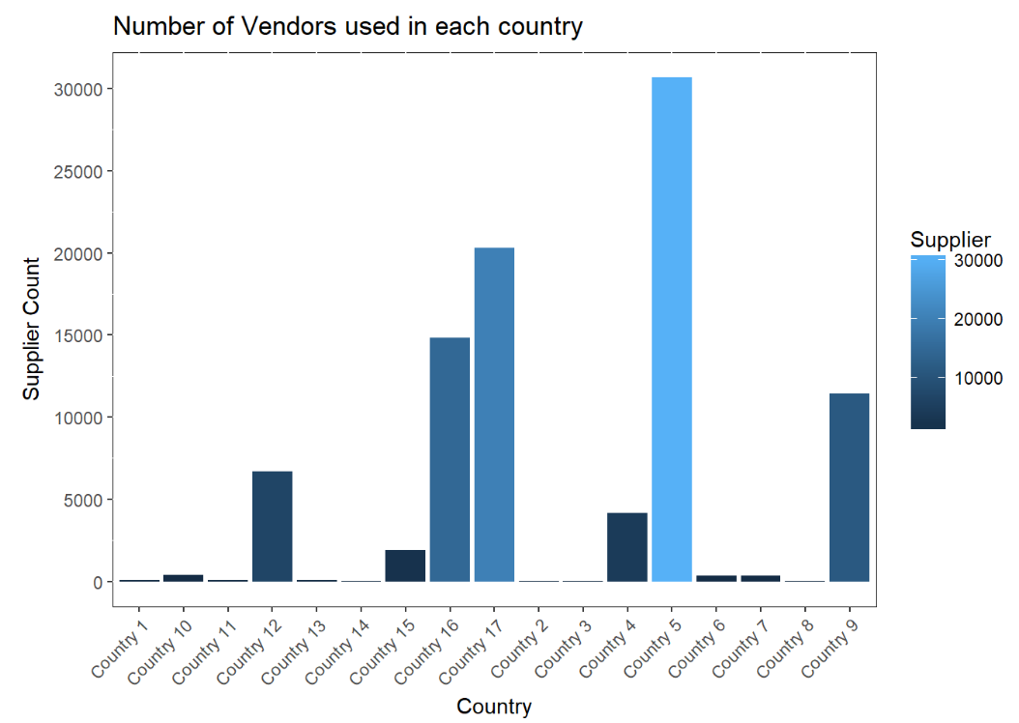
There are 45 Vendors in Suppliers and there are 17 Countries. The maximum number of Vendor count is in Country 5 .
Top Suppliers in terms of Billable Coding Effort (CE) Delivered per developer

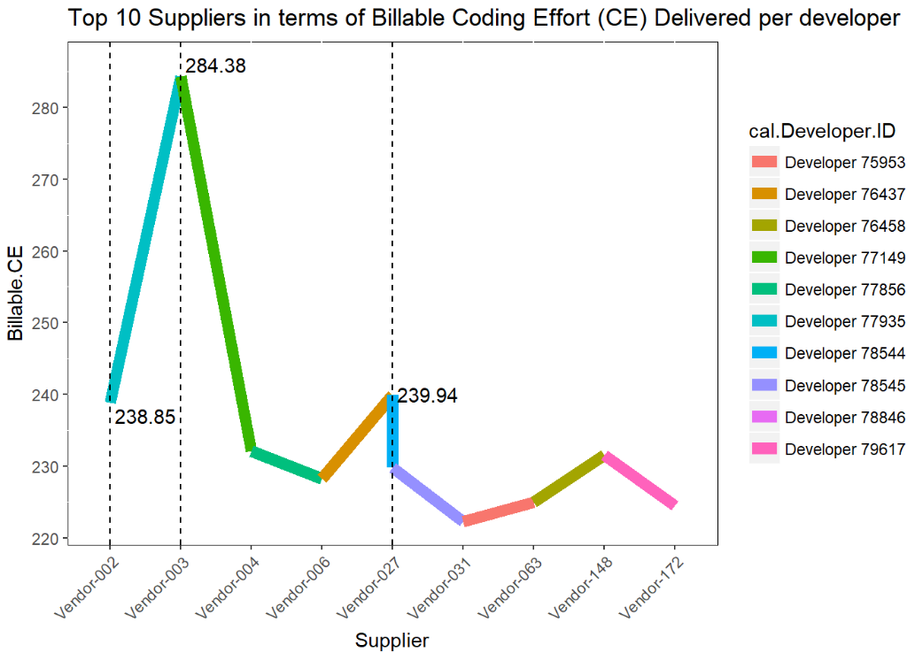

Supplier Developer.ID Billable.CE
Vendor-003 77149 284.38
Vendor-027 78544 239.94
Vendor-002 77935 238.85

Project with a maximum number of Billable CE hours per day delivered per developer

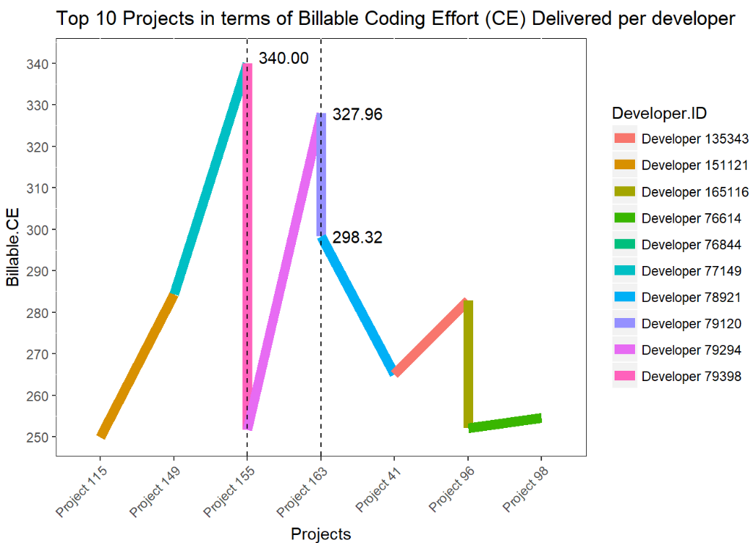
Project 155, Developer 79398, Billable CE 340.00

Total Actual CE delivered between July and August in Country 17

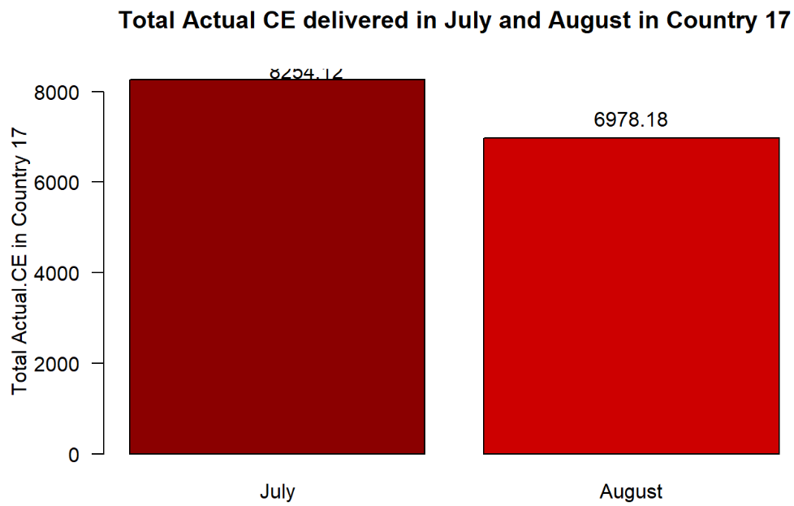
The difference in total Actual CE between July and August in Country 17 is 1275.94.
Actual CE for July was 8254.12
Actual CE for August was 6978.18

Total number of developers in each one of the last 3 months for Vendor-002

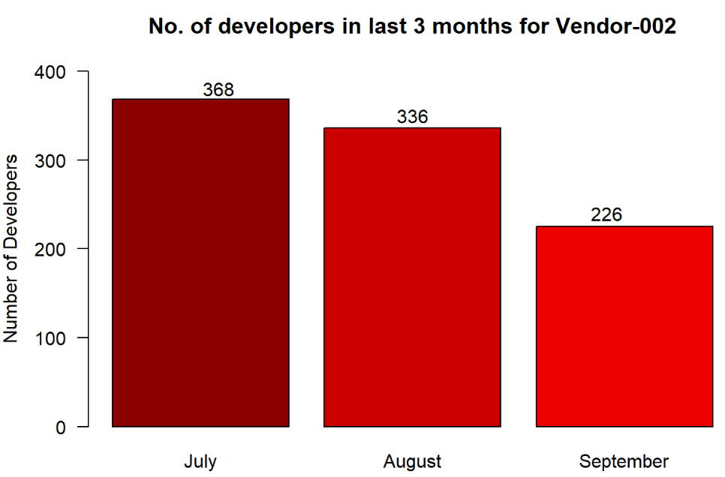
Total number of developers in each one of the last 3 months for Vendor-002 in :
July : 368
August : 336
September : 226

Percentage of the total projects working with Different Files

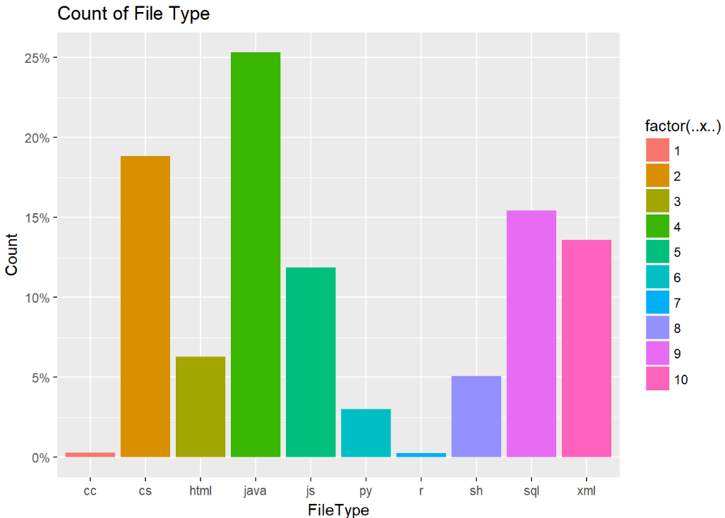
We can see that maximum number of file type was Java type with 25.30933 % Projects in it.

Most common task type in Repository 642

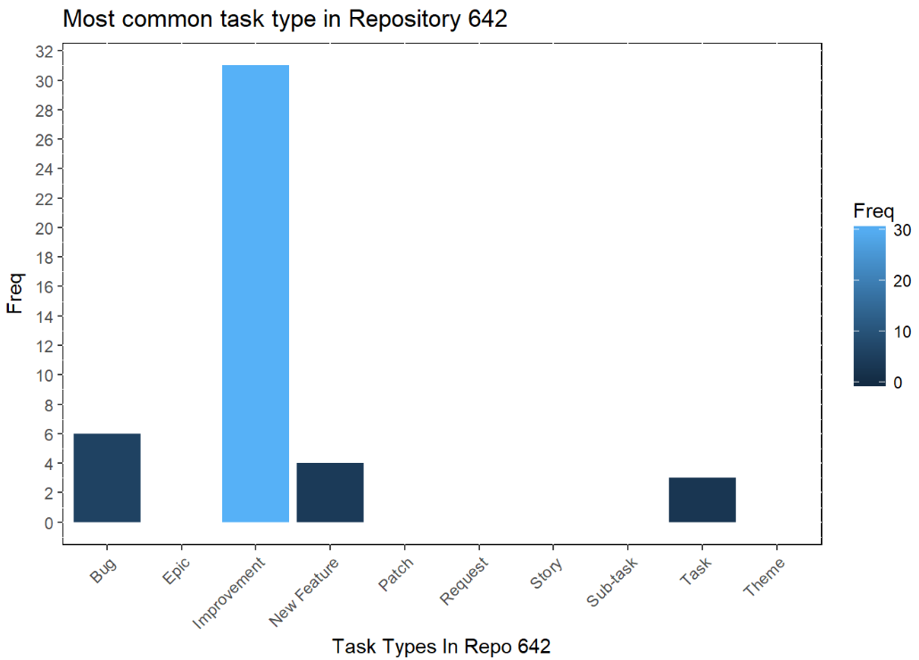
The most common Task Type in Repository 642 is Improvement with frequency of 31.
Clustering
I built a clustering model using K means clustering to classify the developers using the following 3 features: Number of distinct file types committed, Number of distinct repositories used, Number of days worked
To specify the optimal number of clusters we can use
- Elbow method
- Silhouette method

# Elbow Method
# library("factoextra")
fviz_nbclust(norm_ft_new, kmeans, method = "wss")

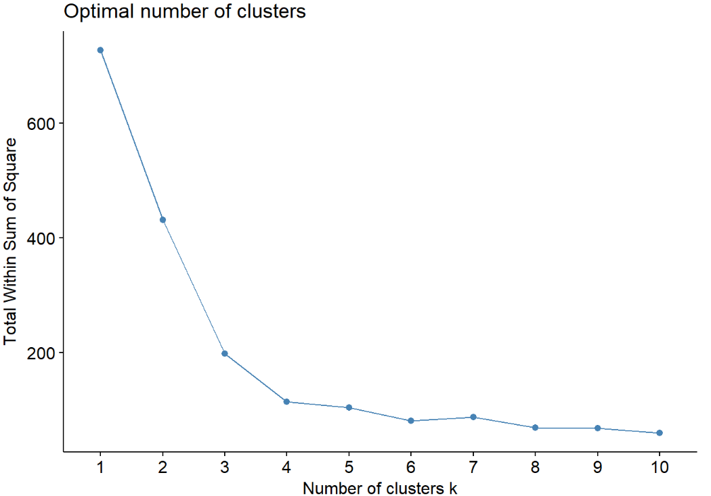

# silhouette Method
fviz_nbclust(norm_ft_new, kmeans, method = "silhouette")

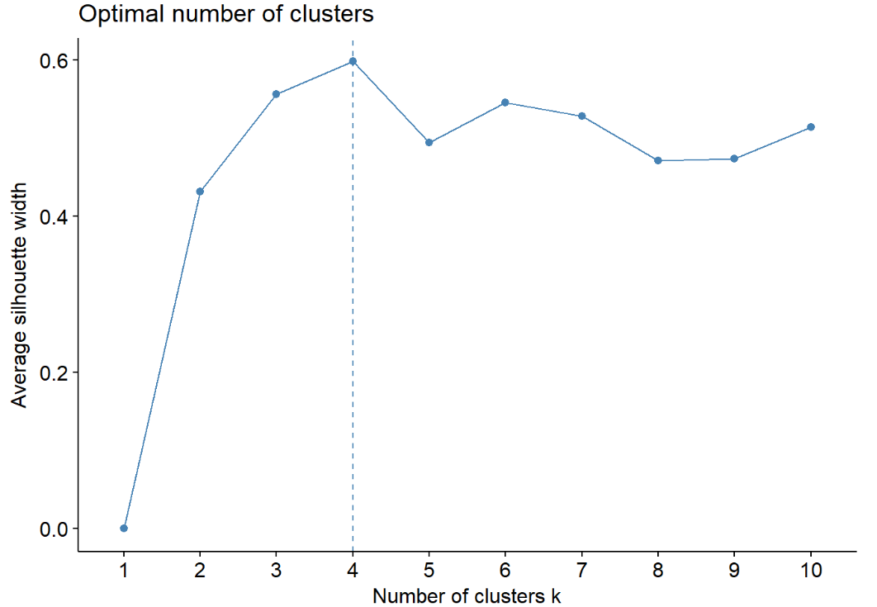
Elbow and Silhouette Method showing 4 clusters to be considered. So I considered K = 4 in my Kmeans clustering.

# kmeans
cluster_ft <- kmeans(norm_ft_new, centers = 4, nstart = 25) # with 4 clusters

str(cluster_ft)
## List of 9
## $ cluster : int [1:3488] 4 4 4 4 4 4 4 4 4 4 ...
## $ centers : num [1:4, 1:3] 0.0625 0.6762 0.6688 0.0603 0.9064 ...
## ..- attr(*, "dimnames")=List of 2
## .. ..$ : chr [1:4] "1" "2" "3" "4"
## .. ..$ : chr [1:3] "InfraId" "FileType" "Date"
## $ totss : num 727
## $ withinss : num [1:4] 21.2 28.5 18.2 46.3
## $ tot.withinss: num 114
## $ betweenss : num 613
## $ size : int [1:4] 1033 669 542 1244
## $ iter : int 2
## $ ifault : int 0
## - attr(*, "class")= chr "kmeans"
# it outputs a cluster of size 1033, 669, 542 and 1244

fviz_cluster(cluster_ft, data = norm_ft_new) # to visualize the results

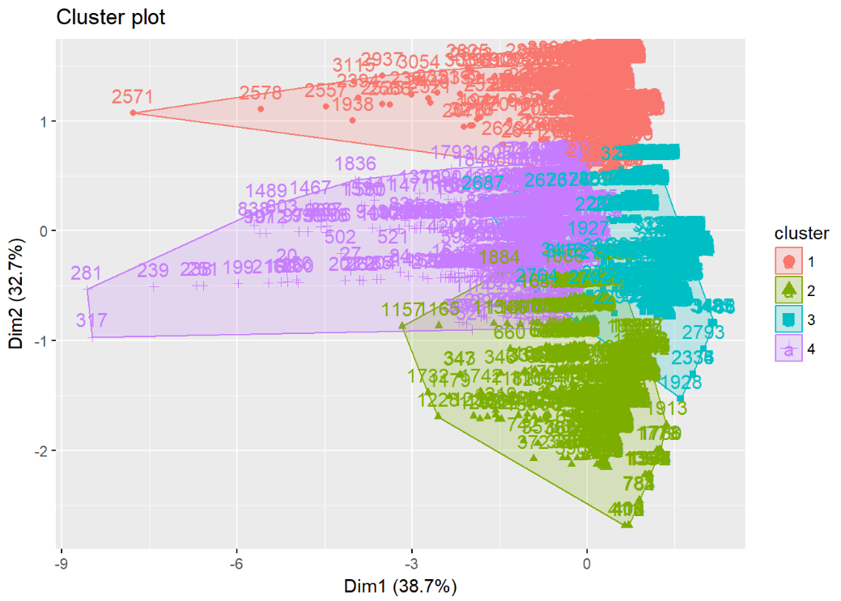

After using Kmeans Clustering we can conclude that Developers can be divided in 4 clusters According to Number of Days, File Types and Their Repository.

# Extract the clusters and add to our initial data to do some descriptive statistics at the cluster level:

ft_new %>%
mutate(Cluster = cluster_ft$cluster) %>%
group_by(Cluster) %>%
summarise_all("mean")
## # A tibble: 4 x 4
## Cluster InfraId FileType Date
## <int> <dbl> <dbl> <dbl>
## 1 1 44605.98 9.157793 13.365924
## 2 2 79238.59 3.859492 13.651719
## 3 3 78820.05 9.173432 8.651292
## 4 4 44485.81 3.640675 21.058682
Conclusion
After building a Cluster with K = 4 value we can now classify the Developers under these 4 clusters.

