To start the game, press the start text on the menu screen.



The idea of the game is to move the goalie left and right using the left and right arrow keys. If the goalie does not reach the location of the ball before it hits the net, you lose a “life”. A ball is generated every 4 seconds and tweens towards an area within the bounds of the net, the speed of the animation varies between 0.5s and 1.5s. During this tween animation, the ball is also scaled down over time to give the illusion that it is getting further away from the originating point.

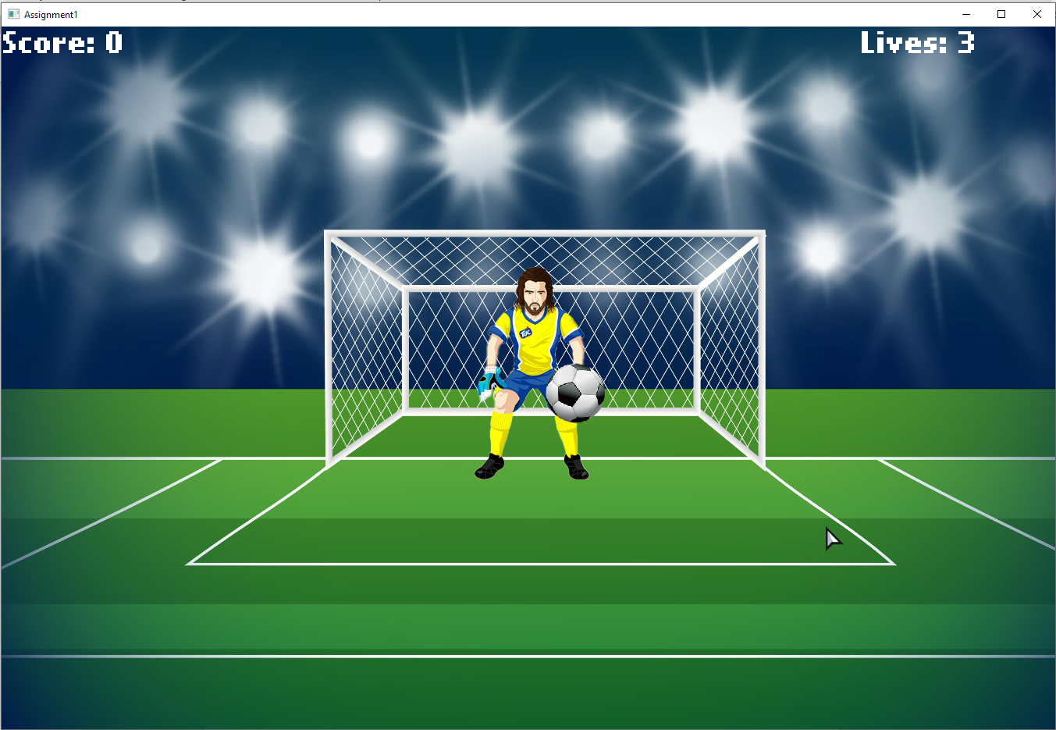

Starting at 3 lives, once you reach 0 the game is over, and you are sent to the game over screen. The game over screen will display your final score and give you the option to play again.

