Postoperative morbidity and mortality of defunctioning stoma in radical rectal cancer surgery: a systematic review and meta-analysis of proportions
Nikita Burlov^{1,2,*}, Vadim Shindyapin^{3,4}, Maksim Popov⁵, Artem Goncharov^{6,10}, Vladislava Goncharova^{1,7}, Ilya Zorin⁸, Georgy Mashkov^{9,10}, Gleb Khrykov¹¹, Ilya Chernikovskiy⁸
¹ Autonomous Non-Profit Organization "Scientific and Practical Club for the Development of Modern Medical Technologies", Moscow, Russian Federation.
² S.M. Kirov Military Medical Academy, Saint Petersburg, Russian Federation.
³ Sirius University of Science and Technology, Federal Territory Sirius, Russian Federation.
⁴ Bashkir State Medical University, Ufa, Russian Federation.
⁵ Republican Clinical Oncology Center, Ufa, Russian Federation.
⁶ Central Clinical Hospital of the Administrative Directorate of the President of the Russian Federation, Moscow, Russian Federation.
⁷ Central State Medical Academy of the Administrative Directorate of the President of the Russian Federation, Moscow, Russian Federation.
⁸ Moscow City Oncology Hospital No. 62, Moscow Department of Health, Moscow, Russian Federation.
⁹ Moscow Institute of Physics and Technology, Dolgoprudny, Moscow Region, Russian Federation.
¹⁰ I.M. Sechenov First Moscow State Medical University (Sechenov University), Moscow, Russian Federation.
¹¹ Research Institute of Clinical Oncology, Nizhny Novgorod Regional Clinical Oncology Dispensary, Nizhny Novgorod, Russian Federation.
* Corresponding author: Nikita Burlov. E-mail: dikefsound@gmail.com
ORCID: N.B. 0000-0003-3407-4406; V.S. 0009-0006-3165-6872; M.P. 0009-0002-0468-1221; A.G. 0000-0002-1326-7893; V.G. 0009-0001-2545-1911; I.Z. 0000-0002-1621-7015; G.M. 0009-0001-0612-4456; G.K. 0000-0002-0249-4759; I.C. 0000-0002-8791-9241.
Abstract
A defunctioning (preventive) loop stoma is formed routinely during sphincter-preserving surgery for rectal cancer to mitigate the consequences of anastomotic leakage (AL), yet the absolute risk carried by the diverted patient has not been quantified across contemporary practice. We searched MEDLINE/PubMed and the Cochrane Database of Systematic Reviews from 1 January 1982 to 10 April 2026 and pooled proportions from 72 studies with random-effects generalised linear mixed models (PROSPERO CRD420261422080). Among 26,598 diverted patients, clinically relevant AL occurred in 7.09% (95% CI 6.00–8.37; prediction interval 2.05–21.77), and 30-day mortality in 18,189 patients was 0.91% (0.60–1.38). Overall 30-day morbidity was 32.58% (27.08–38.60), complications of Clavien–Dindo grade IIIa or higher 7.61% (4.88–11.67) and stoma-related complications 4.26% (2.16–8.22). Heterogeneity was high (I² 87–95%). The rate of AL was not associated with the type of preventive stoma formed, study design or publication era. About one diverted patient in fourteen still develops AL and one in three a complication within 30 days, whereas early stoma-specific morbidity is uncommon. Most of the burden of the stoma therefore falls after discharge, which supports risk-based rather than routine diversion.
Keywords: rectal neoplasms; defunctioning stoma; loop ileostomy; anastomotic leak; postoperative complications; meta-analysis of proportions
Introduction
Colorectal cancer is among the most frequently diagnosed malignancies and a leading cause of cancer death worldwide, and rectal cancer accounts for a substantial and separately reported share of that burden [1]. This review concerns patients with localised or locally advanced rectal cancer treated with curative intent. Radical resection along the mesorectal plane, introduced by Heald and colleagues in the 1980s [2,3], remains the standard, and European and North American guidelines recommend sphincter preservation whenever the tumour permits an oncologically adequate distal margin and acceptable function [4–6]. Several sphincter-preserving operations are in use, including intersphincteric resection and abdominoanal pull-through resection with a delayed or immediate coloanal anastomosis, but the most widely performed is low anterior resection with total mesorectal excision (TME) and a stapled or hand-sewn colorectal or coloanal anastomosis in the pelvis.
Anastomotic leakage (AL) after anterior resection is defined by the International Study Group of Rectal Cancer (ISREC) as a defect of the intestinal wall integrity at the colorectal or coloanal anastomotic site, including suture and staple lines of neorectal reservoirs, leading to a communication between the intraluminal and extraluminal compartments; a pelvic abscess close to the anastomosis is also considered AL [7]. ISREC grades severity by the management required: grade A requires no active therapeutic intervention, grade B requires active therapeutic intervention but can be managed without re-laparotomy, and grade C requires re-laparotomy [7]. Reported incidence depends heavily on definition, case mix and completeness of ascertainment: a systematic review applying the ISREC grading to 24,288 anterior resections found an overall AL rate of 8.58%, with grade C AL in 5.40% [8]; a pooled analysis of five European randomised trials reported symptomatic AL in 9.7% of 2,726 low anterior resections [9]; a meta-analysis of 18,039 patients reported 9.8% [10]; and a multicentre observational series with prospective audit reported 14.8% [11]. The consequences are consistent across these datasets. Thirty-day mortality rose from 1.2% to 4.3% in the audit cohort [11] and from 1.3% to 5.7% in the trial pooling [9], and AL was associated with higher local recurrence (odds ratio (OR) 1.50, 95% CI 1.23–1.82) and worse overall (OR 0.69, 95% CI 0.60–0.81) and disease-free survival (OR 0.51, 95% CI 0.36–0.73) [10].
Formation of a preventive loop ileostomy or colostomy aims to prevent or mitigate the clinical consequences of AL after TME. A Swedish multicentre randomised trial of 234 patients undergoing low anterior resection showed that a defunctioning loop stoma reduces symptomatic AL and the reoperations it provokes [12], and successive syntheses have reproduced the effect: clinically relevant AL OR 0.32 (95% CI 0.17–0.59) and reoperation OR 0.27 (95% CI 0.14–0.51) in a mixed-design meta-analysis [13]; risk ratios of 0.39 and 0.29 respectively in the randomised subset of a design-stratified analysis [14]; and, restricting to eight randomised trials of 892 patients, AL in 6.3% versus 18.3% (RR 0.36, 95% CI 0.24–0.54) and reoperation in 5.9% versus 16.7% (RR 0.40, 95% CI 0.26–0.60) [15]. On this evidence, proximal diversion has become close to routine for low pelvic anastomoses.
The formation of a preventive stoma may be accompanied by stoma-associated surgical complications. A review of 18 randomised trials reported all-cause stoma complication rates with a median of 14.3% for loop ileostomy and 26.3% for loop colostomy [16]. Take-down of a preventive stoma carries morbidity of 17.3% and mortality of 0.4% across 6,107 patients [17]. A Swedish population-based cohort study reported permanent stoma rates after anterior resection of 13.6% and 15.2% in its derivation and validation sets [18]. Existing quantitative syntheses answer comparative questions, stoma versus no stoma [13–15] or loop ileostomy versus loop colostomy [19,20], and most pool proportions with the Freeman–Tukey double arcsine transformation, whose back-transformation can mislead when events are rare and study sizes unbalanced [21–24]; none reports the absolute risk of AL, death, overall and severe morbidity and early stoma-related morbidity in the population that actually receives a stoma, drawn from the whole eligible literature and modelled on the binomial likelihood [25].
We undertook a systematic review and random-effects meta-analysis of proportions, to estimate the pooled prevalence of postoperative morbidity and 30-day mortality in adults undergoing TME with preventive stoma for rectal cancer, with prespecified subgroup analyses by stoma type, study design and publication era, and to estimate how much of the early morbidity is attributable to the stoma itself.
Results
Study selection
Database searching identified 1,323 records. After removal of 387 duplicates and 78 records rejected by automation tools, 858 records were screened, of which 613 were excluded on title and abstract. Of 245 reports sought for retrieval, one could not be obtained, leaving 244 assessed in full text. One hundred and seventy-two reports were excluded at that stage: 45 because patients with stage IV disease exceeded 5% of the cohort, 37 because emergency operations exceeded 5%, and 90 because the cohort contained fewer than 50 eligible patients, TME with primary anastomosis and simultaneous stoma was not the operation studied, or outcome data could not be disaggregated for the eligible subgroup (Fig. 1); representative examples of each exclusion category are given in Supplementary Table S4. Seventy-two studies were included and all contributed to the meta-analysis. Included designs were 4 randomised controlled trials, 7 prospective cohorts and 61 retrospective cohorts, published between 2002 and 2026. Two studies reported loop ileostomy and loop colostomy subgroups separately and contributed two estimates each, giving 74 estimates in total. Not every study reported every outcome, so the number of contributing studies and patients differs between analyses (Table 1); the characteristics of each included study are listed in Supplementary Table S3 and summarised in Supplementary Table S5. Most extracted cohorts were published after 2009 (65 of 74, 87.8%) and were retrospective (63, 85.1%); loop ileostomy alone was used in 43 (58.1%), ileostomy or colostomy in 29 (39.2%) and colostomy alone in 2 (2.7%). Cohort size had a median of 214.5 patients (Q1–Q3 100.0–560.0; range 63–17,867). Among the cohorts that reported them, the mean proportion of men was 61.0% (SD 9.7), mean age 62.0 years (SD 4.8), mean body mass index 24.7 kg/m² (SD 1.9) and mean length of stay 10.9 days (SD 4.2); median reported rates were 49.5% for neoadjuvant chemo(radio)therapy, 30.4% for any complication, 9.4% for severe complications, 5.4% for AL, 10.1% for infectious complications and 0.7% for mortality. These unweighted study-level medians describe the corpus only; the model-based estimates are given below. Item-level missingness was extensive, reaching 37 of 74 cohorts for body mass index, 45 for any complication, 51 for infection, 52 for severe complications, 54 for mortality and 59 for length of stay.
Risk of bias
Among the four randomised trials, one was judged at low overall risk of bias and three raised some concerns (Fig. 2a,b). Concerns arose in the domain of deviations from the intended intervention in two trials, reflecting the impossibility of blinding stoma formation, and in outcome measurement and selection of the reported result in the earliest trial; no trial was at high risk of bias in any domain. Newcastle–Ottawa total scores for the 68 non-randomised studies ranged from 4 to 9 of a maximum 9, with a median of 7; 45 studies (66.2%) scored 7 or more, and 40 were rated good and 28 poor (Fig. 2c). Points were lost mainly in the comparability domain, which single-arm and registry reports cannot satisfy by design, and a study with no comparability point was rated poor regardless of its total score.
Anastomotic leakage
Sixty-seven estimates from 65 studies reported clinically relevant AL in 2,443 of 26,598 patients. The pooled prevalence was 7.09% (95% CI 6.00–8.37), with substantial heterogeneity (I² 87.4%, 95% CI 84.7–89.6; τ² 0.411; p < 0.0001) and a 95% prediction interval of 2.05% to 21.77% (Fig. 3). Study-specific estimates spanned an order of magnitude, from 1.34% to 28.00%, and the width of the prediction interval indicates that the pooled value should not be read as the risk expected in any individual centre.
Prespecified subgroup analyses did not explain this dispersion (Table 2). AL occurred in 7.06% (5.64–8.81) of patients in the 39 estimates confined to loop ileostomy and in 7.31% (5.54–9.59) in the 26 estimates from cohorts containing both ileostomies and colostomies (p for subgroup difference 0.842; Supplementary Fig. S1). By design, AL occurred in 7.01% (5.83–8.41) in retrospective cohorts, 9.18% (4.85–16.69) in prospective cohorts and 5.47% (2.27–12.62) in randomised trials (p = 0.359; Supplementary Fig. S2). By publication era, AL occurred in 7.69% (4.79–12.13) before 2010, 7.97% (6.30–10.03) between 2010 and 2019, and 6.12% (4.58–8.14) from 2020 onwards (p = 0.327; Supplementary Fig. S3). Heterogeneity remained above 80% within every subgroup except randomised trials (66.6%), so none of these stratifications identifies the source of between-study variation. Only two estimates were confined to loop colostomy, too few to form a separate stratum, and the subgroup analysis by surgical approach specified in the protocol could not be performed because approach was reported too inconsistently to classify cohorts.
Mortality
Twenty studies reported 30-day mortality in 478 of 18,189 patients. The pooled prevalence was 0.91% (95% CI 0.60–1.38), with high heterogeneity (I² 92.3%, 95% CI 89.6–94.4; τ² 0.400; p < 0.0001) and a prediction interval of 0.23% to 3.57% (Fig. 4). Most studies clustered between 0.16% and 1.59%; the single outlying estimate of 5.30% came from the largest contributing dataset, a registry-based cohort of 7,148 patients, and its weight explains much of the observed inconsistency.
Morbidity
Twenty-nine estimates from 28 studies reported any complication within 30 days in 2,974 of 9,619 patients, giving a pooled prevalence of 32.58% (95% CI 27.08–38.60) with I² 94.5% (93.0–95.6), τ² 0.444 and a prediction interval of 10.72% to 66.04% (Fig. 5a). Study-specific values ranged from 14.08% to 80.49%. Twenty-two studies reported severe complications, defined as Clavien–Dindo grade IIIa or higher, in 518 of 4,635 patients, giving 7.61% (4.88–11.67) with I² 87.7% (82.8–91.3), τ² 0.983 and a prediction interval of 0.98% to 40.71% (Fig. 5b). The gap between overall and severe morbidity indicates that roughly three-quarters of recorded complications required neither surgical, endoscopic or radiological intervention nor intensive care, although the between-study variance of the severe-complication estimate was the largest of the four principal outcomes.
Infectious complications, including surgical site infection (SSI), were reported by 23 estimates from 22 studies covering 8,638 patients, under definitions that ranged from superficial SSI to any infectious event at any site, with study-level proportions between 1.2% and 25.9%; they were not pooled because the definitions were not comparable. Reoperation and readmission within 30 days were reported still less often and were frequently given for the whole operated cohort rather than for the diverted subgroup. Length of hospital stay was not pooled by design.
Stoma-related complications
Twelve studies reported complications attributed to the stoma itself within 30 days, in 148 of 3,292 patients. The pooled prevalence was 4.26% (95% CI 2.16–8.22), with I² 92.3% (88.5–94.9), τ² 1.011 and a prediction interval of 0.42% to 31.80% (Supplementary Fig. S4). Eleven of the twelve studies reported values between 1.72% and 10.18%; the outlier, 42.25%, came from a series of 71 patients in which peristomal dermatitis alone accounted for 20 events. In the six studies that reported both overall morbidity and stoma-related events, stoma-related complications made up 15.22% (8.08–26.82) of all patients with a complication (91 of 479; I² 75.7%, 45.2–89.2; prediction interval 3.10–50.20%; Supplementary Fig. S5). Where the type of event was specified (69 events in nine studies; Supplementary Table S6), peristomal dermatitis or skin erosion (21 events), high output with dehydration or electrolyte disturbance (14), retraction or mucocutaneous separation (9) and outlet obstruction (6) were the most frequent, whereas stoma necrosis (1), prolapse (1) and early parastomal hernia (3) were rare. Pooling by event type was not attempted because no category was reported by more than four studies.
Small-study effects and sensitivity analyses
Small-study effects were examined for AL only, the single outcome with enough contributing estimates to support the assessment. The funnel plot was visually asymmetric, with a deficit of small studies reporting high AL rates (Fig. 6a), but Peters' regression test did not confirm the asymmetry (p = 0.820), and restriction to the 26 cohorts of at least 150 patients did not change that conclusion (p = 0.194; Fig. 6b). Trim-and-fill imputed 25 estimates on the right-hand side of the distribution (Fig. 6c) and raised the pooled prevalence to 10.77% (95% CI 8.93–12.94), with a prediction interval of 2.07% to 40.85%, so the primary estimate is more likely to be conservative than inflated. A conventional inverse-variance random-effects meta-analysis of logit-transformed proportions returned 7.50% (6.38–8.80), with a prediction interval of 2.32% to 21.70%, close to the generalised linear mixed model estimate, so the choice of pooling model does not drive the result (Table 1). In leave-one-out analyses no single study moved any pooled estimate outside its confidence interval: the estimates ranged from 6.95% to 7.25% for AL, 0.87% to 0.99% for mortality, 31.05% to 33.45% for any complication and 7.15% to 8.19% for severe complications.
Certainty of evidence
Certainty was rated very low for every pooled outcome. The evidence base is dominated by non-randomised cohorts, which carries a serious risk of bias for an absolute-risk question; inconsistency was very serious for every outcome, with I² above 75% and prediction intervals spanning ranges that would support opposite clinical conclusions; and the funnel plot for AL was visually asymmetric, although Peters' test did not confirm asymmetry, so publication bias was judged suspected but undetected rather than a further reason to downgrade. Imprecision was not a limiting factor given the sample sizes involved (Table 1).
Discussion
Across 72 studies and up to 26,598 patients, the diverted patient undergoing radical sphincter-preserving surgery for rectal cancer still faces a 7.09% risk of clinically relevant AL, a 0.91% risk of death within 30 days, a 32.58% risk of any complication and a 7.61% risk of a complication requiring intervention, intensive care or proving fatal. Diversion is performed in the expectation that it protects the anastomosis, and randomised evidence supports a relative reduction in symptomatic AL [12–15]. Yet the absolute AL rate in a fully diverted population is only modestly lower than the rates reported from unselected and largely undiverted series: 8.58% in 24,288 anterior resections graded by ISREC criteria [8], 9.7% in a pooled analysis of five randomised trials [9] and 9.8% across 18,039 patients [10]. Because stomas are formed preferentially in patients at higher baseline risk, this comparison cannot be read as evidence that diversion is ineffective; it shows that the diverted patient remains at substantial absolute risk. The nationwide RALAR cohort of 5,398 anterior resections reached a consistent conclusion from individual patient data, reporting an overall AL rate of 10.2% and finding that the stoma did not reduce the AL rate but did reduce AL severity and the reoperation rate [26]. A stoma reduces the consequences of AL more reliably than it prevents the leak, and about one diverted patient in fourteen develops AL despite the stoma.
The AL estimate did not vary with the type of stoma, study design or publication era, and heterogeneity remained high within almost every stratum. Two decades of technical change have not translated into a demonstrable fall in the pooled AL rate: the estimate for studies published from 2020 onwards, 6.12%, overlaps completely with the pre-2010 estimate of 7.69%. That flat trajectory is consistent with the literature on newer platforms. A meta-analysis of proportions across 41 transanal TME series and 2,446 patients returned a pooled AL rate of 6.8% (95% CI 5.2–8.9) and pooled morbidity of 30.0% (26.4–34.0) [27], values close to the estimates reported here, and the REAL randomised trial found that a robotic platform lowered Clavien–Dindo grade II or higher complications from 23.1% to 16.2% [28]. Surgical approach could not be classified in the present dataset, so the absence of a temporal trend cannot be attributed to any specific factor. Thirty-day mortality of 0.91% is relatively low and well below the 4.3% to 5.7% reported in patients who develop AL [9,11], which is consistent with diversion converting a potentially lethal event into a manageable one. The consequences of AL extend well past 30 days: in the TENTACLE-Rectum cohort of 2,499 patients with AL from 216 centres, only 45.0% were stoma-free one year later [29], and a synthesis of 35 studies and 44,698 patients linked AL to local recurrence (OR 1.93, 95% CI 1.57–2.38), worse overall survival (OR 1.64, 1.37–1.95) and worse disease-free survival (OR 2.07, 1.50–2.87) [30]. What is being averted is not only a perioperative event.
The stoma-related estimates change how the 30-day morbidity figure should be read. Only 4.26% of diverted patients had a complication attributed to the stoma during the index period, and such events made up about one in seven of all patients with a complication; most early morbidity in the diverted patient therefore arises from the resection and anastomosis rather than from the stoma itself. The 30-day estimate is lower than the median of 14.3% reported for loop ileostomy across the whole period of stoma carriage in randomised trials [16], which indicates that most stoma-specific morbidity accrues after discharge. The ileostomy-specific liabilities that drive it are fluid and renal: acute kidney injury complicated 19.4% of index admissions after ileostomy formation in a consecutive series of 262 patients, and 11% of that cohort were readmitted with dehydration [31]; in the Swedish Colorectal Cancer Registry, five-year renal failure was 7.2% with a defunctioning stoma against 3.3% without, with a weighted hazard ratio at one year of 11.59 (95% CI 5.68–23.65) [32]; and a meta-analysis of 10 studies and 2,036 patients found almost three times the risk of dehydration and electrolyte disturbance with loop ileostomy as with loop colostomy (RR 2.98, 95% CI 1.51–5.89), which in turn carried more prolapse and retraction [33]. Closure is a second operation with morbidity of 17.3% and mortality of 0.4% [17], and 13.6% to 15.2% of stomas are never reversed [18]. These figures cannot be added to the 30-day estimate, because they partly concern the same patients and because non-closure also reflects adjuvant chemotherapy, age, comorbidity and patient preference rather than complications alone. The functional cost accrues over years: pooled across 50 studies, major low anterior resection syndrome affected 44% of patients, and a defunctioning stoma was an independent risk factor (OR 1.89, 95% CI 1.58–2.27) [34]; in the EASY trial, a permanent stoma was present in 6 patients after late closure against 1 after early closure [35]. The period of stoma carriage, the proportion and timing of closure and the morbidity of closure are the quantities that complete the risk profile of diversion; they lie outside the 30-day window of this review and are the subject of a planned companion meta-analysis.
Selection is now technically possible. A risk score developed in 2,727 Swedish patients meeting the criteria of the SELSA trial, in whom AL occurred in 7.3%, retained male sex (OR 2.00, 95% CI 1.45–2.75), obesity (OR 1.82, 1.21–2.74) and radiotherapy (OR 1.90, 1.35–2.69), and is being used prospectively to randomise patients below a 10% predicted risk to no defunctioning stoma [36]. The TASTY project took the same logic into practice: after external validation of the anastomotic failure observed risk score, 122 patients were allocated by score, and the 48 classified as low risk and operated on without diversion developed AL in 10%, against 23% in the high-risk diverted group, with the lowest incidence of major low anterior resection syndrome in the undiverted cohort [37]. Practice has not yet followed: among 1,019 surgeons surveyed internationally, decisions in low-risk and moderate-risk patients were most often described as influenced by personal experience rather than by any model [38]. The adjuncts proposed as substitutes for diversion perform inconsistently. The IntAct randomised trial found clinically relevant AL in 10% with indocyanine green fluorescence angiography against 15% with standard care, a difference that did not reach significance (adjusted OR 0.667, 95% CI 0.419–1.060) [39], whereas a meta-analysis of nine randomised trials and 4,754 patients found an overall reduction (RR 0.66, 95% CI 0.56–0.78) concentrated in low anterior resection, where the number needed to treat was 13 [40]. Ghost ileostomy avoided a stoma in most patients without altering AL rates or overall morbidity across 14 studies and 946 patients, but ISREC grade C AL accounted for 19.1% of leaks in the ghost group and none in the loop ileostomy group [41]. None of these options removes the risk quantified here; each redistributes it.
Previous meta-analyses in this field are comparative and therefore report relative effects conditional on inclusion in a comparative cohort [13–15,19,20]. By pooling proportions across the whole eligible literature, including registry and single-arm series, this review yields the quantity needed at the point of consent, an absolute risk, and does so with a logit-link generalised linear mixed model that models the binomial likelihood directly rather than relying on the Freeman–Tukey double arcsine transformation [21,22,25]. Reporting prediction intervals alongside confidence intervals is a deliberate part of that approach. Across 479 significant Cochrane meta-analyses with heterogeneity, the prediction interval admitted a null or reversed effect in 72.4% of cases [42], and in a review of 134 prevalence syntheses the median I² was 96.9% while only 2% reported a prediction interval [43]. The prediction intervals reported here also provide audit thresholds: a unit whose AL rate among diverted patients exceeds about 22%, or whose 30-day mortality exceeds about 3.6%, lies outside the range expected from the published literature. No absolute-risk synthesis can support a causal claim about the effect of diversion, and none is made here.
Several limitations bound the conclusions. Heterogeneity was very high for every outcome, so the prediction intervals rather than the confidence intervals describe what a new centre should expect. Much of this dispersion is definitional. Studies differ in whether radiologically detected asymptomatic leaks are counted, whether complications are captured prospectively or from discharge coding, and whether follow-up truly extends to 30 days, and the subgroup analyses show that these differences are not captured by stoma type, design or era. The transanal synthesis quantified the same effect directly, reporting morbidity of 35.5% in studies with explicit 30-day follow-up against 23.4% where follow-up length was undefined (p = 0.003) [27]. The stoma-related estimate rests on 12 studies that did not share a definition, early high output and dehydration are often managed without being recorded as complications, and the estimate is therefore more likely to understate than to overstate early stoma morbidity. The evidence base is predominantly retrospective, with only 4 randomised trials and 611 randomised patients, and the median Newcastle–Ottawa score of 7 reflects cohorts that are adequately selected and followed but frequently non-comparable by design. The funnel plot was visually asymmetric and trim-and-fill raised the AL estimate to 10.77%, although Peters' test was not significant, so cohorts with high AL rates may be under-represented and the true AL rate in diverted patients may exceed 7.09%. Full-text eligibility was restricted to English-language reports, the requirement for at least 50 eligible patients excludes small series, and the prespecified analyses of surgical approach and of infection, reoperation and readmission could not be completed because the primary literature does not report these items consistently enough. That reporting gap is itself a finding: the infectious and reintervention burden of a procedure performed this often cannot currently be estimated from published data. The CoReAL framework, a modified Delphi consensus that fixed 33 statements and 43 reporting elements for AL after colorectal cancer surgery [44], provides the instrument; applying it prospectively, with explicit 30-day ascertainment, Clavien–Dindo grading and separate recording of stoma-related events, would remove most of the dispersion documented here.
In summary, a defunctioning stoma reduces the consequences of AL, but the diverted patient still develops AL in about 7% of cases, has a complication within 30 days in about one-third and dies within 30 days in about 1%. Early complications of the stoma itself are uncommon and account for a small share of this morbidity, so the main costs of diversion are deferred to the period of stoma carriage, to closure and to the minority of stomas that are never reversed. Risk scores that identify patients in whom a stoma can be safely omitted, and prospective reporting that separates stoma-related from anastomosis-related events across the full stoma pathway, are the next steps.
Methods
Protocol, registration and reporting
The review was designed and conducted in accordance with a protocol registered prospectively in PROSPERO (CRD420261422080; record created 12 June 2026, registered and last edited 7 July 2026). Reporting follows the PRISMA 2020 statement [45], and the completed checklist is provided as Supplementary Table S1. Before registration the protocol, including the PICO framework, eligibility criteria, search strategies and risk-of-bias plan, was reviewed by an external content expert in colorectal surgery not otherwise involved in the review; recommendations to expand the stoma-related controlled vocabulary and to clarify the comparator structure were incorporated, and no comment was rejected without a documented rationale. Deviations from the registered protocol are listed at the end of this section. The review analysed only aggregate data from previously published reports; no new experiments on human participants, human tissue or animals were undertaken, no identifiable patient information was collected, and institutional ethics approval and individual informed consent were therefore not applicable.
Eligibility criteria
Eligible participants were adults aged 18 years or older with histologically confirmed rectal adenocarcinoma, localised or locally advanced (TNM stage I–III, or M0 where TNM was not reported), undergoing elective radical sphincter-preserving surgery with simultaneous creation of a defunctioning loop stoma and a colorectal or coloanal anastomosis at the same operation. Studies were eligible when at least one arm or a clearly defined subgroup met these criteria. We excluded non-adenocarcinoma rectal pathology, anal canal cancer, benign and non-oncological indications, metastatic or oligometastatic disease at the index operation and emergency surgery (in both cases when these accounted for more than 5% of the cohort), and palliative or purely endoscopic procedures unless a curative-intent surgical subgroup was reported separately.
The eligible intervention was elective anterior or low anterior resection with TME, including intersphincteric resection and other sphincter-preserving variants, with simultaneous formation of a defunctioning loop ileostomy or loop colostomy and a primary anastomosis. All operative approaches were eligible. Operations with and without neoadjuvant chemoradiotherapy or short-course radiotherapy were eligible, and enhanced recovery pathways were recorded but not used as an eligibility criterion. We excluded delayed or staged stoma formation, permanent end stomas, ghost or virtual ileostomy, Hartmann's procedure and other resections without a primary anastomosis, abdominoperineal resection, operations without rectal resection, stoma closure as the principal intervention, and stomas created reactively for an established leak.
Because the target of inference is an absolute prevalence, non-comparative studies required no internal comparator. Where comparative data existed, two prespecified contrasts informed subgroup analysis: stoma type and study design. Studies whose only comparator was a historical or external control, or in which groups were defined post hoc by the occurrence of AL, were excluded.
Randomised controlled trials, non-randomised comparative studies, prospective and retrospective cohorts, registry and population-based analyses, and single-arm series were all eligible. Records in any language were considered at title and abstract screening; full-text assessment and data extraction were restricted to reports published in English. Studies contributing fewer than 50 eligible patients were excluded, as were studies in which the eligible subgroup could not be sized or its outcome data disaggregated, studies using matching at the sampling stage, studies applying propensity-score matching without reporting unmatched descriptive statistics, and case–control studies, case reports, narrative reviews and previous systematic reviews. To contribute to quantitative synthesis a study had to report both numerator and denominator for at least one prespecified outcome. Any clinical setting in which elective radical sphincter-preserving rectal cancer surgery is routinely performed was eligible, with no geographical restriction.
Information sources and search strategy
MEDLINE/PubMed and the Cochrane Database of Systematic Reviews were searched for records published from 1 January 1982, the year in which the mesorectal plane was first described as the determinant of pelvic recurrence [2], to 10 April 2026. Only published studies were sought; no grey-literature, trial-registry or citation-tracking supplements were used, and study authors were not contacted.
Two search strategies were developed independently and in parallel by two reviewers (V.S. and N.B.), each combining controlled vocabulary and free-text title and abstract terms across three conceptual blocks: rectal neoplasms; sphincter-preserving rectal resection with TME; and any proximal defunctioning stoma. Publication-type exclusions removed reviews, meta-analyses, editorials, letters, comments and case reports, and title-level exclusions removed reports focused on stoma closure or reversal, low anterior resection syndrome, cost-effectiveness, quality of life, stoma care, microbiome, body image, psychological outcomes, palliative or paediatric populations, and permanent stoma. Human and English-language filters were applied. Both strategies were audited against the PRESS 2015 checklist [46] and returned 682 and 641 records respectively when executed on 10 April 2026, giving the 1,323 records shown in Fig. 1. Records were exported to Zotero in RIS format and deduplicated automatically with manual verification of near-duplicates; 387 were duplicates and 78 were rejected by automation tools before screening. The full Boolean syntax of both strategies is reproduced in Supplementary Table S2.
Study selection and data extraction
Title and abstract screening and full-text eligibility assessment were performed independently and in duplicate by two reviewers (M.P. and I.Z.) using structured templates, with reviewers blinded to each other's decisions until conflict resolution. Disagreements were resolved by discussion, and persistent disagreements were adjudicated by a senior arbitrator (A.G.). Reasons for exclusion at full text were recorded, are summarised in Fig. 1 and are illustrated with representative examples in Supplementary Table S4. Data were extracted independently and in duplicate into a piloted form covering bibliographic details and publication type; country; study design, centre status and recruitment period; number of eligible patients; demographic and tumour characteristics where reported; operative approach and type of resection; stoma type; use of neoadjuvant therapy; the definition and grading system used for each outcome; duration of follow-up; and the numerator and denominator for every prespecified outcome. Discrepancies were resolved by discussion and arbitration as above.
Outcomes and definitions
Two co-primary outcomes were prespecified. The first was AL within 30 days after surgery or during hospitalization, defined according to the ISREC consensus as a defect of intestinal wall integrity at the anastomotic site producing communication between the intraluminal and extraluminal compartments, with an adjacent pelvic abscess also counted as AL [7]. The primary estimate combines clinically relevant leaks corresponding to ISREC grades B and C. The second co-primary outcome was 30-day all-cause postoperative mortality, with deaths occurring later during the same uninterrupted acute-care admission also captured.
Secondary outcomes were overall postoperative complications within 30 days after surgery or during hospitalization, defined as any deviation from the normal postoperative course of Clavien–Dindo grade I or higher [47]; severe complications, defined as Clavien–Dindo grade IIIa or higher; SSI within 30 days as defined by the CDC/NHSN criteria [48]; unplanned reoperation within 30 days related to the index resection; unplanned readmission within 30 days of discharge; and stoma-related complications within 30 days, defined as any complication that the primary report attributed to the stoma itself (for example, high output with dehydration or electrolyte disturbance, peristomal skin complications, retraction or mucocutaneous separation, necrosis, outlet obstruction, prolapse, parastomal hernia or parastomal abscess). For stoma-related complications, the share of overall 30-day morbidity attributable to the stoma was estimated in studies that reported both counts. Length of hospital stay was recorded but not pooled, because discharge criteria, health-system context and the frequent absence of dispersion measures make a pooled central estimate uninterpretable.
Risk of bias and certainty of evidence
Risk of bias in randomised trials was assessed with the Cochrane RoB 2 tool [49], with the overall judgement set at the most severe judgement in any domain, and in non-randomised studies with the Newcastle–Ottawa Scale [50], independently and in duplicate by two reviewers (G.M. and G.K.), with disagreements resolved by discussion. Newcastle–Ottawa scores were converted to quality ratings using the conventional thresholds: good, 3 or 4 points for selection, 1 or 2 for comparability and 2 or 3 for outcome; fair, 2 points for selection with at least 1 for comparability and 2 for outcome; poor, 0 or 1 point for selection, 0 for comparability or 0 or 1 for outcome. Risk of bias arising from missing results within studies was not formally assessed, in line with the registered protocol. Certainty of the body of evidence was rated for each outcome using the GRADE approach [51,52] and is reported in Table 1; because every pooled outcome is an absolute prevalence derived predominantly from non-randomised cohorts, the starting point for rating was low certainty, with further downgrading for inconsistency and suspected publication bias as applicable.
Statistical analysis
Study characteristics and outcome rates were first summarised descriptively. Continuous variables are reported as mean (SD), median [Q1, Q3] and range; categorical variables as counts and percentages.
For each outcome (AL, overall or severe postoperative complications, mortality and stoma-related complications), event counts and sample sizes were analysed using a generalised linear mixed-effects model (GLMM) with a binomial likelihood, logit link and random study-level intercept [53].
A random-effects model was used throughout, with τ² estimated by maximum likelihood [54]. Confidence intervals were based on the Knapp–Hartung approach for standard random-effects meta-analysis [55]. Heterogeneity was reported as Cochran's Q, I² (with 95% CI) and τ², together with a 95% prediction interval for each pooled estimate, calculated with the Higgins–Thompson–Spiegelhalter method [56,57].
For the AL outcome, prespecified subgroup analyses were run by stoma type (ileostomy versus combined ileostomy and colostomy; colostomy alone included only two estimates and was not analysed separately), study design (retrospective cohort, prospective cohort, randomised controlled trial) and publication period (before 2010, 2010–2019, 2020 onwards). Each subgroup was pooled with the same random-effects GLMM, τ² was estimated separately per subgroup, and differences between subgroups were assessed using a χ² test for subgroup differences [58].
Small-study effects were assessed visually using funnel plots and formally using Peters' regression test [59]. As a sensitivity analysis, the Duval and Tweedie trim-and-fill method [60] was used to estimate the pooled effect after imputing studies that would restore funnel-plot symmetry; given the substantial heterogeneity, these results were interpreted cautiously. The GLMM estimate was compared with a conventional inverse-variance random-effects meta-analysis of logit-transformed proportions. Influence of individual studies was examined by leave-one-out analysis for each of the four principal outcomes.
All analyses were performed by N.B. in R version 4.6.1, using RStudio version 2026.07.1, with the meta, metafor and dmetar packages [61–63].
Deviations from the registered protocol
Six deviations are declared. First, the protocol both stated that no minimum cohort size would be imposed a priori and excluded studies with fewer than 50 eligible patients; the 50-patient rule was applied, and cohorts in which stage IV disease or emergency operations exceeded 5% were additionally excluded at full text as an operational refinement of the registered population criteria. Second, the protocol announced six secondary outcomes and enumerated five; the five enumerated outcomes plus length of hospital stay are treated as the registered secondary outcome set, of which overall and severe complications could be pooled. Third, stoma-related complications within 30 days were added as a secondary outcome after registration, at the data-extraction stage, to separate stoma-specific morbidity from morbidity of the resection and anastomosis; this analysis is reported as post hoc. Fourth, the prespecified subgroup analysis by surgical approach was not performed because approach was reported too inconsistently to classify cohorts, and only two estimates were confined to loop colostomy, so the stoma-type subgroup compares ileostomy-only cohorts against mixed cohorts rather than ileostomy against colostomy. Fifth, the planned sensitivity analysis using the broadest AL definition reported by each study was not retained, because the cohorts able to contribute to it differed from those in the primary analysis and the resulting estimate could not be interpreted as a pooled prevalence. Sixth, meta-regression on study-level covariates was not performed: age, sex distribution, proportion of minimally invasive procedures and use of neoadjuvant therapy were missing for a large share of cohorts, were reported in mutually incompatible formats, and where present referred to the whole operated cohort rather than to the diverted subgroup, so no covariate could be modelled on the units contributing to the pooled estimates.
Data Availability
All data supporting the findings of this study are contained within the article and its Supplementary Information. The search strategies, the extracted study-level dataset, the stoma-related complication dataset, the list of excluded-study examples and the analysis code are available at МОЙ РЕПОЗИТОРИЙ. The registered protocol is publicly available from PROSPERO (CRD420261422080). No individual participant data were obtained or analysed.
References
1. Bray, F. et al. Global cancer statistics 2022: GLOBOCAN estimates of incidence and mortality worldwide for 36 cancers in 185 countries. CA Cancer J. Clin. 74, 229–263 (2024). https://doi.org/10.3322/caac.21834
2. Heald, R. J., Husband, E. M. & Ryall, R. D. The mesorectum in rectal cancer surgery: the clue to pelvic recurrence? Br. J. Surg. 69, 613–616 (1982). https://doi.org/10.1002/bjs.1800691019
3. Heald, R. J. & Ryall, R. D. Recurrence and survival after total mesorectal excision for rectal cancer. Lancet 327, 1479–1482 (1986). https://doi.org/10.1016/S0140-6736(86)91510-2
4. Glynne-Jones, R. et al. Rectal cancer: ESMO Clinical Practice Guidelines for diagnosis, treatment and follow-up. Ann. Oncol. 28, iv22–iv40 (2017). https://doi.org/10.1093/annonc/mdx224
5. You, Y. N. et al. The American Society of Colon and Rectal Surgeons clinical practice guidelines for the management of rectal cancer. Dis. Colon Rectum 63, 1191–1222 (2020). https://doi.org/10.1097/DCR.0000000000001762
6. Benson, A. B. et al. NCCN Guidelines Insights: rectal cancer, version 3.2024. J. Natl Compr. Canc. Netw. 22, 366–375 (2024). https://doi.org/10.6004/jnccn.2024.0041
7. Rahbari, N. N. et al. Definition and grading of anastomotic leakage following anterior resection of the rectum: a proposal by the International Study Group of Rectal Cancer. Surgery 147, 339–351 (2010). https://doi.org/10.1016/j.surg.2009.10.012
8. Cong, Z. J. et al. Systematic review of anastomotic leakage rate according to an international grading system following anterior resection for rectal cancer. PLoS ONE 8, e75519 (2013). https://doi.org/10.1371/journal.pone.0075519
9. den Dulk, M. et al. Multicentre analysis of oncological and survival outcomes following anastomotic leakage after rectal cancer surgery. Br. J. Surg. 96, 1066–1075 (2009). https://doi.org/10.1002/bjs.6694
10. Karim, A. et al. Anastomotic leak and cancer-specific outcomes after curative rectal cancer surgery: a systematic review and meta-analysis. Tech. Coloproctol. 24, 513–525 (2020). https://doi.org/10.1007/s10151-020-02153-5
11. Ptok, H. et al. Impact of anastomotic leakage on oncological outcome after rectal cancer resection. Br. J. Surg. 94, 1548–1554 (2007). https://doi.org/10.1002/bjs.5707
12. Matthiessen, P., Hallböök, O., Rutegård, J., Simert, G. & Sjödahl, R. Defunctioning stoma reduces symptomatic anastomotic leakage after low anterior resection of the rectum for cancer: a randomized multicenter trial. Ann. Surg. 246, 207–214 (2007). https://doi.org/10.1097/SLA.0b013e3180603024
13. Hüser, N. et al. Systematic review and meta-analysis of the role of defunctioning stoma in low rectal cancer surgery. Ann. Surg. 248, 52–60 (2008). https://doi.org/10.1097/SLA.0b013e318176bf65
14. Tan, W. S., Tang, C. L., Shi, L. & Eu, K. W. Meta-analysis of defunctioning stomas in low anterior resection for rectal cancer. Br. J. Surg. 96, 462–472 (2009). https://doi.org/10.1002/bjs.6594
15. Phan, K. et al. Does a stoma reduce the risk of anastomotic leak and need for re-operation following low anterior resection for rectal cancer: systematic review and meta-analysis of randomized controlled trials. J. Gastrointest. Oncol. 10, 179–187 (2019). https://doi.org/10.21037/jgo.2018.11.07
16. Malik, T. A. M., Lee, M. J. & Harikrishnan, A. B. The incidence of stoma related morbidity: a systematic review of randomised controlled trials. Ann. R. Coll. Surg. Engl. 100, 501–508 (2018). https://doi.org/10.1308/rcsann.2018.0126
17. Chow, A. et al. The morbidity surrounding reversal of defunctioning ileostomies: a systematic review of 48 studies including 6,107 cases. Int. J. Colorectal Dis. 24, 711–723 (2009). https://doi.org/10.1007/s00384-009-0660-z
18. Back, E. et al. Permanent stoma rates after anterior resection for rectal cancer: risk prediction scoring using preoperative variables. Br. J. Surg. 108, 1388–1395 (2021). https://doi.org/10.1093/bjs/znab260
19. Gavriilidis, P., Azoulay, D. & Taflampas, P. Loop transverse colostomy versus loop ileostomy for defunctioning of colorectal anastomosis: a systematic review, updated conventional meta-analysis, and cumulative meta-analysis. Surg. Today 49, 108–117 (2019). https://doi.org/10.1007/s00595-018-1708-x
20. Du, R. et al. Postoperative morbidity and mortality after anterior resection with preventive diverting loop ileostomy versus loop colostomy for rectal cancer: an updated systematic review and meta-analysis. Eur. J. Surg. Oncol. 47, 1514–1525 (2021). https://doi.org/10.1016/j.ejso.2021.01.030
21. Schwarzer, G., Chemaitelly, H., Abu-Raddad, L. J. & Rücker, G. Seriously misleading results using inverse of Freeman-Tukey double arcsine transformation in meta-analysis of single proportions. Res. Synth. Methods 10, 476–483 (2019). https://doi.org/10.1002/jrsm.1348
22. Röver, C. & Friede, T. Double arcsine transform not appropriate for meta-analysis. Res. Synth. Methods 13, 645–648 (2022). https://doi.org/10.1002/jrsm.1591
23. Lin, L. & Xu, C. Arcsine-based transformations for meta-analysis of proportions: pros, cons, and alternatives. Health Sci. Rep. 3, e178 (2020). https://doi.org/10.1002/hsr2.178
24. Doi, S. A. R. & Xu, C. The Freeman–Tukey double arcsine transformation for the meta-analysis of proportions: recent criticisms were seriously misleading. J. Evid. Based Med. 14, 259–261 (2021). https://doi.org/10.1111/jebm.12445
25. Stijnen, T., Hamza, T. H. & Özdemir, P. Random effects meta-analysis of event outcome in the framework of the generalized linear mixed model with applications in sparse data. Stat. Med. 29, 3046–3067 (2010). https://doi.org/10.1002/sim.4040
26. Degiuli, M. et al. Risk factors for anastomotic leakage after anterior resection for rectal cancer (RALAR study): a nationwide retrospective study of the Italian Society of Surgical Oncology Colorectal Cancer Network Collaborative Group. Colorectal Dis. 24, 264–276 (2022). https://doi.org/10.1111/codi.15997
27. An, Y. et al. A systematic review and meta-analysis on complications of transanal total mesorectal excision. Colorectal Dis. 23, 2527–2538 (2021). https://doi.org/10.1111/codi.15792
28. Feng, Q. et al. Robotic versus laparoscopic surgery for middle and low rectal cancer (REAL): short-term outcomes of a multicentre randomised controlled trial. Lancet Gastroenterol. Hepatol. 7, 991–1004 (2022). https://doi.org/10.1016/S2468-1253(22)00248-5
29. Greijdanus, N. G. et al. Stoma-free survival after rectal cancer resection with anastomotic leakage. Ann. Surg. 278, 772–780 (2023). https://doi.org/10.1097/SLA.0000000000006043
30. Yang, J., Chen, Q., Jindou, L. & Cheng, Y. The influence of anastomotic leakage for rectal cancer oncologic outcome: a systematic review and meta-analysis. J. Surg. Oncol. 121, 1283–1297 (2020). https://doi.org/10.1002/jso.25921
31. Loria, A. et al. Acute kidney injury is a common and significant complication following ileostomy formation. Colorectal Dis. 24, 102–110 (2022). https://doi.org/10.1111/codi.15917
32. Rutegård, M. et al. Defunctioning loop ileostomy in anterior resection for rectal cancer and subsequent renal failure: nationwide population-based study. BJS Open 7, zrad010 (2023). https://doi.org/10.1093/bjsopen/zrad010
33. Yang, S., Tang, G., Zhang, Y., Wei, Z. & Du, D. Meta-analysis: loop ileostomy versus colostomy to prevent complications of anterior resection for rectal cancer. Int. J. Colorectal Dis. 39, 68 (2024). https://doi.org/10.1007/s00384-024-04639-2
34. Sun, R. et al. The incidence and risk factors of low anterior resection syndrome (LARS) after sphincter-preserving surgery of rectal cancer: a systematic review and meta-analysis. Support. Care Cancer 29, 7249–7258 (2021). https://doi.org/10.1007/s00520-021-06326-2
35. Keane, C. et al. Functional outcomes from a randomized trial of early closure of temporary ileostomy after rectal excision for cancer. Br. J. Surg. 106, 645–652 (2019). https://doi.org/10.1002/bjs.11092
36. Rutegård, M. et al. Development and validation of an anastomotic risk score for use in a randomized clinical trial on defunctioning stoma use in low anterior resection for rectal cancer. Colorectal Dis. 27, e70089 (2025). https://doi.org/10.1111/codi.70089
37. Boissieras, L., Harji, D., Celerier, B., Rullier, E. & Denost, Q. Tailored stoma policy after TME for rectal cancer: the TASTY approach. Colorectal Dis. 26, 1683–1692 (2024). https://doi.org/10.1111/codi.17095
38. Balla, A. et al. Protective ileostomy creation after anterior resection of the rectum (PICARR): a decision-making exploring international survey. Updates Surg. 77, 805–823 (2025). https://doi.org/10.1007/s13304-025-02111-6
39. Jayne, D. et al. Intraoperative fluorescence angiography with indocyanine green to prevent anastomotic leak in rectal cancer surgery (IntAct): an unblinded randomised controlled trial. Lancet Gastroenterol. Hepatol. 10, 806–817 (2025). https://doi.org/10.1016/S2468-1253(25)00101-3
40. Ryan, É. J. et al. Indocyanine green fluorescence angiography for anastomotic perfusion assessment in colorectal surgery: a systematic review with meta-analysis, meta-regression, and trial sequential analyses. Lancet Gastroenterol. Hepatol. 11, 367–379 (2026). https://doi.org/10.1016/S2468-1253(25)00373-5
41. McKechnie, T. et al. Ghost ileostomy versus loop ileostomy following oncologic resection for rectal cancer: a systematic review and meta-analysis. Surg. Innov. 30, 501–516 (2023). https://doi.org/10.1177/15533506231169066
42. IntHout, J., Ioannidis, J. P. A., Rovers, M. M. & Goeman, J. J. Plea for routinely presenting prediction intervals in meta-analysis. BMJ Open 6, e010247 (2016). https://doi.org/10.1136/bmjopen-2015-010247
43. Migliavaca, C. B. et al. Meta-analysis of prevalence: I² statistic and how to deal with heterogeneity. Res. Synth. Methods 13, 363–367 (2022). https://doi.org/10.1002/jrsm.1547
44. Heuvelings, D. J. et al. International consensus on reporting anastomotic leaks after colorectal cancer surgery: the CoReAL reporting framework. Dis. Colon Rectum 68, 941–950 (2025). https://doi.org/10.1097/DCR.0000000000003790
45. Page, M. J. et al. The PRISMA 2020 statement: an updated guideline for reporting systematic reviews. BMJ 372, n71 (2021). https://doi.org/10.1136/bmj.n71
46. McGowan, J. et al. PRESS Peer Review of Electronic Search Strategies: 2015 guideline statement. J. Clin. Epidemiol. 75, 40–46 (2016). https://doi.org/10.1016/j.jclinepi.2016.01.021
47. Dindo, D., Demartines, N. & Clavien, P. A. Classification of surgical complications: a new proposal with evaluation in a cohort of 6336 patients and results of a survey. Ann. Surg. 240, 205–213 (2004). https://doi.org/10.1097/01.sla.0000133083.54934.ae
48. Mangram, A. J., Horan, T. C., Pearson, M. L., Silver, L. C. & Jarvis, W. R. Guideline for prevention of surgical site infection, 1999. Am. J. Infect. Control 27, 97–134 (1999). https://doi.org/10.1016/S0196-6553(99)70088-X
49. Sterne, J. A. C. et al. RoB 2: a revised tool for assessing risk of bias in randomised trials. BMJ 366, l4898 (2019). https://doi.org/10.1136/bmj.l4898
50. Wells, G. A. et al. The Newcastle–Ottawa Scale (NOS) for assessing the quality of nonrandomised studies in meta-analyses. Ottawa Hospital Research Institute https://www.ohri.ca/programs/clinical_epidemiology/oxford.asp (accessed 10 April 2026).
51. Guyatt, G. H. et al. GRADE guidelines: 1. Introduction: GRADE evidence profiles and summary of findings tables. J. Clin. Epidemiol. 64, 383–394 (2011). https://doi.org/10.1016/j.jclinepi.2010.04.026
52. Balshem, H. et al. GRADE guidelines: 3. Rating the quality of evidence. J. Clin. Epidemiol. 64, 401–406 (2011). https://doi.org/10.1016/j.jclinepi.2010.07.015
53. Schwarzer, G., Carpenter, J. R. & Rücker, G. Meta-Analysis with R (Springer, Cham, 2015). https://doi.org/10.1007/978-3-319-21416-0
54. Viechtbauer, W. Bias and efficiency of meta-analytic variance estimators in the random-effects model. J. Educ. Behav. Stat. 30, 261–293 (2005). https://doi.org/10.3102/10769986030003261
55. Knapp, G. & Hartung, J. Improved tests for a random effects meta-regression with a single covariate. Stat. Med. 22, 2693–2710 (2003). https://doi.org/10.1002/sim.1482
56. Higgins, J. P. T. & Thompson, S. G. Quantifying heterogeneity in a meta-analysis. Stat. Med. 21, 1539–1558 (2002). https://doi.org/10.1002/sim.1186
57. Higgins, J. P. T., Thompson, S. G. & Spiegelhalter, D. J. A re-evaluation of random-effects meta-analysis. J. R. Stat. Soc. Ser. A Stat. Soc. 172, 137–159 (2009). https://doi.org/10.1111/j.1467-985X.2008.00552.x
58. Borenstein, M. & Higgins, J. P. T. Meta-analysis and subgroups. Prev. Sci. 14, 134–143 (2013). https://doi.org/10.1007/s11121-013-0377-7
59. Peters, J. L., Sutton, A. J., Jones, D. R., Abrams, K. R. & Rushton, L. Comparison of two methods to detect publication bias in meta-analysis. JAMA 295, 676–680 (2006). https://doi.org/10.1001/jama.295.6.676
60. Duval, S. & Tweedie, R. Trim and fill: a simple funnel-plot-based method of testing and adjusting for publication bias in meta-analysis. Biometrics 56, 455–463 (2000). https://doi.org/10.1111/j.0006-341X.2000.00455.x
61. Balduzzi, S., Rücker, G. & Schwarzer, G. How to perform a meta-analysis with R: a practical tutorial. Evid. Based Ment. Health 22, 153–160 (2019). https://doi.org/10.1136/ebmental-2019-300117
62. Viechtbauer, W. Conducting meta-analyses in R with the metafor package. J. Stat. Softw. 36, 1–48 (2010). https://doi.org/10.18637/jss.v036.i03
63. Harrer, M., Cuijpers, P., Furukawa, T. A. & Ebert, D. D. Doing Meta-Analysis with R: A Hands-On Guide (Chapman & Hall/CRC, Boca Raton, 2021). https://doi.org/10.1201/9781003107347
Acknowledgements
The authors thank Prof. Evgeny G. Rybakov (Ryzhikh National Medical Research Centre of Coloproctology, Ministry of Health of the Russian Federation, Moscow) for independent external peer review of the review protocol. This review received no funding and no agreed support from an academic institution; it was carried out in the authors' own time.
Author Contributions
N.B. and I.C. conceived the study. V.S., N.B. and A.G. designed the methodology. V.S. and N.B. developed and executed the search strategies. M.P. and I.Z. screened records and assessed full-text eligibility. A.G. arbitrated screening disagreements. M.P., I.Z. and V.G. extracted the data. G.M. and G.K. assessed risk of bias and methodological quality of the included studies. N.B. performed the statistical analysis. G.K., I.Z. and I.C. supervised the work. V.S. and N.B. wrote the original draft. All authors critically revised the manuscript, read and approved the final version, and accept accountability for all aspects of the work.
Additional Information
Competing interests: The authors declare no competing interests.
Figure Legends
Figure 1. Study selection. PRISMA 2020 flow diagram showing records identified from database searching, removed before screening as duplicates or by automation tools, screened on title and abstract, sought for retrieval, assessed in full text with reasons for exclusion, and included in the review and in the meta-analysis.
Figure 2. Risk of bias and methodological quality of the included studies. (a) Cochrane RoB 2 domain-level and overall judgements for the four randomised controlled trials. D1, bias arising from the randomisation process; D2, bias due to deviations from the intended intervention; D3, bias due to missing outcome data; D4, bias in measurement of the outcome; D5, bias in selection of the reported result. (b) Distribution of RoB 2 judgements by domain across the four trials, expressed as a percentage of trials. (c) Newcastle–Ottawa Scale scores for the 68 non-randomised studies, showing points awarded for selection (maximum 4), comparability (maximum 2) and outcome (maximum 3) and the total (maximum 9). Colour indicates the overall quality rating of each study derived from the domain scores (green, good; red, poor); no study met the criteria for fair quality.
Figure 3. Pooled prevalence of clinically relevant anastomotic leakage. Forest plot of study-specific proportions with 95% confidence intervals, the random-effects pooled estimate from a generalised linear mixed model with a logit link, and the 95% prediction interval. Squares are proportional to study weight; horizontal lines are 95% confidence intervals, with arrows indicating intervals extending beyond the plotted range. Where a study contributed more than one estimate, the subset is given in parentheses. Heterogeneity is summarised by I² with its 95% confidence interval and by τ².
Figure 4. Pooled prevalence of 30-day all-cause postoperative mortality. Forest plot constructed as in Fig. 3.
Figure 5. Pooled prevalence of postoperative complications. (a) Any complication within 30 days, corresponding to Clavien–Dindo grade I or higher. (b) Severe complications, corresponding to Clavien–Dindo grade IIIa or higher. Both panels are constructed as in Fig. 3.
Figure 6. Assessment of small-study effects for anastomotic leakage. (a) Funnel plot of logit-transformed proportions against standard error, all contributing estimates. (b) The same plot restricted to cohorts of at least 150 patients. (c) Trim-and-fill analysis; filled circles are observed estimates and open circles are imputed estimates. Dashed lines indicate the pooled estimate and its pseudo 95% confidence region. Small-study effects were not assessed for the other outcomes, which had too few contributing estimates.
Tables
Table 1. Pooled prevalence of postoperative outcomes after radical sphincter-preserving rectal cancer surgery with a simultaneous defunctioning loop stoma.
Outcome | k | Patients | Events | Pooled prevalence, % (95% CI) | 95% PI, % | I², % (95% CI) | τ² | GRADE
Anastomotic leakage, clinically relevant | 67 | 26,598 | 2,443 | 7.09 (6.00–8.37) | 2.05–21.77 | 87.4 (84.7–89.6) | 0.411 | Very low
30-day all-cause mortality | 20 | 18,189 | 478 | 0.91 (0.60–1.38) | 0.23–3.57 | 92.3 (89.6–94.4) | 0.400 | Very low
Any complication, 30 days (CD ≥ I) | 29 | 9,619 | 2,974 | 32.58 (27.08–38.60) | 10.72–66.04 | 94.5 (93.0–95.6) | 0.444 | Very low
Severe complications (CD ≥ IIIa) | 22 | 4,635 | 518 | 7.61 (4.88–11.67) | 0.98–40.71 | 87.7 (82.8–91.3) | 0.983 | Very low
Stoma-related complications, 30 days | 12 | 3,292 | 148 | 4.26 (2.16–8.22) | 0.42–31.80 | 92.3 (88.5–94.9) | 1.011 | Very low
Stoma-related share of 30-day morbidityª | 6 | 479 | 91 | 15.22 (8.08–26.82) | 3.10–50.20 | 75.7 (45.2–89.2) | 0.309 | Very low
Sensitivity analyses for anastomotic leakage
Inverse-variance random-effects model | 67 | 26,598 | 2,443 | 7.50 (6.38–8.80) | 2.32–21.70 | – | – | –
Trim-and-fill (25 imputed estimates) | 92 | – | – | 10.77 (8.93–12.94) | 2.07–40.85 | – | – | –
All principal estimates were obtained from random-effects generalised linear mixed models with a logit link and study-level random intercepts, with τ² estimated by maximum likelihood, Knapp–Hartung confidence intervals and results back-transformed to the proportion scale; p < 0.0001 for the test of heterogeneity in every analysis except the stoma-related share (p = 0.001). The number of estimates exceeds the number of studies for anastomotic leakage (65 studies) and any complication (28 studies) because two studies reported loop ileostomy and loop colostomy subgroups separately. Certainty was rated using GRADE, starting at low for an absolute-risk question answered predominantly by non-randomised cohorts and downgraded once further for very serious inconsistency. ªDenominator is the number of patients with any 30-day complication in studies reporting both counts. k, number of contributing estimates; PI, prediction interval; CD, Clavien–Dindo; CI, confidence interval.

Table 2. Subgroup analyses of clinically relevant anastomotic leakage.
Subgroup | k | Patients | Events | Pooled prevalence, % (95% CI) | 95% PI, % | I², % | τ² | Test for subgroup differences
Stoma type |  |  |  |  |  |  |  | p = 0.842
Loop ileostomy only | 39 | 17,804 | 1,751 | 7.06 (5.64–8.81) | 2.00–22.05 | 87.6 | 0.407
Loop ileostomy and loop colostomy | 26 | 8,516 | 679 | 7.31 (5.54–9.59) | 1.93–24.02 | 87.3 | 0.432
Study design |  |  |  |  |  |  |  | p = 0.359
Retrospective cohort | 57 | 24,260 | 2,212 | 7.01 (5.83–8.41) | 1.99–21.87 | 87.8 | 0.419
Prospective cohort | 6 | 1,727 | 198 | 9.18 (4.85–16.69) | 1.65–37.90 | 86.5 | 0.349
Randomised controlled trial | 4 | 611 | 33 | 5.47 (2.27–12.62) | 0.61–35.51 | 66.6 | 0.192
Publication era |  |  |  |  |  |  |  | p = 0.327
Before 2010 | 9 | 2,800 | 284 | 7.69 (4.79–12.13) | 1.93–26.05 | 81.8 | 0.324
2010–2019 | 29 | 15,294 | 1,466 | 7.97 (6.30–10.03) | 2.54–22.35 | 88.5 | 0.327
2020 onwards | 29 | 8,504 | 693 | 6.12 (4.58–8.14) | 1.46–22.27 | 87.9 | 0.498
The two estimates confined to loop colostomy (both subsets of studies that also contributed a loop ileostomy estimate) were too few to form a separate stratum, so the stoma-type comparison contrasts cohorts restricted to loop ileostomy against cohorts containing both stoma types. Forest plots for all three stratifications are provided as Supplementary Figs S1–S3. k, number of contributing estimates; PI, prediction interval; CI, confidence interval.

Supplementary Information (uploaded separately)
• Table S1. PRISMA 2020 checklist with manuscript locations.
• Table S2. Full Boolean search strategies with record counts and execution dates.
• Table S3. Characteristics of the 72 included studies.
• Table S4. Reasons for exclusion at full-text assessment, with representative examples.
• Table S5. Summary of study-level characteristics across the 74 extracted cohorts.
• Table S6. Types of stoma-related complications within 30 days reported by the included studies.
• Figure S1. Anastomotic leakage stratified by stoma type.
• Figure S2. Anastomotic leakage stratified by study design.
• Figure S3. Anastomotic leakage stratified by publication era.
• Figure S4. Pooled prevalence of stoma-related complications within 30 days.
• Figure S5. Share of 30-day morbidity attributable to stoma-related complications.
• Supplementary references. Full citations of the 72 included studies.
Figures
Main figures are embedded below, one per page, in numerical order.

Figure 1
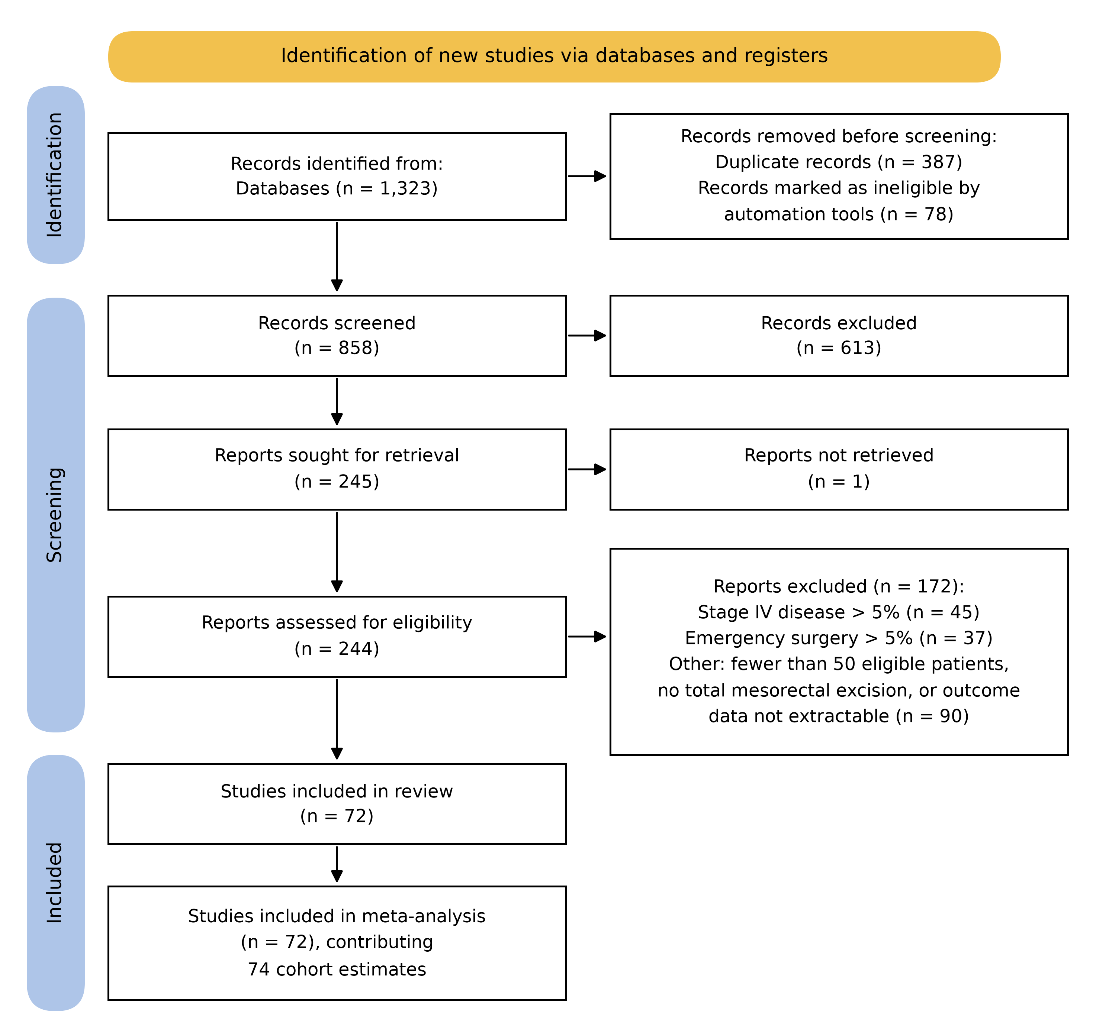

Figure 2

Figure 3
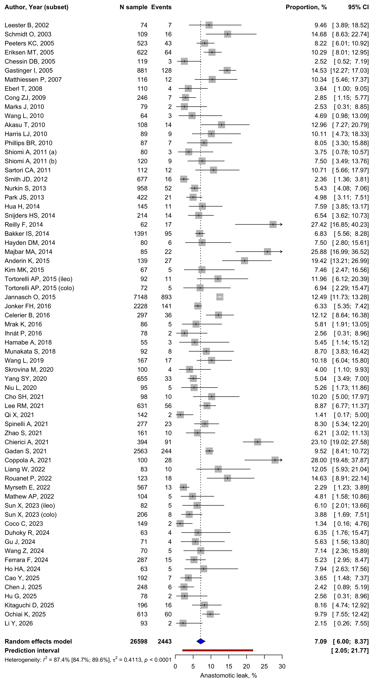

Figure 4
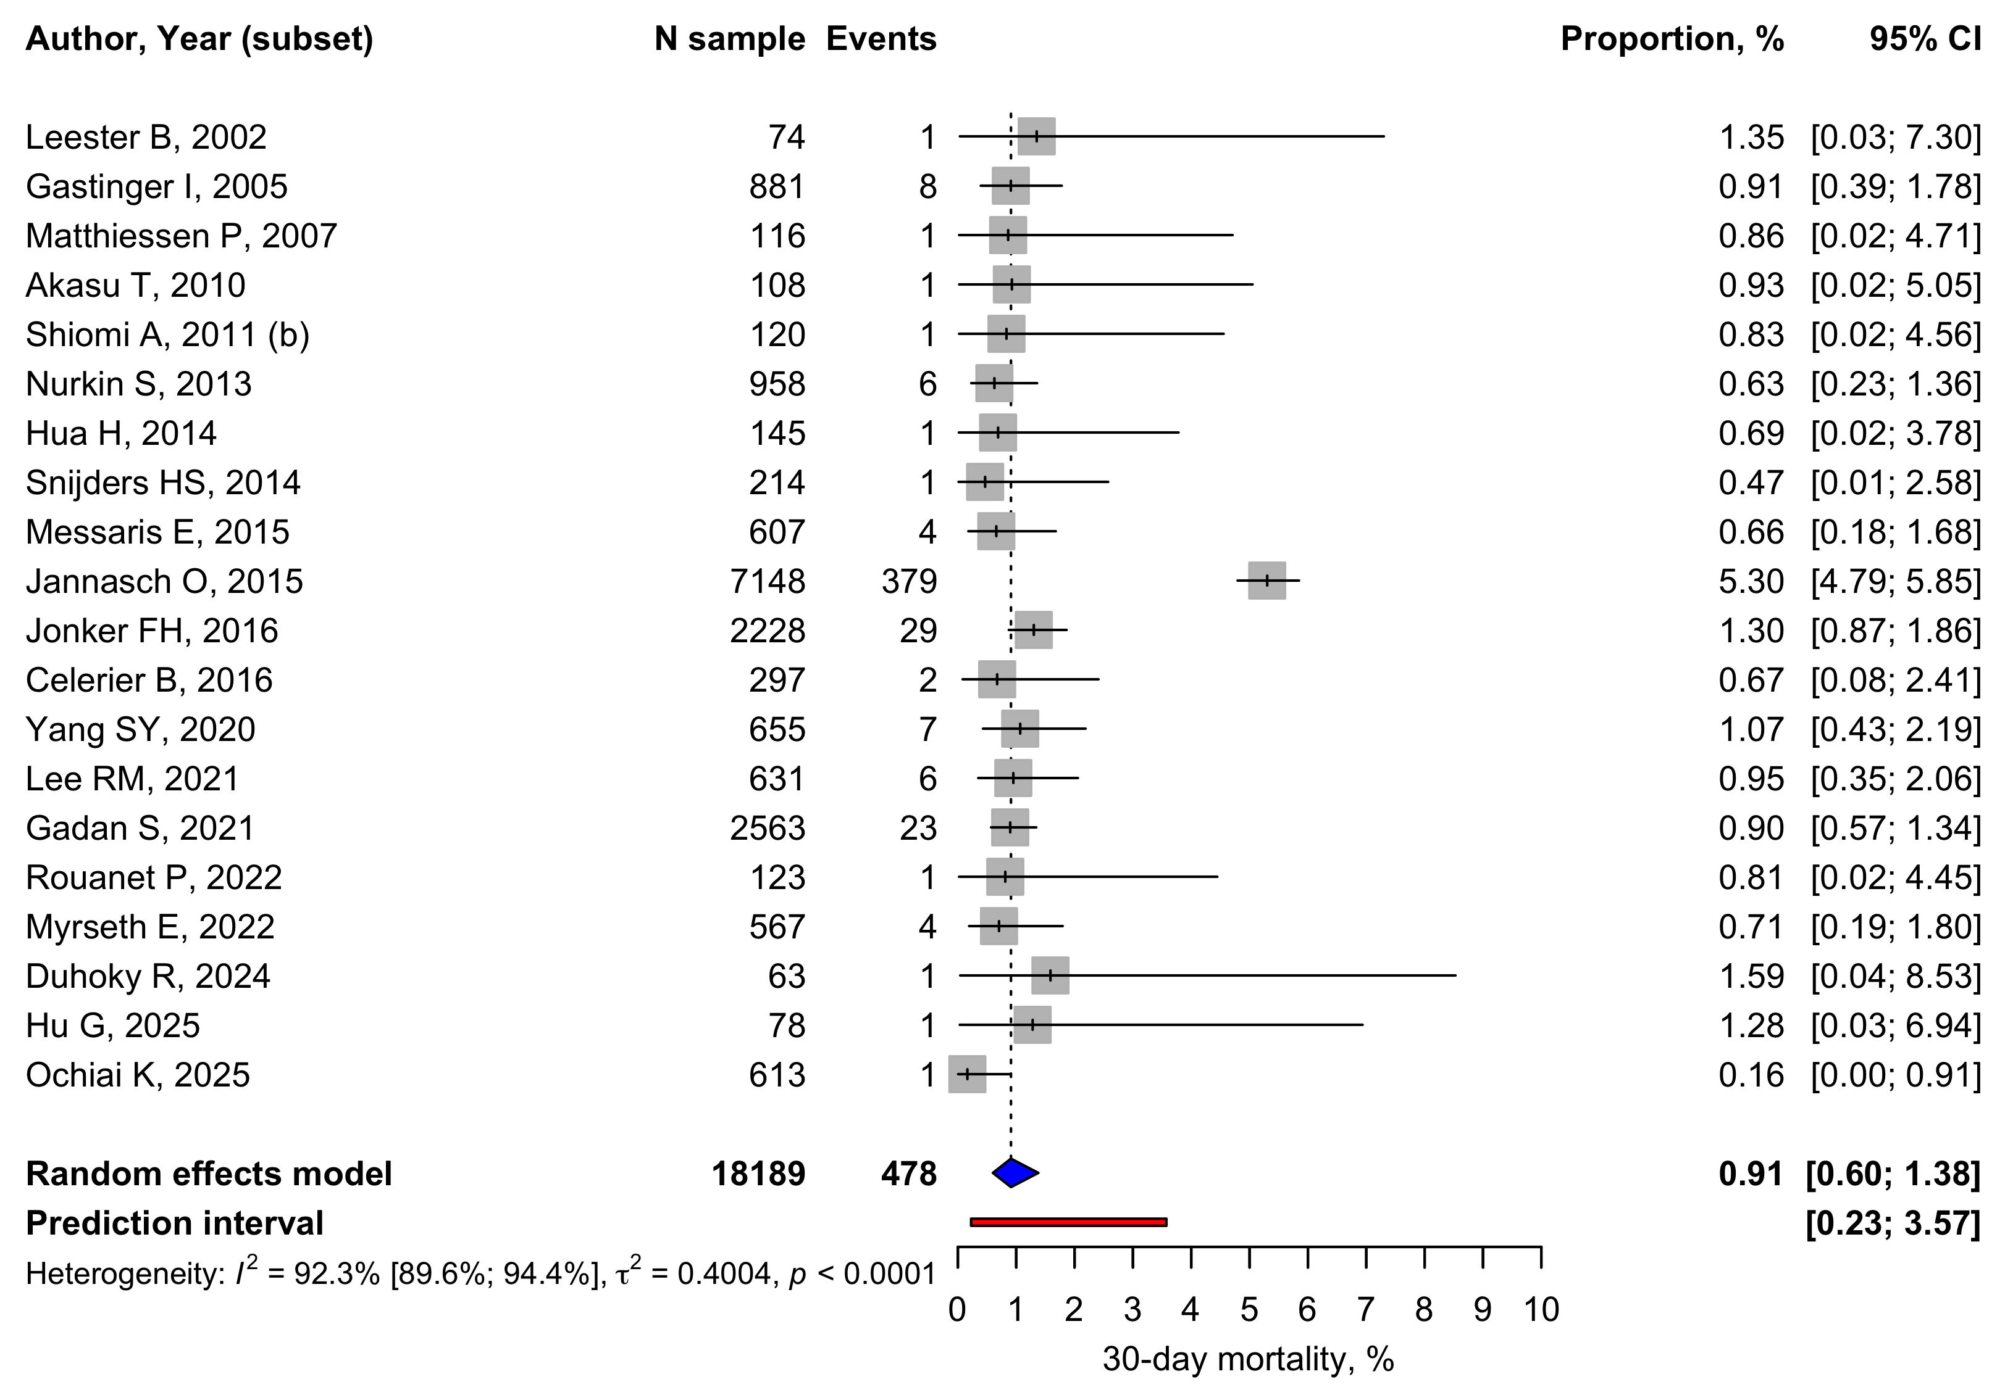

Figure 5
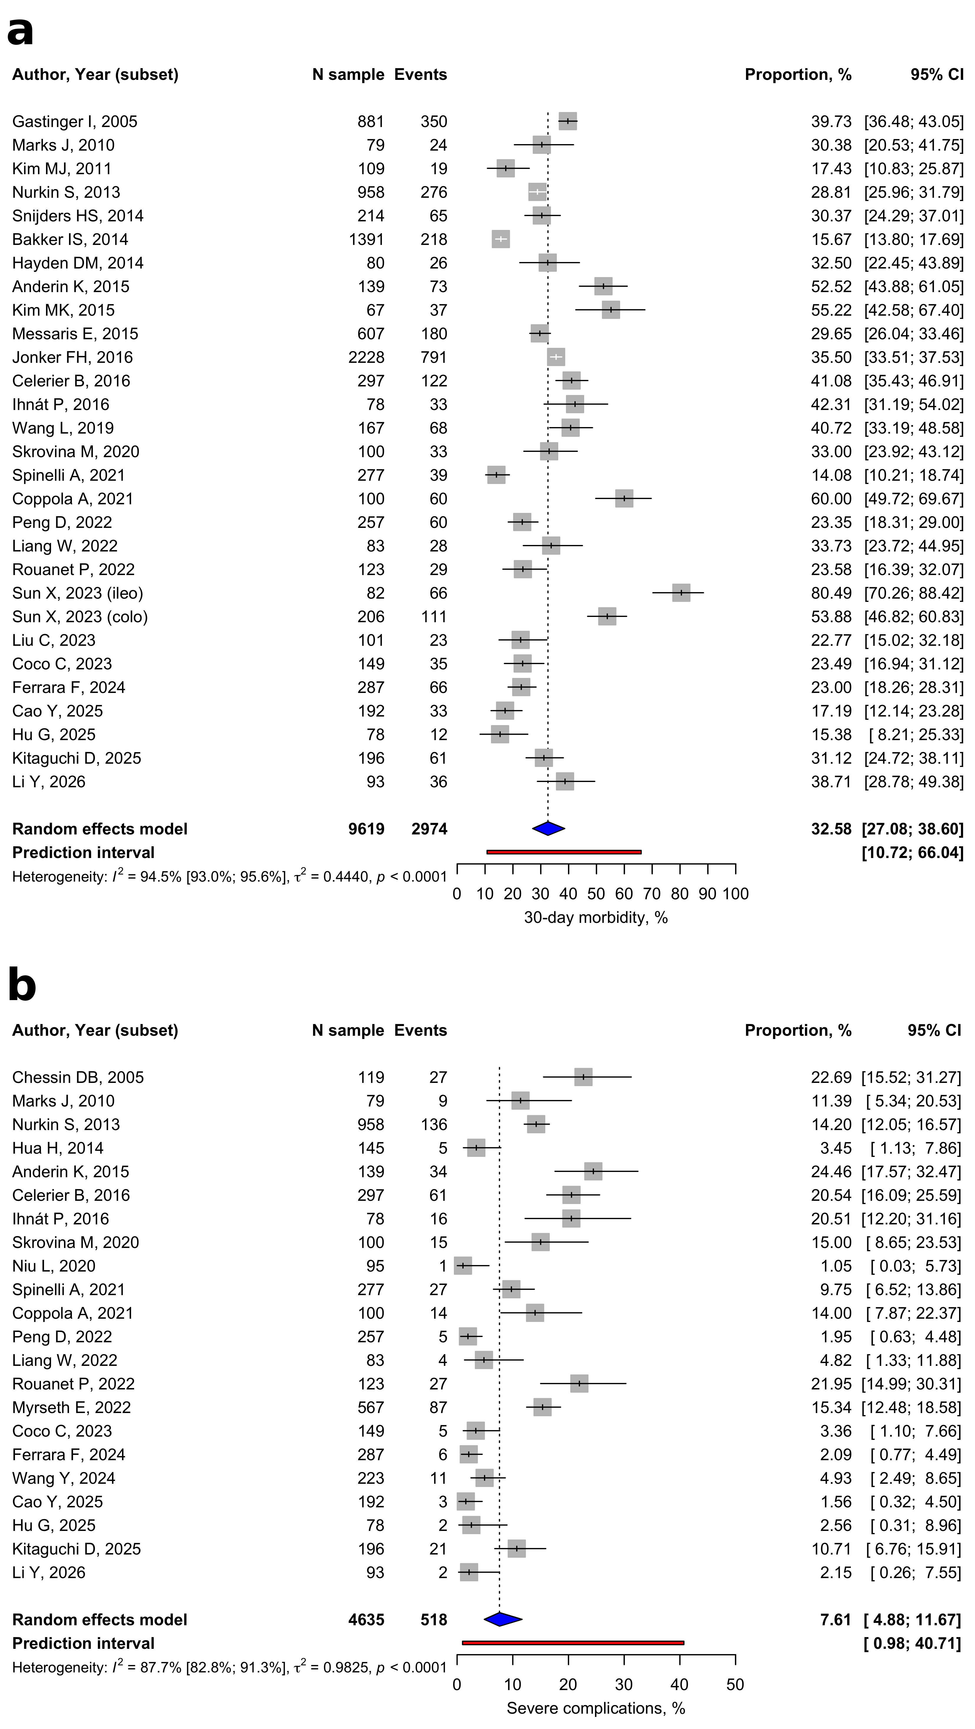

Figure 6


