Supplementary Information
Postoperative morbidity and mortality of defunctioning stoma in radical rectal cancer surgery: a systematic review and meta-analysis of proportions

Contents
Table S1. PRISMA 2020 checklist with manuscript locations.
Table S2. Full Boolean search strategies with record counts and execution dates.
Table S3. Characteristics of the 72 included studies.
Table S4. Reasons for exclusion at full-text assessment, with representative examples.
Table S5. Summary of study-level characteristics across the 74 extracted cohorts.
Table S6. Types of stoma-related complications within 30 days reported by the included studies.
Figure S1. Anastomotic leakage stratified by stoma type.
Figure S2. Anastomotic leakage stratified by study design.
Figure S3. Anastomotic leakage stratified by publication era.
Figure S4. Pooled prevalence of stoma-related complications within 30 days.
Figure S5. Share of 30-day morbidity attributable to stoma-related complications.
Supplementary references. Included studies.

Table S1. PRISMA 2020 checklist with the location of each item in the manuscript.
Section headings follow the PRISMA 2020 statement (Page et al., BMJ 2021;372:n71, https://doi.org/10.1136/bmj.n71). Locations refer to the submitted manuscript and to this Supplementary Information.
Item | Checklist item | Location
TITLE
1 | Title. Identify the report as a systematic review. | Title page: the title states 'a systematic review and meta-analysis of proportions'.
ABSTRACT
2 | Abstract. See the PRISMA 2020 for Abstracts checklist. | Abstract: background, eligibility, sources, synthesis method, pooled results with confidence and prediction intervals, limitations, interpretation and registration number are all reported.
INTRODUCTION
3 | Rationale. Describe the rationale for the review in the context of existing knowledge. | Introduction, paragraphs 1-3.
4 | Objectives. Provide an explicit statement of the objective(s) or question(s) the review addresses. | Introduction, final paragraph.
METHODS
5 | Eligibility criteria. Specify the inclusion and exclusion criteria for the review and how studies were grouped for the syntheses. | Methods, 'Eligibility criteria'; grouping for synthesis in Methods, 'Statistical analysis'.
6 | Information sources. Specify all databases, registers, websites, organisations, reference lists and other sources searched or consulted. Specify the date when each source was last searched or consulted. | Methods, 'Information sources and search strategy'; full strategies and dates in Supplementary Table S2.
7 | Search strategy. Present the full search strategies for all databases, registers and websites, including any filters and limits used. | Supplementary Table S2.
8 | Selection process. Specify the methods used to decide whether a study met the inclusion criteria, including how many reviewers screened each record and each report, whether they worked independently, and if applicable, details of automation tools used. | Methods, 'Study selection and data extraction'.
9 | Data collection process. Specify the methods used to collect data from reports, including how many reviewers collected data from each report, whether they worked independently, any processes for obtaining or confirming data from study investigators, and if applicable, details of automation tools used. | Methods, 'Study selection and data extraction'.
10a | Data items: outcomes. List and define all outcomes for which data were sought. Specify whether all results that were compatible with each outcome domain in each study were sought, and if not, the methods used to decide which results to collect. | Methods, 'Outcomes and definitions'.
10b | Data items: other variables. List and define all other variables for which data were sought. Describe any assumptions made about any missing or unclear information. | Methods, 'Study selection and data extraction'; item-level completeness in Supplementary Tables S3 and S5.
11 | Study risk of bias assessment. Specify the methods used to assess risk of bias in the included studies, including details of the tool(s) used, how many reviewers assessed each study and whether they worked independently, and if applicable, details of automation tools used. | Methods, 'Risk of bias and certainty of evidence'.
12 | Effect measures. Specify for each outcome the effect measure(s) (e.g. risk ratio, mean difference) used in the synthesis or presentation of results. | Methods, 'Statistical analysis': pooled prevalence (proportion) with 95% confidence and prediction intervals.
13a | Synthesis methods: eligibility for synthesis. Describe the processes used to decide which studies were eligible for each synthesis. | Methods, 'Statistical analysis'; Results, 'Study selection'.
13b | Synthesis methods: data preparation. Describe any methods required to prepare the data for presentation or synthesis, such as handling of missing summary statistics, or data conversions. | Methods, 'Statistical analysis'; Methods, 'Deviations from the registered protocol'.
13c | Synthesis methods: tabulation and visual display. Describe any methods used to tabulate or visually display results of individual studies and syntheses. | Figures 3-5, Supplementary Figures S1-S5, Tables 1 and 2, Supplementary Tables S3, S5 and S6.
13d | Synthesis methods: synthesis and heterogeneity. Describe any methods used to synthesise results and provide a rationale for the choice(s). If meta-analysis was performed, describe the model(s), method(s) to identify the presence and extent of statistical heterogeneity, and software package(s) used. | Methods, 'Statistical analysis'.
13e | Synthesis methods: subgroups. Describe any methods used to explore possible causes of heterogeneity among study results (e.g. subgroup analysis, meta-regression). | Methods, 'Statistical analysis'; Methods, 'Deviations from the registered protocol' for the analyses that could not be performed.
13f | Synthesis methods: sensitivity analyses. Describe any sensitivity analyses conducted to assess robustness of the synthesised results. | Methods, 'Statistical analysis'; Results, 'Small-study effects and sensitivity analyses'.
14 | Reporting bias assessment. Describe any methods used to assess risk of bias due to missing results in a synthesis (arising from reporting biases). | Methods, 'Statistical analysis': funnel plots, Peters' regression test, restriction by cohort size and trim-and-fill.
15 | Certainty assessment. Describe any methods used to assess certainty (or confidence) in the body of evidence for an outcome. | Methods, 'Risk of bias and certainty of evidence'.
RESULTS
16a | Study selection: flow. Describe the results of the search and selection process, from the number of records identified in the search to the number of studies included in the review, ideally using a flow diagram. | Results, 'Study selection'; Figure 1.
16b | Study selection: exclusions. Cite studies that might appear to meet the inclusion criteria, but which were excluded, and explain why they were excluded. | Supplementary Table S4 (exclusion categories with counts and representative examples); Results, 'Study selection'.
17 | Study characteristics. Cite each included study and present its characteristics. | Supplementary Table S3 and Supplementary references; summary in Supplementary Table S5 and in Results, 'Study selection'.
18 | Risk of bias in studies. Present assessments of risk of bias for each included study. | Figure 2; Results, 'Risk of bias'.
19 | Results of individual studies. For all outcomes, present, for each study: (a) summary statistics for each group and (b) an effect estimate and its precision, ideally using structured tables or plots. | Figures 3-5 and Supplementary Figures S1-S5; Supplementary Tables S3 and S6.
20a | Results of syntheses: study characteristics. For each synthesis, briefly summarise the characteristics and risk of bias among contributing studies. | Results, 'Study selection' and 'Risk of bias'; Table 1.
20b | Results of syntheses: statistical results. Present results of all statistical syntheses conducted. If meta-analysis was done, present for each the summary estimate and its precision and measures of statistical heterogeneity. | Results, 'Anastomotic leakage', 'Mortality', 'Morbidity' and 'Stoma-related complications'; Tables 1 and 2.
20c | Results of syntheses: heterogeneity. Present results of all investigations of possible causes of heterogeneity among study results. | Results, 'Anastomotic leakage'; Table 2; Supplementary Figures S1-S3.
20d | Results of syntheses: sensitivity. Present results of all sensitivity analyses conducted to assess the robustness of the synthesised results. | Results, 'Small-study effects and sensitivity analyses'.
21 | Reporting biases. Present assessments of risk of bias due to missing results (arising from reporting biases) for each synthesis assessed. | Results, 'Small-study effects and sensitivity analyses'; Figure 6.
22 | Certainty of evidence. Present assessments of certainty (or confidence) in the body of evidence for each outcome assessed. | Results, 'Certainty of evidence'; GRADE column of Table 1.
DISCUSSION
23a | Interpretation. Provide a general interpretation of the results in the context of other evidence. | Discussion, paragraphs 1-5.
23b | Limitations of evidence. Discuss any limitations of the evidence included in the review. | Discussion, limitations paragraph.
23c | Limitations of review processes. Discuss any limitations of the review processes used. | Discussion, limitations paragraph; Methods, 'Deviations from the registered protocol'.
23d | Implications. Discuss implications of the results for practice, policy and future research. | Discussion, final two paragraphs.
OTHER INFORMATION
24a | Registration. Provide registration information for the review, including register name and registration number, or state that the review was not registered. | Methods, 'Protocol, registration and reporting': PROSPERO CRD420261422080.
24b | Protocol. Indicate where the review protocol can be accessed, or state that a protocol was not prepared. | Methods, 'Protocol, registration and reporting'; Data Availability.
24c | Amendments. Describe and explain any amendments to information provided at registration or in the protocol. | Methods, 'Deviations from the registered protocol'.
25 | Support. Describe sources of financial or non-financial support for the review, and the role of the funders or sponsors in the review. | Acknowledgements: the review received no funding.
26 | Competing interests. Declare any competing interests of review authors. | Additional Information: the authors declare no competing interests.
27 | Availability of data, code and other materials. Report which of the following are publicly available and where they can be found: template data collection forms; data extracted from included studies; data used for all analyses; analytic code; any other materials used in the review. | Data Availability (public repository with data and code); Supplementary Tables S2, S3, S5 and S6.

Table S2. Full Boolean search strategies, with record counts and execution dates.
Both strategies were developed in parallel and executed independently in PubMed by two reviewers. The union of the two result sets was exported to Zotero, merged and deduplicated automatically with manual verification of near-duplicates, as shown in Fig. 1 of the main text. The strategies were audited against the PRESS 2015 checklist (McGowan et al., J Clin Epidemiol 2016;75:40-46, https://doi.org/10.1016/j.jclinepi.2016.01.021).
Element | Content
Database and date | PubMed (MEDLINE). Searched for records published from 1 January 1982; strategies executed on 10 April 2026.
Strategy 1 (reviewer V.S.) - 682 records | ("rectal neoplasms"[MeSH Terms] OR "rectal cancer"[tiab] OR "rectal carcinoma"[tiab]) AND ("anterior resection"[tiab] OR "low anterior resection"[tiab] OR "total mesorectal excision"[tiab] OR "TME"[tiab] OR "proctectomy"[tiab] OR "rectal resection"[tiab] OR "intersphincteric resection"[tiab] OR "sphincter-preserving"[tiab] OR "sphincter preserving"[tiab]) AND ("diverting stoma"[tiab] OR "defunctioning stoma"[tiab] OR "protective stoma"[tiab] OR "preventive stoma"[tiab] OR "diverting ileostomy"[tiab] OR "defunctioning ileostomy"[tiab] OR "protective ileostomy"[tiab] OR "loop ileostomy"[tiab] OR "temporary ileostomy"[tiab] OR "fecal diversion"[tiab] OR "faecal diversion"[tiab] OR "covering stoma"[tiab] OR "proximal diversion"[tiab] OR "diverting colostomy"[tiab] OR "defunctioning colostomy"[tiab] OR "protective colostomy"[tiab] OR "preventive colostomy"[tiab]) NOT ("review"[pt] OR "systematic review"[pt] OR "meta-analysis"[pt] OR "case reports"[pt] OR "editorial"[pt] OR "letter"[pt] OR "comment"[pt] OR "palliative"[ti] OR "case report"[ti] OR "pediatric"[ti] OR "paediatric"[ti] OR "closure"[ti] OR "reversal"[ti] OR "takedown"[ti] OR "low anterior resection syndrome"[ti] OR "LARS"[ti] OR "cost"[ti] OR "costs"[ti] OR "cost-effectiveness"[ti] OR "quality of life"[ti] OR "nursing"[ti] OR "stoma care"[ti] OR "microbiome"[ti] OR "body image"[ti] OR "psychological"[ti] OR "protocol"[ti] OR "permanent"[ti]) AND English[la] NOT ("Animals"[MeSH] NOT "Humans"[MeSH])
Strategy 2 (reviewer N.B.) - 641 records | (prophylactic stoma[Title/Abstract] OR protective stoma[Title/Abstract] OR preventive stoma[Title/Abstract] OR defunctioning stoma[Title/Abstract] OR prophylactic ileostoma[Title/Abstract] OR protective ileostoma[Title/Abstract] OR preventive ileostoma[Title/Abstract] OR defunctioning ileostoma[Title/Abstract] OR prophylactic colostoma[Title/Abstract] OR protective colostoma[Title/Abstract] OR preventive colostoma[Title/Abstract] OR defunctioning colostoma[Title/Abstract]) AND (rectal cancer[Title/Abstract] OR colorectal cancer[Title/Abstract] OR rectal carcinoma[Title/Abstract] OR rectum cancer[Title/Abstract] OR colorectal carcinoma[Title/Abstract]) AND (anterior resection[Title/Abstract] OR anterior rectal resection[Title/Abstract] OR low anterior resection[Title/Abstract] OR rectal resection[Title/Abstract] OR TME[Title/Abstract] OR total mesorectal excision[Title/Abstract]) NOT (protocol[Title] OR review[Title] OR meta-analysis[Title] OR meta analysis[Title] AND closure[Title] AND emergency[Title/Abstract])
Total before deduplication | 1,323 records (682 + 641).
Deduplication | 387 duplicate records and 78 records marked as ineligible by automation tools were removed before screening, leaving 858 records for title and abstract screening.

Table S3. Characteristics of the 72 included studies.
Two studies (Tortorelli AP 2015 and Sun X 2023) reported loop ileostomy and loop colostomy subgroups separately and are shown as two rows each, giving 74 rows for 72 studies. Counts are numbers of patients unless stated otherwise; age is in years and body mass index in kg/m2, each as reported by the primary study (mean or median). Unit of data indicates whether the extracted figures describe the diverted subgroup or the whole operated cohort. An em dash means the item was not reported. AL, anastomotic leakage; MIS, minimally invasive surgery; Neoadj., neoadjuvant therapy; Prosp., prospective cohort; RCT, randomised controlled trial; Retro., retrospective cohort.
Study | Design | Data unit | Total cohort | Eligible n | Men | Age | BMI | Neoadj. | MIS | Stoma | AL | Any compl. | Severe | Infection | Death
Leester B 2002 | Retro. | Whole cohort | 249 | 74 | – | 63.0 | – | – | – | Ileostomy | 7 | – | – | – | 1
Schmidt O 2003 | Retro. | Whole cohort | 296 | 109 | – | 62.0 | – | – | – | Mixed | 16 | – | – | – | –
Peeters KC 2005 | Retro. | Whole cohort | 924 | 523 | 336 | 64.0 | – | 465 | – | Mixed | 43 | – | – | – | –
Eriksen MT 2005 | Retro. | Whole cohort | 1,958 | 622 | 1,129 | 69.0 | – | 59 | – | Mixed | 64 | – | – | – | –
Chessin DB 2005 | Retro. | Whole cohort | 297 | 119 | 186 | 61.5 | – | 297 | – | Mixed | 3 | – | 27 | – | –
Gastinger I 2005 | Prosp. | Diverted | 2,729 | 881 | 554 | 64.6 | – | 119 | – | Mixed | 128 | 350 | – | – | 8
Matthiessen P 2007 | RCT | Diverted | 116 | 116 | 70 | 68.0 | 25.0 | 94 | – | Mixed | 12 | – | – | – | 1
Eberl T 2008 | Retro. | Whole cohort | 472 | 110 | 266 | 65.0 | – | 51 | – | Mixed | 4 | – | – | – | –
Cong ZJ 2009 | Retro. | Whole cohort | 738 | 246 | 454 | 59.0 | – | 32 | – | Mixed | 7 | – | – | – | –
Marks J 2010 | Retro. | Diverted | 79 | 79 | 54 | 59.2 | 26.5 | 79 | 79 | Mixed | 2 | 24 | 9 | 3 | –
Wang L 2010 | Retro. | Whole cohort | 217 | 64 | 113 | 57.0 | – | 217 | – | Mixed | 3 | – | – | – | –
Akasu T 2010 | Retro. | Whole cohort | 120 | 108 | 92 | 57.0 | – | – | – | Mixed | 14 | – | – | – | 1
Harris LJ 2010 | Retro. | Diverted | 89 | 89 | – | – | – | 89 | – | Mixed | 9 | – | – | – | –
Phillips BR 2010 | Retro. | Diverted | 87 | 87 | 51 | 58.0 | – | 87 | – | Mixed | 7 | – | – | – | –
Shiomi A 2011 (a) | Retro. | Whole cohort | 222 | 80 | 144 | 62.2 | 22.5 | 5 | – | Mixed | 3 | – | – | – | –
Shiomi A 2011 (b) | Retro. | Diverted | 329 | 120 | 85 | 59.4 | 22.3 | – | – | Mixed | 9 | – | – | – | 1
Kim MJ 2011 | Retro. | Whole cohort | 215 | 109 | 145 | 60.0 | – | 126 | 9 | Mixed | – | 19 | – | – | –
Sartori CA 2011 | Retro. | Whole cohort | 174 | 112 | 102 | 64.2 | – | 68 | 174 | Ileostomy | 12 | – | – | – | –
Smith JD 2012 | Retro. | Diverted | 677 | 677 | 406 | 59.0 | – | 550 | – | Mixed | 16 | – | – | – | –
Beirens K 2012 | Prosp. | Whole cohort | 1,912 | 1,183 | – | 65.5 | – | – | – | Mixed | – | – | – | – | –
Nurkin S 2013 | Retro. | Diverted | 958 | 958 | 608 | – | 28.5 | 476 | – | Mixed | 52 | 276 | 136 | 248 | 6
Park JS 2013 | Retro. | Whole cohort | 1,609 | 422 | 1,052 | – | – | 264 | 1,609 | Ileostomy | 21 | – | – | – | –
Jafari MD 2013 | Retro. | Diverted | 991 | 991 | – | 60.0 | – | – | – | Ileostomy | – | – | – | – | –
Hua H 2014 | Prosp. | Diverted | 145 | 145 | 102 | 61.8 | 23.9 | 20 | 29 | Ileostomy | 11 | – | 5 | – | 1
Snijders HS 2014 | Retro. | Diverted | 214 | 214 | 127 | 63.0 | – | 199 | 74 | Mixed | 14 | 65 | – | 4 | 1
Reilly F 2014 | Retro. | Whole cohort | 129 | 62 | 84 | 64.6 | – | 37 | 20 | Ileostomy | 17 | – | – | – | –
Bakker IS 2014 | Retro. | Diverted | 1,391 | 1,391 | 845 | 66.0 | – | 1,183 | – | Mixed | 95 | 218 | – | 63 | –
Hayden DM 2014 | Retro. | Whole cohort | 123 | 80 | 71 | 59.2 | 27.2 | 82 | 45 | Ileostomy | 6 | 26 | – | – | –
Majbar MA 2014 | Retro. | Whole cohort | 130 | 85 | 68 | 55.0 | – | 55 | 36 | Mixed | 22 | – | – | – | –
Anderin K 2015 | Prosp. | Diverted | 139 | 139 | 87 | 62.0 | 25.0 | 113 | – | Mixed | 27 | 73 | 34 | 27 | –
Kim MK 2015 | Retro. | Diverted | 67 | 67 | 48 | 32.2 | 24.3 | – | 61 | Ileostomy | 5 | 37 | – | 2 | –
Tortorelli AP 2015 (ileo) | Retro. | Whole cohort | 475 | 92 | 296 | 64.0 | – | 188 | – | Ileostomy | 11 | – | – | – | –
Tortorelli AP 2015 (colo) | Retro. | Whole cohort | 72 | 72 | – | – | – | – | – | Colostomy | 5 | – | – | – | –
Messaris E 2015 | Retro. | Diverted | 607 | 607 | 377 | 60.2 | 28.3 | – | 148 | Mixed | – | 180 | – | 95 | 4
Jannasch O 2015 | Retro. | Whole cohort | 17,867 | 7,148 | 10,477 | 67.0 | 26.5 | – | – | Ileostomy | 893 | – | – | – | –
Jonker FH 2016 | Retro. | Diverted | 2,228 | 2,228 | 1,438 | 63.9 | 25.9 | 2,228 | 1,272 | Ileostomy | 141 | 791 | – | 226 | 29
Celerier B 2016 | Retro. | Diverted | 297 | 297 | 192 | 65.0 | – | 186 | 194 | Mixed | 36 | 122 | 61 | – | 2
Mrak K 2016 | RCT | Diverted | 86 | 86 | 49 | 64.0 | 26.1 | 45 | – | Ileostomy | 5 | – | – | – | –
Ihnát P 2016 | Retro. | Diverted | 78 | 78 | 50 | 62.8 | 26.9 | 28 | 78 | Ileostomy | 2 | 33 | 16 | – | –
Hamabe A 2018 | Retro. | Whole cohort | 296 | 55 | 186 | 62.0 | 22.6 | – | 296 | Mixed | 3 | – | – | – | –
Munakata S 2018 | Retro. | Diverted | 92 | 92 | 64 | 64.0 | 21.6 | – | 75 | Ileostomy | 8 | – | – | – | –
Wang L 2019 | Retro. | Diverted | 167 | 167 | 127 | 64.2 | – | – | 167 | Mixed | 17 | 68 | – | 6 | –
Skrovina M 2020 | Retro. | Diverted | 100 | 100 | 63 | 63.7 | 27.0 | 71 | 100 | Ileostomy | 4 | 33 | 15 | – | –
Yang SY 2020 | Retro. | Whole cohort | 1,903 | 655 | 1,198 | 60.6 | 23.2 | 711 | 1,592 | Ileostomy | 33 | – | – | – | 7
Niu L 2020 | Retro. | Diverted | 95 | 95 | 59 | 64.2 | – | 34 | 78 | Ileostomy | 5 | – | 1 | – | –
Cho SH 2021 | Retro. | Diverted | 98 | 98 | 62 | 62.5 | – | 52 | 98 | Ileostomy | 10 | – | – | – | –
Lee RM 2021 | Retro. | Whole cohort | 996 | 631 | 503 | 58.2 | 28.8 | 569 | 368 | Ileostomy | 56 | – | – | 155 | 6
Qi X 2021 | Retro. | Whole cohort | 298 | 142 | 169 | 63.0 | 25.0 | 48 | 298 | Ileostomy | 2 | – | – | – | –
Spinelli A 2021 | Retro. | Diverted | 277 | 277 | 174 | 64.0 | 25.0 | 171 | 277 | Ileostomy | 23 | 39 | 27 | – | –
Zhao S 2021 | RCT | Whole cohort | 560 | 161 | 346 | 61.5 | 23.1 | 28 | 560 | Ileostomy | 10 | – | – | – | –
Chierici A 2021 | Retro. | Diverted | 394 | 394 | 242 | 59.0 | – | 331 | 392 | Ileostomy | 91 | – | – | – | –
Gadan S 2021 | Retro. | Diverted | 2,563 | 2,563 | 1,567 | 66.4 | – | 1,960 | – | Ileostomy | 244 | – | – | – | 23
Coppola A 2021 | Retro. | Diverted | 100 | 100 | 60 | 68.0 | 25.2 | 67 | 100 | Ileostomy | 28 | 60 | 14 | 12 | –
Peng D 2022 | Retro. | Diverted | 257 | 257 | 163 | 61.3 | 22.9 | 73 | 257 | Ileostomy | – | 60 | 5 | 22 | –
Liang W 2022 | Prosp. | Diverted | 83 | 83 | 51 | 58.2 | – | 53 | 83 | Ileostomy | 10 | 28 | 4 | 6 | –
Rouanet P 2022 | Retro. | Diverted | 123 | 123 | 86 | 65.0 | 23.1 | 84 | 123 | Ileostomy | 18 | 29 | 27 | – | 1
Myrseth E 2022 | Retro. | Diverted | 567 | 567 | 359 | – | – | 208 | 384 | Mixed | 13 | – | 87 | – | 4
Mathew AP 2022 | Retro. | Diverted | 104 | 104 | 58 | 58.5 | – | 98 | 41 | Ileostomy | 5 | – | – | – | –
Sun X 2023 (ileo) | Retro. | Diverted | 82 | 82 | 50 | 60.5 | 24.6 | 25 | – | Ileostomy | 5 | 66 | – | 3 | –
Sun X 2023 (colo) | Retro. | Diverted | 206 | 206 | 136 | 61.2 | 24.0 | 87 | – | Colostomy | 8 | 111 | – | 3 | –
Liu C 2023 | Retro. | Diverted | 101 | 101 | 55 | 62.0 | 24.2 | 62 | 62 | Ileostomy | – | 23 | – | – | –
Coco C 2023 | Retro. | Diverted | 149 | 149 | 92 | 65.0 | – | 113 | 91 | Ileostomy | 2 | 35 | 5 | 4 | –
Duhoky R 2024 | Retro. | Whole cohort | 70 | 63 | 45 | 68.0 | 27.0 | 16 | 70 | Ileostomy | 4 | – | – | – | 1
Gu J 2024 | Retro. | Diverted | 71 | 71 | 38 | 59.0 | 23.2 | 20 | 71 | Ileostomy | 4 | – | – | 18 | –
Wang Z 2024 | Retro. | Diverted | 70 | 70 | 49 | 63.3 | – | 6 | – | Ileostomy | 5 | – | – | – | –
Ferrara F 2024 | Prosp. | Diverted | 287 | 287 | 146 | 61.4 | – | 131 | 210 | Ileostomy | 15 | 66 | 6 | 48 | –
Wang Y 2024 | Retro. | Diverted | 809 | 223 | 180 | 71.0 | 24.8 | 141 | 231 | Ileostomy | – | – | 11 | 39 | –
Ho HA 2024 | Retro. | Diverted | 63 | 63 | 40 | 62.6 | 22.5 | 14 | 63 | Ileostomy | 5 | – | – | 13 | –
Cao Y 2025 | Prosp. | Diverted | 192 | 192 | 127 | 59.5 | 23.1 | 41 | 192 | Ileostomy | 7 | 33 | 3 | 29 | –
Chen J 2025 | RCT | Diverted | 248 | 248 | 172 | 61.8 | 24.6 | 67 | – | Ileostomy | 6 | – | – | 3 | –
Hu G 2025 | Retro. | Diverted | 78 | 78 | 34 | 64.0 | 23.9 | 4 | 78 | Ileostomy | 2 | 12 | 2 | – | 1
Kitaguchi D 2025 | Retro. | Diverted | 196 | 196 | 147 | 61.0 | 23.6 | 97 | 196 | Ileostomy | 16 | 61 | 21 | 23 | –
Ochiai K 2025 | Retro. | Whole cohort | 922 | 613 | 637 | 63.0 | 22.2 | 262 | 400 | Mixed | 60 | – | – | – | 1
Li Y 2026 | Retro. | Diverted | 93 | 93 | 56 | – | – | 20 | 93 | Ileostomy | 2 | 36 | 2 | – | –

Table S4. Reasons for exclusion at full-text assessment, with representative examples.
Of 244 reports assessed in full text, 172 were excluded. Each report was assigned the first applicable reason in the order shown. For each category two reports are given as representative examples of the reasoning applied; they illustrate the category and are not a complete list.
Exclusion category | Reports, n | Criterion applied | Representative examples and reason
Stage IV disease in more than 5% of the cohort | 45 | Patients with synchronous distant metastases at the index operation made up more than 5% of the cohort and outcomes were not reported separately for M0 patients. | Nash, G. M. et al. Radical resection of rectal cancer primary tumor provides effective local therapy in patients with stage IV disease. Ann. Surg. Oncol. 9, 954–960 (2002). https://doi.org/10.1007/BF02574512 Reason: Cohort consisted of 80 patients with stage IV disease.  Luna-Pérez, P. et al. Preoperative chemoradiation therapy and anal sphincter preservation with locally advanced rectal adenocarcinoma. World J. Surg. 25, 1006–1011 (2001). https://doi.org/10.1007/s00268-001-0071-y Reason: M1 disease in 6% of patients; results not stratified by stage.
Emergency surgery in more than 5% of the cohort | 37 | Emergency or urgent resections (obstruction, perforation, bleeding) made up more than 5% of the cohort and elective cases could not be separated. | 2017 European Society of Coloproctology (ESCP) collaborating group. Safety of primary anastomosis following emergency left sided colorectal resection: an international, multi-centre prospective audit. Colorectal Dis. 20 (Suppl. 6), 47–57 (2018). https://doi.org/10.1111/codi.14373 Reason: Emergency operations only; colonic and rectal resections combined.  Minasyan, A. & Sargsyan, R. Efficacy of the anterior resection in management of acute colonic obstruction in patients with rectal cancer. Georgian Med. News 259, 7–10 (2016). PMID 27845278 Reason: All 73 patients underwent emergent anterior resection for obstruction.
Other: fewer than 50 eligible diverted patients | 90 (combined) | Fewer than 50 patients met the eligibility criteria and received a simultaneous defunctioning stoma. | Lefebure, B. et al. Evaluation of selective defunctioning stoma after low anterior resection for rectal cancer. Int. J. Colorectal Dis. 23, 283–288 (2008). https://doi.org/10.1007/s00384-007-0380-1 Reason: Stoma formed in 42 of 132 patients.  Polglase, A. L., McMurrick, P. J., Tremayne, A. B. & Bhathal, P. S. Local recurrence after curative anterior resection with principally blunt dissection for carcinoma of the rectum and rectosigmoid. Dis. Colon Rectum 44, 947–954 (2001). https://doi.org/10.1007/BF02235481 Reason: Stoma formed in 37 of 131 patients; rectosigmoid tumours included.
Other: operation not eligible |  | The operation studied was not TME with primary anastomosis and simultaneous stoma for rectal adenocarcinoma, for example mixed colonic and rectal resections or benign indications. | Kream, J., Ludwig, K. A., Ridolfi, T. J. & Peterson, C. Y. Achieving low anastomotic leak rates utilizing clinical perfusion assessment. Surgery 160, 960–967 (2016). https://doi.org/10.1016/j.surg.2016.06.007 Reason: Sigmoid colectomy, left colectomy and low anterior resection analysed together.  Talaiezadeh, A., Shoushtary, M. S., Salmasi, A. A. & Afkhami, M. A. Applying protective rectal tube in intestinal anastomosis. Prz. Gastroenterol. 13, 99–101 (2018). https://doi.org/10.5114/pg.2018.76006 Reason: Mainly ileal pouch–anal anastomosis for ulcerative colitis or familial adenomatous polyposis.
Other: outcomes not disaggregated for the diverted subgroup |  | Outcomes were reported only for the whole operated cohort, which mixed diverted and undiverted patients, and could not be extracted for patients with a stoma. | Bennis, M. et al. Morbidity risk factors after low anterior resection with total mesorectal excision and coloanal anastomosis: a retrospective series of 483 patients. Ann. Surg. 255, 504–510 (2012). https://doi.org/10.1097/SLA.0b013e31824485c4 Reason: Morbidity reported for all 483 patients only.  Penninckx, F. et al. Risk adjusted benchmarking of clinical anastomotic leakage rate after total mesorectal excision in the context of an improvement project. Colorectal Dis. 14, e413–e421 (2012). https://doi.org/10.1111/j.1463-1318.2012.02977.x Reason: Leak rate given for the whole national cohort, not by stoma status.
Report not retrieved | 1 (before full-text assessment) | Full text could not be obtained. | –
The 90 reports in the combined 'other' category were excluded for one of the three reasons listed; counts by reason within this category were not recorded separately. TME, total mesorectal excision.

Table S5. Summary of study-level characteristics across the 74 extracted cohorts.
Rows marked † report the absolute frequency and the percentage; rows marked * report mean (SD), median [Q1, Q3] and range. The unit is the extracted cohort, so the two studies that reported loop ileostomy and loop colostomy subgroups separately contribute two rows each and the denominator is 74 rather than 72. Rates are the crude proportions reported by the primary studies and are unweighted; they are given to describe the corpus and differ from the model-based pooled estimates in Table 1 of the main text. Not reported is the number of cohorts for which the item was not available.
Characteristic | Extracted cohorts (n = 74)
Publication period†
Before 2010 | 9 (12%)
2010–2019 | 33 (45%)
2020 onwards | 32 (43%)
Study design†
Retrospective cohort | 62 (83.8%)
Prospective cohort | 8 (10.8%)
Randomised controlled trial | 4 (5.4%)
Stoma type†
Loop colostomy only | 2 (2.7%)
Loop ileostomy only | 43 (58.1%)
Loop ileostomy and loop colostomy | 29 (39.2%)
Extracted data refer to†
The diverted cohort only | 47 (63.5%)
The whole operated cohort | 27 (36.5%)
Size sample of study*
Median [Q1, Q3] | 214.5 [100.0, 560.0]
Range | 63–17,867
Cohort size*
Median [Q1, Q3] | 119.5 [86.0, 297.0]
Min–Max | 55.0–7,148.0
Sum | 30,069.0
Proportion of men, %*
Mean (SD) | 60.9 (9.3)
Median [Q1, Q3] | 62.5 [58.6, 65.0]
Range | 20.3–76.7
Not reported | 6
Age, years*
Mean (SD) | 62.0 (4.8)
Median [Q1, Q3] | 62.4 [60.0, 64.2]
Range | 32.2–71.0
Not reported | 6
Body mass index, kg/m²*
Mean (SD) | 24.7 (1.9)
Median [Q1, Q3] | 24.6 [23.1, 26.1]
Range | 21.6–28.8
Not reported | 37
Length of hospital stay, days*
Mean (SD) | 11.2 (4.1)
Median [Q1, Q3] | 11.0 [8.0, 14.0]
Range | 5.0–21.0
Not reported | 59
Neoadjuvant chemo(radio)therapy, %*
Median [Q1, Q3] | 49.5 [27.0, 71.0]
Range | 2.3–100.0
Not reported | 13
Any complication, %*
Median [Q1, Q3] | 29.6 [21.4, 37.1]
Range | 8.8–60.0
Not reported | 46
Severe complications, %*
Median [Q1, Q3] | 7.3 [2.7, 15.0]
Range | 1.1–24.5
Not reported | 52
Anastomotic leakage, %*
Median [Q1, Q3] | 5.6 [2.5, 8.2]
Range | 0.7–28.0
Not reported | 7
Infectious complications, %*
Median [Q1, Q3] | 10.9 [3.7, 15.6]
Range | 1.2–25.9
Not reported | 54
Mortality, %*
Median [Q1, Q3] | 0.3 [0.0, 0.7]
Range | 0.0–1.4
Not reported | 42

Table S6. Types of stoma-related complications within 30 days reported by the included studies.
Event counts as reported by the primary studies. Thirteen studies reported stoma-related complications (250 events in 3,579 patients); nine of them specified the type of event (69 events). Bakker IS 2014 (58 events), Myrseth E 2022 (15) and Snijders HS 2014 (4) reported totals only, and two of the nine events in Coco C 2023 were not typed. Ileus was attributed to the stoma by the primary authors in one study and is listed as reported. Pooled estimates by event type were not calculated because no category was reported by more than four studies.
Type of complication | Events, n | Studies (events)
Electrolyte disturbances/dehydration/high output | 65 | Mrak K, 2016 (2); Munakata S, 2018 (5); Wang L, 2019 (4); Coco C, 2023 (3); Ferrara F, 2024 (51)
Parastomal dermatitis/erosions | 60 | Wang L, 2019 (1); Gu J, 2024 (20); Ferrara F, 2024 (39)
Stoma retraction/detachment | 21 | Ihnát P, 2016 (1); Coco C, 2023 (1); Gu J, 2024 (7); Ferrara F, 2024 (12)
Obstruction | 6 | Matthiessen P, 2007 (2); Ihnát P, 2016 (4)
Parastomal abscess | 4 | Ihnát P, 2016 (2); Wang L, 2019 (2)
Stoma site bleeding | 4 | Wang L, 2019 (1); Peng D, 2022 (2); Mathew AP, 2022 (1)
Ileus | 3 | Coco C, 2023 (3)
Parastomal hernia | 3 | Gu J, 2024 (3)
Stoma edema | 2 | Peng D, 2022 (2)
Prolapse | 1 | Mathew AP, 2022 (1)
Stoma necrosis | 1 | Peng D, 2022 (1)
Stoma site infection | 1 | Munakata S, 2018 (1)
Total typed events | 250 | Thirteen studies

Figure S1. Pooled prevalence of clinically relevant anastomotic leakage stratified by stoma type. Cohorts confined to loop ileostomy are compared with cohorts containing both loop ileostomies and loop colostomies; the two estimates confined to loop colostomy are not shown. Squares are study-specific proportions, horizontal lines are 95% confidence intervals, diamonds are subgroup pooled estimates from a random-effects generalised linear mixed model with a logit link, and bars are 95% prediction intervals.
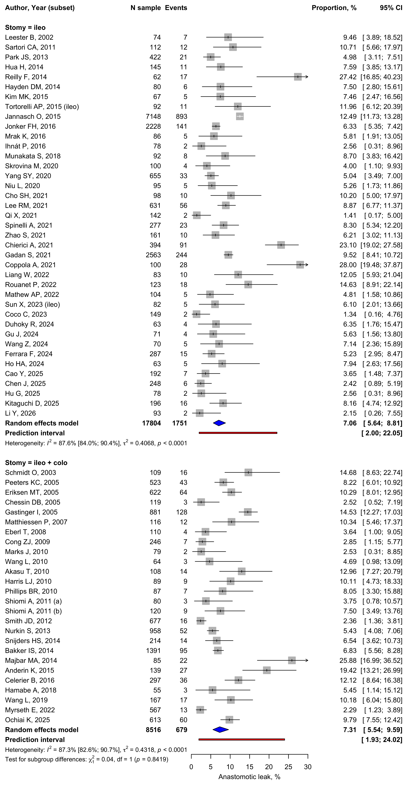

Figure S2. Pooled prevalence of clinically relevant anastomotic leakage stratified by study design (retrospective cohort, prospective cohort, randomised controlled trial). Constructed as in Fig. S1.
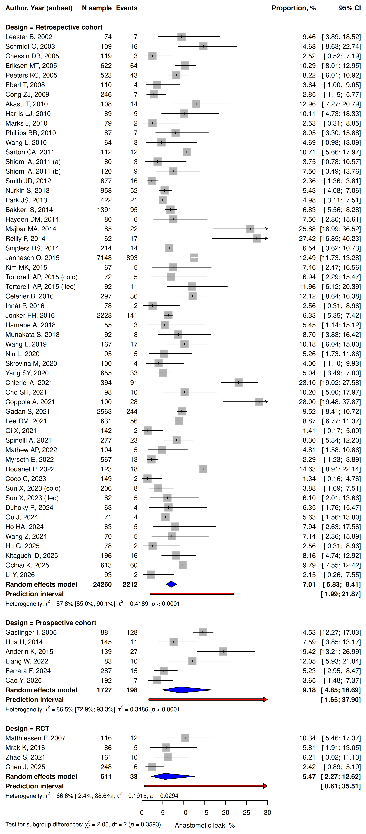

Figure S3. Pooled prevalence of clinically relevant anastomotic leakage stratified by publication era (before 2010, 2010–2019, 2020 onwards). Constructed as in Fig. S1.
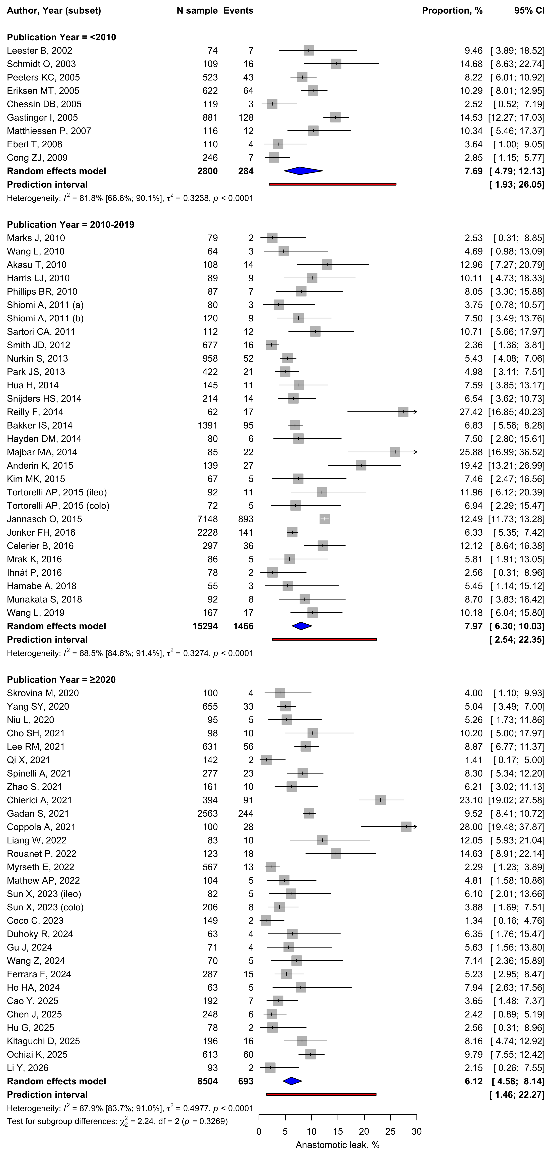

Figure S4. Pooled prevalence of stoma-related complications within 30 days, as defined by each primary study, in 12 studies. Constructed as in Fig. S1.
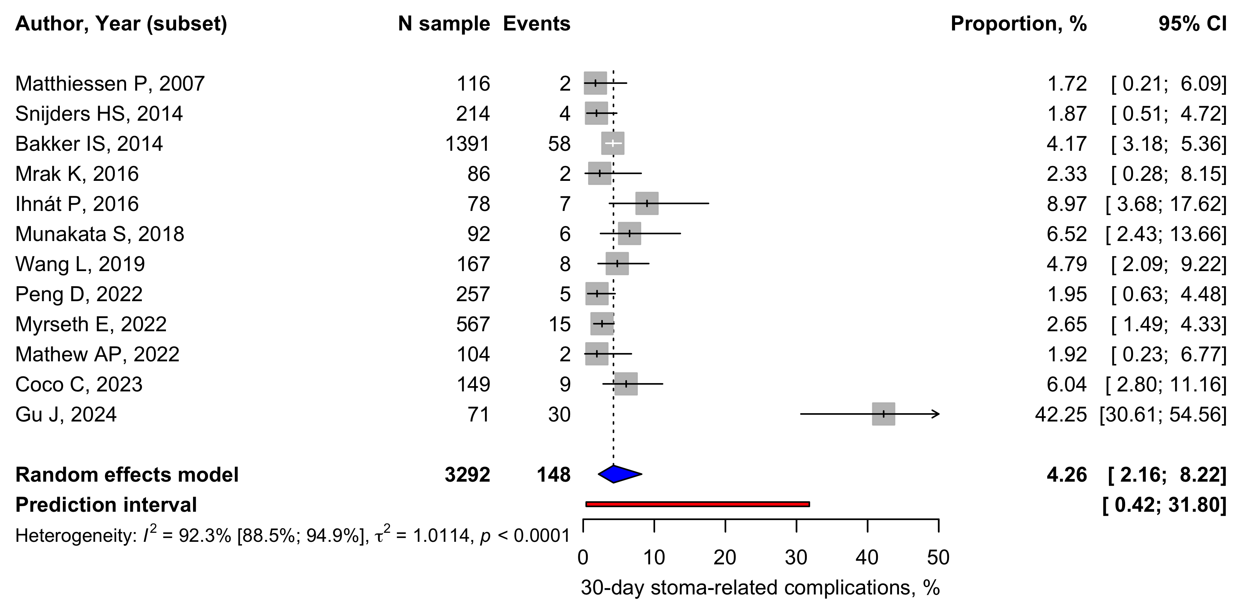

Figure S5. Share of 30-day morbidity attributable to stoma-related complications in the six studies that reported both the number of patients with any complication (denominator) and the number of stoma-related complications (events). Constructed as in Fig. S1.
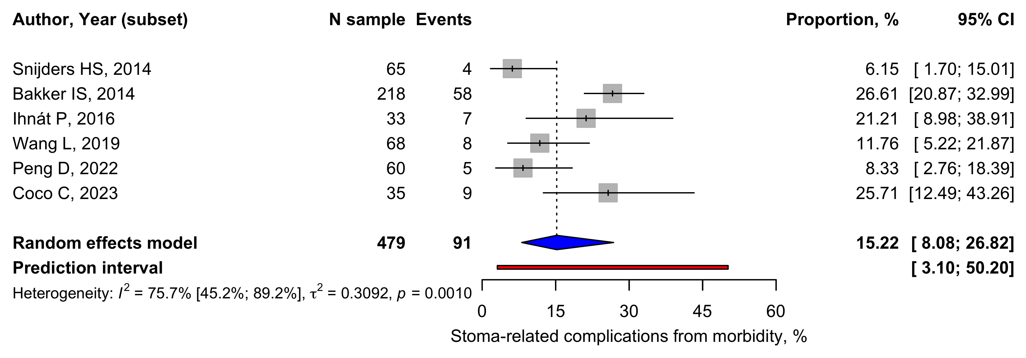

Supplementary references: studies included in the review
Listed in the order of Supplementary Table S3; the label before each reference matches the study label used in Table S3 and in the forest plots.
1. [Leester B, 2002] Leester, B., Asztalos, I. & Polnyib, C. Septic complications after low anterior rectal resection--is diverting stoma still justified?. Acta Chir Iugosl 49, 67-71 (2002). https://doi.org/10.2298/aci0202067l PMID 12587473.
2. [Schmidt O, 2003] Schmidt, O., Merkel, S. & Hohenberger, W. Anastomotic leakage after low rectal stapler anastomosis: significance of intraoperative anastomotic testing. Eur J Surg Oncol 29, 239-43 (2003). https://doi.org/10.1053/ejso.2002.1416 PMID 12657233.
3. [Peeters KC, 2005] Peeters, K. C. et al. Risk factors for anastomotic failure after total mesorectal excision of rectal cancer. Br J Surg 92, 211-6 (2005). https://doi.org/10.1002/bjs.4806 PMID 15584062.
4. [Eriksen MT, 2005] Eriksen, M. T., Wibe, A., Norstein, J., Haffner, J. & Wiig, J. N. Anastomotic leakage following routine mesorectal excision for rectal cancer in a national cohort of patients. Colorectal Dis 7, 51-7 (2005). https://doi.org/10.1111/j.1463-1318.2004.00700.x PMID 15606585.
5. [Chessin DB, 2005] Chessin, D. B. et al. Complications after preoperative combined modality therapy and radical resection of locally advanced rectal cancer: a 14-year experience from a specialty service. J Am Coll Surg 200, 876-82; discussion 882-4 (2005). https://doi.org/10.1016/j.jamcollsurg.2005.02.027 PMID 15922198.
6. [Gastinger I, 2005] Gastinger, I. et al. Protective defunctioning stoma in low anterior resection for rectal carcinoma. Br J Surg 92, 1137-42 (2005). https://doi.org/10.1002/bjs.5045 PMID 15997447.
7. [Matthiessen P, 2007] Matthiessen, P., Hallböök, O., Rutegård, J., Simert, G. & Sjödahl, R. Defunctioning stoma reduces symptomatic anastomotic leakage after low anterior resection of the rectum for cancer: a randomized multicenter trial. Ann Surg 246, 207-14 (2007). https://doi.org/10.1097/SLA.0b013e3180603024 PMID 17667498.
8. [Eberl T, 2008] Eberl, T., Jagoditsch, M., Klingler, A. & Tschmelitsch, J. Risk factors for anastomotic leakage after resection for rectal cancer. Am J Surg 196, 592-8 (2008). https://doi.org/10.1016/j.amjsurg.2007.10.023 PMID 18571620.
9. [Cong ZJ, 2009] Cong, Z. J. et al. Influencing factors of symptomatic anastomotic leakage after anterior resection of the rectum for cancer. World J Surg 33, 1292-7 (2009). https://doi.org/10.1007/s00268-009-0008-4 PMID 19363687.
10. [Marks J, 2010] Marks, J., Mizrahi, B., Dalane, S., Nweze, I. & Marks, G. Laparoscopic transanal abdominal transanal resection with sphincter preservation for rectal cancer in the distal 3 cm of the rectum after neoadjuvant therapy. Surg Endosc 24, 2700-7 (2010). https://doi.org/10.1007/s00464-010-1028-8 PMID 20414681.
11. [Wang L, 2010] Wang, L. & Gu, J. Risk factors for symptomatic anastomotic leakage after low anterior resection for rectal cancer with 30 Gy/10 f/2 w preoperative radiotherapy. World J Surg 34, 1080-5 (2010). https://doi.org/10.1007/s00268-010-0449-9 PMID 20145926.
12. [Akasu T, 2010] Akasu, T. et al. Risk factors for anastomotic leakage following intersphincteric resection for very low rectal adenocarcinoma. J Gastrointest Surg 14, 104-11 (2010). https://doi.org/10.1007/s11605-009-1067-4 PMID 19841989.
13. [Harris LJ, 2010] Harris, L. J., Phillips, B. R., Maxwell, P. J., Isenberg, G. A. & Goldstein, S. D. Outcomes of low anterior resection anastomotic leak after preoperative chemoradiation therapy for rectal cancer. Am Surg 76, 747-51 (2010). PMID 20698384.
14. [Phillips BR, 2010] Phillips, B. R., Harris, L. J., Maxwell, P. J., Isenberg, G. A. & Goldstein, S. D. Anastomotic leak rate after low anterior resection for rectal cancer after chemoradiation therapy. Am Surg 76, 869-71 (2010). PMID 20726419.
15. [Shiomi A, 2011 (a)] Shiomi, A. et al. The indications for a diverting stoma in low anterior resection for rectal cancer: a prospective multicentre study of 222 patients from Japanese cancer centers. Colorectal Dis 13, 1384-9 (2011). https://doi.org/10.1111/j.1463-1318.2010.02481.x PMID 20977591.
16. [Shiomi A, 2011 (b)] Shiomi, A. et al. Diverting stoma in rectal cancer surgery. A retrospective study of 329 patients from Japanese cancer centers. Int J Colorectal Dis 26, 79-87 (2011). https://doi.org/10.1007/s00384-010-1036-0 PMID 20686775.
17. [Kim MJ, 2011] Kim, M. J. et al. The impact of heavy smoking on anastomotic leakage and stricture after low anterior resection in rectal cancer patients. World J Surg 35, 2806-10 (2011). https://doi.org/10.1007/s00268-011-1286-1 PMID 21959931.
18. [Sartori CA, 2011] Sartori, C. A. et al. Laparoscopic total mesorectal excision for rectal cancer: experience of a single center with a series of 174 patients. Surg Endosc 25, 508-14 (2011). https://doi.org/10.1007/s00464-010-1202-z PMID 20607560.
19. [Smith JD, 2012] Smith, J. D. et al. Anastomotic leak is not associated with oncologic outcome in patients undergoing low anterior resection for rectal cancer. Ann Surg 256, 1034-8 (2012). https://doi.org/10.1097/SLA.0b013e318257d2c1 PMID 22584695.
20. [Beirens K, 2012] Beirens, K. & Penninckx, F. Defunctioning stoma and anastomotic leak rate after total mesorectal excision with coloanal anastomosis in the context of PROCARE. Acta Chir Belg 112, 10-4 (2012). https://doi.org/10.1080/00015458.2012.11680789 PMID 22442904.
21. [Nurkin S, 2013] Nurkin, S., Kakarla, V. R., Ruiz, D. E., Cance, W. G. & Tiszenkel, H. I. The role of faecal diversion in low rectal cancer: a review of 1791 patients having rectal resection with anastomosis for cancer, with and without a proximal stoma. Colorectal Dis 15, e309-16 (2013). https://doi.org/10.1111/codi.12248 PMID 23586660.
22. [Park JS, 2013] Park, J. S. et al. Multicenter analysis of risk factors for anastomotic leakage after laparoscopic rectal cancer excision: the Korean laparoscopic colorectal surgery study group. Ann Surg 257, 665-71 (2013). https://doi.org/10.1097/SLA.0b013e31827b8ed9 PMID 23333881.
23. [Jafari MD, 2013] Jafari, M. D. et al. Morbidity of diverting ileostomy for rectal cancer: analysis of the American College of Surgeons National Surgical Quality Improvement Program. Am Surg 79, 1034-9 (2013). PMID 24160794.
24. [Hua H, 2014] Hua, H. et al. Defunctioning cannula ileostomy after lower anterior resection of rectal cancer. Dis Colon Rectum 57, 1267-74 (2014). https://doi.org/10.1097/DCR.0000000000000217 PMID 25285693.
25. [Snijders HS, 2014] Snijders, H. S. et al. High 1-year complication rate after anterior resection for rectal cancer. J Gastrointest Surg 18, 831-8 (2014). https://doi.org/10.1007/s11605-013-2381-4 PMID 24249050.
26. [Reilly F, 2014] Reilly, F. et al. Incidence, risks and outcome of radiological leak following early contrast enema after anterior resection. Int J Colorectal Dis 29, 453-8 (2014). https://doi.org/10.1007/s00384-013-1820-8 PMID 24420736.
27. [Bakker IS, 2014] Bakker, I. S. et al. High complication rate after low anterior resection for mid and high rectal cancer; results of a population-based study. Eur J Surg Oncol 40, 692-8 (2014). https://doi.org/10.1016/j.ejso.2014.02.234 PMID 24655803.
28. [Hayden DM, 2014] Hayden, D. M., Mora Pinzon, M. C., Francescatti, A. B. & Saclarides, T. J. Patient factors may predict anastomotic complications after rectal cancer surgery: Anastomotic complications in rectal cancer. Ann Med Surg (Lond) 4, 11-6 (2015). https://doi.org/10.1016/j.amsu.2014.12.002 PMID 25685338.
29. [Majbar MA, 2014] Majbar, M. A. et al. Risk factors for anastomotic leakage after anterior resection for rectal adenocarcinoma. Tunis Med 92, 493-6 (2014). PMID 25775290.
30. [Anderin K, 2015] Anderin, K., Gustafsson, U. O., Thorell, A. & Nygren, J. The effect of diverting stoma on postoperative morbidity after low anterior resection for rectal cancer in patients treated within an ERAS program. Eur J Surg Oncol 41, 724-30 (2015). https://doi.org/10.1016/j.ejso.2015.03.234 PMID 25908011.
31. [Kim MK, 2015] Kim, M. K. et al. Comparative study between transanal tube and loop ileostomy in low anterior resection for mid rectal cancer: a retrospective single center trial. Ann Surg Treat Res 88, 260-8 (2015). https://doi.org/10.4174/astr.2015.88.5.260 PMID 25960989.
32. [Tortorelli AP, 2015] Tortorelli, A. P. et al. Anastomotic leakage after anterior resection for rectal cancer with mesorectal excision: incidence, risk factors, and management. Am Surg 81, 41-7 (2015). PMID 25569064.
33. [Messaris E, 2015] Messaris, E. et al. Is a diverting ostomy needed in mid-high rectal cancer patients undergoing a low anterior resection after neoadjuvant chemoradiation? An NSQIP analysis. Surgery 158, 686-91 (2015). https://doi.org/10.1016/j.surg.2015.02.026 PMID 26008960.
34. [Jannasch O, 2015] Jannasch, O. et al. Risk factors, short and long term outcome of anastomotic leaks in rectal cancer. Oncotarget 6, 36884-93 (2015). https://doi.org/10.18632/oncotarget.5170 PMID 26392333.
35. [Jonker FH, 2016] Jonker, F. H., Tanis, P. J., Coene, P. P., Gietelink, L. & van der Harst, E. Comparison of a low Hartmann's procedure with low colorectal anastomosis with and without defunctioning ileostomy after radiotherapy for rectal cancer: results from a national registry. Colorectal Dis 18, 785-92 (2016). https://doi.org/10.1111/codi.13281 PMID 26788679.
36. [Celerier B, 2016] Celerier, B., Denost, Q., Van Geluwe, B., Pontallier, A. & Rullier, E. The risk of definitive stoma formation at 10 years after low and ultralow anterior resection for rectal cancer. Colorectal Dis 18, 59-66 (2016). https://doi.org/10.1111/codi.13124 PMID 26391723.
37. [Mrak K, 2016] Mrak, K. et al. Diverting ileostomy versus no diversion after low anterior resection for rectal cancer: A prospective, randomized, multicenter trial. Surgery 159, 1129-39 (2016). https://doi.org/10.1016/j.surg.2015.11.006 PMID 26706610.
38. [Ihnát P, 2016] Ihnát, P. et al. Diverting ileostomy in laparoscopic rectal cancer surgery: high price of protection. Surg Endosc 30, 4809-4816 (2016). https://doi.org/10.1007/s00464-016-4811-3 PMID 26902615.
39. [Hamabe A, 2018] Hamabe, A., Ito, M., Nishigori, H., Nishizawa, Y. & Sasaki, T. Preventive effect of diverting stoma on anastomotic leakage after laparoscopic low anterior resection with double stapling technique reconstruction applied based on risk stratification. Asian J Endosc Surg 11, 220-226 (2018). https://doi.org/10.1111/ases.12439 PMID 29230964.
40. [Munakata S, 2018] Munakata, S. et al. Defunctioning loop ileostomy with restorative proctocolectomy for rectal cancer: Friend or foe?. J Anus Rectum Colon 1, 136-140 (2017). https://doi.org/10.23922/jarc.2017-023 PMID 31583314.
41. [Wang L, 2019] Wang, L. et al. Diverting Stoma Versus No Diversion in Laparoscopic Low Anterior Resection: A Single-center Retrospective Study in Japan. In Vivo 33, 2125-2131 (2019). https://doi.org/10.21873/invivo.11713 PMID 31662547.
42. [Skrovina M, 2020] Skrovina, M. et al. The significance of intraoperative fluorescence angiography in miniinvasive low rectal resections. Wideochir Inne Tech Maloinwazyjne 15, 43-48 (2020). https://doi.org/10.5114/wiitm.2019.84851 PMID 32117485.
43. [Yang SY, 2020] Yang, S. Y. et al. Late anastomotic leakage after anal sphincter saving surgery for rectal cancer: is it different from early anastomotic leakage?. Int J Colorectal Dis 35, 1321-1330 (2020). https://doi.org/10.1007/s00384-020-03608-9 PMID 32372379.
44. [Niu L, 2020] Niu, L., Wang, J., Zhang, P. & Zhao, X. Protective ileostomy does not prevent anastomotic leakage after anterior resection of rectal cancer. J Int Med Res 48, 300060520946520 (2020). https://doi.org/10.1177/0300060520946520 PMID 32862745.
45. [Cho SH, 2021] Cho, S. H., Lee, I. K., Lee, Y. S. & Kim, M. K. The usefulness of transanal tube for reducing anastomotic leak in mid rectal cancer: compared to diverting stoma. Ann Surg Treat Res 100, 100-108 (2021). https://doi.org/10.4174/astr.2021.100.2.100 PMID 33585354.
46. [Lee RM, 2021] Lee, R. M. et al. Revisiting the Value of Drains After Low Anterior Resection for Rectal Cancer: a Multi-institutional Analysis of 996 Patients. J Gastrointest Surg 25, 2000-2010 (2021). https://doi.org/10.1007/s11605-020-04781-6 PMID 32869144.
47. [Qi X, 2021] Qi, X. et al. Risk factors of symptomatic anastomotic leakage and its impacts on a long-term survival after laparoscopic low anterior resection for rectal cancer: a retrospective single-center study. World J Surg Oncol 19, 187 (2021). https://doi.org/10.1186/s12957-021-02303-5 PMID 34172053.
48. [Spinelli A, 2021] Spinelli, A. et al. Transanal Transection and Single-Stapled Anastomosis (TTSS): A comparison of anastomotic leak rates with the double-stapled technique and with transanal total mesorectal excision (TaTME) for rectal cancer. Eur J Surg Oncol 47, 3123-3129 (2021). https://doi.org/10.1016/j.ejso.2021.08.002 PMID 34384655.
49. [Zhao S, 2021] Zhao, S. et al. Transanal Drainage Tube Use for Preventing Anastomotic Leakage After Laparoscopic Low Anterior Resection in Patients With Rectal Cancer: A Randomized Clinical Trial. JAMA Surg 156, 1151-1158 (2021). https://doi.org/10.1001/jamasurg.2021.4568 PMID 34613330.
50. [Chierici A, 2021] Chierici, A., Frontali, A., Godefroy, W., Spiezio, G. & Panis, Y. Can end-to-end anastomosis reduce the risks of anastomotic leak compared to side-to-end anastomosis? A comparative study of 518 consecutive patients undergoing laparoscopic total mesorectal excision for low- or mid-rectal cancer. Tech Coloproctol 25, 1019-1026 (2021). https://doi.org/10.1007/s10151-021-02468-x PMID 34120290.
51. [Gadan S, 2021] Gadan, S., Brand, J. S., Rutegård, M. & Matthiessen, P. Defunctioning stoma and short- and long-term outcomes after low anterior resection for rectal cancer-a nationwide register-based cohort study. Int J Colorectal Dis 36, 1433-1442 (2021). https://doi.org/10.1007/s00384-021-03877-y PMID 33728534.
52. [Coppola A, 2021] Coppola, A. et al. Laparoscopic total mesorectal excision (L-TME) for rectal cancer surgery: does elective diverting ileostomy really protect? An observational retrospective cohort study. Ann Ital Chir 92, pii: S0003469X21036101 (2021). PMID 35642649.
53. [Peng D, 2022] Peng, D. et al. Does temporary ileostomy via specimen extraction site affect the short outcomes and complications after laparoscopic low anterior resection in rectal cancer patients? A propensity score matching analysis. BMC Surg 22, 263 (2022). https://doi.org/10.1186/s12893-022-01715-8 PMID 35799152.
54. [Liang W, 2022] Liang, W. et al. Comparison of postoperative complication rates between a novel endoluminal balloon-assisted drainage and diverting stoma after low rectal cancer. Clin Transl Oncol 24, 1347-1353 (2022). https://doi.org/10.1007/s12094-021-02775-7 PMID 35029803.
55. [Rouanet P, 2022] Rouanet, P. et al. Tailored Management with Highly-Selective Diversion for Low Colorectal Anastomosis: Biochemical Postoperative Follow-Up and Long-Term Results from a Single-Institution Cohort. Ann Surg Oncol 29, 2514-2524 (2022). https://doi.org/10.1245/s10434-021-11197-2 PMID 34994889.
56. [Myrseth E, 2022] Myrseth, E., Nymo, L. S., Gjessing, P. F. & Norderval, S. Diverting stomas reduce reoperation rates for anastomotic leak but not overall reoperation rates within 30 days after anterior rectal resection: a national cohort study. Int J Colorectal Dis 37, 1681-1688 (2022). https://doi.org/10.1007/s00384-022-04205-8 PMID 35739403.
57. [Mathew AP, 2022] Mathew, A. P., M, S., K, C., Muralee, M. & Wagh, M. Morbidity of Temporary Loop Ileostomy in Patients with Colorectal Cancer. Indian J Surg Oncol 13, 468-473 (2022). https://doi.org/10.1007/s13193-022-01501-1 PMID 36187539.
58. [Sun X, 2023] Sun, X. et al. Comparison of safety of loop ileostomy and loop transverse colostomy for low-lying rectal cancer patients undergoing anterior resection: A retrospective, single institution, propensity score-matched study. Asia Pac J Clin Oncol 19, e5-e11 (2023). https://doi.org/10.1111/ajco.13322 PMID 32199033.
59. [Liu C, 2023] Liu, C. et al. Comparison of specimen extraction site and another site for protective loop ileostomy in laparoscopic low anterior rectal resection: a retrospective comparative study. Langenbecks Arch Surg 408, 151 (2023). https://doi.org/10.1007/s00423-023-02886-5 PMID 37055576.
60. [Coco C, 2023] Coco, C. et al. Role and Morbidity of Protective Ileostomy after Anterior Resection for Rectal Cancer: One Centre Experience and Review of Literature. J Clin Med 12 (2023). https://doi.org/10.3390/jcm12237229 PMID 38068281.
61. [Duhoky R, 2024] Duhoky, R. et al. An Institutional Shift from Routine to Selective Diversion of Low Anastomosis in Robotic TME Surgery for Rectal Cancer Patients Using the KHANS Technique: A Single-Centre Cohort Study. J Pers Med 14 (2024). https://doi.org/10.3390/jpm14070725 PMID 39063979.
62. [Gu J, 2024] Gu, J. et al. 'Dumpling suture method' versus traditional suture method of protective loop ileostomy in laparoscopic anterior rectal resection with specimen extraction through stoma incision: a retrospective comparative cohort study. Int J Surg 110, 1367-1375 (2024). https://doi.org/10.1097/JS9.0000000000000953 PMID 38484258.
63. [Wang Z, 2024] Wang, Z. et al. The impact of transanal drainage tube on the incidence of anastomotic leakage and small bowel obstruction in radical surgery (Dixon) for rectal cancer: a retrospective cohort study. J Gastrointest Oncol 15, 1508-1518 (2024). https://doi.org/10.21037/jgo-24-537 PMID 39279931.
64. [Ferrara F, 2024] Ferrara, F. et al. Outcomes of loop ileostomy after rectal resection for cancer: A prospective observational multicenter snapshot study from Multidisciplinary Italian Study group for STOmas (MISSTO). Tech Coloproctol 29, 16 (2024). https://doi.org/10.1007/s10151-024-03047-6 PMID 39661237.
65. [Wang Y, 2024] Wang, Y., Wang, X., Huang, S., Zhu, H. & Huang, Y. Impact of diversion ileostomy on postoperative complications and recovery in the treatment of locally advanced upper-half rectal cancer. Sci Rep 14, 26812 (2024). https://doi.org/10.1038/s41598-024-78409-z PMID 39501068.
66. [Ho HA, 2024] Ho, H. A., Trieu, T. D. & Nguyen, M. D. Anastomotic leakage following rectal cancer laparoscopic surgery: can a transanal drainage tube be an alternative to diverting stoma?. Eur Rev Med Pharmacol Sci 28, 3642-3649 (2024). https://doi.org/10.26355/eurrev_202405_36301 PMID 38856140.
67. [Cao Y, 2025] Cao, Y. et al. Prophylactic ileostomy vs. nonprophylactic ileostomy in laparoscopic low anterior resection for rectal cancer (PILLAR): a prospective, multicenter, cohort study in china. Int J Surg 112, 9680-91 (2025). https://doi.org/10.1097/JS9.0000000000004528 PMID 41405334.
68. [Chen J, 2025] Chen, J., Fei, R., Wang, F., Li, W. & Hua, H. Pressure-controlled tube ileostomy after lower anterior resection of rectal cancer: a new type of protective stoma in rectal anastomosis. Minerva Surg 80, 442-451 (2025). https://doi.org/10.23736/S2724-5691.25.10981-7 PMID 41622823.
69. [Hu G, 2025] Hu, G. et al. Patient selection and operative strategies for laparoscopic intersphincteric resection without diverting stoma. World J Gastrointest Surg 17, 95983 (2025). https://doi.org/10.4240/wjgs.v17.i3.95983 PMID 40162392.
70. [Kitaguchi D, 2025] Kitaguchi, D. et al. Delayed vs Immediate Coloanal Anastomosis after Total Mesorectal Excision for Low Rectal Cancer: An International Multicenter Retrospective Cohort Study. J Am Coll Surg 241, 448-459 (2025). https://doi.org/10.1097/XCS.0000000000001410 PMID 40226931.
71. [Ochiai K, 2025] Ochiai, K. et al. Risk Factors for and Oncologic Impact of Anastomotic Leakage After Sphincter-Preserving Proctectomy for Mid/Low Rectal Cancer: A Multi-institutional Cohort Study in Japan. Ann Surg Oncol 32, 7315-7325 (2025). https://doi.org/10.1245/s10434-025-17763-2 PMID 40624310.
72. [Li Y, 2026] Li, Y. et al. A single-center retrospective study of prophylactic loop ileostomies and transverse end colostomies after laparoscopic radical resection for rectal cancer: a comparison of safety and functional outcomes. Int J Colorectal Dis 41, 35 (2026). https://doi.org/10.1007/s00384-026-05082-1 PMID 41535631.

